WARNING- **This is not as easy as it sounds**.  Do not wait until the last two days.

No sense on letting good code go to waste so once more we are going to revisit assignments 11.

Once more we are doing a random rain generation with structures.  You will have that code from the previous assignment.

Once the rainfall is generated write the data to an output file called scramble.txt.

The data output file must meet the following requirements

* The file needs to be overwritten every time the code runs.
* The month order to be written to the file will be random so you will need to use another random generator.
* The output file will contain the 12 records stored in the structure written in random order.
* Create a loop that retrieves one random month at a time.
* Insert the month's name and rainfall to the output file ONLY IF the month has not been previously added.
* To prevent duplication, every time you write a month's name to the file add it to a string variable .
* Before writing a new month record to the output file, verify the month is not in the string variable.
* No other method of circumventing the random duplication will be accepted.
* If it is a duplicate skip the record.  To determine if the month is duplicate I suggest using "size_t pos" see [http://www.cplusplus.com/reference/string/string/substr/ (Links to an external site.)](http://www.cplusplus.com/reference/string/string/substr/) for an example on how to determine the position (existence) of one string inside the other.    
  Once you write to the output file do not forget to increment your loop counter otherwise, you will end up on an endless loop and freeze/crash.
* To avoid errors don't forget to close() the file when you are done writing to it.
* Your code needs to be divided into functions at the bare minimum you need to have functions for  
  Generating Rainfall  
  Adding a new record to output  
  Checking if the month is duplicate  
  Writing to file
* Attempting to hardcode not so random output to file or any other method that does not follow the directions will result in a zero grade for the assignment.

All the code must be modularized into functions.

All functions must be prototyped (declared). Not function code must appear above the main function just the function definitions. No calculations inside the main function.

* + See sample run below
  + 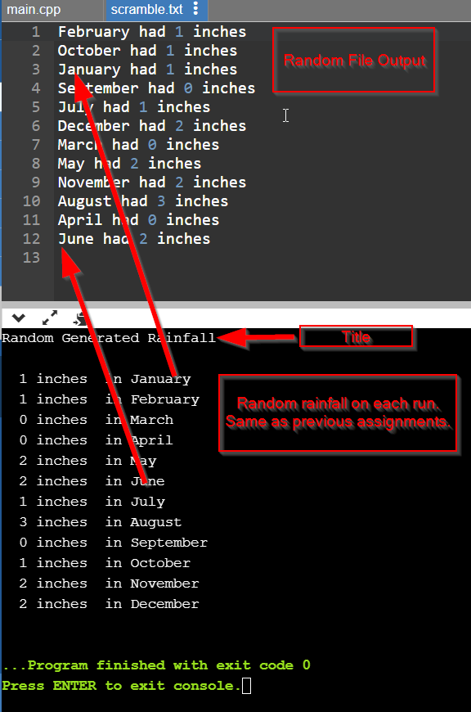

These instructions are pretty specific do not expect any leeway if they are not followed.