Functional Requirements:

*Let's play Number Series Games*

Display a Menu of Number Series Games including Count Backwards, Even-Number Series, and Negative Ten Series

Input what game the user wishes to play.  Play that game.

Display the Menu.

Repeat until the user chooses Option 4 to Exit the program.

Programming Requirements:

1.  Count Backwards

2.  Even-Number Series

3.  Negative Ten Series

4.  Exit

Prompt for and input the user choice of game.

If user enters menu option 1:  prompt for and input a positive number.  Validate user input for start number > 0.  While number is not valid, give error message and input a new number.  Display all numbers in the series starting the user's start number and ending with 0.   (Use a for loop to generate the numbers.)

If user enters menu option 2:  prompt for and input a positive number that is a multiple of 2.  Validate user input for >0 and multiple of 2.  While number is not valid, give error message and input a new number. Display all numbers in the series up to and including the end number. (Use a for loop to generate the numbers)

If user enters menu option 3:  prompt for and input a negative number that is a multiple of 10.  Validate user input for <0 and multiple of 10.  While number is not valid, give error message and input a new number. Display all numbers in the series up to and including the end number.  (Use a for loop to generate the numbers.)

If user enters option 4 then give a polite message about the program ending.

Continue the menu looping and displaying the menu, etc, until the user enters 4 and then stop.

-------

1.  Use a *do-while loop* to drive the menu.  See Program 5-8 in your textbook for driving the menu.

2.  Use a *switch* *statement* to decide which function to execute and to validate menu input.

3.  Use*for loops* to generate the 3 games.

4.  Use a while loop to validate user input inside of each game.

 See the pseudocode below for help on how to construct all of this.

*-----------*

*do loop*

*output menu*

*input menuChoice*

*Switch (menuChoice)*

*Case (1)*

*prompt for startNumber*

*get startNumber*

*while(startNumber <=0)  // use a while loop to validate user's input*

*display error message*

*get startNumber*

*end while loop*

*for(int i = highNumber; i>=0; i--)  // use a for loop to count backwards*

*display i following by a space*

*end for loop*

*break;*

*Case (2)*

*//code for Even Number Series*

*Case(3):*

*//code for Negative Three Series*

*Case(4):  output goodbye line*

*Default:  output that number is not on the menu //that's the validation part.*

*End Switch*

*while (menuChoice !! 4) loop  // it's the bottom of the do loop from up above*

*end the program.*

*Sample Output*

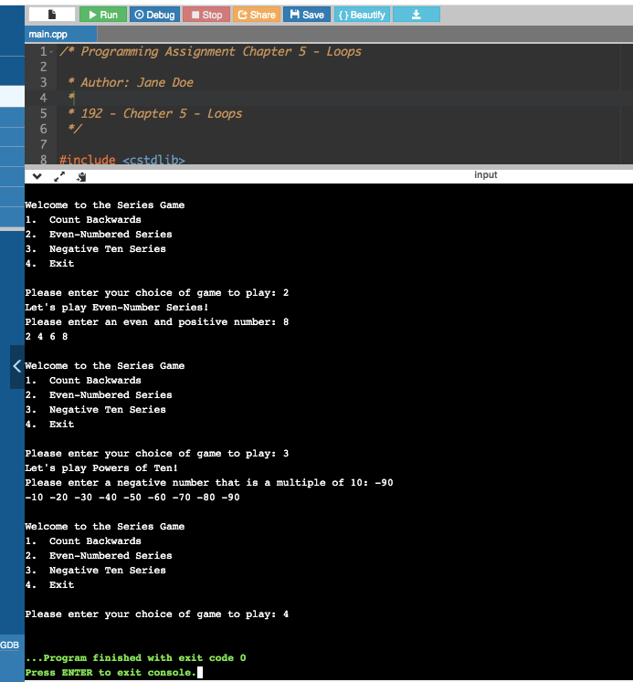

Programming Notes:

**No global variables

**You MUST use for loops to do calculate each series.

**Make your output look good - clean and professional.

Submit in accordance with the [General Homework Instructions](https://sdccd.instructure.com/courses/2414265/pages/general-homework-instructions)

1.  your .cpp file

2.  a link to your program in [onlineGDB.com](http://onlinegdb.com/)

50 points