Chapter 9:

Write a program that generates our recurring theme of the month and random rainfall.

For this assignment, you will need to use pointers for the months and rainfall data.   
Unlike the previous assignment this time the random rainfall will be double data type formatted as shown.

Add header file *#include <typeinfo>* to your code so you can display the required results.   
The first two lines of your output will show the type for the months and rainfall.  You can name your pointer anything you want but the following is the required aforementioned code using ptr_month and ptr_rainAmount

cout << "Month has type :" << typeid(ptr_month).name() << "\n";

cout << "Rainfall has type :" << typeid(ptr_rainAmount).name() << "\n";

Your output should resemble:

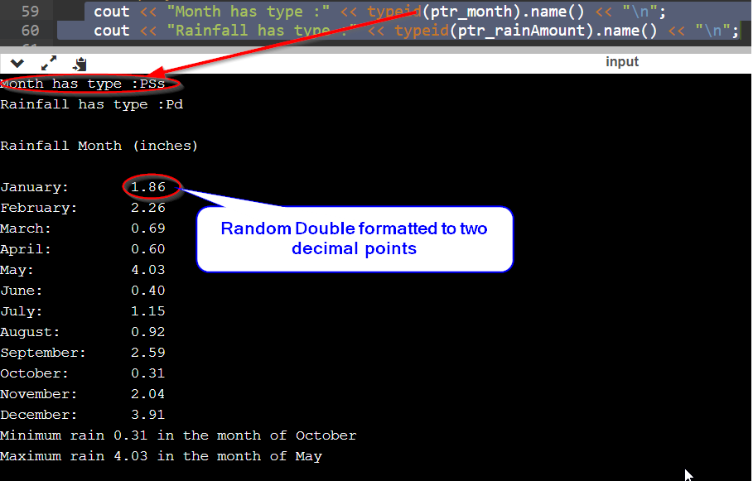

Pointers is the subject of the chapter so if pointers are not used you will not receive any credit for the work submitted,