**TBB Authoring App User Manual**

**Daniel Kozlovsky**

**Arshdeep Saini**

**Kirollos Kamel**

Latest Revision: August. 21st 2018

Table of Contents

**Type chapter title (level 1)1**

Type chapter title (level 2)2

Type chapter title (level 3)3

**Type chapter title (level 1)4**

Type chapter title (level 2)5

Type chapter title (level 3)6

**Installation**

The TBB Authoring App is an executable, meant to be run from any where on your file system. To launch the application, double click on *TBB Authoring App.jar* in the *TBB_Authoring_App.rar* file.

**How to use the TBB Authoring App:**

The TBB Authoring App main screen allows you to choose from two main options

1. Import an existing scenario file:

Importing an existing scenario to the TBB Authoring App can be done easily by first clicking on import scenario button form the main screen

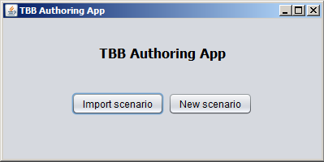

Then a new window will appear this window will allow you to choose the file form your computer.

Chose the appropriate scenario file

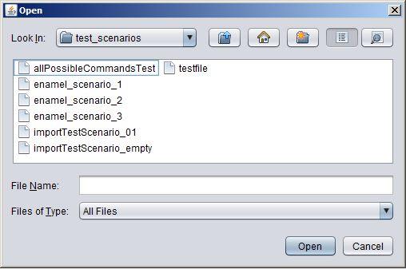

*Then click open which will load the scenario into the program*

1. Creating new Scenario

Creating a new scenario can be done by pressing on the new scenario button from the main screen of the TBB Authoring App

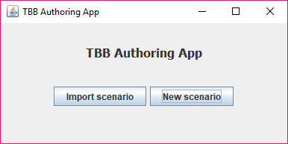

Then it will open the create scenario screen which will allow the user to add command, remove command or to move commands

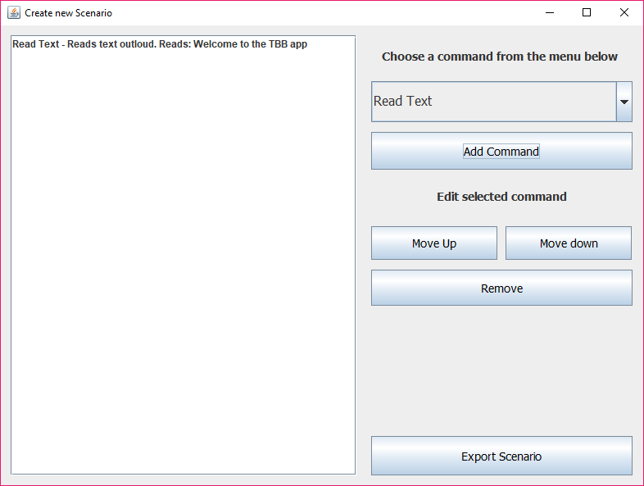

2

1

2

Adding command can be easily done choosing from the command drop-down menu

The drop-down command menu that allow the user to choose from a list of commands which are (Read text, pause, Display text, Start Repeat, End Repeat, skip button, User input, sound, reset buttons, clear all cell Display, clear cell Display, Display cell pins, Display Character, Raise pin, Lower pins, Skip location)

1-

Then pressing on add command button, a message will pop up to add the command arguments. Adding the correct arguments to the command then pressing ok button it will appear on the command list

There is two ways you can add sound to the scenario

* Import an audio file from the computer
* record sound from the sound window that will pop up

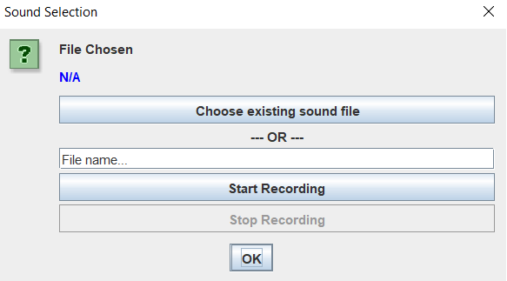

2-

the command list is where all added commands is displayed. select any command and then press action buttons like Remove, move up and move down you can edit the command location or remove the command.

Export the scenario to a text file to be used in the braille device is can be done by the Export Scenario button. Then a new window will appear this window will allow you to choose where you want to save the scenario file in your computer.

s