A Role-Aware Explainable AI Dashboard for At-Risk Student Classification∗
  - Design and Technical Evaluation on the Open University Learning Analytics Dataset

Daniel Larry†
Department of Computer Science
American University of Nigeria
Yola, Adamawa, Nigeria
daniel.larry@aun.edu.ng
Zainab Shamsiya Usman
Department of Computer Science
American University of Nigeria
Yola, Adamawa, Nigeria

ABSTRACT
Predictive models built on learning management system (LMS) data can flag students at risk of failing or withdrawing, but most systems present isolated risk scores without the reasoning behind them and give every staff role the same view. This study designed, implemented and technically evaluated a role-aware explainable artificial intelligence (XAI) dashboard that delivers explanations from one prediction system to instructors, academic advisors and administrators at different levels of aggregation. Following design science research with the CommonKADS knowledge engineering methodology, Random Forest, XGBoost and Gradient Boosting classifiers were evaluated on the Open University Learning Analytics Dataset (32,593 student-module-presentation observations) using four-fold cross-validation grouped by course presentation. SHAP and LIME formed the explanation layer, and the prototype was integrated with Moodle and Canvas. The XGBoost prototype, selected on recall, achieved out-of-fold accuracy of 0.877, precision of 0.866, recall of 0.909, F1-score of 0.887 and AUC of 0.962; Random Forest obtained a marginally higher F1-score (0.898). Accuracy ranged from 0.846 to 0.916 across held-out presentations. Both explanation methods ranked the number of assessments submitted first and shared seven of their top ten features, but the mean instance-level top-5 overlap was only 0.635. A role-aware explanation layer is technically feasible at full dataset scale, and the partial agreement between SHAP and LIME supports showing both methods side by side. The features cover the full presentation, so results describe retrospective classification; practitioner trust, calibration and fairness remain to be evaluated.
∗This article is based on the first author’s MSc thesis in Computer Science at the American University of Nigeria.
†Corresponding author.
Permission to make digital or hard copies of part or all of this work for personal or classroom use is granted without fee provided that copies are not made or distributed for profit or commercial advantage and that copies bear this notice and the full citation on the first page. Copyrights for third-party components of this work must be honored. For all other uses, contact the owner/author(s).
[Venue, year: to be completed on acceptance]
© 2026 Copyright held by the owner/author(s). [ISBN/ISSN and DOI supplied by ACM]
CCS CONCEPTS
• Applied computing → Learning management systems • Computing methodologies → Machine learning • Human-centered computing → Visualization systems and tools
KEYWORDS
explainable artificial intelligence, learning analytics dashboards, at-risk student prediction, SHAP, LIME, knowledge engineering, OULAD
ACM Reference format:
Daniel Larry and Zainab Shamsiya Usman. 2026. A Role-Aware Explainable AI Dashboard for At-Risk Student Classification: Design and Technical Evaluation on the Open University Learning Analytics Dataset. [Venue details to be completed on acceptance].
1 Introduction
Learning management systems (LMS) such as Moodle, Canvas and Blackboard now support course delivery, assessment and communication at scale, and their use grew substantially when teaching moved online during the COVID-19 pandemic, increasing the volume of behavioural data available for analysis [49]. Learning analytics, defined as the measurement, collection, analysis and reporting of data about learners and their contexts to understand and optimise learning [56], has used these data to identify students at risk of failing or withdrawing early enough for staff to intervene [26, 33]. The Open University Learning Analytics Dataset (OULAD), which records 32,593 student-module-presentation observations across 22 module presentations [33], has become one of the most widely used benchmarks for this work [17, 26, 65].
Predictive accuracy on such benchmarks is now high, but less attention has been given to what happens after a student is flagged. Many prediction systems generate risk scores without explaining the reasoning behind them, leaving staff without enough context to decide whether and how to act [61]. Explainable AI (XAI) techniques such as SHapley Additive exPlanations (SHAP) and Local Interpretable Model-agnostic Explanations (LIME) can attribute a prediction to the features that drove it, yet their integration into working learning analytics dashboards remains limited [3, 4]. A further problem is that institutional stakeholders need different kinds of explanation from the same model: an instructor monitoring a running course does not need the same view as an administrator reviewing withdrawal across a cohort [31]. The literature suggests that explanations should reflect the recipient’s role and expertise [20, 31], but the reviewed studies did not identify a dashboard that delivers role-specific explanations to several staff roles from a single prediction system [2, 9, 29, 61].
This study treats the problem as both a design problem and a technical one. It designs, implements and technically evaluates a role-aware XAI dashboard for at-risk student classification, guided by the CommonKADS knowledge engineering methodology [54], and asks three research questions:
RQ1. How can SHAP and LIME be integrated into a knowledge engineering pipeline to improve transparency in student at-risk prediction models?
RQ2. What dashboard features and explanation structures, based on the CommonKADS Agent Model and the learning analytics dashboard literature, can be specified to support the different information needs of instructors, advisors and administrators within an LMS?
RQ3. What do the predictive performance and explainability findings indicate about the technical potential of the role-aware dashboard to support practitioner interpretation and decision-making?
The study makes four contributions: (1) an implemented role-aware XAI dashboard architecture that differentiates SHAP and LIME explanations across instructor, advisor and administrator views of one LMS-integrated prediction system; (2) a documented ensemble model evaluated on OULAD under a protocol that holds out entire course presentations; (3) technical evidence on the agreement and divergence of SHAP and LIME on a real educational dataset; and (4) candidate design guidelines for explainable learning analytics dashboards, derived from the CommonKADS models and the implemented system. The evaluation is technical and uses secondary data only. Findings are therefore reported at three levels of evidence: properties demonstrated by measurement, properties supported by the design but not tested with users, and properties not empirically established.
2 Related work
2.1 At-risk prediction and evaluation protocols
Research on at-risk prediction spans logistic regression, decision trees, ensembles and deep learning. In a systematic review of OULAD studies, Jin et al. [26] found that ensemble methods, particularly gradient boosting variants and random forests, are common and typically outperform simpler classifiers, while practitioner-facing aspects receive little attention. Reported accuracies can be very high: Wang [65] reports 96.9% accuracy on OULAD for a hybrid ensemble, and Rebelo Marcolino et al. [49] report strong dropout prediction on Moodle logs using CatBoost with multi-objective optimisation. Guevara-Reyes et al. [16] show that more complex ensembles gain accuracy at the cost of intrinsic interpretability. Engagement-based features tend to outperform static demographic ones [25], useful predictions can be made after a fraction of a course has elapsed [1], and deadline-anchored activity windows have been reported to give stronger early-warning signals on OULAD than calendar windows [23].
Reported figures depend strongly on the evaluation protocol. Jin et al. [26] note that protocols vary considerably across OULAD studies, Krstajic et al. [32] show that letting observations from the same higher-level unit appear in both training and validation folds produces optimistic estimates, and Pelánek [47] argues that cross-validation, filtering and metric choices materially change reported performance in student modelling independently of model quality. Fairness is a further concern: Baker and Hawn [5] document systematic performance disparities across demographic subgroups in educational models, and Yu et al. [66] show that error rates can differ across student groups even when overall accuracy is high.
2.2 Explainable AI in education
XAI surveys distinguish intrinsically interpretable models from post-hoc explanation techniques and argue that the choice depends on the deployment context and the expertise of the user [6]. Ali et al. [4] report that tailoring explanations to user types remains an open problem, with most systems defaulting to technically framed outputs. In education, SHAP [36, 37] and LIME [50] dominate current applications. Nnadi et al. [44] found SHAP the most consistent of several methods for attribution stability, Salih et al. [52] discuss the computational cost of SHAP, its feature independence assumption and the sensitivity of LIME to sampling, and Gunasekara and Saarela [17] apply both methods to models trained on OULAD. Hooshyar and Yang [24] report significant variability in the feature importance assigned by SHAP variants and LIME to the same educational model. Critiques of post-hoc explanation add caution: Rudin [51] argues that high-stakes decisions should rest on intrinsically interpretable models, and Slack et al. [57] show that both SHAP and LIME can be manipulated through their perturbation schemes.
Work on the human side of explanation argues that explanations should be contrastive, selective and suited to the recipient [39], and that their effectiveness depends on the fit between content, expertise and decision [14, 35]. Khosravi et al. [30] identify several stakeholder groups in educational XAI whose explanation needs differ, and Conati et al. [12] show that learners with different prior knowledge derive different value from the same explanations. Afzaal et al. [2] present an early example of SHAP-based explanations delivered within an LMS, but for students rather than for the staff who make intervention decisions.
2.3 Learning analytics dashboards and role-aware design
Learning analytics dashboards (LADs) are the main channel through which analytics reach staff, but reviews report limited theoretical grounding and evaluation [38, 55]. Cabral et al. [9] identify limited XAI integration as one of the most persistent gaps in AI-powered LADs. Existing designs typically serve one user group: Susnjak et al. [61] combine descriptive, predictive and prescriptive analytics for learners, Chavan and Mitra [10] design for instructors, and Kaliisa and Dolonen [28] found that instructors prioritise summary-level alerts over granular breakdowns. Even within one role, needs vary; in the LADA advising dashboard, senior advisors preferred cohort views while less experienced advisors relied on individual detail [19]. Kaliisa et al. [29] provide a checklist for planning, designing, implementing and evaluating LADs that calls for engagement with the full range of stakeholders. Knowledge engineering offers a structured way to do this: CommonKADS models agents, their tasks and the knowledge they require as distinct artefacts [54, 60]. Taken together, the reviewed literature shows mature technical components for prediction and explanation, but no staff-facing design that serves instructors, advisors and administrators from one prediction system with role-specific explanations.
3 Method
3.1 Research design
The study follows the Design Science Research Methodology [22, 46], with CommonKADS [54] as the knowledge engineering and design framework applied within it. The Technology Acceptance Model [13] was used only as a design lens for perceived usefulness and ease of use, and the checklist of Kaliisa et al. [29] guided dashboard design. Table 1 summarises how each of the six CommonKADS models was instantiated. Because no institutional partner or practitioners were involved, the Organisation and Agent Models were populated from published literature rather than from knowledge elicitation, which CommonKADS would ordinarily expect; the resulting role characterisations are therefore well-sourced hypotheses rather than documented accounts.

Table 1: Instantiation of the six CommonKADS models in this study.
Model | Instantiation | Resulting design decision
Organisation | How at-risk information reaches instructors, advisors and administrators and where the flow breaks down (scores without explanation; one view for all roles), from published accounts [29, 34, 62]. | Three staff roles served from one shared prediction system; students out of scope.
Task | Risk assessment, explanation generation, role assignment and explanation delivery; intervention left to the human agent [63]. | Layered architecture separating data, prediction, explanation, role assignment and presentation.
Agent | Knowledge, capabilities and explanation needs of each role, from literature rather than elicitation [20, 31]. | Three information briefs at individual, caseload and cohort granularity (Table 2).
Knowledge | Engagement, assessment and demographic features and their SHAP attributions [33, 37]. | Feature families with a human-readable feature dictionary.
Communication | Selective explanations phrased for the recipient [39]. | Progressive disclosure, side-by-side SHAP and LIME, role-gated views.
Design | Mapping of the five models above onto the technical architecture [54]. | Five-layer architecture with role-based access control (Section 4).

3.2 Dataset and target
OULAD comprises seven relational tables covering registrations, demographics, module presentations, assessments, assessment results, VLE resources and VLE interaction logs [33]. These were joined into one row per student, module and presentation, giving 32,593 observations. Following the convention in the OULAD literature [26], Withdrawn (n = 10,156) and Fail (n = 7,052) outcomes were mapped to the at-risk class (17,208 observations, 52.8%) and Pass (n = 12,361) and Distinction (n = 3,024) to the not-at-risk class (15,385, 47.2%). The classes are only mildly imbalanced. Because withdrawals account for 59% of the positive class, the model is best understood as substantially a withdrawal predictor.
3.3 Features
The model input comprised 24 columns (17 numeric and 7 categorical), expanding to 59 features after one-hot encoding (Appendix B). The features form three families. The engagement family contains total VLE clicks, active days, mean daily clicks and clicks in 7-, 14- and 28-day windows before each assessment deadline, following the deadline-anchored strategy of Hlosta et al. [23]; a programmatic check raises an error if any window includes activity on or after its deadline. The assessment family contains the number of assessments submitted, mean and minimum score, lateness, late submissions and banked results. The demographic and registration family contains module, gender, region, highest education, index of multiple deprivation (IMD) band, age band, disability, previous attempts, studied credits, registration date and presentation length. Counts were set to zero where no activity was recorded; other missing values were imputed inside the model pipeline (median or most frequent value) using the training folds only. All behavioural and assessment features were computed over the full course presentation, so the evaluation measures retrospective classification rather than performance at a predefined early-warning point.
3.4 Models and evaluation protocol
Three ensembles representing different points on the bias-variance spectrum were compared: Random Forest [8], XGBoost [11] and scikit-learn Gradient Boosting [15, 45]. Evaluation used four-fold GroupKFold cross-validation grouped by course presentation (2013B, 2013J, 2014B and 2014J), so no presentation appears in both the training and validation partitions of a fold, avoiding the leakage pattern described by Krstajic et al. [32]. The folds were not stratified, since stratification is incompatible with grouping on a variable with four values. XGBoost used a fixed configuration (300 estimators, maximum depth 5, learning rate 0.05, subsample 0.8 and column subsample 0.8) without hyperparameter search or resampling, and the other two models were run under the identical preprocessing pipeline and protocol. Accuracy, precision, recall and F1-score were computed over out-of-fold predictions for all 32,593 observations at a 0.5 threshold, together with ROC-AUC. F1-score was used for comparative reporting, while recall was the primary criterion for selecting the prototype model: a student who is at risk but not flagged receives no support, whereas a student flagged unnecessarily is reviewed by a practitioner and can be set aside.
3.5 Explanation analysis
Global importance was computed with TreeSHAP [36] using the final fitted model across all 32,593 observations, ranking the 59 transformed features by mean absolute SHAP value in log-odds units; these values explain the final model and are not fold-specific. LIME [50] was run on a random sample of 40 observations (NumPy default_rng, seed 42), with explanations aggregated by mean absolute weight. Agreement was assessed at two levels: overlap of the aggregate top-10 rankings, and the mean overlap between each sampled instance’s top-5 SHAP and top-5 LIME features. To test whether the ordering of two near-duplicate engagement features was stable, the final model was refitted with seven further random seeds. The explanation stability and fidelity checks originally specified, following Visani et al. [64], were not completed, so the explanation evaluation is limited to cross-method agreement.
4 System design and implementation
4.1 Architecture
The system has five layers (Figure 1): a Data Layer for feature engineering, a Prediction Engine for risk classification, an Explainability Module for SHAP and LIME, an Interface/API layer enforcing authentication and role-based access control, and a Presentation Layer with three role-differentiated views. The layers communicate through REST endpoints, so each can be revised independently, and explanation is treated as a core architectural component rather than an addition to the model [41]. The fitted preprocessing pipeline and model are saved as one versioned artefact with a manifest recording the training date, feature dictionary version and evaluation metrics, so any prediction returned by the API can be traced to the model version and feature contract that produced it. A versioned feature dictionary also carries a human-readable label for each feature, so explanations are shown with meaningful labels rather than variable names [39].
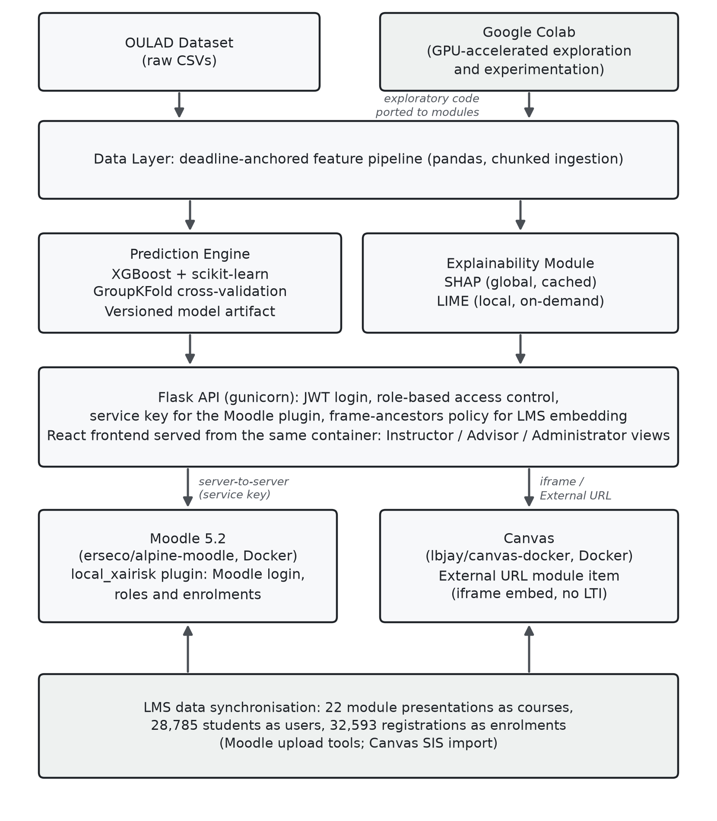
Figure 1: Implemented system architecture, showing the data, prediction, explainability, API and presentation layers, the model development environment and the two LMS integration paths tested. All services run locally under Docker Compose.
4.2 Explanation services
The Explainability Module has two services (Figure 2). A global service computes TreeSHAP values once per model version and caches them for the cohort-level views. A local service computes a local SHAP explanation and an independent LIME explanation on demand for a single prediction, using the exact feature vector the model scored. Caching the global values reflects the higher computing time of SHAP reported by Salih et al. [52], whereas LIME relies on perturbation and must be regenerated for each instance. Both explanations are shown side by side so that a user can see where they agree and where they differ, following the argument of Salih et al. [52] for using the two methods together. Following the selectivity property of explanations [39] and evidence that comprehension degrades when full attribution vectors are displayed [48], the interface shows a small number of leading contributions rather than the complete vector.
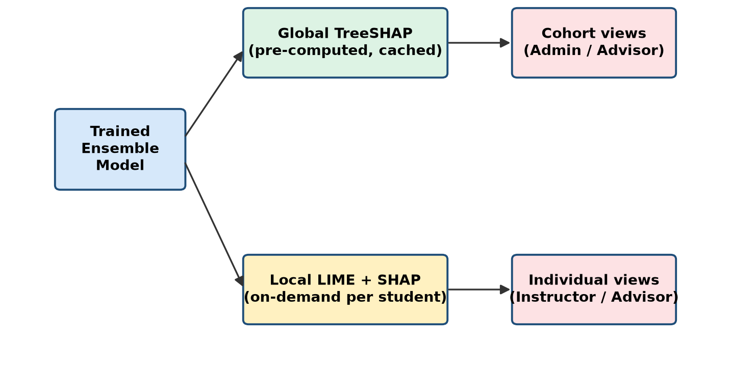
Figure 2: Dual-service explainability pipeline: global TreeSHAP values are pre-computed and cached for cohort views, while LIME and local SHAP are generated on demand for individual students.
4.3 Role-aware views
Each view was designed around an information brief derived from the Agent Model (Table 2). The instructor view gives per-student detail with SHAP and LIME shown side by side, following evidence that teachers act on dashboard information at the level of the individual learner [42]. The advisor view averages the reasoning across a caseload of students at or above the watch threshold, following the caseload orientation of LADA [19]. The administrator view shows institution-wide model performance and a full-population reasoning trail, in line with institutional decision-support patterns [62]. All three views reuse one "reasoning trail" component, a chart of signed SHAP and LIME contributions, at different levels of aggregation, so the roles differ in the granularity rather than the visual form of the knowledge they receive [58]. Progressive disclosure is applied throughout: compact risk summaries appear by default and attribution detail on request [59]. Figure 3 shows the three views.

Table 2: Role-based dashboard design.
Role | Decision | Information needed | Dashboard component | Granularity
Instructor | Whether to act within a course that is currently running. | Class-level engagement in the current period and per-student risk drivers at the level of assessments and weekly activity. | Per-student reasoning trail with SHAP and LIME side by side. | Individual
Advisor | How to approach a particular student and prioritise a caseload. | Views across modules for a caseload, with demographic context suited to one-to-one consultations. | Caseload-averaged reasoning trail for students at or above the watch threshold. | Caseload
Administrator | Where to direct institutional attention and resources. | Cohort-level aggregations and module-over-module comparisons. | Institution-wide performance summary and full-population reasoning trail. | Cohort

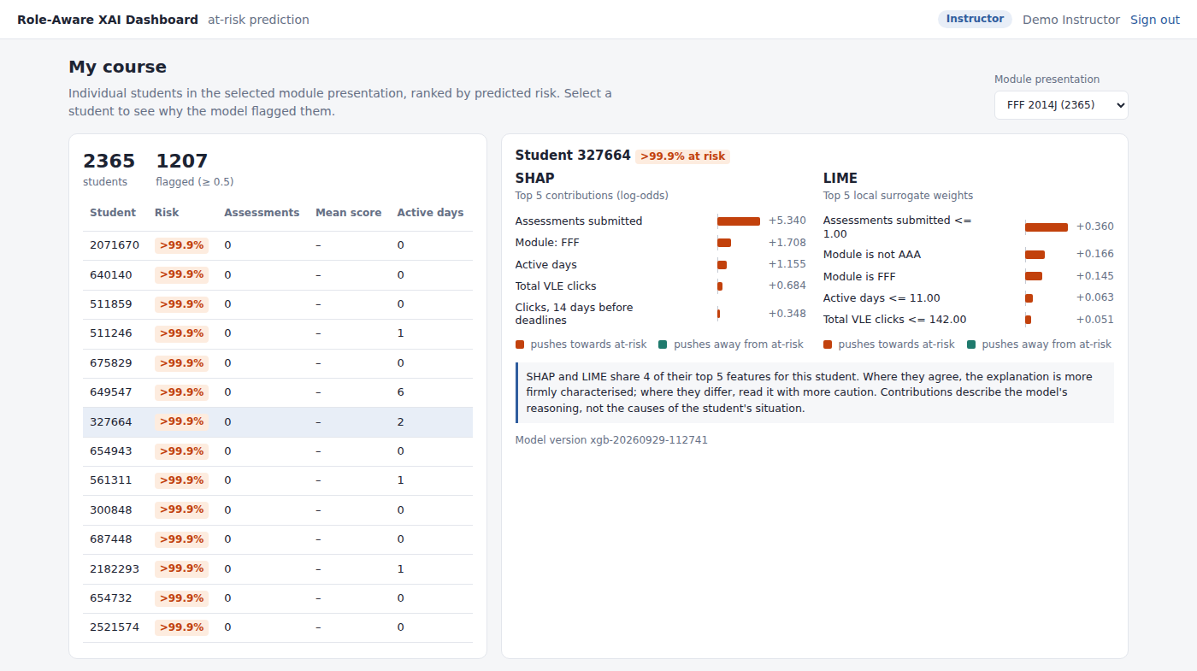
(a) Instructor view: per-student SHAP and LIME reasoning trail.
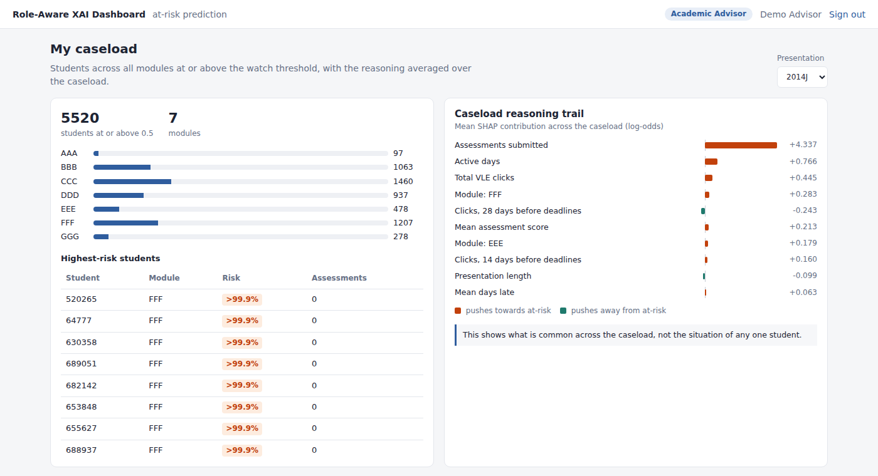
(b) Advisor view: caseload-averaged reasoning trail for students at or above the watch threshold.
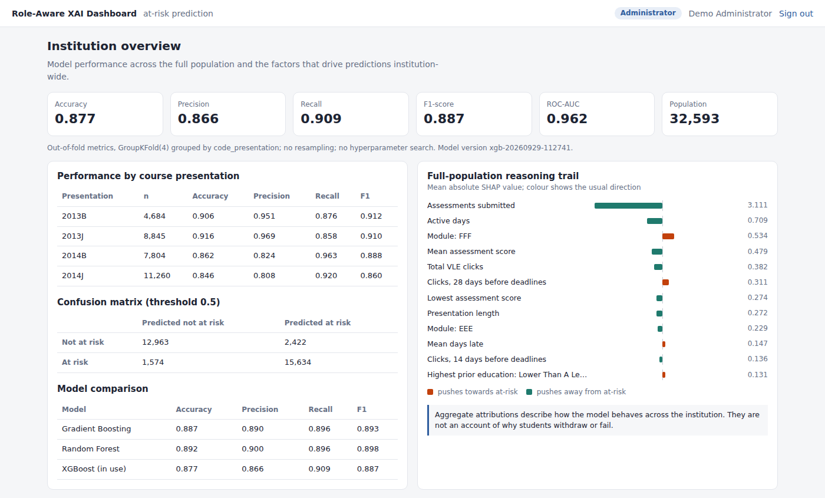
(c) Administrator view: institution-wide performance summary and full-population reasoning trail.
Figure 3: The three role-gated dashboard views rendered from the same prediction and explanation services.

4.4 Security and LMS integration
Role separation is enforced at both the LMS and the API, following the defence-in-depth principle of Saltzer and Schroeder [53]. The API accepts either a JSON Web Token [27] from its own login or, for server-to-server calls from the Moodle plugin, a shared service key, and it checks the forwarded role against each endpoint. The visible view is gated by the authenticated session, with no client-side mechanism to switch roles. Two integration paths were tested locally in Docker. In Moodle 5.2 the dashboard was integrated as a native local plugin, with all 22 module presentations loaded as courses, 28,785 students as users and 32,593 registrations as enrolments; login, role and course context come from Moodle, and cross-role and cross-course requests were refused when tested (Figure 4). In Canvas, the dashboard was embedded through an External URL module item, because the available Canvas image predates LTI 1.3 support, so role resolution on that path relies on the dashboard’s own authentication. Both integrations establish technical feasibility rather than deployment readiness.
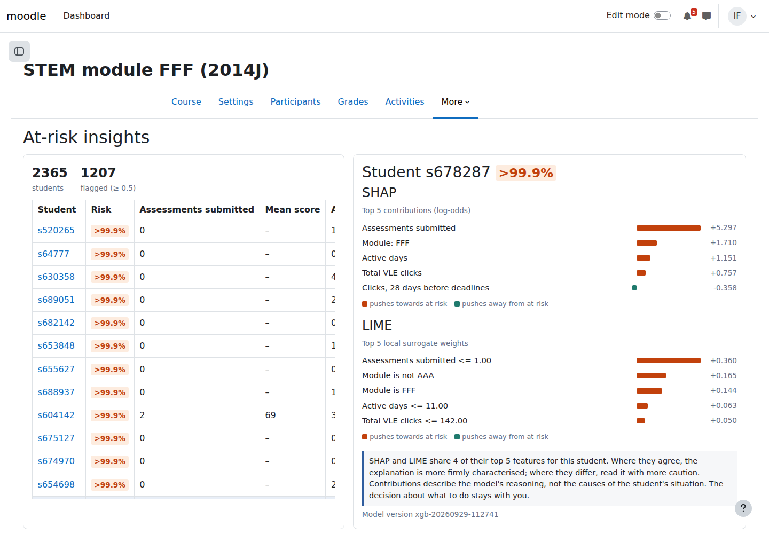
Figure 4: At-risk insights page of the Moodle plugin in course FFF-2014J, showing the SHAP and LIME reasoning trail for one student.
5 Results
5.1 Predictive performance
Table 3 reports out-of-fold performance for the three models. The prototype XGBoost model reached an accuracy of 0.8774, precision of 0.8659, recall of 0.9085, F1-score of 0.8867 and ROC-AUC of 0.9624. Its confusion matrix (Figure 5) contains 15,634 true positives, 1,574 false negatives, 12,963 true negatives and 2,422 false positives, giving a specificity of 0.8426; about 13% of positive flags were therefore false. Random Forest obtained the highest F1-score (0.8976), accuracy and precision, while XGBoost had the highest recall. The spread in F1-score across the three models was 0.011. Under the recall-first selection criterion, XGBoost was retained for the prototype.

Table 3: Out-of-fold performance under four-fold GroupKFold cross-validation grouped by course presentation (n = 32,593; threshold 0.5).
Model | Accuracy | Precision | Recall | F1-score | Prototype
XGBoost | 0.8774 | 0.8659 | 0.9085 | 0.8867 | Yes
Random Forest | 0.8921 | 0.8997 | 0.8955 | 0.8976 | No
Gradient Boosting | 0.8869 | 0.8904 | 0.8962 | 0.8932 | No
Note. ROC-AUC for XGBoost was 0.9624. Bold marks the best value in each column.

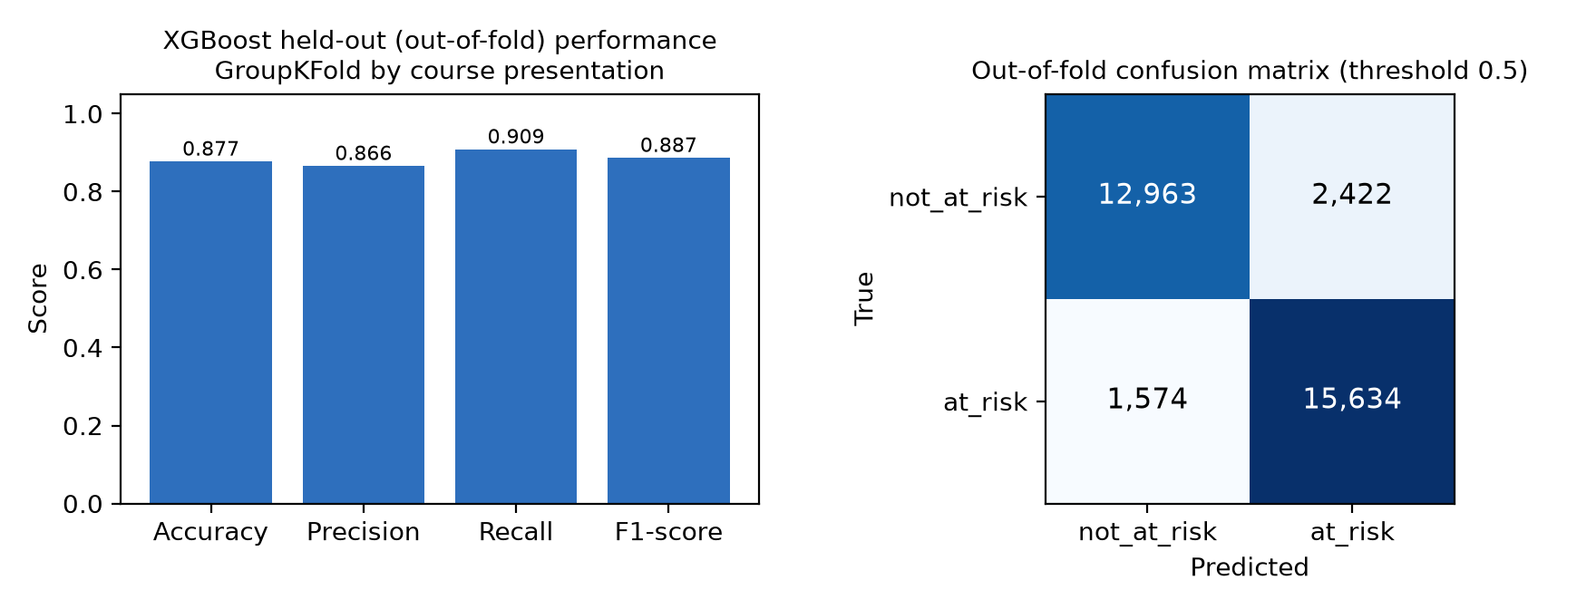
Figure 5: Out-of-fold accuracy, precision, recall and F1-score of the XGBoost prototype (left) and its confusion matrix at the 0.5 threshold (right), across all 32,593 observations.

5.2 Variability across course presentations
Because each fold holds out one presentation, performance can be reported for each unseen presentation (Table 4, Figure 6). Accuracy ranged from 0.8456 (2014J) to 0.9161 (2013J), a spread of more than seven percentage points, and the error pattern reversed: the 2013 presentations had precision above 0.95 with recall of 0.86 to 0.88, while the 2014 presentations had precision of 0.81 to 0.82 with recall up to 0.9627. With only four presentation-level folds, the source of this variation cannot be attributed precisely, but the model’s operating point was not stable across cohorts even with the model and threshold held fixed.

Table 4: XGBoost out-of-fold performance with each course presentation held out in turn.
Presentation | n | At-risk rate | Accuracy | Precision | Recall | F1-score
2013B | 4,684 | 0.5527 | 0.9065 | 0.9506 | 0.8764 | 0.9120
2013J | 8,845 | 0.4941 | 0.9161 | 0.9690 | 0.8577 | 0.9099
2014B | 7,804 | 0.5697 | 0.8619 | 0.8243 | 0.9627 | 0.8882
2014J | 11,260 | 0.5154 | 0.8456 | 0.8075 | 0.9197 | 0.8600

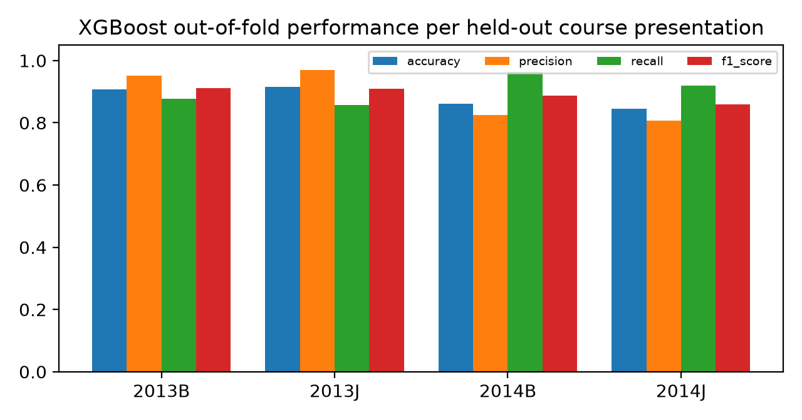
Figure 6: XGBoost out-of-fold accuracy, precision, recall and F1-score for each held-out course presentation.
5.3 Global SHAP explanations
The number of assessments submitted dominated the global TreeSHAP ranking, with a mean absolute SHAP value of 3.1110, more than four times that of the second feature, active days (0.7087) (Table 5, Figure 7). For the number of assessments submitted, mean score, active days, total clicks and minimum score, the correlation between feature value and SHAP value was strongly negative (−0.69 to −0.96), so higher values pushed predictions away from the at-risk class. The 28-day pre-deadline click window was an exception, with a positive correlation (+0.8354), in the opposite direction to total clicks and active days. The engagement variables are highly collinear (Spearman correlation of 0.98 between the 28-day window and total clicks; 0.95 and 0.92 for the 14- and 7-day windows), and SHAP attributions are affected by collinearity [52]. This is one possible explanation, but no dependence analysis was carried out, so the sign is reported as an observed property of the fitted model and not as evidence that late-window activity is itself a risk factor.

Table 5: Top 10 features by global TreeSHAP importance and by aggregate LIME weight.
Rank | SHAP feature | Mean |SHAP| | LIME feature (40 instances) | Mean |weight|
1 | Assessments submitted | 3.1110 | Assessments submitted | 0.3961
2 | Active days | 0.7087 | Module = FFF | 0.1397
3 | Module = FFF | 0.5338 | Module = AAA | 0.0995
4 | Mean score | 0.4790 | Mean score | 0.0640
5 | Total clicks | 0.3819 | Active days | 0.0498
6 | Clicks 28 days before deadline | 0.3111 | Presentation length | 0.0447
7 | Minimum score | 0.2741 | Clicks 28 days before deadline | 0.0236
8 | Presentation length | 0.2718 | Minimum score | 0.0183
9 | Module = EEE | 0.2285 | Registration date | 0.0073
10 | Mean days late | 0.1468 | Region = Wales | 0.0043
Note. SHAP values are in log-odds units, computed with the final fitted model over all 32,593 observations. Seven features appear in both top-10 lists. Mean instance-level top-5 overlap: 0.635 (SD 0.197).

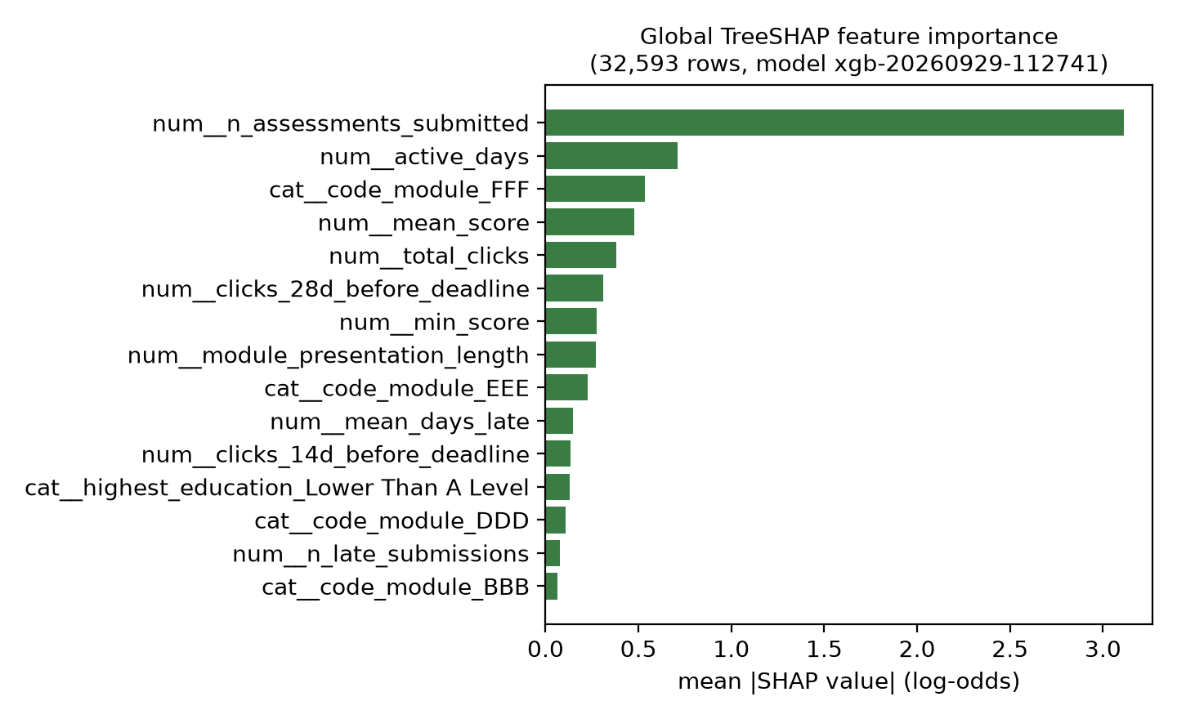
Figure 7: Top 15 features by global TreeSHAP importance (mean absolute SHAP value), computed with the final fitted model across all 32,593 observations.
5.4 Agreement between SHAP and LIME
Aggregated over the 40 sampled instances, LIME also ranked the number of assessments submitted first (mean absolute weight 0.3961), followed by the FFF and AAA module indicators and mean score (Figure 8). The two aggregate top-10 rankings shared seven features: assessments submitted, active days, module FFF, mean score, the 28-day click window, minimum score and presentation length. SHAP additionally ranked total clicks, module EEE and mean lateness in its top ten, whereas LIME ranked module AAA, registration date and the Wales region indicator. At the instance level, the mean top-5 overlap was 0.635 (SD 0.197): on average just over three of a student’s top five SHAP features also appeared in that student’s top five LIME features. LIME tended to rank module indicators higher, consistent with its local, sample-based construction being more sensitive to instances in which module identity is locally decisive. In representative cases, such as a student in FFF-2014J predicted at 0.9998 (true label at risk) and a student in FFF-2014B predicted at 0.0038 (true label not at risk), both methods led with the number of assessments submitted.

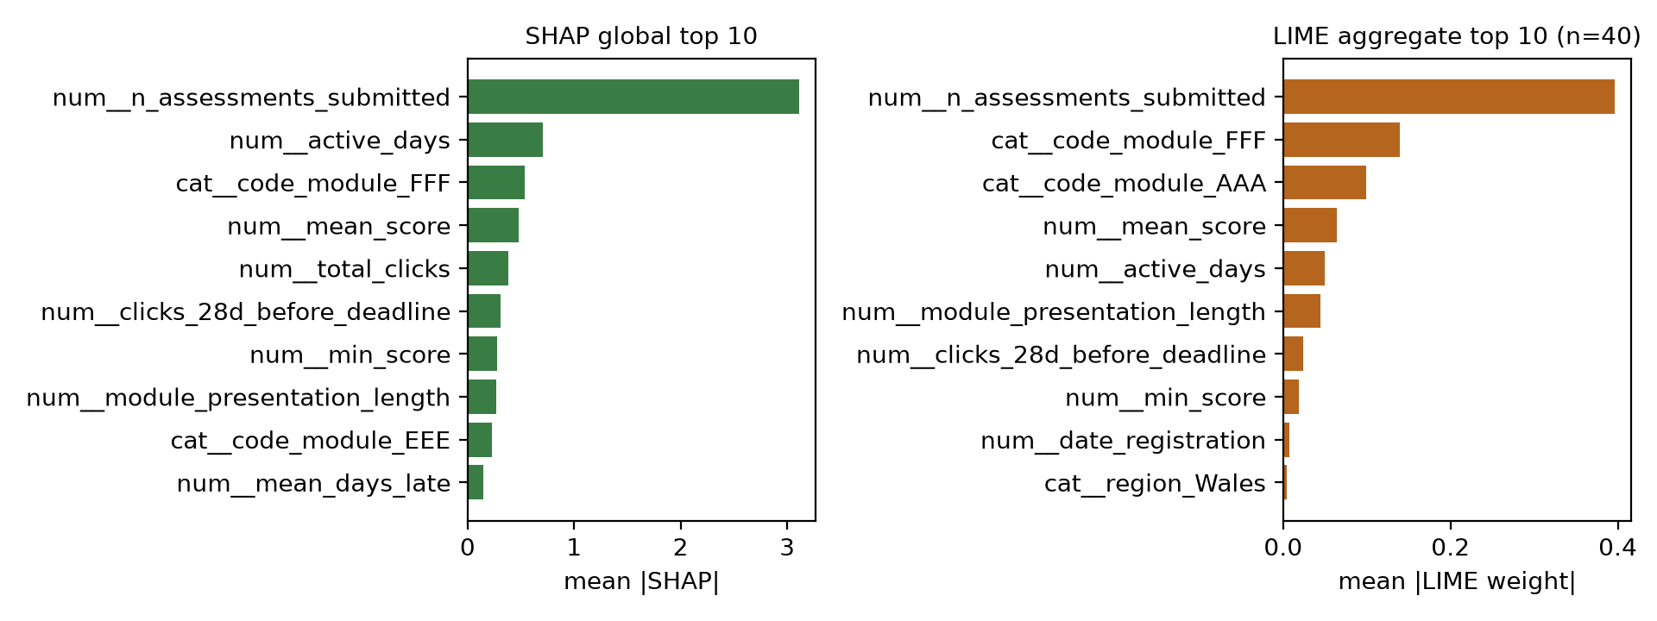
Figure 8: Global SHAP top-10 features (left) and aggregate LIME top-10 features over 40 sampled instances (right).

5.5 Stability of near-duplicate feature rankings
The 28-day click window (0.3111) and total clicks (0.3819) sat close together in the SHAP ranking. Across eight fits with different random seeds, the 28-day window ranked above total clicks in four fits and below it in the other four, while the combined importance of the two features stayed within 0.57 to 0.69. Their relative order is therefore not a stable property of the model: where two features carry almost the same information, the ensemble distributes credit between them according to its random subsampling. The combined share of pre-deadline and total engagement was stable and well below that of assessment submission. In a separate execution, the out-of-fold metrics were reproduced exactly, matching those recorded in the model manifest, including the confusion matrix cell for cell.
6 Discussion
6.1 Predictive performance under a strict protocol
The figures in Table 3 are lower than the highest accuracies reported on OULAD, such as the 96.9% reported by Wang [65], but they are not comparable. Grouping folds by presentation means every prediction was made by a model that had not seen the student’s cohort, which is closer to applying an existing model to a new presentation than the stratified random splits used in much of the literature [26, 32]. The per-presentation results reinforce this: one fixed model under one fixed protocol varied by more than seven accuracy points depending only on which presentation was held out. If protocol and cohort produce this much variation within a single evaluation, numerical differences between studies that differ in split, label definition and feature horizon carry little information about relative model quality [47].
The error profile is asymmetric: recall exceeded precision at the untuned 0.5 threshold, so the model leans towards flagging. The 1,574 false negatives are students for whom no role would have received a basis to act, while the 2,422 false positives represent staff effort directed at students who did not withdraw or fail. The comparison with Random Forest shows that the choice of selection metric encodes a judgement about which error matters more, and stating that judgement explicitly is preferable to inheriting it from a general-purpose metric. Because the operating point changed between cohorts, an institution could not fully anticipate the error profile for a new cohort, which argues for periodic revalidation and for showing the current operating point to the roles that rely on it.
6.2 What the explanations show
The concentration of attribution on the number of assessments submitted has a benefit and a cost. Assessment submission is a concrete behaviour that an instructor or advisor can act on, but a reasoning trail dominated by one feature offers less differentiated information than an explanation layer might suggest, and may be read as confirming what is already visible in the gradebook. The direction of that association is also ambiguous, since a student who has decided to withdraw will stop submitting work. The attributions describe how the fitted model reached its output, not what caused a student’s situation, and the dashboard and this paper use the language of contribution and association rather than cause.
The partial agreement between the methods is the most distinctive explainability finding. The methods agree strongly in aggregate but are not interchangeable for a single prediction, which is the level at which an instructor or advisor would consult them. This is not an error in either method: TreeSHAP computes exact Shapley values for the tree ensemble, whereas LIME fits a sparse local surrogate to sampled perturbations, so the two answer related but different questions [36, 50]. The measured overlap converts the principled argument for showing both methods [52] into an argument from evidence within this system: showing one method alone would hide a measurable degree of disagreement. Where the methods agree, a practitioner has a firmer basis for treating a contributor as a stable part of the model’s reasoning; where they diverge, the appropriate response is more caution about that explanation. The finding is consistent with the variability reported by Hooshyar and Yang [24] and adds a quantity to it for this model and dataset. The 28-day window result shows why direction must be inspected alongside magnitude: a ranking alone would have suggested that heavier late activity is a warning sign, which the evidence does not support.
6.3 Role-aware design and the limits of the system
The rationale for differentiating views is that the three roles act on different objects. The prediction and its attribution are the same for each role, but an instructor decides whether to change something in a running course, an advisor decides how to approach a particular student, and an administrator decides where to direct institutional attention. A single view would require at least two of them to aggregate or disaggregate information themselves. The technical results also indicate what each role specifically needs. For advisors, a caseload drawn from a cohort resembling 2014B (recall 0.9627, precision 0.8243) would be larger and contain more students who were not going to withdraw, so a caseload view that does not show current precision leaves the advisor unable to weigh each flag. For administrators, the between-cohort variability is arguably the most useful single output, since it indicates how often the model needs revisiting.
CommonKADS contributed traceability from institutional context to interface: the Task Model’s decomposition into risk assessment, explanation generation, role assignment and explanation delivery is mirrored by the five-layer architecture, and each view’s granularity traces to the Agent Model. The Task Model stops at explanation delivery. Intervention is a task for the human agent, and the system is designed to support human interpretation without taking over the intervention decision (Figure 9). An attribution identifying low assessment submission narrows where a practitioner should look but does not indicate what to do, since a student struggling with the material, one managing illness and one who has decided to leave may present the same feature values. A flag with a plausible explanation may still be a false positive, as roughly 13% of flags were here, and each would have been accompanied by a coherent reasoning trail. Whether side-by-side explanations help practitioners calibrate their reliance or make the interface harder to read can only be settled by observation; Brdnik et al. [7] show how perceived trust and satisfaction with SHAP and LIME can be measured in a learning analytics setting.

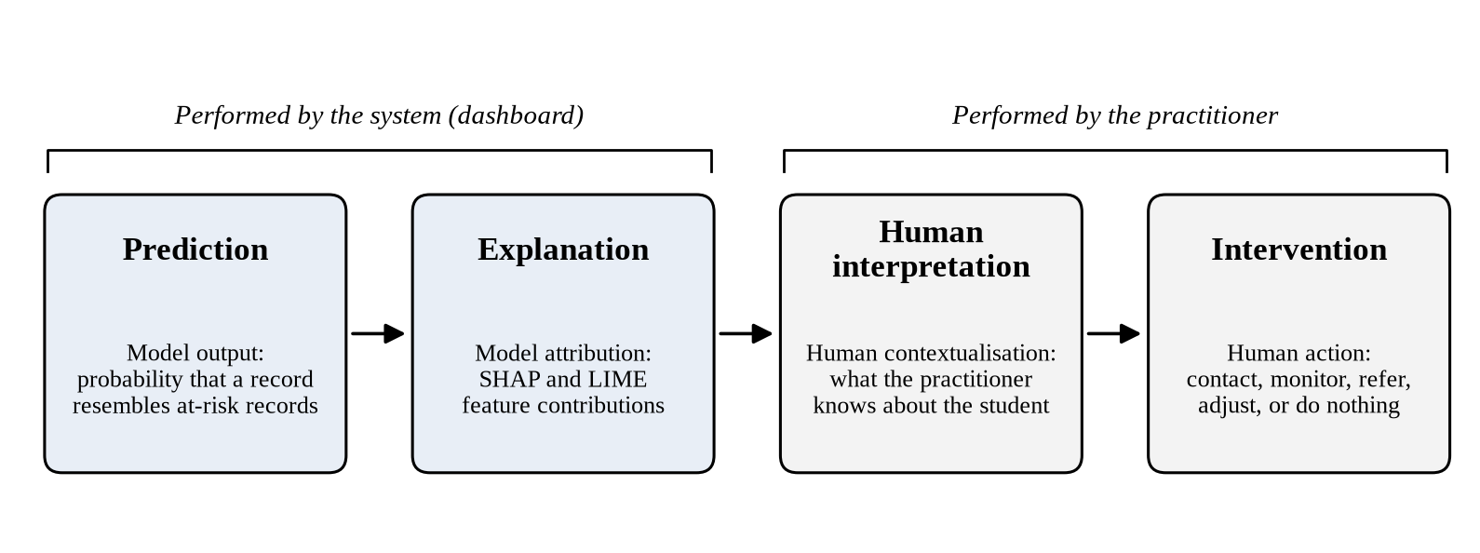
Figure 9: Relationship between prediction, explanation, human interpretation and intervention. The system performs the first two stages; interpretation and intervention remain with the practitioner.

6.4 Candidate design guidelines
The findings suggest six guidelines for explainable learning analytics dashboards, offered as candidates for empirical validation:
- Report the agreement between explanation methods where more than one is available, since a single method presents a more settled picture of local model behaviour than the attributions support.
- Let users inspect the direction of each contribution, not only its magnitude, and check for collinearity artefacts before attributions reach practitioners.
- Use the language of contribution and association rather than causal or prescriptive language.
- Show the current operating point (the balance between missed students and false alarms) to the roles that rely on it, and revalidate it for each new cohort.
- Keep the boundary between explanation delivery by the system and intervention by the human, rather than extending the system to recommend actions its explanation methods cannot justify.
- Report subgroup performance before the system is used to direct resources, and enforce role-based access to per-student risk information at more than one layer.
6.5 Transferability
All results come from one distance-learning institution, where the LMS is the primary site of study and withdrawal is common, and from presentations in 2013 and 2014. Given that performance moved by more than seven accuracy points across four presentations of the same modules, a model trained at one institution should be expected to need retraining and revalidation elsewhere rather than transfer as a fitted artefact. The CommonKADS design process, the layered architecture, the cached-global and on-demand-local explanation services and the reasoning trail rendered at several levels of aggregation do not depend on OULAD and are the parts most likely to transfer. Transfer would require LMS interaction and assessment data of sufficient completeness, reliably recorded deadlines, an outcome definition suited to the institution, roles that correspond to those modelled here and a governance position on the use of per-student risk predictions. Where teaching is largely in person and the LMS holds only supplementary material, the engagement features that carry much of the signal here would be sparse, and the approach would need to be reconsidered at the level of the Knowledge Model.
6.6 Limitations
Five limitations constrain these findings. First, no practitioner used the system, so trust, comprehension, usability and decision quality were not measured, and the role-specific design rests on published accounts rather than elicitation. Second, the features were computed over the full presentation, so the evaluation establishes retrospective classification rather than early-warning performance. Third, calibration of the displayed probabilities, subgroup fairness, explanation stability and fidelity, hyperparameter tuning, class-imbalance handling and trajectory features were planned but not completed, and the LIME analysis rests on 40 instances, with explanations computed in a one-hot feature space that splits categorical attributes across several indicators. Fourth, one registration feature (withdrew_before_start) partly encodes the outcome, since all 3,097 observations with this flag are labelled at risk; its mean absolute SHAP value in the final model is 0.00, because the same students have no submitted assessments, but it should be removed in future iterations. Fifth, the LMS integrations were tested in local containers rather than institutional installations.
6.7 Future work
Three priorities follow directly from these limitations: an early-warning evaluation with features restricted to the information available at fixed points such as weeks 2, 4, 6 and 8 [1]; a calibration study comparing isotonic regression and Platt scaling [18, 43]; and a subgroup fairness assessment across gender, age band, disability and IMD band [21, 40]. Beyond these, a study with instructors, advisors and administrators should test how the role-specific views are read and used, drawing on the perceived usefulness and ease of use constructs of TAM, and the approach should be applied to data from other institutions and modes of study.
7 Conclusion
This study designed, implemented and technically evaluated a role-aware explainable AI dashboard that delivers predictions and explanations from one model to instructors, advisors and administrators at different levels of aggregation. On RQ1, a cached global TreeSHAP service paired with on-demand local SHAP and LIME ran at full dataset scale and produced attributions traceable to a versioned model and feature contract. On RQ2, the CommonKADS models yielded a traceable specification of three role-gated views that share one reasoning trail at individual, caseload and cohort granularity. On RQ3, the technical preconditions for supporting practitioner interpretation are in place: the model discriminates well on unseen presentations, and its explanations are human-readable and cross-checked, with a measured instance-level SHAP and LIME overlap of 0.635 that supports showing both methods. Results describe retrospective classification on a single dataset, and whether the dashboard improves practitioners’ trust, understanding or decisions remains to be tested. The prototype provides a verified technical foundation for that evaluation.
ACKNOWLEDGMENTS
This article is based on the first author’s MSc thesis in Computer Science at the American University of Nigeria.
The study used only the publicly available, anonymised Open University Learning Analytics Dataset. No primary data were collected from students, instructors, advisors or administrators. OULAD is publicly available [33]. The prototype source code, including data preparation, model training, explanation services, the Flask API, the React dashboard and the Moodle plugin, is available at https://github.com/daniel-larry/role-aware-xai-dashboard.
During the preparation of this work the authors used Claude (Anthropic) to condense the master’s thesis on which this article is based into journal format and to verify and format the references. After using this tool, the authors reviewed and edited the content as needed and take full responsibility for the content of the published article. [Authors to confirm.]
This research did not receive any specific grant from funding agencies in the public, commercial, or not-for-profit sectors. The authors declare that they have no known competing financial interests or personal relationships that could have appeared to influence the work reported in this paper. [Authors to confirm.]
REFERENCES
[1] Muhammad Adnan, Asad Habib, Jawad Ashraf, Shafaq Mussadiq, Arsalan Ali Raza, Muhammad Abid, Maryam Bashir, and Sana Ullah Khan. 2021. Predicting at-risk students at different percentages of course length for early intervention using machine learning models. IEEE Access 9, (2021), 7519–7539. https://doi.org/10.1109/ACCESS.2021.3049446
[2] Muhammad Afzaal, Jalal Nouri, Aayesha Zia, Panagiotis Papapetrou, Uno Fors, Yongchao Wu, Xiu Li, and Rebecka Weegar. 2021. Explainable AI for data-driven feedback and intelligent action recommendations to support students self-regulation. Frontiers in Artificial Intelligence 4, (2021), Article 723447. https://doi.org/10.3389/frai.2021.723447
[3] Wesam Ahmed, Mudasir Ahmad Wani, Pawel Plawiak, Souham Meshoul, Amena Mahmoud, and Mohamed Hammad. 2025. Machine learning-based academic performance prediction with explainability for enhanced decision-making in educational institutions. Scientific Reports 15, 1 (2025), Article 26879. https://doi.org/10.1038/s41598-025-12353-4
[4] Sajid Ali, Tamer Abuhmed, Shaker El-Sappagh, Khan Muhammad, Jose M. Alonso-Moral, Roberto Confalonieri, Riccardo Guidotti, Javier Del Ser, Natalia Díaz-Rodríguez, and Francisco Herrera. 2023. Explainable Artificial Intelligence (XAI): What we know and what is left to attain Trustworthy Artificial Intelligence. Information Fusion 99, (2023), Article 101805. https://doi.org/10.1016/j.inffus.2023.101805
[5] Ryan S. Baker and Aaron Hawn. 2022. Algorithmic bias in education. International Journal of Artificial Intelligence in Education 32, 4 (2022), 1052–1092. https://doi.org/10.1007/s40593-021-00285-9
[6] Alejandro Barredo Arrieta, Natalia Díaz-Rodríguez, Javier Del Ser, Adrien Bennetot, Siham Tabik, Alberto Barbado, Salvador García, Sergio Gil-López, Daniel Molina, Richard Benjamins, Raja Chatila, and Francisco Herrera. 2020. Explainable Artificial Intelligence (XAI): Concepts, taxonomies, opportunities and challenges toward responsible AI. Information Fusion 58, (2020), 82–115. https://doi.org/10.1016/j.inffus.2019.12.012
[7] Saša Brdnik, Vili Podgorelec, and Boštjan Šumak. 2023. Assessing perceived trust and satisfaction with multiple explanation techniques in XAI-enhanced learning analytics. Electronics 12, 12 (2023), 2594. https://doi.org/10.3390/electronics12122594
[8] Leo Breiman. 2001. Random forests. Machine Learning 45, 1 (2001), 5–32. https://doi.org/10.1023/A:1010933404324
[9] Luís Cabral, Rui Pinto, and Gil Gonçalves. 2025. AI-powered learning analytics dashboards: A systematic review of applications, techniques, and research gaps. Discover Education 4, 1 (2025), Article 525. https://doi.org/10.1007/s44217-025-00964-y
[10] Pankaj Chavan and Ritayan Mitra. 2022. Tcherly: A teacher-facing dashboard for online video lectures. Journal of Learning Analytics 9, 3 (2022), 125–151. https://doi.org/10.18608/jla.2022.7555
[11] Tianqi Chen and Carlos Guestrin. 2016. XGBoost: A scalable tree boosting system. In Proceedings of the 22nd ACM SIGKDD International Conference on Knowledge Discovery and Data Mining, 2016. ACM, 785–794. https://doi.org/10.1145/2939672.2939785
[12] Cristina Conati, Oswald Barral, Vanessa Putnam, and Lea Rieger. 2021. Toward personalized XAI: A case study in intelligent tutoring systems. Artificial Intelligence 298, (2021), Article 103503. https://doi.org/10.1016/j.artint.2021.103503
[13] Fred D. Davis. 1989. Perceived usefulness, perceived ease of use, and user acceptance of information technology. MIS Quarterly 13, 3 (1989), 319–340. https://doi.org/10.2307/249008
[14] Upol Ehsan, Q. Vera Liao, Michael Muller, Mark O. Riedl, and Justin D. Weisz. 2021. Expanding explainability: Towards social transparency in AI systems. In Proceedings of the 2021 CHI Conference on Human Factors in Computing Systems, 2021. ACM, 1–19. https://doi.org/10.1145/3411764.3445188
[15] Jerome H. Friedman. 2001. Greedy function approximation: A gradient boosting machine. The Annals of Statistics 29, 5 (2001), 1189–1232. https://doi.org/10.1214/aos/1013203451
[16] Rodrigo Guevara-Reyes, Iván Ortiz-Garcés, Roberto Andrade, Fernanda Cox-Riquetti, and William Villegas-Ch. 2025. Machine learning models for academic performance prediction: Interpretability and application in educational decision-making. Frontiers in Education 10, (2025), Article 1632315. https://doi.org/10.3389/feduc.2025.1632315
[17] Sachini Gunasekara and Mirka Saarela. 2025. Explainable AI in education: Techniques and qualitative assessment. Applied Sciences 15, 3 (2025), 1239. https://doi.org/10.3390/app15031239
[18] Chuan Guo, Geoff Pleiss, Yu Sun, and Kilian Q. Weinberger. 2017. On calibration of modern neural networks. In Proceedings of the 34th International Conference on Machine Learning (Proceedings of Machine Learning Research), 2017. PMLR, 1321–1330. Retrieved from https://proceedings.mlr.press/v70/guo17a.html
[19] Francisco Gutiérrez, Karsten Seipp, Xavier Ochoa, Katherine Chiluiza, Tinne De Laet, and Katrien Verbert. 2020. LADA: A learning analytics dashboard for academic advising. Computers in Human Behavior 107, (2020), Article 105826. https://doi.org/10.1016/j.chb.2018.12.004
[20] AKM Bahalul Haque, A. K. M. Najmul Islam, and Patrick Mikalef. 2023. Explainable artificial intelligence (XAI) from a user perspective: A synthesis of prior literature and problematizing avenues for future research. Technological Forecasting and Social Change 186, (2023), Article 122120. https://doi.org/10.1016/j.techfore.2022.122120
[21] Moritz Hardt, Eric Price, and Nati Srebro. 2016. Equality of opportunity in supervised learning. Advances in Neural Information Processing Systems 29, (2016), 3315–3323. Retrieved from https://proceedings.neurips.cc/paper/2016/hash/6a9659feb1216f14f7384ba499518b38-Abstract.html
[22] Alan R. Hevner, Salvatore T. March, Jinsoo Park, and Sudha Ram. 2004. Design science in information systems research. MIS Quarterly 28, 1 (2004), 75–106. https://doi.org/10.2307/25148625
[23] Martin Hlosta, Zdenek Zdrahal, and Jaroslav Zendulka. 2017. Ouroboros: Early identification of at-risk students without models based on legacy data. In Proceedings of the Seventh International Learning Analytics & Knowledge Conference, 2017. ACM, 6–15. https://doi.org/10.1145/3027385.3027449
[24] Danial Hooshyar and Yeongwook Yang. 2024. Problems with SHAP and LIME in interpretable AI for education: A comparative study of post-hoc explanations and neural-symbolic rule extraction. IEEE Access 12, (2024), 137472–137490. https://doi.org/10.1109/ACCESS.2024.3463948
[25] Mushtaq Hussain, Wenhao Zhu, Wu Zhang, and Syed Muhammad Raza Abidi. 2018. Student engagement predictions in an e-learning system and their impact on student course assessment scores. Computational Intelligence and Neuroscience 2018, (2018), Article 6347186. https://doi.org/10.1155/2018/6347186
[26] Lingxi Jin, Yao Wang, Huiying Song, and Hyo-Jeong So. 2024. Predictive modelling with the Open University Learning Analytics Dataset (OULAD): A systematic literature review. In Artificial intelligence in education. Posters and late breaking results, workshops and tutorials, industry and innovation tracks, practitioners, doctoral consortium and blue sky, Andrew M. Olney, Irene-Angelica Chounta, Zitao Liu, Olga C. Santos and Ig Ibert Bittencourt (eds.). Springer, 477–484. https://doi.org/10.1007/978-3-031-64315-6_46
[27] M. Jones, J. Bradley, and N. Sakimura. 2015. JSON Web Token (JWT). Internet Engineering Task Force. https://doi.org/10.17487/RFC7519
[28] Rogers Kaliisa and Jan Arild Dolonen. 2023. CADA: A teacher-facing learning analytics dashboard to foster teachers’ awareness of students’ participation and discourse patterns in online discussions. Technology, Knowledge and Learning 28, 3 (2023), 937–958. https://doi.org/10.1007/s10758-022-09598-7
[29] Rogers Kaliisa, Ioana Jivet, and Paul Prinsloo. 2023. A checklist to guide the planning, designing, implementation, and evaluation of learning analytics dashboards. International Journal of Educational Technology in Higher Education 20, 1 (2023), Article 28. https://doi.org/10.1186/s41239-023-00394-6
[30] Hassan Khosravi, Simon Buckingham Shum, Guanliang Chen, Cristina Conati, Yi-Shan Tsai, Judy Kay, Simon Knight, Roberto Martinez-Maldonado, Shazia Sadiq, and Dragan Gašević. 2022. Explainable artificial intelligence in education. Computers and Education: Artificial Intelligence 3, (2022), Article 100074. https://doi.org/10.1016/j.caeai.2022.100074
[31] Georgios Kostopoulos, Gregory Davrazos, and Sotiris Kotsiantis. 2024. Explainable artificial intelligence-based decision support systems: A recent review. Electronics 13, 14 (2024), 2842. https://doi.org/10.3390/electronics13142842
[32] Damjan Krstajic, Ljubomir J Buturovic, David E Leahy, and Simon Thomas. 2014. Cross-validation pitfalls when selecting and assessing regression and classification models. Journal of Cheminformatics 6, 1 (2014), Article 10. https://doi.org/10.1186/1758-2946-6-10
[33] Jakub Kuzilek, Martin Hlosta, and Zdenek Zdrahal. 2017. Open University Learning Analytics dataset. Scientific Data 4, 1 (2017), Article 170171. https://doi.org/10.1038/sdata.2017.171
[34] Philipp Leitner, Markus Ebner, and Martin Ebner. 2019. Learning analytics challenges to overcome in higher education institutions. In Utilizing learning analytics to support study success, Dirk Ifenthaler, Dana-Kristin Mah and Jane Yin-Kim Yau (eds.). Springer, 91–104. https://doi.org/10.1007/978-3-319-64792-0_6
[35] Q. Vera Liao and Kush R. Varshney. 2022. Human-centered explainable AI (XAI): From algorithms to user experiences. https://doi.org/10.48550/arXiv.2110.10790
[36] Scott M. Lundberg, Gabriel Erion, Hugh Chen, Alex DeGrave, Jordan M. Prutkin, Bala Nair, Ronit Katz, Jonathan Himmelfarb, Nisha Bansal, and Su-In Lee. 2020. From local explanations to global understanding with explainable AI for trees. Nature Machine Intelligence 2, 1 (2020), 56–67. https://doi.org/10.1038/s42256-019-0138-9
[37] Scott M. Lundberg and Su-In Lee. 2017. A unified approach to interpreting model predictions. Advances in Neural Information Processing Systems 30, (2017), 4765–4774. Retrieved from https://proceedings.neurips.cc/paper/2017/hash/8a20a8621978632d76c43dfd28b67767-Abstract.html
[38] Wannisa Matcha, Noraayu Ahmad Uzir, Dragan Gašević, and Abelardo Pardo. 2020. A systematic review of empirical studies on learning analytics dashboards: A self-regulated learning perspective. IEEE Transactions on Learning Technologies 13, 2 (2020), 226–245. https://doi.org/10.1109/TLT.2019.2916802
[39] Tim Miller. 2019. Explanation in artificial intelligence: Insights from the social sciences. Artificial Intelligence 267, (2019), 1–38. https://doi.org/10.1016/j.artint.2018.07.007
[40] Margaret Mitchell, Simone Wu, Andrew Zaldivar, Parker Barnes, Lucy Vasserman, Ben Hutchinson, Elena Spitzer, Inioluwa Deborah Raji, and Timnit Gebru. 2019. Model cards for model reporting. In Proceedings of the Conference on Fairness, Accountability, and Transparency, 2019. ACM, 220–229. https://doi.org/10.1145/3287560.3287596
[41] Sina Mohseni, Niloofar Zarei, and Eric D. Ragan. 2021. A multidisciplinary survey and framework for design and evaluation of explainable AI systems. ACM Transactions on Interactive Intelligent Systems 11, 3–4 (2021), Article 24. https://doi.org/10.1145/3387166
[42] I. Molenaar and C. A. N. Knoop-van Campen. 2019. How teachers make dashboard information actionable. IEEE Transactions on Learning Technologies 12, 3 (2019), 347–355. https://doi.org/10.1109/TLT.2018.2851585
[43] Alexandru Niculescu-Mizil and Rich Caruana. 2005. Predicting good probabilities with supervised learning. In Proceedings of the 22nd International Conference on Machine Learning, 2005. ACM Press, 625–632. https://doi.org/10.1145/1102351.1102430
[44] Leonard Chukwualuka Nnadi, Yutaka Watanobe, Md. Mostafizer Rahman, and Adetokunbo Macgregor John-Otumu. 2024. Prediction of students’ adaptability using explainable AI in educational machine learning models. Applied Sciences 14, 12 (2024), 5141. https://doi.org/10.3390/app14125141
[45] Fabian Pedregosa, Gaël Varoquaux, Alexandre Gramfort, Vincent Michel, Bertrand Thirion, Olivier Grisel, Mathieu Blondel, Peter Prettenhofer, Ron Weiss, Vincent Dubourg, Jake Vanderplas, Alexandre Passos, David Cournapeau, Matthieu Brucher, Matthieu Perrot, and Édouard Duchesnay. 2011. Scikit-learn: Machine learning in Python. Journal of Machine Learning Research 12, (2011), 2825–2830. Retrieved from https://jmlr.org/papers/v12/pedregosa11a.html
[46] Ken Peffers, Tuure Tuunanen, Marcus A. Rothenberger, and Samir Chatterjee. 2007. A design science research methodology for information systems research. Journal of Management Information Systems 24, 3 (2007), 45–77. https://doi.org/10.2753/MIS0742-1222240302
[47] Radek Pelánek. 2018. The details matter: Methodological nuances in the evaluation of student models. User Modeling and User-Adapted Interaction 28, 3 (2018), 207–235. https://doi.org/10.1007/s11257-018-9204-y
[48] Forough Poursabzi-Sangdeh, Daniel G Goldstein, Jake M Hofman, Jennifer Wortman Vaughan, and Hanna Wallach. 2021. Manipulating and measuring model interpretability. In Proceedings of the 2021 CHI Conference on Human Factors in Computing Systems, 2021. ACM. https://doi.org/10.1145/3411764.3445315
[49] Markson Rebelo Marcolino, Thiago Reis Porto, Tiago Thompsen Primo, Rafael Targino, Vinicius Ramos, Emanuel Marques Queiroga, Roberto Munoz, and Cristian Cechinel. 2025. Student dropout prediction through machine learning optimization: Insights from Moodle log data. Scientific Reports 15, 1 (2025), Article 9840. https://doi.org/10.1038/s41598-025-93918-1
[50] Marco Tulio Ribeiro, Sameer Singh, and Carlos Guestrin. 2016. “Why should I trust you?”: Explaining the predictions of any classifier. In Proceedings of the 22nd ACM SIGKDD International Conference on Knowledge Discovery and Data Mining, 2016. ACM, 1135–1144. https://doi.org/10.1145/2939672.2939778
[51] Cynthia Rudin. 2019. Stop explaining black box machine learning models for high stakes decisions and use interpretable models instead. Nature Machine Intelligence 1, 5 (2019), 206–215. https://doi.org/10.1038/s42256-019-0048-x
[52] Ahmed M. Salih, Zahra Raisi-Estabragh, Ilaria Boscolo Galazzo, Petia Radeva, Steffen E. Petersen, Karim Lekadir, and Gloria Menegaz. 2025. A perspective on explainable artificial intelligence methods: SHAP and LIME. Advanced Intelligent Systems 7, 1 (2025), Article 2400304. https://doi.org/10.1002/aisy.202400304
[53] J.H. Saltzer and M.D. Schroeder. 1975. The protection of information in computer systems. Proceedings of the IEEE 63, 9 (1975), 1278–1308. https://doi.org/10.1109/PROC.1975.9939
[54] Guus Schreiber, Hans Akkermans, Anjo Anjewierden, Robert de Hoog, Nigel R. Shadbolt, Walter Van de Velde, and Bob J. Wielinga. 2000. Knowledge engineering and management: The CommonKADS methodology. MIT Press. https://doi.org/10.7551/mitpress/4073.001.0001
[55] Beat A. Schwendimann, Maria Jesus Rodríguez-Triana, Andrii Vozniuk, Luis P. Prieto, Mina Shirvani Boroujeni, Adrian Holzer, Denis Gillet, and Pierre Dillenbourg. 2017. Perceiving learning at a glance: A systematic literature review of learning dashboard research. IEEE Transactions on Learning Technologies 10, 1 (2017), 30–41. https://doi.org/10.1109/TLT.2016.2599522
[56] George Siemens and Phil Long. 2011. Penetrating the fog: Analytics in learning and education. EDUCAUSE Review 46, 30–40. Retrieved from https://er.educause.edu/articles/2011/9/penetrating-the-fog-analytics-in-learning-and-education
[57] Dylan Slack, Sophie Hilgard, Emily Jia, Sameer Singh, and Himabindu Lakkaraju. 2020. Fooling LIME and SHAP: Adversarial attacks on post hoc explanation methods. In Proceedings of the AAAI/ACM Conference on AI, Ethics, and Society, 2020. ACM, 180–186. https://doi.org/10.1145/3375627.3375830
[58] Kacper Sokol and Peter Flach. 2020. Explainability fact sheets: A framework for systematic assessment of explainable approaches. In Proceedings of the 2020 Conference on Fairness, Accountability, and Transparency, 2020. ACM, 56–67. https://doi.org/10.1145/3351095.3372870
[59] Aaron Springer and Steve Whittaker. 2020. Progressive disclosure: When, why, and how do users want algorithmic transparency information? ACM Transactions on Interactive Intelligent Systems 10, 4 (2020), 1–32. https://doi.org/10.1145/3374218
[60] Rudi Studer, V.Richard Benjamins, and Dieter Fensel. 1998. Knowledge engineering: Principles and methods. Data & Knowledge Engineering 25, 1–2 (1998), 161–197. https://doi.org/10.1016/S0169-023X(97)00056-6
[61] Teo Susnjak, Gomathy Suganya Ramaswami, and Anuradha Mathrani. 2022. Learning analytics dashboard: A tool for providing actionable insights to learners. International Journal of Educational Technology in Higher Education 19, 1 (2022), Article 12. https://doi.org/10.1186/s41239-021-00313-7
[62] Yi-Shan Tsai and Dragan Gašević. 2017. Learning analytics in higher education: Challenges and policies. In Proceedings of the Seventh International Learning Analytics & Knowledge Conference, 2017. ACM, 233–242. https://doi.org/10.1145/3027385.3027400
[63] Katrien Verbert, Erik Duval, Joris Klerkx, Sten Govaerts, and José Luis Santos. 2013. Learning analytics dashboard applications. American Behavioral Scientist 57, 10 (2013), 1500–1509. https://doi.org/10.1177/0002764213479363
[64] Giorgio Visani, Enrico Bagli, Federico Chesani, Alessandro Poluzzi, and Davide Capuzzo. 2022. Statistical stability indices for LIME: Obtaining reliable explanations for machine learning models. Journal of the Operational Research Society 73, 1 (2022), 91–101. https://doi.org/10.1080/01605682.2020.1865846
[65] Yueying Wang. 2025. Artificial intelligence in student management systems to enhance academic performance monitoring and intervention. Scientific Reports 15, 1 (2025), Article 35122. https://doi.org/10.1038/s41598-025-19159-4
[66] Renzhe Yu, Qiujie Li, Christian Fischer, Shayan Doroudi, and Di Xu. 2020. Towards accurate and fair prediction of college success: Evaluating different sources of student data. In Proceedings of the 13th International Conference on Educational Data Mining, 2020. International Educational Data Mining Society, 292–301.
A Reproducibility details

Table A.1: Reproducibility details of the evaluated pipeline.
Item | Value
Software | Python 3.11.16; scikit-learn 1.9.1; xgboost 3.2.0; pandas 3.0.6; NumPy 2.4.6; SHAP 0.51.0; LIME 0.2.0.1; joblib 1.6.0; Flask 3.1.3; PyJWT 2.15.1; gunicorn 26.2.0.
Hardware | Docker container on a Linux x86_64 host with 4 virtual CPUs and 16 GB of memory; no GPU.
Code version | github.com/daniel-larry/role-aware-xai-dashboard, branch main, commit 7c0068b.
Model artefact | Serialised joblib pipeline (preprocessing and model) with a JSON manifest; identifier xgb-20260929-112741.
Model configuration | XGBoost, 300 estimators, maximum depth 5, learning rate 0.05, subsample 0.8, column subsample 0.8; threshold 0.5; no resampling or hyperparameter search.
Validation | GroupKFold, four folds grouped by code_presentation (2013B, 2013J, 2014B, 2014J); out-of-fold metrics over all 32,593 observations.
Random seeds | random_state = 42 throughout; LIME sample of 40 instances with NumPy default_rng, seed 42; seed-stability refits with random_state 1 to 7.

B Feature definitions
Features marked "Full presentation" were computed over the whole course presentation and are not available at an early-warning point as constructed.

Table B.1: Input features of the evaluated model.
Feature | Definition | Availability
num_of_prev_attempts | Number of previous attempts at the module | Registration
studied_credits | Total credits of the modules being studied | Registration
date_registration | Registration date relative to module start (days) | Registration
withdrew_before_start | Unregistered on or before the module start (see Section 6.6) | Before start
module_presentation_length | Length of the module presentation (days) | Before start
n_assessments_submitted | Number of assessments submitted | Full presentation
mean_score | Mean score of submitted assessments | Full presentation
min_score | Lowest score of submitted assessments | Full presentation
mean_days_late | Mean lateness of submissions (on-time counted as 0) | Full presentation
n_late_submissions | Number of submissions after the deadline | Full presentation
n_banked | Assessment results carried over from a previous presentation | Full presentation
clicks_7d/14d/28d_before_deadline | VLE clicks in the 7, 14 and 28 days before assessment deadlines | Full presentation
total_clicks | Total VLE clicks | Full presentation
active_days | Number of days with VLE activity | Full presentation
mean_daily_clicks | Total clicks divided by active days | Full presentation
code_module, gender, region, highest_education, imd_band, age_band, disability | Categorical attributes, one-hot encoded | Registration

The existing Bibstrip data, copyright text and permission block in the sample file are dummy values, so the user needs to provide the correct values required for the submission in the metadata dialog box.

