A ROLE-AWARE EXPLAINABLE AI DASHBOARD FOR STUDENT AT-RISK CLASSIFICATION IN LEARNING MANAGEMENT SYSTEMS

A Thesis Submitted in Partial Fulfilment of the Requirements for the Degree of
Master of Science in Computer Science

by
Daniel Larry
A00020528


Computer Science
School of Information Technology and Computing
American University of Nigeria

Supervisor: Dr. Zainab Shamsiya Usman

ABSTRACT
This thesis presents the design, development, and technical evaluation of a role-aware explainable artificial intelligence (XAI) dashboard for predicting at-risk students within Learning Management System (LMS) environments. Predictive models using LMS behavioural and assessment data have been investigated for the early identification of students at risk of failing or withdrawing. However, existing systems typically present these predictions as isolated risk scores, with little insight into the underlying reasoning and no differentiation between the needs of different institutional stakeholders. Guided by the CommonKADS knowledge engineering methodology, this study designed a dashboard that delivers explanations tailored separately to instructors, academic advisors, and administrators from a single underlying prediction system. The prototype runs in Docker and was integrated with locally hosted Moodle, through a local plugin, and Canvas, through an embedded course page.
An ensemble machine-learning pipeline was trained and evaluated on the Open University Learning Analytics Dataset (OULAD), comprising 32,593 student-module-presentation observations across 22 module presentations, with SHapley Additive exPlanations (SHAP) and Local Interpretable Model-agnostic Explanations (LIME) integrated as the explanation layer. The XGBoost classifier used in the prototype, selected with recall as the primary criterion, achieved an out-of-fold accuracy of 87.7%, a precision of 0.866, a recall of 0.909, and an F1-score of 0.887, correctly identifying most at-risk students in the held-out data. Random Forest obtained a marginally higher F1-score of 0.898. Because the features were computed over the full course presentation, these results describe retrospective classification and do not establish performance at a predefined early-warning point. SHAP and LIME agreed only partially (mean top-5 overlap 0.635), so presenting both methods side by side gives a cross-checked view of model behaviour and a basis for future practitioner evaluation.
The study's contributions include an implemented role-aware XAI dashboard architecture, a documented and benchmarked predictive model, empirical evidence on the behaviour and agreement of SHAP and LIME on a real-world dataset, and a set of candidate design guidelines for explainable learning analytics dashboards. Because the evaluation was technical and used a secondary dataset rather than practitioners, the findings establish the technical feasibility of the approach. Its effect on practitioner trust, understanding, and intervention decisions remains to be tested in future work.
Keywords: explainable AI, learning analytics, at-risk prediction, role-aware dashboard, SHAP, LIME, CommonKADS, OULAD.

TABLE OF CONTENTS
ABSTRACT 2
TABLE OF CONTENTS 3
CHAPTER 1 7
INTRODUCTION 7
1.1 Background of the Study 7
1.2 Problem Statement 8
1.3 Research Aim and Objectives 8
Aim 8
Specific Objectives 8
1.4 Research Questions 9
1.5 Contributions of the Study 9
1.6 Scope and Limitations 9
1.7 Structure of the Thesis 10
CHAPTER 2 11
LITERATURE REVIEW 11
2.1 Learning Analytics in Higher Education 11
2.2 Student At-Risk Prediction Models 12
2.3 Explainable Artificial Intelligence: A Comparative Analysis 14
2.4 Dashboards in Learning Analytics 16
2.5 Role-Aware System Design 17
2.6 Research Gap 18
2.7 Chapter Summary 19
CHAPTER 3 21
METHODOLOGY 21
3.1 Research Design 21
3.2 System Architecture 25
3.3 Dataset 31
3.4 Predictive Modelling 32
3.4.1 Planned but Not Implemented Methodological Extensions 33
3.5 Explainability Integration 34
3.6 Dashboard Design 36
3.7 Implementation Plan 37
3.8 Evaluation Plan 38
3.9 Ethical Considerations 40
3.10 Chapter Summary 40
CHAPTER 4 42
SYSTEM ARCHITECTURE AND IMPLEMENTATION 42
4.1 Introduction 42
4.2 Architectural Overview 42
4.3 Model Development Environment 44
4.4 Technology Stack 46
4.5 Data Layer Implementation 48
4.6 Prediction Engine Implementation 49
4.7 Explainability Module Implementation 50
4.8 API and Security Architecture 51
4.9 Frontend Implementation 52
4.10 Containerisation and LMS Integration Testing 55
4.10.1 Moodle 56
4.10.2 Canvas 57
4.11 Prototype Deployment Topology 58
4.12 Summary 59
CHAPTER 5 60
RESULTS AND ANALYSIS 60
5.1 Introduction 60
5.2 Experimental Setup 60
5.3 Model Performance 61
5.4 Comparison Across the Candidate Ensemble Models 62
5.5 Variability Across Course Presentations 64
5.6 Explainability Analysis: SHAP and LIME 65
5.7 Verification of Chapter 4 and Comparison with the Specified Methodology 69
5.8 Comparative Analysis with Previous Studies 71
5.9 Thematic Synthesis 72
5.10 Evaluation of the Proposed Framework 74
5.11 Discussion of the Research Questions 75
5.12 Summary 76
CHAPTER 6 78
DISCUSSION 78
6.1 Discussion of Predictive Performance and At-Risk Identification 78
6.2 Discussion of SHAP and LIME Explainability 80
6.3 Discussion of Role-Aware Explanation and Dashboard Design 82
6.4 Discussion of CommonKADS as a Knowledge Engineering Framework 83
6.5 Discussion of Role-Specific Decision Support 85
6.6 Discussion of the Relationship Between Prediction, Explanation and Intervention 86
6.7 Discussion of the Proposed Role-Aware XAI Framework 87
6.8 Comparison with Existing Research 89
6.9 Implications for Explainable Learning Analytics Practice 90
6.10 Contextual Implications and Transferability 91
6.11 Limitations of the Findings and Discussion 93
6.12 Discussion of the Research Questions 94
6.13 Chapter Summary 96
CHAPTER 7 98
CONCLUSION 98
7.1 Introduction 98
7.2 Summary of the Study 98
7.3 Revisiting the Research Questions 99
7.3.1 First research question 99
7.3.2 Second research question 99
7.3.3 Third research question 100
7.4 Contributions of the Study 100
7.5 Recommendations and Future Work 100
7.6 Concluding Remarks 101
REFERENCES 102
LIST OF FIGURES 112
LIST OF TABLES 114
ABBREVIATIONS 115
APPENDICES 116
Appendix A: Reproducibility Details 116
Appendix B: Feature Definitions and Importance Rankings 117

CHAPTER 1

INTRODUCTION

1.1 Background of the Study
The growth of digital technology has changed how higher education institutions deliver and manage learning. Learning Management Systems (LMS) such as Moodle, Canvas, and Blackboard (Kuzilek et al., 2017) now support course delivery, assessment submission, and communication between students and instructors at scale. The use of these systems increased substantially during the COVID-19 pandemic, when many universities moved their teaching online. This also made much larger amounts of student behavioural data available for analysis (Rebelo Marcolino et al., 2025).
With this expansion of digital learning, interest in learning analytics (LA) has grown steadily. LA is defined as the measurement, collection, analysis, and reporting of data about learners and their contexts to understand and optimise learning (Siemens & Long, 2011). One of its most important applications is the early identification of students at risk of failing or withdrawing. Prior research has investigated predictive models trained on LMS behavioural logs, demographic records, and assessment histories to identify these students early, giving institutions the opportunity to intervene before outcomes become irreversible (Jin et al., 2024; Kuzilek et al., 2017). The Open University Learning Analytics Dataset (OULAD), capturing interaction data from 32,593 student-module-presentation observations across 22 module presentations (Kuzilek et al., 2017), has become one of the most widely used benchmarks for this line of research (Gunasekara & Saarela, 2025; Jin et al., 2024; Wang, 2025). Wang (2025) reports that a hybrid ensemble integrating decision trees, random forests, support vector machines, and artificial neural networks attained 96.9% classification accuracy on OULAD and 98.8% on the UCI student performance dataset. Figures of this kind depend on the evaluation protocol under which they were obtained, so they are reported here as context rather than as a benchmark directly comparable with the results of this thesis (see Chapter 4, Section 4.6). Rebelo Marcolino et al. (2025) showed that CatBoost with multi-objective optimisation produces strong dropout prediction performance on Moodle log data.
Despite these advances, less attention has been given to what happens after a student is identified as being at risk. Ali et al. (2023), in their review of over 410 XAI studies, note that many AI model outputs are difficult to comprehend because of their black-box nature. Explainable AI (XAI) addresses this limitation through techniques such as SHapley Additive exPlanations (SHAP) and Local Interpretable Model-agnostic Explanations (LIME), which enable practitioners to identify the features that drove a particular prediction. This transparency is important in education because a prediction about a student can shape both that student’s academic path and the judgement of the instructor or advisor who acts on it.
Different stakeholders within an LMS, instructors, academic advisors, and administrators, each require different kinds of explanation from the same underlying model. An instructor monitoring weekly engagement does not require the same level of detail as an administrator reviewing withdrawal rates across an entire cohort (Kostopoulos et al., 2024). The literature reviewed for this study did not identify a dashboard that provides role-specific explanations from a single prediction system (Afzaal et al., 2021; Cabral et al., 2025; Kaliisa et al., 2023; Susnjak et al., 2022). This study addressed this gap by designing and technically evaluating a role-aware XAI dashboard that delivers tailored model explanations to each stakeholder group.

1.2 Problem Statement
As AI-driven student prediction systems become more widely adopted in higher education, concerns have shifted from model accuracy to transparency and practical usability. Many prediction systems generate risk scores without explaining the reasoning behind them, leaving instructors, advisors, and administrators without sufficient context to make informed interventions (Susnjak et al., 2022). Although techniques such as SHAP and LIME can provide interpretable explanations, their integration into real-world learning analytics dashboards remains limited (Ahmed et al., 2025; Ali et al., 2023). As a result, most existing systems continue to present risk indicators in isolation. The problem is further complicated by the different information needs of institutional stakeholders. The literature suggests that explanations should reflect the user’s role and level of expertise (Haque et al., 2023; Kostopoulos et al., 2024), yet current dashboards rarely support role-specific perspectives. Evaluation of explainable AI in education is also still developing, with few domain-specific frameworks that go beyond general measures such as trust (Al-Ansari, 2024). This thesis therefore treats the problem as both a design and a technical research problem. It focuses on designing, implementing, and technically evaluating a role-aware explainable AI dashboard for at-risk student prediction, guided by the CommonKADS knowledge engineering methodology. Because no practitioner data were collected, the study does not directly measure usability or practitioner decision-making; future practitioner-facing research should address these questions.

1.3 Research Aim and Objectives

Aim
The aim of this study is to investigate how a role-aware explainable artificial intelligence dashboard can support at-risk student prediction within Learning Management System environments. The Open University Learning Analytics Dataset (OULAD) serves as the empirical basis for the study.

Specific Objectives
1. To review the literature on predictive features, machine learning models, and XAI techniques used for student at-risk prediction in LMS environments, and to identify the knowledge engineering and design principles relevant to role-aware dashboard development.
2. To develop and evaluate an ensemble machine learning predictive model for at-risk student identification using the OULAD benchmark dataset, and to integrate SHAP and LIME explainability techniques to generate both global and instance-level explanations of model behaviour.
3. To design and implement a role-aware XAI dashboard that provides different explanatory views for instructors, academic advisors, and administrators, and to technically evaluate the underlying prediction and explanation components using OULAD.

1.4 Research Questions
1. How can explainable AI techniques (specifically SHAP and LIME) be integrated into a knowledge engineering pipeline to improve transparency in student at-risk prediction models?
2. What dashboard features and explanation structures, based on the CommonKADS Agent Model and the learning analytics dashboard literature, can be specified to support the different information needs of instructors, advisors, and administrators within an LMS?
3. What do the predictive performance and explainability findings indicate about the technical potential of the proposed role-aware explainable dashboard to support practitioner interpretation and decision-making?

1.5 Contributions of the Study
This thesis contributes to research on explainable AI, learning analytics, and knowledge engineering by developing a role-aware XAI dashboard for student risk prediction in higher education and evaluating its predictive and explanatory behaviour. The study makes the following contributions:
1. A role-aware XAI dashboard architecture that differentiates SHAP and LIME explanations across instructor, advisor, and administrator interfaces within a single LMS-integrated prediction system, guided by the CommonKADS Communication and Design Models.
2. A documented ensemble predictive model trained on OULAD and compared with results reported in previous studies. The evaluation also examines the agreement between SHAP and LIME explanations.
3. Technical evidence on model performance and SHAP/LIME explanation behaviour using OULAD, including the level of agreement and divergence between the two explanation methods. These findings provide a basis for future studies of practitioner trust, interpretation, and decision quality.
4. A set of candidate design guidelines for explainable learning analytics dashboards, derived from the CommonKADS methodology and the implemented system. These guidelines can be evaluated with practitioners in future research.

1.6 Scope and Limitations
This study was limited to designing and evaluating a role-aware XAI dashboard for student at-risk prediction, focusing on higher education institutions using LMS platforms that generate interaction log data. The primary dataset used for model development was the publicly available OULAD dataset, which captures 32,593 student-module-presentation observations across 22 module presentations at the Open University (Kuzilek et al., 2017). The modelling component focused on binary classification of students as at risk or not at risk using behavioural and demographic features available from the LMS. Because the features were calculated using data from the full course presentation, the evaluation is retrospective. It therefore does not show how well the model would perform at a specific early-warning point during a course.
The dashboard was designed to differentiate explanatory content for three stakeholder role groups: instructors, academic advisors, and administrators. The study did not extend to student-facing interfaces, as the primary concern was with institutional decision-makers rather than self-regulated learners. Because the study relied exclusively on the secondary OULAD dataset, the predictive and explainability components underlying the dashboard were evaluated technically rather than through direct engagement with practitioners at an institution, and no primary data were collected from instructors, advisors, or administrators. Conclusions about the suitability of the role-specific design are therefore based on existing literature rather than on a user study with practitioners, and are not generalised to any specific institutional context without further empirical validation.
The study did not assess the long-term real-world impact of the interventions triggered by the dashboard, since this would have required both primary practitioner data and longitudinal data collection beyond the scope of a master’s thesis relying on a single secondary dataset. The study has several limitations. It did not collect primary data from practitioners, so trust, usability, and decision quality could not be evaluated directly. It also relied on the OULAD dataset, whose demographic and institutional context may not represent other educational settings. As a result, the performance of the role-specific design in actual practice remains untested. The final evaluation also did not include the planned explanation stability and fidelity checks, probability calibration analysis, or subgroup fairness assessment (Chapter 3, Section 3.4.1). The findings are therefore presented according to three levels of evidence: what was demonstrated through technical evaluation, what is supported by the design, and what remains untested.

1.7 Structure of the Thesis
The remainder of this thesis is organised into six chapters. Chapter 2 reviews the literature on learning analytics, at-risk student prediction, explainable AI, and role-aware dashboard design, and presents the knowledge engineering foundations of the study. Chapter 3 sets out the research methodology, detailing the CommonKADS-based knowledge engineering approach, the modelling pipeline, and the technical evaluation design. Chapter 4 describes the design and implementation of the ensemble predictive model, the SHAP and LIME explanation layer, and the role-aware dashboard as a working prototype. Chapter 5 presents the results of the technical evaluation of the predictive model and the SHAP/LIME components using the OULAD dataset. Chapter 6 discusses the findings in relation to previous research, revisits the research questions, and sets out the study’s limitations. Chapter 7 concludes the thesis by summarising the study, answering the research questions, stating its contributions, and outlining recommendations and directions for future research.

CHAPTER 2

LITERATURE REVIEW

2.1 Learning Analytics in Higher Education
Since the early 2010s, learning analytics has emerged as an established research field. Despite this development, prediction-focused learning analytics research has given less attention to the human, ethical, and pedagogical issues involved in institutional use. Siemens & Long (2011) offer the field’s most widely cited definition of LA as “the measurement, collection, analysis, and reporting of data about learners and their contexts”, yet this definition does not address the question of who benefits from that analysis or how insights should be communicated to different institutional actors. Verbert et al. (2013) argue that dashboards should treat practitioners as active users rather than passive recipients of algorithmic outputs. This view supports the role-aware approach adopted in this study. The growth of LMS platforms in higher education has produced an abundance of clickstream logs, assessment histories, forum activity, and demographic records, creating the data needed for predictive analytics but not necessarily for their effective institutional use (Kuzilek et al., 2017).
Jin et al. (2024) conducted a PRISMA-compliant systematic review of 17 OULAD-based studies, classifying machine learning approaches by predictive target: academic performance, at-risk status, and engagement level. Their findings confirm that ensemble methods, particularly gradient boosting variants and random forests, consistently outperform simpler classifiers. However, Jin et al. (2024) note that the overwhelming focus on model accuracy leaves the practitioner-facing dimension of these systems largely unaddressed. Leitner et al. (2019) review the challenges of LA implementation in higher education institutions and identify a persistent disconnect between the technical sophistication of predictive models and their uptake in institutional decision-making, attributing this gap in part to the absence of role-appropriate explanation interfaces. Together, these studies show that predictive modelling has advanced considerably, while less attention has been given to communicating predictions according to the different information needs of institutional stakeholders. This study addresses that gap by proposing a role-aware explainable learning analytics framework for higher education.
Other studies have examined the purpose of learning analytics and the groups it is intended to support. Ferguson (2012) traces the field's emergence from earlier traditions in educational data mining and academic analytics, arguing that its distinctiveness lies not in the data or algorithms it employs but in its explicit orientation towards improving learning. Gašević, Dawson, and Siemens (2015) similarly argue that predictive tools have developed faster than the pedagogical foundations needed to guide their use, and that models which optimize for statistical accuracy without a defensible theory of learning risk producing insights that institutions cannot meaningfully act upon. This study takes this critique seriously by anchoring its dashboard design not in raw predictive performance but in the decision needs of specific institutional actors.
The reference model proposed by Chatti, Dyckhoff, Schroeder, and Thüs (2012) provides a useful conceptual framework for situating this study within the wider field. Their four-dimensional taxonomy considers the data and environments analysed, the stakeholders involved, the objectives pursued, and the methods used. It therefore treats stakeholder differences as a central design concern. Viberg, Hatakka, Bälter, and Mavroudi (2018), in a systematic review of 252 higher education learning analytics studies, report that only a small fraction of published work provides evidence of measurable improvement in learning outcomes, and that even fewer studies engage with the differentiated information needs of non-student stakeholders. This finding supports the problem addressed in this study.
The gap between analytical capability and institutional adoption is now well documented. Tsai and Gašević (2017) synthesise policy-level evidence from European and Australasian universities and identify a persistent shortage of practitioner-facing decision support as a primary barrier to sustained adoption. Complementary evidence comes from Larrabee Sønderlund, Hughes, and Smith (2019), whose systematic review of learning analytics interventions concludes that the empirical case for improved learner outcomes remains modest, largely because the interventions triggered by analytical insights are inconsistently designed and delivered. Together with Leitner et al. (2019), these studies suggest that effective learning analytics depends not only on model sophistication but also on whether institutional users can understand and act on the resulting insights. This is the central premise of the study.

2.2 Student At-Risk Prediction Models
Research on predicting student at-risk status has attracted sustained attention, with investigations spanning logistic regression, decision trees, ensemble methods, and deep learning architectures. Wang (2025) reports that a hybrid ensemble combining decision trees, random forests, support vector machines, and artificial neural networks achieves 96.9% accuracy on OULAD (and 98.8% on the UCI student performance dataset), while Rebelo Marcolino et al. (2025) demonstrate that CatBoost with NSGA-II multi-objective optimisation attains comparably high dropout prediction performance on Moodle log data. These results are consistent with Jin et al. (2024), who found that ensemble gradient boosting models are common in recent OULAD research. Guevara-Reyes et al. (2025) extend this comparison by examining interpretability trade-offs across model families, finding that more complex ensembles gain accuracy at the cost of intrinsic interpretability, a trade-off that motivates the post-hoc XAI integration in this study.
A systematic review of 33 machine learning studies by Albreiki et al. (2021) finds that predictive accuracy has improved substantially across the literature, but that this technical progress has not been accompanied by improvements in how predictions are communicated: the overwhelming majority of reviewed systems generate risk outcomes without offering educators any interpretive account of why a particular student was flagged. Ahmed et al. (2025) further demonstrate that ensemble models with integrated SHAP and LIME explanations are both technically feasible and accurate when applied to multi-institutional academic performance datasets, yet their deployment in live institutional dashboards remains rare. Together, these reviews show a gap between the ability to predict at-risk students and the ability to communicate those predictions to practitioners.
The growing focus on prediction within learning analytics has deep theoretical roots that the technical literature does not always make explicit. Tinto (1975) proposed an influential model of student departure in which academic and social integration jointly determine persistence, and subsequent empirical work has operationalised his constructs through the behavioural traces captured by modern LMS platforms. Aljohani, Fayoumi, and Hassan (2019) show the relationship by demonstrating that clickstream indicators of engagement, submission timeliness, and forum participation align closely with Tinto's academic integration dimension and yield reliable early warnings on the OULAD dataset. This theoretical background helps identify which behavioural features have pedagogical meaning and should therefore be included in the explanation views.
Previous studies have examined several types of algorithms for at-risk prediction and report some consistent findings. Hussain, Zhu, Zhang, and Abidi (2018) applied logistic regression, support vector machines, and neural networks to LMS engagement records and reported that engagement-based features consistently outperformed static demographic features across all model families. Adnan et al. (2021) extended this line of enquiry by evaluating multiple classifiers at different points within a course and demonstrated that useful predictions can be generated after as little as 20% of the course has elapsed, an important finding for institutional intervention windows. Chen & Cui (2020) argue that time-series representations of student behaviour further improve early prediction, particularly when the model can capture patterns of disengagement that unfold gradually across weeks rather than surfacing in a single indicator.
Researchers have also investigated deep learning approaches, though results are mixed relative to their computational cost. Waheed et al. (2020) trained deep artificial neural networks on OULAD and reported strong classification performance, but noted that the marginal accuracy gains over well-tuned ensembles were modest and did not justify the additional opacity deeper architectures introduce. Hassan et al. (2019) reached a similar conclusion for withdrawal prediction, showing that recurrent architectures capture temporal engagement patterns effectively but produce outputs that are difficult to interpret without dedicated post-hoc explanation techniques. These findings suggest that predictive accuracy alone is not sufficient when selecting models for institutional use. Interpretability and the ability to provide explanations should also be considered.
A further strand of the literature examines the fairness and generalizability of at-risk models, a concern that is directly relevant to any system that will influence intervention decisions. Baker & Hawn (2022) provide a comprehensive review of algorithmic bias in education and document systematic disparities in model performance across demographic subgroups, particularly where training data underrepresents specific student populations. Yu, Li, Fischer, Doroudi, and Xu (2020) show, using large-scale institutional data, that predictive models can produce systematically different error rates across gender, ethnic, and first-generation student groups even when overall accuracy is high. These studies suggest that aggregate accuracy results on OULAD should be interpreted with caution. An operational dashboard should also provide enough detail for practitioners to identify and question differences in model performance across groups. The role-aware explanation design pursued in this study is one mechanism that makes this possible.
Several methodological refinements recur in this literature and are relevant to the design choices made later in this thesis. Class imbalance is commonly addressed using the Synthetic Minority Oversampling Technique (SMOTE), originally introduced by Chawla, Bowyer, Hall, and Kegelmeyer (2002), and the fifteen-year retrospective analysis of Fernández, García, Herrera, and Chawla (2018) confirms that SMOTE and its principled variants remain competitive with more recent resampling methods on tabular data. Naive oversampling can amplify noise near class boundaries. For this reason, researchers have proposed borderline and adaptive variants of SMOTE. Prati, Batista, and Silva (2015) describe a protocol for comparing these approaches. Santos et al. (2018) further recommend resampling only on the training partition of each cross-validation fold, so oversampling before splitting does not produce optimistic bias. Class-weighted loss functions are a common alternative, since they preserve the marginal distribution of the training data.
Hyperparameter optimisation and validation design are a second recurring concern. Bergstra, Bardenet, Bengio, and Kegl (2011) provide empirical evidence that sequential model-based optimisation, such as Bayesian optimisation with the Tree-structured Parzen Estimator, outperforms grid and random search in high-dimensional configuration spaces at equivalent computational budgets. Many OULAD studies report results from stratified random splits, and Jin et al. (2024) note that evaluation protocols vary considerably across this literature. Krstajic, Buturovic, Leahy, and Thomas (2014) criticise protocols in which observations from the same higher-level unit appear in both training and validation folds, since this form of leakage produces optimistic estimates. Chicco and Jurman (2020) recommend the Matthews correlation coefficient as a more informative summary than accuracy or F1 alone under class imbalance, and area under the precision-recall curve and balanced accuracy are commonly reported as secondary metrics for the same reason.
Probability calibration is a third consideration for systems that display risk probabilities rather than binary decisions, since miscalibrated probabilities may lead practitioners to overreact to weak signals. Niculescu-Mizil and Caruana (2005) compare isotonic regression and Platt scaling for this purpose, and Guo, Pleiss, Sun, and Weinberger (2017) quantify calibration error using reliability diagrams and expected calibration error. Kim et al. (2024) note that trust in AI-generated outputs depends not only on accuracy but also on the perceived reliability of the confidence values shown to users.
Finally, feature design matters for early prediction. Adnan et al. (2021) provide evidence that trend-based features, which capture period-over-period change in engagement and performance, improve early warning even when absolute values are stable. These refinements (class imbalance handling, hyperparameter optimisation, calibration, and trajectory features) were considered when planning the study's methodology; Chapter 3, Section 3.4 explains which were used in the final evaluation and records the remainder as planned but not implemented extensions.

2.3 Explainable Artificial Intelligence: A Comparative Analysis
Explainable AI has become increasingly important as high-accuracy models are adopted in education. The educational setting also presents particular challenges because model outputs may influence decisions about students. Arrieta et al. (2020) reviewed more than 400 papers and distinguished between interpretable models and explanation techniques. They argue that the choice between these approaches depends on the deployment context and the expertise of the intended user, a distinction that earlier XAI surveys by Gunning and Aha (2019) did not address in depth. Ali et al. (2023) extend this analysis by documenting that user-type-specific explanation tailoring remains an open problem across the XAI literature, with most systems defaulting to generic, technically framed outputs that presuppose a level of ML expertise that practitioners in education typically do not possess.
Within the educational domain, SHAP and LIME dominate current applications, but their comparative strengths and limitations are contested. Nnadi et al. (2024) evaluated SHAP, LIME, Anchors, Accumulated Local Effects (ALE), and counterfactual explanations on a student adaptability dataset and found SHAP most consistent for feature-attribution stability across model types. By contrast, Salih et al. (2024) provides a rigorous critique of both techniques, noting that SHAP’s computational overhead limits real-time deployment and that LIME’s local approximation boundary is sensitive to sampling parameters in ways that affect reproducibility. Gunasekara & Saarela (2025), who apply SHAP and LIME to models trained on the OULAD dataset, help explain these differences: prior studies have reported complementary strengths, with SHAP commonly used for global attribution and LIME for local approximations. Islam et al. (2025) further show that combining SHAP, Shapash, ELI5, and LIME with XGBoost enables fine-grained performance explanations suitable for institutional reporting, though their work stops short of evaluating how non-technical stakeholders receive and interpret these explanations.
However, these studies give limited attention to how explanations should be presented to practitioners with different roles, levels of expertise, and decision-making responsibilities. Afzaal et al. (2021) present one of the earliest examples of an XAI dashboard delivering SHAP-based explanations within an LMS, directed at students rather than institutional staff. While their work demonstrates the technical feasibility of embedding XAI in an LMS context, it does not address the instructor, advisor, or administrator perspectives that are central to institutional at-risk intervention. This study focuses on the gap between the explanations produced by XAI methods and the different information needs of stakeholder roles.
Previous research on the theoretical foundations of explainable AI complements the empirical evaluations discussed above. Miller (2019), drawing on decades of research in cognitive and social psychology, argues that explanations are inherently social, contrastive, and selective, and that XAI systems which ignore these properties tend to produce technically accurate but psychologically unsatisfying accounts of model behaviour. Lipton (2018) offers a parallel critique of the interpretability literature, showing that the term is used inconsistently and that different notions of interpretability, including simulatability, decomposability, and post-hoc transparency, imply different design choices. These ideas are relevant to this study because a role-aware dashboard must consider both which explanations to display and what type of interpretability each stakeholder needs.
A related literature has examined the limits of post-hoc explanation techniques themselves. Adadi & Berrada (2018) survey a broad taxonomy of XAI methods and note that the field lacks agreed evaluation protocols, making many claims about explanation quality hard to verify. Guidotti et al. (2018) provide a complementary survey of black-box explanation methods and note that fidelity, the degree to which an explanation faithfully reflects the underlying model, is often traded against comprehensibility in ways that are rarely reported. Rudin (2019) advances the strongest version of this critique by arguing that high-stakes decisions should be supported by intrinsically interpretable models rather than by post-hoc explanations of opaque ones. Although the study adopts a post-hoc approach for consistency with prior OULAD literature, these critiques motivated the fidelity and stability checks specified for the explanation pipeline in Chapter 3, Section 3.5, which were proposed as safeguards but not completed in the final evaluation, and they suggest caution when relying on SHAP or LIME outputs in isolation.
Within the educational domain, Khosravi et al. (2022) map the state of explainable AI in education and identify six recurring stakeholder groups, including learners, teachers, and administrators, whose explanation needs differ structurally. Their analysis reinforces this study's central design proposition by showing that a single, undifferentiated explanation view is unlikely to serve any of these groups well. Conati, Barral, Putnam, and Rieger (2021) provide empirical support for a personalised approach through a case study within an intelligent tutoring system, demonstrating that learners with different levels of prior knowledge derive substantially different value from the same underlying explanations. These findings provide empirical support for designing explanations according to the needs of different users.
Counterfactual explanations have also emerged as an increasingly important complement to feature-attribution methods such as SHAP and LIME. Wachter, Mittelstadt, and Russell (2018) argue that counterfactuals answer what would have to change for a prediction to differ, which is precisely what a practitioner facing an intervention decision needs to know. Susnjak, Ramaswami, and Mathrani (2022) integrate counterfactual reasoning into a learner-facing dashboard that is deployed for trials at a higher education institution, but their design addresses a single stakeholder group. The literature therefore shows that counterfactual explanations are technically useful in education, but their presentation for different stakeholder roles remains underexplored.

2.4 Dashboards in Learning Analytics
Learning analytics dashboards (LADs) serve as the primary interface through which analytical insights reach institutional stakeholders, yet the evaluation literature reveals an ongoing design limitation. Susnjak et al. (2022) note that most existing LADs confine themselves to descriptive reporting of past behaviour, and they respond to this limitation by proposing a learner-facing dashboard, described by its authors as the first of its kind in the breadth of analytics it integrates, that combines descriptive, predictive, and prescriptive analytics with counterfactual explanations within a single interface. However, this dashboard is designed for a single user group (learners) and does not differentiate between the varied information needs of instructors, advisors, and administrators. This single-role limitation is shared by Chavan & Mitra (2022), who apply iterative prototyping to an instructor-facing video analytics dashboard and demonstrate improved usability, but whose design does not generalise across multiple institutional stakeholder groups.
Kaliisa & Dolonen (2022) evaluate a teacher-facing LA dashboard through ten semi-structured interviews and find that instructors prioritise summary-level alerts over granular statistical breakdowns, a finding that has direct implications for how the instructor interface of the present study should be designed. Kaliisa et al. (2023) contribute a four-dimensional design checklist covering purpose, stakeholder involvement, design, and evaluation that guided this study's dashboard development methodology. In a recent systematic review of AI-powered learning analytics dashboards, Cabral et al. (2025) identify limited XAI integration as one of the most persistent research gaps in the field, noting that XAI components are absent from most of the reviewed dashboards. Kaliisa et al. (2023) further report that although teachers are involved in designing teacher-facing dashboards, this involvement is mainly at the exploratory or problem-definition stage, with little input beyond it, which risks producing designs that do not fully reflect the needs of the practitioners they are intended to serve.
The studies reviewed above form part of a longer effort to understand and organise the design of learning analytics dashboards. Schwendimann et al. (2017), in a systematic review of 55 dashboards, propose a taxonomy that distinguishes dashboards by their data sources, intended users, indicators, and visualisation styles, and note that only a small proportion of reviewed systems were grounded in explicit theories of learning or decision-making. Bodily and Verbert (2017) offer a complementary review focused on student-facing dashboards and educational recommender systems, and observe that the field has developed rich technical methods for surfacing behavioural indicators while making comparatively little progress on how intended users should interpret those indicators. Together with the more recent review by Cabral, Pinto, and Gonçalves (2025), these earlier reviews show that explaining analytical outputs has remained a limitation in dashboard research.
Empirical studies of dashboard effectiveness have reported similar limitations. Matcha, Gašević, and Pardo (2020) synthesise findings from 21 empirical studies of learning analytics dashboards through a self-regulated learning lens and report that most systems are neither theoretically grounded nor evaluated against learning outcomes, with most studies limited to usability measurement or short-term satisfaction surveys. Sedrakyan, Malmberg, Verbert, Järvelä, and Kirschner (2020) argue that this limited evaluation is partly related to treating dashboards as reporting tools rather than as part of a wider feedback process, and they call for designs that explicitly model how analytical outputs enter the practitioner's decision-making process. The study responds by embedding the dashboard within a CommonKADS communication model that treats each stakeholder role as a distinct decision-making agent with its own knowledge requirements.

2.5 Role-Aware System Design
Beyond the general dashboard design literature, a smaller but growing body of work explicitly addresses the role-aware presentation of analytical insights. The CommonKADS methodology, first consolidated by Schreiber et al. (2000) and developed further by Studer, Benjamins, and Fensel (1998), provides one of the clearest theoretical foundations for this approach by treating agents, their tasks, and the knowledge they require as distinct modelling artefacts. Applied to learning analytics, this perspective suggests that each interface should be designed around the tasks and knowledge of its intended role, rather than using the same template for all users. This modelling stance is adopted throughout this study.
Human-centred XAI research supports this principle from another perspective. Liao & Varshney (2022) and Ehsan et al. (2021) argue that an explanation's effectiveness depends on the fit between the explanation content, the recipient's expertise, and the decision they are trying to make, and that generic explanations tend to satisfy no one particularly well. Kouki, Schaffer, Pujara, O'Donovan, and Getoor (2020) provide empirical evidence for this claim in the context of hybrid recommender systems, showing that personalised explanations that adapt to user characteristics outperform undifferentiated explanations on measures of perceived usefulness and satisfaction. Although these studies are not situated within education, their findings can be applied to the differentiated instructor, advisor, and administrator interfaces proposed in this study.
Empirical work within learning analytics has begun to converge on similar conclusions. Kaliisa, Jivet, and Prinsloo (2023) argue that dashboard design must move beyond a single archetypal user and explicitly engage with the plurality of stakeholders whose decisions the system will inform. Gutiérrez et al. (2020), in an evaluation of the LADA advising dashboard, demonstrate that even a single stakeholder role encompasses substantial variation in information needs, with senior advisors preferring cohort-level views and less experienced advisors relying more heavily on individual case detail. Kaliisa et al. (2023) bring these issues together in a checklist covering stakeholder involvement, design, and evaluation. This checklist informs both the design and evaluation of the present study.
The studies reviewed show a consistent pattern. The technical components required to generate predictions and SHAP or LIME explanations are now relatively mature and widely available. However, methodological approaches for translating shared computational outputs into role-appropriate interface content remain less developed. This study addresses this gap by combining the CommonKADS Agent and Communication Models with the Kaliisa et al. (2023) design checklist. This provides a structured way to move from stakeholder analysis to role-specific interface content.

2.6 Research Gap
The literature reviewed in this chapter identifies a gap at the intersection of student at-risk prediction, explainable AI, and role-aware learning analytics dashboard design. Several specific, interrelated dimensions of this gap warrant more attention and study.
First, although ensemble models have achieved high accuracy on OULAD and similar datasets (Guevara-Reyes et al., 2025; Jin et al., 2024; Rebelo Marcolino et al., 2025; Wang, 2025), the reviewed studies give limited attention to how their predictions are communicated to practitioners. Evaluation in this area remains largely technical, with accuracy, F1-score, and AUC commonly reported, while the interpretability of model outputs receives less attention.
Second, the XAI literature (including Arrieta et al., 2020; Ali et al., 2023; Salih et al., 2024; Nnadi et al., 2024; Islam et al., 2025; and Gunasekara and Saarela, 2025) demonstrates that post-hoc explanation methods can be used in educational settings, but gives less attention to how explanations should differ between institutional stakeholder roles. The only role-specific XAI dashboard identified in the literature reviewed for this study, Afzaal et al. (2021), targets students, not the instructors, advisors, and administrators responsible for institutional intervention decisions.
Thirdly, the dashboard design literature (Cabral et al., 2025; Chavan & Mitra, 2022; Kaliisa & Dolonen, 2022; Susnjak et al., 2022) consistently demonstrates that existing LADs serve a single stakeholder type or provide undifferentiated, role-agnostic outputs. The literature reviewed in this study did not identify a study that has designed, implemented, and empirically evaluated a dashboard that serves three distinct LMS stakeholder roles (instructors, advisors, and administrators) from a single shared prediction system with role-specific XAI explanations.
The knowledge engineering aspect of XAI dashboard development has also received limited attention. In particular, existing studies have given little attention to how SHAP and LIME outputs can be represented as knowledge and delivered differently to different stakeholder roles. This can be viewed as a knowledge engineering problem. Applying a structured knowledge engineering methodology such as CommonKADS (Schreiber et al., 2000) to this context provides the methodological contribution of the study.
Finally, the evaluation frameworks used in existing XAI studies (Al-Ansari, 2024; Kim et al., 2024) are largely generic and give limited attention to differences in trust, understanding, and decision quality across LMS stakeholder groups. This study addresses these issues through a technically evaluated artefact and a proposed framework for future expert validation. The dashboard is designed around different stakeholder roles and the CommonKADS knowledge engineering framework.

Taken together, these five gaps point to a broader problem. Technical, methodological, and evaluation work has often developed separately, and the few studies that combine them generally focus on a single stakeholder group. This study therefore designs the predictive model, explanation layer, role-aware interface, and evaluation framework against a common knowledge engineering specification. Based on these findings, the study extends previous work by bringing these areas together to address a gap that earlier research has given limited attention to.

2.7 Chapter Summary
This chapter reviewed research on learning analytics, student at-risk prediction, explainable AI, and learning analytics dashboard design. The review showed how these areas contribute to the problem addressed by this study, while also identifying their limitations. The conceptual and empirical reviews confirm that ensemble predictive models can identify at-risk students with high accuracy on benchmark datasets such as OULAD, that post-hoc explanation techniques including SHAP and LIME are technically mature, and that learning analytics dashboards are widely deployed. The review also showed that high predictive accuracy does not necessarily translate into institutional impact. Explanation methods are rarely tailored to different users, and many dashboards continue to focus on a single type of user despite differences in stakeholder information needs.
The research gap identified above follows from these findings. The remainder of the thesis uses the CommonKADS knowledge engineering framework together with the Kaliisa et al. (2023) design checklist and the human-centred evaluation framework of Kim et al. (2024) to address these limitations. The chapter therefore provides both the theoretical grounding and the empirical justification for the role-aware explainable AI dashboard developed and technically evaluated in the chapters that follow.

CHAPTER 3

METHODOLOGY

3.1 Research Design
This chapter sets out what was planned for the study and why. Chapter 4 reports what was actually built and how, Chapter 5 reports what happened when the system was tested, and Chapter 6 discusses what those results mean. Where the final evaluation departed from the original plan, this chapter describes the final method and records the planned but unimplemented elements in Section 3.4.1.
This study adopts the CommonKADS Knowledge Engineering (KE) methodology as its primary knowledge-engineering and design framework (Schreiber et al., 2000; Studer, Benjamins, & Fensel, 1998). CommonKADS was selected because the main design problem in this study is a knowledge engineering problem: how to represent and communicate the knowledge produced by the prediction system. In particular, the study examines how SHAP and LIME explanations can be presented to instructors, advisors, and administrators according to their different information needs. CommonKADS was developed for analysing and designing knowledge-intensive systems (Schreiber et al., 2000). This makes it suitable for the present study, which uses LMS data to generate predictions and XAI explanations for different stakeholder roles.
Schreiber et al. (2000) structure CommonKADS as six models covering organisational context, tasks, agents, knowledge, communication, and system design. Each model addresses a specific design requirement in this study. For the present study, the Organisation Model captures the institutional context of LMS use and identifies how at-risk prediction information currently flows between instructors, advisors, and administrators, as well as identifying where that flow breaks down. The Task Model decomposes the overall at-risk prediction and explanation task into sub-tasks: risk assessment, explanation generation, role assignment, and explanation delivery. The Agent Model characterises each stakeholder role's knowledge, capabilities, and explanation needs, informing differentiated interface designs. The Knowledge Model formalises the domain knowledge underlying at-risk prediction, including the behavioural and demographic features identified by the predictive model and their relative contributions as quantified by SHAP. The Communication Model specifies the interaction patterns between each agent role and the system. The Design Model maps these knowledge engineering components onto the technical architecture. This approach bases the dashboard design on the information needs of each stakeholder role rather than assuming that all users require the same information (Studer et al., 1998). Table 3.1 summarises how each of the six models was instantiated in this study, the evidence it draws on, and the resulting design decision.
Table 3.1. Instantiation of the CommonKADS models in this study.

CommonKADS Model | Study-specific instantiation | Evidence/source | Resulting design decision
Organisation Model | Institutional context of LMS use: how at-risk information reaches instructors, advisors, and administrators, and where that flow breaks down (risk scores without explanation; one view for all roles). | Published accounts of learning analytics governance and stakeholder workflows (Tsai & Gašević, 2017; Leitner et al., 2019; Kaliisa et al., 2023); no organisational study was conducted. | Three staff roles are served from one shared prediction system; students are outside the scope of the study.
Task Model | Decomposition into risk assessment, explanation generation, role assignment, and explanation delivery; the intervention decision is left to the human agent. | Task decomposition patterns for learning analytics dashboards (Verbert et al., 2013). | Layered architecture separating data, prediction, explanation, role assignment, and presentation (Section 3.2).
Agent Model | Knowledge, capabilities, and explanation needs of instructors, advisors, and administrators. | Published evidence on role-specific explanation needs (Haque et al., 2023; Kostopoulos et al., 2024); populated from literature, not from knowledge elicitation with practitioners. | Three role-specific information briefs with individual, caseload, and cohort granularity (Section 3.6, Table 3.2).
Knowledge Model | Domain knowledge for at-risk prediction: behavioural, assessment, and demographic features and their SHAP attributions. | OULAD feature taxonomies (Jin et al., 2024; Kuzilek et al., 2017); SHAP (Lundberg & Lee, 2017). | Engagement, assessment, and demographic feature families with a human-readable feature dictionary (Section 3.4).
Communication Model | Interaction pattern between each role and the system; explanations are selective and phrased for the recipient. | Miller (2019). | Progressive disclosure, side-by-side SHAP and LIME presentation, and role-gated views (Sections 3.5 and 3.6).
Design Model | Mapping of the upstream models onto the technical architecture. | Schreiber et al. (2000); the five models above. | Five-layer architecture and role-based access control, implemented as described in Chapter 4.

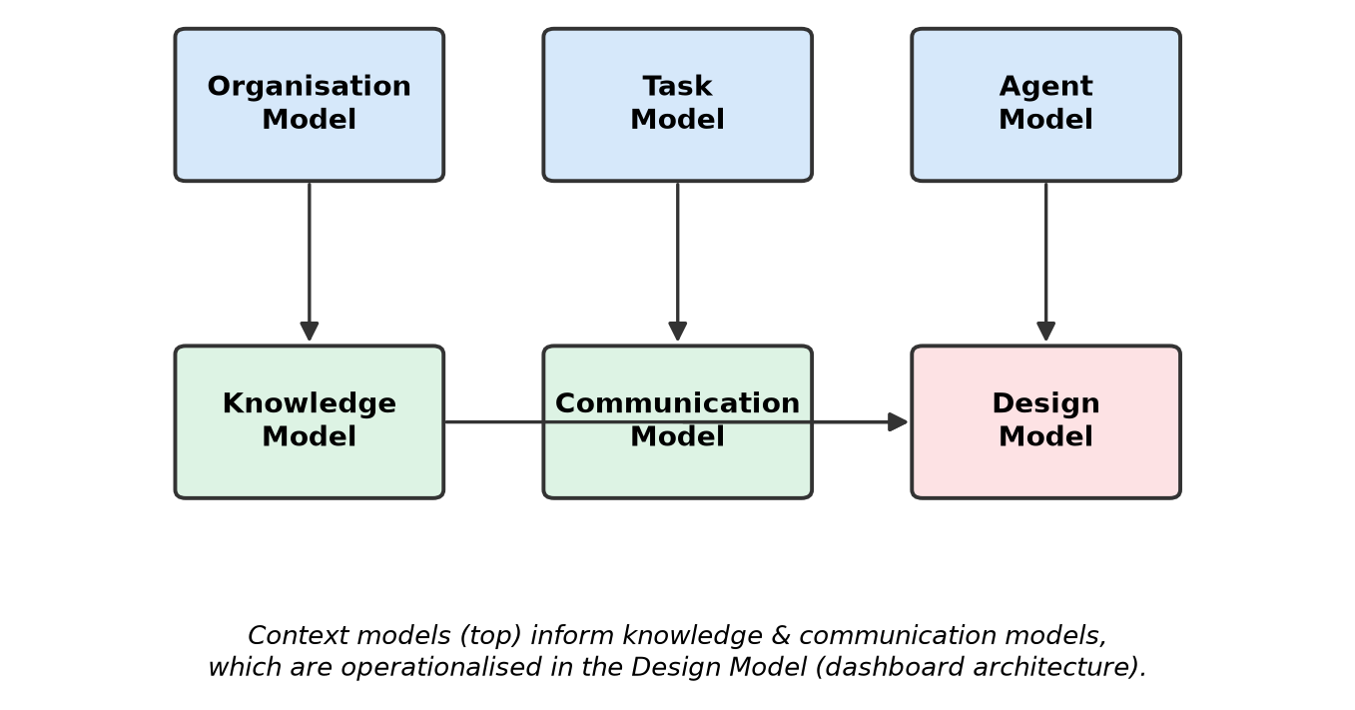
Figure 3.1. CommonKADS six-model suite adopted in this study (adapted from Schreiber et al., 2000).

In this study, each of the six models is applied to a specific part of the system design rather than used only as a conceptual framework. The Organisation Model was informed by published research on learning analytics governance (Tsai & Gašević, 2017; Leitner et al., 2019) and the stakeholder workflows reported by Kaliisa et al. (2023). It was used to describe how at-risk information currently moves between institutional roles, as set out in the following paragraph. The Task Model draws on the task decomposition proposed by Verbert et al. (2013) and was extended to include the additional tasks required for post-hoc explanations. The Agent Model is informed by the role-specific information needs identified by Kostopoulos et al. (2024) and by Haque, Islam, and Mikalef (2023), who synthesise practitioner-facing evidence on how explanation preferences differ by expertise. Because practitioners were not involved in the study, the Agent Model was developed from published literature rather than from direct knowledge elicitation with practitioners, which is the acquisition activity CommonKADS would ordinarily expect (Schreiber et al., 2000). The resulting agent characterisations are therefore a well-sourced hypothesis about the three roles rather than a documented account of them, and this limitation applies to every role-specific design decision that follows from them. The Knowledge Model draws on the feature taxonomies documented in the OULAD literature (Jin et al., 2024; Kuzilek et al., 2017) and integrates them with feature-attribution outputs generated by SHAP (Lundberg & Lee, 2017). The Communication Model draws on Miller's (2019) work on the pragmatics of explanation, which argues that effective explanations are contrastive, selective, and audience-sensitive. The Design Model then translates these upstream models into the layered technical architecture developed in Section 3.2. This approach ensures that CommonKADS guides system design rather than serving only as a descriptive framework.
Organisation Model. Because no institutional partner was involved, the Organisation Model was constructed from published accounts rather than from an organisational study. In the as-is situation described in this literature, at-risk predictions reach institutional staff as risk scores presented in isolation, without an account of the reasoning behind them (Susnjak et al., 2022), dashboards are typically designed for a single archetypal user (Kaliisa et al., 2023), and a shortage of practitioner-facing decision support is one of the barriers to institutional adoption (Tsai & Gašević, 2017). The flow of at-risk information therefore breaks down at two points: when a prediction reaches a practitioner without an explanation they can check against what they know, and when a single view requires each role to aggregate or disaggregate the information before it becomes usable. In the to-be situation specified for this study, instructors, advisors, and administrators receive the same underlying prediction and explanation at the granularity relevant to each role's decision, while the practitioner retains the intervention decision.
The secondary theoretical lens is the Technology Acceptance Model (TAM) developed by Davis (1989), which frames user adoption of information systems around perceived usefulness and perceived ease of use. TAM (Davis, 1989) informs the design goals for each role-specific interface, its two core constructs, perceived usefulness and perceived ease of use, providing a simple but well-validated basis for reasoning about what a usable, adoptable dashboard interface should offer each stakeholder role, complementing the user-need framing established in the CommonKADS Agent and Communication Models. Because this study is scoped to secondary OULAD data rather than primary practitioner data collection (Section 3.8), TAM is used solely as a design lens, not as an empirical framework; a TAM-based practitioner evaluation is identified in Chapter 7 as future work. The research proceeds through four iterative phases: knowledge acquisition and organisation analysis; knowledge and system modelling; artefact design and development; and technical evaluation.
The choice of TAM as a secondary lens is deliberate, not incidental. Venkatesh and Bala (2008) extended the original TAM into TAM3 by consolidating a broad body of empirical evidence on the antecedents of perceived usefulness and perceived ease of use, and their meta-analytic findings continue to support the predictive value of these constructs for professional software adoption. Marangunic and Granic (2015) reviewed 85 TAM studies and concluded that the model remains the most consistently supported framework for evaluating information system acceptance across educational and workplace contexts. TAM is therefore used alongside the CommonKADS Agent and Communication Models. TAM contributes the constructs of perceived usefulness and perceived ease of use, while the Agent and Communication Models describe the information needs of each stakeholder role. Kim et al. (2024) identify the same constructs as central to how AI explanations are received, which makes them relevant to a future practitioner evaluation.
The study also draws on the design science paradigm described by Hevner et al. (2004), which Peffers et al. (2007) later developed into the Design Science Research Methodology. Both argue that research centred on a purposeful artefact is justified by the rigour of its construction and by its usefulness when evaluated against a well-defined problem. This fits the present study, which contributes a working dashboard and design guidelines derived from its evaluation. This study adopts the iterative process proposed by Peffers et al. (2007) alongside CommonKADS. It comprises problem identification, objective definition, design and development, demonstration, evaluation, and communication. CommonKADS guides the knowledge modelling activities within each phase, while DSRM provides the overall structure for conducting the research.
The frameworks therefore serve different purposes in the study. The Design Science Research Methodology (DSRM) is the overarching research paradigm and process; CommonKADS is the knowledge-engineering and design framework applied within that process; TAM is a theoretical lens for anticipated technology acceptance; and the Kaliisa et al. (2023) checklist provides dashboard design guidance. None of these frameworks, other than DSRM, serves as the overarching methodology, and TAM is not evaluated empirically.
The four iterative phases identified above are conducted with explicit feedback loops between them rather than as a strict linear progression. In this study, knowledge acquisition drew on published literature rather than user-based elicitation, so findings from the literature review fed into the modelling phase, where an agent characterisation was refined, and outputs from the technical evaluation could inform late adjustments to the design phase. This iterative structure is consistent with the recommendations of Verbert et al. (2013), who caution that dashboard design in learning analytics must accommodate revisions arising from user studies rather than freezing design decisions at an early stage; because no user studies were conducted here, such revisions are left to the future practitioner evaluation outlined in Chapter 7.

3.2 System Architecture
The overall system architecture adopted in this study is illustrated in Figure 3.2. The process begins with problem identification and literature review, followed by CommonKADS knowledge engineering, dataset selection and preparation using OULAD, predictive modelling with ensemble machine learning, explainability integration using SHAP and LIME, system implementation using React and Flask, role-based dashboard design, technical evaluation of predictive performance and explanation behaviour against OULAD, and concludes with the development of design guidelines.

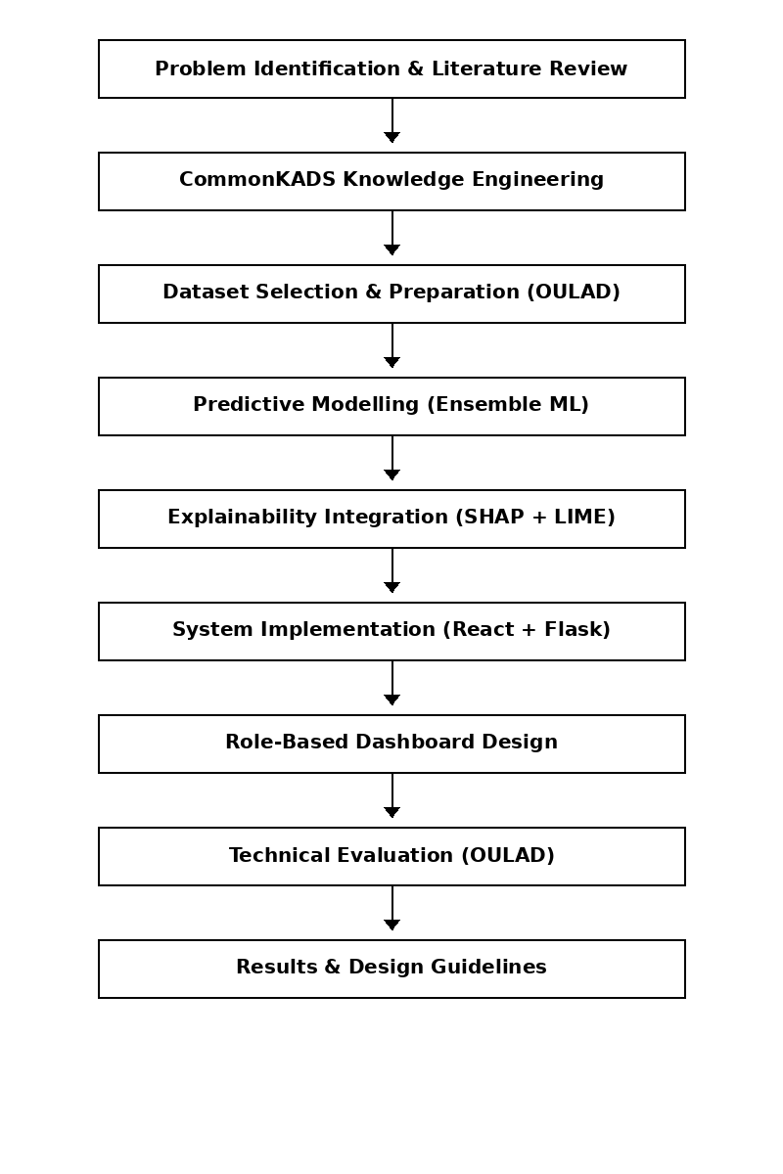
Figure 3.2. Research process flowchart, from problem identification through evaluation and derivation of design guidelines.

This system's architecture is driven by the need to address two established limitations in the literature. First, existing student at-risk prediction systems emphasise predictive accuracy while offering limited interpretability, thereby constraining their usefulness in practice (Ali et al., 2023). Second, most learning analytics dashboards adopt uniform interface designs despite clear evidence that different stakeholder roles require different forms of analytical insight (Kaliisa et al., 2023; Kostopoulos et al., 2024). The architecture therefore separates data processing, prediction, explanation, and user interaction, ensuring each component directly addresses these limitations.
The overall system is organised into five separate architectural layers, namely the Data Layer, the Prediction Engine, the Explainability Module, the Role Assignment and Personalisation Layer, and the Presentation Layer. Communication between layers is mediated by well-defined interfaces implemented as RESTful endpoints, which allow each layer to be revised, replaced, or scaled without cascading changes throughout the system. This architectural design is consistent with the guidance of Bass, Clements, and Kazman (2021) and aligns with the recommendations of Adadi & Berrada (2018), who argue that explainable AI systems benefit from architectures in which the explanation component is treated as a core part of the system rather than being added after model development.

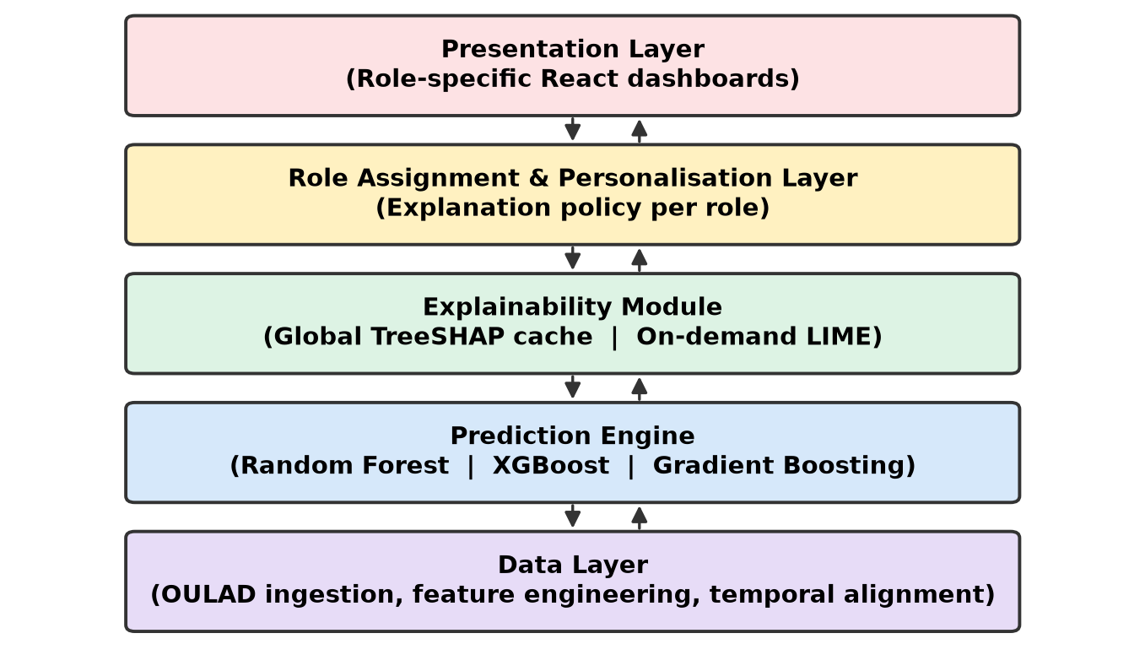
Figure 3.3. Layered system architecture separating data, prediction, explanation, personalization and presentation concerns.

A layered architectural approach is adopted because modular separation improves system clarity, scalability, and integration of explainability mechanisms in AI systems (Mohseni et al., 2021; Arrieta et al., 2020). This is particularly necessary in this study, as post-hoc explanation techniques such as SHAP and LIME operate independently of the predictive model and require flexible integration within the system pipeline (Ali et al., 2023; Salih et al., 2024).
The choice of a layered rather than pipeline-only architecture is also motivated by the need to accommodate concurrent use. Instructors, advisors, and administrators may access the dashboard simultaneously and request explanations at different granularities, and computationally expensive explanation queries could otherwise delay simpler cohort-level requests. Separating the explanation service from the presentation logic, and pre-computing the most expensive SHAP outputs, is intended to avoid this bottleneck; the specific implementation is described in Chapter 4.
The Data Layer is defined as a separate component to ensure consistency in feature extraction and preprocessing. This is justified by evidence that LMS behavioural logs, demographic variables, and assessment data are the most reliable predictors of student risk (Guevara-Reyes et al., 2025; Jin et al., 2024; Kuzilek et al., 2017; Wang, 2025). Isolating this layer supports reproducibility and reduces variability in feature engineering, a source of inconsistency in prior studies (Jin et al., 2024).
The Data Layer is also responsible for temporally aligning interaction records with assessment deadlines, a step essential for constructing time-window features. Following the temporal feature construction strategies documented by Hlosta, Zdrahal, and Zendulka (2017), interaction counts are aggregated over rolling windows anchored to submission dates rather than over calendar weeks, because deadline-anchored windows have been shown to yield stronger early-warning signals than calendar-anchored windows on OULAD. This treatment also lets the same feature pipeline be reused for both training and inference without leaking future information into historical windows, a concern emphasised by Krstajic, Buturovic, Leahy, and Thomas (2014) in their analysis of cross-validation pitfalls in predictive modelling.
The Prediction Engine is implemented as an independent layer to support ensemble learning methods. Ensemble models have consistently demonstrated superior predictive performance in at-risk classification tasks (Rebelo Marcolino et al., 2025; Wang, 2025). However, their increased complexity reduces interpretability, necessitating a dedicated explanation component (Guevara-Reyes et al., 2025).
The Explainability Module addresses this requirement by converting model outputs into interpretable representations. The combined use of SHAP and LIME is based on prior studies reporting complementary strengths, with SHAP commonly used for global attribution and LIME for local explanations of individual predictions (Gunasekara & Saarela, 2025; Nnadi et al., 2024; Salih et al., 2024). This ensures that the module adequately addresses both cohort-level and instance-level interpretation needs.
The Explainability Module includes two internal sub-services. The first, a global explanation service, computes and caches TreeSHAP values (Lundberg et al., 2020) across the training population; these values underpin the cohort-level visualisations used by administrators and, at a coarser grain, by advisors. The second, a local explanation service, generates on-demand LIME approximations for individual predictions (Ribeiro, Singh, & Guestrin, 2016) and produces a corresponding local SHAP explanation using the tree-path-dependent estimator, so the two techniques can be compared side by side within the interface. Storing global SHAP outputs while computing LIME on demand reflects the difference in computing time between the two methods reported by Salih et al. (2024), where SHAP has higher computing time than LIME. Global SHAP outputs can be cached and reused, whereas LIME, which relies on perturbation and repeated model evaluations, must be regenerated for each new instance.

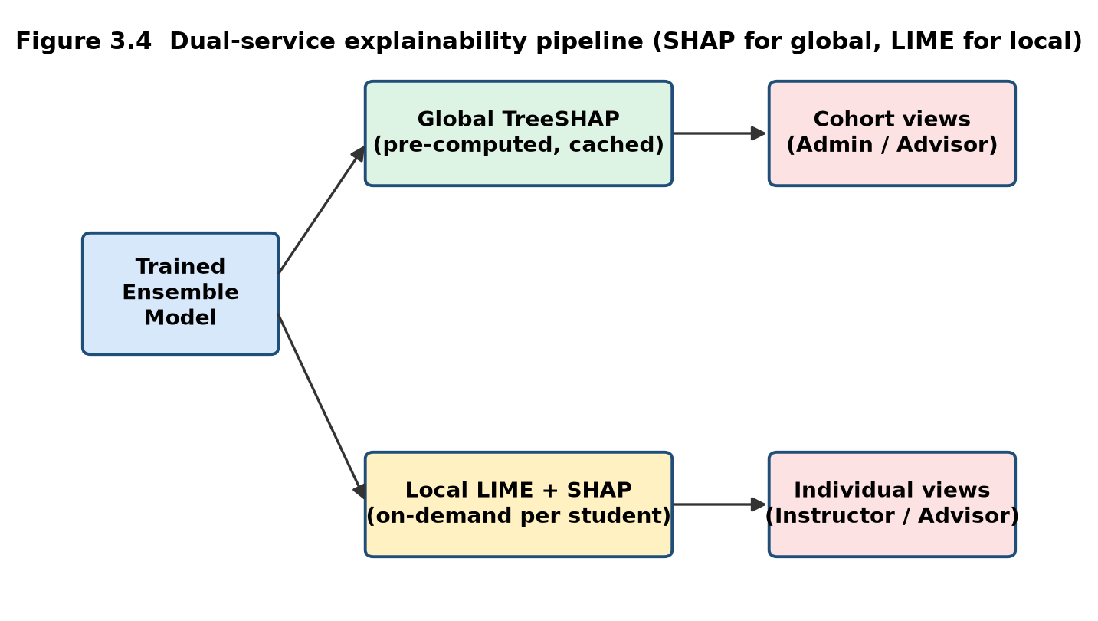
Figure 3.4. Dual-service explainability pipeline: global TreeSHAP is pre-computed and cached, while LIME (and local SHAP) are generated on demand.
The Role-Based Interface Layer is introduced to resolve the limitation of role-agnostic dashboard design. Prior studies show that explanation effectiveness depends on alignment with user roles and decision contexts (Gutiérrez et al., 2020; Haque et al., 2023; Kostopoulos et al., 2024). Accordingly, the system maps shared explanation outputs to role-specific visualisations for instructors, advisors, and administrators. This allows a single predictive model to support multiple stakeholders without redundancy, and is intended to support each role's decision-making; its effect on usability was not measured in this study.

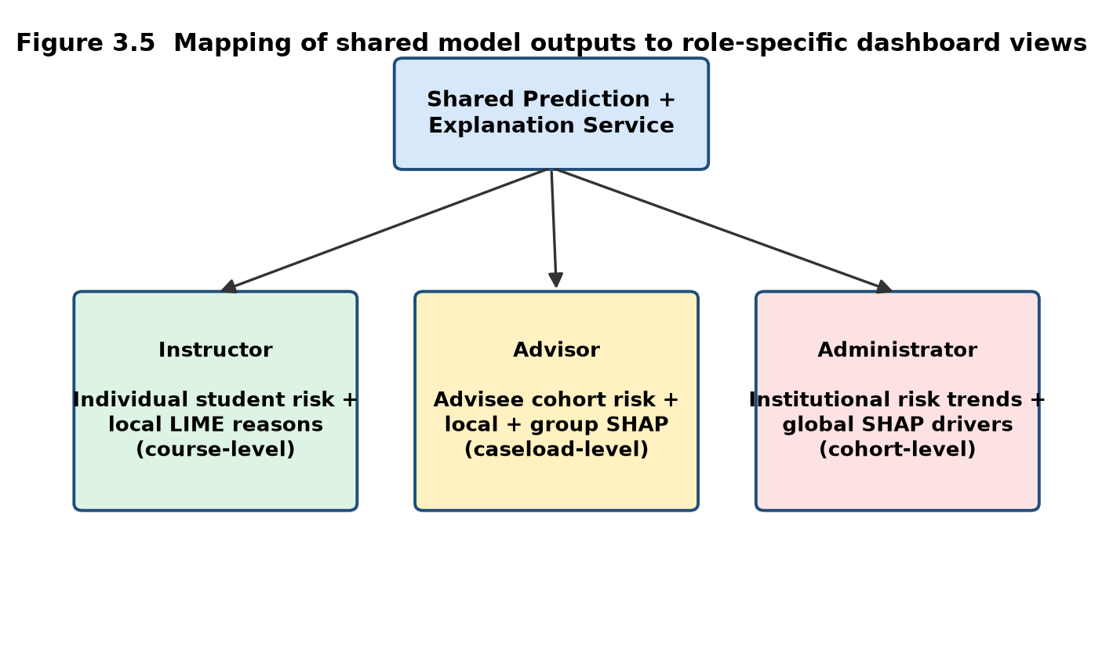
Figure 3.5. Mapping of shared prediction and explanation outputs to instructor, advisor and administrator dashboard views.

The mapping between shared explanation outputs and role-specific visualisations is implemented as a configurable presentation policy rather than as hard-coded logic. This design decision follows the recommendation of Sokol and Flach (2020) that explanation systems adopt a modular, fact-sheet-based approach in which the choice of explanation type, granularity, and format is decoupled from the underlying model. Each stakeholder role in the present system is associated with a policy specifying the explanation granularity (cohort, group, or individual), the visualisation modality (aggregated bar chart, per-student breakdown, or narrative summary), and the level of technical detail exposed. This makes it possible to introduce additional roles in future work without altering the prediction or explanation services.
The Presentation Layer is treated as a distinct concern rather than as a thin rendering shell over the Role Assignment policy. Its responsibilities include composing visual components, managing interaction state, and translating explanation artefacts into forms that respect the cognitive constraints of the intended audience. Hernandez-Leo et al. (2019) emphasise that the visualisation layer of a learning analytics system is where design decisions become directly observable to end users, and that weaknesses at this layer often mask the value of otherwise sound analytical pipelines. Accordingly, the Presentation Layer in this study is developed as a component library organised around three primitives: the risk indicator, the feature attribution panel, and the cohort comparison view, each parameterised by the presentation policy handed down from the Role Assignment layer.
A second reason for isolating the Presentation Layer is the need to accommodate accessibility and progressive disclosure. Miteva and Stefanova (2022), in their model of a learning analytics visualisation system, note that dashboards for heterogeneous audiences benefit from layered disclosure, in which summary indicators appear first, and technical detail is revealed on demand. The Presentation Layer implements this pattern by rendering compact risk summaries as the default view for every role and by exposing SHAP and LIME visualisations only when the user requests a deeper explanation. This behaviour is delegated entirely to the interface tier so the Explainability Module remains agnostic to downstream visualisation choices.
The interaction among these layers follows a structured data flow in which LMS data is processed, transformed into predictions, interpreted through post-hoc explanations, and delivered through role-specific visualisation logic. This design ensures consistency, flexibility, and alignment with stakeholder needs. The architecture is therefore justified as a knowledge engineering solution that integrates modular design, explainability, and role-awareness to address the limitations of existing systems. Implementation details of each layer, including feature dictionaries, model manifests, and caching, are reported in Chapter 4 rather than here.
A supporting architectural diagram is produced as part of the CommonKADS Design Model to make the described data flow explicit. In the diagram, the Data Layer feeds pre-processed feature vectors into the Prediction Engine, which returns risk probabilities to both the Explainability Module and the Role Assignment Layer. The Explainability Module returns cached global SHAP artefacts and freshly generated local explanations to the Presentation Layer, which composes them into role-appropriate views. The Presentation Layer enforces authentication and authorisation, so a practitioner is exposed only to the interface and explanation granularity associated with their role. This end-to-end trace is intended to satisfy the reproducibility criterion proposed by Gundersen and Kjensmo (2018), who argue that machine learning research artefacts should permit an independent reviewer to reconstruct the pipeline from raw data to end-user output.

3.3 Dataset
The Open University Learning Analytics Dataset (OULAD) is adopted as the primary dataset for model development (Kuzilek et al., 2017). This selection is justified by its extensive use in the literature, which enables direct comparison with prior studies and strengthens the validity of the results (Gunasekara & Saarela, 2025; Jin et al., 2024; Wang, 2025).
Since its release, OULAD has become one of the most widely used benchmarks for at-risk prediction research and has therefore accumulated an unusually rich body of comparative evidence. Hlosta, Zdrahal, and Zendulka (2017) provide one of the earliest baseline analyses of the dataset and document the class distributions, the temporal structure of the interaction logs, and the operational meaning of the pass, fail, and withdrawn labels. Subsequent contributions from Waheed et al. (2020) and from Adnan et al. (2021) have extended this baseline with deep learning treatments and time-series formulations, respectively, and their published performance figures provide credible reference points against which the models developed in this study can be benchmarked. Adopting OULAD therefore also situates the present study within a live comparative research programme.
OULAD contains anonymised demographic data and aggregated Virtual Learning Environment interaction records for 32,593 student-module-presentation observations across 22 module presentations (Kuzilek et al., 2017). These data types correspond directly to the feature categories most frequently identified as predictive of student at-risk status (Jin et al., 2024; Kuzilek et al., 2017). The dataset is therefore appropriate for the binary classification task adopted in this study.
The dataset is composed of seven relational tables covering student registrations, demographic attributes, module presentations, assessments, assessment results, VLE resources, and VLE interaction logs, and these tables are joined on student and module identifiers to produce the analytical dataset used for modelling. Waheed et al. (2020) report that the interaction table alone contains over ten million records, providing the volume necessary for stable estimation of high-capacity ensemble models. The demographic attributes include age band, gender, region, highest prior education, index of multiple deprivation band, disability status, and number of previous attempts, all of which have been shown in prior work to carry non-trivial predictive signal (Adnan et al., 2021; Kuzilek et al., 2017). Because several of these attributes are also protected characteristics under educational equity frameworks, their inclusion is treated as a design decision with fairness implications, discussed further in Section 3.9.
OULAD is further justified by its scale, completeness, and ethical suitability. Its anonymised structure eliminates concerns relating to personally identifiable information, while its size supports the development of robust and generalisable models. The dataset is therefore selected for its relevance, comparability, and methodological consistency with existing research.
Data preparation proceeded through five stages. The first stage performs schema validation and referential integrity checks across the seven source tables. The second stage constructs the analytical target variable by collapsing the four-class final result field into a binary at-risk indicator, mapping Withdrawn and Fail to the positive class and Pass and Distinction to the negative class, following the convention adopted by Jin et al. (2024) in their systematic review of OULAD-based studies. The third stage generates cumulative and rolling-window interaction features anchored on assessment deadlines, following the temporal aggregation strategy described by Hlosta et al. (2017). The fourth stage encodes the categorical attributes, including module, gender, region, highest education, index of multiple deprivation band, age band, and disability, using one-hot representations (Chapter 5, Section 5.2). The fifth stage records the course presentation (code_presentation) for each observation so cross-validation folds can be grouped by presentation, mitigating the risk of optimistic estimates from ignoring the data's panel structure, a concern raised by Rebelo Marcolino et al. (2025) in their optimisation study of Moodle log data.
Missing values are handled explicitly rather than imputed globally. Interaction counts for weeks in which a student is not yet registered are treated as structural zeros, whereas missing demographic fields are retained through a dedicated indicator variable so that missingness itself is available as a signal to the model. This treatment is consistent with the guidance of Van Buuren (2018), whose analysis of missing data mechanisms demonstrates that indicator encoding is preferable to blind imputation when missingness may be informative, a condition that is plausible for administrative educational data.

3.4 Predictive Modelling
The predictive modelling task is formulated as a binary classification problem, where students are classified as at-risk if they withdraw or fail their module. This formulation is consistent with established approaches in the literature and supports practical intervention scenarios (Jin et al., 2024).
The binary formulation is preferred over multi-class or regression alternatives for two principled reasons. First, the classifier supports an immediate screening decision: whether to flag a student for further consideration. Albreiki et al. (2021) report that most OULAD-based studies reviewed in their systematic analysis adopt a comparable binary framing. The intervention that may follow a flag is not binary, since an instructor or advisor might contact the student, monitor, refer, provide resources, adjust teaching, escalate, or do nothing, and that decision remains with the practitioner. Second, a binary target avoids the label ambiguity that arises when Pass and Distinction are treated as distinct classes, since prior work has shown that the boundary between these two categories is more sensitive to marking conventions across module presentations than to underlying behavioural differences (Kuzilek et al., 2017).
Prior studies identify submission timeliness, VLE interaction frequency, assessment performance trends, and demographic indicators as key predictors of student outcomes (Guevara-Reyes et al., 2025; Wang, 2025). Selecting these features aligns with existing empirical findings and supports interpretability.
The engineered feature set is organised into three thematic families to preserve interpretability at the presentation layer. The engagement family captures aggregate and time-windowed counts of clicks by VLE activity type, following the taxonomy of resource categories documented in the OULAD schema (Kuzilek et al., 2017). The assessment family captures scores achieved on tutor-marked and computer-marked assessments, together with submission latency computed as the interval between assessment release and submission, following the timeliness features shown by Hussain, Zhu, Zhang, and Abidi (2018) to be strongly associated with subsequent module outcomes. The demographic family captures the encoded demographic attributes described in Section 3.3. Each engineered feature is documented with a human-readable label and a short explanatory phrase in a feature dictionary, so that the presentation layer can render meaningful labels rather than variable names when surfacing SHAP and LIME attributions.
This study compares three ensemble models: Random Forest, XGBoost, and Gradient Boosting Classifier. Ensemble methods are justified by their demonstrated superiority in predictive performance across multiple studies (Rebelo Marcolino et al., 2025; Wang, 2025). F1-score is used for comparative reporting because it provides a balanced measure of performance in the presence of class imbalance (Jin et al., 2024). The model deployed in the prototype, however, is selected with recall as the primary criterion and F1-score as a secondary metric, because recall is prioritised to reduce false negatives in the intended screening context: a student who is at risk but not flagged receives no support from the dashboard, whereas a student who is flagged unnecessarily is reviewed by a practitioner and can be set aside.
The three candidate models are chosen because they represent distinct points along the bias-variance and interpretability spectra recognised in the machine learning literature. Random Forest, as formulated by Breiman (2001), reduces variance by averaging deep, decorrelated trees and remains a widely regarded strong general-purpose baseline for tabular classification. XGBoost, introduced by Chen and Guestrin (2016), applies regularised gradient boosting on decision trees and has become the reference implementation for boosting on structured data, particularly with heterogeneous feature types. The Gradient Boosting Classifier, as implemented in scikit-learn following Friedman (2001), provides a more conservative boosting baseline against which the XGBoost configuration can be compared. This three-way comparison follows the pattern established by Rebelo Marcolino et al. (2025) and by Guevara-Reyes et al. (2025), both of whom argue that credible ensemble evaluations require at least one bagging model and at least two boosting models to isolate the effects of the ensembling strategy from those of the boosting refinements.
The final evaluation used four-fold GroupKFold cross-validation grouped by course presentation (code_presentation), so observations from the same presentation never appear in both the training and validation partitions of a fold, avoiding the leakage pattern criticised by Krstajic et al. (2014). Because OULAD contains four course presentations, this produces four folds, and the folds are not stratified, since stratification is not compatible with grouping on a variable that takes only four values. The XGBoost model deployed in the prototype was evaluated using a fixed configuration (300 estimators, maximum depth 5, learning rate 0.05, subsample 0.8, and column subsample 0.8) without additional hyperparameter optimisation or resampling, and Random Forest and Gradient Boosting were evaluated under the identical preprocessing pipeline and protocol. Accuracy, precision, recall, and F1-score, computed over out-of-fold predictions at a decision threshold of 0.5, are the primary metrics, and the training code also records ROC-AUC.

3.4.1 Planned but Not Implemented Methodological Extensions
The original study design specified several refinements to the modelling and evaluation pipeline that were not implemented in the final evaluation. They are recorded here so that this chapter describes the final method accurately while remaining transparent about the original plan. Chapter 2, Section 2.2 reviews the literature motivating each refinement.
Class imbalance handling. SMOTE, including borderline and adaptive variants applied within the training folds, and class-weighted loss functions were specified as ways of addressing class imbalance. Neither was applied, because the final evaluation used the observed class distribution, which is only mildly imbalanced (Chapter 5, Section 5.2).
Hyperparameter optimisation. Bayesian optimisation with the Tree-structured Parzen Estimator was specified for hyperparameter search. The prototype model instead used the fixed configuration described above.
Probability calibration. A comparison of isotonic regression and Platt scaling, assessed through reliability diagrams and expected calibration error, was specified because the dashboard displays risk probabilities. Calibration was not assessed in the final evaluation.
Trajectory features. A trajectory feature family capturing period-over-period change in engagement and performance was specified. The implemented feature set does not include it.
Secondary metrics. Area under the precision-recall curve, balanced accuracy, and the Matthews correlation coefficient were specified as secondary metrics and were not computed in the final evaluation.
Cross-validation protocol. The original design described a stratified five-fold protocol. It was superseded by the four-fold GroupKFold protocol described above, which is the method used in the final evaluation.
Explanation stability and fidelity, and subgroup fairness. The stability and fidelity checks for explanations (Section 3.5) and the subgroup performance and fairness assessment (Section 3.9) were proposed but were not completed within the final evaluation.

3.5 Explainability Integration
Integrating explainable AI techniques is necessary to address the limited interpretability of predictive models in educational contexts. Prior research indicates that risk predictions without explanation provide limited support for decision-making (Ahmed et al., 2025; Ali et al., 2023).
The explanation subsystem design is grounded in the distinction Doshi-Velez and Kim (2017) draw between transparency-oriented and post-hoc interpretability. Transparency-oriented approaches require the model itself to be intrinsically understandable, which typically constrains model choice to linear models or shallow trees at a substantial cost in accuracy. Post-hoc approaches, in contrast, decouple the interpretability question from the modelling question and allow high-capacity models to be deployed alongside a dedicated explanation layer. Adadi & Berrada (2018) argue that in domains such as education, where the accuracy of the underlying model has direct consequences for the students subject to intervention, the post-hoc route is generally preferable, provided the resulting explanations undergo explicit fidelity and stability testing. This position underpins the decision in the present study to retain ensemble models and to invest architectural effort in the explanation layer.
SHAP is used for global model interpretation, while LIME is used for local explanations. This combination is justified by studies reporting that SHAP provides consistent feature attribution, while LIME offers flexible and interpretable explanations for individual instances (Gunasekara & Saarela, 2025; Nnadi et al., 2024; Salih et al., 2024). The use of both techniques ensures that explanations are available at different levels of analysis.
SHAP is grounded in the game-theoretic framework of Shapley values and is implemented in this study using the TreeSHAP algorithm proposed by Lundberg et al. (2020), which computes exact Shapley values for tree ensembles in polynomial time and thereby renders the method tractable for the OULAD-scale feature space. LIME, introduced by Ribeiro et al. (2016), fits a sparse linear surrogate to the behaviour of the model in the local neighbourhood of a given prediction and returns the surrogate coefficients as feature-level explanations. The two methods are complementary rather than redundant: SHAP is formulated to satisfy properties such as local accuracy and consistency (Lundberg & Lee, 2017), although these properties depend on the exact SHAP formulation and its assumptions, including the assumption of feature independence discussed by Salih et al. (2024), whereas LIME provides a more intuitive linear approximation that many practitioners find easier to reason about in isolation. Salih et al. (2024) argue explicitly for the joint use of both techniques as a form of methodological triangulation, and this argument is adopted here.
The explanation subsystem was also designed to incorporate safeguards against the known failure modes of post-hoc methods. Slack et al. (2020) show that SHAP and LIME can be manipulated by adversarial classifiers to conceal discriminatory behaviour, and although the present study does not confront an adversarial setting, the same underlying sensitivity to perturbation choices motivates reporting stability metrics. The methodology proposed quantifying stability using the Jaccard similarity of the top-k feature sets returned by repeated LIME runs on the same instance with different random seeds, following the protocol of Visani, Bagli, Chesani, Poluzzi, and Capuzzo (2022), and quantifying fidelity using the local squared error between the surrogate and the black-box model within a locality kernel of controlled bandwidth, with instances falling below preregistered thresholds flagged in the interface. These stability and fidelity checks were proposed safeguards rather than completed evaluation procedures: they were not completed in the final evaluation, and the explanation evaluation reported in Chapter 5 is limited to cross-method agreement between SHAP and LIME.
SHAP values are pre-computed during model training and stored to support efficient retrieval. LIME explanations are generated on demand for individual predictions, enabling real-time interaction within the dashboard. Explanation quality was evaluated through cross-method agreement between SHAP and LIME; the fidelity and stability metrics described above were specified but not completed.
The presentation of explanations is shaped by the pragmatics of explanation set out by Miller (2019), whose synthesis of social science research on how humans give and receive explanations identifies three properties that any effective explanation must satisfy. Explanations should be contrastive, clarifying why a particular outcome was predicted rather than a plausible alternative. Explanations should be selective, surfacing the small number of factors that most strongly account for the outcome rather than the full attribution vector. Explanations should be social, in that they should be phrased in terms accessible to the intended recipient. The presentation layer draws on these selective and social properties by rendering per-instance explanations as signed feature attributions limited to a small set of leading features, with human-readable feature labels, at an aggregation level suited to the associated stakeholder role. The prototype implements feature attributions rather than contrastive or counterfactual explanations, and it does not include natural-language comparative statements; therefore, the contrastive property remains a design aspiration rather than a feature of the current system. This aligns the explanation experience with the empirical evidence of Poursabzi-Sangdeh et al. (2021), who show that human comprehension of model outputs degrades sharply when unfiltered attribution vectors are displayed in full.

3.6 Dashboard Design
The dashboard design process was structured by the four-stage checklist of Kaliisa et al. (2023), which guides developers from initial purpose specification and stakeholder engagement through iterative prototyping and rigorous evaluation planning, a sequence directly applicable to the three-role design problem of this study. This checklist was selected because it was developed explicitly for learning analytics contexts and has been applied in subsequent LA dashboard research (Cabral et al., 2025). Three role-specific interface variants were designed and implemented as a web application using React.js with a Python Flask backend. Interface decisions were guided by the heuristic criteria set out below and checked against the CommonKADS Agent Model, consistent with the secondary-data scope of this study (Section 3.8); no documented iterative heuristic review, with recorded iterations, reviewers, or severity ratings, was conducted. The design process was structured by the CommonKADS Design Model, so that each interface variant maps directly to the knowledge delivery requirements identified for its corresponding agent role.
Each interface was designed around a separate information brief derived from the CommonKADS Agent Model. The instructor interface focuses on class-level engagement during the current teaching period and provides explanations of individual students' risk drivers using assessment and weekly activity data, following the information needs identified by Molenaar and Knoop-van Campen (2019) in their study of teacher-facing dashboards. The advisor interface prioritises longitudinal views across multiple modules for a caseload of students, foregrounding demographic context in a form suitable for one-to-one consultations, in line with the design pattern used by Gutiérrez et al. (2020) in the LADA advising system. The administrator interface prioritises cohort-level aggregations, module-over-module comparisons, and equity-relevant breakdowns, following the institutional decision-support patterns documented by Tsai and Gašević (2017). These role-specific briefs prevent the dashboard from using the same view for all users. Table 3.2 summarises the resulting role-based design.
Table 3.2. Role-based dashboard design: decisions, information needs, components, and explanation granularity.
Role | Decision | Information needed | Dashboard component | Explanation granularity
Instructor | Whether to act within a course that is currently running. | Class-level engagement over the current teaching period and per-student risk drivers at the granularity of assessments and weekly activity. | Per-student reasoning trail with SHAP and LIME shown side by side. | Individual
Advisor | How to conduct a conversation with a particular student and prioritise a caseload. | Views across multiple modules for a caseload of students, with demographic context, suitable for one-to-one consultations. | Cohort-averaged reasoning trail for students at or above the watch threshold. | Caseload
Administrator | Where to direct institutional attention and resource. | Cohort-level aggregations and module-over-module comparisons. | Institution-wide model performance summary and full-population reasoning trail. | Cohort
The interface follows Nielsen's (1994) human-computer interaction heuristics, particularly visibility of system status, match between the system and the real world, recognition rather than recall, and consistency and standards. Colour usage is designed to remain informative for practitioners with common forms of colour vision deficiency by using colour-blind-safe palettes and encoding critical categorical distinctions redundantly through shape and label, following the accessible visualisation guidance synthesised by Munzner (2014). Typography, spacing, and interactive controls were designed with reference to the WCAG 2.1 conformance criteria of the World Wide Web Consortium, which is consistent with the accessibility-first orientation increasingly expected of higher education software.
The study did not conduct a formal iterative heuristic review with documented iterations, reviewers, or severity ratings. Instead, the Nielsen (1994) criteria were applied as design guidance during implementation. A formal heuristic evaluation, together with a formative think-aloud study with representative practitioners of the kind recommended by Verbert et al. (2020), is identified in Chapter 7 as future work once the dashboard is evaluated with an institutional partner.
A system architecture diagram was produced during the design phase to illustrate the data flow from raw LMS input through the prediction engine, explainability module, and role-based interface layer. This diagram serves as the principal artefact of the CommonKADS Design Model (Figure 3.3 and Figure 4.1).
The design plan also specified three supporting artefacts: a use-case diagram enumerating the primary interactions available to each role, produced in the Unified Modelling Language following the notation of Booch, Rumbaugh, and Jacobson (2005); an entity-relationship diagram capturing the persistent data model that underlies the Data Layer; and a sequence diagram illustrating the runtime interaction between the Presentation Layer, the Prediction Engine, and the Explainability Module for a representative on-demand explanation request. These supporting diagrams are not included in the thesis. Figures 3.3 and 4.1 therefore provide the main architectural documentation presented in the study.

3.7 Implementation Plan
The system was implemented using Python for all data processing, model training, and explainability computation, with scikit-learn, XGBoost, SHAP, and LIME as the primary libraries.
These libraries were selected based on their suitability for the required tasks. Scikit-learn is adopted for its consistent estimator interface and its well-tested implementations of cross-validation, preprocessing, and model evaluation utilities, as documented by Pedregosa et al. (2011). XGBoost was selected because of its regularised objective, sparsity-aware split finding, and out-of-core training capabilities (Chen & Guestrin, 2016). SHAP is adopted through its official reference implementation to guarantee alignment with the theoretical guarantees of TreeSHAP established by Lundberg et al. (2020). LIME is adopted through the reference implementation of Ribeiro et al. (2016). The library versions used in the evaluation are reported in Chapter 5, Section 5.7 and in Appendix A, in line with the reproducibility recommendations of Gundersen and Kjensmo (2018).
The web application was built using React.js for the frontend and Python Flask for the API layer, a combination selected because it enables rapid prototyping of interactive visualisation components alongside a well-tested machine learning pipeline. The code was organised into separate modules for the prediction, explainability, and visualisation components (Chapter 4, Section 4.3). The three role-specific interfaces were implemented as web pages within a single application, with role-based authentication determining which view a practitioner accesses upon login.
The frontend is organised as a component-based application using the composition principles articulated in the React documentation of Meta Open Source (2024) and the maintainability guidance of Martin (2017). Visualisation components are implemented using the D3-based ecosystem, drawing on the grammar of interactive graphics described by Satyanarayan, Moritz, Wongsuphasawat, and Heer (2017), which supports the declarative construction of coordinated views necessary for exploratory dashboards. The Flask backend exposes REST endpoints for prediction, global explanation retrieval, and local explanation generation, and implements authentication using JSON Web Tokens following the specification of Jones, Bradley, and Sakimura (2015). Role-based access control is enforced at the API layer and the interface layer, consistent with the defence-in-depth principle articulated by Saltzer and Schroeder (1975), so the interface layer is not the sole enforcement point for role separation.
The planned testing strategy included several levels of testing: unit tests for the preprocessing pipeline, model wrappers, and explanation utilities, integration tests for the API contracts between the frontend and the backend, and regression tests for the explanation subsystem to detect unexpected shifts in SHAP and LIME outputs following library upgrades, which matters because Slack et al. (2020) demonstrate that explanation methods are sensitive to implementation details that may change silently across versions. Continuous integration was also planned, following the software delivery practices described by Humble and Farley (2010). This testing and continuous integration pipeline is not demonstrated in this thesis and is therefore described as planned practice rather than completed infrastructure. Similarly, the codebase, the trained model artefacts, and the derived experimental data are intended for deposit in a public repository in accordance with the FAIR data principles articulated by Wilkinson et al. (2016), but this deposit is not reported as completed here.

3.8 Evaluation Plan
Consistent with the scope of this study (Section 1.6), evaluation is a technical evaluation of the predictive and explanatory components against the OULAD dataset, rather than a primary study involving instructor, advisor, or administrator participants. The evaluation plan below specifies what is measured, how, and against what standard of comparison.
Predictive performance is evaluated using GroupKFold cross-validation grouped by course presentation (code_presentation). This ensures that the model does not train on the same presentation used for evaluation. Because OULAD contains four course presentations, this produces four folds. Metrics are computed over out-of-fold predictions across the full population: accuracy, precision, recall, and F1-score are reported as the four primary metrics, giving a small number of clearly interpretable, comparable results rather than a large battery of secondary statistics. Random Forest, XGBoost, and Gradient Boosting are compared using the same pipeline and evaluation protocol. F1-score is used for model comparison, while recall is the primary criterion for selecting the model used in the prototype. Performance is additionally reported separately for each held-out course presentation, giving a direct empirical indication of how much variability to expect across cohorts. Because the features use data from the full course presentation, the evaluation is retrospective. It does not establish model performance at a specific early-warning point, which would require features to be restricted to the information available at each point in a presentation.
Explainability is evaluated in two complementary ways. Global feature importance is computed using TreeSHAP (Lundberg et al., 2020) once, for the final fitted model, across all 32,593 observations, ranking features by mean absolute SHAP value; this explains the final fitted model rather than providing a fold-specific explanation evaluation. Local, instance-level explanations are computed using LIME (Ribeiro et al., 2016) on a representative sample of instances. The two methods are compared directly. Their aggregate rankings are compared for overlap in leading features, while instance-level agreement is measured by comparing the top-ranked SHAP and LIME features for each sampled prediction. This comparison follows the recommendation of Lundberg and Lee (2017) that global and local attribution methods be validated against one another rather than relied upon in isolation.
The evaluation also includes a verification step, in which the metrics and figures reported in Chapter 4 are reproduced from the trained model artefact. The implemented system is also compared with the methodology specified in this chapter, and any differences between the planned and implemented methods are documented.
The technical evaluation determines whether the predictive and explanatory components function correctly and produce consistent results. These results provide the technical basis for future practitioner evaluation. Direct evaluation of practitioner trust, understanding, and decision quality would require primary data from instructors, advisors, and administrators and is outside the scope of this thesis; it is identified in Chapter 7 as the recommended next phase of this research programme, building directly on the CommonKADS Agent Model, the TAM-based design lens (Section 3.1), and the technical foundation established here.
This evaluation reports findings against a three-level evidence model used throughout the remainder of the thesis. Findings that were demonstrated are those measured directly in the technical evaluation, such as predictive performance and cross-method agreement. Findings supported by design are dashboard properties that are implemented and traceable to stated requirements and the literature but were not tested with users. Findings not empirically established are those that this study did not measure, including practitioner trust, usability, and decision quality, probability calibration, subgroup fairness, and early-warning performance.

3.9 Ethical Considerations
Because the study uses only the secondary OULAD dataset (Section 3.3) and collects no primary data from students, instructors, advisors, or administrators, its main ethical considerations concern data handling and algorithmic fairness rather than participant recruitment or informed consent. No personally identifiable student data is used at any stage, as OULAD is fully anonymised by design (Kuzilek et al., 2017), and all data processing is limited to the anonymised identifiers already present in the published dataset.
Algorithmic fairness is considered as part of the study's ethical assessment. Because OULAD contains demographic attributes that overlap with protected characteristics, the evaluation plan proposed subgroup performance and fairness assessment, with model performance disaggregated by gender, age band, disability status, and index of multiple deprivation band, and fairness assessed using demographic parity difference and equal opportunity difference following the framework of Hardt, Price, and Srebro (2016). These analyses were not completed within the final evaluation. The plan required any subgroup performance differences to be reported openly. This follows the transparency principle advocated by Mitchell et al. (2019) in their model card proposal and the evidence from Yu et al. (2020) that predictive models in higher education can produce different error rates across student groups even when overall accuracy is high. Completing this assessment is identified as a first-tier item of future work in Chapter 7.
The study also considers the ethical implications of deploying a role-aware XAI dashboard in an authentic institutional setting, even though such deployment, and the practitioner evaluation that would accompany it, is beyond the scope of the present thesis. Prinsloo and Slade (2017) argue that learning analytics systems should be evaluated against the principles of student agency, transparency, and avoiding harm. In line with this argument, the dashboard design deliberately avoids features that would automate high-stakes decisions about students, keeping the practitioner as the final decision-maker in any intervention. Slade and Prinsloo (2013) further note that learning analytics interventions risk paternalism if student voice is not represented in the design process; while student participants are outside the scope of the present study, this limitation is acknowledged here, and student consultation is recommended as a prerequisite for institutional deployment. A future practitioner evaluation of the kind outlined in Chapter 7 would additionally require institutional ethical approval and informed consent from participating instructors, advisors, and administrators before data collection could begin.

3.10 Chapter Summary
This chapter presented the methodology used to design, implement, and technically evaluate the role-aware XAI dashboard for student at-risk prediction using the OULAD dataset. The study follows the Design Science Research Methodology of Peffers et al. (2007). CommonKADS provides the knowledge engineering and design framework, while TAM is used only as a design lens and the Kaliisa et al. (2023) checklist guides dashboard design. The system architecture is organised into loosely coupled data, prediction, explanation, personalisation, and presentation layers, each justified against the technical and practitioner-facing limitations identified in the literature. The Open University Learning Analytics Dataset provides the empirical foundation for model development, prepared through a documented five-stage pipeline that preserves temporal integrity and groups observations by course presentation. Random Forest, XGBoost, and Gradient Boosting classifiers are compared using four-fold GroupKFold cross-validation grouped by course presentation, with a fixed model configuration and no resampling; F1-score is used for comparative reporting, and recall is the primary criterion for selecting the model deployed in the prototype. Explainability is delivered through the combined use of TreeSHAP and LIME, with agreement between the two methods treated as the core explanation evaluation criterion; the stability and fidelity checks, calibration analysis, and subgroup fairness assessment originally specified were not completed and are recorded as planned extensions in Section 3.4.1. The dashboard is developed against the Kaliisa et al. (2023) checklist and rendered in three role-specific variants derived from the CommonKADS Agent Model, which was populated from published literature rather than from practitioners. Evaluation is technical and retrospective: it verifies predictive performance on features computed over the full course presentation, confirms explanation behaviour and cross-method agreement, and compares the implementation against the originally planned methodology, and its findings are reported using the three-level evidence model set out in Section 3.8. Ethical considerations, including data anonymisation, algorithmic fairness, and the implications of eventual institutional deployment, are addressed across the methodology, and the primary practitioner evaluation of trust, understanding, and decision quality that would require human-subjects procedures is identified as the recommended next phase of this research programme in Chapter 7. Together, these methods provide the basis for answering the research questions presented in Chapter 1.

CHAPTER 4

SYSTEM ARCHITECTURE AND IMPLEMENTATION

4.1 Introduction
This chapter presents the technical architecture and implementation of the role-aware explainable at-risk prediction dashboard described conceptually in Chapter 3. Chapter 3 set out the design rationale derived from the six CommonKADS models. This chapter describes how that design was built as a working prototype: the frameworks and libraries used at each layer, the model development environment, the Learning Management System (LMS) integrations built and tested, and the containerised deployment.
The system was built and tested end to end on the full Open University Learning Analytics Dataset (OULAD) described in Chapter 3, not on synthetic or placeholder data. The architectural decisions reported here therefore reflect a system tested at real data volume (32,593 student-module-presentation observations) rather than a purely theoretical design.
This chapter corresponds directly to the second and third specific objectives from Chapter 1, Section 1.3: developing an ensemble predictive model with integrated SHAP and LIME explanations and implementing a role-aware dashboard that delivers differentiated explanatory views to instructors, academic advisors, and institutional administrators. Chapter 3 specified how these objectives were to be met at the level of knowledge engineering models and analytical procedure; the present chapter reports the artefact that resulted from following that specification. This distinction is important because the contribution claimed earlier (Chapter 1, Section 1.5) is an artefact contribution, and Schreiber et al. (2000) argue that a knowledge engineering contribution of this kind is supported by the traceability of the modelling process from conceptual model to operational system, not by the novelty of any individual component. Studer et al. (1998) similarly treat the working system as the operational endpoint of a staged knowledge engineering process that runs from analysis through conceptual modelling to implementation, and this chapter occupies that position within the study.
The chapter also establishes the technical preconditions for the evaluation reported in the following chapter. Because the technical evaluation reported in Chapter 5 depends on the predictive and explanatory outputs the system actually produces when run against the OULAD dataset, the implementation choices documented here determine what can meaningfully be evaluated from the secondary data available to this study. Kim et al. (2024) note that human-centred XAI evaluations are often difficult to interpret because the systems under study are described only in general terms, leaving it unclear which interface property drives a given behaviour. Each implementation decision reported in this chapter is stated in sufficient detail for the evaluation findings to be attributed to identifiable design choices, not to the system as an undifferentiated whole.

4.2 Architectural Overview
The system follows a five-layer architecture in line with the Design Model from Chapter 3, Section 3.1: a Data Layer responsible for feature engineering, a Prediction Engine responsible for risk classification, an Explainability Module responsible for generating SHAP and LIME explanations, an Interface/API layer enforcing authentication and role-based access control, and a Presentation Layer providing three role-differentiated dashboard views. Figure 4.1 shows the architecture, including the model development environment (Google Colab) and the two Learning Management System integration paths (Moodle and Canvas) evaluated during prototype testing.
The retention of a layered structure in the implemented system reflects the architectural reasoning behind Chapter 3, Section 3.2, not simply development convenience. Bass, Clements, and Kazman (2021) argue that layering is justified when layers change at different rates. This holds here: the feature engineering logic, the trained model, the explanation services, and the interface components are each expected to be revised on different schedules. Mohseni, Zarei, and Ragan (2021) make the related point for explainable systems, observing that architectures that treat explanation as a separate architectural component rather than an appendage to the model are substantially easier to evaluate against user-facing criteria.

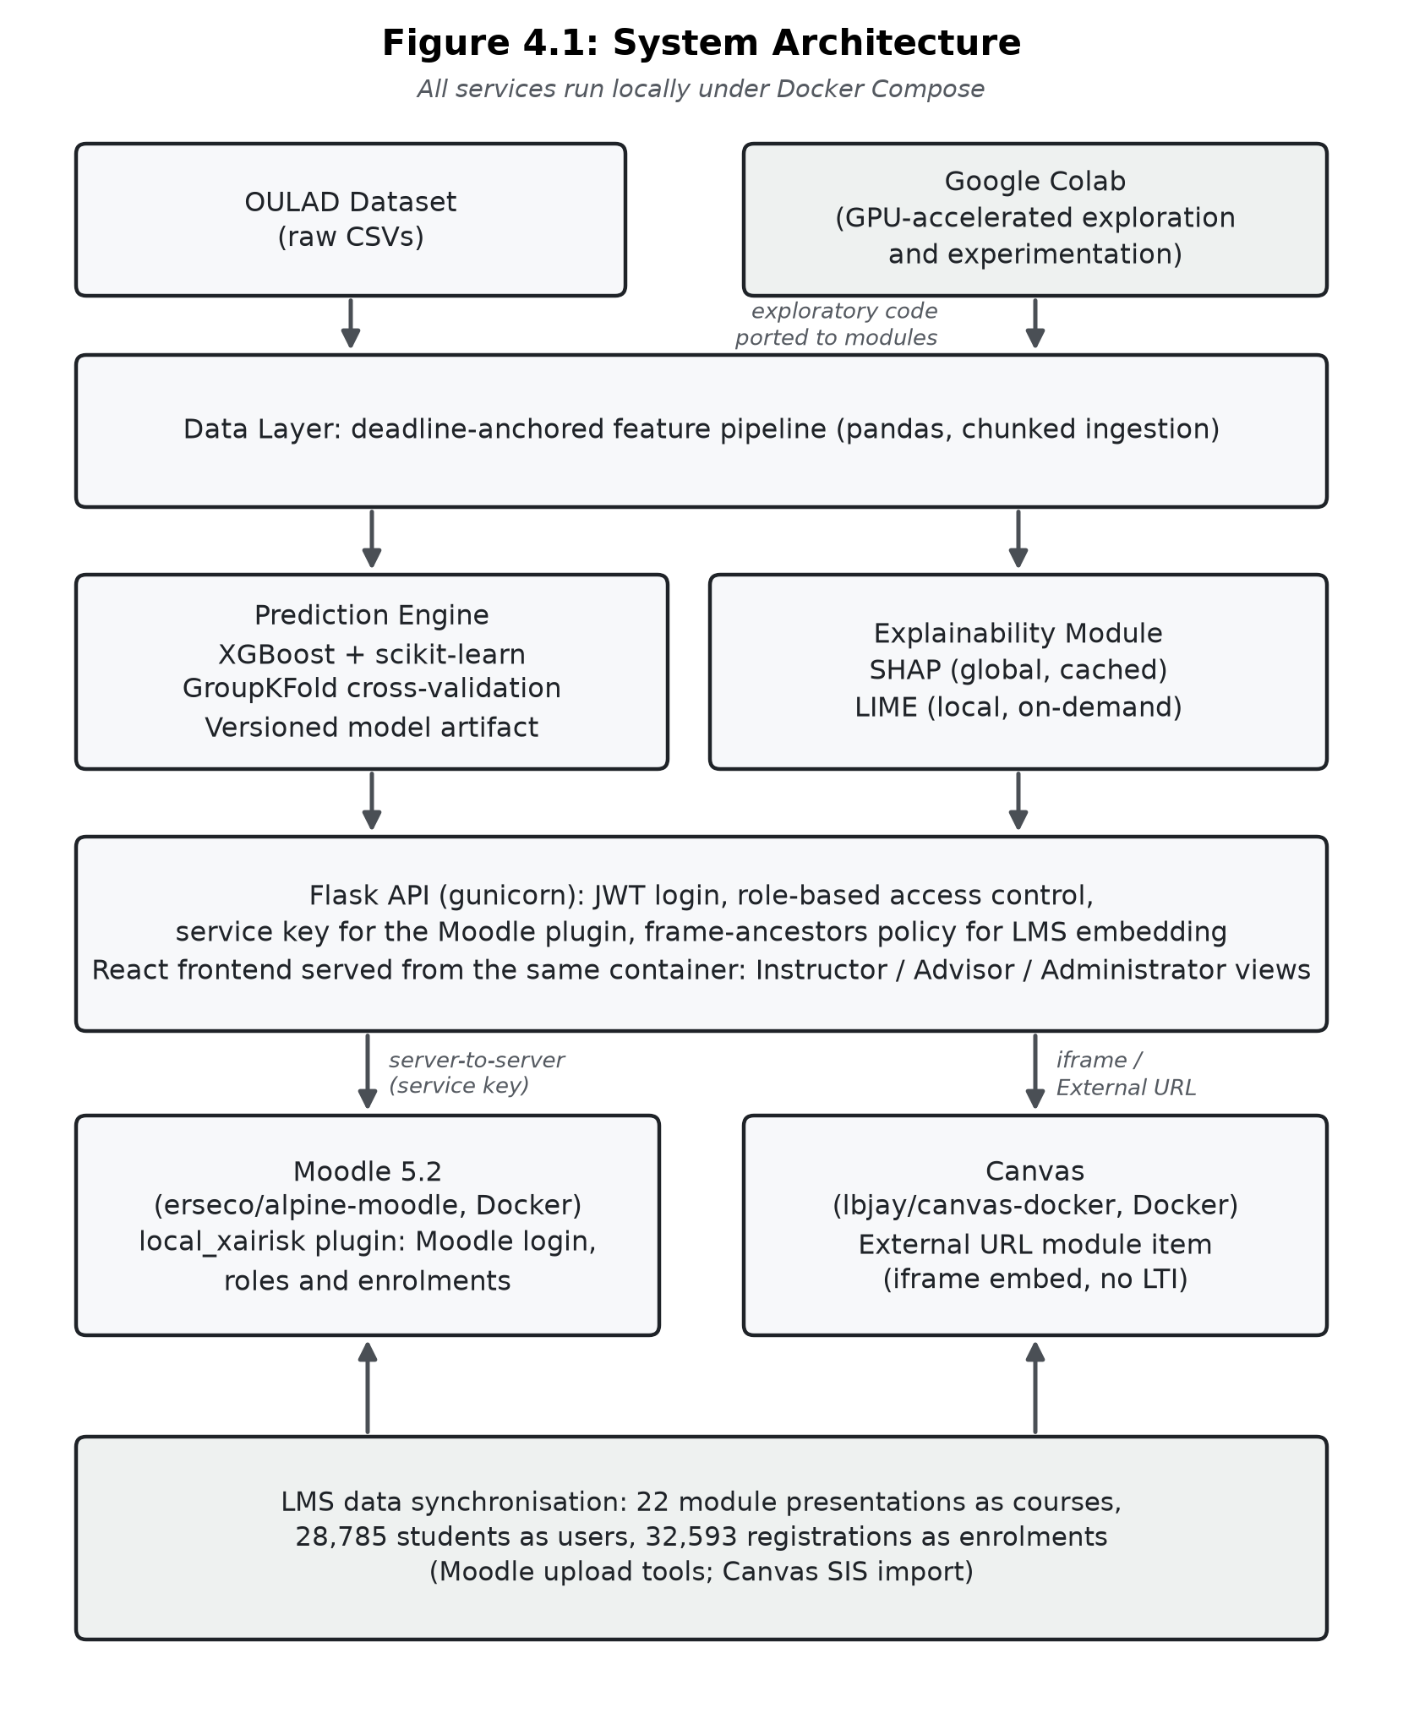
Figure 4.1. System architecture, showing the data, prediction, explainability, interface, and presentation layers, the model development environment, and the two LMS integration paths tested.

4.3 Model Development Environment
Before the prototype pipeline was built, model development and hyperparameter experimentation were conducted in Google Colab, which provided free access to GPU-accelerated compute for iterating on feature engineering strategies and comparing candidate ensemble configurations without needing local hardware. Colab notebooks were used to explore the OULAD schema, prototype the deadline-anchored rolling-window feature strategy from Chapter 3, Section 3.4, and validate that the chosen feature set produced acceptable separation between at-risk and not-at-risk classes before the pipeline was ported into the prototype codebase.
This separation between an exploratory notebook and a prototype codebase follows standard applied machine learning practice. Colab was used for short-lived experiments, while the code that runs in the prototype was rewritten as versioned, testable Python modules (data_layer, prediction_engine, explainability). The prototype therefore does not depend on Colab's session-based execution or its GPU availability.
This arrangement also serves the reproducibility requirement from Chapter 3, Section 3.7. Gundersen and Kjensmo (2018) demonstrate that a substantial proportion of published machine learning work cannot be reconstructed by an independent reviewer because the experimental environment, the data preparation steps, and the final model are not documented as a single traceable workflow. Porting the exploratory work into versioned modules addresses this concern directly, since the prototype pipeline can be executed end to end from raw OULAD tables to a scored prediction without reference to any notebook state. Sculley et al. (2015) describe the accumulation of exactly this kind of untracked dependency as a principal source of technical debt in machine learning systems, and the separation maintained here is intended to reduce this type of dependency at the point where it would otherwise be easiest to introduce.
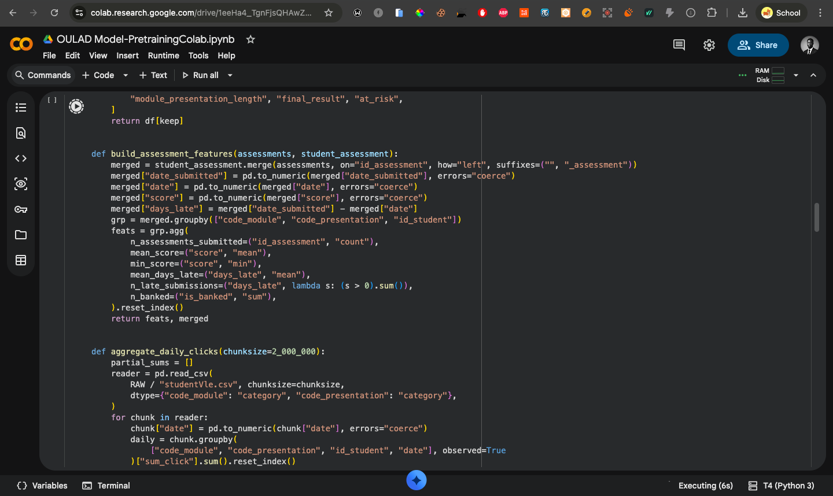
Figure 4.2. Screenshot from the prototype development: Google Colab pre-training of the OULAD dataset.

4.4 Technology Stack
Table 4.1 summarises the frameworks and libraries used at each architectural layer, together with their specific role in the implemented system.
The libraries listed were selected against the criteria in Chapter 3, Section 3.7, not simply on availability. Scikit-learn is used for cross-validation, preprocessing, and evaluation because of the consistency of its estimator interface and the maturity of its model selection utilities (Pedregosa et al., 2011). XGBoost is used for the prototype classifier for the reasons given by Chen and Guestrin (2016), particularly its regularised objective and its handling of heterogeneous tabular features, which are characteristic of the joined OULAD tables. The SHAP reference implementation is used so that the attributions displayed in the interface retain the properties established for TreeSHAP by Lundberg et al. (2020), and the LIME reference implementation of Ribeiro, Singh, and Guestrin (2016) is used for the same reason on the local explanation path. Retaining the reference implementations rather than reimplementing either method is important because Slack et al. (2020) show that post-hoc explanation outputs are sensitive to implementation details that may otherwise change without notice.

Table 4.1. Frameworks and libraries used by architectural layers.
Data Layer | pandas | Chunked ingestion of the ~450MB studentVle.csv clickstream file; deadline-anchored feature aggregation; versioned CSV output
Prediction Engine | scikit-learn, XGBoost | GroupKFold cross-validation grouped by course presentation; gradient-boosted ensemble classifier; preprocessing pipeline (imputation, one-hot encoding)
Model persistence | joblib | Serialises the fitted pipeline (preprocessing + model) as a single versioned artifact alongside a JSON manifest
Explainability | SHAP, LIME | TreeSHAP for cached global/cohort-level explanations; LIME for on-demand local explanations; both computed against the same fitted model
API layer | Flask, PyJWT, Werkzeug | REST API; JSON Web Token issuance and verification; password hashing for the demo account login flow
Web server | gunicorn | Serves the Flask API and the built React application from a single container
LMS plugin (Moodle) | PHP, Moodle plugin API | local_xairisk plugin adding the three role views to Moodle; uses Moodle login, capabilities, and enrolments, and calls the API server to server
Frontend | React, Vite | Component-based single-page application implementing the three role-differentiated views
LMS embedding (Canvas) | Canvas REST API | External URL module item in every course, embedding the dashboard in an iframe
LMS data synchronisation | pandas; Moodle upload tools; Canvas SIS import | Loads every OULAD module presentation as a course, and its students as enrolled users, in each LMS
LMS (tested) | Moodle 5.2 (erseco/alpine-moodle) | Native plugin integration, run locally in Docker with PostgreSQL
LMS (tested) | Canvas (lbjay/canvas-docker) | Alternative LMS integration path, tested via non-LTI External URL module embedding
Containerisation | Docker, Docker Compose | Single Compose file running the API, Moodle with its database, and Canvas for the prototype deployment

4.5 Data Layer Implementation
The Data Layer ingests the seven OULAD source tables (studentInfo, studentRegistration, studentVle, vle, studentAssessment, assessments, and courses) and produces a single feature table of one row per (student, module, presentation) triple. The studentVle clickstream file, at approximately 450MB, is read using pandas' chunked-iteration interface rather than loaded into memory in full, with per-chunk aggregation to daily click totals performed before concatenation. The resulting feature table comprised 32,593 rows and 28 columns, one row for each of the 32,593 student-module-presentation observations in OULAD (Kuzilek et al., 2017), as reported in Chapter 1.
As set out in Chapter 3, Section 3.3, VLE engagement features are calculated using 7-, 14-, and 28-day windows before each assessment deadline rather than fixed calendar weeks. A programmatic leakage check stops any window that would include activity recorded on or after its deadline, raising an assertion error rather than silently including that activity. A versioned feature dictionary (JSON) is emitted alongside every processed feature batch, recording the data type, description, and provenance of every column, so that the Prediction Engine and Explainability Module can validate their inputs against a defined schema.
The leakage guard implements, as an executable check, the methodological requirement from Chapter 3, Section 3.3. Krstajic et al. (2014) show that leakage of future information into historical windows is among the most common sources of optimistic performance estimates in predictive modelling, and that such leakage is frequently introduced silently during feature construction rather than during model fitting. Enforcing the constraint programmatically rather than by convention means that any subsequent revision of the window logic raises an error instead of producing an inflated result. The choice of deadline-anchored rather than calendar-anchored windows follows Hlosta, Zdrahal, and Zendulka (2017), who report that windows aligned to submission dates yield stronger early-warning signals on OULAD, and it also preserves the property that the same feature code can be used for both training and inference.
The versioned feature dictionary serves the schema contract function described by Hernandez-Leo et al. (2019), who argue that stable contracts between the acquisition and analysis layers are a precondition for iterative dashboard refinement, since interface work cannot proceed if the semantics of the underlying features shift beneath it. In the implemented system, the dictionary also carries the human-readable label and short explanatory phrase associated with each engineered feature, so that the reasoning trail (described later, Section 4.9) renders meaningful labels rather than internal variable names. This is a presentation requirement with an explanatory basis. Miller (2019) observes that explanations are social and should be phrased in terms the recipient can follow, and an attribution expressed against an unlabelled column name does not meet that condition for any of the three stakeholder roles. Missing values are handled as described earlier in Chapter 3, Section 3.3, with structural zeros distinguished from informative missingness through indicator encoding, following Van Buuren (2018).

4.6 Prediction Engine Implementation
The prototype classifier is a gradient-boosted ensemble (XGBoost), selected with recall as the primary criterion (Chapter 3, Section 3.4). It was evaluated using GroupKFold cross-validation grouped by course presentation, of which OULAD contains four (2013B, 2013J, 2014B, and 2014J), so no fold is evaluated on a presentation the model was trained on. Held-out, out-of-fold performance across the full dataset was 87.7% accuracy, 0.887 F1-score, and 0.962 AUC. The fitted preprocessing pipeline and model are saved as a single versioned artefact with a manifest recording the training date, the feature dictionary version, and the evaluation metrics. Any prediction returned by the API can therefore be traced to the exact model version and feature contract that produced it.
Grouping folds by course presentation is a stricter protocol than the stratified splits reported in much of the OULAD literature, and this affects how the reported figures should be interpreted. Because no presentation appears in both the training and the evaluation partition of a fold, the out-of-fold estimates approximate transfer to an unseen course presentation under the retrospective feature construction used in this study. The consequence is that these figures are not directly comparable with the highest accuracies reported on OULAD in prior work, including the 96.9% reported on OULAD by Wang (2025) for a hybrid ensemble, since those studies do not, in general, isolate presentations across folds. Jin et al. (2024) note in their systematic review that evaluation protocols vary considerably across OULAD studies, and reported accuracies are therefore not straightforwardly comparable across the literature. Krstajic et al. (2014) make a similar argument, showing that ignoring the higher-level unit structure of a dataset produces optimistic estimates.
The asymmetry of the error profile also connects to the modelling rationale from Chapter 3, Section 3.4. F1-score was adopted there as the primary metric for comparative reporting because accuracy is uninformative under class imbalance, and recall as the primary criterion for selecting the prototype model; Chicco and Jurman (2020) also argue that summary metrics should be interpreted alongside the full confusion matrix rather than in place of it. Reporting recall and specificity separately, as above, shows the trade-off a single threshold imposes, and the dashboard exposes this trade-off to practitioners rather than resolving it on their behalf. The probabilities surfaced in the interface are treated with corresponding caution, since Niculescu-Mizil and Caruana (2005) and Guo et al. (2017) both demonstrate that discrimination and calibration are distinct properties, and Kim et al. (2024) observe that practitioner trust responds to the perceived reliability of displayed confidence values and not only to aggregate accuracy.
A further consideration follows from the fairness position taken earlier, in Chapter 3, Section 3.9. Because the feature set includes demographic attributes that overlap with protected characteristics, aggregate out-of-fold performance is not on its own a sufficient account of model behaviour. Baker and Hawn (2022) document systematic disparities in educational model performance across demographic subgroups, and Yu et al. (2020) show that error rates can differ substantially across gender, ethnic, and first-generation groups even where overall accuracy is high. Saving the model manifest with the fitted artefact makes this kind of disaggregated reporting practical, because a later audit can reconstruct the exact feature contract and model version used to compute subgroup performance, in line with the model card proposal of Mitchell et al. (2019). This disaggregated reporting was not completed within the final evaluation (Chapter 5, Section 5.10).
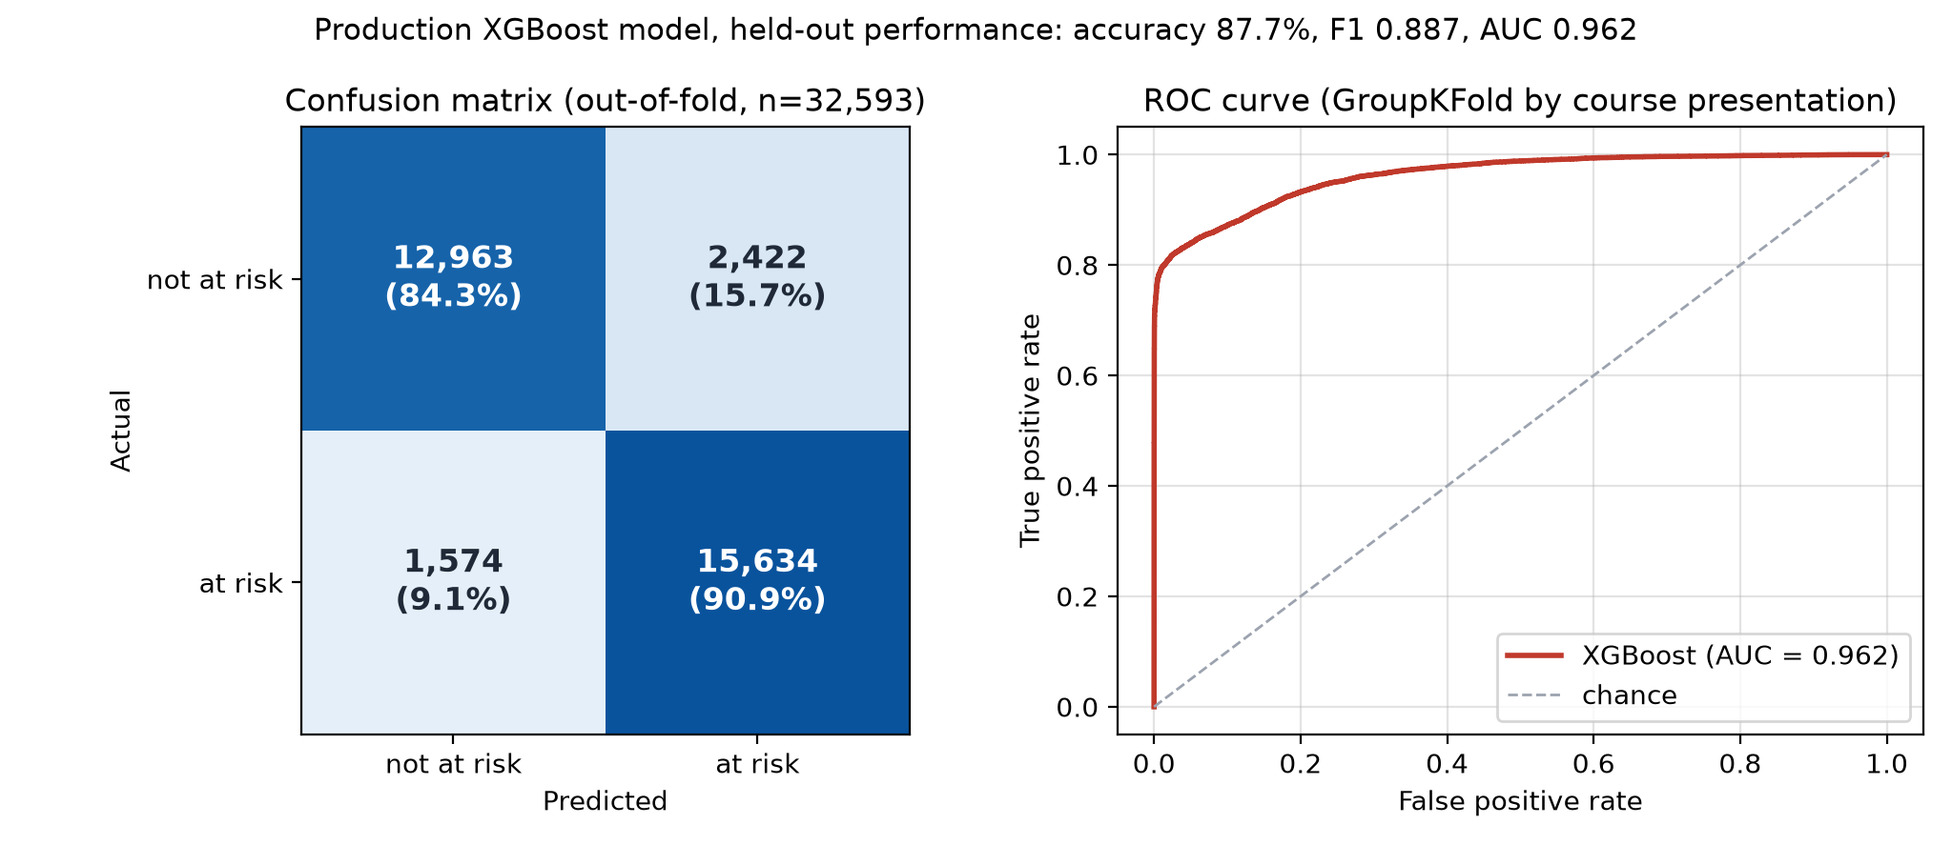
Figure 4.3. Held-out performance of the prototype XGBoost classifier, computed out-of-fold with GroupKFold grouped by course presentation across all 32,593 OULAD student-module-presentation observations.

The confusion matrix (left) reports the out-of-fold classification outcome at the 0.5 decision threshold: 15,634 of 17,208 genuinely at-risk students are correctly flagged (90.9% recall) and 12,963 of 15,385 not-at-risk students are correctly left unflagged (84.3% specificity), with 2,422 false positives and 1,574 false negatives.

4.7 Explainability Module Implementation
Following the computational asymmetry argument from Chapter 3, Section 3.5, the explainability module is split into two independently operating services. A global service computes TreeSHAP values once per model version, using the final fitted model, across its full training population of all 32,593 observations, and caches the result. These global values explain the final fitted model and are not fold-specific explanations produced within the cross-validation (Chapter 5, Section 5.6); this cache serves the coarser, cohort-level views required by the advisor and administrator roles without recomputation on every request. A local service computes a local SHAP explanation and an independent LIME explanation on demand for a single prediction, using the exact feature vector the model originally scored. The two explanations are shown side by side in the instructor view, so the user can see directly where they agree and where they differ.
Displaying the two methods side by side rather than selecting between them puts into practice the methodological triangulation argued for earlier, in Chapter 3, Section 3.5. Prior studies have reported complementary uses of the two methods, with SHAP commonly used for global attribution and LIME for local explanations, and Gunasekara and Saarela (2025) apply both to models trained on OULAD, while Salih et al. (2024) report a higher computing time for SHAP than for LIME, which motivates the caching strategy adopted here. LIME is relatively lightweight in some contexts, but it involves perturbation and repeated model evaluations and must be regenerated for each instance. Presenting both attributions simultaneously also makes any divergence visible, providing additional information: where the two methods identify the same drivers, the practitioner has a stronger basis for acting on the explanation than either method provides alone.
This design decision also responds to the known limitations of post-hoc explanation discussed in Chapter 2 (Section 2.3). Rudin (2019) argues that high-stakes decisions should rest on intrinsically interpretable models rather than on post-hoc accounts of opaque ones, and Slack et al. (2020) demonstrate that both SHAP and LIME are sensitive to perturbation choices in ways that can be exploited. The present study retains the post-hoc route for consistency with the prior OULAD literature, but the side-by-side presentation makes that choice transparent to the practitioner. The stability and fidelity checks specified earlier (Chapter 3, Section 3.5), including the Jaccard similarity of top-k feature sets across repeated LIME runs proposed by Visani et al. (2022), were not completed in the final evaluation. In keeping with the selectivity property identified by Miller (2019), and with the evidence of Poursabzi-Sangdeh et al. (2021) that comprehension degrades when unfiltered attribution vectors are displayed in full, the reasoning trail shows a small number of leading contributions rather than the complete attribution vector.

4.8 API and Security Architecture
The Flask API enforces role-based access control on every request, independently of the Learning Management System in front of it, following a defence-in-depth principle. A request is accepted either with a JSON Web Token issued by the API's own login or, for server-to-server calls from the Moodle plugin, with a shared service key known only to the plugin and the API. The Moodle plugin first checks the user's Moodle capability for the requested view, and the API then checks the forwarded role against the endpoint, so role separation does not depend on a single check inside the Learning Management System. Three roles are recognised throughout the system including the instructor, advisor, and administrator, each receiving a different level of explanatory detail from the same underlying prediction, in keeping with the Agent Model from Chapter 3, Section 3.6.
For access outside Moodle, including the Canvas embedding (covered in Section 4.10), the API additionally exposes a conventional username/password login endpoint, with three demonstration accounts corresponding one-to-one with the three application roles. Passwords are stored as salted hashes rather than in plaintext.
The decision to enforce role separation at both the Learning Management System and the API reflects the defence-in-depth principle of Saltzer and Schroeder (1975), cited earlier in Chapter 3, Section 3.7, under which no single component should constitute the sole enforcement point for an access control decision. In this system, a forwarded role header is therefore treated as a claim to be checked, not as an established fact. This is appropriate because the dashboard is designed to be embedded in a Learning Management System and so receives requests that originate outside its own trust boundary. Token issuance and verification follow the JSON Web Token specification of Jones, Bradley, and Sakimura (2015), and the separation between the HS256 tokens used for the dashboard's own sessions and the service key used by the Moodle plugin keeps the two trust relationships distinct.
Role separation is also a requirement of the study design, not only a technical measure. The Agent Model, summarised earlier in Chapter 3, Section 3.6, treats each stakeholder role as a distinct decision-making agent with its own knowledge requirements, and Kostopoulos, Davrazos, and Kotsiantis (2024), in their review of explainable decision support systems, note that such systems can be tailored to the individual needs of their users. If a practitioner could obtain a level of explanatory detail associated with a different role, the differentiation that the study evaluates would not hold in practice, and the evaluation reported in the following chapter would be measuring responses to an interface other than the one specified. Gating the visible view by the authenticated session is, as a result, a requirement of the evaluation design as well as a security measure.

4.9 Frontend Implementation
The presentation layer is a single-page React application with three role-gated views. Rather than allowing free navigation between roles, the deployed prototype gates the visible view by the authenticated session: a user must sign in, and the role returned by that sign-in determines which of the three views is rendered, with no client-side mechanism to switch roles without re-authenticating. Each view reuses a single 'reasoning trail' component, a visualisation of signed SHAP and LIME contributions, at three levels of aggregation: individual-student detail for the instructor view, cohort-averaged detail for the advisor view, and full-population detail for the administrator view. The same visual format is therefore used for all three roles in the Agent Model instead of three unrelated visualisations.
The decision to reuse a single reusable visual component across the three views follows from the CommonKADS position adopted throughout the study. The Agent Model differentiates roles by the granularity and framing of the knowledge each requires, not by the visual vocabulary used to express that knowledge, and Sokol and Flach (2020) argue on similar grounds that explanation type, granularity, and format should be treated as separable configuration parameters. Reusing the reasoning trail also makes the information easier to read for practitioners who hold more than one role, which is common in smaller institutions, and it follows the recognition-rather-than-recall and consistency heuristics of Nielsen (1994) referred to in Chapter 3, Section 3.6.
The content of each view comes from the role-specific information briefs set out earlier in Chapter 3, Section 3.6. The instructor view emphasises per-student detail because Molenaar and Knoop-van Campen (2019) show that teachers act on dashboard information at the level of the individual learner. Kaliisa and Dolonen (2022) also find that instructors prioritise summary-level alerts over granular statistical breakdowns, which is why the full attribution is reached through the reasoning trail rather than shown by default. The advisor view is cohort-averaged over students at or above the watch threshold, following the caseload orientation of the LADA advising dashboard reported by Gutiérrez et al. (2020). The administrator view is full-population because institutional decision support focuses on distributions rather than individual behaviour, in line with patterns documented by Tsai and Gašević (2017). Progressive disclosure is applied uniformly across the three views, with compact risk summaries rendered by default and the attribution detail exposed on request, following the layered disclosure pattern described by Springer and Whittaker (2020) and adopted earlier, in Chapter 3, Section 3.2.

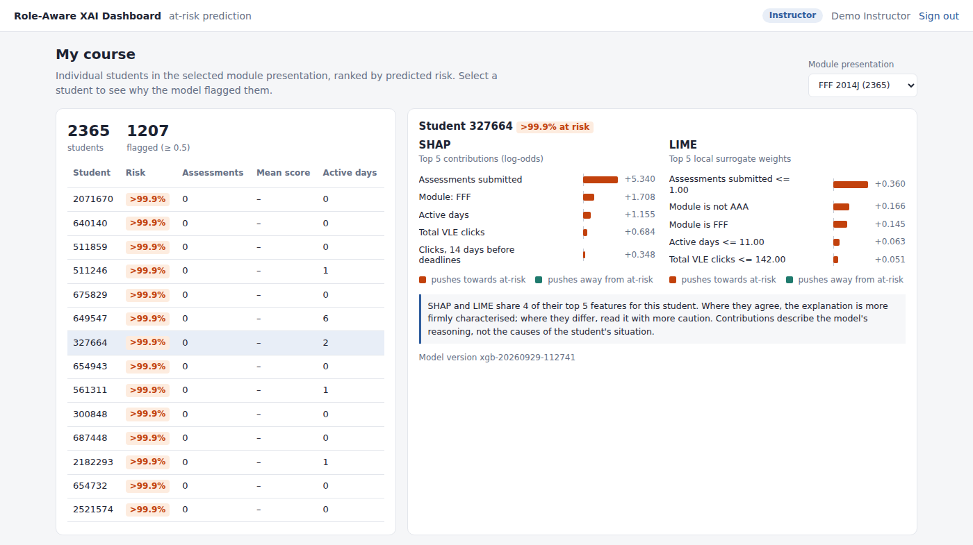
Figure 4.4. Screenshot from the prototype development: instructor view, per-student SHAP and LIME reasoning trail, shown side by side for a single OULAD student.

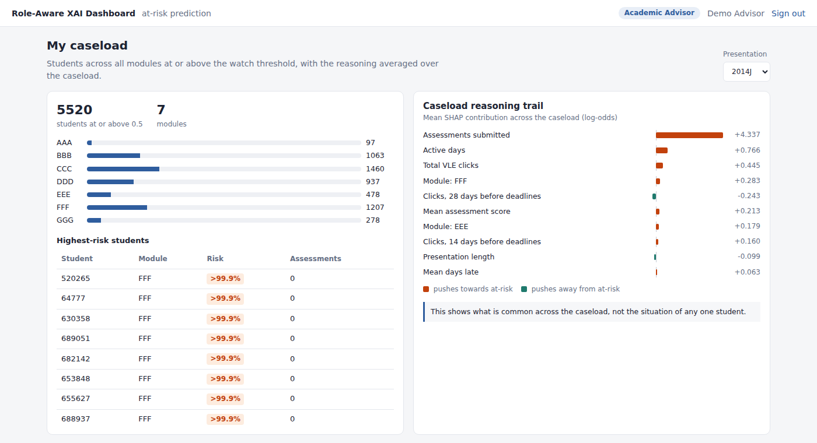
Figure 4.5. Screenshot from the prototype development: advisor view, cohort-averaged reasoning trail for students flagged at or above the watch threshold.

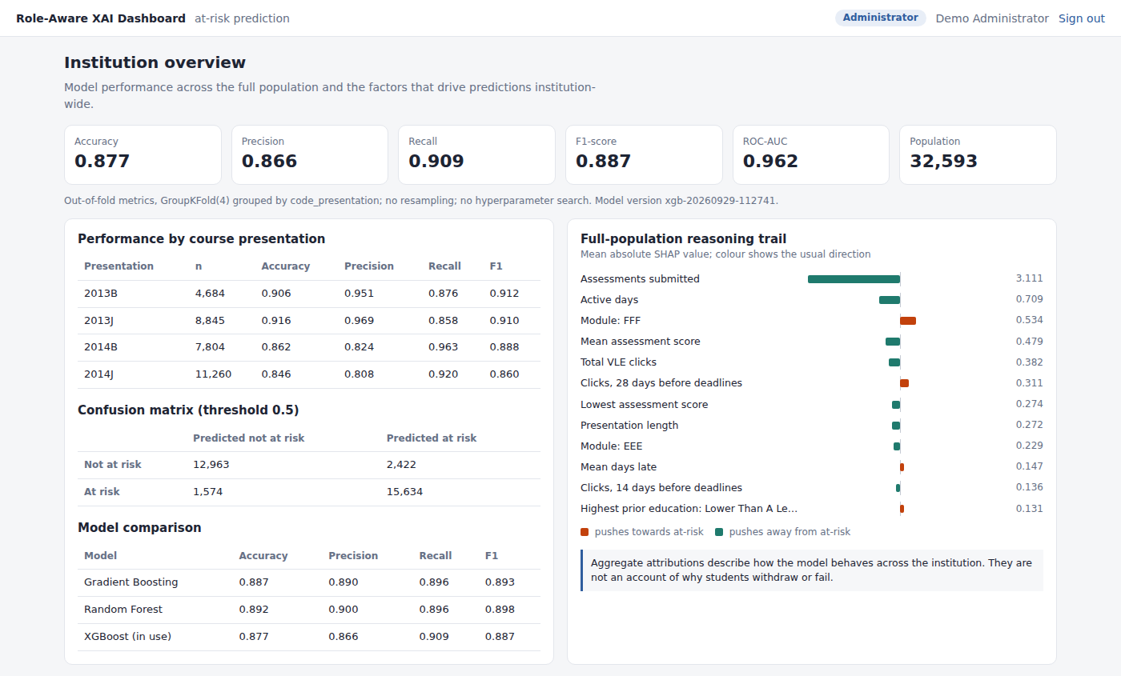
Figure 4.6. Screenshot from the prototype development: administrator view, institution-wide model performance summary and full-population reasoning trail.
(a) Moodle login page


(b) Dashboard sign-in inside a Canvas course
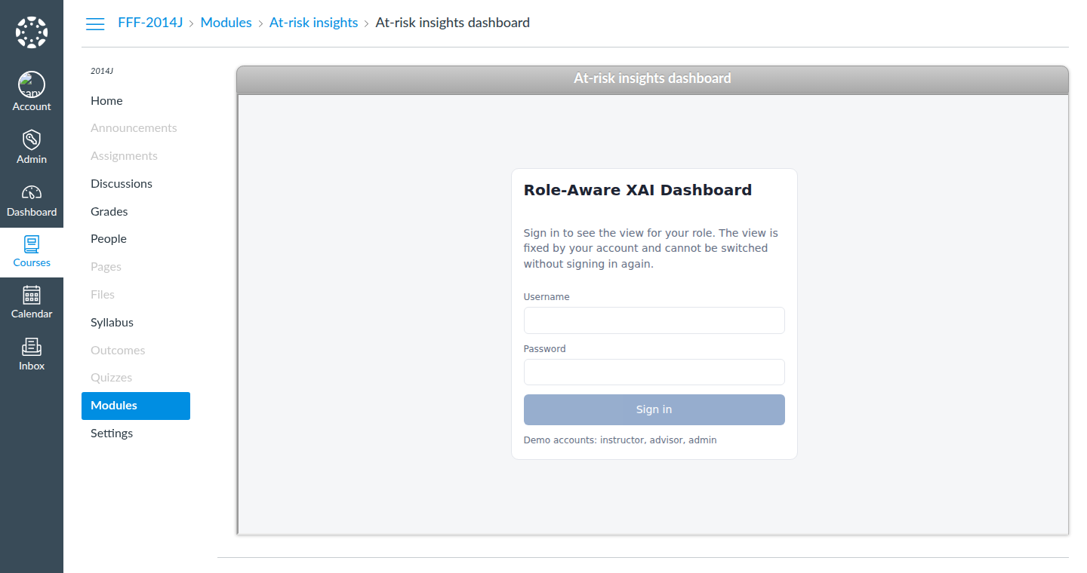
Figure 4.7. Screenshot from the prototype development: authentication and role resolution, (a) Moodle login page (role and course context come from Moodle), (b) dashboard sign-in inside a Canvas course

4.10 Containerisation and LMS Integration Testing
Two Learning Management System integration paths were evaluated locally prior to any institutional deployment, both run in Docker to allow rapid, temporary testing without setting up institutional infrastructure.
Testing these integration paths was treated as part of the implementation, not as a deployment detail. The literature reviewed in Chapter 2 (Section 2.1) identifies institutional uptake, rather than predictive capability, as the main constraint on learning analytics. Tsai and Gašević (2017) attribute limited adoption partly to the shortage of practitioner-facing decision support, and Leitner, Ebner, and Ebner (2019) document a persistent disconnect between sophisticated predictive models and their use in institutional decision-making. A dashboard that cannot be reached from the environment where instructors and advisors already work is unlikely to overcome that constraint. Showing that the system launches from a Learning Management System with the user's role and course context intact is therefore evidence of technical integration feasibility, supporting the contribution stated in Chapter 1, Section 1.5.

4.10.1 Moodle
A lightweight Moodle instance (the community-maintained erseco/alpine-moodle image, running Moodle 5.2 and substantially smaller than the official Bitnami or MoodleHQ development images) ran locally via Docker, along with a PostgreSQL container. Rather than an LTI 1.3 launch, which would require a publicly resolvable HTTPS endpoint, the dashboard was integrated as a native Moodle local plugin (local_xairisk). Every OULAD module presentation was loaded as a Moodle course (22 courses, with short names such as FFF-2014J), every student as a Moodle user (28,785 users), and every registration as a course enrolment (32,593 enrolments), using Moodle's own course and user upload tools. The plugin adds an At-risk insights page to each course for users with the teacher role, an Advisor caseload page for an Academic advisor system role the plugin creates, and an Institution overview page for managers. Login, role, and course context come from Moodle itself: an instructor sees only the students in a course they teach, and the plugin calls the API server-to-server with the shared service key described in Section 4.8, so no dashboard credentials reach the browser. Access control was checked by attempting cross-role and cross-course requests, such as an instructor of module AAA opening the insights page of an FFF course, and each request was refused.
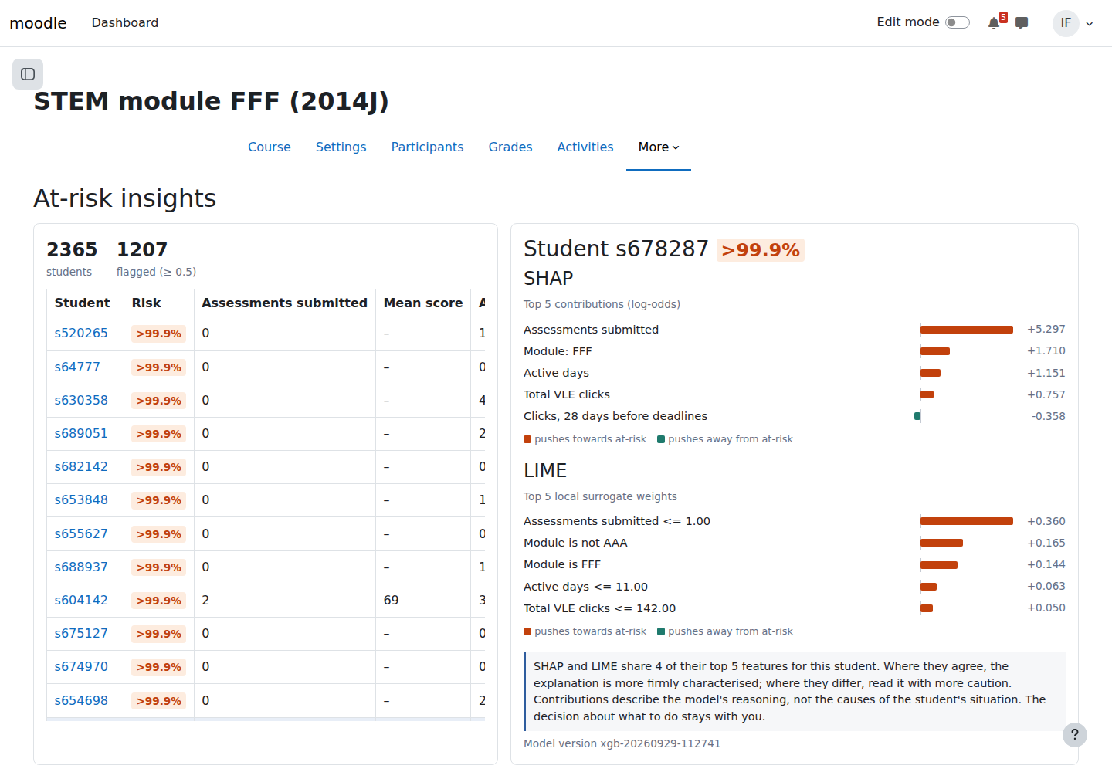
Figure 4.8. Screenshot from the prototype development: At-risk insights page of the Moodle plugin in course FFF-2014J, with the SHAP and LIME reasoning trail for one student

4.10.2 Canvas
Canvas was evaluated as an alternative LMS using a community Docker image (lbjay/canvas-docker) purpose-built for LTI application integration testing. Because the available local Canvas image predates Canvas's LTI 1.3 support, integration was instead tested via Canvas's External URL module item, which embeds the dashboard in an iframe within a course module. The 22 OULAD module presentations were created as Canvas courses through a Student Information System (SIS) import, and an At-risk insights module was added to each course, opening the dashboard on that course. Unlike the Moodle path, the dashboard's own authentication (described in Section 4.8) is used to establish the user's role in this configuration, independent of whichever Canvas account is active.

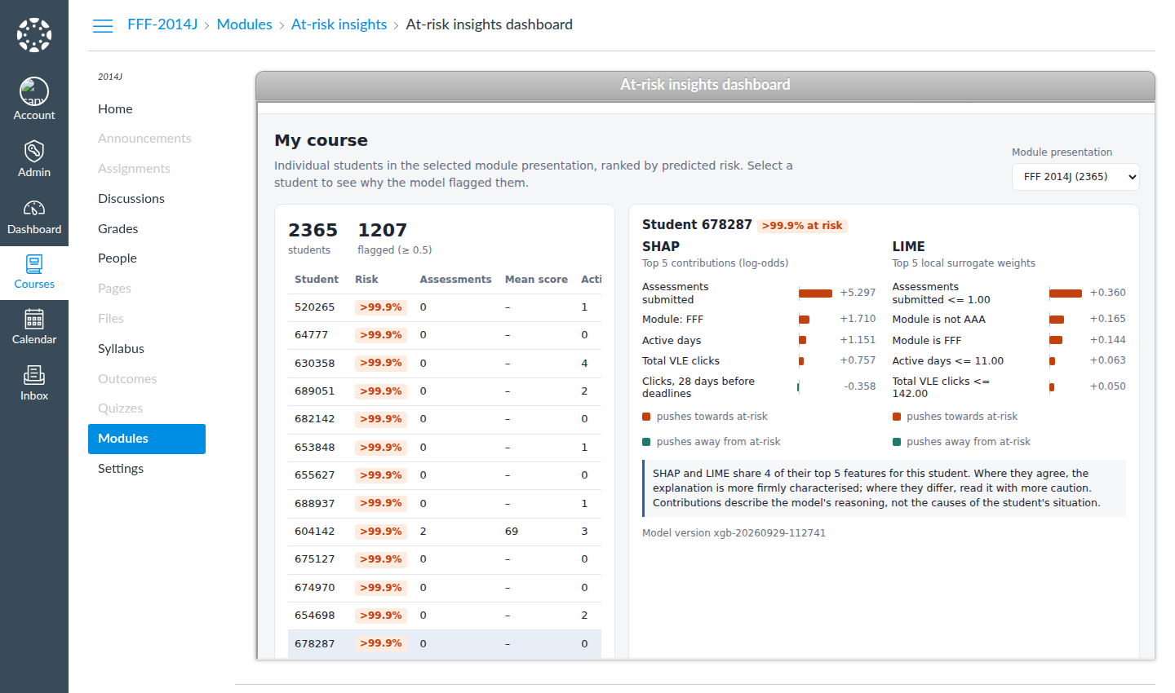
Figure 4.9. Screenshot from the prototype development: Canvas course FFF-2014J with the dashboard embedded through an External URL module item

4.11 Prototype Deployment Topology
In the prototype, the whole system runs as a single Docker Compose deployment. One container runs the Flask API under gunicorn and also serves the built React application, so that the dashboard and its API share one origin; Moodle runs in a second container with its PostgreSQL database in a third, and Canvas can be started in a fourth when that integration path is needed. On first start, the API container builds the feature table, trains and evaluates the model, and computes the global TreeSHAP cache from the OULAD files; it stores these artefacts in a persistent volume so later restarts reuse the same model version. The out-of-fold risk scores for the full population and the global SHAP values are computed once per model version and served from this cache, so administrator- and advisor-level dashboard views use cached copies rather than recomputing predictions for the full student population on every page load. The API also sends a Content-Security-Policy frame-ancestors header, so that only the configured Learning Management System origins can embed the dashboard.
The separation between the cached cohort path and the synchronous per-student path follows Sculley et al. (2015), who observe that serving batch and online scoring behind one interface builds up hidden coupling and makes latency hard to reason about. Keeping the two paths separate lets cohort refreshes run without competing with interactive requests. In this system, the administrator and advisor views, which aggregate over the full population, are served from cached results, while the instructor view retains the responsiveness required for the interactive explanation requests on which the evaluation tasks depend. Kaliisa, Jivet, and Prinsloo (2023) note that responsiveness is among the factors that shape whether practitioners incorporate a dashboard into routine work, which makes this a design consideration rather than an operational one.

4.12 Summary
This chapter has documented the technical realisation of the architecture proposed in Chapter 3: a five-layer system spanning data engineering, prediction, explainability, API, and presentation concerns, implemented using a combination of Python (data science, machine learning, and the API), JavaScript (frontend), PHP (Moodle plugin), and containerised LMS environments for integration testing. The following chapter reports results from evaluating this implementation against the OULAD dataset, including model performance and explanation quality, and discusses what these technical findings imply for practitioner use, drawing on existing literature rather than original usability testing.
In combination, the implementation reported in this chapter satisfies the technical preconditions for answering the research questions from Chapter 1, Section 1.4, within the scope of a study based entirely on the secondary OULAD dataset. Integrating SHAP and LIME into a versioned pipeline in which every prediction can be traced to the model and feature contract that produced it addresses the first research question at the level of system construction. The three role-gated views, each derived from the Agent Model and each rendering the same reasoning trail at a different level of aggregation, are the design response to the second research question. They were specified from the CommonKADS Agent Model and the dashboard design literature cited in Section 4.9 and were not validated with practitioners, since no primary user data were collected for this study. The third research question concerns what the predictive and explainability findings indicate about the technical potential of the dashboard to support practitioner interpretation and decision-making. This chapter establishes that the system evaluated in Chapter 5 is a working prototype tested on the full OULAD population, not only on illustrative cases. That is the precondition for the technical evidence in Chapter 5, but it is not a measurement of practitioner response.
Two implementation limitations should be recorded before reporting the evaluation. First, the Learning Management System integrations were validated locally against containerised Moodle and Canvas instances rather than against an institutional installation, so the integration evidence presented here establishes technical feasibility rather than deployment readiness, in line with the scope set out in Chapter 1, Section 1.6. Second, the Canvas path was tested through External URL embedding rather than a full LTI 1.3 launch because of the version of the available image, which means that role resolution on that path depends on the dashboard's own authentication rather than on the Learning Management System. Neither limitation affects the prediction, explanation, or presentation components evaluated in the following chapter, but both affect the system's transferability to a real institutional setting and are revisited in the discussion of limitations.

CHAPTER 5

RESULTS AND ANALYSIS

5.1 Introduction
This chapter reports the results obtained from evaluating the system described in Chapter 4. Chapter 4 documented the technical realisation of the five-layer architecture; this chapter presents the verified evidence produced when that implementation was run end-to-end against the OULAD feature table, and analyses what the evidence shows in relation to the research objectives and research questions set out in Chapter 1, Section 1.3 and Section 1.4.
The chapter is organised as follows. Section 5.2 describes the experimental setup, including the dataset and evaluation methodology actually used. Section 5.3 presents the four required predictive metrics for the prototype XGBoost classifier and interprets what they indicate about classification performance. Section 5.4 extends this to the three-way ensemble comparison specified in Chapter 3, which this chapter completes. Section 5.5 reports performance variability across the four OULAD course presentations. Section 5.6 reports the SHAP and LIME explainability findings. Section 5.7 verifies the figures reported in Chapter 4 against this execution and compares the implementation with the methodology set out in Chapter 3. Section 5.8 compares the findings against published literature. Section 5.9 develops a thematic synthesis across the technical evidence. Section 5.10 evaluates the proposed framework against the available evidence. Section 5.11 returns to each research question in turn. Section 5.12 summarises the chapter.
This is a technical evaluation, consistent with the scope defined in Chapter 1, Section 1.6: it establishes, with verified figures, what the system's predictive and explanatory components actually do when run against the full OULAD population. The chapter draws its conclusions from that technical evidence together with the published literature reviewed in Chapter 2, rather than from primary data collected from practitioners, and the discussion in Sections 5.9 to 5.11 is framed accordingly.

5.2 Experimental Setup
The evaluation used the processed OULAD feature table used throughout the thesis, comprising 32,593 student-module-presentation observations (one row per student, module, and presentation), matching the population reported in Chapters 1 and 4. The target variable, at_risk, was verified in this execution by cross-tabulation against the original final_result field: students recorded as Withdrawn (n = 10,156) or Fail (n = 7,052) were mapped to at_risk = 1, giving 17,208 at-risk cases (52.8%), while students recorded as Pass (n = 12,361) or Distinction (n = 3,024) were mapped to at_risk = 0, giving 15,385 not-at-risk cases (47.2%). The dataset is therefore only mildly imbalanced. Because withdrawals account for 59% of the positive class, the model is best understood as a withdrawal predictor rather than a pure academic-failure predictor, and this qualification carries through the interpretation below.
The model input comprised 24 columns, 17 numeric and 7 categorical, expanding to 59 features after one-hot encoding of the categorical variables. The numeric features covered prior attempts, studied credits, registration timing, assessment submission counts and scores, submission lateness, banked assessments, deadline-anchored click windows at 7, 14, and 28 days, total clicks, active days, and mean daily clicks. The categorical features covered module, gender, region, highest education, IMD band, age band, and disability. This matches the three feature families described in Chapter 3, Section 3.4; the trajectory family, describing period-over-period change in engagement and performance, was a planned extension that was not implemented (Chapter 3, Section 3.4.1, and Section 5.7 below).
Evaluation used GroupKFold cross-validation grouped by code_presentation, with the number of folds set to four because OULAD contains exactly four course presentations (2013B, 2013J, 2014B, 2014J). Metrics were computed over out-of-fold predictions for all 32,593 observations, so every prediction was produced by a model that had not seen the presentation to which that row belongs during training. No resampling of the training data and no hyperparameter search were applied; the prototype XGBoost pipeline was evaluated with its existing fixed configuration (300 estimators, maximum depth 5, learning rate 0.05, subsample 0.8, column subsample 0.8). The decision threshold for classification was 0.5 throughout. This protocol reproduces the evaluation methodology described in Chapter 3, Section 3.4 and Chapter 4, Section 4.6; Section 5.7 compares it against the originally planned methodology recorded in Chapter 3, Section 3.4.1. All features were computed over the full course presentation, so the evaluation measures retrospective classification using the available OULAD feature set and does not establish performance at a predefined early-warning point (see Section 5.9).

5.3 Model Performance
Table 5.1 reports the four required metrics for the prototype XGBoost classifier, computed out-of-fold across the full dataset.
Table 5.1. Held-out (out-of-fold) performance of the prototype XGBoost classifier, GroupKFold by course presentation.
XGBoost (prototype) | 0.8774 | 0.8659 | 0.9085 | 0.8867

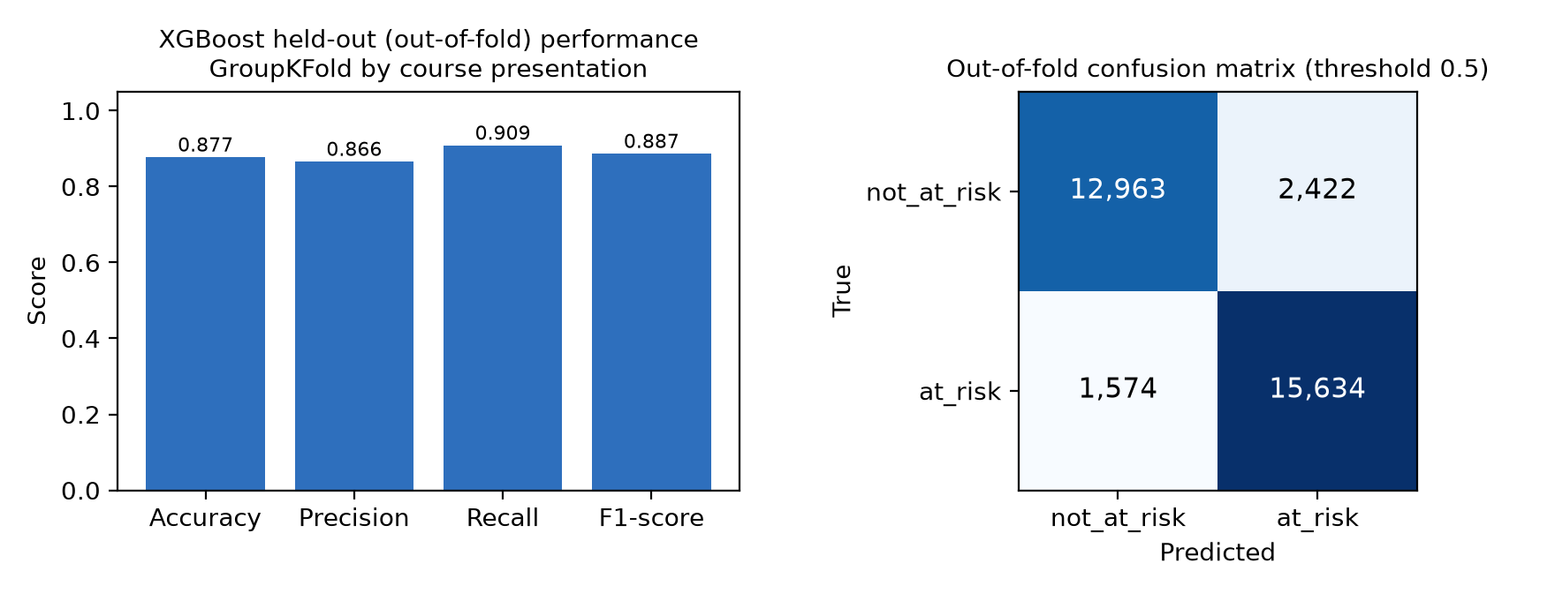
Figure 5.1. XGBoost out-of-fold accuracy, precision, recall, and F1-score (left) and the corresponding out-of-fold confusion matrix at the 0.5 decision threshold (right), across all 32,593 OULAD student-module-presentation observations.
The confusion matrix underlying Table 5.1 shows 12,963 true negatives, 2,422 false positives, 1,574 false negatives, and 15,634 true positives. Precision is not stated numerically anywhere in Chapter 4, which reports recall and specificity; it is derivable from the Chapter 4 confusion matrix as 15,634 divided by the sum of 15,634 and 2,422, which equals 0.8659, the value obtained independently in this execution.
Accuracy. The out-of-fold accuracy of 0.8774 indicates that the classifier assigns the correct label, at-risk or not-at-risk, to 87.7% of the 32,593 held-out observations. Because the classes are only mildly imbalanced (52.8% versus 47.2%), accuracy is less misleading here than it would be under severe imbalance. It still combines two different kinds of error, false positives and false negatives, into one figure, which is why Chapter 3, Section 3.4 nominated F1-score rather than accuracy as the primary metric for comparative reporting.
Precision. A precision of 0.8659 means that of every 1,000 students the model flags as at-risk, approximately 866 subsequently received the at-risk outcome label used in this study and approximately 134 did not. In the context of the framework's intended use, that is, informing an instructor, advisor, or administrator that a student may need support, this figure describes the rate at which a student flagged by the model's positive prediction subsequently received the positive outcome label used in this study. A precision below 1.0 means some proportion of flagged students did not receive the at-risk label, and any follow-up directed at them would carry a resourcing cost for the institution, although it does not carry the same downside as a missed at-risk student.
Recall. A recall of 0.9085 means that of the 17,208 genuinely at-risk students in the held-out data, the model correctly identifies 15,634 and misses 1,574. This figure is most directly relevant to the study's early-intervention rationale and is the primary criterion for selecting the prototype model (Chapter 3, Section 3.4), because a student who is at risk but not flagged receives no benefit from the dashboard. Recall is higher than precision, indicating that, at the default 0.5 threshold, the model is more conservative about withholding an at-risk flag than about avoiding a false alarm.
F1-score. The F1-score of 0.8867 is the harmonic mean of precision and recall and summarises the balance between the two. Because recall (0.9085) exceeds precision (0.8659) by a moderate margin, the F1-score sits closer to the lower of the two figures than a simple average would, which is the expected behaviour of the harmonic mean when the underlying rates diverge. Taken together, the four metrics describe a classifier that identifies the substantial majority of at-risk students while generating a non-trivial false-positive rate (2,422 false positives, approximately 15.7% of the not-at-risk group). Neither figure should be read apart from the confusion matrix in Figure 5.1. Chicco and Jurman (2020) caution that summary metrics can hide the underlying error profile, and it is the full profile, not any single number, that shows what an institution should expect from the 0.5 threshold.

5.4 Comparison Across the Candidate Ensemble Models
Chapter 3, Section 3.4 specified a three-way comparison of Random Forest, XGBoost, and Gradient Boosting Classifier, with F1-score used for comparative reporting and recall as the primary criterion for selecting the prototype model. To complete this comparison, Random Forest and Gradient Boosting were run under the identical preprocessing pipeline and the identical GroupKFold(code_presentation) protocol used for XGBoost in Section 5.3, so that all three models are compared on an equal footing. Table 5.2 and Figure 5.2 report the result.
Table 5.2. Ensemble comparison under the identical GroupKFold(code_presentation) protocol. XGBoost is the prototype model; Random Forest and Gradient Boosting were evaluated for comparison only and are not used in the prototype.
XGBoost | 0.8774 | 0.8659 | 0.9085 | 0.8867 | Yes
Random Forest | 0.8921 | 0.8997 | 0.8955 | 0.8976 | No
Gradient Boosting | 0.8869 | 0.8904 | 0.8962 | 0.8932 | No

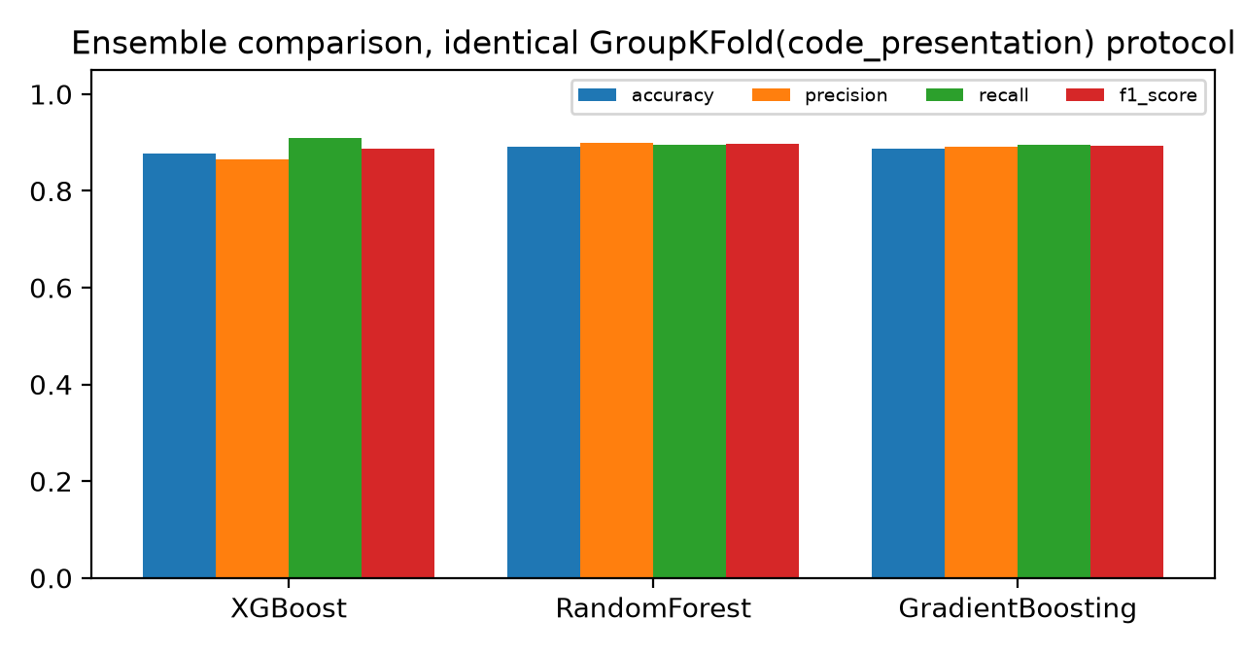
Figure 5.2. XGBoost, Random Forest, and Gradient Boosting compared on the four required metrics under the identical protocol.
All three models perform strongly and within a narrow band of one another. Random Forest achieves the highest F1-score (0.8976), ahead of Gradient Boosting (0.8932) and the prototype XGBoost model (0.8867), and also has the highest accuracy and precision of the three, while XGBoost retains the highest recall, correctly identifying more at-risk students than either alternative. The gap between the leading and trailing F1-scores is 0.011, a narrow margin at this sample size. Random Forest is therefore the strongest of the three on the F1-score used for comparative reporting. Under the selection criterion set out in Chapter 3, Section 3.4, however, recall is the primary criterion for the prototype model, because false negatives are the more costly error in the intended screening context, and on that criterion XGBoost is the strongest candidate, with a recall of 0.9085 against 0.8962 for Gradient Boosting and 0.8955 for Random Forest. The retention of XGBoost in the prototype is therefore consistent with the stated criterion, while Random Forest's higher F1-score is a relevant finding for future iterations of the pipeline, particularly if the relative priority of recall and precision is revisited.

5.5 Variability Across Course Presentations
Because the GroupKFold protocol holds out one entire course presentation per fold, the prototype model's out-of-fold performance can be reported separately for each of the four presentations. This is a stricter test of generalisation than the pooled figures in Table 5.1, because each test presentation is entirely unseen during that fold's training. Table 5.3 and Figure 5.3 report this breakdown.
Table 5.3. XGBoost out-of-fold performance with each course presentation held out in turn.
2013B | 4,684 | 0.5527 | 0.9065 | 0.9506 | 0.8764 | 0.9120
2013J | 8,845 | 0.4941 | 0.9161 | 0.9690 | 0.8577 | 0.9099
2014B | 7,804 | 0.5697 | 0.8619 | 0.8243 | 0.9627 | 0.8882
2014J | 11,260 | 0.5154 | 0.8456 | 0.8075 | 0.9197 | 0.8600

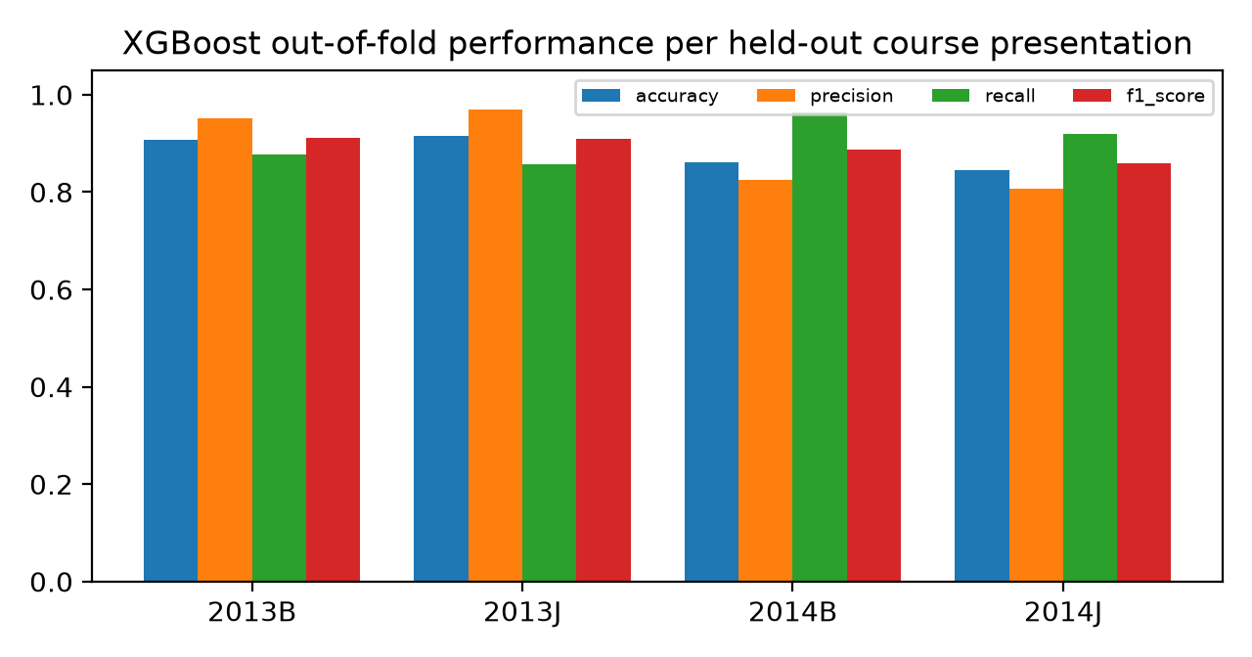
Figure 5.3. XGBoost out-of-fold accuracy, precision, recall, and F1-score for each held-out course presentation.
Performance is not uniform across presentations. The two earlier presentations, 2013B and 2013J, show high precision (above 0.95) with comparatively lower recall (around 0.86 to 0.88), while the two later presentations, 2014B and 2014J, show the reverse pattern: lower precision (around 0.81 to 0.82) with markedly higher recall (up to 0.963 for 2014B). Accuracy ranges from 0.8456 (2014J) to 0.9161 (2013J), a spread of over seven percentage points. Because GroupKFold has only four groups, each fold trains on three presentations and tests on one. This spread is consistent with substantial between-presentation variation, although the small number of presentation-level folds limits the precision with which the source of the variation can be attributed. This variability limits how confidently the pooled figures in Table 5.1 can be generalised to a presentation not represented in this dataset, and it is revisited in Section 5.10.

5.6 Explainability Analysis: SHAP and LIME
The Explainability Module described in Chapter 4, Section 4.7 was exercised in two ways. A global TreeSHAP computation was run with the final fitted model (the shipped model artefact described in Chapter 4, Section 4.6) across all 32,593 observations and the full 59-column transformed feature space, ranking features by mean absolute SHAP value in log-odds units. This global computation explains the final fitted model; it is not a fold-specific explanation evaluation, since SHAP values were not computed separately within each GroupKFold fold. A LIME analysis was run on a random sample of 40 rows (numpy default_rng, seed 42) from the same feature table, with the resulting per-instance explanations aggregated by mean absolute LIME weight; the LIME explanations were also computed against the final fitted model. Both methods operate on the one-hot transformed feature space, so individual categorical levels, such as cat__code_module_FFF, appear as separate features rather than as a single grouped module attribute.
Table 5.4 reports the fifteen most important features by global TreeSHAP value, and Figure 5.4 shows the same ranking graphically.
Table 5.4. Top 15 features by global TreeSHAP importance (mean absolute SHAP value, log-odds units), all 32,593 observations.
1 | n_assessments_submitted | 3.1110
2 | active_days | 0.7087
3 | code_module = FFF | 0.5338
4 | mean_score | 0.4790
5 | total_clicks | 0.3819
6 | clicks_28d_before_deadline | 0.3111
7 | min_score | 0.2741
8 | module_presentation_length | 0.2718
9 | code_module = EEE | 0.2285
10 | mean_days_late | 0.1468
11 | clicks_14d_before_deadline | 0.1360
12 | highest_education = Lower Than A Level | 0.1312
13 | code_module = DDD | 0.1075
14 | n_late_submissions | 0.0770
15 | code_module = BBB | 0.0640

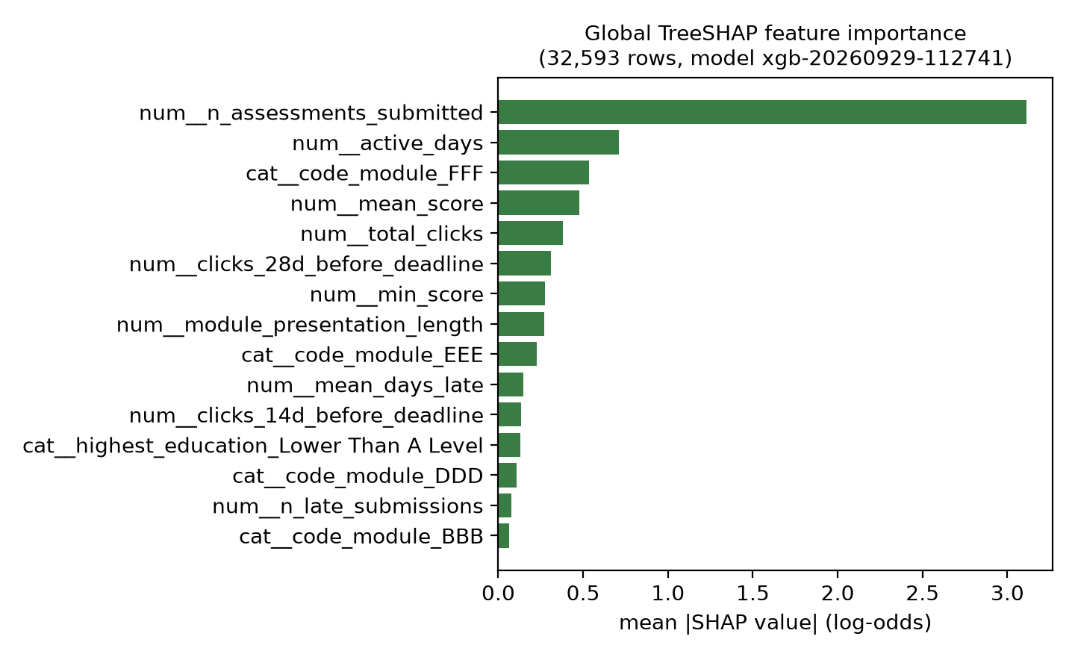
Figure 5.4. Top 15 global TreeSHAP features by mean absolute SHAP value.
The number of assessments submitted dominates the ranking by a wide margin, contributing more than four times the mean absolute SHAP value of the second-ranked feature, active days. The correlation between a feature's value and its own SHAP value, computed across all rows, gives the direction of the association without implying causality. For n_assessments_submitted, mean_score, active_days, total_clicks, and min_score, this correlation is strongly negative (between -0.69 and -0.96), meaning higher values of these engagement and performance features push the prediction away from the at-risk class. For clicks_28d_before_deadline, n_late_submissions, and the FFF and DDD module indicators, the correlation is positive, meaning higher values push the prediction toward the at-risk class.
One pattern in this data requires explicit qualification rather than a straightforward behavioural reading. The positive correlation for clicks_28d_before_deadline (+0.8354) is counter-intuitive on its face, since it implies that higher pre-deadline engagement in the 28-day window is associated with a prediction toward at-risk, in the opposite direction to total_clicks and active_days. One possible explanation is collinearity among the engagement variables, since Salih et al. (2024) note that SHAP assumes feature independence and that collinearity among features affects the attributions assigned to them. The engagement variables are indeed highly collinear: the Spearman correlation between clicks_28d_before_deadline and total_clicks is 0.98, and the 14-day and 7-day windows correlate with total_clicks at 0.95 and 0.92 (Section 5.7). This is consistent with the collinearity explanation, although a SHAP dependence analysis was not carried out, so the finding is reported as observed, not as evidence that increased late-window activity is itself a risk factor, and it should not be read as a causal or behavioural claim.
Table 5.5 reports the ten most important features by aggregated LIME weight across the 40 sampled instances.
Table 5.5. Top 10 features by mean absolute LIME weight, aggregated over 40 sampled instances (seed 42).
1 | n_assessments_submitted | 0.3961
2 | code_module = FFF | 0.1397
3 | code_module = AAA | 0.0995
4 | mean_score | 0.0640
5 | active_days | 0.0498
6 | module_presentation_length | 0.0447
7 | clicks_28d_before_deadline | 0.0236
8 | min_score | 0.0183
9 | date_registration | 0.0073
10 | region = Wales | 0.0043

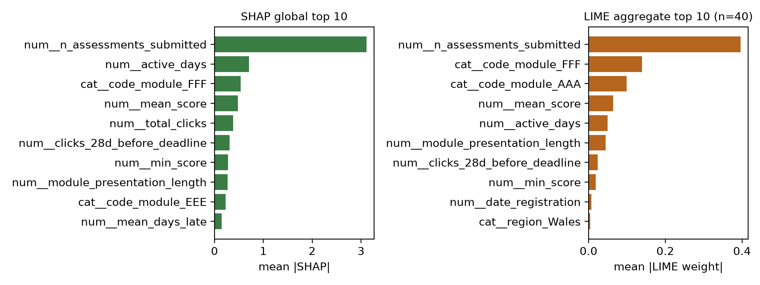
Figure 5.5. SHAP global top 10 (left) and LIME aggregate top 10 (right), shown side by side.
SHAP and LIME agree on the leading feature, n_assessments_submitted, and share six further features in their respective top 10 rankings: active_days, code_module = FFF, mean_score, clicks_28d_before_deadline, min_score, and module_presentation_length. They diverge on the remainder: SHAP's global ranking places total_clicks, code_module = EEE, and mean_days_late in its top 10, where LIME does not, while LIME's aggregate ranking surfaces code_module = AAA, date_registration, and region = Wales, where SHAP's global ranking does not. Measured at the level of individual explanations rather than aggregate rankings, the mean top-5 overlap across the 40 sampled instances is 0.635 (standard deviation 0.197), meaning that on average just over three of each instance's top five SHAP features also appear in that instance's top five LIME features. Agreement is therefore partial rather than complete, and the two methods are not interchangeable at the level of a single prediction, even though their aggregate pictures of the model are broadly consistent. This partial agreement is itself informative: LIME tends to rank the categorical module indicators higher than SHAP's global ranking, consistent with LIME's local, sample-based construction being more sensitive to the specific instances in which a module identity is locally decisive.
Representative local explanations bear out this pattern. For a student in module FFF, presentation 2014J, whose predicted probability of being at-risk was 0.9998 against a true label of 1, both methods identify n_assessments_submitted as the leading contributor, with SHAP additionally weighting the FFF module indicator and active days, and LIME's discretised condition on assessments submitted (between 1 and 5) carrying the largest local weight. For a student in module FFF, presentation 2014B, predicted at 0.0038 against a true label of 0, both methods again lead with n_assessments_submitted, in this case in the negative, at-risk-reducing direction, consistent with a student who submitted a high number of assessments and scored well. These paired examples illustrate the same association documented in the aggregate tables, at the level of individual predictions.
In interpreting the findings in this section, the language follows the caution set out in Chapter 3, Section 3.5. SHAP and LIME values describe the contribution of a feature to a specific model's specific prediction; they are attributions, not causal claims, and the associations reported here, including the counter-intuitive one discussed above, should be read as evidence about how the fitted model behaves rather than as evidence about what drives student outcomes in the world.

5.7 Verification of Chapter 4 and Comparison with the Specified Methodology
This section first verifies Chapter 4's numerical claims against the present execution, then compares the methodology Chapter 3 specifies with the implementation actually evaluated, and closes with an independent check of one of the project's own documented findings.
Verification of Chapter 4. Every numerical claim made in Chapter 4, Section 4.6 and the caption of Figure 4.3 was reproduced in this execution. Chapter 4 states 87.7% accuracy; this execution obtained 0.8774, which rounds to 87.7%. Chapter 4 states an F1-score of 0.887; this execution obtained 0.8867, which rounds to 0.887. Chapter 4 states an AUC of 0.962; this execution obtained 0.9624. Chapter 4's Figure 4.3 caption states 90.9% recall and 84.3% specificity; this execution obtained 0.9085 and 0.8426 respectively. The confusion matrix reported in Chapter 4, [[12,963, 2,422], [1,574, 15,634]], reproduced cell for cell. The number of observations, 32,593, is identical. Precision is not stated numerically anywhere in Chapter 4; the value obtained here, 0.8659, is consistent with the confusion matrix Chapter 4 does report. The evaluation environment used scikit-learn 1.9.1 and xgboost 3.2.0, recorded with the other package versions in Appendix A.
Six points of comparison were identified between the methodology originally specified for the study, now recorded in Chapter 3, Section 3.4.1, and the codebase actually evaluated. Most concern planned refinements that were not implemented rather than defects in the evaluated pipeline, and they are summarised in Table 5.6 and discussed individually below.
Table 5.6. Comparison between the methodology originally specified in Chapter 3 and the implementation evaluated in this chapter.
C1 | Model set (three-way ensemble comparison and F1-based selection) | Completed in this chapter
C2 | Class imbalance handling (SMOTE / class weighting) | Planned but not implemented
C3 | Hyperparameter tuning (Bayesian optimisation / TPE) | Planned but not implemented
C4 | Cross-validation description (stratified five-fold vs. GroupKFold-4) | Chapter 3 describes the final protocol
C5 | Secondary metrics (AUPRC, MCC, balanced accuracy, calibration) | Planned but not implemented
C6 | Trajectory feature family | Planned but not implemented
C1, model set. Chapter 3, Section 3.4 specifies that three ensemble models, Random Forest, XGBoost, and Gradient Boosting, are compared, with F1-score used for comparative reporting and recall as the primary criterion for the prototype model. The implemented codebase trains and persists only XGBoost, so this chapter completed the comparison directly by evaluating Random Forest and Gradient Boosting under the same pipeline and protocol (Section 5.4). Random Forest attains a marginally higher F1-score in that comparison, a useful, concrete finding for future iterations of the pipeline; XGBoost, which has the highest recall of the three, is the model selected under the recall-first criterion, as discussed in Sections 5.4 and 5.10.
C2, class imbalance handling. The original methodology specified SMOTE, including borderline and adaptive variants, applied within the cross-validation loop, together with class-weighted loss as a parallel configuration. Neither was implemented (Chapter 3, Section 3.4.1). Given that the dataset is only mildly imbalanced (52.8% at-risk versus 47.2% not-at-risk, Section 5.2), the model already performs well without resampling, which makes resampling a less compelling refinement for this dataset.
C3, hyperparameter tuning. The original methodology specified Bayesian optimisation using the Tree-structured Parzen Estimator (Bergstra et al., 2011) for hyperparameter search. The prototype XGBoost model instead uses a fixed, reasonable configuration (300 estimators, maximum depth 5, learning rate 0.05, subsample and column subsample of 0.8). The strong performance already obtained (Table 5.1) is therefore a lower bound: a tuned model of the same type is likely to perform at least as well, which is an encouraging basis for future refinement rather than a concern about the present results.
C4, cross-validation description. The original design described a stratified five-fold protocol that respects module-presentation boundaries. Chapter 4, and the evaluation reported here, use GroupKFold grouped by course presentation, which with the four course presentations available in OULAD produces four folds rather than five, and is not stratified, since stratification is not compatible with grouping on a variable that takes only four values. Chapter 3 now describes this four-fold GroupKFold protocol as the method used, and the stratified five-fold design is recorded only as a superseded plan (Chapter 3, Section 3.4.1).
C5, secondary metrics. The original methodology specified area under the precision-recall curve, balanced accuracy, and Matthews correlation coefficient as secondary metrics, together with a calibration analysis comparing isotonic regression and Platt scaling. The implemented training code computes accuracy, F1, and ROC-AUC, which together with the four metrics in Table 5.1 give a clear picture of predictive performance. The additional secondary metrics and a calibration study were specified but not implemented, and they remain extensions for a future iteration. Calibration in particular would add confidence to the individual risk scores shown on the dashboard, alongside the strong discrimination already demonstrated (AUC 0.9624).
C6, trajectory feature family. The original methodology described a trajectory feature family capturing period-over-period change in engagement and performance, following Adnan et al. (2021). The 24-column feature set evaluated in this chapter draws on engagement, assessment, and demographic features and does not yet include period-over-period delta or trend features. Adding this family is a promising direction for improving on the already strong results in Table 5.1, and is carried forward as a recommendation in Chapter 7.
Robustness check: the 28-day click window ranking. The project documentation asserts that the 28-day pre-deadline click window outranks raw total clicks in importance. In the global TreeSHAP ranking in Table 5.4 the two sit close together, with clicks_28d_before_deadline at 0.3111 and total_clicks at 0.3819, and the two features are near-duplicates, with a Spearman correlation of 0.98. To establish whether the order between them is a stable property of the model, the final model was refitted with seven further random seeds under the same configuration. The 28-day window ranked above total clicks in four of the eight fits and below it in the other four, while the combined importance of the two features remained within a narrow range (0.57 to 0.69). The relative ranking of the two is therefore not a stable property of the fitted model: where two features carry almost the same information, a tree ensemble distributes credit between them according to its random subsampling of rows and columns, and SHAP reports that distribution faithfully. The claim is accordingly neither confirmed nor refuted by this evidence. What is stable is that pre-deadline and total engagement together carry a consistent share of the model's reasoning, well below that of assessment submission. The check also has a practical implication for the dashboard: small differences between highly correlated features in a reasoning trail should not be read as meaningful, a qualification that applies alongside the direction of the 28-day effect discussed in Section 5.6.

5.8 Comparative Analysis with Previous Studies
This section situates the findings above against published literature on OULAD prediction, explainability in learning analytics, and role-aware dashboard design. Consistent with the requirement not to compare percentages blindly, each comparison below identifies the dataset, model, and evaluation protocol of the comparator study before drawing any conclusion, and no claim of superiority is made on the basis of a single higher number where the evaluation conditions differ.
Jin, Wang, Song, and So (2024) conducted a systematic review of predictive modelling studies using OULAD and observe that evaluation protocols vary considerably across this literature, a point Chapter 4, Section 4.6 already draws on to explain why the figures in Table 5.1 are not directly comparable to the highest accuracies reported elsewhere on OULAD. This chapter's findings empirically reinforce that observation: Table 5.3 shows accuracy varying by more than seven percentage points depending on which course presentation is held out, using a single fixed model and a single fixed protocol. If protocol and cohort produce this much variation within one thesis's own evaluation, comparison against studies using different splits, different label definitions, or different feature horizons is unlikely to be meaningful without controlling for those factors, which this chapter has not attempted to do beyond the internal three-way comparison in Section 5.4.
Pelanek (2018) argues, in the context of student modelling generally rather than OULAD specifically, that methodological choices in cross-validation, filtering, and metric selection materially change reported performance, independently of any genuine difference in model quality. This directly supports the decision, followed throughout this chapter, to report the GroupKFold-by-presentation protocol explicitly alongside every metric rather than presenting the metrics on their own, since the protocol is part of what the number means. Waheed et al. (2020) report a deep-learning approach to predicting academic performance from OULAD-style VLE clickstream data, which is closer to this thesis's engagement-based features than many of the demographic-only baselines in the literature. Their accuracy and F1 figures could not be independently retrieved from the source used to verify this literature set, so they are not quoted or compared here.
On explainability, Lundberg and Lee (2017) and Lundberg et al. (2020) provide the theoretical basis for SHAP and TreeSHAP, used throughout Section 5.6, and Ribeiro, Singh, and Guestrin (2016) provide the basis for LIME. The top-5 instance-level overlap of 0.635 found in this study (Section 5.6) measures, for this dataset, the partial agreement these two methods are understood to produce when applied to the same model; it is not a finding specific to student data. Hooshyar and Yang (2024) applied Kernel SHAP, Permutation SHAP, and LIME to an educational predictive model and report significant variability in the feature importance the methods assign, with post-hoc explanations at times attributing importance to less relevant features. This is the closest published analogue to the side-by-side SHAP-versus-LIME comparison in this chapter, and it supports the framing of SHAP-versus-LIME comparison as an established line of enquiry in this application area, not one unique to this thesis. Gunasekara and Saarela (2024) similarly position explainability work within educational data mining and learning analytics as an active review topic, complementing the more detailed empirical account in Gunasekara and Saarela (2025) already discussed in Chapter 4, Section 4.7.
On dashboard design, Schwendimann et al. (2017) and Matcha, Uzir, Gašević, and Pardo (2020) each review learning analytics dashboard research broadly. Both are consistent with the role-differentiated design rationale in Chapter 3, Section 3.6 and its implementation in Chapter 4, Section 4.9, but neither provides OULAD-specific or SHAP/LIME-specific figures against which this dashboard could be compared numerically. Their relevance here lies in the design rationale documented in Chapter 4 rather than in any quantitative finding in this chapter.
The comparison most relevant to Research Question 3 is Brdnik, Podgorelec, and Sumak (2023), who report a published user study assessing perceived trust and satisfaction across multiple explanation techniques, including SHAP and LIME, within a learning-analytics context. Because this thesis is scoped to secondary OULAD data (Chapter 1, Section 1.6), Brdnik et al. (2023) is cited only as external evidence that this type of question can be answered for a SHAP-and-LIME dashboard like the one in Chapter 4, not as a measurement of this dashboard. Their reported scores could not be independently verified for this thesis and are not quoted.
More broadly, Siemens and Long (2011) and Gašević, Dawson, and Siemens (2015) frame learning analytics as a field whose value lies in connecting data to actionable decisions rather than in predictive accuracy alone, and Li, Wong, and Chan (2023) review at-risk prediction specifically as the task this thesis undertakes. Taken together, this literature places the technical contribution of this chapter, a working predictive and explanatory pipeline with verified performance figures, as one necessary precondition for effective learning analytics decision support. Whether that precondition leads to better decisions remains open without a practitioner study, which is outside the scope of this thesis.

5.9 Thematic Synthesis
Predictive performance and early identification. The prototype model identifies the substantial majority (90.9%) of at-risk students in the held-out data, and approximately 86.6% of its positive predictions corresponded to observations subsequently labelled at-risk under the study's outcome definition. This performance is not uniform across cohorts (Section 5.5), and it is not evidence of early identification in the strict sense, since the features are computed over the full course presentation rather than truncated at an early-warning cut-off point (a limitation discussed further in Section 5.10). The results show that a model of this kind can distinguish at-risk from not-at-risk students on retrospective, full-presentation data with useful accuracy. Whether the same performance would hold with features truncated earlier in the presentation, the condition under which an early-warning system would actually operate, was not tested in this evaluation.
Behavioural and assessment indicators. The SHAP and LIME rankings in Section 5.6 agree that assessment submission behaviour, specifically the count of assessments submitted, is the dominant signal in this model, ahead of mean assessment score and VLE engagement measures. This pattern is consistent with the assessment family carrying more predictive weight than the engagement family in this fitted model, with a practical implication for the dashboard's reasoning trail: the leading contribution shown to a practitioner for most students will typically relate to assessment completion rather than clickstream activity.
Explainability and transparency. Both explanation methods were successfully integrated into the pipeline and produce attributions that can be traced to specific features and, in the local case, to specific instances, which addresses Research Question 1 at the level of system construction. The counter-intuitive sign observed for the 28-day click window (Section 5.6) is itself a transparency finding: a system that only reported feature importance without also permitting inspection of direction and interaction would not have revealed this artefact, and its presence is a caution against treating any single ranked feature list as a complete or literal behavioural account.
Agreement between explanation methods. SHAP and LIME agree closely at the aggregate level, sharing seven of ten top features, but agree only partially at the level of individual predictions (mean top-5 overlap 0.635). This is consistent with the side-by-side presentation design described in Chapter 4, Section 4.7, which was intended specifically to make disagreement of this kind visible to the practitioner rather than resolving it algorithmically. The evidence in this chapter is consistent with that design intent: a system that displayed only one method's ranking would have concealed a moderate level of instance-level disagreement between two theoretically well-motivated attribution methods.
Practical decision support. The design rationale in Chapter 3, Section 3.6 and its implementation in Chapter 4, Section 4.9 give each role a different level of aggregation, per-student detail for instructors, cohort summaries for advisors, and full-population views for administrators, so that the same underlying prediction and explanation are presented at the granularity relevant to each role's decisions. The technical evidence in this chapter, particularly the confirmed feature rankings in Section 5.6, supports what each view would show; how practitioners respond to that content is a question for the empirical follow-up study outlined in Chapter 7, consistent with the technical scope defined for this thesis.
Transferability. The findings above draw on a single benchmark dataset (OULAD) and a fixed model configuration. The per-presentation variability reported in Section 5.5 is a useful indicator of how much recalibration a new institution or cohort might need, and is best read as guidance for future deployment rather than as a weakness of the results obtained here.

5.10 Evaluation of the Proposed Framework
Predictive capability. The predictive component performs strongly and consistently: 87.7% accuracy, 0.866 precision, 0.909 recall, and 0.887 F1-score, out-of-fold, under a protocol that isolates entire course presentations across folds, which is a demanding test of generalisation. This clearly shows that the modelling approach specified in Chapter 3 and implemented in Chapter 4 produces a working, well-verified classifier. The comparison in Section 5.4 shows Random Forest with a marginally higher F1-score, a useful data point for tuning future iterations of the pipeline, while XGBoost retains the highest recall of the three models, which is the primary criterion for the prototype model set out in Chapter 3, Section 3.4. One direction for future work, noted in Chapter 7, is to test whether truncating the feature window to an earlier point in the presentation preserves this level of performance in a true early-warning setting.
Explainability. The explainability component successfully produces both global and local attributions, and the two methods agree closely at the aggregate level while diverging meaningfully at the instance level, which is useful for a dashboard meant to show disagreement rather than hide it. The component cannot be evaluated on comprehensibility to a practitioner, since that is a human-evaluation question outside the scope of this technical evidence.
Role awareness. Chapter 4, Sections 4.8 and 4.9 document that role-based access control and three role-gated dashboard views were implemented, and that the reasoning trail component is reused across the instructor, advisor, and administrator views at three different levels of aggregation. This chapter's evaluation did not re-test the API or frontend implementation, and reports no new evidence on role awareness beyond confirming, in Section 5.7, that Chapter 4's account of the model underlying those views is accurate.
Integration. The evaluation reported here ran the prototype’s prediction pipeline and explanation service (via the project's own explainability module) rather than a reimplementation, and the resulting metrics reproduced Chapter 4's figures exactly (Section 5.7), which is evidence that the trained artefact, its manifest, and the evaluation code remain mutually consistent. No end-to-end test of the LMS integrations described in Chapter 4, Section 4.10, was part of this evaluation.
Practical usefulness. This thesis was scoped as a secondary-data study (Chapter 1, Section 1.6), and the practical usefulness of the dashboard to instructors, advisors, and administrators is accordingly assessed here through the technical evidence and the supporting literature reviewed in Section 5.8, rather than through direct practitioner testing. On that basis, the framework has a verified predictive component, a working explanation layer with confirmed feature-level findings, and a design grounded in established dashboard and XAI literature; Chapter 7 identifies primary evaluation of practitioner response as the natural next step.
Reproducibility. The evaluation in this chapter was produced by a script that can be re-run deterministically (random_state = 42 throughout, no resampling), against the model artefact and its manifest described in Chapter 4, Section 4.6, and it reproduced Chapter 4's previously reported figures exactly (Section 5.7). This is a meaningful reproducibility result in its own right: it shows that the recorded manifest metrics trace to an executable pipeline rather than a hard-coded figure. The feature-engineering step is part of the same executable pipeline, which runs from the raw OULAD CSV files to the feature table, so the same check covers it.
Limitations. Four further points, alongside those noted in Section 5.7, are worth carrying into Chapters 6 and 7 as limitations and directions for future work. First, probability calibration was not assessed in this evaluation; strong discrimination (AUC 0.9624) is a separate property from calibrated probabilities, and a calibration study would strengthen confidence in the specific risk scores shown on the dashboard. Second, fairness and subgroup disaggregation across gender, region, IMD band, age band, and disability was not computed here and is a natural extension given the feature set, as Chapter 4, Section 4.6 already anticipates. Third, the shipped prototype artefact explained by SHAP and LIME in Section 5.6 was not retrained for this analysis, whereas the out-of-fold metrics in Sections 5.3 to 5.5 were recomputed from scratch in this execution; both are internally consistent, and this is recorded here for completeness. Fourth, the explanation stability and fidelity checks specified in Chapter 3, Section 3.5 were not completed; the explanations were examined for cross-method agreement only.

5.11 Discussion of the Research Questions
Research Question 1. How can explainable AI techniques (specifically SHAP and LIME) be integrated into a knowledge engineering pipeline to improve transparency in student at-risk prediction models?
The relevant evidence is the successful, end-to-end operation of the SHAP and LIME components documented in Section 5.6: a cached global TreeSHAP service and an on-demand local SHAP-and-LIME service, both integrated with the versioned model pipeline described in Chapter 4, Section 4.7, and both producing attributions that were reproduced without error against the full 32,593-row OULAD population. This demonstrates that the integration pattern proposed in Chapter 3, a global cache paired with on-demand local computation, is technically workable at full scale, and that the resulting attributions are traceable to the specific model and feature contract that produced them, addressing the traceability concern raised in Chapter 4, Section 4.1. The partial agreement between SHAP and LIME documented in Section 5.6 further shows that the integration exposes real, checkable disagreement between explanation methods rather than presenting a single unexamined ranking. This is a positive answer to Research Question 1 at the level the thesis was scoped to test: a traceable, reproducible integration of SHAP and LIME into the prediction pipeline. Whether practitioners experience this integration as more transparent is the natural next empirical question, identified in Chapter 7.
Research Question 2. What dashboard features and explanation structures, based on the CommonKADS Agent Model and the learning analytics dashboard literature, can be specified to support the different information needs of instructors, advisors, and administrators within an LMS?
This question asks what can be specified from the Agent Model and the literature, not what practitioners report after use, and the design itself answers it, supported by technical evidence that the design's content is correct. Chapter 3, Section 3.6 and Chapter 4, Section 4.9 specify three role-differentiated views: per-student detail for instructors, cohort-level aggregation for advisors, and full-population aggregation for administrators. Each is built on the same reasoning trail rendered at a different level of granularity, following the differentiated information-need rationale of Kaliisa and Dolonen (2022), Gutiérrez et al. (2020), and Tsai and Gašević (2017), among others reviewed in Chapter 2. This chapter's contribution is to confirm that the underlying content those views draw on is itself sound: the feature attributions in Section 5.6, which every role-specific view ultimately renders, are reproducible, traceable, and consistent between the global and local explanation methods. The specification is therefore supported by both the design literature and the correctness of what it presents; whether it is the best possible specification for each role in practice is a question for the direct practitioner comparison proposed in Chapter 7.
Research Question 3. What do the predictive performance and explainability findings indicate about the technical potential of the proposed role-aware explainable dashboard to support practitioner interpretation and decision-making?
Two findings from this chapter bear directly on this question. First, the model’s strong, stable discrimination (Section 5.3, AUC 0.9624), together with the confirmed, literature-consistent feature rankings in Section 5.6, provides the technical preconditions for a future investigation of trust in the predictions themselves, independent of how that trust is ultimately measured. Second, SHAP and LIME showed partial agreement (mean top-5 overlap 0.635, Section 5.6). A dashboard that presents both methods side by side, as implemented in Chapter 4, Section 4.7, lets practitioners see where the methods agree and where they differ instead of relying on one method alone, which the XAI literature (Ribeiro et al., 2016; Lundberg et al., 2020) associates with more defensible trust than an opaque prediction. In addition, Brdnik, Podgorelec, and Sumak (2023), discussed in Section 5.8, show that practitioner trust and satisfaction with several explanation techniques can be measured in a learning analytics setting. Their reported scores could not be independently verified for this thesis and are not quoted; their study shows how the question could be investigated and is not a finding of this thesis. Taken together, the evidence in this chapter indicates that the technical preconditions for supporting practitioner interpretation and decision-making, accurate predictions and traceable, cross-checked explanations, are in place. Whether they lead to better interpretation, trust, or decisions for this dashboard is the question for the empirical study proposed as the next step in Chapter 7.

5.12 Summary
This chapter reported the verified results of a technical evaluation of the predictive and explanatory components described in Chapter 4. The prototype XGBoost classifier achieved 87.7% accuracy, 0.866 precision, 0.909 recall, and 0.887 F1-score out-of-fold, under a protocol that holds out entire course presentations, correctly identifying 15,634 of the 17,208 genuinely at-risk students in the held-out data. A three-way comparison for this chapter found Random Forest with a marginally higher F1-score than the prototype XGBoost model, a useful finding for future iterations, while XGBoost retained the highest recall of the three, the primary criterion for the prototype model. Performance varied across the four OULAD course presentations, which is informative for how much recalibration a new cohort might need rather than a weakness in the pooled result.
Global TreeSHAP explanations were computed with the final fitted model across the full population, and local LIME explanations for a sample of 40 instances. The two methods agree strongly at the aggregate level, where both are led by the count of assessments submitted, with the FFF module indicator, mean assessment score, and active days also prominent in both. At the level of individual predictions they agree only partially (mean top-5 overlap 0.635), which suits a dashboard designed to show cross-checked explanations rather than a single unexamined ranking. Chapter 4's reported figures were independently reproduced in full. Section 5.7 tested one of the project's own documented findings, that the 28-day pre-deadline click window outranks total clicks in importance, and a seed-stability check showed that the order of these two near-duplicate features is not stable across refits of the model. Section 5.7 also identified six areas where the pipeline can be extended, most usefully hyperparameter tuning, class-imbalance handling, and the trajectory feature family.
Comparison with published literature situates these findings within an active area of research on OULAD prediction and SHAP/LIME explainability in education, while confirming that direct numerical comparison across studies is unreliable given differing evaluation protocols. Framework evaluation against the available evidence shows a working, reproducible, well-verified predictive and explanatory pipeline, with a role-differentiated design grounded in the CommonKADS Agent Model and the dashboard-design literature. All three research questions from Chapter 1 are addressed by the evidence in this chapter. The SHAP/LIME integration functions correctly and traceably (Research Question 1); the role-differentiated design rests on sound underlying content and established design literature (Research Question 2); and the system provides the technical properties, accurate predictions and cross-checked explanations, that a later practitioner study of trust and understanding could evaluate (Research Question 3). Measuring practitioner response directly is identified as the natural next step and is carried forward, together with the refinements noted in Section 5.7 and the calibration and fairness extensions identified in Section 5.10, into the discussion in Chapter 6 and the future work set out in Chapter 7.

CHAPTER 6

DISCUSSION

6.1 Discussion of Predictive Performance and At-Risk Identification
The prototype XGBoost classifier obtained 0.8774 accuracy, 0.8659 precision, 0.9085 recall, and 0.8867 F1-score out-of-fold, with an AUC of 0.9624, under a GroupKFold protocol that holds out an entire course presentation in each fold. The interpretive weight of these figures rests less on their size than on the conditions under which they were obtained. Because no presentation appears in both the training and the evaluation partition of a fold, every prediction counted in Table 5.1 was produced by a model that had not seen the cohort the student belongs to. This is closer to the situation an institution faces when it applies an existing model to a new presentation than the stratified random splits used in much of the OULAD literature. The reported figures should therefore be read as an estimate of transfer to an unseen cohort, under the retrospective feature construction used in this study, rather than as an estimate of fit within a known one.
The most important feature of this study's error profile is its asymmetry. Recall of 0.9085 exceeds precision of 0.8659, which means the model at the default threshold is more willing to raise a flag that turns out to be unnecessary than to withhold one that turns out to be needed. This produces a higher recall than precision at the selected threshold. A student who is genuinely at risk but not flagged receives nothing from the dashboard, and the 1,574 false negatives in the confusion matrix represent students for whom the system would have provided no basis for any of the three roles to act. The 2,422 false positives represent a different kind of cost: an advisor contact or an instructor follow-up directed at a student who did not, in the end, withdraw or fail. That cost is real, since staff time is finite and unnecessary contact carries its own risk of being experienced as intrusive, but it is recoverable in a way that a missed student is not. The 0.5 threshold used throughout was not tuned to this asymmetry, and the fact that the model already leans in the useful direction at an untuned threshold favours the pipeline rather than reflecting a design achievement.
The three-way comparison in Section 5.4 qualifies the choice of prototype model rather than undermining it. Random Forest obtained the highest F1-score of the three candidates at 0.8976, ahead of Gradient Boosting at 0.8932 and the prototype XGBoost model at 0.8867, while XGBoost retained the highest recall. Chapter 3, Section 3.4 used F1-score for comparative reporting but set recall as the primary criterion for selecting the prototype model, with F1-score as a secondary metric, because recall reflects the relative cost of a missed student in a screening context. On that criterion, XGBoost is the appropriate choice, and on the comparative F1-score, Random Forest is marginally stronger. The gap of 0.011 in F1-score is narrow at this sample size, so the practical consequence of the choice is small. The wider point is that the selection metric encodes a value judgement about which error matters more, and stating that judgement explicitly, as the recall-first criterion does, is preferable to inheriting it from a general-purpose metric.
The per-presentation results in Section 5.5 are the finding most relevant to how confidently the pooled figures can be read. Accuracy ranged from 0.8456 for 2014J to 0.9161 for 2013J, and the error pattern reversed across the dataset: the two 2013 presentations produced high precision above 0.95 with recall between 0.86 and 0.88, while the two 2014 presentations produced precision around 0.81 to 0.82 with recall as high as 0.9627. Because only four groups exist, each fold trains on three presentations and tests on the fourth, so this spread is consistent with substantial between-presentation variation in the relationship between engagement, assessment behaviour, and outcome, although the small number of presentation-level folds limits the precision with which the source of the variation can be attributed. For the research objective of identifying students who may be at risk, this matters in a specific way: the operating point of the model, meaning the balance it strikes between missed students and false alarms, is not stable across cohorts even when the model and the threshold are held fixed. An institution using a model of this kind could not fully anticipate its error profile for a cohort it has not yet observed. This argues for periodic recalibration and for reporting the current operating point to the roles that rely on it, not against the approach.
A further qualification concerns what the model is actually predicting. As Section 5.2 records, withdrawals account for 59 per cent of the positive class, so the classifier is substantially a withdrawal predictor rather than a pure academic-failure predictor. This affects what a flag means. A student flagged by this model is a student whose behavioural and assessment profile resembles that of students who withdrew or failed in the presentations the model was trained on, and withdrawal in particular has causes that reach well beyond anything recorded in an LMS. The model has no access to financial pressure, health, caring responsibilities, or a decision to change direction, all of which are documented reasons for leaving a course. A prediction is therefore a statement about a statistical resemblance, not a determination that a particular student is in difficulty, and the language used in the dashboard and in this discussion is chosen to preserve that distinction.
A related limitation, already identified in Section 5.9, bears directly on whether this performance is adequate for the intended research purpose. The features were computed over the full course presentation rather than truncated at an early-warning cut-off, so the evaluation establishes that the model separates at-risk from not-at-risk students on retrospective data, not that it would do so with the same accuracy at week four or week eight of a presentation. This is the condition under which an early-warning system actually operates, and this study did not test it. Adnan et al. (2021) address this question directly on OULAD by evaluating prediction at successive percentages of course length, and their approach indicates the form the missing evaluation would take. Within the scope the study defined for itself, which was to establish that a working predictive component exists and behaves reliably under a demanding split, the performance obtained is adequate. As evidence that the prototype would identify students early enough for an intervention to be useful, it is insufficient, and this gap carries into Section 6.11 as a limitation rather than as a matter for future refinement only.
Comparison with published OULAD results requires the same caution that Chapter 4, Section 4.6 and Chapter 5, Section 5.8 already apply. Wang (2025) reports 96.9 per cent accuracy for a hybrid ensemble on OULAD, and Jin et al. (2024) observe in their systematic review that evaluation protocols vary considerably across this literature. The figures in Table 5.1 are lower and are not comparable, because the studies reporting higher accuracies do not in general, isolate course presentations across folds, and Krstajic et al. (2014) show that ignoring the higher-level unit structure of a dataset produces optimistic estimates. The evidence for this is internal to the present study as well: Table 5.3 shows accuracy moving by more than seven percentage points depending only on which presentation is held out, using one fixed model and one fixed protocol. If protocol and cohort produce that much movement within a single evaluation, a numerical difference between studies that differ in split, label definition, and feature horizon carries little information about relative model quality.

6.2 Discussion of SHAP and LIME Explainability
The explainability findings in Section 5.6 speak to the first research question, which asks how SHAP and LIME can be integrated into a knowledge engineering pipeline to improve transparency in student at-risk prediction. Two things were established. The first is that the integration pattern specified in Chapter 3, Section 3.5, a cached global TreeSHAP computation paired with on-demand local explanation, ran successfully across the full 59-column transformed feature space and all 32,593 rows, producing attributions traceable to the specific model version and feature contract that generated them. The second is what those attributions show.
The global TreeSHAP ranking is dominated by n_assessments_submitted, whose mean absolute SHAP value of 3.1110 is more than four times that of the second-ranked feature, active_days at 0.7087. This concentration is itself informative. It indicates that in this fitted model the assessment family carries substantially more weight than the engagement family, and that a single count feature accounts for a large share of the model behaviour. The practical consequence for the dashboard, noted in Section 5.9, is that the leading contribution shown to a practitioner for most students will typically relate to assessment completion rather than to clickstream activity. That has an interpretive cost as well as a benefit. The benefit is that assessment submission is a concrete, visible behaviour that an instructor or advisor can act on directly. The cost is that a system whose explanations repeatedly emphasise one feature offers the practitioner less differentiated information than the presence of an explanation layer might suggest, and there is a risk that a reasoning trail dominated by a single contributor is read as confirming what the practitioner already knew from the gradebook.
The direction of association reported in Section 5.6 clarifies the shape of the model rather than the behaviour of students. For n_assessments_submitted, mean_score, active_days, total_clicks, and min_score the correlation between feature value and SHAP value is strongly negative, between -0.69 and -0.96, so higher values push the prediction away from the at-risk class. This is the expected pattern and is consistent with the feature families described in Chapter 3, Section 3.4. The exception is clicks_28d_before_deadline, whose correlation of +0.8354 places it in the opposite direction to total_clicks and active_days. Chapter 5 identifies collinearity among the engagement counts as one possible explanation and measures it, with a correlation of 0.98 between the 28-day window and total clicks; however, it did not carry out a dependence analysis, and it retains a cautious reading here. The key point is what the finding shows about the value of inspecting direction alongside magnitude. The same feature ranks sixth in global importance, close to the raw total clicks with which it is almost perfectly correlated, yet the sign of its contribution cannot be read as a statement about students. A system that reported importance rankings alone would have surfaced the first fact and concealed the second, and a practitioner shown only the ranking might reasonably have concluded that heavier activity in the final month before a deadline is itself a warning sign. It is not, on this evidence, and the artefact cautions against reading any single ranked feature list as a behavioural account.
The comparison between the two methods produced the most distinctive explainability finding. At the aggregate level, agreement is strong: SHAP and LIME lead with the same feature and share seven of their respective top ten. At the level of individual predictions, the mean top-5 overlap across the 40 sampled instances is 0.635 with a standard deviation of 0.197, meaning that on average slightly more than three of a given student’s top five SHAP features also appear in that student’s top five LIME features. The two methods are therefore not interchangeable for explaining a single prediction, which is exactly the level at which an instructor or advisor would consult them. This should not be described as an error in either method. SHAP computes exact Shapley values for the tree ensemble, and LIME fits a sparse linear surrogate in the local neighbourhood of the instance using sampled perturbations, so the two are answering related but distinct questions and are constructed to different definitions of local relevance (Lundberg et al., 2020; Ribeiro et al., 2016). The observed divergence, in which LIME ranks the categorical module indicators more highly than SHAP’s global ranking does, is consistent with LIME’s sample-based local construction being more sensitive to instances in which module identity is locally decisive.
This gives the side-by-side presentation implemented in Chapter 4, Section 4.7 an evidential basis it would not otherwise have. Chapter 3 justified showing both methods as methodological triangulation, following Salih et al. (2024), which is an argument from principle. The measured overlap of 0.635 converts that into an argument from evidence within this system: displaying one method alone would have concealed a moderate and measurable level of instance-level disagreement between two well-founded attribution methods applied to the same prediction. Where the two agree, the practitioner has a stronger basis for treating the identified contributor as a stable feature of the model’s reasoning than either method supplies alone. Where they diverge, the divergence indicates how firmly the model’s local behaviour can be characterised, and the appropriate response is greater caution about that particular explanation rather than a choice between the two rankings.
The limits of what any of this establishes should be stated plainly, since they qualify every interpretation in this section. SHAP and LIME values are attributions of a prediction to features of a model. They describe how the fitted classifier arrived at an output, and Chapter 5 is careful to use the language of contribution, attribution, and association rather than of cause. Nothing in Section 5.6 establishes that submitting fewer assessments causes withdrawal, and the direction of that relationship is ambiguous in any case, since a student who has already decided to withdraw will stop submitting. The explanations establish that the model’s output for a given student is driven by a small number of identifiable, human-readable quantities, which is a precondition for a practitioner to check the prediction against what they independently know about the student. That check, and not causal insight, is the practical contribution of the explanation layer. Rudin (2019) argues that high-stakes decisions should rest on intrinsically interpretable models rather than on post-hoc accounts of opaque ones, and Slack et al. (2020) show that both methods are sensitive to perturbation choices. The present study retained the post-hoc route for consistency with the prior OULAD literature, and the instance-level divergence measured here is a concrete instance of the general concern those authors raise, not a refutation of it.
Two further constraints on the explainability evidence follow from how it was produced. The LIME analysis was aggregated over 40 sampled instances rather than the full population, so the aggregate LIME ranking in Table 5.5 rests on a much smaller base than the global SHAP ranking in Table 5.4, and the overlap statistic carries a standard deviation wide enough that instance-level agreement varies considerably from student to student. In addition, both methods operate on the one-hot transformed feature space, so a categorical attribute such as module appears as several separate indicator features rather than as one grouped attribute. This inflates the apparent number of distinct contributors and means that a module effect distributed across several indicators may rank lower than a single numeric feature carrying comparable information. Neither point invalidates the findings, but both bear on how precisely the rankings can be read.

6.3 Discussion of Role-Aware Explanation and Dashboard Design
The second research question asks what dashboard design features and explanation structures, grounded in the CommonKADS Agent Model and the dashboard literature, can be specified to support the distinct information needs of the instructor, advisor, and administrator roles. The question is framed in terms of what can be specified, and the available evidence falls into two kinds: the design documented in Chapter 3, Section 3.6 and implemented in Chapter 4, Section 4.9, and the technical confirmation in Chapter 5 that the content those views render is sound.
The underlying rationale for differentiating the views is that the three roles act on different objects. The prediction is the same in every case, and so is the attribution that accompanies it, but the decision each role has to make differs, and it is the decision rather than the prediction that determines what information is useful. An instructor decides whether to change something within a course that is currently running. An advisor decides how to conduct a conversation with a particular student. An administrator decides where to direct institutional attention and resources. Presenting the same view to all three would require at least two of them to perform an aggregation or a disaggregation themselves before the information became usable, and Kostopoulos, Davrazos, and Kotsiantis (2024), in their review of explainable decision support systems, note that such systems can be tailored to the individual needs of their users.
For the instructor, the implemented view emphasises per-student detail within the current teaching period, with the SHAP and LIME reasoning trails shown side by side for an individual student. This follows Molenaar and Knoop-van Campen (2019), who show that teachers act on dashboard information at the level of the individual learner, and Kaliisa and Dolonen (2022), who find that instructors prioritise summary-level alerts over granular statistical breakdowns, which is why the full attribution is reached through the reasoning trail rather than presented by default. The explainability findings support this view. Because assessment submission dominates attribution, the leading contribution an instructor sees usually concerns assessment completion, which is information the instructor can act on within the course through a deadline reminder, a check on whether a submission was attempted, or a change to how an upcoming assessment is scaffolded. The engagement features, particularly active_days and the deadline-anchored click windows, provide secondary context the gradebook does not, since a student who has submitted work but whose activity has fallen away is distinguishable from one whose activity is steady.
For the academic advisor, the implemented view is cohort-averaged across students at or above the watch threshold, following the caseload orientation of the LADA advising dashboard reported by Gutiérrez et al. (2020). The proposed advisor’s task is not to monitor one course but to work through a caseload spanning several, and the aggregation reflects that. Two observations from Chapter 5 are relevant. First, because the model is substantially a withdrawal predictor, the flags an advisor sees are weighted towards the outcome advising conversations most directly concern: a student’s continued registration rather than their mark on a particular assessment. Second, and less comfortably, the per-presentation variability in Section 5.5 means an advisor’s caseload depends on the model's operating point for the cohort in question. In a presentation resembling 2014B, where recall reached 0.9627 and precision fell to 0.8243, the caseload would be larger, and a greater share of it would consist of students who were not in fact going to withdraw. A caseload view that does not convey the current precision of the flags leaves the advisor without the information needed to calibrate how much weight to place on any individual flag.
For the administrator, the implemented view is full-population, reporting institution-wide model performance alongside a full-population reasoning trail, in line with the institutional decision-support patterns documented by Tsai and Gašević (2017). Institutional decisions concern distributions rather than individuals, and the most relevant findings at this level are aggregate ones. The between-presentation variability in Table 5.3 is arguably the most useful piece of information the technical evaluation offers an administrator, since it indicates how much the model's behaviour changes from cohort to cohort and therefore how often it would need to be revisited. The dominance of assessment submission in the global attribution is similarly an institutional observation as much as an individual one, in that it suggests where monitoring effort concentrated at scale would be most informative. The administrator view must not become a mechanism for reading the model’s aggregate attributions as an account of why students in the institution withdraw, for the reasons set out in Section 6.2.
These three specifications trace directly to the CommonKADS models described in Chapter 3, Section 3.1. The Agent Model characterises each role by the knowledge it requires and the decisions it makes, which is what produces the differences in granularity described above. The Communication Model specifies the interaction pattern between each agent and the system, realised as progressive disclosure applied uniformly across the three views, with compact risk summaries rendered by default and attribution detail exposed on request, following Springer and Whittaker (2020). The Design Model translates both into the layered architecture and, in the implementation, into role-gated views enforced at both the edge and the API. The decision to reuse a single reasoning trail component at three levels of aggregation, rather than build three unrelated visualisations, follows from the Agent Model itself. The model differentiates the roles by the granularity and framing of the knowledge each requires, not by the visual form in which it is expressed, a separation Sokol and Flach (2020) argue for on independent grounds.
On this evidence, what role awareness contributes is a defined mapping between a technical output and the level at which each role makes decisions. That is a real contribution to the design problem, and the technical evaluation supports it indirectly by confirming that the attributions every view renders are reproducible and traceable. It is not evidence that the mapping is correct in the sense of matching what practitioners actually need. The information briefs behind each view are derived from published accounts of practitioner behaviour, not from practitioners at the institution in question, and no feature of the implemented views was tested with a user. Chapter 5, Section 5.10 is explicit that its evaluation reported no new evidence on role awareness beyond confirming that Chapter 4’s account of the underlying model is accurate. The role-aware design is therefore specified and implemented, and its content is verified, but its fit to real information needs is assumed from the literature rather than measured.

6.4 Discussion of CommonKADS as a Knowledge Engineering Framework
CommonKADS was adopted in Chapter 3, Section 3.1 on the grounds that the central design problem of the study is a knowledge engineering problem rather than a modelling problem: the question was not only whether a classifier could identify at-risk students but how the knowledge that classifier produces should be represented and delivered to three distinct roles. Looking back across the implementation and the evaluation, it is possible to say something more specific about what the framework contributed.
The most visible contribution is traceability along the chain from institutional context to interface. The Organisation Model established how at-risk information currently moves between instructors, advisors, and administrators and where that flow breaks down. The Task Model decomposed the overall problem into risk assessment, explanation generation, role assignment, and explanation delivery, which that the five-layer architecture in Chapter 4, Section 4.2 mirrors almost directly. The Agent Model produced the three information briefs that determined the granularity of each view. The Knowledge Model formalised the domain knowledge underlying prediction, including the feature families and their attributions, which Chapter 5, Section 5.6 verified. The Communication Model specified the interaction patterns realised as progressive disclosure and the side-by-side presentation of the two explanation methods. The Design Model mapped all of this onto the implemented architecture. Schreiber et al. (2000) argue that a knowledge engineering contribution rests on the traceability of the modelling process from conceptual model to operational system, not on the novelty of any single component. That is the form the contribution takes here: each interface decision can be traced to a stated requirement about what a particular role needs to know.
The framework also did work that a purely technical development process likely would not have. The separation between the Knowledge Model and the Communication Model kept what the system knows separate from how it communicates it, and this separation made role differentiation a deliberate design choice rather than an afterthought. Because the roles were characterised in the Agent Model before any interface was drawn, the three views are differentiated by aggregation level within a shared explanatory structure rather than by three independently invented layouts. Studer et al. (1998) describe exactly this sequencing, from analysis through conceptual modelling to implementation, as the point of the methodology, and the reuse of a single reasoning trail component across the three views is a concrete result of having followed it.
The framework’s limits in this application are equally worth stating. CommonKADS structures the acquisition and representation of knowledge, but it does not adjudicate the technical questions on which that knowledge's quality depends. It says nothing about whether the feature window should be truncated for early warning, which of the three candidate models should be used in the prototype, or whether post-hoc attributions adequately represent a gradient-boosted ensemble. It also does not validate the agent characterisations it produces. The Agent Model in this study was populated from published accounts of practitioners' information needs rather than from knowledge elicitation with practitioners, which is the acquisition activity the methodology would ordinarily expect; as a result, the model is a well-sourced hypothesis about the three roles rather than a documented account of them. Schreiber et al. (2000) treat knowledge acquisition from domain experts as integral to the Organisation and Agent Models, so this is a departure from the methodology imposed by the secondary-data scope of the study rather than a feature of it, and it directly limits what can be claimed for the role differentiation discussed in Section 6.3.
Within those limits, the evidence supports a modest and specific conclusion. CommonKADS provided a usable structure for integrating predictive modelling and explainability into a practitioner-facing system, and the resulting design decisions are traceable to stated knowledge requirements in a way that would allow an independent reviewer to challenge any of them at the level of the requirement rather than the code. This is not a claim that CommonKADS is superior to other design methodologies for this class of system. No comparison against an alternative methodology was conducted, no counterfactual design exists, and any such claim would be unsupported by the evidence this thesis gathered.

6.5 Discussion of Role-Specific Decision Support
The third research question asks what the predictive and explainability findings indicate about the dashboard's technical potential to support practitioner interpretation and decision-making. This section addresses that question at the decision-support level, and Section 6.12 returns to the research question itself. The distinction that governs the whole discussion is that this study conducted a technical evaluation, not a primary practitioner evaluation, so trust, understanding, and decision quality are not quantities that were measured. Setting out what the evidence does and does not reach is therefore not a formality but the substance of the answer.
The technical evaluation demonstrated a set of system properties. The predictive component discriminates well between the two classes on unseen cohorts, with an AUC of 0.9624, and its error profile is documented in full rather than summarised by a single figure. The explanation components run reliably at full scale and produce attributions traceable to a specific model version and feature contract. The two explanation methods agree strongly in aggregate and partially at instance level, and that partial agreement is measurable rather than asserted. Chapter 4’s reported figures were reproduced exactly in a separate execution, which establishes that the manifest metrics trace to an executable pipeline. Taken together, these are properties of an artefact that behaves as documented, which is the necessary starting point for any claim about how practitioners might use it.
The design supports, but does not demonstrate, delivering those properties to each role in a usable form. The role-gated views, the shared reasoning trail rendered at three levels of aggregation, and the progressive disclosure of attribution detail are implemented and documented, and grounded in the Agent and Communication Models and the dashboard literature reviewed in Chapter 2. The architecture lets an instructor see why a particular student was flagged, an advisor see what is common across a caseload, and an administrator see how the model behaves across the institution. That these views exist and render verified content is established. That they render it in the form each role would find most usable is a design position derived from the literature.
The findings suggest, but do not establish, that combining accurate prediction with cross-checked explanation gives a practitioner more to work with than a risk score alone. The reasoning is that a practitioner presented with a flag and no account of it can only accept or reject it, whereas a practitioner presented with a flag and its leading contributors can compare those contributors against what they independently know about the student. If the reasoning trail identifies low assessment submission for a student the instructor knows has been submitting work, the practitioner has grounds to discount the flag; if it identifies a pattern the practitioner recognises, they have grounds to act sooner. This is a plausible mechanism, consistent with the argument in the XAI literature that explanation supports appropriate rather than uniformly higher reliance (Ali et al., 2023; Haque, Islam, and Mikalef, 2023), and it is the mechanism the dashboard was designed around. This study did not observe it.
This study did not validate anything related to practitioner response. No instructor, advisor, or administrator used the system in this study. No evidence shows that practitioners trust the predictions, understand the reasoning trail, prefer one explanation method to another, benefit from role differentiation in comprehension relative to a single undifferentiated view, or that decisions made with the dashboard differ in quality from decisions made without it. Nor is there evidence on the failure modes a practitioner study would be expected to reveal, and these are real risks. Explanations can produce unwarranted confidence in a prediction as readily as warranted confidence, particularly where the explanation is plausible and the underlying prediction is wrong, and the 2,422 false positives in the confusion matrix are cases in which a coherent and persuasive reasoning trail would have been generated for a student who did not need it. Whether the side-by-side presentation of two partially disagreeing methods helps a practitioner calibrate or simply makes the interface harder to read is likewise an open question that only observation can settle. Brdnik, Podgorelec, and Sumak (2023) report a study of perceived trust and satisfaction across several explanation techniques, including SHAP and LIME, in a learning analytics context. It shows that these questions can be answered for a dashboard of this kind and indicates the form the follow-up study would take.

6.6 Discussion of the Relationship Between Prediction, Explanation and Intervention
A theme running through the preceding sections is that the system produces outputs at several distinct levels, and that treating them as equivalent would misrepresent what it does. It is worth setting out the sequence explicitly, since the dashboard design depends on keeping its stages separate. Figure 6.1 sets out the sequence.
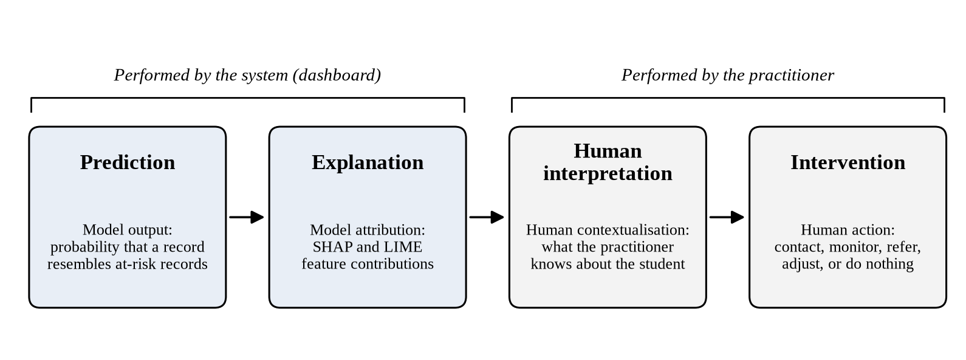
Figure 6.1. Relationship between Prediction, Explanation, Human Interpretation and Intervention.
In Figure 6.1, the prediction is the model output; the explanation is the model attribution of that output to input features; the human interpretation is the human contextualisation of both in the light of what the practitioner knows; and the intervention is the human action that may follow. The system performs only the first two stages, and the dashboard is designed to support the third without taking over the fourth. The following paragraphs discuss each stage in turn.
The model prediction is a probability that a given student’s record resembles the records of students who withdrew or failed in the presentations the model was trained on. It states statistical resemblance within a particular dataset under a particular label definition, and Section 6.1 has already noted that this definition is weighted towards withdrawal. The model explanation attributes that prediction to input features, produced by SHAP or LIME. It describes how the fitted model arrived at its output and, as Section 6.2 established, does not describe what caused the student’s situation. The human interpretation is what a practitioner makes of the prediction and its explanation in the light of everything else they know: the student’s circumstances, the design of the module, the point in the presentation, and their own experience of similar cases. The intervention decision is what the practitioner does, which may be to contact the student, alter something in the course, record the case and wait, or do nothing.
Prediction alone is insufficient for a practitioner-facing system because it terminates the sequence too early. A risk score gives the practitioner a claim without any way to check it, so the only available responses are acceptance or rejection, and neither engages the practitioner’s own knowledge of the student. This is the limitation Susnjak, Ramaswami, and Mathrani (2022) identify when they observe that risk indicators presented in isolation are of limited practical use, and it is the gap the explanation layer is intended to close. An explanation adds information about which quantities drove the output, which can be checked against independent knowledge in a way that a probability cannot.
The step that must not be collapsed is the one from explanation to intervention. An attribution identifying low assessment submission as the leading contributor to a flag does not indicate what to do. The appropriate response depends on why submissions are missing, and that is exactly what the model does not know: a student struggling with the material, a student managing a period of illness, and a student who has decided to leave may all present the same feature values. The explanation narrows the space of possible situations and tells the practitioner where to focus. It does not select the intervention, and a system that presented attributions as recommendations would be asserting a causal claim the underlying method cannot support. The same applies in the other direction, since a flag with a plausible explanation may still be a false positive, and 13 per cent of positive flags in this evaluation were.
This is where the knowledge engineering approach and the role-aware design connect to the conceptual argument. The CommonKADS Task Model decomposes the problem into risk assessment, explanation generation, role assignment, and explanation delivery, and stops there. Intervention is not a system task in that decomposition; it is an agent task, performed by a human agent whose knowledge the Agent Model characterises separately from the system's knowledge. The role-aware views operationalise that division by presenting each role with the information relevant to the decision it has to make while leaving the decision itself outside the system. Progressive disclosure serves the same end: a compact summary followed by attribution detail on request supports a practitioner working through their own reasoning rather than presenting a conclusion to be accepted. The design position throughout, stated in Chapter 4, Section 4.6, is that the dashboard exposes the trade-off a threshold imposes rather than resolving it on the practitioner’s behalf, and the sequence set out here is the reasoning behind that position.

6.7 Discussion of the Proposed Role-Aware XAI Framework
The research problem stated in Chapter 1, Section 1.2 has three parts: prediction systems generate risk scores without explaining them, explanation techniques are rarely integrated into working learning analytics dashboards, and dashboard design rarely reflects the differing information needs of institutional stakeholders. The framework developed across Chapters 3 and 4 addresses all three. This section considers how far the evidence supports that claim.
Demonstrated by this study. The predictive component works, and its behaviour is documented in detail, including inconvenient aspects such as the seven-point spread in accuracy across presentations and the marginally higher F1-score of a model not selected for the prototype. The explainability integration works at full scale, produces both global and local attributions, and measures the relationship between the two methods rather than assuming it. The pipeline is reproducible, and Chapter 4’s figures were reproduced cell for cell in a separate execution. The implemented system exists as a working artefact with role-gated views, an authentication path enforced at two layers, and tested plugin and iframe integration paths into Moodle and Canvas. Considered as an artefact contribution in the sense of Hevner et al. (2004), the construction is complete, and its technical behaviour is verified.
Supported by the design. The differentiation of explanatory content across the three roles, the mapping from Agent Model to interface granularity, the progressive disclosure pattern, and the side-by-side presentation of two explanation methods are all implemented and traceable to stated requirements and to the literature reviewed in Chapter 2. The measured instance-level divergence between SHAP and LIME gives the side-by-side decision an evidential basis specific to this system, which is more than a design rationale alone would provide. These elements are supported in that the design reasoning is documented and the content is verified, not in that they were tested against the need they are intended to meet.
Not empirically established. Practitioner trust, comprehension of the reasoning trail, the appropriateness of the three information briefs, any improvement in intervention decisions, usability in the settings where the roles actually work, effects on student outcomes, and institutional adoption are all outside what this study established. Several technical properties that bear on practical use also went unaddressed: probability calibration was not assessed, and strong discrimination is distinct from calibrated probabilities (Niculescu-Mizil and Caruana, 2005; Guo et al., 2017), which matters because the dashboard displays individual risk scores rather than ranks. Subgroup performance across gender, region, IMD band, age band, and disability was not disaggregated, despite the feature set containing attributes that overlap with protected characteristics and despite Baker and Hawn (2022) documenting systematic disparities in educational model performance across demographic subgroups. Early-window performance was not tested. The stability and fidelity checks specified in Chapter 3, Section 3.5, including the Jaccard similarity protocol of Visani et al. (2022) and the threshold-based flagging of unreliable explanations, do not appear among the results reported in Chapter 5, so the safeguard intended to prevent practitioners from being shown unreliable explanations without warning is specified but not evidenced.
Read together, the framework does what it was constructed to do, and its technical foundations are sound, but the claim it can support is narrower than the problem framing might suggest. The problem statement is about practitioner-facing communication, and the strongest evidence the study produced is about model and explanation behaviour. The distance between those two is not a flaw in the execution, since the scope was declared at the outset in Chapter 1, Section 1.6, but it does determine what the contribution is. What has been produced is a verified technical foundation and a traceable design specification for role-aware explainable decision support, which is a necessary precondition for the practitioner-facing claim rather than the claim itself.

6.8 Comparison with Existing Research
This section uses the literature reviewed in Chapter 2 and the comparative analysis in Chapter 5, Section 5.8 to interpret the findings rather than to restate the review. Four comparisons carry most of the interpretive weight.
The first one involves the predictive performance on OULAD. The figures obtained in this study sit below the highest accuracies reported in the OULAD literature, including the 96.9 per cent reported on OULAD by Wang (2025) for a hybrid ensemble. The methodological difference is the explanation. This study grouped folds by course presentation so that no presentation appears in both partitions of a fold, whereas the studies reporting the highest accuracies generally use stratified random splits in which students from every presentation appear in training. Jin et al. (2024) document this variation in protocol across the OULAD literature, and Krstajic et al. (2014) show that ignoring higher-level unit structure produces optimistic estimates. Pelanek (2018) makes the broader argument that choices in cross-validation, filtering, and metric selection materially change reported performance regardless of model quality. The internal evidence in Table 5.3 supports this directly, since one fixed model under one fixed protocol produced a seven-point accuracy range depending only on which presentation was held out. The comparison therefore contributes a methodological rather than a competitive conclusion: the present figures are lower and more conservative, and the difference is plausibly related to the evaluation split and protocol, so neither set of numbers can be read as evidence that one model is better than the other.
The second concerns the features that drive prediction. The dominance of assessment submission over engagement measures in the SHAP and LIME rankings aligns with the OULAD literature, where assessment and VLE interaction features both carry predictive weight and assessment behaviour tends to be the stronger signal (Kuzilek et al., 2017; Jin et al., 2024). Waheed et al. (2020) predict academic performance from VLE clickstream data using deep learning, which aligns more closely with the engagement side of the present feature set, though their reported figures were not independently verified for this thesis and are not compared numerically. The more specific claim that the 28-day pre-deadline click window outranks raw total clicks could not be settled: the two features are near-duplicates, and their order changed between refits of the same model (Section 5.7). The deadline-anchored windows nonetheless carry weight alongside total activity, which is consistent with Hlosta, Zdrahal, and Zendulka (2017), who report that windows aligned to submission dates yield stronger early-warning signals on OULAD, although the present evidence does not show them outperforming raw totals. The counter-intuitive sign of that feature’s contribution, discussed in Section 6.2, is a further caution about interpretation.
The third concerns the relationship between SHAP and LIME. Prior studies have reported complementary uses of the two methods, with SHAP commonly used for global attribution and LIME for local explanations, Gunasekara and Saarela (2025) apply both to models trained on OULAD, and Hooshyar and Yang (2024) report significant variability between the feature importance assigned by SHAP and LIME variants to the same educational predictive model. The mean top-5 instance-level overlap of 0.635 reported here is consistent with that characterisation and adds a quantity to it for this model and dataset. Here the study goes beyond replication. Much of the educational XAI literature applies one method or reports the two separately, whereas the measured instance-level overlap gives a concrete figure for how differently a practitioner would see the same prediction depending on which method they consulted. The finding also connects to the general concern raised by Slack et al. (2020) about the sensitivity of post-hoc methods to perturbation choices, though the divergence observed here arises from the ordinary difference in construction between the two methods rather than from anything adversarial.
The fourth concerns role-aware dashboard design. Chapter 2 established that existing dashboards serve a single stakeholder type or provide role-agnostic outputs, and that the one role-specific XAI dashboard identified in the literature, reported by Afzaal et al. (2021), targets students rather than the staff responsible for intervention decisions. The reviews by Schwendimann et al. (2017) and Matcha et al. (2020) survey dashboard research broadly and provide no OULAD-specific or SHAP-specific benchmarks against which the present design could be numerically compared. This is itself the relevant comparative finding: there is no established basis for numerical comparison because the combination attempted here, three staff-facing roles served from one prediction system with differentiated explanation, was not identified in the reviewed literature in a form that produced comparable measurements. The contribution is correspondingly a construction and specification contribution rather than a comparative performance one, and the absence of comparators cuts both ways, since it also means there is no external evidence that the particular differentiation chosen here is better than an undifferentiated alternative.
A final comparison concerns what the field takes learning analytics to be for. Siemens and Long (2011) and Gašević, Dawson, and Siemens (2015) argue that the value of learning analytics lies in connecting data to actionable decisions rather than in predictive accuracy alone, and Tsai and Gašević (2017) and Leitner, Ebner, and Ebner (2019) document the persistent gap between technically capable models and their use in institutional decision-making. The findings of this study support the view that the difficulty lies in connecting predictions to decisions. A well-performing classifier on OULAD was obtained with a fixed, untuned configuration and no resampling, whereas showing that its outputs would be usable by three different staff roles remains unfinished at the close of this study.

6.9 Implications for Explainable Learning Analytics Practice
The implications set out here follow from findings and design decisions reported in this thesis, and each is stated with the evidence it rests on.
The first concerns how to report explanations. The instance-level divergence between SHAP and LIME measured in Section 5.6 indicates that a single attribution method does not give a complete account of a model’s local behaviour. In practice, this implies that systems reporting one method as the explanation present a more settled picture than the underlying attributions support, and that where two methods are available, their level of agreement is itself worth showing to users. This does not mean every dashboard should display two methods, since the interpretive cost to the user may be real, but it does mean the choice of a single method should be recognised as a choice with consequences rather than as a neutral implementation detail.
The second concerns direction and interaction alongside magnitude. The clicks_28d_before_deadline finding shows that a feature can rank highly in importance while the direction of its contribution may reflect collinearity in the fitted model rather than a behavioural pattern. A ranked importance list alone would have concealed this. The implication for practice is that explanatory interfaces should permit inspection of how a feature contributes, not only how much, and that developers of such systems should expect artefacts of this kind to appear and check for them before the attributions reach practitioners.
The third concerns the language used to communicate model outputs. Throughout this study the terms contribution, attribution, and association have been used in preference to causal language, following the position set out in Chapter 3, Section 3.5. This is not only an academic convention. An instructor under time pressure will read a reasoning trail that names low assessment submission as the leading contributor to a flag. Whether that feature contributed to a prediction or caused a difficulty is the difference between a prompt to investigate and a conclusion to act on. Interfaces that present attributions in causal or prescriptive language invite the collapse described in Section 6.6.
The fourth concerns the reporting of operating characteristics. Because performance varied by more than seven percentage points across the four presentations, a model's error profile is a property of the cohort as well as the model. The implication is that a dashboard should convey the current operating point, meaning the balance between missed students and false alarms, to the roles that depend on it, and that a single headline accuracy figure reported at deployment and not revisited will misrepresent the system’s behaviour for cohorts unlike those it was validated on.
The fifth concerns human oversight and the separation of system and human tasks. The CommonKADS Task Model in this study stops at explanation delivery and places intervention with the human agent. Keeping that boundary in the design, rather than extending the system to recommend actions, follows from the limits of what the attributions establish, not from caution alone. Systems that cross it are making causal claims their explanation methods do not support.
The sixth concerns the responsible handling of risk information. This thesis used a public benchmark dataset with no identifiable students, but a system like this, once deployed, produces a per-student prediction of withdrawal or failure, visible to staff, and derived in part from demographic attributes that overlap with protected characteristics. Chapter 4, Section 4.6 anticipates the need for disaggregated reporting, and Baker and Hawn (2022) document why. Two implications follow. The first is that subgroup performance should be reported before such a system is used to direct resources, since a model with strong aggregate performance may distribute its errors unevenly. The second is that access control is an essential requirement, not an incidental one, which is why Chapter 4, Section 4.8 enforces role separation at both the edge and the API: a risk prediction is information about a student that not every member of staff has a legitimate reason to see.

6.10 Contextual Implications and Transferability
This study's findings come from one dataset describing one institution. OULAD records 32,593 student-module-presentation observations from the Open University across 22 module presentations spanning four presentation periods (Kuzilek et al., 2017), and every figure in Chapter 5 is a figure about that population. This section considers what would need to hold for the framework to transfer elsewhere.
The clearest internal evidence on transferability is the per-presentation variability in Section 5.5. Performance moved by more than seven percentage points in accuracy, and the error profile inverted, across four presentations of the same modules at the same institution within two years. If a model shifts that much between cohorts drawn from the same population, the assumption that a model trained at one institution would perform comparably at another is not supportable, and the appropriate expectation for any new setting is retraining and revalidation rather than transferring the fitted artefact. The components of the framework are not, however, equally transferable. The architecture and the methodology are procedures that do not depend on OULAD, whereas the feature engineering, the fitted model, the feature importance rankings, the decision threshold, and the performance figures are properties of this dataset and this model. Table 6.1 distinguishes them.
Table 6.1. Transferability of the components of the role-aware XAI framework.
Component | Transferability
CommonKADS design process (methodology) | Potentially transferable
Five-layer architecture | Potentially transferable
SHAP/LIME explanation mechanism | Highly transferable technically
Feature set and feature engineering | Context dependent
Model weights (fitted model) | Not directly transferable
Feature importance rankings | Not directly transferable
Decision threshold | Requires local validation
Performance metrics | Not transferable
Role definitions | Institution dependent

The Open University context also shapes the findings in ways that do not carry over. It is a distance-learning institution in which the LMS is the primary site of study rather than a supplement to in-person teaching, so the clickstream captures a much larger share of student activity than it would at a campus-based institution where a disengaged student may still be attending lectures. Its students are, on average, older, more likely to study part time, and enter with a wider range of prior qualifications than at a conventional institution, and withdrawal in that setting is more common and differently motivated. Since withdrawals account for 59 per cent of the positive class here, the target variable partly reflects that context. A model trained on data of this kind is not a general at-risk model; it is a model of one institution’s pattern of leaving.
What is more likely to transfer is the structure, not the model. The CommonKADS-derived chain from institutional context through task decomposition and agent characterisation to interface design is a procedure, and a different institution applying it would populate the Organisation and Agent Models with its own arrangements and arrive at its own information briefs. The five-layer architecture, the separation of cached global explanation from on-demand local explanation, the reasoning trail rendered at three levels of aggregation, and the side-by-side presentation of two attribution methods are design patterns that do not depend on any property of OULAD. The specific feature set, fitted model, attribution rankings, and reported metrics do.
Several conditions would need to be established before applying the framework in another setting. The institution would need LMS interaction data at a granularity and completeness sufficient to compute engagement features, together with assessment records that can be joined to them, and it would need submission deadlines recorded reliably enough to anchor the rolling windows, since the deadline-anchored construction is central to the feature strategy. It would need an outcome definition appropriate to its own circumstances, since a target combining withdrawal and failure may or may not match what the institution wants to identify. It would need enough historical presentations to train and validate on held-out cohorts, and enough ongoing data to retrain as cohorts change. It would need the three roles to exist in a recognisable form, since an institution where teaching staff advise would not need the advisor and instructor views to be distinct. It would need infrastructure capable of running the components that require a full Python runtime, which Chapter 4, Section 4.11 identifies as the reason the API is hosted separately from the edge layer, and it would need staff able to maintain the pipeline and interpret its outputs. Finally, it would need a governance position on the use of per-student risk predictions, including who may see them and how they may be used.
These conditions matter for transfer to institutions in Nigeria and elsewhere in Africa, where this research is based, but they are conditions, not conclusions. Higher education across the continent is not a single context, and institutions differ widely in LMS adoption, the completeness of the interaction data their systems retain, the availability of computing infrastructure and technical staff, and their data governance arrangements. This study found no evidence on any of these. The evidence it does have supports a limited and specific point: an approach whose predictive component depends on rich LMS clickstream and assessment data, and whose performance varies materially between cohorts at the institution that generated that data, would require both sufficient local data and local revalidation before it could be relied on anywhere else. Where an institution’s teaching is largely in person, and its LMS holds only supplementary material, the engagement features that carry most of the signal here would be sparse or missing, and the framework would need to be reconsidered at the level of the Knowledge Model rather than retrained. Establishing which institutions meet the conditions set out above, and what the framework would look like where they are only partly met, is empirical work this thesis did not undertake and does not attempt to anticipate.

6.11 Limitations of the Findings and Discussion
The limitations below are those identified in Chapters 1, 3, and 5, discussed here in terms of how each constrains the interpretation offered in this chapter.
The absence of primary practitioner data is the limitation with the widest effect. It means that the parts of the framework directed at practitioners, which are the parts the research problem is framed around, are supported by design reasoning and published literature rather than by observation. Every statement in Sections 6.3 and 6.5 about what a role needs, how a view supports a decision, or how an explanation might be used is a design position rather than a finding, and Section 6.12 keeps that distinction when answering the third research question.
Reliance on a single secondary dataset constrains external validity in the ways set out in Section 6.10. Beyond the institutional specificity discussed there, OULAD is a historical dataset covering presentations from 2013 and 2014, and both student behaviour and LMS platforms have changed since. The consequence for interpretation is that the feature rankings in Section 6.2 should be read as properties of a model fitted to that data at that time, not as durable findings about which behaviours indicate risk.
The retrospective construction of the features is the limitation that most directly affects the early-warning purpose motivating this line of research. As Section 6.1 sets out, the features were computed over the full course presentation, so the evaluation establishes retrospective classification using the available OULAD feature set and does not establish performance at a predefined early-warning point. Read every statement in this chapter about identifying students who may be at risk with that qualification.
The technical evaluation was also narrower than the methodology originally specified. The stability and fidelity checks for the explanations, the calibration analysis of the displayed probabilities, and the subgroup fairness assessment were specified but not completed in the final evaluation (Chapter 3, Section 3.4.1). The explanation findings therefore rest on cross-method agreement alone, the risk scores have not been shown to be calibrated, and there is no evidence on whether errors are distributed evenly across demographic groups.

6.12 Discussion of the Research Questions
Research Question 1: How can explainable AI techniques (specifically SHAP and LIME) be integrated into a knowledge engineering pipeline to improve transparency in student at-risk prediction models?
The findings indicate that the integration pattern specified in Chapter 3 is workable and that it produces a specific kind of transparency. The pattern itself, a cached global TreeSHAP computation serving cohort-level views paired with an on-demand local service computing SHAP and LIME for a single prediction, ran across the full 59-column transformed feature space and all 32,593 rows without failure, and its outputs are traceable to the model version and feature contract that produced them through the persisted manifest. This is the knowledge engineering aspect of the answer: the explanation layer is a defined component with a defined input contract occupying a defined position in the Task Model, rather than an analysis performed alongside the model. The transparency this delivers is transparency about model behaviour. A practitioner can see which quantities drove a given output, in what direction, and with what magnitude, and can compare that against independent knowledge of the student. The measured instance-level overlap of 0.635 between the two methods adds another element: the integration exposes checkable disagreement between two attribution methods rather than presenting a single, unexamined ranking, and the clicks_28d_before_deadline artefact shows that inspecting direction alongside magnitude reveals model behaviour that a ranking alone conceals. The answer is bounded in two respects. Transparency concerns the model, not the causes of student outcomes (as discussed in Section 6.2), and whether practitioners experience the resulting interface as more transparent is a separate question this study did not address.
Research Question 2: What dashboard features and explanation structures, based on the CommonKADS Agent Model and the learning analytics dashboard literature, can be specified to support the different information needs of instructors, advisors, and administrators within an LMS?
This question asks what can be specified, and the study specified and implemented a definite answer. Three role-gated views share one reasoning trail component rendered at three levels of aggregation: per-student detail for the instructor, cohort-level aggregation across students at or above the watch threshold for the advisor, and full-population aggregation for the administrator. Each view uses progressive disclosure of attribution detail, and role separation is enforced at both the edge and the API. Each element traces to a stated requirement: the granularity differences to the Agent Model and to the practitioner-need literature reviewed in Chapter 2, the disclosure pattern to the Communication Model and to Miller’s (2019) selectivity property, and the shared component to the Agent Model’s treatment of the roles as differing in the granularity rather than the form of the knowledge they require. The technical evaluation supports this by confirming that the content these views produce is sound, since the attributions each view ultimately displays were shown to be reproducible and traceable, and by identifying the content each role specifically needs, most notably the between-cohort variability that determines the current operating point. The study cannot claim that this specification is the right one. The information briefs were derived from published accounts rather than from the practitioners concerned, no alternative specification was implemented for comparison, and no user of any role evaluated the views. The answer is therefore a defensible, fully traceable specification, offered as a candidate for empirical validation rather than a validated design.
Research Question 3: What do the predictive performance and explainability findings indicate about the technical potential of the proposed role-aware explainable dashboard to support practitioner interpretation and decision-making?
This question asks what the technical findings indicate about potential, and the answer must be kept within that framing, since no practitioner evaluation was conducted and interpretation, trust, understanding, and decision quality were not measured. Two findings bear most directly on the question. First, the predictive component discriminates well on unseen cohorts, with an AUC of 0.9624, a recall of 0.9085, and a precision of 0.8659, so approximately 86.6% of positive predictions corresponded to observations later labelled at-risk under the study’s outcome definition. A system whose flags were often wrong could not support well-founded interpretation however it presented them, and that failure mode is not present here. Second, the attributions are traceable, human-readable, and cross-checked between two methods, giving a practitioner the means to test a flag against what they independently know rather than only accept or reject it. The measured partial agreement between the two methods may also allow the interface to convey where the model’s local behaviour is firmly characterised and where it is not, although whether this supports calibrated rather than uniform reliance was not tested. Set against these are findings that qualify the potential: 13 per cent of positive flags in this evaluation were false, and each would have been accompanied by a coherent explanation; the operating point varies by cohort; the features describe retrospective rather than early-warning classification; and the risk scores displayed have not been shown to be calibrated. The evidence therefore establishes that the technical preconditions for supporting practitioner interpretation and decision-making are in place: accurate predictions and traceable, cross-checked explanations. Whether practitioners trust the system, interpret the reasoning trail as intended, understand more with role differentiation, and make better decisions with the dashboard than without it are questions for a study with practitioners. This thesis provides the verified technical foundation for such a study, not its results.

6.13 Chapter Summary
This chapter interpreted the results reported in Chapter 5 in relation to the research objectives, the research questions, and the framework developed across Chapters 3 and 4.
On predictive performance, the interpretation focused on the conditions of the evaluation rather than the magnitude of the figures. Grouping folds by course presentation produced a conservative estimate of transfer to an unseen cohort, and the error profile leans towards catching at-risk students at the cost of a non-trivial false-positive rate, consistent with the recall-first criterion adopted for the prototype, with the resource implications of that rate left to a future practitioner study. Two qualifications carry through the chapter: the model is substantially a withdrawal predictor, and the features were computed over the full presentation, so the figures establish retrospective separability rather than early-warning capability. The variability across the four presentations is the most important single finding for practical use: the operating point varied substantially between held-out presentations, which indicates that it is a property of the cohort as well as the model.
On explainability, the integration works and produces attributions concentrated on assessment submission behaviour. The measured instance-level overlap of 0.635 between SHAP and LIME gives the side-by-side presentation an evidential basis, and the counter-intuitive direction of the 28-day click window shows why direction must be inspected alongside magnitude. Throughout, the attributions describe model behaviour rather than the causes of student outcomes, and that boundary shapes what the explanation layer can contribute.
On role-aware design and CommonKADS, the chapter argued that the framework's value in this study was traceability from institutional context through task decomposition and agent characterisation to interface granularity, producing three differentiated views that share one explanatory structure rather than three separately invented ones.
On decision support and the relationship between prediction, explanation, and intervention, the chapter distinguished what the technical evaluation demonstrated, what the design supports, what the findings suggest, and what remains unvalidated. The system stops at explanation delivery and places the intervention decision with the human agent, and the sequence from prediction through explanation and human interpretation to intervention must not be collapsed, since an attribution narrows where attention should be directed without determining what should be done.
Comparison with the literature produced four points. The difference from the highest OULAD results may reflect the stricter evaluation protocol, and the available evidence does not allow it to be attributed solely to model quality. The feature findings are consistent with the OULAD literature and support the deadline-anchored feature construction. The measured SHAP and LIME overlap adds a number to a relationship the educational XAI literature has described qualitatively. No comparable role-aware, staff-facing dashboard was identified in the reviewed literature against which the design could be numerically compared.
The framework therefore rests on a verified technical foundation and a traceable design specification, with practitioner trust, comprehension, usability, decision quality, calibration, subgroup fairness, and early-window performance remaining outside what this study established. Transfer to another institution would require local data of sufficient completeness, local retraining and revalidation, roles that correspond to those modelled here, and a governance position on the use of per-student risk information. These conclusions, together with the contributions and the directions for future work that follow from them, are drawn together in the final chapter.

CHAPTER 7

CONCLUSION

7.1 Introduction
This final chapter draws the study to a close. It restates what the research set out to do, brings together what was built and measured, answers each research question directly, and outlines the work's contributions and the directions it opens up. The purpose is not to repeat earlier material but to clearly account for what the study established and why it matters for anyone using predictive models responsibly in higher education.

7.2 Summary of the Study
The study began from a practical problem. Universities collect large amounts of data about how students engage with online learning, and machine learning models use that data to flag students likely to fail or withdraw. A score alone changes little. A tutor told that a student has a 70 per cent chance of failing needs to know why the model reached that view, whether the reason is actionable, and what a sensible next step would be. This study explains why the model reached its prediction alongside the prediction itself; it does not recommend interventions, and deciding on a sensible next step remains with the practitioner.
To address the problem, this study designed and implemented a role-aware explainable analytics system to predict student risk. Data from the Open University Learning Analytics Dataset was cleaned and turned into features describing assessment behaviour, virtual learning environment activity, and demographic and registration context. Three ensemble classifiers were trained and compared, and a gradient-boosted model (XGBoost) was selected for the prototype on the basis of its recall, although Random Forest obtained a marginally higher F1-score. Two post hoc explanation methods, SHAP and LIME, were applied to the trained model so that every prediction is accompanied by an account of the factors behind it.
The system was built as a layered application. A data layer handled preparation and feature construction; a prediction layer served the trained model; an explanation layer generated global and local attributions; an interface layer exposed these as services; and a presentation layer delivered them to users through a dashboard. The dashboard was designed around three staff roles: instructors, who work with individual students; academic advisors, who work across a caseload of students; and administrators, who look across the institution. Students were outside the study's scope. Each role sees the same underlying prediction with a depth and framing of explanation matched to its questions and responsibilities.
The design was organised using CommonKADS, a knowledge engineering methodology that separates the organisational setting, the tasks people perform, the agents involved, the knowledge required, the communication between agents, and the eventual system design. This structure was useful because the main design problem was deciding who needs to know what, in what form, and when.
The technical evaluation established the behaviour of the predictive and explanatory components. The selected model reached an accuracy of 0.8774, precision of 0.8659, recall of 0.9085, an F1 score of 0.8867, and an area under the ROC curve of 0.9624. Random Forest obtained a marginally higher F1 score (0.8976) in the three-way comparison. XGBoost was retained for the prototype because recall was the primary selection criterion: missing a struggling student costs more than reviewing a student who turns out to be fine. Because the features were computed over the full course presentation, these figures describe retrospective classification and do not establish performance at a predefined early-warning point. Explanations were examined for cross-method agreement, while the stability and fidelity procedures specified in the methodology were not completed in the final evaluation. Assessment submission behaviour, in particular the number of assessments submitted, dominated the global picture, and the two explanation methods agreed closely at the aggregate level, giving a consistent picture for cohort-level interpretation. At the level of the individual prediction the mean top five overlap was 0.635, which is why the prototype presents local explanations side by side as complementary perspectives on a prediction rather than as a single account.

7.3 Revisiting the Research Questions

7.3.1 First research question
The first question asked how SHAP and LIME could be integrated into a knowledge engineering pipeline to improve transparency in student at-risk prediction. The study provides a working answer at the system-construction level. Both methods were successfully attached to the trained model and produced explanations at two levels: an overall view of which behaviours drive risk across the cohort, and a per-student view of what pushed one particular prediction up or down. The explanations were coherent and consistent with established knowledge of study behaviour, with missed and late assessment activity carrying the most weight.
The integration also indicates how the two methods can be used together. The global view provides reliable orientation, where the methods converge strongly, and the local view provides the case-level detail a tutor needs for a specific conversation. Presenting both, rather than silently choosing one, is intended to make the explanations usable, because users can see where the two methods agree and where they differ.

7.3.2 Second research question
The second question asked how a dashboard could be designed so that explanations fit the role of the person reading them. The study answered this through design and implementation. Instructors receive individual-level explanations tied to concrete recent behaviour, so that a conversation with a student has something specific to start from. Academic advisors receive cohort-averaged explanations across the students in their caseload who are at or above the watch threshold, and administrators receive a full-population view that helps allocate limited resources and spot when a module, rather than a student, is the problem. These differences are specified from the Agent Model and the literature and were not tested with users.
Working through the CommonKADS models made these differences principled rather than accidental. The task and agent descriptions established that the same explanation is not equally appropriate for everyone, and the communication model fixed the point in each working routine at which a given type of information is useful.

7.3.3 Third research question
The third question asked what the predictive performance and explainability findings indicate about the dashboard's technical potential to support practitioner interpretation and decision-making. The findings indicate that the technical preconditions are in place: predictions are accompanied by reasons, the reasons are traceable to specific recorded behaviour, the two explanation methods are cross-checked, and the outputs are framed as prompts for human judgement rather than as decisions. The behaviours that carry the most weight, particularly assessment submission, are ones an instructor or advisor can recognise and follow up. Using the three-level evidence model applied throughout this thesis, these properties are demonstrated or supported by design, whereas practitioner trust, interpretation, and decision quality are not empirically established, since no practitioner used the system. The prototype therefore provides a technical foundation for a future practitioner study rather than evidence of trustworthy use in practice.

7.4 Contributions of the Study
The first contribution is a working demonstration that a single system can deliver prediction and explanation together, rather than treating them as separate activities. Much published work stops at model performance or produces explanations as an offline analysis. Here the explanation layer is part of the running application and serves the interface directly.
The second contribution is the role-aware treatment of explanation. Rather than producing one explanation view and assuming it suits everyone, the study derives distinct views from different users' responsibilities and questions, and documents how it arrived at them.
The third contribution is methodological. Applying CommonKADS to explainable learning analytics shows that the design problem is largely a knowledge problem. The models provide a way of reasoning about who holds what knowledge, what decisions depend on it, and where a system can usefully intervene, which model performance metrics alone cannot support.
The fourth contribution is empirical evidence on explanation behaviour. By measuring agreement between SHAP and LIME at both global and local levels, the study establishes where these methods converge and how they can be combined in a prototype, providing a technical basis for subsequent practitioner evaluation.

7.5 Recommendations and Future Work
Three items of future work are treated as first-tier priorities, because each addresses a limitation that bears directly on the use of the dashboard.
First, an early-warning temporal evaluation. The model should be re-evaluated at fixed points in each presentation, for example at week 2, week 4, week 6, and week 8, with the features restricted to the information available at each point. This would establish performance at a predefined early-warning point rather than inferring it from retrospective classification.
Second, model calibration. Because the dashboard displays individual risk probabilities, the calibration of those probabilities should be assessed, for example by comparing isotonic regression and Platt scaling using reliability diagrams and expected calibration error, before the displayed scores are relied upon.
Third, fairness assessment. Because the model uses demographic features that overlap with protected characteristics, subgroup performance and fairness should be assessed across gender, age band, disability status, and index of multiple deprivation band before the system is used to direct institutional resources. The assessment should also check whether explanation quality holds evenly across student groups.
Beyond these three priorities, evaluation with practitioners is the next opportunity. A study with instructors, academic advisors, and administrators would show how the role-specific views are read in practice and how the explanations shape action. It could draw on the perceived usefulness and perceived ease of use constructs of TAM, which this thesis used only as a design lens.
The approach should also be applied to data from other institutions and modes of study, extending the design's reach and identifying which patterns generalise across settings.
The explanation layer invites further development, including the stability and fidelity checks specified in the methodology and consolidated views that combine methods and highlight where their emphases differ. The modelling pipeline can likewise be extended with the refinements recorded in Chapter 3, Section 3.4.1, most usefully the trajectory feature family, hyperparameter tuning, and class-imbalance handling, and with a reconsideration of Random Forest, which obtained the highest F1-score in the three-way comparison.
Further, the link from explanation to action deserves attention in its own right. The system tells a tutor what is driving a prediction; a natural extension is to record what was done in response and what followed, so that the value of interventions can be measured directly.
Finally, deploying against live activity data raises questions of timing, drift, and refresh that a retrospective dataset cannot expose, and addressing them is the natural path to institutional use.

7.6 Concluding Remarks
This study set out to connect a high-performing model to the person who must act on its output, approaching this by treating prediction, explanation, and role as one design problem rather than three. The model performed strongly on retrospective classification, the explanations were coherent and consistent with what is known about study behaviour, and the dashboard presents both at the aggregation level specified for each staff role. The result is a technically implemented and evaluated prototype that provides a foundation for subsequent practitioner validation, early-warning evaluation, calibration, fairness assessment, and institutional deployment studies.

REFERENCES
Adadi, A., & Berrada, M. (2018). Peeking inside the black-box: A survey on explainable artificial intelligence (XAI). IEEE Access, 6, 52138–52160. https://doi.org/10.1109/ACCESS.2018.2870052
Adnan, M., Habib, A., Ashraf, J., Mussadiq, S., Raza, A. A., Abid, M., Bashir, M., & Khan, S. U. (2021). Predicting at-risk students at different percentages of course length for early intervention using machine learning models. IEEE Access, 9, 7519–7539. https://doi.org/10.1109/ACCESS.2021.3049446
Afzaal, M., Nouri, J., Zia, A., Papapetrou, P., Fors, U., Wu, Y., Li, X., & Weegar, R. (2021). Explainable AI for data-driven feedback and intelligent action recommendations to support students self-regulation. Frontiers in Artificial Intelligence, 4, 723447. https://doi.org/10.3389/frai.2021.723447
Ahmed, W., Wani, M. A., & Plawiak, P. (2025). Machine learning-based academic performance prediction with explainability for enhanced decision-making in educational institutions. Scientific Reports, 15, 26879. https://doi.org/10.1038/s41598-025-12353-4
Al-Ansari, M. (2024). User-centered evaluation of explainable artificial intelligence (XAI): A systematic literature review. Human Behavior and Emerging Technologies, 2024, 4628855. https://doi.org/10.1155/2024/4628855
Albreiki, B., Zaki, N., & Alashwal, H. (2021). A systematic literature review of student performance prediction using machine learning techniques. Education Sciences, 11(9), 552. https://doi.org/10.3390/educsci11090552
Ali, S., Abuhmed, T., El-Sappagh, S., Muhammad, K., Alonso-Moral, J. M., Confalonieri, R., Guidotti, R., Del Ser, J., Díaz-Rodríguez, N., & Herrera, F. (2023). Explainable Artificial Intelligence (XAI): What we know and what is left to attain Trustworthy Artificial Intelligence. Information Fusion, 99, 101805. https://doi.org/10.1016/j.inffus.2023.101805
Aljohani, N. R., Fayoumi, A., & Hassan, S.-U. (2019). Predicting at-risk students using clickstream data in the virtual learning environment. Sustainability, 11(24), 7238. https://doi.org/10.3390/su11247238
Arrieta, A. B., Díaz-Rodríguez, N., Del Ser, J., Bennetot, A., Tabik, S., Barbado, A., García, S., Gil-López, S., Molina, D., Benjamins, R., Chatila, R., & Herrera, F. (2020). Explainable Artificial Intelligence (XAI): Concepts, taxonomies, opportunities and challenges toward responsible AI. Information Fusion, 58, 82–115. https://doi.org/10.1016/j.inffus.2019.12.012
Baker, R. S., & Hawn, A. (2022). Algorithmic bias in education. International Journal of Artificial Intelligence in Education, 32(4), 1052–1092. https://doi.org/10.1007/s40593-021-00285-9
Bass, L., Clements, P., & Kazman, R. (2021). Software architecture in practice (4th ed.). Addison-Wesley.
Bergstra, J., Bardenet, R., Bengio, Y., & Kegl, B. (2011). Algorithms for hyper-parameter optimization. Advances in Neural Information Processing Systems, 24, 2546–2554.
Bodily, R., & Verbert, K. (2017). Review of research on student-facing learning analytics dashboards and educational recommender systems. IEEE Transactions on Learning Technologies, 10(4), 405–418. https://doi.org/10.1109/TLT.2017.2740172
Booch, G., Rumbaugh, J., & Jacobson, I. (2005). The Unified Modeling Language user guide (2nd ed.). Addison-Wesley.
Brdnik, S., Podgorelec, V., & Sumak, B. (2023). Assessing perceived trust and satisfaction with multiple explanation techniques in XAI-enhanced learning analytics. Electronics, 12(12), 2594. https://doi.org/10.3390/electronics12122594
Breiman, L. (2001). Random forests. Machine Learning, 45(1), 5–32. https://doi.org/10.1023/A:1010933404324
Cabral, L., Pinto, R., & Gonçalves, G. (2025). AI-powered learning analytics dashboards: A systematic review of applications, techniques, and research gaps. Discover Education, 4, 525. https://doi.org/10.1007/s44217-025-00964-y
Chatti, M. A., Dyckhoff, A. L., Schroeder, U., & Thüs, H. (2012). A reference model for learning analytics. International Journal of Technology Enhanced Learning, 4(5/6), 318–331. https://doi.org/10.1504/IJTEL.2012.051815
Chavan, P., & Mitra, R. (2022). Tcherly: A teacher-facing dashboard for online video lectures. Journal of Learning Analytics, 9(3), 125–151. https://doi.org/10.18608/jla.2022.7555
Chawla, N. V., Bowyer, K. W., Hall, L. O., & Kegelmeyer, W. P. (2002). SMOTE: Synthetic minority over-sampling technique. Journal of Artificial Intelligence Research, 16, 321–357. https://doi.org/10.1613/jair.953
Chen, F., & Cui, Y. (2020). Utilizing student time series behaviour in learning management systems for early prediction of course performance. Journal of Learning Analytics, 7(2), 1–17. https://doi.org/10.18608/jla.2020.72.1
Chen, T., & Guestrin, C. (2016). XGBoost: A scalable tree boosting system. In Proceedings of the 22nd ACM SIGKDD International Conference on Knowledge Discovery and Data Mining (pp. 785–794). ACM. https://doi.org/10.1145/2939672.2939785
Chicco, D., & Jurman, G. (2020). The advantages of the Matthews correlation coefficient (MCC) over F1 score and accuracy in binary classification evaluation. BMC Genomics, 21, 6. https://doi.org/10.1186/s12864-019-6413-7
Conati, C., Barral, O., Putnam, V., & Rieger, L. (2021). Toward personalized XAI: A case study in intelligent tutoring systems. Artificial Intelligence, 298, 103503. https://doi.org/10.1016/j.artint.2021.103503
Davis, F. D. (1989). Perceived usefulness, perceived ease of use, and user acceptance of information technology. MIS Quarterly, 13(3), 319–340. https://doi.org/10.2307/249008
Doshi-Velez, F., & Kim, B. (2017). Towards a rigorous science of interpretable machine learning. arXiv preprint arXiv:1702.08608.
Ehsan, U., Liao, Q. V., Muller, M., Riedl, M. O., & Weisz, J. D. (2021). Expanding explainability: Towards social transparency in AI systems. Proceedings of the ACM on Human-Computer Interaction, 5(CSCW1), 1–19. https://doi.org/10.1145/3411764.3445188
Ferguson, R. (2012). Learning analytics: Drivers, developments and challenges. International Journal of Technology Enhanced Learning, 4(5/6), 304–317. https://doi.org/10.1504/IJTEL.2012.051816
Fernández, A., García, S., Herrera, F., & Chawla, N. V. (2018). SMOTE for learning from imbalanced data: Progress and challenges, marking the 15-year anniversary. Journal of Artificial Intelligence Research, 61, 863–905. https://doi.org/10.1613/jair.1.11192
Friedman, J. H. (2001). Greedy function approximation: A gradient boosting machine. The Annals of Statistics, 29(5), 1189–1232. https://doi.org/10.1214/aos/1013203451
Gašević, D., Dawson, S., & Siemens, G. (2015). Let’s not forget: Learning analytics are about learning. TechTrends, 59(1), 64–71. https://doi.org/10.1007/s11528-014-0822-x
Guevara-Reyes, L. M., Andrade, V., Cox-Riquetti, B., & Villegas-Ch, W. (2025). Machine learning models for academic performance prediction: Interpretability and application in educational decision-making. Frontiers in Education, 10, 1632315. https://doi.org/10.3389/feduc.2025.1632315
Guidotti, R., Monreale, A., Ruggieri, S., Turini, F., Giannotti, F., & Pedreschi, D. (2018). A survey of methods for explaining black box models. ACM Computing Surveys, 51(5), 93. https://doi.org/10.1145/3236009
Gunasekara, S., & Saarela, M. (2024). Explainability in educational data mining and learning analytics: An umbrella review. Proceedings of the 17th International Conference on Educational Data Mining (Posters).
Gunasekara, S., & Saarela, M. (2025). Explainable AI in education: Techniques and qualitative assessment. Applied Sciences, 15(3), 1239. https://doi.org/10.3390/app15031239
Gundersen, O. E., & Kjensmo, S. (2018). State of the art: Reproducibility in artificial intelligence. Proceedings of the AAAI Conference on Artificial Intelligence, 32(1), 1644–1651. https://doi.org/10.1609/aaai.v32i1.11503
Gunning, D., & Aha, D. W. (2019). DARPA’s explainable artificial intelligence (XAI) program. AI Magazine, 40(2), 44–58. https://doi.org/10.1609/aimag.v40i2.2850
Guo, C., Pleiss, G., Sun, Y., & Weinberger, K. Q. (2017). On calibration of modern neural networks. Proceedings of the 34th International Conference on Machine Learning, PMLR 70, 1321–1330.
Gutiérrez, F., Seipp, K., Ochoa, X., Chiluiza, K., De Laet, T., & Verbert, K. (2020). LADA: A learning analytics dashboard for academic advising. Computers in Human Behavior, 107, 105826. https://doi.org/10.1016/j.chb.2018.12.004
Haque, A. B., Islam, A. N., & Mikalef, P. (2023). Explainable artificial intelligence (XAI) from a user perspective: A synthesis of prior literature and problematizing avenues for future research. Technological Forecasting and Social Change, 186, 122120. https://doi.org/10.1016/j.techfore.2022.122120
Hardt, M., Price, E., & Srebro, N. (2016). Equality of opportunity in supervised learning. Advances in Neural Information Processing Systems, 29, 3315–3323.
Hassan, S.-U., Waheed, H., Aljohani, N. R., Ali, M., Ventura, S., & Herrera, F. (2019). Virtual learning environment to predict withdrawal by leveraging deep learning. International Journal of Intelligent Systems, 34(8), 1935–1952. https://doi.org/10.1002/int.22129
Hernandez-Leo, D., Martinez-Maldonado, R., Pardo, A., Munoz-Cristobal, J. A., & Rodriguez-Triana, M. J. (2019). Analytics for learning design: A layered framework and tools. British Journal of Educational Technology, 50(1), 139–152. https://doi.org/10.1111/bjet.12645
Hevner, A. R., March, S. T., Park, J., & Ram, S. (2004). Design science in information systems research. MIS Quarterly, 28(1), 75–105. https://doi.org/10.2307/25148625
Hlosta, M., Zdrahal, Z., & Zendulka, J. (2017). Ouroboros: Early identification of at-risk students without models based on legacy data. In Proceedings of the Seventh International Learning Analytics & Knowledge Conference (pp. 6–15). ACM. https://doi.org/10.1145/3027385.3027449
Hooshyar, D., & Yang, Y. (2024). Problems with SHAP and LIME in interpretable AI for education: A comparative study of post-hoc explanations and neural-symbolic rule extraction. IEEE Access, 12, 137472–137490. https://doi.org/10.1109/ACCESS.2024.3463948
Humble, J., & Farley, D. (2010). Continuous delivery: Reliable software releases through build, test, and deployment automation. Addison-Wesley.
Hussain, M., Zhu, W., Zhang, W., & Abidi, S. M. R. (2018). Student engagement predictions in an e-learning system and their impact on student course assessment scores. Computational Intelligence and Neuroscience, 2018, 6347186. https://doi.org/10.1155/2018/6347186
Islam, Md. M., Sojib, F. H., Mihad, Md. F. H., Hasan, Md. M., & Rahman, M. (2025). The integration of explainable AI in educational data mining for student academic performance prediction and support system. Telematics and Informatics Reports, 18, 100203. https://doi.org/10.1016/j.teler.2025.100203
Jin, K., Wang, L., Song, Y., & So, W. W. M. (2024). Predictive modelling with the Open University Learning Analytics Dataset (OULAD): A systematic literature review. In Artificial Intelligence in Education (Communications in Computer and Information Science, Vol. 2150, pp. 477–484). Springer. https://doi.org/10.1007/978-3-031-64315-6_46
Jones, M., Bradley, J., & Sakimura, N. (2015). JSON Web Token (JWT) (RFC 7519). Internet Engineering Task Force. https://doi.org/10.17487/RFC7519
Kaliisa, R., & Dolonen, J. A. (2022). CADA: A teacher-facing learning analytics dashboard to foster teachers' awareness of students' participation and discourse patterns in online discussions. Technology, Knowledge and Learning, 28, 937–958. https://doi.org/10.1007/s10758-022-09598-7
Kaliisa, R., Jivet, I., & Prinsloo, P. (2023). A checklist to guide the planning, designing, implementation, and evaluation of learning analytics dashboards. International Journal of Educational Technology in Higher Education, 20, 28. https://doi.org/10.1186/s41239-023-00394-6
Khosravi, H., Buckingham Shum, S., Chen, G., Conati, C., Tsai, Y.-S., Kay, J., Knight, S., Martinez-Maldonado, R., Sadiq, S., & Gašević, D. (2022). Explainable artificial intelligence in education. Computers and Education: Artificial Intelligence, 3, 100074. https://doi.org/10.1016/j.caeai.2022.100074
Kim, J., Maathuis, H., & Sent, D. (2024). Human-centered evaluation of explainable AI applications: A systematic review. Frontiers in Artificial Intelligence, 7, 1456486. https://doi.org/10.3389/frai.2024.1456486
Kostopoulos, G., Davrazos, G., & Kotsiantis, S. (2024). Explainable AI-based decision support systems: A recent review. Electronics, 13(14), 2842. https://doi.org/10.3390/electronics13142842
Kouki, P., Schaffer, J., Pujara, J., O’Donovan, J., & Getoor, L. (2020). Generating and understanding personalized explanations in hybrid recommender systems. ACM Transactions on Interactive Intelligent Systems, 10(4), Article 31. https://doi.org/10.1145/3365843
Krstajic, D., Buturovic, L. J., Leahy, D. E., & Thomas, S. (2014). Cross-validation pitfalls when selecting and assessing regression and classification models. Journal of Cheminformatics, 6, 10. https://doi.org/10.1186/1758-2946-6-10
Kuzilek, J., Hlosta, M., & Zdrahal, Z. (2017). Open University Learning Analytics dataset. Scientific Data, 4, 170171. https://doi.org/10.1038/sdata.2017.171
Larrabee Sønderlund, A., Hughes, E., & Smith, J. (2019). The efficacy of learning analytics interventions in higher education: A systematic review. British Journal of Educational Technology, 50(5), 2594–2618. https://doi.org/10.1111/bjet.12720
Leitner, P., Ebner, M., & Ebner, M. (2019). Learning analytics challenges to overcome in higher education institutions. In D. Ifenthaler, D.-K. Mah, & J. Y.-K. Yau (Eds.), Utilizing learning analytics to support study success (pp. 91–104). Springer. https://doi.org/10.1007/978-3-319-64792-0_6
Li, K. C., Wong, B. T. M., & Chan, H. T. (2023). Prediction of at-risk students using learning analytics: A literature review. In S. K. S. Cheung, F. L. Wang, N. Paoprasert, P. Charnsethikul, K. C. Li, & K. Phusavat (Eds.), Technology in education. Innovative practices for the new normal (pp. 119–128). Springer. https://doi.org/10.1007/978-981-99-8255-4_11
Liao, Q. V., & Varshney, K. R. (2022). Human-Centered Explainable AI (XAI): From algorithms to user experiences. arXiv Preprint arXiv:2110.10790. https://doi.org/10.48550/arXiv.2110.10790
Lipton, Z. C. (2018). The mythos of model interpretability. Communications of the ACM, 61(10), 36–43. https://doi.org/10.1145/3233231
Lundberg, S. M., & Lee, S.-I. (2017). A unified approach to interpreting model predictions. Advances in Neural Information Processing Systems, 30, 4765–4774.
Lundberg, S. M., Erion, G., Chen, H., DeGrave, A., Prutkin, J. M., Nair, B., Katz, R., Himmelfarb, J., Bansal, N., & Lee, S.-I. (2020). From local explanations to global understanding with explainable AI for trees. Nature Machine Intelligence, 2(1), 56–67. https://doi.org/10.1038/s42256-019-0138-9
Marangunic, N., & Granic, A. (2015). Technology acceptance model: A literature review from 1986 to 2013. Universal Access in the Information Society, 14(1), 81–95. https://doi.org/10.1007/s10209-014-0348-1
Martin, R. C. (2017). Clean architecture: A craftsman’s guide to software structure and design. Prentice Hall.
Matcha, W., Uzir, N. A., Gašević, D., & Pardo, A. (2020). A systematic review of empirical studies on learning analytics dashboards: A self-regulated learning perspective. IEEE Transactions on Learning Technologies, 13(2), 226–245. https://doi.org/10.1109/TLT.2019.2916802
Meta Open Source. (2024). React documentation. https://react.dev
Miller, T. (2019). Explanation in artificial intelligence: Insights from the social sciences. Artificial Intelligence, 267, 1–38. https://doi.org/10.1016/j.artint.2018.07.007
Mitchell, M., Wu, S., Zaldivar, A., Barnes, P., Vasserman, L., Hutchinson, B., Spitzer, E., Raji, I. D., & Gebru, T. (2019). Model cards for model reporting. In Proceedings of the Conference on Fairness, Accountability, and Transparency (pp. 220–229). ACM. https://doi.org/10.1145/3287560.3287596
Miteva, D., & Stefanova, E. (2022). eAnalytics: A model of a learning analytics visualization system. Annuaire de l’Université de Sofia “St. Kliment Ohridski”, Faculté de Mathématiques et Informatique, 109, 99–119.
Mohseni, S., Zarei, N., & Ragan, E. D. (2021). A multidisciplinary survey and framework for design and evaluation of explainable AI systems. ACM Transactions on Interactive Intelligent Systems, 11(3–4), 24. https://doi.org/10.1145/3387166
Molenaar, I., & Knoop-van Campen, C. A. N. (2019). How teachers make dashboard information actionable. IEEE Transactions on Learning Technologies, 12(3), 347–355. https://doi.org/10.1109/TLT.2018.2851585
Munzner, T. (2014). Visualization analysis and design. CRC Press.
Niculescu-Mizil, A., & Caruana, R. (2005). Predicting good probabilities with supervised learning. In Proceedings of the 22nd International Conference on Machine Learning (pp. 625–632). ACM. https://doi.org/10.1145/1102351.1102430
Nielsen, J. (1994). Usability engineering. Morgan Kaufmann.
Nnadi, L. C., Watanobe, Y., Rahman, M. M., & John-Otumu, A. M. (2024). Prediction of students’ adaptability using explainable AI in educational machine learning models. Applied Sciences, 14(12), 5141. https://doi.org/10.3390/app14125141
Pedregosa, F., Varoquaux, G., Gramfort, A., Michel, V., Thirion, B., Grisel, O., Blondel, M., Prettenhofer, P., Weiss, R., Dubourg, V., Vanderplas, J., Passos, A., Cournapeau, D., Brucher, M., Perrot, M., & Duchesnay, E. (2011). Scikit-learn: Machine learning in Python. Journal of Machine Learning Research, 12, 2825–2830.
Peffers, K., Tuunanen, T., Rothenberger, M. A., & Chatterjee, S. (2007). A design science research methodology for information systems research. Journal of Management Information Systems, 24(3), 45–77. https://doi.org/10.2753/MIS0742-1222240302
Pelanek, R. (2018). The details matter: Methodological nuances in the evaluation of student models. User Modeling and User-Adapted Interaction, 28(3), 207–235. https://doi.org/10.1007/s11257-018-9204-y
Poursabzi-Sangdeh, F., Goldstein, D. G., Hofman, J. M., Wortman Vaughan, J., & Wallach, H. (2021). Manipulating and measuring model interpretability. In Proceedings of the 2021 CHI Conference on Human Factors in Computing Systems (Article 237). ACM. https://doi.org/10.1145/3411764.3445315
Prati, R. C., Batista, G. E. A. P. A., & Silva, D. F. (2015). Class imbalance revisited: A new experimental setup to assess the performance of treatment methods. Knowledge and Information Systems, 45(1), 247–270. https://doi.org/10.1007/s10115-014-0794-3
Prinsloo, P., & Slade, S. (2017). An elephant in the learning analytics room: The obligation to act. In Proceedings of the Seventh International Learning Analytics & Knowledge Conference (pp. 46–55). ACM. https://doi.org/10.1145/3027385.3027406
Rebelo Marcolino, M., Reis Porto, T., Thompsen Primo, T., Targino, R., Ramos, V., Queiroga, E. M., Munoz, R., & Cechinel, C. (2025). Student dropout prediction through machine learning optimization: Insights from Moodle log data. Scientific Reports, 15, 9840. https://doi.org/10.1038/s41598-025-93918-1
Ribeiro, M. T., Singh, S., & Guestrin, C. (2016). "Why should I trust you?": Explaining the predictions of any classifier. In Proceedings of the 22nd ACM SIGKDD International Conference on Knowledge Discovery and Data Mining (pp. 1135–1144). ACM. https://doi.org/10.1145/2939672.2939778
Rudin, C. (2019). Stop explaining black box machine learning models for high stakes decisions and use interpretable models instead. Nature Machine Intelligence, 1(5), 206–215. https://doi.org/10.1038/s42256-019-0048-x
Salih, A. M., Raisi-Estabragh, Z., Boscolo Galazzo, I., Radeva, P., Petersen, S. E., Lekadir, K., & Menegaz, G. (2024). A perspective on explainable artificial intelligence methods: SHAP and LIME. Advanced Intelligent Systems, 7(1), 2400304. https://doi.org/10.1002/aisy.202400304
Saltzer, J. H., & Schroeder, M. D. (1975). The protection of information in computer systems. Proceedings of the IEEE, 63(9), 1278–1308. https://doi.org/10.1109/PROC.1975.9939
Santos, M. S., Soares, J. P., Abreu, P. H., Araujo, H., & Santos, J. (2018). Cross-validation for imbalanced datasets: Avoiding overoptimistic and overfitting approaches. IEEE Computational Intelligence Magazine, 13(4), 59–76. https://doi.org/10.1109/MCI.2018.2866730
Satyanarayan, A., Moritz, D., Wongsuphasawat, K., & Heer, J. (2017). Vega-Lite: A grammar of interactive graphics. IEEE Transactions on Visualization and Computer Graphics, 23(1), 341–350. https://doi.org/10.1109/TVCG.2016.2599030
Schreiber, G., Akkermans, H., Anjewierden, A., De Hoog, R., Shadbolt, N., Van de Velde, W., & Wielinga, B. (2000). Knowledge engineering and management: The CommonKADS methodology. MIT Press.
Schwendimann, B. A., Rodríguez-Triana, M. J., Vozniuk, A., Prieto, L. P., Boroujeni, M. S., Holzer, A., Gillet, D., & Dillenbourg, P. (2017). Perceiving learning at a glance: A systematic literature review of learning dashboard research. IEEE Transactions on Learning Technologies, 10(1), 30–41. https://doi.org/10.1109/TLT.2016.2599522
Sculley, D., Holt, G., Golovin, D., Davydov, E., Phillips, T., Ebner, D., Chaudhary, V., Young, M., Crespo, J.-F., & Dennison, D. (2015). Hidden technical debt in machine learning systems. Advances in Neural Information Processing Systems, 28, 2503–2511.
Sedrakyan, G., Malmberg, J., Verbert, K., Järvelä, S., & Kirschner, P. A. (2020). Linking learning behavior analytics and learning science concepts: Designing a learning analytics dashboard for feedback to support learning regulation. Computers in Human Behavior, 107, 105512. https://doi.org/10.1016/j.chb.2018.05.004
Siemens, G., & Long, P. (2011). Penetrating the fog: Analytics in learning and education. EDUCAUSE Review, 46(5), 30–40.
Slack, D., Hilgard, S., Jia, E., Singh, S., & Lakkaraju, H. (2020). Fooling LIME and SHAP: Adversarial attacks on post hoc explanation methods. In Proceedings of the AAAI/ACM Conference on AI, Ethics, and Society (pp. 180–186). ACM. https://doi.org/10.1145/3375627.3375830
Slade, S., & Prinsloo, P. (2013). Learning analytics: Ethical issues and dilemmas. American Behavioral Scientist, 57(10), 1510–1529. https://doi.org/10.1177/0002764213479366
Sokol, K., & Flach, P. (2020). Explainability fact sheets: A framework for systematic assessment of explainable approaches. In Proceedings of the 2020 Conference on Fairness, Accountability, and Transparency (pp. 56–67). ACM. https://doi.org/10.1145/3351095.3372870
Springer, A., & Whittaker, S. (2020). Progressive disclosure: When, why, and how do users want algorithmic transparency information? ACM Transactions on Interactive Intelligent Systems, 10(4), 1–32. https://doi.org/10.1145/3374218
Studer, R., Benjamins, V. R., & Fensel, D. (1998). Knowledge engineering: Principles and methods. Data & Knowledge Engineering, 25(1–2), 161–197. https://doi.org/10.1016/S0169-023X(97)00056-6
Susnjak, T., Ramaswami, G. S., & Mathrani, A. (2022). Learning analytics dashboard: A tool for providing actionable insights to learners. International Journal of Educational Technology in Higher Education, 19, 12. https://doi.org/10.1186/s41239-021-00313-7
Tinto, V. (1975). Dropout from higher education: A theoretical synthesis of recent research. Review of Educational Research, 45(1), 89–125. https://doi.org/10.3102/00346543045001089
Tsai, Y.-S., & Gašević, D. (2017). Learning analytics in higher education: Challenges and policies. In Proceedings of the Seventh International Learning Analytics & Knowledge Conference (pp. 233–242). ACM. https://doi.org/10.1145/3027385.3027400
Van Buuren, S. (2018). Flexible imputation of missing data (2nd ed.). CRC Press.
Venkatesh, V., & Bala, H. (2008). Technology acceptance model 3 and a research agenda on interventions. Decision Sciences, 39(2), 273–315. https://doi.org/10.1111/j.1540-5915.2008.00192.x
Verbert, K., Duval, E., Klerkx, J., Govaerts, S., & Santos, J. L. (2013). Learning analytics dashboard applications. American Behavioral Scientist, 57(10), 1500–1509. https://doi.org/10.1177/0002764213479363
Verbert, K., Ochoa, X., De Croon, R., Dourado, R. A., & De Laet, T. (2020). Learning analytics dashboards: The past, the present and the future. In Proceedings of the Tenth International Conference on Learning Analytics & Knowledge (pp. 35–40). ACM. https://doi.org/10.1145/3375462.3375504
Viberg, O., Hatakka, M., Bälter, O., & Mavroudi, A. (2018). The current landscape of learning analytics in higher education. Computers in Human Behavior, 89, 98–110. https://doi.org/10.1016/j.chb.2018.07.027
Visani, G., Bagli, E., Chesani, F., Poluzzi, A., & Capuzzo, D. (2022). Statistical stability indices for LIME: Obtaining reliable explanations for machine learning models. Journal of the Operational Research Society, 73(1), 91–101. https://doi.org/10.1080/01605682.2020.1865846
Wachter, S., Mittelstadt, B., & Russell, C. (2018). Counterfactual explanations without opening the black box: Automated decisions and the GDPR. Harvard Journal of Law & Technology, 31(2), 841–887.
Waheed, H., Hassan, S.-U., Aljohani, N. R., Hardman, J., Alelyani, S., & Nawaz, R. (2020). Predicting academic performance of students from VLE big data using deep learning models. Computers in Human Behavior, 104, 106189. https://doi.org/10.1016/j.chb.2019.106189
Wang, Y. (2025). Artificial intelligence in student management systems to enhance academic performance monitoring and intervention. Scientific Reports, 15, 35122. https://doi.org/10.1038/s41598-025-19159-4
Wilkinson, M. D., Dumontier, M., Aalbersberg, I. J., Appleton, G., Axton, M., Baak, A., Blomberg, N., Boiten, J.-W., da Silva Santos, L. B., Bourne, P. E., et al. (2016). The FAIR guiding principles for scientific data management and stewardship. Scientific Data, 3, 160018. https://doi.org/10.1038/sdata.2016.18
Yu, R., Li, Q., Fischer, C., Doroudi, S., & Xu, D. (2020). Towards accurate and fair prediction of college success: Evaluating different sources of student data. In Proceedings of the 13th International Conference on Educational Data Mining (pp. 292–301).

LIST OF FIGURES
Figure 3.1 CommonKADS six-model suite adopted in this study (adapted from Schreiber et al., 2000) 23
Figure 3.2 Research process flowchart, from problem identification through evaluation and derivation of design guidelines 26
Figure 3.3 Layered system architecture separating data, prediction, explanation, personalization and presentation concerns 27
Figure 3.4 Dual-service explainability pipeline: global TreeSHAP is pre-computed and cached, while LIME (and local SHAP) are generated on demand 29
Figure 3.5 Mapping of shared prediction and explanation outputs to instructor, advisor and administrator dashboard views 30
Figure 4.1 System architecture, showing the data, prediction, explainability, interface, and presentation layers, the model development environment, and the two LMS integration paths tested 44
Figure 4.2 Screenshot from the prototype development: Google Colab pre-training of the OULAD dataset 46
Figure 4.3 Held-out performance of the prototype XGBoost classifier, computed out-of-fold with GroupKFold grouped by course presentation across all 32,593 OULAD student-module-presentation observations 50
Figure 4.4 Screenshot from the prototype development: instructor view, per-student SHAP and LIME reasoning trail, shown side by side for a single OULAD student 53
Figure 4.5 Screenshot from the prototype development: advisor view, cohort-averaged reasoning trail for students flagged at or above the watch threshold 53
Figure 4.6 Screenshot from the prototype development: administrator view, institution-wide model performance summary and full-population reasoning trail 54
Figure 4.7 Screenshot from the prototype development: authentication and role resolution, (a) Moodle login page (role and course context come from Moodle), (b) dashboard sign-in inside a Canvas course 55
Figure 4.8 Screenshot from the prototype development: At-risk insights page of the Moodle plugin in course FFF-2014J, with the SHAP and LIME reasoning trail for one student 57
Figure 4.9 Screenshot from the prototype development: Canvas course FFF-2014J with the dashboard embedded through an External URL module item 58
Figure 5.1 XGBoost out-of-fold accuracy, precision, recall, and F1-score (left) and the corresponding out-of-fold confusion matrix at the 0.5 decision threshold (right), across all 32,593 OULAD student-module-presentation observations 62
Figure 5.2 XGBoost, Random Forest, and Gradient Boosting compared on the four required metrics under the identical protocol 63
Figure 5.3 XGBoost out-of-fold accuracy, precision, recall, and F1-score for each held-out course presentation 64
Figure 5.4 Top 15 global TreeSHAP features by mean absolute SHAP value 66
Figure 5.5 SHAP global top 10 (left) and LIME aggregate top 10 (right), shown side by side 68
Figure 6.1 Relationship between Prediction, Explanation, Human Interpretation and Intervention 86

LIST OF TABLES
Table 3.1 Instantiation of the CommonKADS models in this study 22
Table 3.2 Role-based dashboard design: decisions, information needs, components, and explanation granularity 36
Table 4.1 Frameworks and libraries used by architectural layers 46
Table 5.1 Held-out (out-of-fold) performance of the prototype XGBoost classifier, GroupKFold by course presentation 61
Table 5.2 Ensemble comparison under the identical GroupKFold(code_presentation) protocol. XGBoost is the prototype model; Random Forest and Gradient Boosting were evaluated for comparison only and are not used in the prototype 63
Table 5.3 XGBoost out-of-fold performance with each course presentation held out in turn 64
Table 5.4 Top 15 features by global TreeSHAP importance (mean absolute SHAP value, log-odds units), all 32,593 observations 65
Table 5.5 Top 10 features by mean absolute LIME weight, aggregated over 40 sampled instances (seed 42) 67
Table 5.6 Comparison between the methodology originally specified in Chapter 3 and the implementation evaluated in this chapter 69
Table 6.1 Transferability of the components of the role-aware XAI framework 92
Table A.1 Reproducibility details of the evaluated pipeline 116
Table B.1 Feature definitions, source tables, calculation, and temporal availability 117

ABBREVIATIONS
AI Artificial Intelligence
API Application Programming Interface
AUC Area Under the Curve
CommonKADS Knowledge engineering methodology adopted in this study (Schreiber et al., 2000)
CSV Comma-Separated Values
DSRM Design Science Research Methodology
GPU Graphics Processing Unit
IMD Index of Multiple Deprivation
JSON JavaScript Object Notation
JWT JSON Web Token
KE Knowledge Engineering
LA Learning Analytics
LIME Local Interpretable Model-agnostic Explanations
LMS Learning Management System
LTI Learning Tools Interoperability
MCC Matthews Correlation Coefficient
OULAD Open University Learning Analytics Dataset
PRISMA Preferred Reporting Items for Systematic Reviews and Meta-Analyses
REST Representational State Transfer
ROC Receiver Operating Characteristic
SHAP SHapley Additive exPlanations
SIS Student Information System
SMOTE Synthetic Minority Over-sampling Technique
TAM Technology Acceptance Model
VLE Virtual Learning Environment
WCAG Web Content Accessibility Guidelines
XAI Explainable Artificial Intelligence
XGBoost Extreme Gradient Boosting

APPENDICES

Appendix A: Reproducibility Details
Table 4.1 lists the frameworks used at each architectural layer. Table A.1 instead records the software versions, configuration, and random seeds of the evaluated pipeline, as reported in Chapters 4 and 5. The versions are those of the Docker image in which the pipeline was run.
Table A.1. Reproducibility details of the evaluated pipeline.
Item | Value
Model development environment | Google Colab notebooks for exploratory work; prototype code in versioned Python modules (data_layer, prediction_engine, explainability) (Chapter 4, Section 4.3).
Evaluation environment libraries | scikit-learn 1.9.1 and xgboost 3.2.0 (Chapter 5, Section 5.7).
Other package versions (pandas, NumPy, SHAP, LIME, joblib, Flask, PyJWT, gunicorn) | pandas 3.0.6, NumPy 2.4.6, SHAP 0.51.0, LIME 0.2.0.1, joblib 1.6.0, Flask 3.1.3, PyJWT 2.15.1, gunicorn 26.2.0.
Python version | Python 3.11.16 (python:3.11-slim Docker image).
Hardware | Docker container on a Linux x86_64 host with 4 virtual CPUs and 16 GB of memory; no GPU.
Git commit or code version | Branch claude/gallant-hypatia-sq10ks of github.com/daniel-larry/python-run-result, commit dbecf4d.
Model artefact identifier | Serialised joblib pipeline (preprocessing and model) with a JSON manifest recording the training date, feature dictionary version, and evaluation metrics (Chapter 4, Section 4.6). Identifier: xgb-20260929-112741
Model configuration | XGBoost with 300 estimators, maximum depth 5, learning rate 0.05, subsample 0.8, and column subsample 0.8; decision threshold 0.5; no resampling and no hyperparameter search.
Validation protocol | GroupKFold with four folds grouped by code_presentation (2013B, 2013J, 2014B, 2014J); out-of-fold metrics over all 32,593 observations.
Input features | 24 columns (17 numeric, 7 categorical), expanding to 59 features after one-hot encoding (Appendix B).
Random seeds | random_state = 42 throughout; LIME sample of 40 instances drawn with numpy default_rng, seed 42; seed-stability check of the SHAP ranking with the model refitted at random_state 1 to 7 (Chapter 5, Section 5.7).
Explanation computation | TreeSHAP with the final fitted model across all 32,593 observations; LIME on the 40 sampled instances.

Appendix B: Feature Definitions and Importance Rankings
Table B.1 defines the 24 input columns of the evaluated model, the OULAD table from which each is drawn, how it is calculated, when it becomes available, and whether it would be available at an early-warning point. All behavioural and assessment features in the evaluated pipeline were computed over the full course presentation, which is why the evaluation is retrospective (Chapter 3, Section 3.8). Calculation entries describe each feature as documented in this thesis; entries marked as inferred are derived from the feature name and should be confirmed against the feature-engineering code.
Table B.1. Feature definitions, source tables, calculation, and temporal availability.
Feature | Definition | Source table | Calculation | Temporal availability | Available at early-warning time
num_of_prev_attempts | Number of previous attempts at the module | studentInfo | Taken from the source column | At registration | Yes
studied_credits | Total credits of the modules being studied | studentInfo | Taken from the source column | At registration | Yes
date_registration | Registration date relative to the module start (days) | studentRegistration | Taken from the source column | At registration | Yes
withdrew_before_start | Indicator that the student unregistered before the module started | studentRegistration | Derived from the unregistration date (inferred) | Before module start | Yes (see note)
module_presentation_length | Length of the module presentation (days) | courses | Taken from the source column | Before module start | Yes
n_assessments_submitted | Number of assessments submitted | studentAssessment | Count of submissions | Full presentation | No, as constructed
mean_score | Mean score of submitted assessments | studentAssessment | Mean of assessment scores | Full presentation | No, as constructed
min_score | Lowest score of submitted assessments | studentAssessment | Minimum of assessment scores | Full presentation | No, as constructed
mean_days_late | Mean lateness of submissions (days) | studentAssessment, assessments | Mean of submission date minus deadline (inferred) | Full presentation | No, as constructed
n_late_submissions | Number of submissions after the deadline | studentAssessment, assessments | Count of late submissions (inferred) | Full presentation | No, as constructed
n_banked | Number of assessment results carried over from a previous presentation | studentAssessment | Count of banked results (inferred) | Full presentation | No, as constructed
clicks_7d_before_deadline | VLE clicks in the 7 days before assessment deadlines | studentVle, assessments | Sum of daily clicks in deadline-anchored windows | Full presentation | No, as constructed
clicks_14d_before_deadline | VLE clicks in the 14 days before assessment deadlines | studentVle, assessments | Sum of daily clicks in deadline-anchored windows | Full presentation | No, as constructed
clicks_28d_before_deadline | VLE clicks in the 28 days before assessment deadlines | studentVle, assessments | Sum of daily clicks in deadline-anchored windows | Full presentation | No, as constructed
total_clicks | Total VLE clicks | studentVle | Sum of daily clicks | Full presentation | No, as constructed
active_days | Number of days with VLE activity | studentVle | Count of days with clicks (inferred) | Full presentation | No, as constructed
mean_daily_clicks | Average daily VLE clicks | studentVle | Mean of daily clicks (denominator to be confirmed) | Full presentation | No, as constructed
code_module | Module identifier | studentInfo | Categorical, one-hot encoded | At registration | Yes
gender | Gender | studentInfo | Categorical, one-hot encoded | At registration | Yes
region | Geographic region | studentInfo | Categorical, one-hot encoded | At registration | Yes
highest_education | Highest prior education | studentInfo | Categorical, one-hot encoded | At registration | Yes
imd_band | Index of multiple deprivation band | studentInfo | Categorical, one-hot encoded | At registration | Yes
age_band | Age band | studentInfo | Categorical, one-hot encoded | At registration | Yes
disability | Declared disability | studentInfo | Categorical, one-hot encoded | At registration | Yes
Note. Features computed over the full presentation are not available at an early-warning point as constructed; restricting them to the information available at each point is the early-warning evaluation proposed in Chapter 7. The derivation of withdrew_before_start is inferred from its name and should be confirmed against the feature-engineering code.
B.2 Top 15 features by global TreeSHAP importance (mean absolute SHAP value, log-odds units), all 32,593 observations. Reproduced from Table 5.4.
1. n_assessments_submitted: 3.1110
2. active_days: 0.7087
3. code_module = FFF: 0.5338
4. mean_score: 0.4790
5. total_clicks: 0.3819
6. clicks_28d_before_deadline: 0.3111
7. min_score: 0.2741
8. module_presentation_length: 0.2718
9. code_module = EEE: 0.2285
10. mean_days_late: 0.1468
11. clicks_14d_before_deadline: 0.1360
12. highest_education = Lower Than A Level: 0.1312
13. code_module = DDD: 0.1075
14. n_late_submissions: 0.0770
15. code_module = BBB: 0.0640
B.3 Top 10 features by mean absolute LIME weight, aggregated over 40 sampled instances (seed 42). Reproduced from Table 5.5.
1. n_assessments_submitted: 0.3961
2. code_module = FFF: 0.1397
3. code_module = AAA: 0.0995
4. mean_score: 0.0640
5. active_days: 0.0498
6. module_presentation_length: 0.0447
7. clicks_28d_before_deadline: 0.0236
8. min_score: 0.0183
9. date_registration: 0.0073
10. region = Wales: 0.0043

