Emissions Compliance Summary Report
Generated on 2025-05-01 13:39:05
Metric | Value
Total Flights | 100
Total Emissions Tonnes | 7492.89
Eea Percent | 44.0
Verified Percent | 34.0
Compliant Percent | 33.0
Report Date | 2025-05-01

Visual Summary
The chart below shows the total CO₂ emissions per aircraft type. This helps identify which aircraft models contribute most to total emissions.
CO₂ Emissions by Aircraft Type
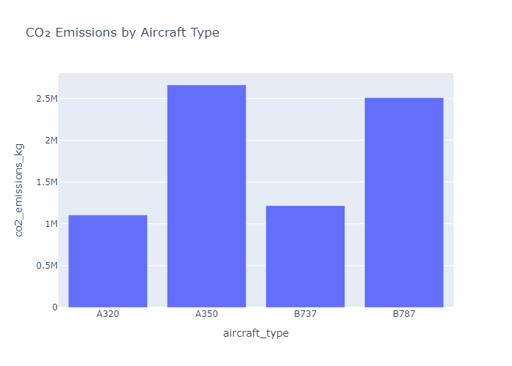
The following pie chart illustrates the proportion of flights that were deemed compliant under EU Emissions Trading Scheme (EU ETS) criteria. Compliance indicates that the flight's emissions data has been verified and the operator has met regulatory obligations. Non-compliant flights may reflect reporting gaps, verification issues, or allowance shortfalls.
Compliance Status Distribution
