Ledger Microservice User Guide
Welcome to the Ledger Microservice User Guide. This microservice is a comprehensive solution for managing financial assets across a diverse set of clients, accounts, and wallets. It provides a robust platform for asset management, including transfers, balance inquiries, and transaction history, built on Spring Boot, Kafka, and an H2 database.

Initial Setup and Default Data
Upon startup, the microservice initializes the database with default data for immediate use:
- Clients: "Zing", "Client A", "Client B"
- Accounts and Wallets:
  - "Zing" has a "saving" account with two wallets: one holding 10,000 USD and another holding 10,000 EUR.
  - "Client A" has an "investment" account with two wallets: both starting with a balance of 0 in USD and EUR.
  - "Client B" is set up without accounts or wallets and is ready for customization.
This default setup is intended to facilitate quick testing and exploration of the microservice's features.

System Requirements
- Java Version: JDK 17
- Spring Boot Version: 3.2.3
- Kafka Version: 2.8.1
- Database: H2

Accessing the Service
- H2 Console URL: http://localhost:8080/h2-console
  - Username/Password: sa / password
- Testing Page URL: http://localhost:8080/index.html

Key Functionalities

1. Managing Client Information
Clients represent entities within the system. The microservice allows for the creation and update of client information, facilitating the management of multiple entities under one system.
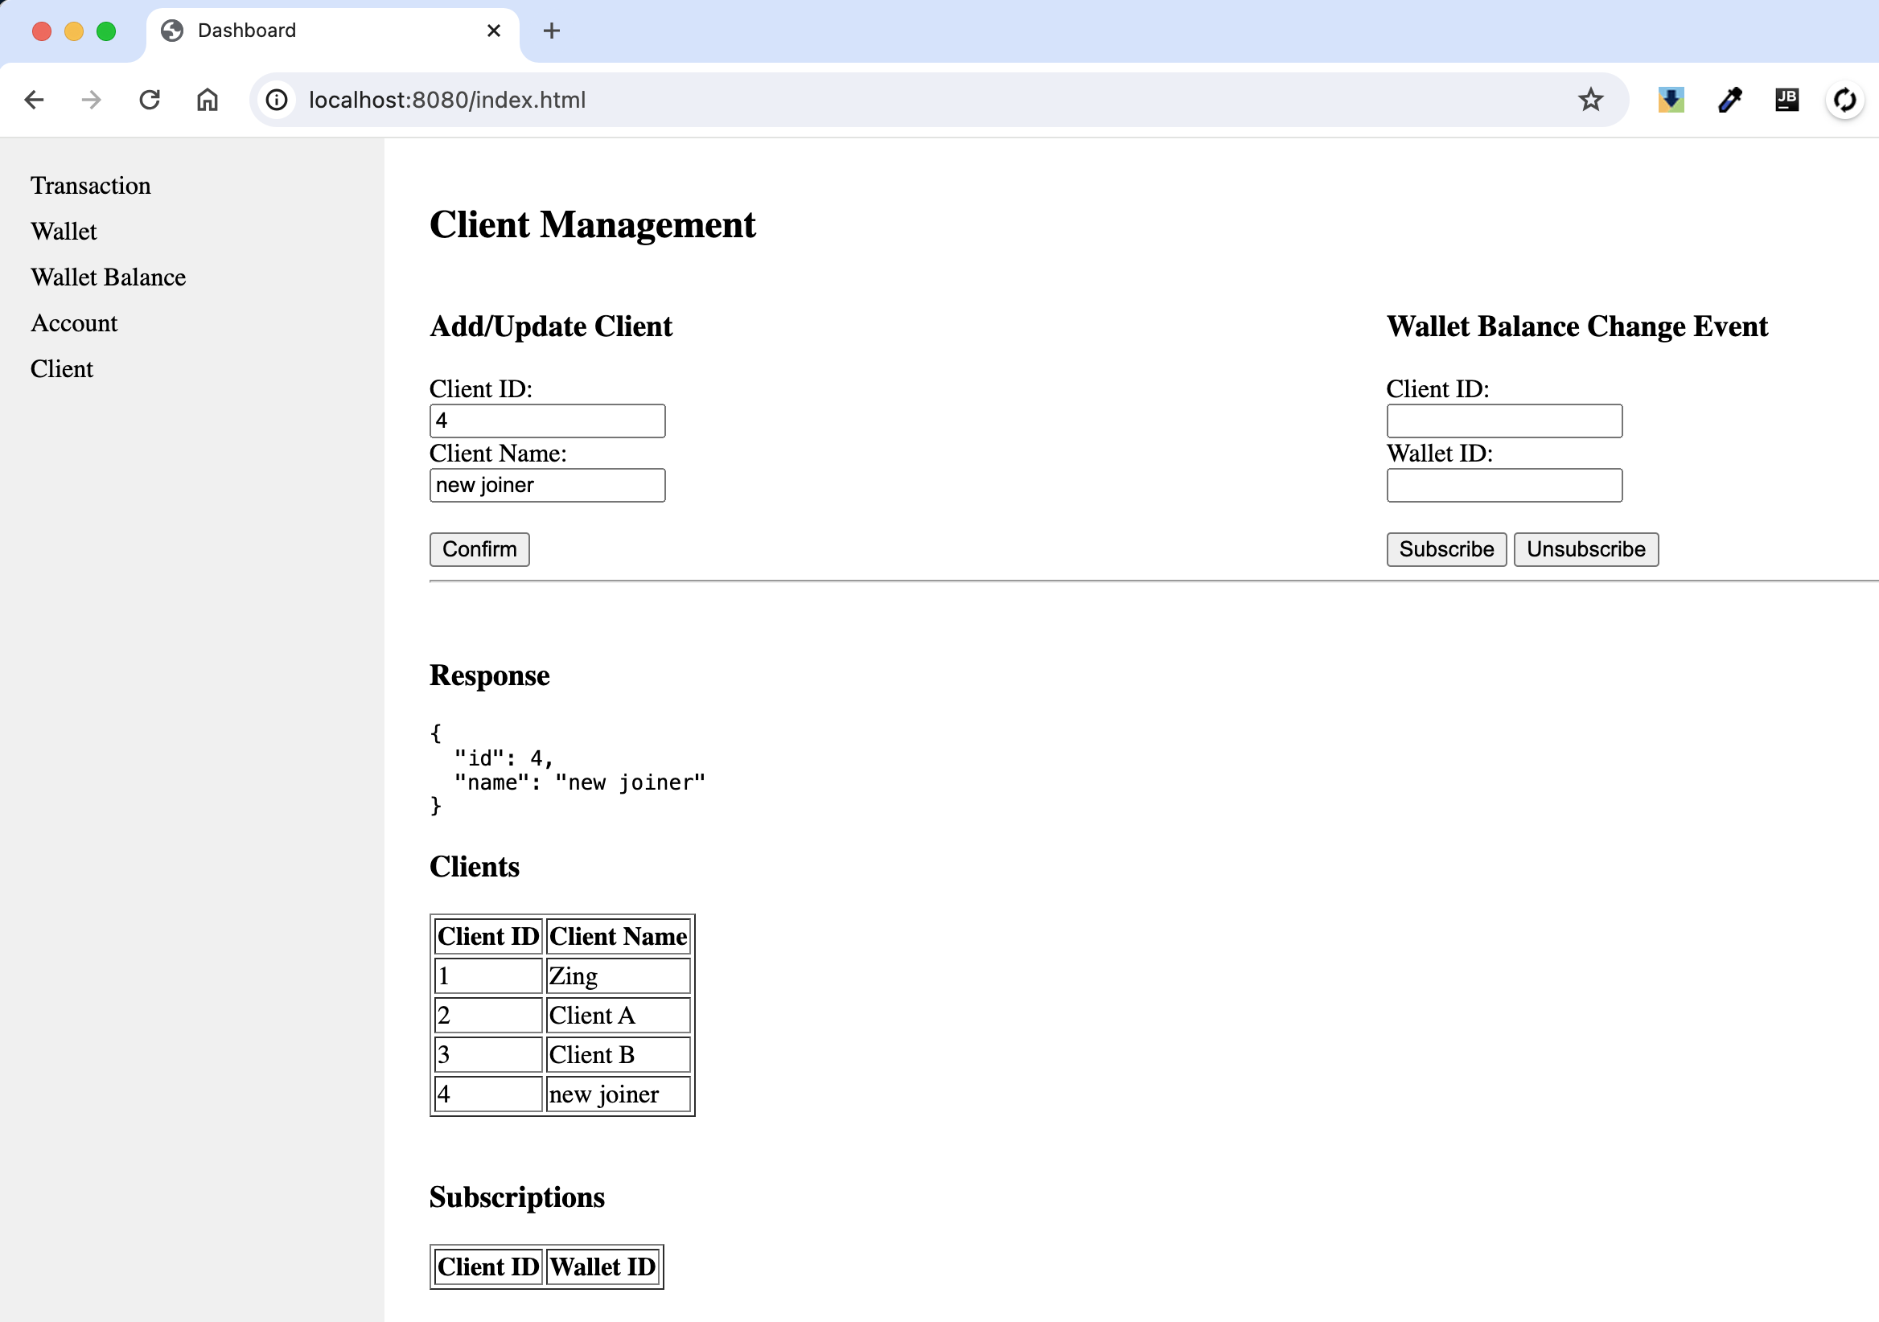

2. Account and Wallet Structure
- Multiple Accounts: An entity can have multiple accounts, each potentially serving different purposes (e.g., saving, investment).
- Wallets in Accounts: Each account can contain multiple wallets, designed to hold specific asset types, ensuring organized asset management.
- Asset Types: Wallets support various assets, including USD, EUR, BTC, and ETH. Each wallet is restricted to holding only one type of asset.
- The Account Page allow user do testing on creating account and updating the account status.
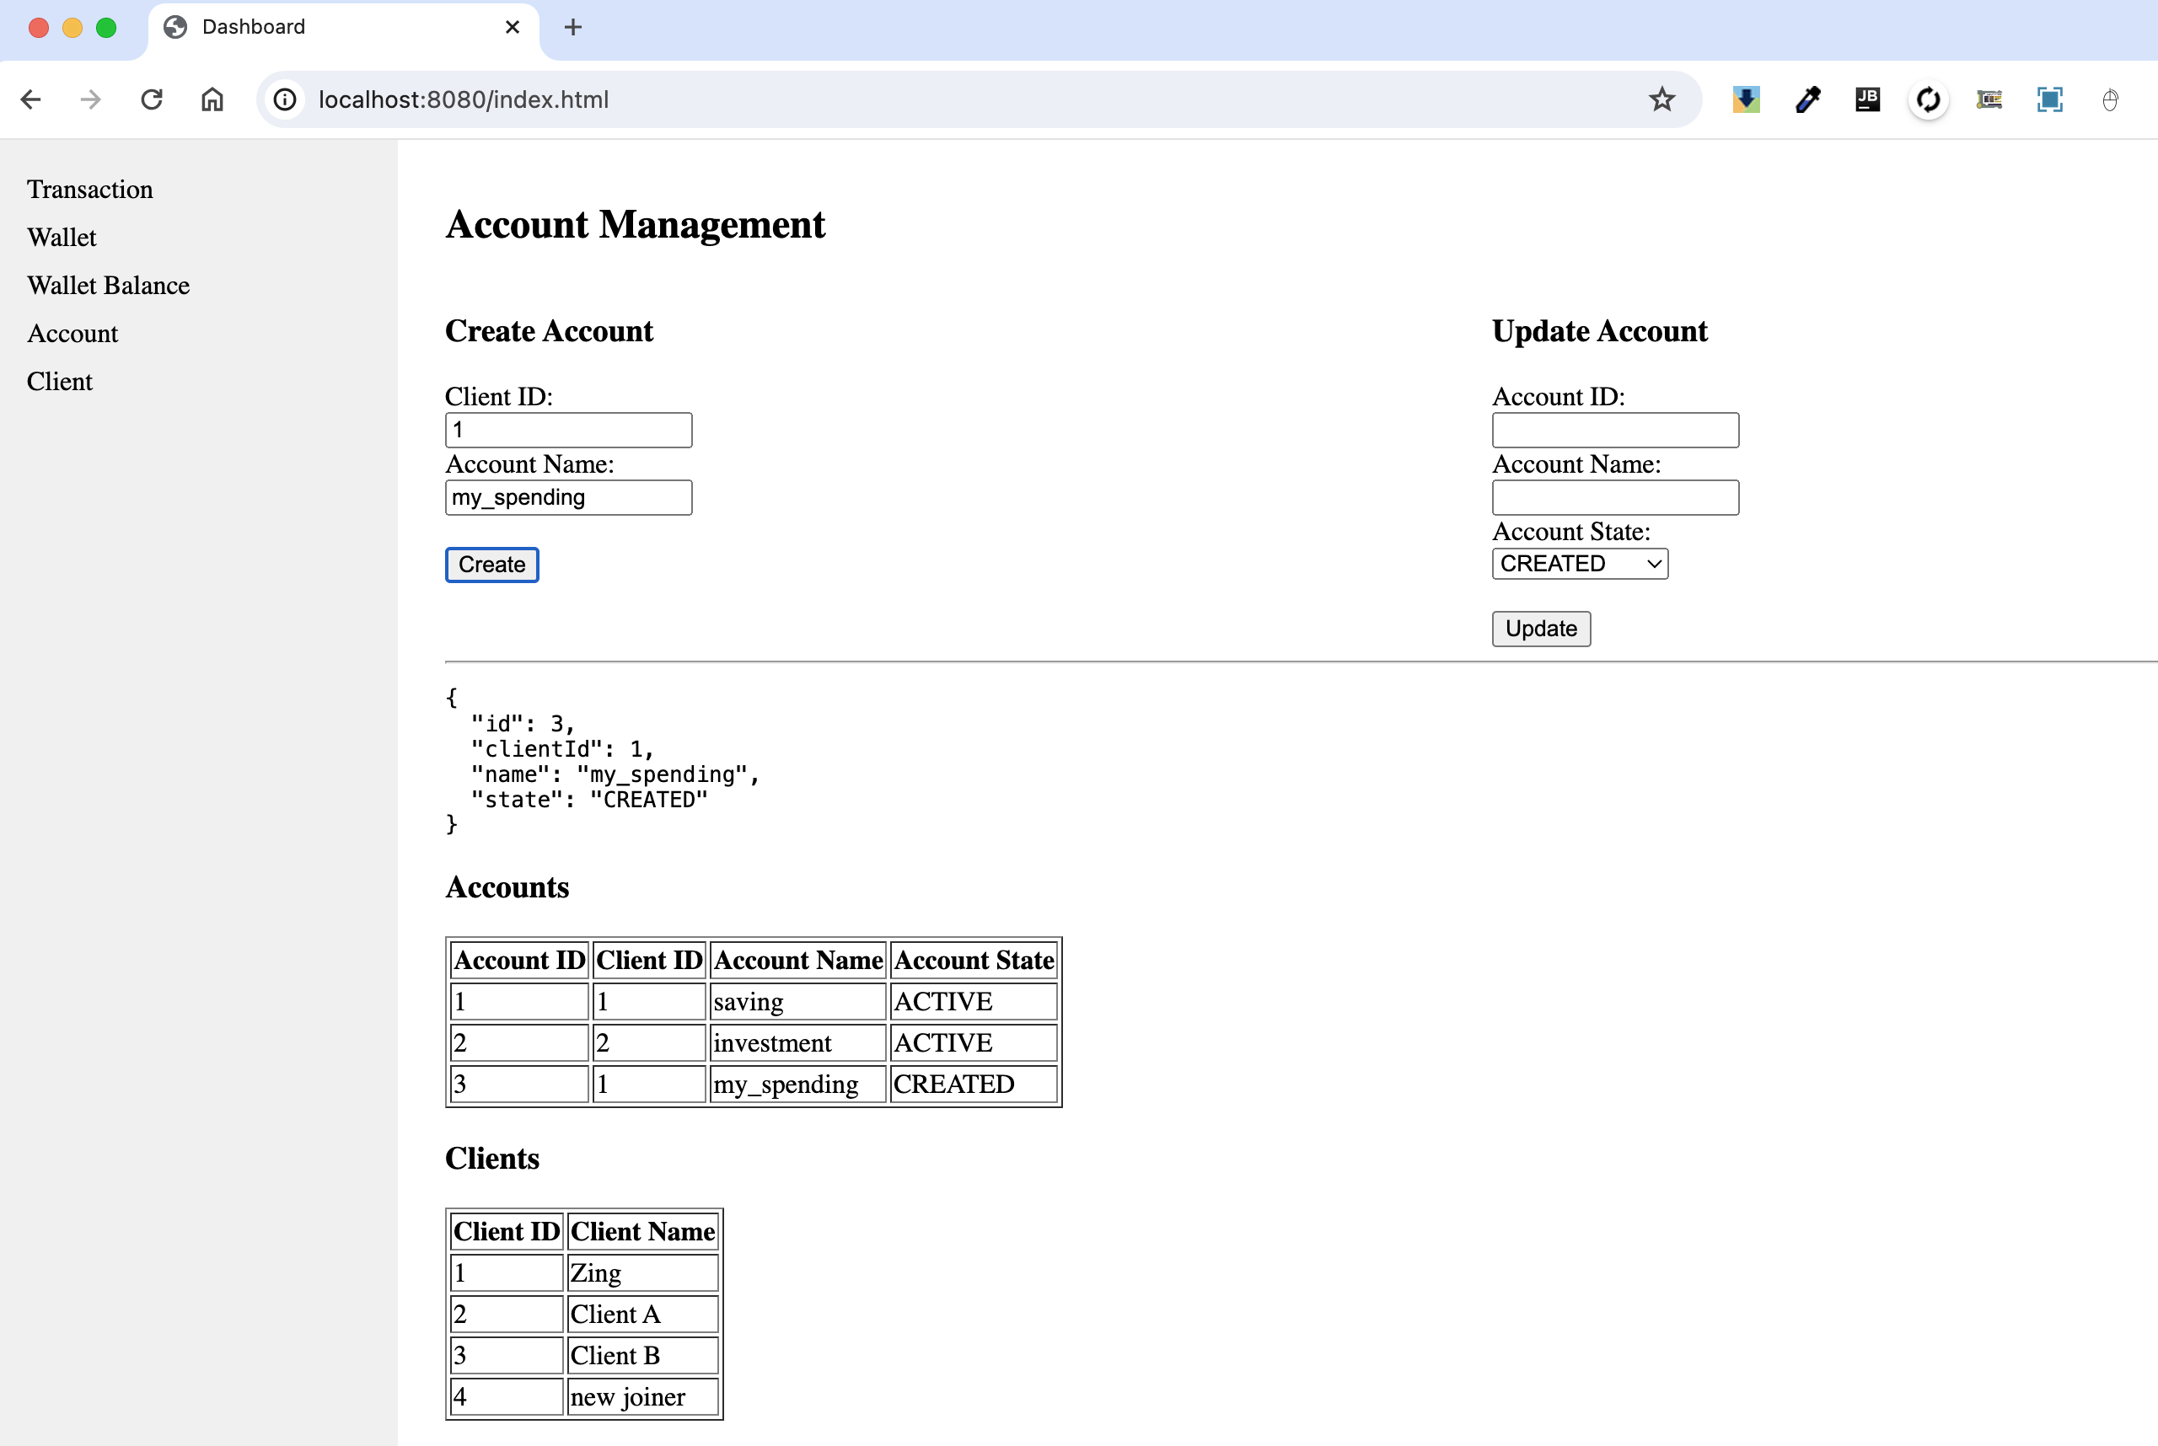

3. Asset Transfers
Clients have the capability to move assets across wallets within their accounts, with the condition that the wallets contain the same asset type. This arrangement facilitates meticulous asset management and allocation. By clicking the "Create Transactions" button, a request that encompasses multiple transactions is sent to the ledger. This request undergoes atomic processing, guaranteeing that either all transactions are executed successfully or fail as a group.The

TransactionQuery table serves as a CQRS mechanism, streamlining data querying. All transaction events are recorded in the eventEntity table, enabling the reconstruction of the TransactionQuery table as needed.

Transactions initially assume a PENDING state due to the asynchronous processing of requests. A simple page refresh updates the status to "clear," indicating the completion of the transactions.

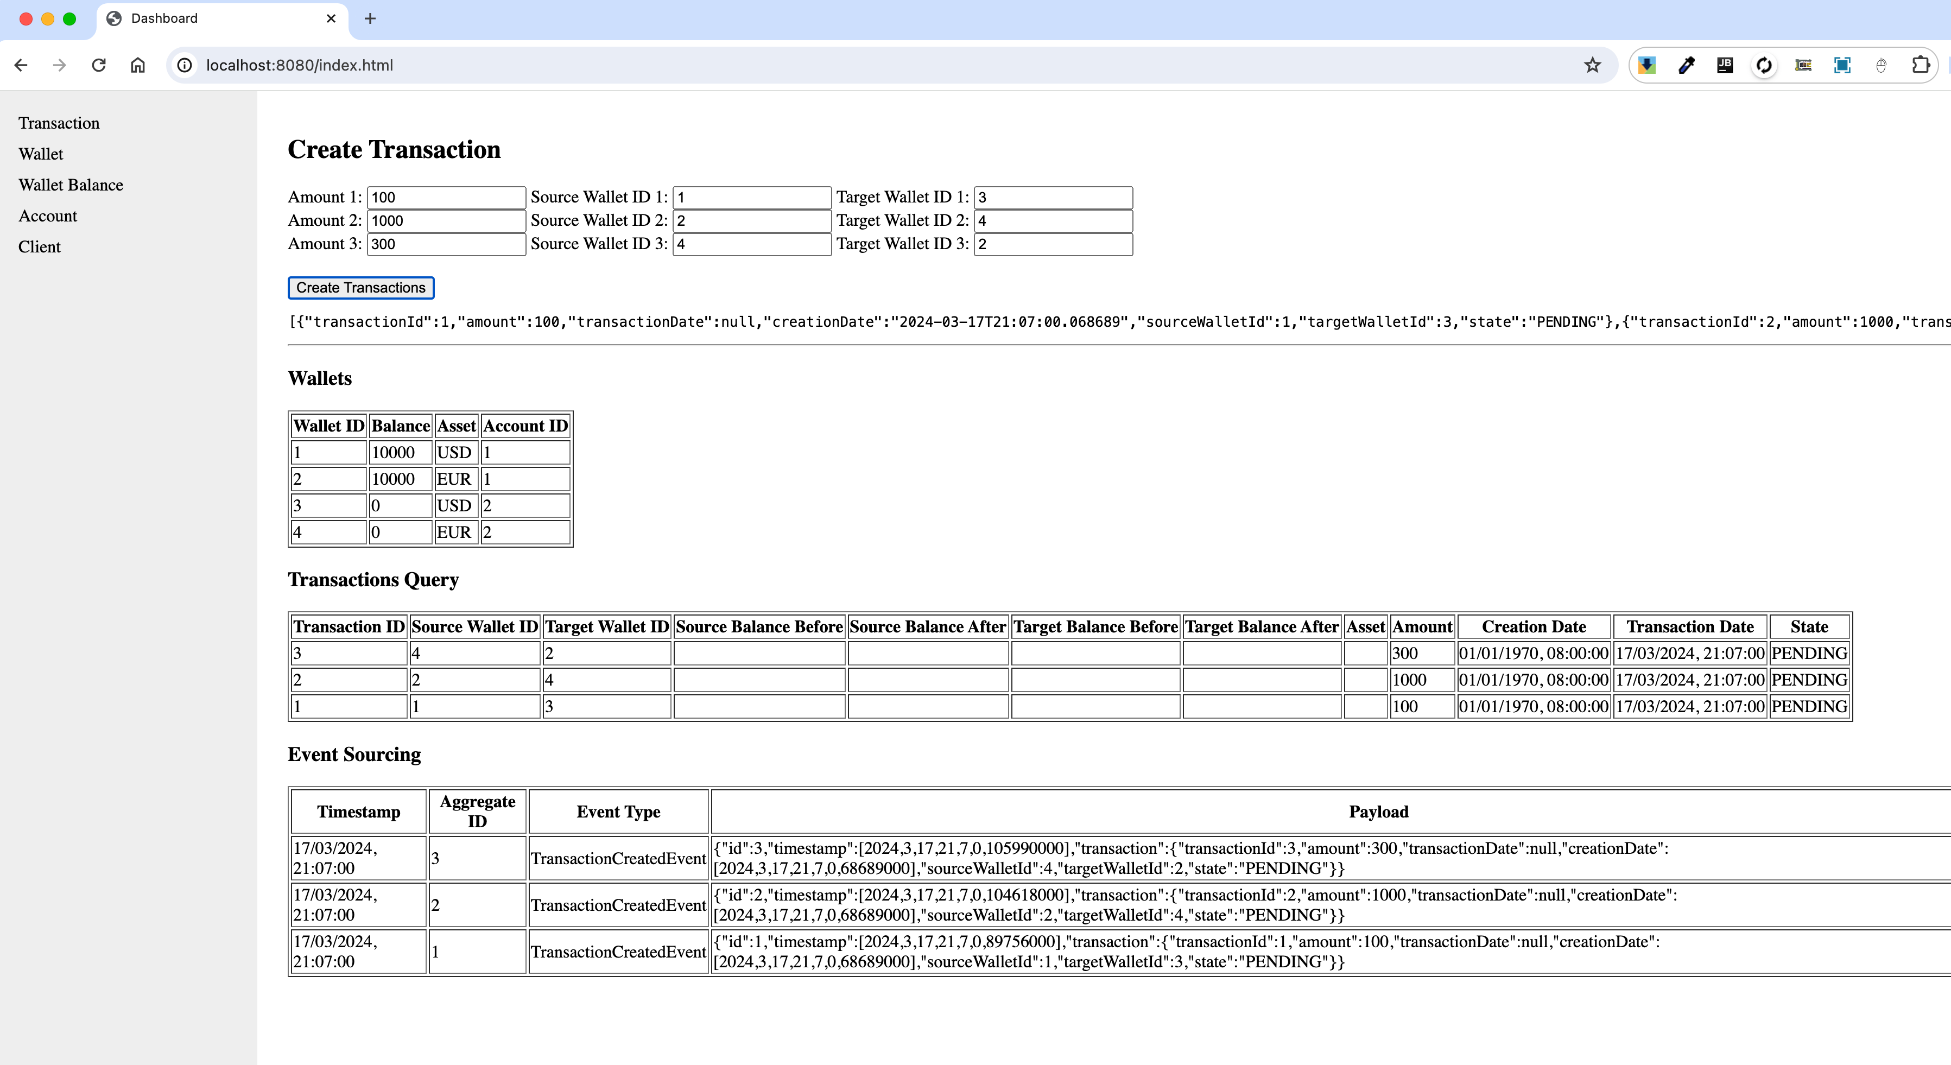
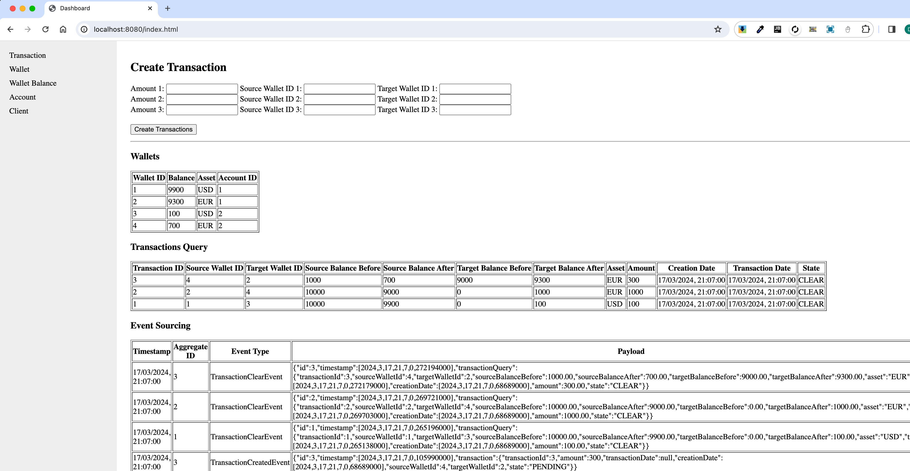

4. Transaction Management
- Create and Update Transactions: Initiate new transactions for asset transfers and update them as long as they remain in a "PENDING" state.
- Transaction and Account States: Manage and query the state of accounts and transactions, with support for states such as CREATED, ACTIVE, SUSPENDED, FROZEN, CLOSED for accounts, and PENDING, CLEAR, FAILED for transactions.

5. Balance Inquiry at Specific Timestamps
Query the balance of any wallet at specific points in time, providing insights into historical asset values change.

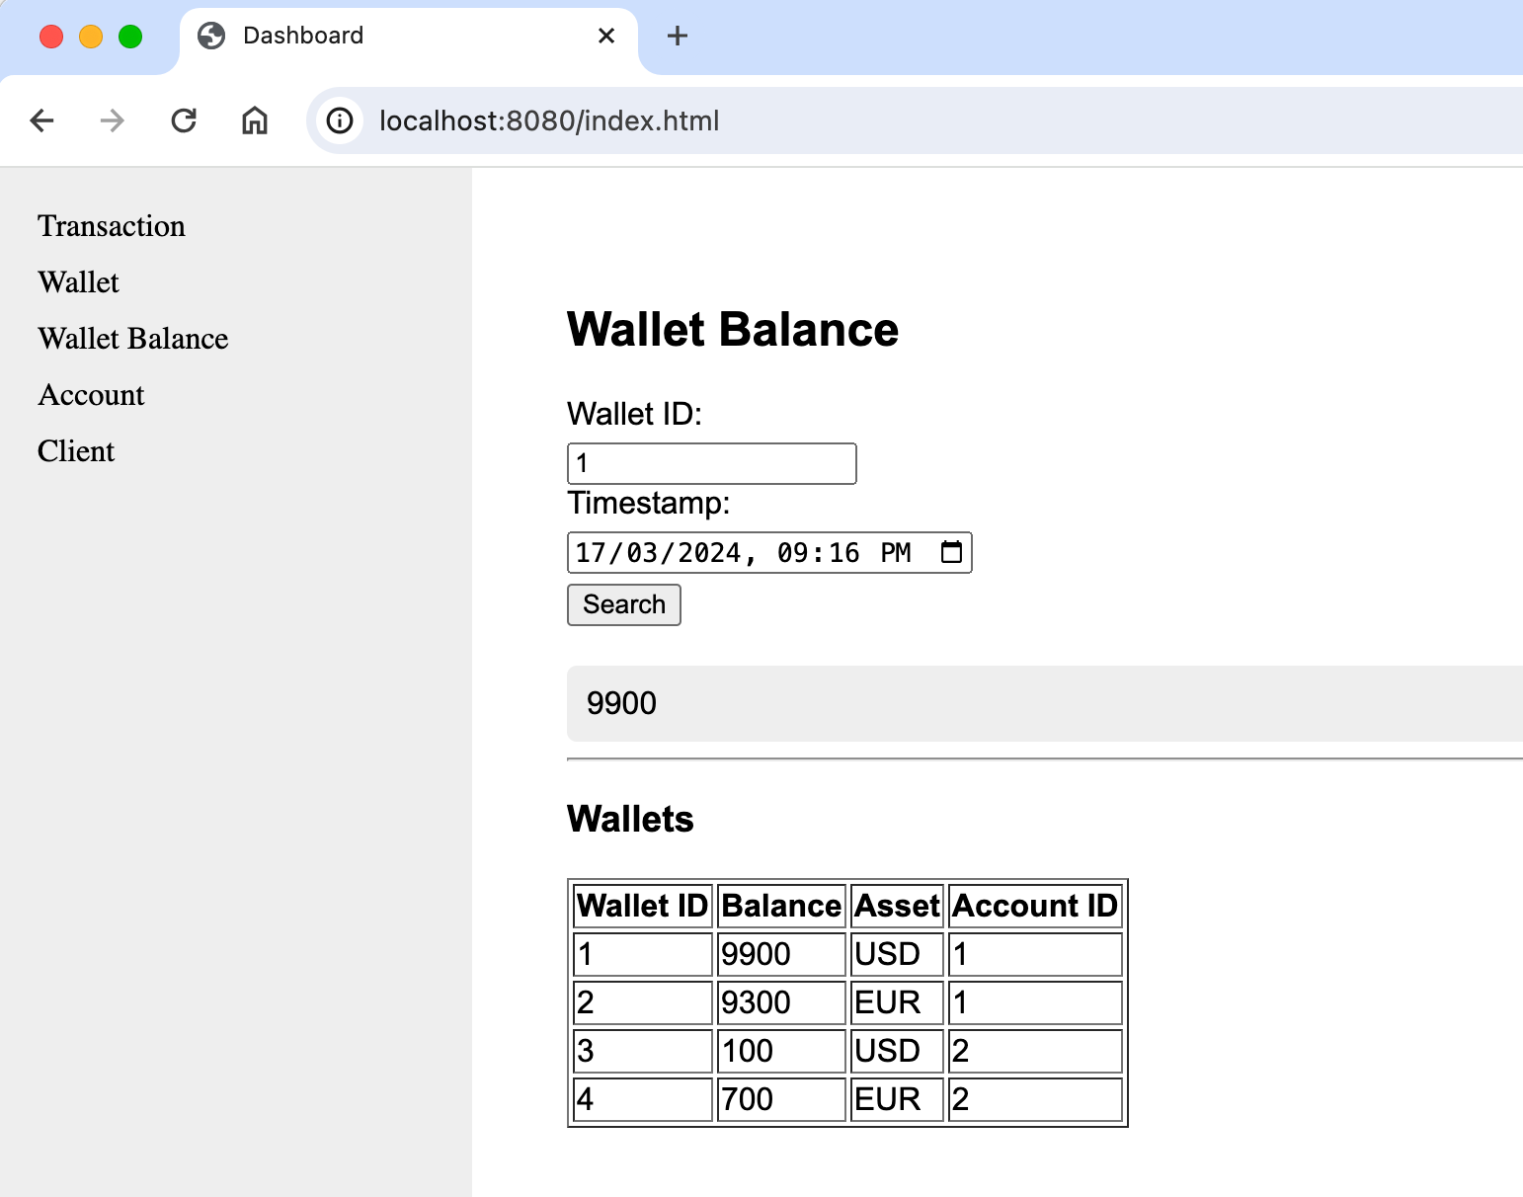

6. Event Sourcing and CQRS
- Event Sourcing: All transaction events (created, cleared, failed) are recorded for auditability and debugging, enhancing the system's reliability and traceability.
- CQRS: Leverage the transactionQuery table for optimized query operations, following the CQRS pattern for separation of command and query responsibilities.

7. Subscribing to Wallet Balance Changes
Clients can subscribe to notifications for balance changes in specific wallets, allowing for real-time updates and responses to financial movements.

