Scenarios

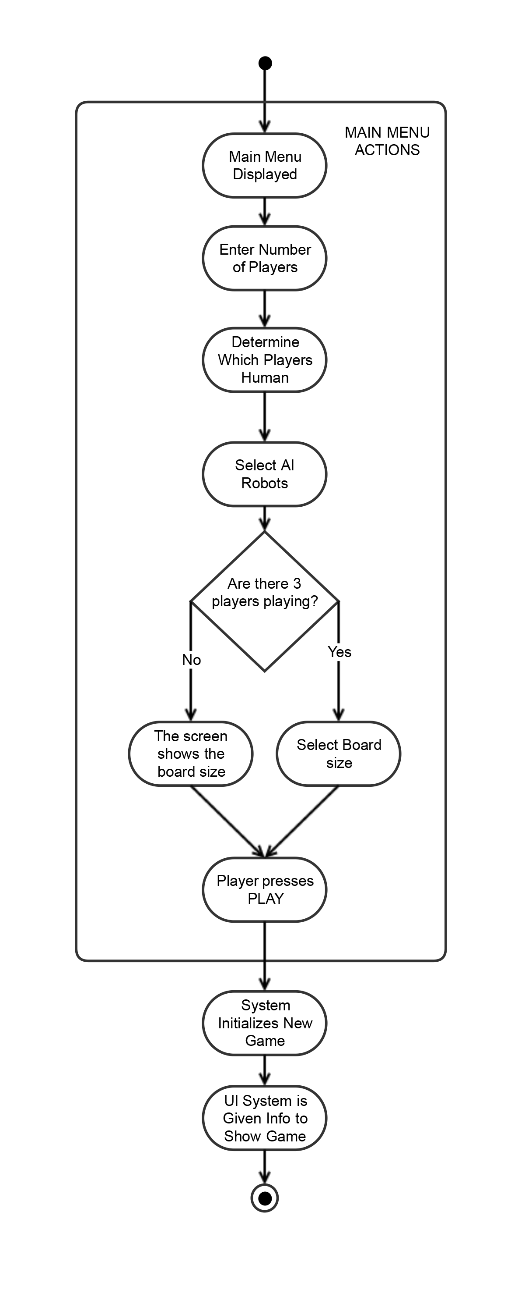
- Create Game Primary Scenario

- When a player presses “PLAY” from the main menu they are prompted with a display showing options that they could play the game with. These options are the number of human players, the number of computer players, the robots that the computer players are using, and an option to change the board size if there is exactly three players in the game. The player will then hit another “PLAY” button to continue to the in game view.

- The use case begins when the player selects play from the main menu
- The player enters the amount of players (2, 3, 6)
- The player selects which players will be human and which will be computer
- The player will select an AI for each of the three types of robot for every computer player
- If the amount of players is 3 the player may select between a board size with sides of length 5 or length 7
- The player presses play
- The system initializes a new game with the specified parameters
- The UI system is notified of the parameters and what will be displayed to the screen
- The use case ends

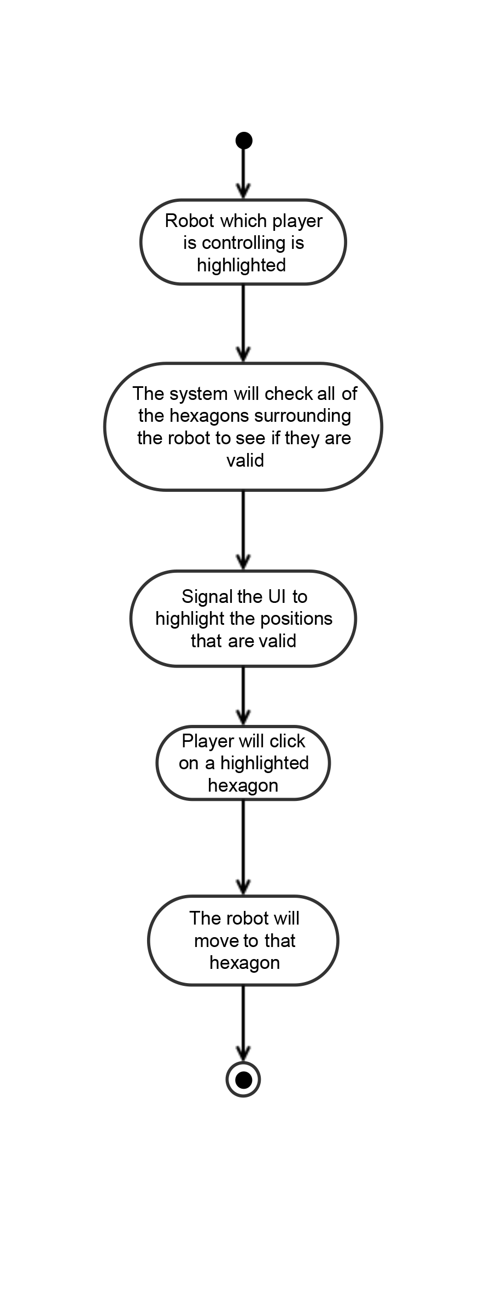
- Move Robot Primary Scenario

- When it is a player’s turn and they wish to move a robot they can do so using the mouse. All of the spaces around the robot that it can possibly move to will be highlighted. Clicking on one of these locations will result in the robot moving one space into that location. If the robot has already moved as far as it can for that turn no spaces will be highlighted.

- The use case begins when it is the player’s turn and they are in moving mode
- The system will determine which of the six positions around the robot are valid locations to move to
- The player will click on the game board on one of the hexagons adjacent to the robot that is highlighted
- The system will determine the necessary number and direction of rotations the robot will need to make to face the selected hexagon
- The system will perform the necessary rotations and move the robot forward into the selected position
- The use case ends

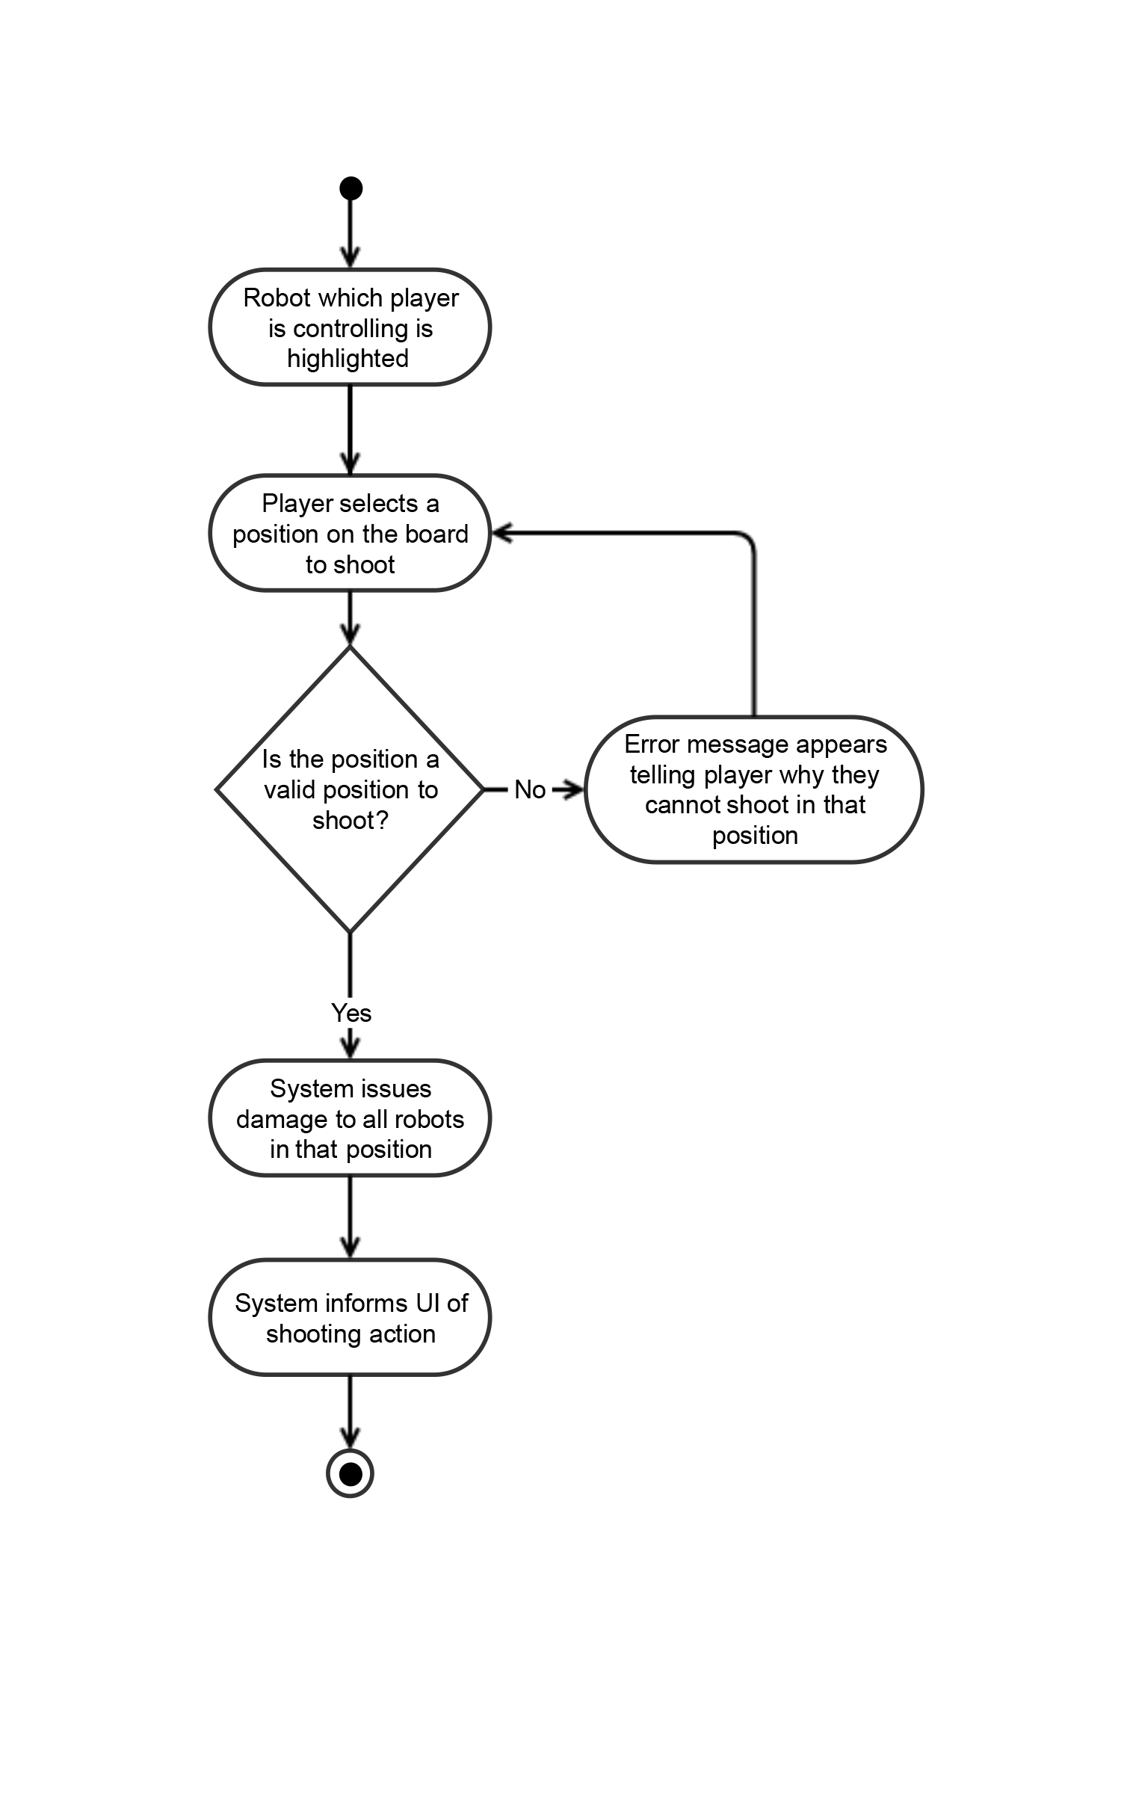
- Shoot Robot Primary Scenario

- When it is a player’s turn and they wish to shoot with a robot they can do so using the mouse. When the player is in shooting mode the player will be able to click on a board tile that is in range to fire upon that location. All robots in the location that is being fired upon will receive damage.

- The use case begins when it is the players turn and they are in shooting mode
- The player will select a position to shoot
- The system will check that the board tile selected is within range and is a valid place to shoot.
- If the board tile is selected is valid the system will issue damage to all robots on that board tile
- The system will inform the UI of the shooting action
- The use case ends

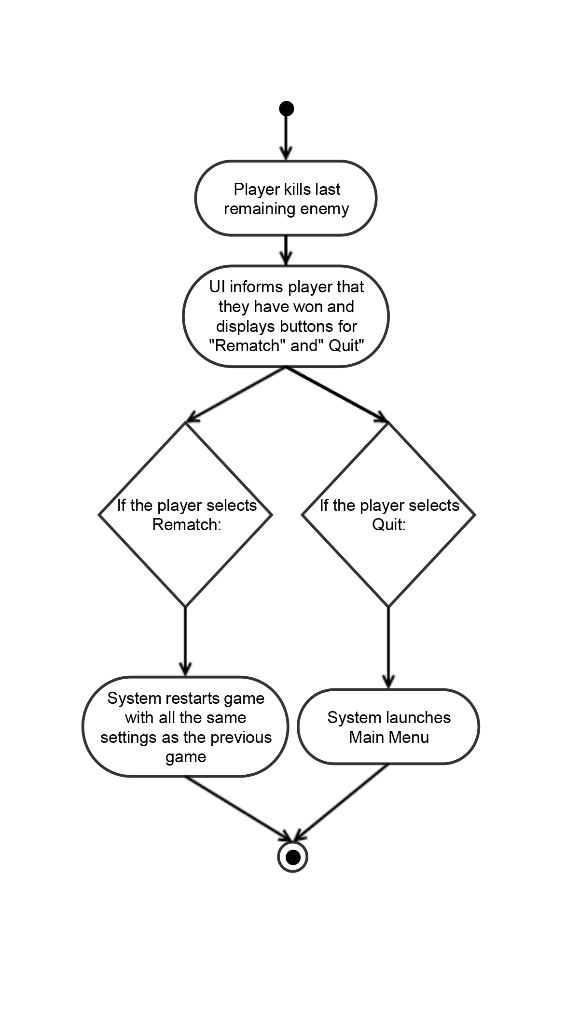

- Winning Primary Scenario

- If a player has killed the last robot of the only remaining team the player has won the game. A message will appear to that player that they have won and will prompt the player to have a rematch or to quit.

- The use case begins when the player kills the last remaining robot of the only enemy team left alive
- The system informs the UI of the victory
- The UI shows on the screen the victory graphic and the two prompts for the player to select from, rematch and quit
- If the player selects rematch the system will restart the game with all of the same settings as before
- If the player selects quit the system will launch the main menu
- The use case ends
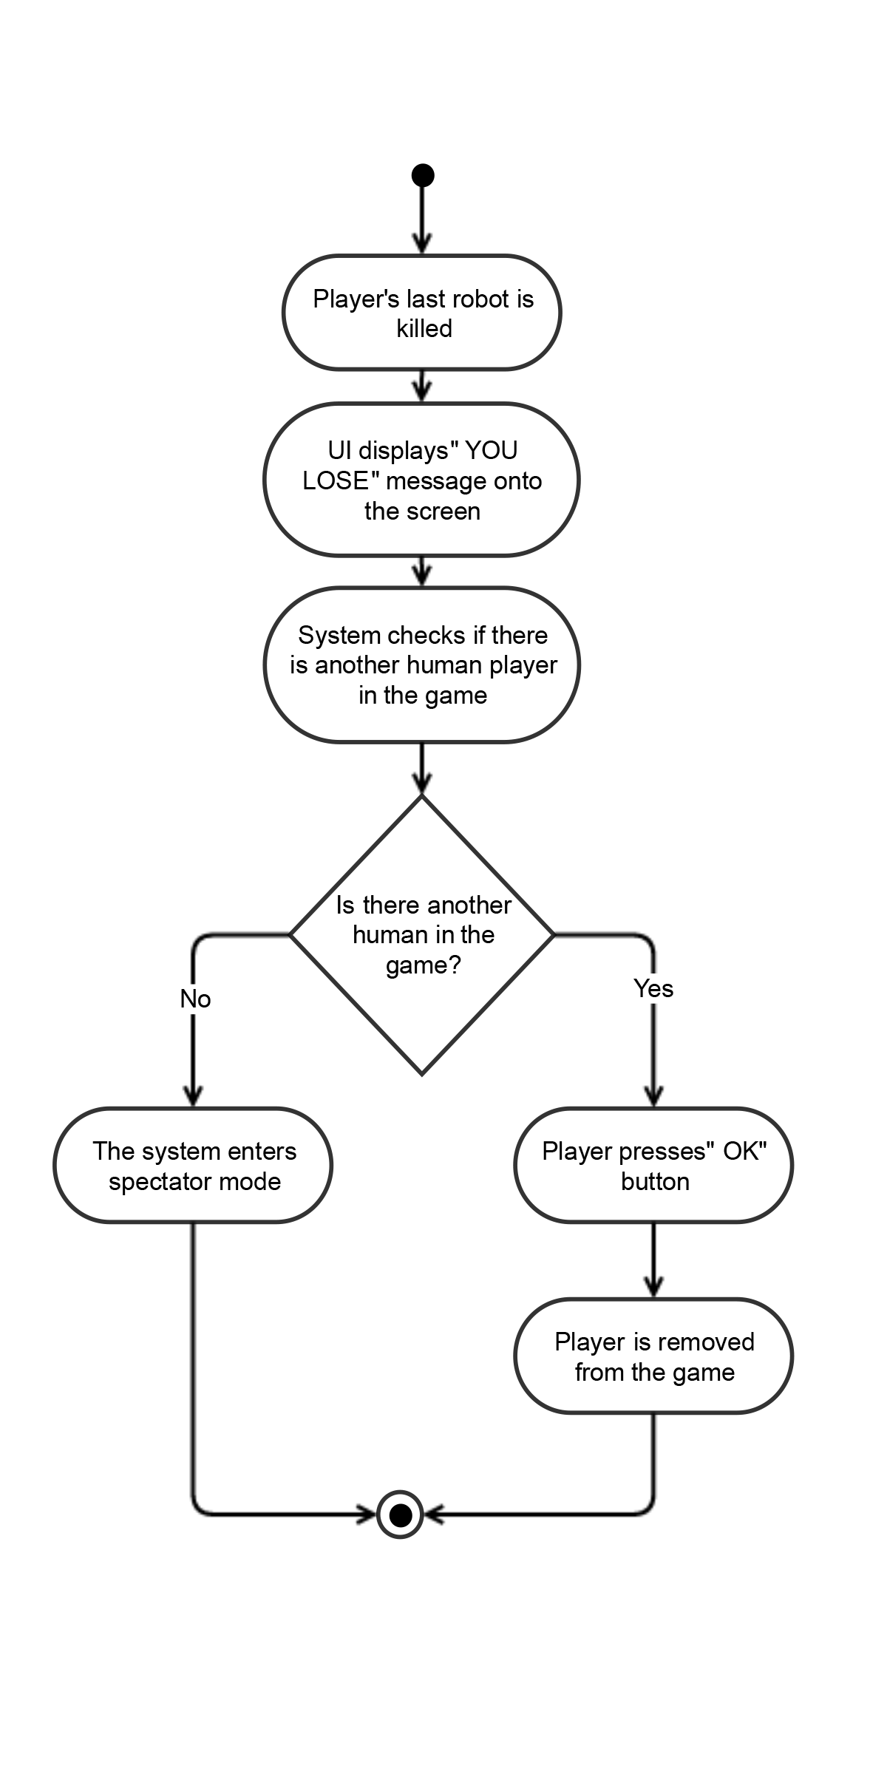
- Losing Primary Scenario

- If a player’s last robot is killed they have lost the game. After a player’s last robot is killed when it is their turn again a message will show on the screen saying they have lost. If the player is the only human left in the game the game will enter into spectator mode.

- The use case begins when the last robot of a player’s team is killed
- The system informs the UI of the players state and the YOU LOSE message is shown
- The system determines if there are any other human players in the game
- If there are not any other human players in the game the game will enter spectator mode
- If there is another human in the game the UI will simply display an OK button
- The use case ends when the user selects an option

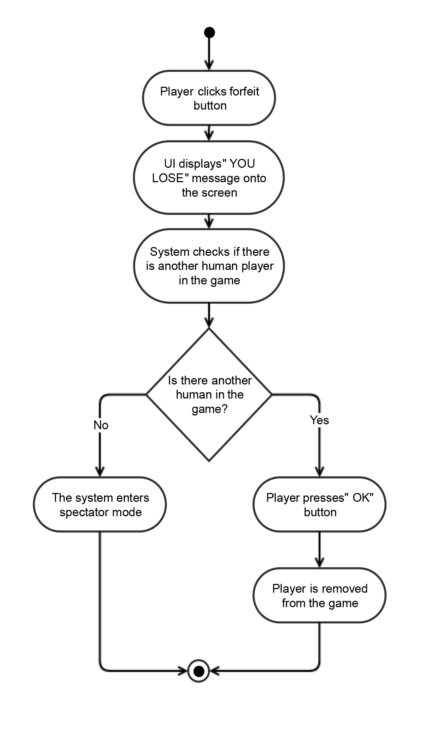
- Forfeiting Game Primary Scenario

- On any turn a player may choose to forfeit the game using the forfeit button in the top right corner of the screen. Upon doing so the player will be directed to the "YOU LOSE" screen which will be the exact same for either death or forfeit. If the player is the only human left in the game the game will enter into spectator mode.

- Use case begins when the player selects forfeit when it is their turn
- System changes all of the player's robots to 0 health.
- The system informs the UI of the player’s state and the YOU LOSE message is shown
- The system determines if there are any other human players in the game
- If there are not any other human players in the game the game will enter spectator mode
- If there is another human in the game the UI will simply display an OK button
- The use case ends when the user selects an option

Spectator Mode

Once all of the human players in the game have forfeited or died the game will enter into spectator mode. In this mode the player(s) will not be playing but rather watching the remaining AI computer players make their moves. When in this mode the button options for “Move”, “Shoot”, and “End Turn” will be changed to “Pause/Play” , “Fast Forward”, “End Game” , “Fog of War”. During spectator mode the game will carry out based on time, regulating the speed of the computer player’s movements based on a timer. (Once every second the computer AI will make a move for example). This is why we have the need for speed controls in the spectator mode.
The fast forward control allows for quick viewing of the game and the pause button allows for the spectator time to view the board. The fog of war button is an on/off toggle for the fog of war view of the board. If the toggle is turned on then the spectator will only be able to see what the computer player can see of who’s turn it is. If the toggle is off, then the spectator can see the entire board regardless of which team’s turn it is. To exit spectator mode the spectator can press “End Game”. This button will skip all remaining turns of the computer players and show the Victory box displaying the stats of all the robots in the winning team.

