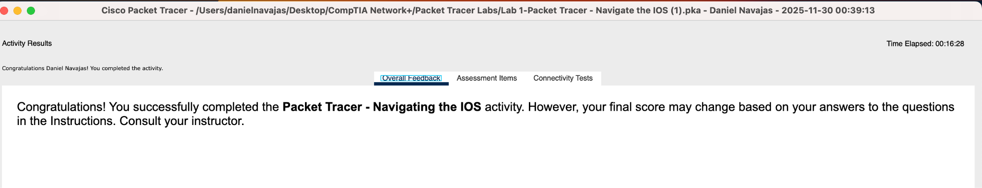
Lab 1 | Packet Tracer - Navigate the IOS

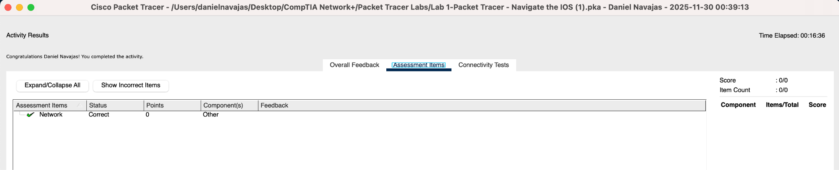

What is the setting for bits per second?
- 9600
What is the prompt displayed on the screen?
- S1?
Which command begins with the letter ‘C’?
- Connect
Which commands are displayed?
- Telnet, terminal, traceroute
Which commands are displayed?
- Terminal, telnet
What information is displayed for the enable command?
- Turn on privileged commands
What displays after pressing the Tab key?
- Enable
What would happen if you typed te<Tab> at the prompt?
- You don’t get a command completion because there are two commands that start with “te” (terminal and telnet), so you would have to type “ter” or “tel” to get one.
How does the prompt change?
- S1#
One command starts with the letter ‘C’ in user EXEC mode.
- Clear, clock, configure, connect, copy
How many commands are displayed now that privileged EXEC mode is active?
- 21 commands (5 that start with “C”)
What is the message that is displayed?
- Configuring from terminal, memory, or network [terminal]?
How does the prompt change?
- S1(config)#
What information is displayed? What is the year that is displayed?
- *15:12:2.540 UTC Wed Jan 31 2035
What information is displayed?
- set Set the time and date
What information is being requested?
- hh:mm:ss Current Time
What information was returned?
- Cl (because you need to type at least “clo” to get clock)
What information was returned?
- % Incomplete command. (because you the correct command is “show clock”)
What information was returned?
- % Invalid input detected at '^' marker.
What information was returned?
- % Invalid input detected at '^' marker.

