**Plots, planes, and pixels: integrating data sources to quantify mass forest mortality extent, severity, and vulnerability**

**Project Summary**

In 2022, the USDA Forest Service Forest Health Protection Aerial Detection Survey (ADS) documented extensive mortality of true firs (*Abies* spp.) in Oregon. Referred to as “Firmageddon”, concerns about its potential economic and ecological impacts highlight the need to develop unbiased and verifiable information on forest mortality events, and improve our understanding of forest vulnerability in the future. However, available datasets about forest disturbances differ in various important aspects, including their spatial and temporal resolution, extent, and agent attribution. This makes gaining a cohesive picture of large-scale forest mortality events difficult. This project compares and integrates three forest disturbance data sources – plot-based data from the USDA Forest Service Forest Inventory and Analysis Program (FIA), aerial data from the Aerial Detection Survey (ADS) program, and remotely-sensed satellite time series imagery – in order to improve estimates of forest disturbance extent, severity, and vulnerability.

**Objectives**

1. *Data source comparisons*

Review and quantify the strengths, weaknesses, and complementary aspects of FIA, ADS, and remotely-sensed data. Compare three core metrics (area impacted, attribution, and severity) across data sources in the context of two case-studies: 2022 Firmageddon event in OR and 20XX pine beetle outbreak in XXXXX.

1. *Data source integration*

Develop a data processing and modeling workflow for integrating ADS, multispectral satellite imagery, and FIA plot measurements to provide spatially-explicit estimates of proportional tree mortality.

1. *Landscape contextualization*

Combine modeled mortality estimates with imputed forest attribute data from the LEMMA GNN project, interpreting model outputs as on-the-ground impacts.

1. *Retrospective and prospective vulnerability*

Use mortality estimates together with GNN forest attribute data and ancillary climatic and biophysical data to model the drivers of large-scale forest mortality. Assess our ability to retrospectively predict vulnerability (i.e., using Firmageddon and pine beetle case studies), and map potential future vulnerability to similar events.

**Approach**

*Data source comparisons*

|  |  |  |  |  |
| --- | --- | --- | --- | --- |
|  |  | **FIA** | **ADS** | **Landsat** |
| **Extent** | *temporal* | 2000-2019 (for annual design) | 1970s? - present | 1984 - present |
|  | *spatial* | national | Depends on annual flown area | global |
| **Scale** | *temporal* | difference between inventories | ? | annual? |
|  | *spatial* | estimation strata; 90 m plot | variable -- watershed? | pixel |
| **Resolution** | *temporal* | decadal or annual sample | annual? | annual |
|  | *spatial* | 90m plot; individual tree | variable | 30 m |
| **Effects** | *attribution* | direct observation, trained crews | indirect observation, expert evaluation | remote observation, spectral analysis |
|  | *specificity* | variable; low specificity for dead, higher specificity for live damage | qualitative determination; variable by agent and region | quantitative determination; generic agent |
|  | *severity* | tree-level effects | variable; stand to watershed-level; binned | quantitative; severity requires context |

We will review literature on field, ADS, and spaceborne approaches to forest mortality estimation and mapping, and catalogue the relevant aspects of each (*e.g.,* Table 1). We will quantitatively compare three aspects of forest mortality estimation across all three data sources – area impacted, attribution, and severity. For FIA-based area estimates, we will follow FIA estimation procedures (Bechtold and Patterson, 2005). For ADS estimates, area impacted can be directly gleaned from survey polygons. Remotely-sensed area estimates will be made using the Landscape Change Monitoring System (LCMS) and/or LandtrendR. Attribution … etc build out.

**Table 1.** Comparison of data attributes.

*Data source integration and landscape contextualization*

Building on prior research in the Pacific Northwest (Meigs et al., 2011, 2015), we will build a workflow integrating FIA, ADS, and remotely sensed data for mortality mapping and estimation (*e.g.,* Figure 1). This workflow has three major components: (1) Merging ADS polygons with Landsat-based disturbance mapping to generate multispectral imagery maps of attributed mortality with pixel-scale spatial resolution, (2) develop statistical models relating Landsat-spectral change to observed mortality on FIA plots, yielding pixel-scale spatial estimates of tree mortality, and (3) combine the results of 1-2 with gradient nearest neighbor (GNN, <https://lemma.forestry.oregonstate.edu/>) maps of forest attributes to contextualize and interpret mortality estimates.

*Retrospective and prospective vulnerability*

The data source integration we propose will generate fine-scale spatial mortality estimates that can be combined with tree-, stand-, and landscape-scale data to examine the drivers of mass mortality events. In particular, we will build models exploring how mortality varies with tree size, stand density, climate, biophysical setting, and topographic position (e.g., Bell et a. 2015, Shriver et al. 2021). Understanding how these variables modulate the probability of mass mortality events could guide management prescriptions for resilient forests in the future (Bradford & Bell 2017). We will challenge our mortality models to retrospectively predict spatial patterns of mortality for both our Firmageddon and pine beetle case studies, to both assess our ability to make these predictions and gain insight into when and where mortality may be more/less predictable. We will also use future climate projections to identify and map areas vulnerable to future large-scale mortality events.

**Questions and points of engagement for Danny**

* How should we think about the spatial precision and accuracy of ADS polygons?
* Are there nuances to the temporal aspects of ADS data (e.g., surveyed area, data processing lags, seasonality of surveys, etc)
* What are the most common ways that people misuse ADS data (so we can avoid doing so)
* Is our assumption that fir mortality is harder to detect than e.g., pine beetle mortality correct? Do those case studies really represent the “end members” of that spectrum?

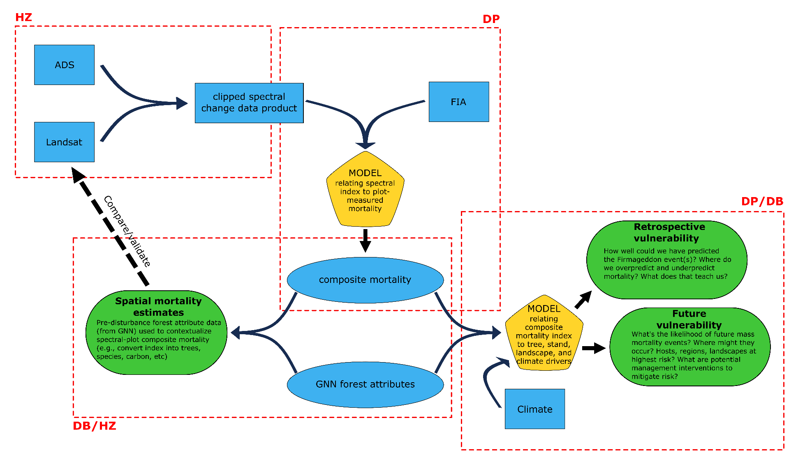

**Figure 1** (*previous page*). **Conceptual workflow diagram for data integration**. Diagram shows the workflow combining primary data sources (blue rectangles; ADS, Landsat, FIA) to generate modeled data (blue ellipses; composite mortality, GNN forest attributes), which are either directly combined or used to train a model (yellow polygon) to generate end products (green ovals; spatial mortality estimates, retrospective vulnerability, future vulnerability). Red dashed lines roughly delineate processing/analysis steps, with initials assigning primary responsibility.