**Subalpine fir – Engelmann spruce mortality/regeneration analysis**

*Interactions between climate change and forest disturbance drive disassembly of subalpine forest communities*

*Demographic mechanisms of coexistence are vulnerable to climate-disturbance interactions*

Daniel L. Perret, David M. Bell, Andrew N. Gray, Harold S. J. Zald (+ others?)

**Context**

Our subalpine fir status and trends paper suggested that the future trajectories of subalpine forest communities may depend on interspecific variation in responses to climate change, nondiscriminant forest disturbances (*e.g.,*fire), and host-specific forest disturbances (*e.g.,* biological disturbance agents, BDAs; Perret et al., 2023). This was supported in part by differences we found in the importance of major sources of mortality between regions where subalpine fir was in decline compared to other co-occurring species. The analyses described here dig into this suggestion by focusing on subalpine fir and Engelmann spruce, which co-occur across most of both species’ distributions and form a classic species association for western North American subalpine forests.

Prior work suggests that coexistence of subalpine fir and Engelmann spruce is maintained by interspecific differences in key life history traits and associated vital rates. Specifically, the faster growth and more prolific regeneration of subalpine fir is balanced by higher survival and longevity of Engelmann spruce, leading to overstory codominance despite fir understory dominance (Andrus et al. 2018). Periodic disturbance may also play an important role in providing canopy gaps in which spruce seedlings can outcompete the more shade-tolerant fir seedlings (Shea 1985). Changing climate and disturbance regimes may “break” these demographic pathways that maintain spruce-fir forest systems, insofar as species have different responses to climate, fire, and host-specific biological disturbance agents. We know that subalpine fir and Engelmann spruce were not always as closely associated as they are today -- during Pleistocene glaciations, the bulk of Engelmann spruce refugia were in southern interior highlands (AZ mountains, NM plateau, CO plateau), whereas subalpine fir populations were more widely distributed across northern interior basins and coastal refugia (Roberts & Hamann 2015). Could changing climate and disturbance regimes lead to a similar “disassembly” in the future?

**Analyses**

I’m approaching this issue in two ways. The first is using FIA plot remeasurements to estimate the population trajectories of each species in ecoregion subsections across their shared distribution, using standard FIA estimation procedures. In our subalpine fir paper, we compared changes in basal area to changes in abundance in order to categorize population trajectories. Here I’ve expanded this approach to compare the trajectories of multiple coexisting species, and created broad bins that should correspond with the rough likelihood of continued coexistence (Figure 1). Next, I’ve been building generalized linear mixed models (GLMMs) predicting the probabilities of mortality and regeneration for each species, based on baseline climatic conditions, recent climate anomalies, the distribution and severity of forest disturbances, and several other predictors. I plan to apply these models to explore whether subalpine fir-Engelmann spruce systems will be pushed into demographic states that do not correspond with likely future coexistence under a range of future climate and disturbance scenarios.

**Preliminary results**

*Population estimation and categorization*

Figure 1 shows the conceptual framework for comparing population trajectories of multiple coexisting species, based on basal area and stem density trends. I’ve created four bins of possibilities with respect to the likelihood of future coexistence: (1) *likely persistence* – both species are either undergoing changes corresponding with normal stand development or are actively increasing in density; (2) *vulnerable* – one or both species have experienced significant turnover of individuals, indicating that future trajectories may depend on post-disturbance recovery and survival of new recruits; (3) *mismatched trajectories* – one species is in decline while the other is either undergoing normal stand development or increasing in density, suggesting that one species will become dominant over the other; and (4) *general decline* – indicating that both species are in decline or experiencing significant turnover.

When we categorize ecoregion subsections using this scheme, as in Figure 2a, we find that 21.6% of the species’ shared distribution falls in the *likely persistence* category, 5.3% in the *vulnerable* category, 35.8% in *mismatched trajectories,* and 37.3% in *general decline*. This suggests that, based on population trends estimated between 2000-2009 and 2010-2019 inventory periods, it is unlikely that subalpine fir-Engelmann spruce systems will persist across ~73% of their current distribution. This probably overstates the situation; perhaps we can find ways to add decline thresholds to our categories (or do some more critical thinking about the categories themselves) so that we’re not unnecessarily alarmist. The major sources of mortality for each species differ between categories, shown in Figure 2b. Notably, insect mortality dominates across all categories except *likely persistence* for Engelmann spruce, probably reflecting severe spruce beetle outbreaks in parts of the species’ range. Mortality is more evenly distributed between fire, disease, and insect agents for subalpine fir, except in the *general decline* category, where it seems to be mostly driven by fire. These differences suggest that global change drivers that indirectly cause mortality by acting on these proximate mortality agents may impact the two species differently across their shared distribution.

*Mortality models*

Mortality and regeneration models are still in development. Mortality models are binomial GLMMs with the response variable being tree status (*i.e.,* alive or dead) at the second plot visit for trees that were alive during the initial inventory (*i.e.,* individual probability of survival over a 10-year period). The model incorporates predictors at three levels of organization: tree (tree size, crown ratio, and the presence/absence of insect or disease damage), plot (climate normal and recent anomalies, stand density), and landscape (proportion of ecoregion subsection impacted by fire and biological disturbances); as well as cross-scale interactions (*e.g.,* between tree size, climate anomalies, and disturbance) and ecoregion subsection-level random intercepts. I built a separate model for each species, though I also explored joint models that incorporate interactions between species identity and various other predictors, or species-level random effects; ultimately, separate models performed better and are easier to interpret. I’ve been evaluating model performance in a variety of ways – in short, the models evaluate well at larger scales of organization (*e.g.,* at ecoregion subsection scales), though differentiation between living and dead trees is more difficult at individual scale. The single best predictor of mortality is whether a plot burned between remeasurements; I opted to omit this from the model in order to make larger-scale predictions without trying to model the probability of fire itself.

*Regeneration models*

I chose to model regeneration as the probability of seedling presence at the plot level during the most recent inventory period, again using a binomial GLMM. These models are newer and I haven’t yet done as much work evaluating their performance or exploring the estimated effects. They currently incorporate predictors at the plot (climate normal and recent anomalies, estimated fire severity, estimated BDA severity, slope, aspect, elevation) and landscape (proportion of ecoregion impacted by fire or biological disturbances) level. Ideally, climate and disturbance predictors should correspond to those in the mortality models so that predictions from both models can be evaluated jointly.

**Moving forward**

I’m currently working on refining the mortality and regeneration models, as well as tightening the link between those models and the population trajectory categories. Ideally, modeled or observed vital rates could be used to discern trajectories from one another. An example of how this might work is shown in Figure 3, where trajectory categories have differing mortality and regeneration distributions. It is rather messy at the moment though, and it would be worth exploring other approaches to making this link.

If that link can be established in a tenable way, my plan is to project how mortality and regeneration of each species may change under future climate and disturbance scenarios, and assess whether those changes push parts of the species’ range into different population trajectory categories. This would involve using future climate projections, paired with several coarse disturbance scenarios (*i.e.,* altering the proportion area disturbed, the goal being to avoid getting into directly modeling disturbance itself). An example of what this might look like is shown in Figure 4, which shows the predicted change in mortality from current rates for each species in 2041-2060 under a SSP3-7.0 climate scenario, given current observed disturbance levels.

**Figures**

**Figure 1.** Conceptual diagram of single-species population trajectories (a) and how they combine for two species (b). Panel (a) shows how combinations of basal area and stem density trends suggest differing population trajectories: *decline*, where both basal area and stem density are decreasing; *turnover*, where basal area is decreasing but stem density is increasing; *development*, where increasing basal area and decreasing stem density suggest self-thinning stand development; and *densification*, where both basal area and stem density are increasing. For two species (b), these four categories combine to suggest different likelihoods that species’ coexistence will persist: *likely persistence*, where both species are either experiencing stand development or densification; *vulnerable,* where one of the two species is experiencing high turnover associated with mortality, suggesting that future coexistence depends on increased recruitment and survival; *mismatched trajectories*, where one species is in decline and the other is flourishing, suggesting that one species will likely dominate over the other; and *general decline*, in which both species are experiencing population declines concurrently.

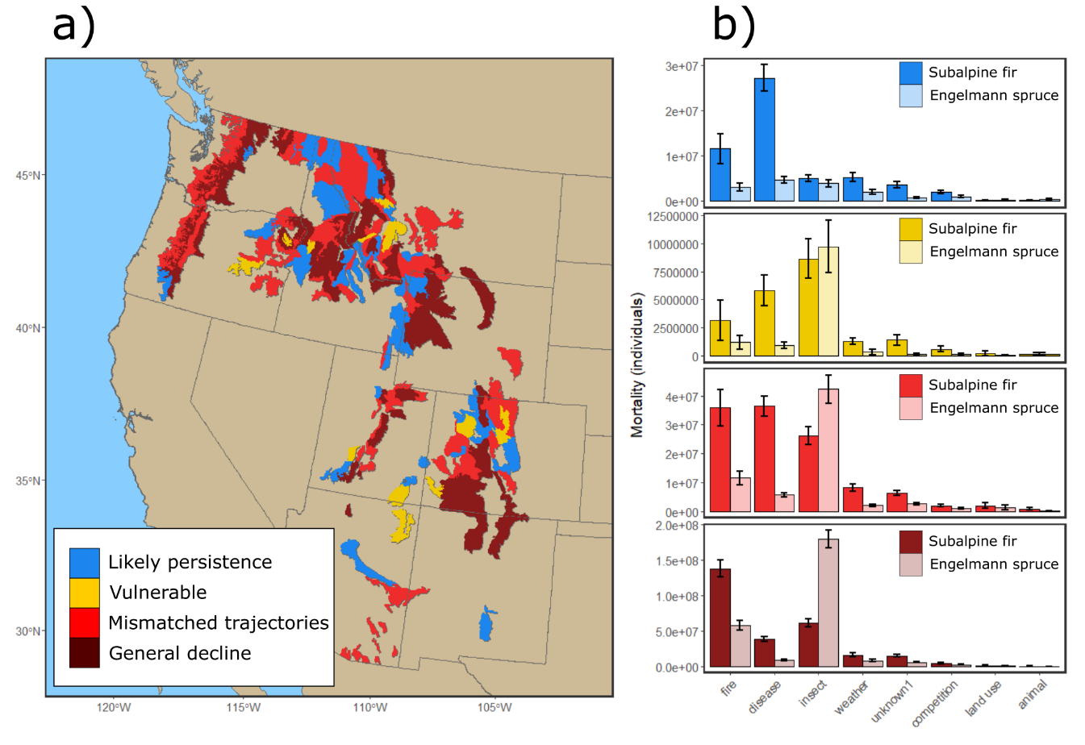

**Figure 2.** Distribution of different population trajectory categories, as estimated at the ecoregion subsection level across the shared range of subalpine fir and Engelmann spruce (a), and the estimated mortality of both species in each category caused by broad classes of mortality agents (b). Colors correspond with the categories in Figure 1.

**Figure 3.** Model-predicted mortality (x-axis) and probability of seedling presence (y-axis) for subalpine fir (blue lines and points) and Engelmann spruce (red lines and points) in each of the population trajectory categories shown in Figure 1. Points indicate the mean predicted rates in an ecoregion subsection, and lines indicate their density distribution.

**Figure 4.** Example of using models to project changes in mortality under future scenarios for subalpine fir (a) and Engelmann spruce (b). Maps show the difference between future predicted mortality and current estimated mortality for 2041-2060 under the SSP3-7.0 climate scenario. Predictions assume current landscape levels of disturbance and observed tree sizes.