**Box 1**. *Conceptual framework for linking single-species population trends to community-level reorganization trajectories.* Changes in either abundance or basal area can be caused by a variety of processes, including stand development, disturbance-related turnover, or mortality. To disentangle these processes, we combined abundance and basal area estimates for each species using a binary categorization scheme (Figure *i*; Perret *et al.* 2023) with four population trajectory categories: *densification* (increases in both basal area and abundance), *development* (declining abundance but increasing basal area), *turnover* (increasing abundance but declining basal area)*,* and *decline* (decreases in both basal area and abundance).

**Figure *i*.** Binary categorization scheme combining trends in abundance and basal area for a single species.

In a simple community comprised of two species, continued coexistence requires positive population trajectories for both species (*i.e.,* *development* or *densification*, described above). In contrast, if one species is experiencing turnover or decline, the spruce-fir system is vulnerable to a shift to single-species dominance or other compositional changes. We used the single-species population trajectories described above to categorize these possibilities (Figure *ii*) after the post-disturbance reorganization schema presented by Seidl & Turner (2022). These possibilities include: (1) *persistence/resilience* – both species are either undergoing changes corresponding with normal stand development or are actively increasing in density; (2) *structural change* – one or both species have experienced significant turnover of individuals, indicating that future trajectories may depend on post-disturbance recovery and survival of new recruits; (3) *compositional change* – one species is in decline while the other is either undergoing normal stand development or increasing in density, suggesting that one species will become dominant over the other; and (4) *replacement* – indicating that both species are in decline, and the system may be replaced entirely.

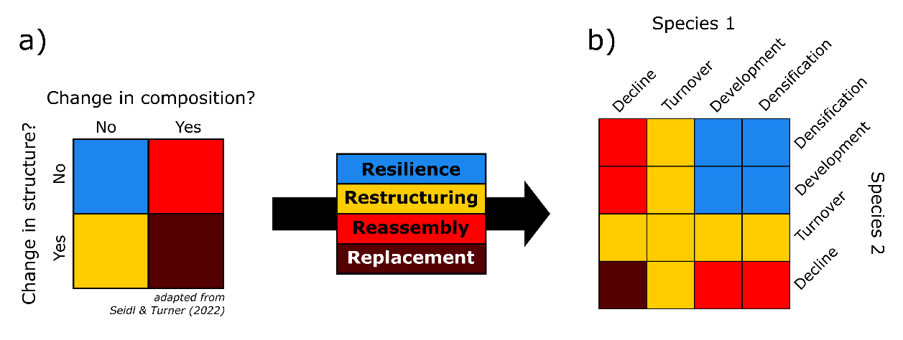

**Figure *ii*.** The post-disturbance reorganization categories (a) described by Seidl & Turner (2022) can be mapped onto a bivariate classification scheme comprised of the population trajectories of two co-occurring species (b).