**Introduction**

Global change is reshuffling species assemblies globally, and predicting what that looks like is very difficult. Predicting community assembly is a longstanding problem in ecology, exacerbated by rapidly shifting environmental/disturbance conditions.

Coexistence theory may help in this respect; explicitly considering how environmental requirements intersect with competition and demography

For example, subalpine fir-spruce codominance in mountains of WNA maintained by very specific balance of demographic rates; those are a product of species-specific responses to environment and disturbance regimes. Prior work suggests that coexistence of subalpine fir and Engelmann spruce is maintained by interspecific differences in key life history traits and associated vital rates. Specifically, the faster growth and more prolific regeneration of subalpine fir is balanced by higher survival and longevity of Engelmann spruce, leading to overstory codominance despite fir understory dominance (Andrus et al. 2018). Periodic disturbance may also play an important role in providing canopy gaps in which spruce seedlings can outcompete the more shade-tolerant fir seedlings (Shea 1985).

Evidence from past glacial-interglacial cycles suggests that no-analog communities formed when climates were different/differently distributed than they are now; we also know that this spruce-fir association looked very different. Highlight a couple examples. We know that subalpine fir and Engelmann spruce were not always as closely associated as they are today -- during Pleistocene glaciations, the bulk of Engelmann spruce refugia were in southern interior highlands (AZ mountains, NM plateau, CO plateau), whereas subalpine fir populations were more widely distributed across northern interior basins and coastal refugia (Roberts & Hamann 2015).

Could current and future global change produce conditions under which current species associations are no longer viable? Changing climate and disturbance regimes may “break” these demographic pathways that maintain spruce-fir forest systems, insofar as species have different responses to climate, fire, and host-specific biological disturbance agents.

Evidence from prior ABLA paper suggesting that trajectories of subalpine forests depends on interspecific variation in climate resposnes responses. Our subalpine fir status and trends paper suggested that the future trajectories of subalpine forest communities may depend on interspecific variation in responses to climate change, nondiscriminant forest disturbances (*e.g.,*fire), and host-specific forest disturbances (*e.g.,* biological disturbance agents, BDAs; Perret et al., 2023). This was supported in part by differences we found in the importance of major sources of mortality between regions where subalpine fir was in decline compared to other co-occurring species.

Here we leverage FIA data to investigate whether demographic mechanisms of coexistence for subalpine fir and Engelmann spruce across the two species’ joint distribution in western NA are vulnerable to changing climates and disturbances. We do this by first estimating population trends between 2000-2009 and 2010-2019 for both species where they co-occur, and using a new conceptual framework to categorize these trajectories. We then build a series of hierarchical Bayesian demographic models that estimate the effect of climate types, climate anomalies, and disturbance on individual mortality, regeneration, and recruitment. We use these models to assess whether projected future change scenarios make future coexistence more/less likely.

*Conceptual framework* (maybe a box?)

Describe conceptual framework for comparing population trajectories of multiple coexisting species based on basal area and stem density trends, e.g., persistence, structural change, compositional change, replacement – grounded in Seidl & Turner paper. Perhaps here is where conceptual diagram figure is referenced.

conceptual framework for comparing population trajectories of multiple coexisting species, based on basal area and stem density trends. I’ve created four bins of possibilities with respect to the likelihood of future coexistence: (1) *persistence/resilience* – both species are either undergoing changes corresponding with normal stand development or are actively increasing in density; (2) *structural change* – one or both species have experienced significant turnover of individuals, indicating that future trajectories may depend on post-disturbance recovery and survival of new recruits; (3) *compositional change* – one species is in decline while the other is either undergoing normal stand development or increasing in density, suggesting that one species will become dominant over the other; and (4) *replacement* – indicating that both species are in decline or experiencing significant turnover.

**Methods**

*Forest inventory data*

The US Forest Service Forest Inventory and Analysis (FIA) database provides nationally-consistent and randomized forest plot measurements across all forest lands in the United States. In the western United States, plots are remeasured on an average rotation of 10 years, facilitating estimates of decadal-scale changes in forest attributes and tree vital rates. In brief, each FIA plot consists of nested subplots on which adult trees (> 12.7 cm DBH) are inventoried, microplots on which seedlings (<2.54 cm DBH and >15.24 cm height) and saplings (2.54 – 12.7 cm DBH) are inventoried, and macroplots on which large trees are inventoried (in certain Western states; size threshold varies by state). FIA field crews collect a vast array of information, including physical tree measurements, tree damages, putative causes of mortality, and disturbance type and extent. For a complete description of FIA sampling and measurement protocols, refer to the FIA user guide and FIA field manual.

We queried the FIA database for plots that had been remeasured during the 2010-2019 inventory period, and contained both subalpine fir and Engelmann spruce. Following Perret *et al.* 2023, we included all plots that contained at least one individual of both species with a DBH > 2.54 cm. We intentionally retained plots that only contained dead individuals of either or both species, in order to avoid excluding plots that had experienced high mortality rates since the previous measurement. Every plot we included in our analyses could be linked back to a previous plot measurement; because Wyoming transitioned to the annualized sampling design later than other western States, initial plot measurements in the state came from the previous periodic survey design. In total, this yielded 2902 plots with two measurements between the 2000-2009 and 2010-2019 inventory periods, containing XX,XXX individual subalpine fir and Engelmann spruce.

*Population trajectories*

The FIA program uses a randomized sampling design that facilitates post-stratified estimation of multiple forest attributes. We used standard FIA estimation procedures (Bechtold & Patterson), modified from implementation in the rFIA package (Stanke), to estimate decadal changes in the abundance and basal area of both subalpine fir and Engelmann spruce within ecoregion subsections (Bailey) occupied by the species. These estimates were categorized for each species and ecoregion subsection using the scheme described above (Figure 1), forming four broad classes of population trajectories: *densification* (increases in both basal area and abundance), *development* (declining abundance but increasing basal area), *turnover* (increasing abundance but declining basal area)*,* and *decline* (decreases in both basal area and abundance). In cases where change estimates were statistically indistinguishable from zero (*i.e.,* sampling error was equal or greater to the magnitude of the change), we treated the estimate as though it were positive.

We combined subalpine fir and Engelmann spruce population trajectories using the two-species case described above (Figure 1), which is loosely based on the post-disturbance reorganization schema presented by Seidl & Turner (2021).

*Community trajectories*

Start with section describing single-species trajectory bins (i.e., decline, turnover, densification, development) > then >

*Demographic models*

Predictor variables

Maximum climate anomalies calculated after Littlefield et al and Davis et al; using maximum z-scores relative to reference period. Reference period is 30 years prior to initial plot measurement, anomalies calculated over remeasurement period.

Mortality model

Filtered tree data to get remeasured subalpine fir and Engelmann spruce from co-occurring stands that were alive at T1. Used tree status (i.e., live or dead) at time two as a response variable – that is, individual survival over a 10-year period. Model incorporates predictors at three levels of organization: tree, plot, and landscape. Tree-level predictors included tree size at T1, crown ratio at T1, and the presence/absence of insect or disease damage at T1. Plot-level predictors include climate normal and climate anomalies, stand density. Landscape-level predictors include the proportion of ecoregion subsection impacted by fire and biological disturbances. We built a binomial GLMM in a Bayesian framework using these predictors for each species.

Where the survival *S* of individual *i* in plot *p* nested in ecoregion *r* at time *t2* is modeled as a linear function of a fixed intercept b0 modified by a random term g1 varying between ecoregions *r*, and predictors varying between individuals *i*, plots *p,* and ecoregions *r*. Individual-level predictors include the diameter of tree *i* at time *t1*, crown ratio of tree *I* at time *t1*, and the damage status of tree *i* at time *t1*. Damage status was coded as 0 if the tree was undamaged, and 1 if any fire, insect, or disease damage was recorded. Plot-level predictors included climate normals *CN* between 1980 and 2010 (the time period corresponding to plot establishment), recent climate anomalies *CA* observed between time *t1* and time *t2,* and interactions between normal and anomalies. The index *j* indicates the climate normal variable (mean annual temperature or mean annual precipitation), whereas the index *k* indicates the climate anomaly variable (mean annual temperature, mean annual precipitation, or climatic moisture deficit). Ecoregion-level predictors include the proportion of spruce-fir forest in each ecoregion impacted by fire mortality *AF* or biological disturbance agent mortality *AB* between time *t1* and time *t2*. The model also included selected cross-scale interactions, namely between tree size *DIA,* climate anomalies *CA*, and disturbed area *AF* and *AB*.

Recruitment model

Regeneration model

Modeled regeneration as the probability of seedling presence (from SEED table) at the plot level during the most recent inventory period, as a function of plot and landscape-level predictors. Plot-level predictors include climate normal and recent anomalies, estimated fire severity, BDA severity, slope, aspect, elevation. Landscape-level predictors are the proportion of ecoregion impacted by fire or BDA. We again built a binomial GLMM in a Bayesian framework for each species. (build out equation).

Community trajectory categorization

Potentially another part here saying we took model-predicted mortality and regen, aggregated them to the ecoregion subsection level, and compared them across community trajectory categories to get a sense of what combinations of demographic rates area associated with coexistence.

*Future Projections*

**Preliminary results**

*Population estimation and categorization*

Figure 1 shows the conceptual framework for comparing population trajectories of multiple coexisting species, based on basal area and stem density trends. I’ve created four bins of possibilities with respect to the likelihood of future coexistence: (1) *persistence/resilience* – both species are either undergoing changes corresponding with normal stand development or are actively increasing in density; (2) *structural change* – one or both species have experienced significant turnover of individuals, indicating that future trajectories may depend on post-disturbance recovery and survival of new recruits; (3) *compositional change* – one species is in decline while the other is either undergoing normal stand development or increasing in density, suggesting that one species will become dominant over the other; and (4) *replacement* – indicating that both species are in decline or experiencing significant turnover. Note that ecoregion subsections for which either basal area or stem density trends were statistically indistinguishable from zero (*i.e.,* sampling error was equal or greater to the magnitude of the estimated change) were treated as though the trend in question was positive.

When we categorize ecoregion subsections using this scheme, as in Figure 2a, we find that 38.4% of the species’ shared distribution falls in the *persistence/resilience* category, 13.0% in the *structural change* category, 38.6% in *compositional change,* and 10.1% in *replacement*. This suggests that, based on population trends estimated between 2000-2009 and 2010-2019 inventory periods, it is unlikely that subalpine fir-Engelmann spruce systems will persist across ~50% of their current distribution. The major sources of mortality for each species differ between categories, shown in Figure 2b. Notably, insect mortality dominates across all categories except *persistence/resilience* for Engelmann spruce, probably reflecting severe spruce beetle outbreaks in parts of the species’ range. Subalpine fir mortality from insects and diseases is fairly consistent across categories, ranging from 2-3 trees per hectare for diseases and 1-3 trees per hectare for insects. Fire mortality was more variable, however, and was the dominant mortality agent for subalpine fir in the *compositional change* and *replacement* categories.

Mortality is more evenly distributed between fire, disease, and insect agents for subalpine fir, except in the *replacement* category, where it seems to be mostly driven by fire. These differences suggest that global change drivers that indirectly cause mortality by acting on these proximate mortality agents may impact the two species differently across their shared distribution.

*Mortality models*

**Effects**

ABLA – negative effect of mean temps on survival but positive effect of temperature anomalies (check interactions between anomalies and refs), super strong negative effect of fire area (with anom interactions), moderate tree size effect that interacts with lots of terms significantly

PIEN – no significant tree size effect! Small/moderate positive effect of temp anoms, very negative effect of CMD anoms (and strong interaction). No effect of MAT reference, moderate neg effect of MAP reference, check interactions with anoms. Strong fire area effect. Strong disturbance x anomaly interactions.

*Regeneration models*

**Effects**

ABLA --

PIEN --

Mortality and regeneration models are still in development. Mortality models are binomial GLMMs with the response variable being tree status (*i.e.,* alive or dead) at the second plot visit for trees that were alive during the initial inventory (*i.e.,* individual probability of survival over a 10-year period). The model incorporates predictors at three levels of organization: tree (tree size, crown ratio, and the presence/absence of insect or disease damage), plot (climate normal and recent anomalies, stand density), and landscape (proportion of ecoregion subsection impacted by fire and biological disturbances); as well as cross-scale interactions (*e.g.,* between tree size, climate anomalies, and disturbance) and ecoregion subsection-level random intercepts. I built a separate model for each species, though I also explored joint models that incorporate interactions between species identity and various other predictors, or species-level random effects; ultimately, separate models performed better and are easier to interpret. I’ve been evaluating model performance in a variety of ways – in short, the models evaluate well at larger scales of organization (*e.g.,* at ecoregion subsection scales), though differentiation between living and dead trees is more difficult at individual scale. The single best predictor of mortality is whether a plot burned between remeasurements; I opted to omit this from the model in order to make larger-scale predictions without trying to model the probability of fire itself.

*Regeneration models*

I chose to model regeneration as the probability of seedling presence at the plot level during the most recent inventory period, again using a binomial GLMM. These models are newer and I haven’t yet done as much work evaluating their performance or exploring the estimated effects. They currently incorporate predictors at the plot (climate normal and recent anomalies, estimated fire severity, estimated BDA severity, slope, aspect, elevation) and landscape (proportion of ecoregion impacted by fire or biological disturbances) level. Ideally, climate and disturbance predictors should correspond to those in the mortality models so that predictions from both models can be evaluated jointly.

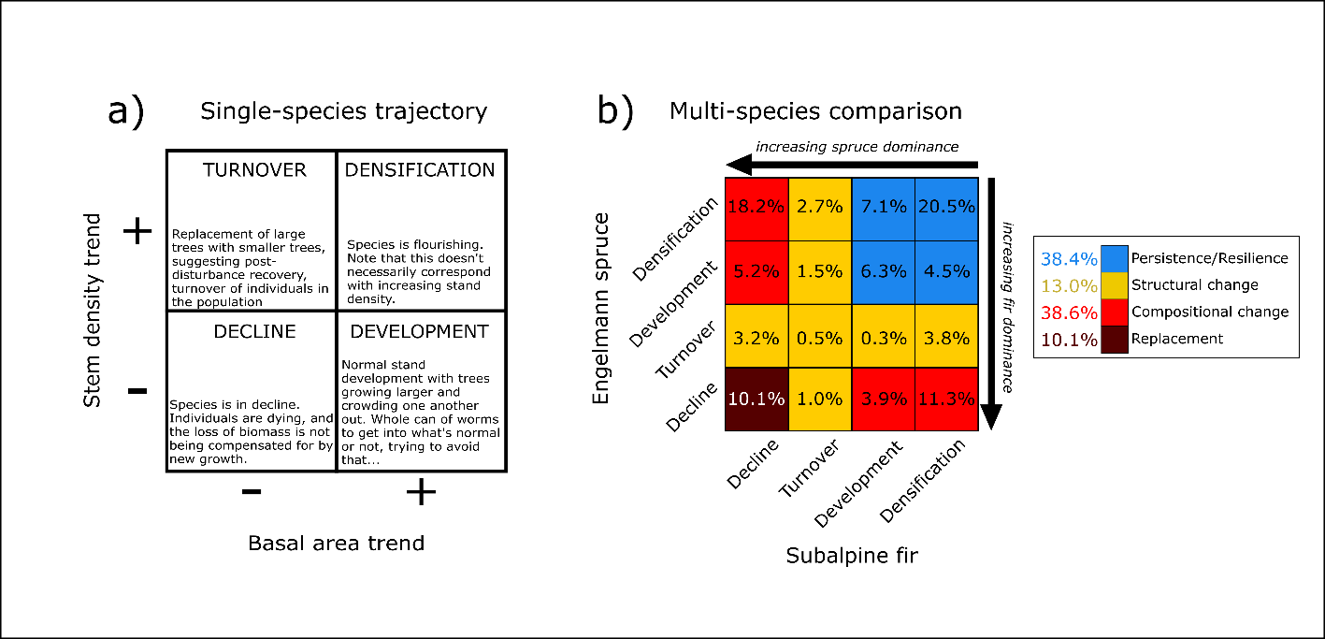**Figures**

**Figure 1.** Conceptual diagram of single-species population trajectories (a) and how they combine for two species (b). Panel (a) shows how combinations of basal area and stem density trends suggest differing population trajectories: *decline*, where both basal area and stem density are decreasing; *turnover*, where basal area is decreasing but stem density is increasing; *development*, where increasing basal area and decreasing stem density suggest self-thinning stand development; and *densification*, where both basal area and stem density are increasing. For two species (b), these four categories combine to suggest different likelihoods that species’ coexistence will persist: *persistence/resilience*, where both species are either experiencing stand development or densification; *structural change,* where one of the two species is experiencing high turnover associated with mortality, suggesting that future coexistence depends on increased recruitment and survival; *compositional change*, where one species is in decline and the other is flourishing, suggesting that one species will likely dominate over the other; and *replacement*, in which both species are experiencing population declines concurrently.

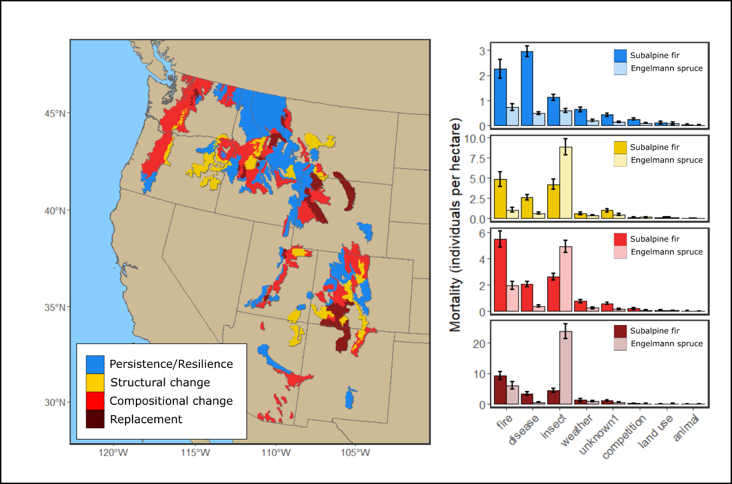

**Figure 2.** Distribution of different population trajectory categories, as estimated at the ecoregion subsection level across the shared range of subalpine fir and Engelmann spruce (a), and the estimated mortality of both species in each category caused by broad classes of mortality agents (b). Colors correspond with the categories in Figure 1.

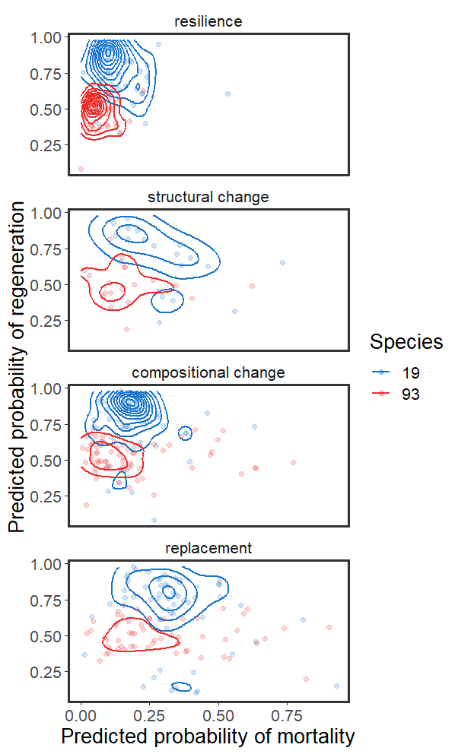**Figure 3.** Model-predicted mortality (x-axis) and probability of seedling presence (y-axis) for subalpine fir (blue lines and points) and Engelmann spruce (red lines and points) in each of the population trajectory categories shown in Figure 1. Points indicate the mean predicted rates in an ecoregion subsection, and lines indicate their density distribution.

**Figure 4.** Example of using models to project changes in mortality under future scenarios for subalpine fir (a) and Engelmann spruce (b). Maps show the difference between future predicted mortality and current estimated mortality for 2041-2060 under the SSP3-7.0 climate scenario. Predictions assume current landscape levels of disturbance and observed tree sizes.