**Demographic mechanisms of species’ coexistence in subalpine forests are vulnerable to changing climate and disturbance**

*Target journals: Global Change Biology? Ecology Letters (long shot)?*

Daniel L. Perret, David M. Bell, Harold H. J. Zald

**Introduction**

Global change is reshuffling species assemblies globally, and predicting what that looks like is very difficult. Predicting community assembly is a longstanding problem in ecology, exacerbated by rapidly shifting environmental/disturbance conditions.

Coexistence theory may help in this respect; explicitly considering how environmental requirements intersect with competition and demography

For example, subalpine fir-spruce codominance in mountains of WNA maintained by very specific balance of demographic rates; those are a product of species-specific responses to environment and disturbance regimes. Prior work suggests that coexistence of subalpine fir and Engelmann spruce is maintained by interspecific differences in key life history traits and associated vital rates. Specifically, the faster growth and more prolific regeneration of subalpine fir is balanced by higher survival and longevity of Engelmann spruce, leading to overstory codominance despite fir understory dominance (Andrus et al. 2018). Periodic disturbance may also play an important role in providing canopy gaps in which spruce seedlings can outcompete the more shade-tolerant fir seedlings (Shea 1985).

Evidence from past glacial-interglacial cycles suggests that no-analog communities formed when climates were different/differently distributed than they are now; we also know that this spruce-fir association looked very different. Highlight a couple examples. We know that subalpine fir and Engelmann spruce were not always as closely associated as they are today -- during Pleistocene glaciations, the bulk of Engelmann spruce refugia were in southern interior highlands (AZ mountains, NM plateau, CO plateau), whereas subalpine fir populations were more widely distributed across northern interior basins and coastal refugia (Roberts & Hamann 2015).

Could current and future global change produce conditions under which current species associations are no longer viable? Changing climate and disturbance regimes may “break” these demographic pathways that maintain spruce-fir forest systems, insofar as species have different responses to climate, fire, and host-specific biological disturbance agents.

Evidence from prior ABLA paper suggesting that trajectories of subalpine forests depends on interspecific variation in climate resposnes responses. Our subalpine fir status and trends paper suggested that the future trajectories of subalpine forest communities may depend on interspecific variation in responses to climate change, nondiscriminant forest disturbances (*e.g.,*fire), and host-specific forest disturbances (*e.g.,* biological disturbance agents, BDAs; Perret et al., 2023). This was supported in part by differences we found in the importance of major sources of mortality between regions where subalpine fir was in decline compared to other co-occurring species.

Here we leverage FIA data to investigate whether demographic mechanisms of coexistence for subalpine fir and Engelmann spruce across the two species’ joint distribution in western NA are vulnerable to changing climates and disturbances. We do this by first estimating population trends between 2000-2009 and 2010-2019 for both species where they co-occur, and using a new conceptual framework to categorize these trajectories. We then build a series of hierarchical Bayesian demographic models that estimate the effect of climate types, climate anomalies, and disturbance on individual mortality, regeneration, and recruitment. We use these models to assess whether projected future change scenarios make future coexistence more/less likely.

**Methods**

Forest inventory data

The US Forest Service Forest Inventory and Analysis (FIA) database provides nationally-consistent and randomized forest plot measurements across all forest lands in the United States. In the western United States, plots are remeasured on an average rotation of 10 years, facilitating estimates of decadal-scale changes in forest attributes and tree vital rates. In brief, each FIA plot consists of nested subplots on which adult trees (> 12.7 cm DBH) are inventoried, microplots on which seedlings (<2.54 cm DBH and >15.24 cm height) and saplings (2.54 – 12.7 cm DBH) are inventoried, and macroplots on which large trees are inventoried (in certain Western states; size threshold varies by state). FIA field crews collect a vast array of information, including physical tree measurements, tree damages, putative causes of mortality, and disturbance type and extent. For a complete description of FIA sampling and measurement protocols, refer to the FIA user guide and FIA field manual.

We queried the FIA database for plots that had been remeasured during the 2010-2019 inventory period, and contained both subalpine fir and Engelmann spruce. Following Perret *et al.* 2023, we included all plots that contained at least one individual of both species with a DBH > 2.54 cm. We intentionally retained plots that only contained dead individuals of either or both species, in order to avoid excluding plots that had experienced high mortality rates since the previous measurement. Every plot we included in our analyses could be linked back to a previous plot measurement; because Wyoming transitioned to the annualized sampling design later than other western States, initial plot measurements in the state came from the previous periodic survey design. In total, this yielded 2,972 plots with two measurements between the 2000-2009 and 2010-2019 inventory periods, containing 34,989 subalpine fir individuals and 27,944 Engelmann spruce individuals.

Population trajectories

The FIA program uses a randomized sampling design that facilitates post-stratified estimation of multiple forest attributes. We used standard FIA estimation procedures (Bechtold & Patterson), modified from implementation in the rFIA package (Stanke), to estimate decadal changes in the abundance and basal area of both subalpine fir and Engelmann spruce within ecoregion subsections (Bailey) occupied by both species. Changes in either abundance or basal area can be caused by a variety of processes, including stand development, disturbance-related turnover, or mortality. To disentangle these processes, we combined abundance and basal area estimates for each species using a binary categorization scheme (Figure 1; Perret *et al.* 2023) with four population trajectory categories: *densification* (increases in both basal area and abundance), *development* (declining abundance but increasing basal area), *turnover* (increasing abundance but declining basal area)*,* and *decline* (decreases in both basal area and abundance). In cases where change estimates were statistically indistinguishable from zero (*i.e.,* sampling error was equal or greater to the magnitude of the change), we treated the estimate as though it were positive.

Continued codominance of Engelmann spruce and subalpine fir requires positive population trajectories (*i.e.,* *development* or *densification*, described above) for both species. In contrast, if one species is experiencing turnover or decline, the spruce-fir system is vulnerable to a shift to single-species dominance or other compositional changes. We used the single-species population trajectories described above to categorize these possibilities (Figure 1) after the post-disturbance reorganization schema presented by Seidl & Turner (2021). These possibilities include: (1) *persistence/resilience* – both species are either undergoing changes corresponding with normal stand development or are actively increasing in density; (2) *structural change* – one or both species have experienced significant turnover of individuals, indicating that future trajectories may depend on post-disturbance recovery and survival of new recruits; (3) *compositional change* – one species is in decline while the other is either undergoing normal stand development or increasing in density, suggesting that one species will become dominant over the other; and (4) *replacement* – indicating that both species are in decline, and the system may be replaced entirely.

Demographic models

We built a series of statistical models for each species predicting individual mortality, seedling presence, and recruitment presence as the linear combination of several predictor variables and their interactions. Because each response variable is a binary state (*i.e.,* the presence or absence of mortality, seedlings, or recruitment), each model is a binomial generalized linear mixed model with a logit link function that we implemented in a Bayesian framework with non-informative priors. We used the ‘brms’ package (cit) in the RX.X.X statistical programming environment (R Core Team, 2023) to build all of our models. All models were trained with uninformative priors over 10,000 “burn-in” iterations and 10,000 sampling iterations across four sampling chains. Model convergence was assessed using Ruben-Gelman statistics for each estimated model parameter and visual inspection of sampling chains.

*Climate data*

Past work has demonstrated tree demography in temperate regions is strongly influenced by aspects of the local climate related to moisture availability (Littlefield, Davis, Babst, etc). However, at regional or continental scales, spatial variation in mean climatic conditions also plays an important role in structuring biogeographical patterns in forest systems, including local responses to temporal climatic variation (cits, Klesse, Perret). We balanced these different influences in our demographic models by including climate predictors reflecting underlying mean climatic conditions, as well as predictors reflecting local climate anomalies. Specifically, we used historical climate data from ClimateNA (Wang et al) to calculate the mean annual temperature, mean annual precipitation, and mean climatic moisture deficit for each FIA plot in our dataset during a reference period comprising the 30 years preceding each site’s initial measurement. We then calculated the maximum mean annual temperature and climatic moisture deficit anomalies each plot experienced between its initial measurement and remeasurement (approximately 10 years) relative to the reference period means. These maximum anomalies were converted to z-scores using variation observed during the reference period, following the procedures of Littlefield *et al.* (2020) and Davis *et al.* (2023). These anomalies capture the maximum degree to which climatic conditions at each FIA plot departed from historical baselines during the period reflecting our population trajectory estimates. In all our demographic models, we incorporated interactions between climate anomalies and reference mean conditions, which allows for regional variation in demographic responses to local temporal climatic variation.

*Mortality models*

The annualized FIA sampling design was implemented in most western US states in 2000, and entails remeasuring each FIA plot on approximately 10 year rotations. For the vast majority of plots, there thus exists an initial measurement between 2000 and 2009, and a single remeasurement between 2010 and 2019. This limits the temporal resolution of any demographic rate (*e.g.,* mortality, growth, recruitment) estimated using FIA remeasurement data. While FIA field crews do assign an estimated year to every observed instance of tree mortality, the accuracy of that estimate likely varies widely depending on mortality agent, stand characteristics, tree species, and region. We thus modeled mortality over the entire remeasurement period, *i.e.,* the decadal probability of mortality.

We filtered FIA tree data to select remeasured subalpine fir and Engelmann spruce from the 2,972 plots on which they cooccurred that were alive at initial measurement and recorded as dead or alive at the second measurement (N = 34,989 subalpine fir and 27,944 Engelmann spruce). For each species, we modeled a tree’s status (*i.e.,* live or dead) at remeasurement using a binomial generalized linear mixed model with individual-, plot-, and landscape-level predictors. The model structures were as follows:

where the survival *S* of individual *i* in plot *p* nested in ecoregion *r* at time *t2* is modeled as a linear function of a fixed intercept b0 modified by a random term g1 varying between ecoregions *r*, and predictors varying between individuals *i*, plots *p,* and ecoregions *r*. Individual-level predictors include the diameter (*DIA*), crown ratio (*CR*), and damage status (*DAM*) of tree *i* at time *t1*. Damage status was coded as 0 if the tree was undamaged, and 1 if any fire, insect, or disease damage was recorded. Plot-level predictors included climate normals *CN* during the 30-year reference period preceding the initial plot measurement, recent climate anomalies *CA* observed between time *t1* and time *t2,* and their interactions. The index *j* indicates the climate normal variable (mean annual temperature or mean annual precipitation), whereas the index *k* indicates the climate anomaly variable (mean annual temperature or climatic moisture deficit). We also included the total stand basal area (*BAH*) within each plot at *t*1. Landscape-level predictors include the proportion of spruce-fir forest in each ecoregion impacted by fire mortality *AF* or biological disturbance agent mortality *AB* between time *t1*and time *t2*. These proportions were calculated using the FIA sampling design, after Perret *et al.* (2023). The model also included selected cross-scale interactions, namely between tree size *DIA,* climate anomalies *CA*, and disturbed area *AF* and *AB*. β4, β5, and β6 terms represent vectors of model-estimated coefficients corresponding to the indices for each covariate and interactions between covariates.

*Regeneration models*

FIA field procedures define seedlings as individual trees with a diameter of less than 2.54 cm and a height of at least 15 cm. Seedlings are inventoried on smaller microplots nested within subplots; because of this, seedling density estimates have more uncertainty than those for adults, and may be unreliable when there is high spatial heterogeneity. We thus chose to model subalpine fir and Engelmann spruce regeneration using seedling presence rather than seedling densities. For each species, we used a binomial generalized linear mixed model to predict the probability of seedling presence at an FIA plot at its remeasurement:

where seedling presence *R* in plot *p* nested in ecoregion *r* at time *t2*is modeled as a linear function of a fixed intercept b0 modified by a random term g1 and several predictor variables. These include the severity of fire disturbance (*SEV*) on a plot between t2 and t1, calculated as the proportion of adult trees of all species living on the plot at t1 that had died due to fire (according to FIA field crew assignments) by t2. Other predictors included total stand basal area (*BAH*) and reference period climate normals (*CN*) and remeasurement period climate anomalies (*CA*), as described for the mortality models above.

*Recruitment models*

Previous work on subalpine fir population trends has demonstrated that sapling recruitment presents a critical demographic bottleneck for the species across its distribution (Perret *et al.* 2023). However, saplings are defined by FIA field protocol as trees with a diameter between 2.54 and 12.7 cm, and are inventoried on microplots similarly to seedlings. We thus chose to model sapling recruitment similarly to seedling regeneration; as the presence or absence of new sapling recruits recorded on the microplot at remeasurement. **sentence about splitting seedlings/saplings getting at different demographic processes?** Sapling recruitment models were structured identically to seedling regeneration models (equation 2) for both species.

Future Projections

*In progress! This section will connect models to change categories, and step through using future climate, disturbance, and management scenarios to assess future vulnerabiliies and opportunities for mitigation (e.g., reducing stand basal area, reducing fire severity, etc).*

1. *Connect demo models to change categories*
2. *Quantify how well demo rates discriminate between categories 🡪 best way to do this? Perhaps with a simple multinomial regression analysis or decision tree might work too*
3. *Force demo models with future scenarios (e.g., 2050 climate with current disturbance, +5% disturbance, +10% disturbance, -10% stand density)*
4. *Connect back to categories to see which areas are most vulnerable to switching from persistence > compositional change, etc.*

**Results**

Population trajectories

*Start with brief couple sentences about each species trajectories separately.*

Across all ecoregion subsections where subalpine fir and Engelmann spruce co-occur, we found that 38.4% of the species’ shared distribution falls in the *persistence/resilience* category (Figure 1), with positive population trajectories for both species. *Structural change,* characterized by significant turnover among one or both species, comprised 13.0% of the shared distribution. In 38.6% of the shared distribution, population trajectories were mismatched between the two species such that one was in decline while the other was not, forming the *compositional change* category. Both species were in decline across 10.1% of the shared distribution, indicating possible *replacement*.

We found notable differences in estimated population trajectories between regions and mountain ranges (Figure 2). Along the Cascade Mountains in Oregon and Washington, almost all subalpine fir-Engelmann spruce forests fell in the *compositional change* category. This is in contrast to the northern Rocky Mountains in northern Idaho and northwestern Montana, which formed the largest contiguous block of estimated *persistence/resilience*. The central Idaho mountains, which have experienced significant large-scale wildfire events and insect/disease outbreaks between inventory periods, were characterized by a mixture of *structural change* and *compositional change*. The largest estimated areas of *decline* were found in southern Colorado and northern New Mexico.

The major sources of mortality for each species differed between population trajectory categories, (Figure 2). Notably, insects were the largest mortality source across all categories except *persistence/resilience* for Engelmann spruce, probably reflecting severe spruce beetle outbreaks in parts of the species’ range (refs). Subalpine fir mortality from insects and diseases was fairly consistent across categories, ranging from 2-3 trees per hectare for diseases and 1-3 trees per hectare for insects. Fire mortality was more variable, however, and was the dominant mortality agent for subalpine fir in the *compositional change* and *replacement* categories. Additionally, mortality in general was substantially higher in *replacement* regions than in any other category.

Demographic models

All demographic models converged adequately, indicated by Gelman-Rubin statistics equal to 1.0 for all covariate estimates and visual inspection of sampling chains.

*Mortality*

Individual probability of mortality on average was substantially higher for subalpine fir than for Engelmann spruce (Figure 3). For both species, probability of mortality increased with tree size, though the effect was stronger for subalpine fir than for Engelmann spruce (Supplementary Figure X). Tree condition was also an important influence on mortality, with higher crown ratios associated with lower probability of mortality and insect/disease damage associated with higher probability of mortality. For subalpine fir, mortality was higher in regions with warmer mean reference temperatures; this effect was weaker for Engelmann spruce (Supplementary Figure X). Despite this, warmer temperature anomalies during remeasurement were associated with lower mortality for both species (Figure 3a), and especially for subalpine fir. Reference precipitation did not have a substantial effect on mortality for either species, though there was some weak evidence that Engelmann spruce mortality was higher in wetter regions. CMD anomalies, however, had more substantial impacts, with higher deficits associated with slightly lower mortality risk for subalpine fir and slightly higher mortality risk for Engelmann spruce (Figure 3b, Supplementary Figure X). Fire disturbance had approximately the same strongly positive effect on mortality for both species (Figure 3c), whereas insect/disease disturbance **work up this partial effects plot**. Greater stand density was associated with substantially lower mortality risk for subalpine fir, and slightly higher mortality risk for Engelmann spruce.

*Regeneration*

On average, seedling presence was more likely for subalpine fir than for Engelmann spruce, with divergent modeled responses between the species (Figure 3). While regeneration probability was higher in regions with colder reference mean annual temperatures for both species (Supplementary Figure X), responses to temperature anomalies varied. Subalpine fir regeneration had a strong negative response to mean annual temperature anomalies during the remeasurement period (Figure 3e), whereas the Engelmann spruce regeneration response to temperature anomalies depended on the reference temperature. Higher temperature anomalies were associated with lower Engelmann spruce regeneration in warmer regions, and higher regeneration in colder regions (Supplementary Figure X). Reference period precipitation had no effect on subalpine fir regeneration, and a weakly negative effect on Engelmann spruce regeneration; similar patterns were also reflected in regeneration responses to CMD anomalies (Supplementary Figure X, Figure 3f). Fire severity, as estimated by the proportion of adult trees on a plot killed by fire between remeasurements, had a strongly negative effect on regeneration probability for both species, but especially for subalpine fir (Figure 3g). Stand density, on the other hand, had a strong negative effect on Engelmann spruce regeneration but no effect on subalpine fir regeneration, likely reflecting differences in the shade-tolerance of the two species.

*Recruitment*

The probability of sapling recruitment was higher on average for subalpine fir than for Engelmann spruce, similarly to our seedling regeneration results. We found that subalpine fir sapling recruitment was less likely in regions with warmer reference temperatures; we found no similar effect for Engelmann spruce. For both species, higher remeasurement period temperature anomalies were associated with a lower probability of sapling recruitment. This relationship was stronger for subalpine fir than for Engelmann spruce, especially in colder regions (Supplementary Figure X). Moisture availability, as represented in the model by reference period mean annual precipitation and remeasurement period CMD anomalies, had no effect on subalpine fir sapling recruitment. For Engelmann spruce, however, higher moisture deficit anomalies were associated with higher sapling recruitment probabilities in drier regions, and lower recruitment in wetter regions (Supplementary Figure X). Fire severity was negatively related to sapling recruitment for both species, with an especially strong effect for subalpine fir. Stand density had a similarly negative effect on sapling recruitment for both species (Figure 3k-m).

Future projections

*in progress*

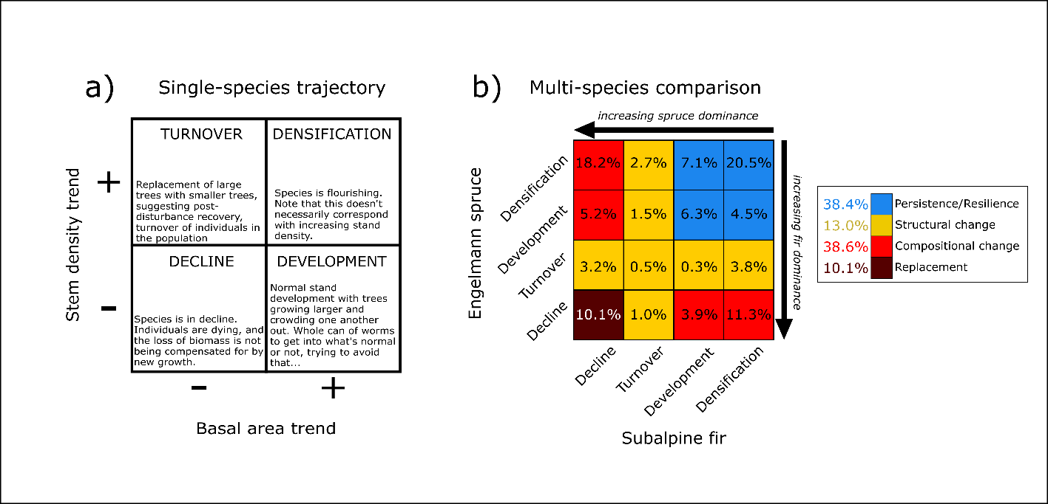**Figures**

**Figure 1.** Conceptual diagram of single-species population trajectories (a) and how they combine for two species (b). Panel (a) shows how combinations of basal area and stem density trends suggest differing population trajectories: *decline*, where both basal area and stem density are decreasing; *turnover*, where basal area is decreasing but stem density is increasing; *development*, where increasing basal area and decreasing stem density suggest self-thinning stand development; and *densification*, where both basal area and stem density are increasing. For two species (b), these four categories combine to suggest different likelihoods that species’ coexistence will persist: *persistence/resilience*, where both species are either experiencing stand development or densification; *structural change,* where one of the two species is experiencing high turnover associated with mortality, suggesting that future coexistence depends on increased recruitment and survival; *compositional change*, where one species is in decline and the other is flourishing, suggesting that one species will likely dominate over the other; and *replacement*, in which both species are experiencing population declines concurrently.

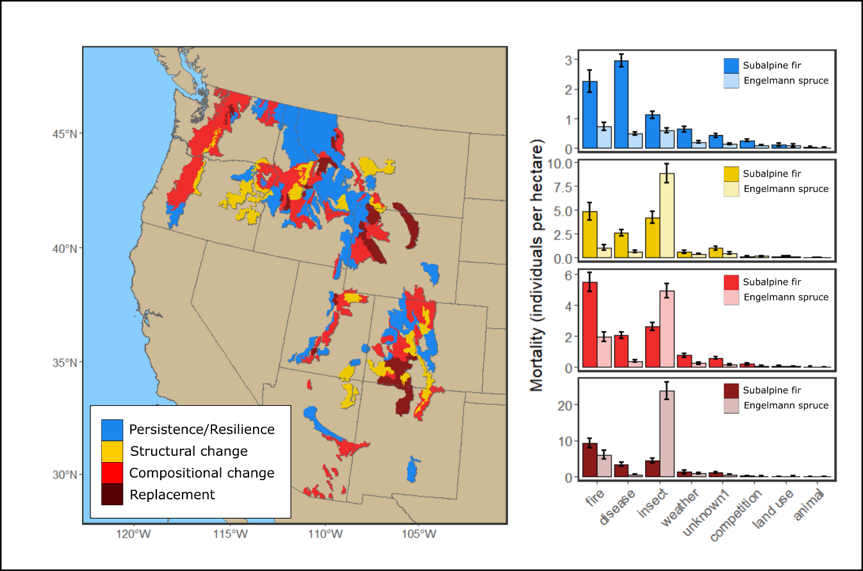

**Figure 2.** Distribution of different population trajectory categories, as estimated at the ecoregion subsection level across the shared range of subalpine fir and Engelmann spruce (a), and the estimated mortality of both species in each category caused by broad classes of mortality agents (b). Colors correspond with the categories in Figure 1.

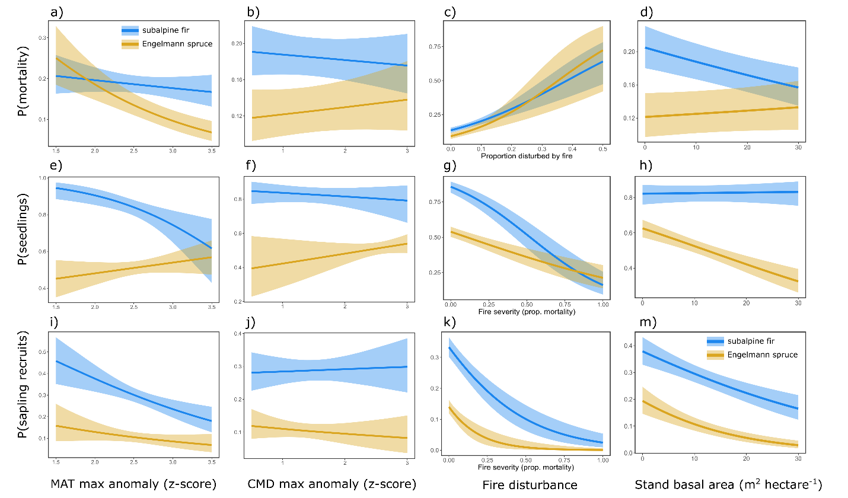

**Figure 3.** Modeled partial effects for selected demographic model covariates, for both subalpine fir (blue lines and shading) and Engelmann spruce (gold lines and shading). Panels *a – d* correspond to mortality models (y-axis shows the predicted individual probability of mortality over a 10 year remeasurement period), panels *e – h* correspond to seedling regeneration models (y-axis shows the probability of seedling presence at plot remeasurement), and panels *i – m* correspond to sapling recruitment models (y-axis shows the probability of new sapling recruitment at plot remeasurement). Covariates on x-axes are the maximum mean annual temperature anomaly during remeasurement periods (panels a, e, i), maximum climatic moisture deficit anomaly during remeasurement periods (panels b, f, j), fire disturbance expressed as the proportion of subalpine forests impacted by fire mortality during the remeasurement period (panel c) or fire severity expressed as the proportion of adult trees in a plot killed by fire during the remeasurement period (panels g, k), and total plot basal area (m2 hectare-1) at initial measurement. Lines and shading indicate marginal mean posterior predictions and 94% credible intervals, respectively, for subalpine fir (blue) and Engelmann spruce (gold). Partial effects are generated by holding all other predictor variables at their mean value and varying the covariate of interest within the range of observed values.

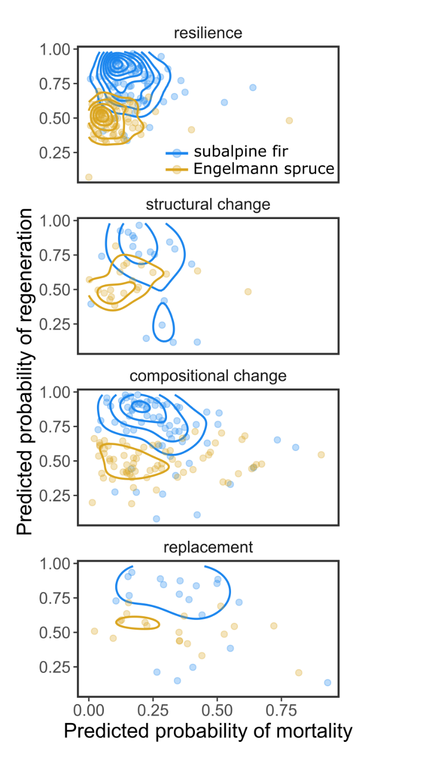

**Figure 4.** Model-predicted mortality (x-axis) and probability of seedling presence (y-axis) for subalpine fir (blue lines and points) and Engelmann spruce (red lines and points) in each of the population trajectory categories shown in Figure 1. Points indicate the mean predicted rates in an ecoregion subsection, and lines indicate their density distribution.

**Likely supplementary figures**

