**abstract**

Use FIA data to fit IPM, use that to predict effects of different stressors on lambda

Fire, wpbr, density key drivers of demography

Reducing fire hazard while doing thinning benefits species

Nice summary of the “four horsemen”

I really like the “contrast between perception and evidence” framing

3530 sugar pine individuals

Recruitment -> number of new recruits per existing individual ;;;

Okay, so they use a single overall fecundity/recruitment rate for the entire species! Recruitment is SO rare and heterogeneous… could this contribute to their estimating more decline than we would expect?

Reported trends in results don’t make sense or match up with referenced supplementary figures. <12.7 or <2.54?? Caption doesn’t match.

Leaves open door for focus on large trees

SO, I have no idea what rFIA fnctions the author used, because the code isn’t supplied with the paper. But I dug into rFIA growMort for sugar pine in CA, and there’s some real fucking weirdness that I can’t figure out. Lots of ingrowth ignored, and lots of survivors ignored for reasons I can’t suss out. Not sure what’s going on, and not sure how much time I want to put into tracking it down. Basically, I don’t trust the rFIA estimates that are getting spit out!

I’m going to leave it for now (02/08/24) – but I know that our status/trends assessments would be different for sure.

Also, I’m harboring some major skepticism about their recruitment/fecundity assumptions. They average across the entire distribution… which ignores that recruitment is incredibly heterogeneous both across space and through time.

13 Feb 24

Some thoughts about how the Foster paper will impact our work:

They had 4 major questions that did overlap quite a bit with some of our work:

1. Recent changes in PILA abundance across range

* *They did sort of answer this with range-wide change estimates… using rFIA, which has some weirdness as noted above (i.e., ditching tons of survival and ingrowth trees?).* *And then they assess ecoregional variation by using their IPM, which assumes a single averaged recruitment rate across the whole distribution – basically, spreading regeneration failure across everywhere…*

1. What are regional differences in trajectory of sugar pine across range

* *See above; using IPM projections with assumed average constant recruitment/fecundity rate*

1. What is the relatie importance of major stressors on sugar pine vital rates

* *Check partial effects plots from IPM. Looks reasonable; but why truncate at 125 cm DBH? Size distribution gets way bigger than that. Stand basal area has huge impact on growth.*

1. Likely impact of stressors on pila dynamics

* *Elasticity analysis with IPM; seems reasonable but would love more detail on interactions*

So, I don’t want to write a competing paper. But on the other hand, I don’t really believe their results and our population estimates are actually pretty different then theirs.

I do think that part of what we do should look at variability in recruitment across the range. Maybe built off of the ABLA approach.

There’s a lot of space to work with tree size; i.e., do some estimation only of large trees. Resources for thinking about variation in important tree size thresholds across range?

I really want to get into the scaling thing… from individual (tree rings and mort models) to stand (FIA plots, ecoregion subsections) to landscape (with RS data – HZ)

HZ/DB meeting;

Thinking through case studies and balancing signals with time period and plot revisits

Make slide that visually points out sweet spot for timing of event ; conceptual figure about how event lines up with temporal aspect of each dataset; something that happens between 2007-2018

BB maybe all works; Firmageddon maybe all falls apart

;;;

Sugar pine –> dave suggestion that we refocus on impacts associated with disturbance history and/or management history… fire severity vs survival of large trees; fire severity x stand density and tree size survival; thinning impacts…

For sugar pine…

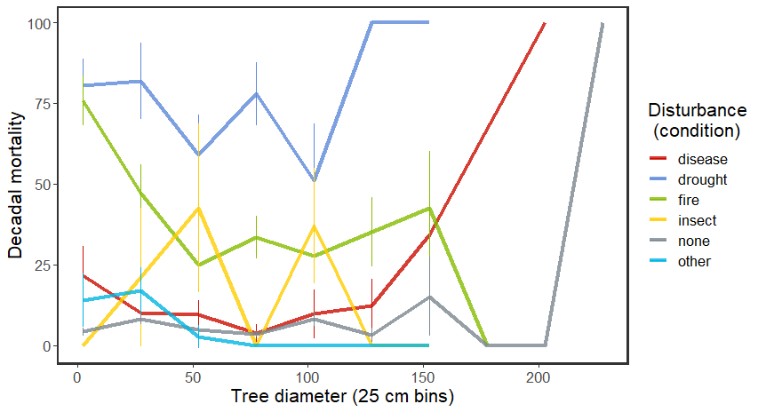

**Figure 1.**

^^ broken out by ownership categories…

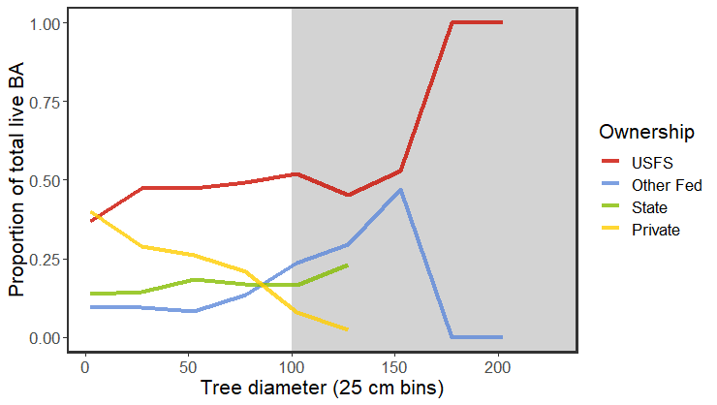

Okay, so very prelim analyses show that disturbances have different size class impacts…

So the Foster paper fills the range-wide status and trends hole that we were planning on addressing. While I do have some concerns about their analyses, we’re all in agreement that we don’t want to write a critical or competing manuscript. We discussed pivoting a bit with the estimation work to instead look at the legacy effects of management and disturbance, with an emphasis on large tree mortality. Some questions we could get at using this approach: Are large sugar pine more resistant to drought and disturbance in stands that have experienced a legacy of intermediate disturbance? Do thinning or fuel reduction treatments produce the same effect? Does this vary by forest type or regionally across the species’ distribution?

Figure 1 shows the results of some preliminary analyses exploring how the relationship between tree size and mortality differs between (condition) disturbance types, suggesting that (1) drought has the largest impact on mortality across size classes; (2) fire has the largest impact on smaller (<50cm DBH) trees; and (3) the impact of disease may be especially important for large trees (>100cm DBH). There are a couple caveats to using condition-level disturbance information, including limited temporal resolution, limitations data on repeat or compound disturbances, and some potential circularity (i.e., condition-level disturbances are identified based on mortality thresholds). Using spectral timeseries to define disturbance strata could get around some of these complications.

Another limitation of the FIA data for this use is that there isn’t much information about management, and where both are recorded, treatments almost always follow disturbances. Figure 2 shows sugar pine mortality-size estimates broken out by ownership group, in an attempt to get some (very coarse) management information. There are some interesting things to note – first, that mortality in drought-disturbed areas was almost non-existent in state and private forests. This could potentially be due to private ownership of the most drought-resistant landscape features (as we found in an analysis of mesic wildlife resources in sage-steppe across the western US). Or maybe private and state forests have significantly lower stand densities as a result of more harvest, contributing to greater drought resistance. Either way, that additional resistance and lower overall mortality won’t help large tree retention – almost all sugar pines > 100 cm DBH (old growth size threshold for Sierra mixed conifer) are on Federal lands.

This all sets an interesting stage for thinking about what kinds of management and/or disturbance histories are associated with better outcomes for sugar pine populations and large sugar pines in particular, and where the best management opportunities might be to increase resistance and resilience. I’m currently wrangling data from the FACTS database and combining it with exact plot coordinates to see whether thinning or fuel reduction treatments during the 2000-2009 inventory period are associated with better post-disturbance outcomes in the 2010-2019 inventory. I’m hoping that we can use LCMS data to get better pictures of disturbance histories for plots – Harold, your ideas there would be great. I’m optimistic that combining these three things – FIA estimation, management histories, and disturbance histories – can generate some interesting and relevant insight. I also think that there is a lot of room to think about regeneration in this story – on the one hand, we want to retain large trees; on the other hand, we need regeneration for long-term population viability. I haven’t had a chance to work up any preliminary regeneration analyses yet in this context, but will let you know when I have.