**New direction for sugar pine status & trends analyses**

The Foster *et al.* (2024) paper addresses many of the range-wide status and trends assessments we were planning to do for sugar pine. While I do have some concerns about their analyses, we’re all in agreement that we don’t want to write a critical or competing manuscript. We discussed pivoting a bit with the estimation work to instead look at the legacy effects of management and disturbance, with an emphasis on large tree mortality. Some questions we could get at using this approach: Are large sugar pine more resistant to drought and disturbance in stands that have experienced a legacy of intermediate disturbance? Do thinning or fuel reduction treatments produce the same effect? Does this vary by forest type or regionally across the species’ distribution?

Figure 1 shows the results of some preliminary analyses exploring how the relationship between tree size and mortality differs between (condition) disturbance types, suggesting that (1) drought is associated with the highest mortality across size classes; (2) fire has the largest impact on smaller (<50cm DBH) trees; and (3) the impact of disease may be especially important for large trees (>100cm DBH). There are a couple caveats to using condition-level disturbance information, including limited temporal resolution, limitations data on repeat or compound disturbances, and some potential circularity (i.e., condition-level disturbances are identified based on mortality thresholds). Using spectral timeseries to define disturbance strata could get around some of these complications.

Another limitation of the FIA data for this use is that there isn’t much information about management, and where both are recorded, treatments almost always follow disturbances. Figure 2 shows sugar pine mortality-size estimates broken out by ownership group, in an attempt to get some (very coarse) management information. There are some interesting things to note – first, that mortality in drought-disturbed areas was almost non-existent in state and private forests. This could potentially be due to private ownership of the most drought-resistant landscape features (as we found in an analysis of mesic wildlife resources in sage-steppe across the western US). Or maybe private and state forests have significantly lower stand densities as a result of more harvest, contributing to greater drought resistance. Either way, that additional resistance and lower overall mortality won’t help large tree retention – almost all sugar pines > 100 cm DBH (old growth size threshold for Sierra mixed conifer) are on Federal lands.

This all sets an interesting stage for thinking about what kinds of management and/or disturbance histories are associated with better outcomes for sugar pine populations and large sugar pines in particular, and where the best management opportunities might be to increase resistance and resilience. I’m currently wrangling data from the FACTS database and combining it with exact plot coordinates to see whether thinning or fuel reduction treatments during the 2000-2009 inventory period are associated with better post-disturbance outcomes in the 2010-2019 inventory. I’m hoping that we can use LCMS data to get better pictures of disturbance histories for plots – Harold, your ideas there would be very helpful. I’m optimistic that combining these three things – FIA estimation, management histories, and disturbance histories – can generate some interesting and relevant insight. I also think that there is a lot of room to think about regeneration in this story – on the one hand, we want to retain large trees; on the other hand, we need regeneration for long-term population viability. I haven’t had a chance to work up any preliminary regeneration analyses yet in this context, but they’ll be coming soon!

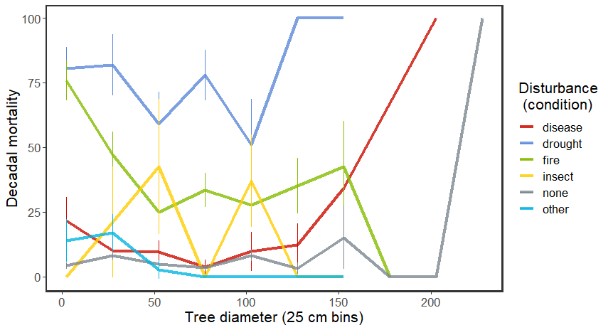

**Figure 1.** Sugar pine mortality in 25-cm size classes between 2000-2009 and 2010-2019 FIA inventory periods, in areas impacted primarily by broad disturbance classes (line colors). Disturbances are based on plot conditions, and require that the disturbance killed or damaged > 25% of trees in an area at least an acre in size.

**Figure 2.** Sugar pine mortality in 25-cm size classes in disturbed areas (line colors), separated by land ownership type (panels; USFS, Other Federal, State, and Private).

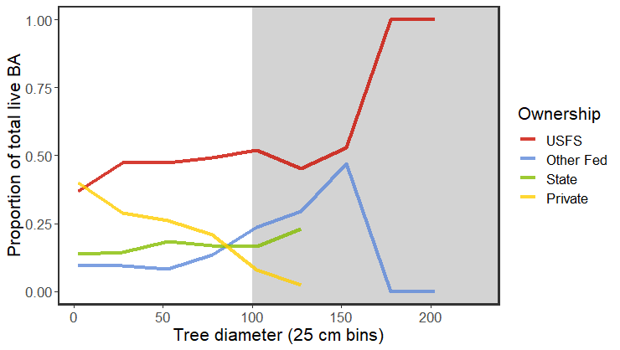

**Figure 3.** Proportion of total live sugar pine basal area in 25-cm size classes contained in different land ownership types (line colors; USFS, Other Federal, State, and Private). For example, y-axis value of 0.5 indicates that 50% of total live sugar pine basal area in the indicated size class falls in the indicated land ownership. Gray shading indicates a tree size threshold associate with the USFS old-growth definition for Sierra mixed conifer forest types.