National/regional-level FVS data updates
This document outlines the methodology for updating variables extracted from the Forest Vegetation Simulator (FVS; i.e. harvest volume, standing timber volume, potential mortality from fire, etc.) for large, landscape-level assessments. This work leverages work done by Riley et al. (2016) to interpolate Forest Inventory Analysis (FIA) stand and tree list data to all forested areas in the lower 48 United States. Stand data are extracted from FIA SQL databases and reformatted as FVS-ready input data. The user then creates FVS input files for each relevant FVS variant for a given study area and runs the stands through FVS using a batch command line file. Completed datasets are then used to attribute outputs to stands in the original study area stand feature class in ArcGIS. See Figure 1 for a detailed flowchart of the steps included here.
Figure 1. Flowchart demonstrating the inputs, processes, and outputs that are used to attribute stands with specific variables, such as harvest volume, standing volume, and potential mortality from fire. Users can alter the R scripts involved in this process to extract any FVS outputs from the growth and management simulations.
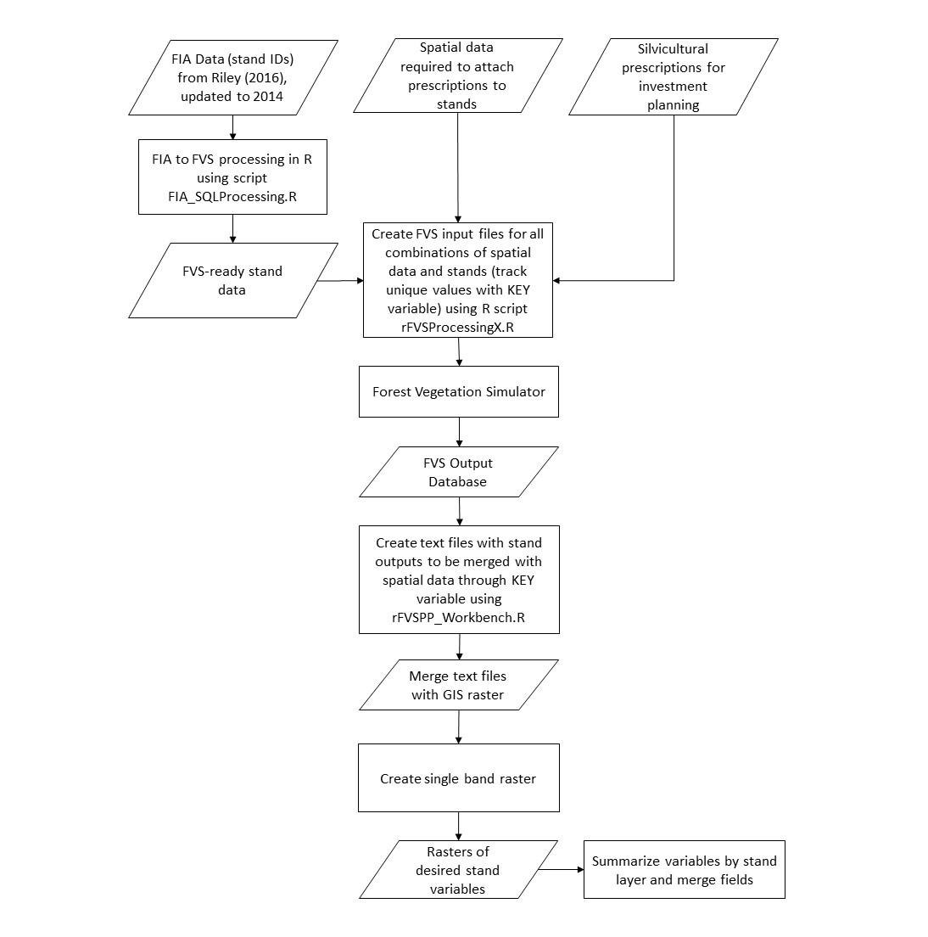
Part one: FIA to FVS-ready database
This first step in the updating process only needs to be carried out if the underlying tree lists from Karin Riley’s work need to be updated, or if the user wants to create a small subset of the larger database. Current vintage is from LANDFIRE 2016. You can also use these methods to create new FVS input databases if you need to run something smaller than the regional level. Smaller databases allow FVS to run faster.
Required scripts:
FIA_SQLProcessing.R
Required data:
- All SQLite databases from https://apps.fs.usda.gov/fia/datamart/datamart.html, by state. File structure should look like this: FIADBs/SQLite_FIADB_XX, with the state abbreviation in the place of the XX.
- Stand list for area of interest (this may be national, regional, forest, or other – for processing speed reasons it is rarely necessary to run the national dataset, because we run FVS at the regional level).
Steps:
- Open FIA_SQLProcessing.R (FIA_SQLProcessing_2016.R runs the single FIADB_USA.db file) script and update any of the pathways that have changed. This includes 1) The working directory, 2) the stand input file, and 3) the output file names at the bottom.
- Run script and check for errors.
- Create new 2003 Access database (.mdb file).
- Import the stand and tree list text files that were created by the script as FVS_StandInit and FVS_TreeInit, respectively.
- The stand database is now prepared to run simple FVS scenarios using the command line version of FVS, with the inputs created with the following methods. NOTE: This database method has NOT been tested in FVS online.
Part two: Preparing a set of FVS simulations
Required scripts
rFVSProcessing.R
Required data:
- Stand/variant raster. This raster was developed by combining Karin Riley’s FIA stand raster and the FVS variant raster in ArcGIS Pro. The resulting table includes all combinations of stand ID and FVS variant that will be used to run FVS simulations.
  - The stand raster is available here: https://data.nal.usda.gov/dataset/treemap-2016-tree-level-model-forests-conterminous-united-states-circa-2016
  - The variant raster is available at the bottom of this page (as of August 2, 2022): https://www.fs.fed.us/fvs/documents/index.shtml
  - Creating this from scratch requires both files as rasters. The FVS variant raster must be built by converting the FVS variant shapefile into a 30m² raster file, snapped to the stand raster.
  - This raster should be clipped to the desired study area to limit the number of stands and trees in the input file. Very large Access databases slow FVS down considerably.

- Stand list. Derived from the stand raster. This is a text file with two columns: 1) StandID, 2) FVS variant. The StandID is the key between the tree and stand tables in the input database and the FVS variant is used to identify which FVS program to use to simulate the stand.
- Input database. This is the name of the Access (.mdb) database that contains the tree and stand stables that will be used to simulate the specific set of stands.
- Output database. This is the name of the empty Access (.mdb) database that will contain all FVS outputs tables after the stands are simulated.
- File containing FVS keywords (kcp file) for any stand actions to be taken, including harvests, regeneration, fuel treatments, and prescribed fires.
Steps:
- Create the stand list. Currently this includes every stand ID and FVS variant on a landscape. I’ve been creating these at the region level because larger stand lists create larger Access databases, which slows down the FVS simulations.
  - Create a shapefile of the outline of the desired extent and clip the national stand raster to that shape.
  - Run the Combine function on the stand raster file and FVS variant raster file in ArcGIS Pro to create a raster that includes every combination of stand ID and FVS variant.
  - Export the table of the final raster to a .csv file. This file is one of the inputs to the rFVSProcessing.R script.
- Create the input database (See Part One).
- Create an empty output database which will be used by FVS when the final batch file is run. The file will not be used by the rFVSProcessing.R script, but the name will be an FVS input so be sure it is spelled correctly and created in the specified folder.
- Update the rFVSProcessing.R script for the following:
  - Input file name.
  - Output file name.
  - Each run may or may not have a specific kcp file. Set the file name if one exists.
  - Stand list file name.
  - Pathways to output files/output file names.
- Run the script. The output files should include a .in and a .key file for each variant that exists within the stand dataset. In addition, a single .bat file will be created to run the stands in each variant through FVS. Double click the .bat file to begin the FVS simulations.
- Often, updating the code creates a situation where there are errors. It is recommended that the output database is checked after the first few stands are run to ensure that tables are populating correctly with data. If errors are apparent, the .out files should be explored for error codes.
Part three: Processing FVS outputs
Once the FVS simulations have completed successfully, the user must extract the desired information from the resulting Access database. Note that this will require running RStudio as a 32-bit program, due to the required query language packages.
Please note that the current script is an example of one way to extract data. You will need to rework this code to pull out the data you want, specifically.
Required scripts:
rFVSPP_Workbench.R
Required data:
Access database populated with FVS outputs.
Steps:
- Open the example rFVSPP workbench script, save as a new file name in order to maintain the original, and set RStudio to the 32 bit version. To do this, select Tools >> Global Options and set it in the R version (change if necessary).
- Update variables as follows:
  - The working directory should point towards the folder that contains the Access database.
  - In the case of multiple databases, the listDatabases variable should use the pattern “*.mdb” to pull data from all databases in the working directory. If only a single database is used, the listDatabase variable should use the pattern “*database_name.mdb”, where the database name replaces the appropriate text.
  - The specific data tables that have the data that need to be extracted are called at this point in the code. Note that, being in R, table and field names are case-sensitive.
  - Update the final output table name at the end of the script to reflect the data you are processing.
- The output file is a csv file with the FVS outputs from all the stands that were run in step two.
  - Import the file into an ArcGIS Pro project with the stand-variant raster file.
  - Copy the table into your project Geodatabase. This will create an objectID that will allow for joining.
  - Join the desired data fields from the table using the “Key” field (concatenation of StandID and FVSVariant).

