Daniel Perry
CS6640 – Project 1

0. Notes:

Code was originally written in Octave (open source implementation of Matlab - https://www.gnu.org/software/octave/ ), but it should run in Matlab fine.

main.m – I've included a main.m script that produces all the graphs shown below.

1. Build a Histogram:

code: histogram.m – calculates the histogram of an image.

Examples:
chang.tif image
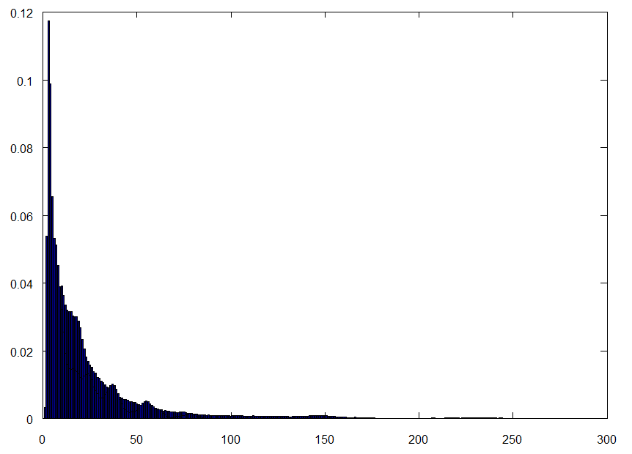Histogram of chang.tif
crowd.tif image

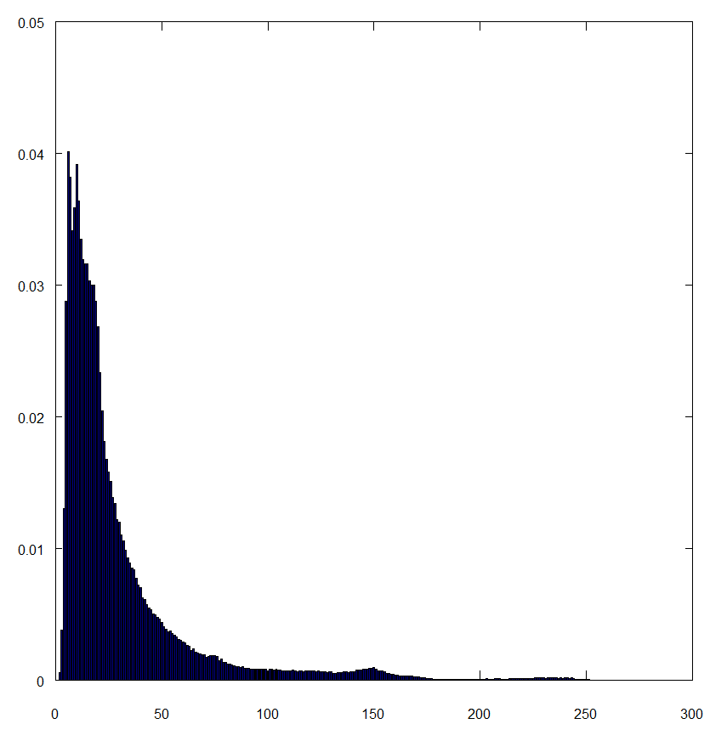Histogram of crowd.tif

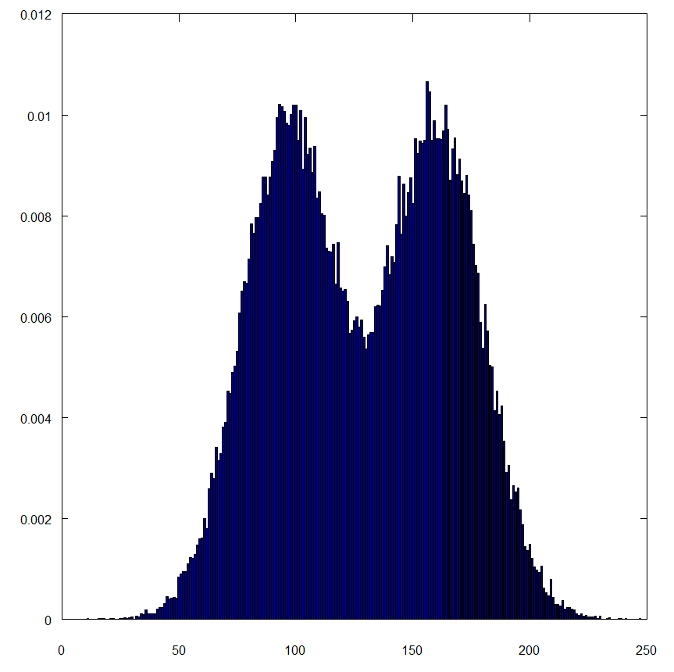Histogram of checker1.tif

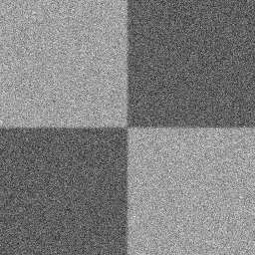checker1.tif image
Discussion:

The first example histogram is take from the “chang.tif” image included in the assignment. The histogram shows a high concentration of lower-intensity pixels. This makes sense when you look at the image, as it is a very dark image, with a lot of low-intensity pixels.

The second example, “crowd.tif”, is similar, but includes some more middle-intensity pixels. This is shown in the histogram as a longer “tail” of intensities spreads out across the histogram. Still the largest concentration of pixels is in the lower intensities. This makes sense when you look at the image, as the majority of the image is very dark, with some spots of highlight (ie – the girls arm, shirt, and hair highlights).

The third example, “checker1.tif” is very different from the first two. This image has two “groups” of intensities, a darker and lighter group. Both groups include a bunch of what appears to be gaussian noise. The histogram reflects this well, with two dominant peaks of intensities, bridged by a narrow valley.

2. Histogram Equalization

code: histogram.m – calculate the histogram of an image.
histoeq.m – return an histogram equalized image.
histoeq2.m – return a histogram equalized image blended with the original by param alpha.

Examples:

