Cabezon sdmTMB
Dan Portnof
2026-02-25

0. LOAD IN AND STAR REPORT VIEW
# ---- 0. LOAD IN AND STAR REPORT VIEW
#Load packages
library(tidyverse)
## ── Attaching core tidyverse packages ──────────────────────── tidyverse 2.0.0 ──
## ✔ dplyr 1.1.4 ✔ readr 2.1.6
## ✔ forcats 1.0.0 ✔ stringr 1.6.0
## ✔ ggplot2 4.0.1 ✔ tibble 3.2.1
## ✔ lubridate 1.9.4 ✔ tidyr 1.3.1
## ✔ purrr 1.0.4
## ── Conflicts ────────────────────────────────────────── tidyverse_conflicts() ──
## ✖ dplyr::filter() masks stats::filter()
## ✖ dplyr::lag() masks stats::lag()
## ℹ Use the conflicted package (<http://conflicted.r-lib.org/>) to force all conflicts to become errors
library(r4ss)
library(here)
## here() starts at C:/Users/machs/Documents/Basilica/Dan's Files/SIO/0_capstone/2_models/cabezon
library(dplyr)
library(ggplot2)
library(sf)
## Linking to GEOS 3.13.0, GDAL 3.10.1, PROJ 9.5.1; sf_use_s2() is TRUE
library(rnaturalearth)
library(rnaturalearthdata)
##
## Attaching package: 'rnaturalearthdata'
##
## The following object is masked from 'package:rnaturalearth':
##
## countries110
library(maps)
##
## Attaching package: 'maps'
##
## The following object is masked from 'package:purrr':
##
## map
library(sdmTMB)
my.seed <- 666
set.seed(my.seed)
wd <- "Cab_SCS_BC_STAR" # Mac
# This reads the output files
pp <- SS_output(wd)
## Multiple files in directory match pattern *.par
## choosing most recently modified:ssOrig.par
## Getting header info from:
## Cab_SCS_BC_STAR/Report.sso
## This function tested on SS versions 3.24 and 3.30.
## You are using 3.30.13.02-safe which SHOULD work with this package.
## Report file time:Fri May 10 15:03:35 2019
## Warning in SS_output(wd): Some stats skipped because the .cor file not found:Cab_SCS_BC_STAR/ssOrig.cor
## Reading full report file
## Got all columns using ncols = 57
## Got Report file
## Setting minimum biomass threshhold to 0.25 based on US west coast assumption associated with biomass target of 0.4. (can replace or override in SS_plots by setting 'minbthresh')
## !warning: temporary files were written in this run:
## TempFile Size
## "size of file gradfil1.tmp = 0" "size of file gradfil2.tmp = 0"
## <NA> <NA>
## "size of file varssave.tmp = 0" "size of file cmpdiff.tmp = 0"
## Got warning file. Therewas 1 warning in Cab_SCS_BC_STAR/warning.sso
## Finished reading files
## CompReport file separated by this code as follows (rows = Ncomps*Nbins):
## 1088 rows of length comp data,
## 0 rows of generalized size comp data,
## 0 rows of age comp data,
## 0 rows of conditional age-at-length data,
## 0 rows of ghost fleet age comp data,
## 0 rows of ghost fleet conditional age-at-length data,
## 0 rows of ghost fleet length comp data,
## 0 rows of mean length at age data,
## 0 rows of mean weight at age data,
## 0 rows of 'TAG1' comp data, and
## 0 rows of 'TAG2' comp data.
## Finished dimensioning
## Got covar file.
## Finished primary run statistics list
## running SS_readstarter
## data, control files: data_scs_4fleets.ss, control_scs_4fleets.ss
## converge_criterion = 1e-04
## SPR_basis = 1
## F_report_basis = 0
## Assuming version 3.30 based on number of numeric values.
## MCMC_output_detail = 0
## ALK_tolerance = 0
## Read of starter file complete. Final value: 3.3
##
## Statistics shown below (to turn off, change input to printstats=FALSE)
## $SS_version
## [1] "3.30.13.02-safe;_2019_05_10;_Stock_Synthesis_by_Richard_Methot_(NOAA)_using_ADMB_12.0"
##
## $SS_versionshort
## [1] "3.30"
##
## $SS_versionNumeric
## [1] 3.3
##
## $StartTime
## [1] "StartTime: Fri May 10 15:03:35 2019"
##
## $RunTime
## [1] "0 hours, 7 minutes, 55 seconds."
##
## $Files_used
## [1] "Data_File: data_scs_4fleets.ss Control_File: control_scs_4fleets.ss"
##
## $Nwarnings
## [1] 1
##
## $warnings
## [1] "#V3.30.13.02-safe;_2019_05_10;_Stock_Synthesis_by_Richard_Methot_(NOAA)_using_ADMB_12.0"
## [2] "#Stock Synthesis (SS) is a work of the U.S. Government and is not subject to copyright protection in the United States."
## [3] "#Foreign copyrights may apply. See copyright.txt for more information."
## [4] "Fri May 10 15:03:34 2019"
## [5] ""
## [6] " "
## [7] " N warnings: 1"
## [8] "Number_of_active_parameters_on_or_near_bounds: 0"
##
## $likelihoods_used
## values lambdas
## TOTAL 282.82800000000 NA
## Catch 0.00000520981 NA
## Equil_catch 0.00000000000 1
## Survey -4.67311000000 NA
## Length_comp 281.64800000000 NA
## Recruitment 4.22084000000 1
## InitEQ_Regime 0.00000000000 1
## Forecast_Recruitment 0.00001037790 1
## Parm_priors 1.62706000000 1
## Parm_softbounds 0.00544214000 NA
## Parm_devs 0.00000000000 1
## Crash_Pen 0.00000000000 1
##
## $likelihoods_by_fleet
## Label ALL Comm.Dead Comm.Live Rec.Shore Rec.Boat
## 157 Catch_lambda NA 1.00000e+00 1.00000e+00 1.00000e+00 1.00000e+00
## 158 Catch_like 5.20981e-06 2.80374e-07 4.03406e-06 3.95488e-07 4.99891e-07
## 159 Surv_lambda NA 0.00000e+00 0.00000e+00 0.00000e+00 0.00000e+00
## 160 Surv_like -4.67311e+00 0.00000e+00 0.00000e+00 0.00000e+00 0.00000e+00
## 161 Length_lambda NA 0.00000e+00 1.00000e+00 1.00000e+00 1.00000e+00
## 162 Length_like 2.81648e+02 0.00000e+00 3.72730e+01 4.25929e+01 2.01782e+02
## CPFV
## 157 1.00000
## 158 0.00000
## 159 1.00000
## 160 -4.67311
## 161 0.00000
## 162 0.00000
##
## $N_estimated_parameters
## [1] 87
##
## $table_of_phases
##
## -99 -4 -3 -2 -1 1 2 3 4 5
## 2 6 18 9 2 48 7 11 3 18
##
## $estimated_non_dev_parameters
## Value Phase Min Max
## NatM_p_1_Fem_GP_1 0.260091 2 0.01 0.5
## NatM_p_1_Mal_GP_1 0.479487 2 0.01 0.6
## SR_LN(R0) 5.213030 1 3.00 31.0
## Q_extraSD_CPFV(5) 0.377135 5 0.00 5.0
## Size_DblN_peak_Comm.Dead(1) 22.994600 2 10.00 91.0
## Size_DblN_top_logit_Comm.Dead(1) -5.999160 3 -15.00 3.0
## Size_DblN_ascend_se_Comm.Dead(1) 8.951140 3 -4.00 12.0
## Size_DblN_peak_Comm.Live(2) 39.851200 2 10.00 91.0
## Size_DblN_top_logit_Comm.Live(2) -4.106120 3 -5.00 3.0
## Size_DblN_ascend_se_Comm.Live(2) -2.218560 3 -4.00 12.0
## Size_DblN_descend_se_Comm.Live(2) -4.126840 3 -10.00 6.0
## Size_DblN_end_logit_Comm.Live(2) -9.643910 2 -15.00 15.0
## Size_DblN_peak_Rec.Shore(3) 38.801700 2 10.00 91.0
## Size_DblN_top_logit_Rec.Shore(3) -6.057410 3 -15.00 3.0
## Size_DblN_ascend_se_Rec.Shore(3) 5.634680 3 -4.00 12.0
## Size_DblN_peak_Rec.Boat(4) 35.058300 2 10.00 91.0
## Size_DblN_top_logit_Rec.Boat(4) -0.742337 3 -5.00 3.0
## Size_DblN_ascend_se_Rec.Boat(4) 4.231090 3 -4.00 12.0
## Size_DblN_peak_Comm.Live(2)_BLK1repl_2000 43.582300 3 10.00 91.0
## Size_DblN_top_logit_Comm.Live(2)_BLK1repl_2000 -3.152750 4 -5.00 3.0
## Size_DblN_ascend_se_Comm.Live(2)_BLK1repl_2000 3.570110 4 -4.00 12.0
## Size_DblN_descend_se_Comm.Live(2)_BLK1repl_2000 3.048340 4 -10.00 6.0
## Size_DblN_end_logit_Comm.Live(2)_BLK1repl_2000 -1.491120 3 -5.00 15.0
## Size_DblN_peak_Rec.Boat(4)_BLK2repl_2004 44.175100 5 10.00 91.0
## Size_DblN_top_logit_Rec.Boat(4)_BLK2repl_2004 -1.989770 5 -5.00 3.0
## Size_DblN_ascend_se_Rec.Boat(4)_BLK2repl_2004 4.456990 5 -4.00 12.0
## Init Status Parm_StDev
## NatM_p_1_Fem_GP_1 0.293000 OK 0.0349975
## NatM_p_1_Mal_GP_1 0.274182 OK 0.1057080
## SR_LN(R0) 5.500000 OK 0.2975000
## Q_extraSD_CPFV(5) 0.000000 OK 0.0670836
## Size_DblN_peak_Comm.Dead(1) 34.390900 OK 398.8780000
## Size_DblN_top_logit_Comm.Dead(1) -6.029520 OK 201.3300000
## Size_DblN_ascend_se_Comm.Dead(1) 3.209950 OK 86.1523000
## Size_DblN_peak_Comm.Live(2) 38.282000 OK 13.0850000
## Size_DblN_top_logit_Comm.Live(2) -0.572000 OK 16.0050000
## Size_DblN_ascend_se_Comm.Live(2) 3.367000 OK 32.9441000
## Size_DblN_descend_se_Comm.Live(2) -1.997000 OK 65.2280000
## Size_DblN_end_logit_Comm.Live(2) 6.243000 OK 74.0287000
## Size_DblN_peak_Rec.Shore(3) 10.800000 OK 5.2094100
## Size_DblN_top_logit_Rec.Shore(3) -0.500000 OK 195.9330000
## Size_DblN_ascend_se_Rec.Shore(3) -0.600000 OK 0.5453850
## Size_DblN_peak_Rec.Boat(4) 45.000000 OK 1.2326900
## Size_DblN_top_logit_Rec.Boat(4) -2.800000 OK 40.8518000
## Size_DblN_ascend_se_Rec.Boat(4) 4.100000 OK 0.1862220
## Size_DblN_peak_Comm.Live(2)_BLK1repl_2000 39.030700 OK 1.3644900
## Size_DblN_top_logit_Comm.Live(2)_BLK1repl_2000 -0.601767 OK 1.9218900
## Size_DblN_ascend_se_Comm.Live(2)_BLK1repl_2000 2.022990 OK 0.3181520
## Size_DblN_descend_se_Comm.Live(2)_BLK1repl_2000 2.567870 OK 2.0030800
## Size_DblN_end_logit_Comm.Live(2)_BLK1repl_2000 -0.816397 OK 1.1952900
## Size_DblN_peak_Rec.Boat(4)_BLK2repl_2004 45.000000 OK 1.3913600
## Size_DblN_top_logit_Rec.Boat(4)_BLK2repl_2004 -1.025070 OK 65.5406000
## Size_DblN_ascend_se_Rec.Boat(4)_BLK2repl_2004 4.100000 OK 0.1699100
## Gradient Pr_type
## NatM_p_1_Fem_GP_1 0.00001365980000 Log_Norm
## NatM_p_1_Mal_GP_1 0.00000096060400 Log_Norm
## SR_LN(R0) -0.00006464320000 No_prior
## Q_extraSD_CPFV(5) -0.00000025231500 No_prior
## Size_DblN_peak_Comm.Dead(1) 0.00000000503855 No_prior
## Size_DblN_top_logit_Comm.Dead(1) -0.00000001312470 No_prior
## Size_DblN_ascend_se_Comm.Dead(1) 0.00000000858107 No_prior
## Size_DblN_peak_Comm.Live(2) -0.00000389914000 No_prior
## Size_DblN_top_logit_Comm.Live(2) -0.00000023736100 No_prior
## Size_DblN_ascend_se_Comm.Live(2) -0.00000002068240 No_prior
## Size_DblN_descend_se_Comm.Live(2) -0.00000020271900 No_prior
## Size_DblN_end_logit_Comm.Live(2) 0.00000000119690 No_prior
## Size_DblN_peak_Rec.Shore(3) 0.00000102565000 No_prior
## Size_DblN_top_logit_Rec.Shore(3) -0.00000000309086 No_prior
## Size_DblN_ascend_se_Rec.Shore(3) -0.00000017739100 No_prior
## Size_DblN_peak_Rec.Boat(4) -0.00002419610000 No_prior
## Size_DblN_top_logit_Rec.Boat(4) 0.00000000765015 No_prior
## Size_DblN_ascend_se_Rec.Boat(4) 0.00002644180000 No_prior
## Size_DblN_peak_Comm.Live(2)_BLK1repl_2000 0.00000075294800 Sym_Beta
## Size_DblN_top_logit_Comm.Live(2)_BLK1repl_2000 0.00000004304540 Sym_Beta
## Size_DblN_ascend_se_Comm.Live(2)_BLK1repl_2000 0.00000029666400 Sym_Beta
## Size_DblN_descend_se_Comm.Live(2)_BLK1repl_2000 0.00000022270900 Sym_Beta
## Size_DblN_end_logit_Comm.Live(2)_BLK1repl_2000 -0.00000217790000 Sym_Beta
## Size_DblN_peak_Rec.Boat(4)_BLK2repl_2004 -0.00000689441000 No_prior
## Size_DblN_top_logit_Rec.Boat(4)_BLK2repl_2004 0.00000000653686 No_prior
## Size_DblN_ascend_se_Rec.Boat(4)_BLK2repl_2004 0.00000923345000 No_prior
## Prior Pr_SD Pr_Like
## NatM_p_1_Fem_GP_1 -1.238730 0.260 0.086268800
## NatM_p_1_Mal_GP_1 -0.924581 0.275 0.237528000
## SR_LN(R0) NA NA NA
## Q_extraSD_CPFV(5) NA NA NA
## Size_DblN_peak_Comm.Dead(1) NA NA NA
## Size_DblN_top_logit_Comm.Dead(1) NA NA NA
## Size_DblN_ascend_se_Comm.Dead(1) NA NA NA
## Size_DblN_peak_Comm.Live(2) NA NA NA
## Size_DblN_top_logit_Comm.Live(2) NA NA NA
## Size_DblN_ascend_se_Comm.Live(2) NA NA NA
## Size_DblN_descend_se_Comm.Live(2) NA NA NA
## Size_DblN_end_logit_Comm.Live(2) NA NA NA
## Size_DblN_peak_Rec.Shore(3) NA NA NA
## Size_DblN_top_logit_Rec.Shore(3) NA NA NA
## Size_DblN_ascend_se_Rec.Shore(3) NA NA NA
## Size_DblN_peak_Rec.Boat(4) NA NA NA
## Size_DblN_top_logit_Rec.Boat(4) NA NA NA
## Size_DblN_ascend_se_Rec.Boat(4) NA NA NA
## Size_DblN_peak_Comm.Live(2)_BLK1repl_2000 38.000000 0.050 0.001480190
## Size_DblN_top_logit_Comm.Live(2)_BLK1repl_2000 -0.300000 0.050 0.017096000
## Size_DblN_ascend_se_Comm.Live(2)_BLK1repl_2000 2.300000 0.050 0.000143334
## Size_DblN_descend_se_Comm.Live(2)_BLK1repl_2000 3.000000 0.050 0.025390600
## Size_DblN_end_logit_Comm.Live(2)_BLK1repl_2000 -3.500000 0.050 0.027350900
## Size_DblN_peak_Rec.Boat(4)_BLK2repl_2004 NA NA NA
## Size_DblN_top_logit_Rec.Boat(4)_BLK2repl_2004 NA NA NA
## Size_DblN_ascend_se_Rec.Boat(4)_BLK2repl_2004 NA NA NA
## Afterbound
## NatM_p_1_Fem_GP_1 OK
## NatM_p_1_Mal_GP_1 OK
## SR_LN(R0) OK
## Q_extraSD_CPFV(5) OK
## Size_DblN_peak_Comm.Dead(1) OK
## Size_DblN_top_logit_Comm.Dead(1) OK
## Size_DblN_ascend_se_Comm.Dead(1) OK
## Size_DblN_peak_Comm.Live(2) OK
## Size_DblN_top_logit_Comm.Live(2) OK
## Size_DblN_ascend_se_Comm.Live(2) OK
## Size_DblN_descend_se_Comm.Live(2) OK
## Size_DblN_end_logit_Comm.Live(2) OK
## Size_DblN_peak_Rec.Shore(3) OK
## Size_DblN_top_logit_Rec.Shore(3) OK
## Size_DblN_ascend_se_Rec.Shore(3) OK
## Size_DblN_peak_Rec.Boat(4) OK
## Size_DblN_top_logit_Rec.Boat(4) OK
## Size_DblN_ascend_se_Rec.Boat(4) OK
## Size_DblN_peak_Comm.Live(2)_BLK1repl_2000 OK
## Size_DblN_top_logit_Comm.Live(2)_BLK1repl_2000 OK
## Size_DblN_ascend_se_Comm.Live(2)_BLK1repl_2000 OK
## Size_DblN_descend_se_Comm.Live(2)_BLK1repl_2000 OK
## Size_DblN_end_logit_Comm.Live(2)_BLK1repl_2000 OK
## Size_DblN_peak_Rec.Boat(4)_BLK2repl_2004 OK
## Size_DblN_top_logit_Rec.Boat(4)_BLK2repl_2004 OK
## Size_DblN_ascend_se_Rec.Boat(4)_BLK2repl_2004 OK
##
## $maximum_gradient_component
## [1] 6.46432e-05
##
## $parameters_with_highest_gradients
## Value Gradient
## SR_LN(R0) 5.213030 -6.46432e-05
## Size_DblN_ascend_se_Rec.Boat(4) 4.231090 2.64418e-05
## Size_DblN_peak_Rec.Boat(4) 35.058300 -2.41961e-05
## NatM_p_1_Fem_GP_1 0.260091 1.36598e-05
## Size_DblN_ascend_se_Rec.Boat(4)_BLK2repl_2004 4.456990 9.23345e-06
##
## $Length_Comp_Fit_Summary
## Factor Fleet Recommend_var_adj # N Npos min_inputN max_inputN
## 3023 4 2 0.120222 # 15 15 1.608 20.502
## 3024 4 3 0.935640 # 8 8 5.000 13.000
## 3025 4 4 0.621710 # 47 47 2.212 55.853
## mean_adj_inputN mean_effN HarMean Curr_Var_Adj Fleet_name
## 3023 9.4604 24.9335 16.9753 0.067 Comm.Live
## 3024 7.5000 10.5720 7.0173 1.000 Rec.Shore
## 3025 22.6377 53.2837 25.4504 0.553 Rec.Boat
##
## $Age_Comp_Fit_Summary
## [1] Factor Fleet Recommend_var_adj #
## [5] Nsamp_adj Npos min_inputN max_inputN
## [9] mean_adj_inputN mean_effN HarMean Curr_Var_Adj
## [13] Fleet_name
## <0 rows> (or 0-length row.names)
##
## $SBzero
## [1] 204.584
##
## $current_depletion
## [1] 0.4916905
##
## $last_years_SPR
## [1] 0.482373
##
## $SPRratioLabel
## [1] "(1-SPR)/(1-SPR_45%)"
##
## $sigma_R_in
## [1] 0.7
##
## $sigma_R_info
## period N_devs SD_of_devs Var_of_devs mean_SE mean_SEsquared
## 1 Main 47 0.4779215 0.2284090 0.5291888 0.2885000
## 2 Early+Main 47 0.4779215 0.2284090 0.5291888 0.2885000
## 3 Early+Main+Late 49 0.4678591 0.2188922 0.5361828 0.2967555
## sqrt_sum_of_components SD_of_devs_over_sigma_R sqrt_sum_over_sigma_R
## 1 0.7189638 0.6827450 1.027091
## 2 0.7189638 0.6827450 1.027091
## 3 0.7180861 0.6683702 1.025837
## alternative_sigma_R
## 1 0.7189638
## 2 0.7189638
## 3 0.7180861
##
## $rmse_table
## ERA N RMSE RMSE_over_sigmaR mean_BiasAdj
## 1 main 47 0.47281 0.456223 0.387766
## 2 early 0 0.00000 0.000000 0.000000
##
## $cormessage1
## [1] Range of abs(parameter correlations) is 0 to 0.95168
##
## $cormessage2
## [1] 1 correlation above threshold (cormax=0.95)
##
## $cormessage3
## label.i label.j corr
## 1 SR_LN(R0) NatM_p_1_Fem_GP_1 0.95168
##
## $cormessage7
## [1] 9 uncorrelated parameters below threshold (cormin=0.01)
##
## $cormessage8
## name max
## 44 Late_RecrDev_2017 6.68249e-04
## 45 Late_RecrDev_2018 0.00000e+00
## 48 Size_DblN_top_logit_Comm.Dead(1) 1.35287e-06
## 51 Size_DblN_top_logit_Comm.Live(2) 2.47717e-03
## 53 Size_DblN_descend_se_Comm.Live(2) 9.90326e-03
## 54 Size_DblN_end_logit_Comm.Live(2) 2.57358e-03
## 56 Size_DblN_top_logit_Rec.Shore(3) 4.52108e-04
## 59 Size_DblN_top_logit_Rec.Boat(4) 1.68744e-03
## 67 Size_DblN_top_logit_Rec.Boat(4)_BLK2repl_2004 1.10231e-03
## completed SS_output
# Pull out derived quantities. These are things like SSB and age-0 recruits.
derived_quants <- pp[["derived_quants"]]
# Pull out parameter estimates. Recruitment deviations are estimated parameters.
params <- pp[["parameters"]]
# Plot recruitment deviations for the main estimation period.
devyrs <- 1970:2018
devdf <- pp$parameters[28:76, ]
devvalue <- devdf[,3]
devsd <- devdf[,11]
devlower <- (devvalue-1.96*devsd)
devmed <- devvalue
devupper <- (devvalue+1.96*devsd)
STAR_recdevs <- data.frame(year=devyrs, value=devmed,lo=devlower,hi=devupper)
STAR_recdevs_plot <- ggplot(data=STAR_recdevs, aes(x=year, ymin=devlower, ymax=devupper)) +
geom_ribbon(fill="skyblue", alpha=0.5) +
geom_line(aes(y=devmed)) +
labs(title="Cabezon SoCal Recruitment Deviations") +
theme_bw()
STAR_recdevs_plot
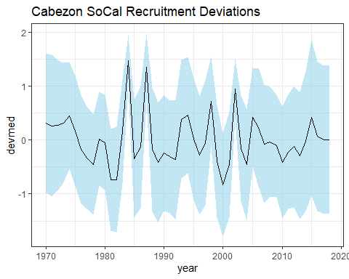
# Plot age-0 recruits
age0yrs <- 1970:2018
startrowindex <- which(rownames(derived_quants)=="Recr_1970")
endrowindex <- which(rownames(derived_quants)=="Recr_2018")
age0 <- derived_quants[174:222, "Value"]
age0sd <- derived_quants[174:222, "StdDev"]
age0lower <- (age0-1.96*age0sd)
age0upper <- (age0+1.96*age0sd)
STAR_age0 <- data.frame(year=age0yrs, value=age0,lo=age0lower,hi=age0upper)
STAR_age0_plot <- ggplot(data=STAR_age0, aes(x=year, ymin=age0lower, ymax=age0upper)) +
geom_ribbon(fill="skyblue", alpha=0.5) +
geom_line(aes(y=age0)) +
labs(title="Cabezon SoCal Age 0 Recruits") +
theme_bw()
STAR_age0_plot
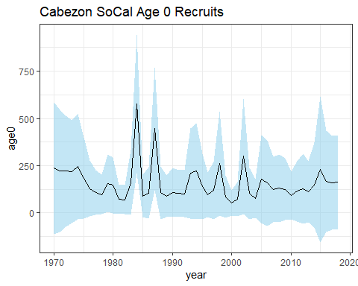
# Plot SSB
ssbyrs <- 1916:2018
startrowindex <- which(rownames(derived_quants)=="SSB_1916")
endrowindex <- which(rownames(derived_quants)=="SSB_2018")
ssb <- derived_quants[3:105, "Value"]
ssbsd <- derived_quants[3:105, "StdDev"]
ssblower <- (ssb-1.96*ssbsd)
ssbupper <- (ssb+1.96*ssbsd)
STAR_SSB <- data.frame(year=ssbyrs, value=ssb,lo=ssblower,hi=ssbupper)
STAR_SSB_plot <- ggplot(data=STAR_SSB, aes(x=year, ymin=ssblower, ymax=ssbupper)) +
geom_ribbon(fill="skyblue", alpha=0.5) +
geom_line(aes(y=ssb)) +
labs(title="Cabezon SoCal SSB") +
theme_bw()
STAR_SSB_plot
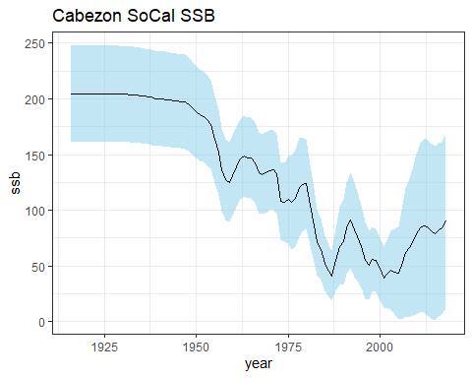

1. DATA QC + EXPLORATION
cabezon <- read.csv("manta cabezon data for Dan.csv")
str(cabezon)
## 'data.frame': 4569 obs. of 21 variables:
## $ time : chr "1981-01-18T11:17:00Z" "1981-01-18T14:26:00Z" "1981-01-18T17:18:00Z" "1981-01-18T20:22:00Z" ...
## $ cruise : int 198101 198101 198101 198101 198101 198101 198101 198101 198101 198101 ...
## $ ship : chr "DAVID STARR JORDAN" "DAVID STARR JORDAN" "DAVID STARR JORDAN" "DAVID STARR JORDAN" ...
## $ ship_code : chr "JD" "JD" "JD" "JD" ...
## $ order_occupied : int 52 53 54 55 56 57 58 59 60 61 ...
## $ tow_type : chr "MT" "MT" "MT" "MT" ...
## $ tow_number : int 1 1 1 1 1 1 1 1 1 1 ...
## $ end_time : chr "1981-01-18T11:32:09Z" "1981-01-18T14:41:11Z" "1981-01-18T17:33:01Z" "1981-01-18T20:36:59Z" ...
## $ latitude : num 31.8 32 32.2 32.3 32.5 ...
## $ longitude : num -120 -119 -119 -119 -118 ...
## $ line : num 93.3 93.3 93.3 93.3 93.3 93.3 93.3 93.3 93.3 90 ...
## $ station : num 60 55 50 45 40 35 30 28 26.7 28 ...
## $ standard_haul_factor: num 0.02 0.02 0.02 0.02 0.02 0.02 0.02 0.01 0.02 0.02 ...
## $ volume_sampled : num 88.7 97.8 93.5 93.7 79.7 81.1 96 104 95.5 97.8 ...
## $ proportion_sorted : num 1 1 1 1 1 1 1 1 1 1 ...
## $ mesh_size : num 0.505 0.505 0.505 0.505 0.505 0.505 0.505 0.505 0.505 0.505 ...
## $ year : int 1981 1981 1981 1981 1981 1981 1981 1981 1981 1981 ...
## $ month : int 1 1 1 1 1 1 1 1 1 1 ...
## $ season : chr "winter" "winter" "winter" "winter" ...
## $ line.station : chr "93.3 60" "93.3 55" "93.3 50" "93.3 45" ...
## $ larvae_100m3 : num 0 0 0 0 0 ...
# ---- 1. DATA QC + EXPLORATION
# Check for how many observations per ...
# year
cabezon %>%
count(year, season, line.station) %>%
filter(n > 1)
## year season line.station n
## 1 1981 spring 80 55 2
## 2 1981 spring 80 60 2
## 3 1981 spring 83.3 40.6 2
## 4 1981 spring 83.3 42 2
## 5 1981 spring 86.7 33 2
## 6 1981 spring 86.7 35 2
## 7 1981 spring 86.7 40 2
## 8 1981 spring 86.7 50 2
## 9 1981 spring 86.7 55 2
## 10 1981 spring 90 28 2
## 11 1981 spring 90 30 2
## 12 1981 spring 90 37 2
## 13 1981 spring 90 45 2
## 14 1981 spring 90 53 2
## 15 1981 spring 90 60 2
## 16 1981 spring 93.3 26.7 2
## 17 1981 spring 93.3 28 2
## 18 1981 spring 93.3 30 2
## 19 1981 spring 93.3 35 2
## 20 1981 spring 93.3 40 2
## 21 1981 spring 93.3 45 2
## 22 1981 spring 93.3 50 2
## 23 1981 winter 76.7 51 2
## 24 1981 winter 83.3 40.6 2
## 25 1981 winter 83.3 42 2
## 26 1981 winter 83.3 51 2
## 27 1981 winter 83.3 55 2
## 28 1981 winter 86.7 33 2
## 29 1981 winter 86.7 35 2
## 30 1981 winter 86.7 40 2
## 31 1981 winter 86.7 45 2
## 32 1981 winter 86.7 50 2
## 33 1981 winter 86.7 55 2
## 34 1981 winter 86.7 60 2
## 35 1981 winter 90 28 2
## 36 1981 winter 90 30 2
## 37 1981 winter 90 37 2
## 38 1981 winter 90 45 2
## 39 1981 winter 90 53 2
## 40 1981 winter 90 60 2
## 41 1981 winter 93.3 26.7 2
## 42 1981 winter 93.3 28 2
## 43 1981 winter 93.3 30 2
## 44 1981 winter 93.3 35 2
## 45 1981 winter 93.3 40 2
## 46 1981 winter 93.3 45 2
## 47 1981 winter 93.3 50 2
## 48 1981 winter 93.3 55 2
## 49 1981 winter 93.3 60 2
## 50 1984 spring 76.7 51 3
## 51 1984 spring 76.7 55 3
## 52 1984 spring 76.7 60 3
## 53 1984 spring 80 51 3
## 54 1984 spring 80 55 2
## 55 1984 spring 80 60 4
## 56 1984 spring 83.3 40.6 3
## 57 1984 spring 83.3 42 3
## 58 1984 spring 83.3 55 3
## 59 1984 spring 83.3 60 3
## 60 1984 spring 86.7 33 3
## 61 1984 spring 86.7 35 3
## 62 1984 spring 86.7 40 3
## 63 1984 spring 86.7 45 3
## 64 1984 spring 86.7 55 3
## 65 1984 spring 86.7 60 3
## 66 1984 spring 90 28 2
## 67 1984 spring 90 30 2
## 68 1984 spring 90 37 2
## 69 1984 spring 90 45 3
## 70 1984 spring 93.3 26.7 2
## 71 1984 spring 93.3 30 3
## 72 1984 spring 93.3 35 2
## 73 1984 spring 93.3 40 2
## 74 1984 spring 93.3 45 2
## 75 1984 spring 93.3 50 2
## 76 1984 spring 93.3 55 2
## 77 1984 spring 93.3 60 2
## 78 1984 summer 80 60 2
## 79 1984 summer 90 28 2
## 80 1984 summer 90 30 2
## 81 1984 summer 90 35 2
## 82 1984 summer 90 37 2
## 83 1984 summer 90 45 2
## 84 1984 summer 93.3 26.7 2
## 85 1984 summer 93.3 30 2
## 86 1984 summer 93.3 35 2
## 87 1984 summer 93.3 40 2
## 88 1984 summer 93.3 45 2
## 89 1984 summer 93.3 50 2
## 90 1984 summer 93.3 55 2
## 91 1984 summer 93.3 60 2
## 92 1984 winter 80 60 2
## 93 1986 fall 76.7 51 2
## 94 1986 fall 76.7 55 2
## 95 1986 fall 80 51 2
## 96 1986 fall 80 55 2
## 97 1986 fall 80 60 2
## 98 1986 fall 83.3 40.6 2
## 99 1986 fall 83.3 42 2
## 100 1986 fall 86.7 33 2
## 101 1986 fall 86.7 35 2
## 102 1986 fall 86.7 45 2
## 103 1986 fall 86.7 50 2
## 104 1986 fall 86.7 55 2
## 105 1986 fall 86.7 60 2
## 106 1986 fall 90 28 2
## 107 1986 fall 90 30 2
## 108 1986 fall 90 35 2
## 109 1986 fall 90 37 2
## 110 1986 fall 90 45 2
## 111 1986 fall 90 53 2
## 112 1986 fall 90 60 2
## 113 1986 fall 93.3 26.7 2
## 114 1986 fall 93.3 28 2
## 115 1986 fall 93.3 30 2
## 116 1986 fall 93.3 35 2
## 117 1986 fall 93.3 40 2
## 118 1986 fall 93.3 45 2
## 119 1986 fall 93.3 50 2
## 120 1986 fall 93.3 55 2
## 121 1986 fall 93.3 60 2
## 122 1987 fall 76.7 49 2
## 123 1987 fall 76.7 51 2
## 124 1987 fall 76.7 55 2
## 125 1987 fall 76.7 60 2
## 126 1987 fall 80 51 2
## 127 1987 fall 81.8 46.9 2
## 128 1987 fall 83.3 40.6 2
## 129 1987 fall 83.3 42 2
## 130 1987 fall 83.3 51 2
## 131 1987 fall 86.7 33 2
## 132 1987 fall 86.7 35 2
## 133 1987 fall 86.7 45 2
## 134 1987 fall 86.7 60 2
## 135 1987 fall 90 28 2
## 136 1987 fall 90 30 2
## 137 1987 fall 90 35 2
## 138 1987 fall 90 37 2
## 139 1987 fall 90 45 2
## 140 1987 fall 90 53 2
## 141 1987 fall 90 60 2
## 142 1987 fall 93.3 26.7 2
## 143 1987 fall 93.3 28 2
## 144 1987 fall 93.3 30 2
## 145 1987 fall 93.3 35 2
## 146 1987 fall 93.3 40 2
## 147 1987 fall 93.3 45 2
## 148 1987 spring 76.7 49 2
## 149 1987 spring 76.7 51 2
## 150 1987 spring 80 51 2
## 151 1987 spring 80 55 2
## 152 1987 spring 80 60 2
## 153 1987 spring 81.8 46.9 2
## 154 1987 spring 83.3 40.6 2
## 155 1987 spring 83.3 42 2
## 156 1987 spring 83.3 51 2
## 157 1987 spring 83.3 55 2
## 158 1987 spring 83.3 60 2
## 159 1987 spring 86.7 33 2
## 160 1987 spring 86.7 35 2
## 161 1987 spring 86.7 45 2
## 162 1987 spring 86.7 50 2
## 163 1987 spring 86.7 55 2
## 164 1987 spring 86.7 60 2
## 165 1987 spring 90 28 2
## 166 1987 spring 90 30 2
## 167 1987 spring 90 35 2
## 168 1987 spring 90 37 2
## 169 1987 spring 90 45 2
## 170 1987 spring 90 53 2
## 171 1987 spring 90 60 2
## 172 1987 spring 93.3 26.7 2
## 173 1987 spring 93.3 28 2
## 174 1987 spring 93.3 30 2
## 175 1987 spring 93.3 35 2
## 176 1987 spring 93.3 40 2
## 177 1987 spring 93.3 45 2
## 178 1987 spring 93.3 50 2
## 179 1987 spring 93.3 55 2
## 180 1987 spring 93.3 60 2
## 181 1990 spring 80 51 2
## 182 1990 spring 80 55 2
## 183 1990 spring 80 60 2
## 184 1990 spring 81.8 46.9 2
## 185 1990 spring 83.3 40.6 2
## 186 1990 spring 83.3 42 2
## 187 1990 spring 83.3 51 2
## 188 1990 spring 83.3 55 2
## 189 1990 spring 83.3 60 2
## 190 1990 spring 86.7 33 2
## 191 1990 spring 86.7 35 2
## 192 1990 spring 86.7 40 2
## 193 1990 spring 90 28 2
## 194 1990 spring 90 30 2
## 195 1990 spring 90 35 2
## 196 1990 spring 90 37 2
## 197 1990 spring 90 45 2
## 198 1990 spring 90 53 2
## 199 1990 spring 90 60 2
## 200 1990 spring 93.3 26.7 2
## 201 1990 spring 93.3 28 2
## 202 1990 spring 93.3 30 2
## 203 1990 spring 93.3 35 2
## 204 1990 spring 93.3 45 2
## 205 1990 spring 93.3 50 2
## 206 1990 spring 93.3 55 2
## 207 1990 spring 93.3 60 2
## 208 1997 fall 90 28 2
## 209 1997 fall 90 30 2
## 210 1997 fall 90 35 2
## 211 1997 fall 90 37 2
## 212 1997 fall 90 45 2
## 213 1997 fall 90 53 2
## 214 1997 fall 90 60 2
## 215 1998 fall 83.3 40.6 3
## 216 1998 fall 83.3 42 4
## 217 1998 fall 83.3 51 4
## 218 1998 fall 83.3 55 3
## 219 1998 fall 83.3 60 3
## 220 1998 fall 90 28 4
## 221 1998 fall 90 30 4
## 222 1998 fall 90 35 4
## 223 1998 fall 90 37 4
## 224 1998 fall 90 45 4
## 225 1998 fall 90 53 4
## 226 1998 fall 90 60 4
## 227 1998 spring 83.3 40.6 3
## 228 1998 spring 83.3 42 3
## 229 1998 spring 83.3 51 2
## 230 1998 spring 90 28 3
## 231 1998 spring 90 30 2
## 232 1998 spring 90 35 3
## 233 1998 spring 90 37 3
## 234 1998 spring 90 45 3
## 235 1998 spring 90 53 2
## 236 1998 spring 90 60 2
## 237 1998 summer 83.3 40.6 3
## 238 1998 summer 83.3 42 3
## 239 1998 summer 83.3 51 3
## 240 1998 summer 83.3 55 2
## 241 1998 summer 83.3 60 3
## 242 1998 summer 90 28 3
## 243 1998 summer 90 30 3
## 244 1998 summer 90 35 3
## 245 1998 summer 90 37 3
## 246 1998 summer 90 45 3
## 247 1998 summer 90 53 3
## 248 1998 summer 90 60 3
# month
cabezon %>%
count(year, month, line.station) %>%
filter(n > 1)
## year month line.station n
## 1 1984 1 80 60 2
## 2 1984 3 90 45 2
## 3 1984 3 93.3 30 2
## 4 1984 4 80 60 2
## 5 1984 7 80 60 2
# cruise
cabezon %>%
count(cruise, line.station) %>%
filter(n > 1)
## cruise line.station n
## 1 198401 80 60 2
## 2 198403 90 45 2
## 3 198403 93.3 30 2
## 4 198404 80 60 2
## 5 198407 80 60 2
# Station coverage across years
cabezon %>%
group_by(year) %>%
summarize(n_stations = n_distinct(line.station))
## # A tibble: 34 × 2
## year n_stations
## <int> <int>
## 1 1981 33
## 2 1983 20
## 3 1984 34
## 4 1985 33
## 5 1986 35
## 6 1987 35
## 7 1988 35
## 8 1989 36
## 9 1990 36
## 10 1991 36
## # ℹ 24 more rows
table(cabezon$line.station, cabezon$year)
##
## 1981 1983 1984 1985 1986 1987 1988 1989 1990 1991 1992 1993 1994
## 76.7 49 0 0 0 0 0 4 4 4 3 3 3 4 4
## 76.7 51 4 0 6 3 3 4 4 4 3 3 3 4 4
## 76.7 55 3 0 6 4 3 3 4 4 3 4 3 4 4
## 76.7 60 2 0 6 4 2 3 4 4 3 4 3 4 3
## 80 51 3 1 6 4 4 4 4 3 4 4 4 4 4
## 80 55 4 1 5 4 4 3 4 3 4 4 4 4 4
## 80 60 4 1 9 3 4 3 4 4 3 4 3 4 4
## 81.8 46.9 0 0 0 0 1 4 4 4 4 3 4 4 3
## 83.3 40.6 5 1 6 4 4 4 4 4 4 4 4 4 4
## 83.3 42 5 0 6 4 4 4 4 4 4 4 4 4 4
## 83.3 51 4 0 4 4 3 4 4 4 4 3 4 4 4
## 83.3 55 3 1 6 3 3 3 4 4 4 3 4 4 4
## 83.3 60 3 0 6 3 3 3 4 4 4 3 4 4 4
## 86.7 33 5 1 6 4 4 4 4 4 4 4 4 3 4
## 86.7 35 5 1 6 4 4 4 4 4 4 4 4 3 4
## 86.7 40 5 1 6 4 2 0 0 2 4 2 2 4 4
## 86.7 45 4 1 6 4 4 4 4 4 3 4 4 4 4
## 86.7 50 5 1 4 4 4 3 4 4 3 3 4 4 4
## 86.7 55 5 0 6 1 2 3 4 4 3 4 4 4 4
## 86.7 60 4 0 6 3 3 4 4 4 3 4 3 4 4
## 90 28 5 1 6 4 4 4 4 4 4 4 4 4 3
## 90 30 5 0 6 4 4 4 4 4 4 4 4 4 4
## 90 35 0 0 5 4 4 4 4 4 4 4 4 4 4
## 90 37 5 0 6 3 4 4 4 4 4 4 4 4 4
## 90 45 5 0 5 3 4 4 3 3 4 4 3 4 4
## 90 53 5 0 3 4 4 4 4 4 4 4 4 4 4
## 90 60 5 0 3 3 4 4 4 3 4 4 4 4 4
## 93.3 26.7 5 1 6 4 4 4 4 4 4 4 4 4 4
## 93.3 28 5 1 1 0 2 4 4 4 4 4 4 4 4
## 93.3 30 5 1 7 4 4 4 4 4 4 4 4 4 4
## 93.3 35 5 1 6 4 4 4 4 4 4 4 4 4 4
## 93.3 40 5 1 6 4 4 4 4 4 3 4 4 4 4
## 93.3 45 5 1 6 3 4 4 4 4 4 4 4 4 4
## 93.3 50 5 1 6 3 4 3 4 4 4 4 4 4 4
## 93.3 55 4 1 5 4 4 3 4 4 4 4 3 4 4
## 93.3 60 4 1 6 2 4 3 4 4 4 4 4 4 4
##
## 1995 1996 1997 1998 1999 2000 2001 2002 2003 2004 2005 2006 2007
## 76.7 49 4 4 3 4 4 4 4 4 4 4 4 4 3
## 76.7 51 4 4 3 4 4 4 4 4 4 4 4 4 4
## 76.7 55 3 4 3 4 4 4 4 4 4 4 4 4 4
## 76.7 60 4 4 3 4 4 4 4 4 4 3 4 4 4
## 80 51 4 4 4 3 4 4 4 4 4 4 4 4 4
## 80 55 4 4 4 4 3 4 4 4 3 4 4 4 4
## 80 60 4 4 4 4 4 4 4 4 3 4 4 4 4
## 81.8 46.9 4 4 4 4 4 4 4 3 4 4 4 3 4
## 83.3 40.6 4 4 4 10 3 4 4 4 4 4 4 4 3
## 83.3 42 4 4 4 11 4 4 4 4 4 4 4 4 3
## 83.3 51 4 4 4 10 3 4 4 4 4 4 4 3 3
## 83.3 55 4 4 4 7 4 4 4 4 4 4 4 4 3
## 83.3 60 4 4 4 8 4 4 4 4 4 3 4 4 3
## 86.7 33 4 4 4 4 4 4 4 4 4 4 4 4 4
## 86.7 35 4 4 4 4 4 4 4 4 4 4 4 4 4
## 86.7 40 4 4 4 4 4 4 4 4 4 4 4 4 4
## 86.7 45 4 4 3 4 4 4 4 4 4 4 4 4 3
## 86.7 50 4 4 3 4 4 4 4 4 4 3 4 4 4
## 86.7 55 4 4 3 4 4 4 4 4 4 4 3 4 4
## 86.7 60 4 4 3 4 4 4 4 4 3 4 2 4 4
## 90 28 4 4 5 11 4 4 4 4 4 4 4 4 4
## 90 30 4 4 5 10 4 4 4 4 4 4 4 4 4
## 90 35 4 4 5 11 4 4 4 4 4 4 4 4 4
## 90 37 4 4 5 11 4 4 4 4 4 4 4 4 4
## 90 45 4 4 5 11 3 4 4 4 4 4 4 4 4
## 90 53 4 3 5 10 4 4 4 4 4 4 4 4 4
## 90 60 4 3 5 10 4 4 4 4 4 4 4 4 4
## 93.3 26.7 4 4 4 4 4 4 4 4 4 4 4 4 3
## 93.3 28 4 4 4 4 4 4 4 4 4 4 4 4 4
## 93.3 30 4 4 4 4 4 4 4 4 4 4 4 4 4
## 93.3 35 4 4 4 4 3 4 4 4 4 4 4 4 4
## 93.3 40 4 4 4 4 4 4 4 4 4 4 4 4 4
## 93.3 45 4 4 4 4 4 4 4 4 4 4 4 4 4
## 93.3 50 4 4 4 4 4 4 4 4 4 4 4 4 4
## 93.3 55 4 4 4 4 4 4 3 4 4 4 4 4 4
## 93.3 60 4 4 4 4 4 4 3 4 4 4 4 4 4
##
## 2008 2009 2010 2011 2012 2013 2014 2015
## 76.7 49 3 2 3 3 4 4 2 1
## 76.7 51 3 3 3 3 4 4 3 1
## 76.7 55 4 3 3 3 4 3 3 1
## 76.7 60 4 2 3 3 4 3 2 1
## 80 51 4 4 3 4 4 4 3 1
## 80 55 3 3 3 4 3 4 3 1
## 80 60 3 3 4 4 3 3 3 1
## 81.8 46.9 4 4 4 4 4 4 3 1
## 83.3 40.6 4 4 4 4 4 3 3 1
## 83.3 42 4 4 4 4 4 3 3 1
## 83.3 51 4 4 3 4 2 3 3 1
## 83.3 55 3 4 4 4 4 3 3 1
## 83.3 60 3 4 4 4 3 3 3 1
## 86.7 33 4 4 4 4 4 4 4 1
## 86.7 35 4 4 4 4 4 4 4 1
## 86.7 40 4 4 4 4 4 4 4 1
## 86.7 45 4 3 3 4 4 4 3 1
## 86.7 50 4 3 4 4 4 3 3 1
## 86.7 55 3 3 4 4 4 4 2 1
## 86.7 60 4 3 4 4 4 4 2 1
## 90 28 4 3 4 4 4 4 4 1
## 90 30 4 4 4 4 4 4 4 1
## 90 35 4 4 4 4 4 4 4 1
## 90 37 4 4 4 4 4 3 4 1
## 90 45 4 4 3 3 4 4 2 1
## 90 53 4 4 4 4 4 4 4 1
## 90 60 4 4 4 4 4 4 4 1
## 93.3 26.7 4 4 4 4 4 4 4 1
## 93.3 28 4 4 4 4 4 4 4 1
## 93.3 30 4 4 4 4 4 4 4 1
## 93.3 35 4 4 4 4 4 4 4 1
## 93.3 40 4 4 4 4 4 4 4 1
## 93.3 45 4 4 4 4 4 4 4 1
## 93.3 50 4 4 4 4 4 4 4 1
## 93.3 55 4 4 4 3 3 4 4 1
## 93.3 60 4 4 4 4 4 4 4 1
# Pretty steady coverage, especially post-1989
# Check the spatial grid for a quick visual
ggplot(cabezon, aes(longitude, latitude)) +
geom_point(alpha = 0.3)
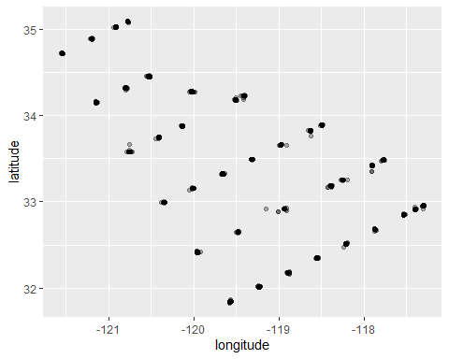
# How much zero inflation do we have?
cabezon %>%
mutate(zero = larvae_100m3 == 0) %>%
count(zero)
## zero n
## 1 FALSE 614
## 2 TRUE 3955
# Roughly ~85% zeros
# Raw distribution visual
plot(cabezon$volume_sampled, cabezon$larvae_100m3)
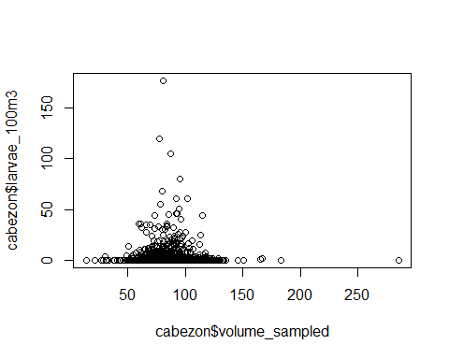

2. DATA EXPLORATION & SUMMARY STATISTICS
#---- 2. DATA EXPLORATION & SUMMARY STATISTICS
# Composite station column (combines line + station)
cabezon <- cabezon %>%
mutate(station_id = paste(line, station, sep = "_"))
# Annual mean larval abundance with SE
annual_cab_summary <- cabezon %>%
group_by(year) %>%
summarize(
mean_larvae = mean(larvae_100m3, na.rm = T),
sd_larvae = sd(larvae_100m3, na.rm = T),
n = n(),
se = sd_larvae / sqrt(n)
)
# Annual mean larval abundance plotted
ggplot(annual_cab_summary, aes(x = year, y = mean_larvae)) +
geom_line() +
geom_point() +
geom_ribbon(aes(ymin = mean_larvae - se,
ymax = mean_larvae + se),
alpha = 0.5,
fill = "skyblue") +
geom_line(color = "steelblue", linewidth = 1) +
geom_point(color = "steelblue") +
#geom_errorbar(aes(ymin = mean_larvae - se, # Can use error bars and/or ribbon
# ymax = mean_larvae + se),
# width = 0.2) +
labs(
x = "Year",
y = expression("Mean larvae per 100 m"^3),
title = "Annual Mean Larval Abundance",
subtitle = expression("Ribbon shows " %+-% " 1 SE")
) +
theme_bw()
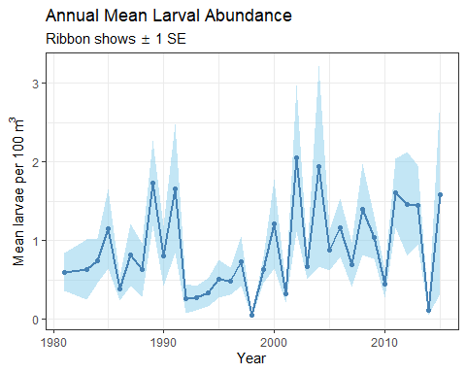
# Average larvae-positive tows by ...
# ... Year
pos_tows_year <- cabezon %>%
group_by(year) %>%
summarise(
total_tows = n(),
positive_tows = sum(larvae_100m3 > 0),
pct_positive_tows = positive_tows / total_tows * 100
)
# ... Month
pos_tows_month <- cabezon %>%
group_by(month) %>%
summarise(
total_tows = n(),
positive_tows = sum(larvae_100m3 > 0),
pct_positive_tows = positive_tows / total_tows * 100
)
# ... Season
pos_tows_season <- cabezon %>%
group_by(season) %>%
summarise(
total_tows = n(),
positive_tows = sum(larvae_100m3 > 0),
pct_positive_tows = positive_tows / total_tows * 100
)
# ... Station
pos_tows_station <- cabezon %>%
group_by(station_id) %>%
summarise(
total_tows = n(),
positive_tows = sum(larvae_100m3 > 0),
pct_positive_tows = positive_tows / total_tows * 100
)
# Average larvae counts (all tows and positive tows only) by ...
# ... Year
avg_larvae_year <- cabezon %>%
group_by(year) %>%
summarise(
mean_all = mean(larvae_100m3),
mean_positive = mean(larvae_100m3[larvae_100m3 > 0])
)
# ... Month
avg_larvae_month <- cabezon %>%
group_by(month) %>%
summarise(
mean_all = mean(larvae_100m3),
mean_positive = mean(larvae_100m3[larvae_100m3 > 0])
)
# ... Season
avg_larvae_season <- cabezon %>%
group_by(season) %>%
summarise(
mean_all = mean(larvae_100m3),
mean_positive = mean(larvae_100m3[larvae_100m3 > 0])
)
# ... Station
avg_larvae_station <- cabezon %>%
group_by(station_id) %>%
summarise(
mean_all = mean(larvae_100m3),
mean_positive = mean(larvae_100m3[larvae_100m3 > 0])
)
plot_data <- bind_rows(
pos_tows_year %>% mutate(group_var = "Year", level = as.character(year)),
pos_tows_month %>% mutate(group_var = "Month", level = as.character(month)),
pos_tows_season %>% mutate(group_var = "Season", level = as.character(season))
) %>%
mutate(negative_tows = total_tows - positive_tows) %>%
pivot_longer(
cols = c(positive_tows, negative_tows),
names_to = "tow_type",
values_to = "count"
)
plot_data <- plot_data %>%
mutate(level = case_when(
group_var == "Month" ~ factor(level, levels = as.character(1:12)),
group_var == "Season" ~ factor(level, levels = c("winter", "spring", "summer", "fall")),
T ~ factor(level)
))

3. STAR COMPARISONS & INITIAL CCFs
#---- 3. STAR COMPARISONS & INITIAL CCFs
# Join CalCOFI abundance to STAR age-0 recruits and recdevs
STAR_age0_calcofi <- left_join(STAR_age0, annual_cab_summary, by = "year")
STAR_recdevs_calcofi <- left_join(STAR_recdevs, annual_cab_summary, by = "year")
# Scale factors for dual axis plots
scale_factor_age0 <- max(STAR_age0_calcofi$value, na.rm = T) / max(STAR_age0_calcofi$mean_larvae, na.rm = T)
scale_factor_recdevs <- max(STAR_recdevs_calcofi$value, na.rm = T) / max(STAR_recdevs_calcofi$mean_larvae, na.rm = T)
# Age-0 recruits vs. observed larval abundance
ggplot(STAR_age0_calcofi, aes(x = year)) +
geom_ribbon(aes(ymin = lo, ymax = hi), fill = "skyblue", alpha = 0.5) +
geom_line(aes(y = value), color = "black") +
geom_line(aes(y = mean_larvae * scale_factor_age0), color = "coral") +
scale_y_continuous(
name = "Age-0 Recruits",
sec.axis = sec_axis(~ . / scale_factor_age0,
name = expression("Mean Larvae per 100 m"^3))
) +
labs(title = "SoCal Cabezon Age-0 Recruits and Larval Abundance Over Time") +
theme_bw()
## Warning: Removed 14 rows containing missing values or values outside the scale range
## (`geom_line()`).
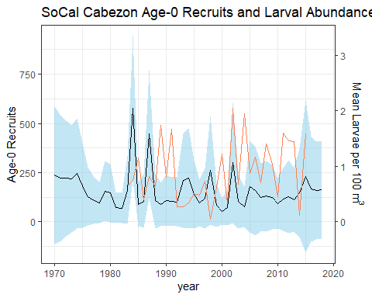
# Recdevs vs. observed larval abundance
ggplot(STAR_recdevs_calcofi, aes(x = year)) +
geom_ribbon(aes(ymin = lo, ymax = hi), fill = "skyblue", alpha = 0.5) +
geom_line(aes(y = value), color = "black") +
geom_line(aes(y = mean_larvae * scale_factor_recdevs), color = "coral") +
scale_y_continuous(
name = "Recruitment Deviations",
sec.axis = sec_axis(~ . / scale_factor_recdevs,
name = expression("Mean Larvae per 100 m"^3))
) +
labs(title = "SoCal Cabezon Recruitment Deviations and Larval Abundance Over Tiem") +
theme_bw()
## Warning: Removed 14 rows containing missing values or values outside the scale range
## (`geom_line()`).
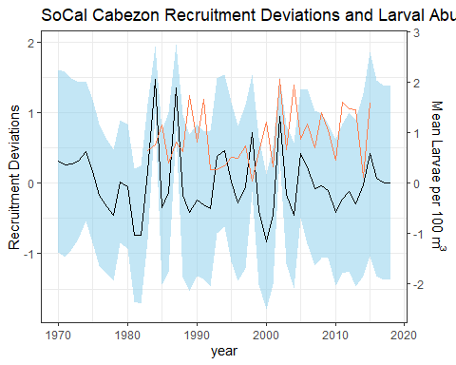
# CCF: Observed larvae vs. recruitment deviations (overlapping years only)
obs_recdevs <- STAR_recdevs_calcofi %>%
filter(year %in% annual_cab_summary$year & year %in% STAR_recdevs$year)
ccf(obs_recdevs$mean_larvae, obs_recdevs$value,
lag.max = 10,
main = "CCF: Larvae vs. Recruitment Deviations (observed years only")
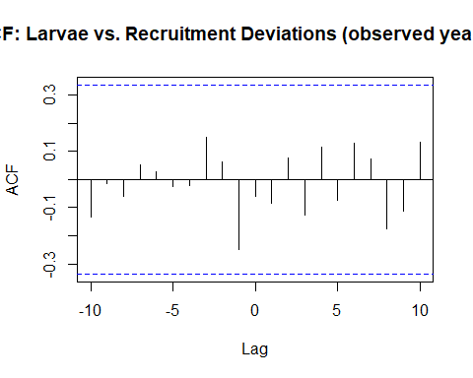
# CCF: Observed larvae vs. age-0 recruits (overlapping years only)
obs_age0 <- STAR_age0_calcofi %>%
filter(year %in% annual_cab_summary$year & year %in% STAR_age0$year)
ccf(obs_age0$mean_larvae, obs_age0$value,
lag.max = 10,
main = "CCF: Larvae vs. Age-0 Recruits (observed years only")
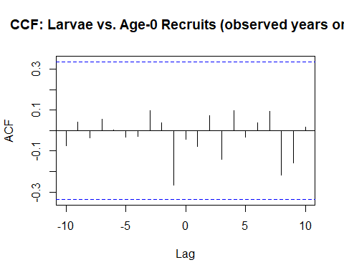

4. DATA VISUALIZATION
# ---- 4. DATA VISUALIZATION
#---- 4.a. Station map for visual reference
station_locations <- cabezon %>%
group_by(line.station) %>%
summarise(
latitude = mean(latitude),
longitude = mean(longitude),
.groups = "drop"
)
coast <- map_data("world", region = c("USA", "Mexico"))
ggplot() +
geom_polygon(data = coast, aes(x = long, y = lat, group = group),
fill = "grey85", color = "grey50", linewidth = 0.3) +
geom_point(data = station_locations,
aes(x = longitude, y = latitude),
color = "steelblue", size = 2) +
geom_text(data = station_locations,
aes(x = longitude, y = latitude, label = line.station),
size = 2.5, hjust = -0.15, vjust = 0.4, color = "grey20") +
coord_fixed(
ratio = 1.3,
xlim = c(min(station_locations$longitude) - 1, max(station_locations$longitude) + 1),
ylim = c(min(station_locations$latitude) - 1, max(station_locations$latitude) + 1)
) +
labs(
title = "Cabezon Larvae Sampling Stations",
subtitle = "CalCOFI survey stations; labels show line.station identifier",
x = "Longitude",
y = "Latitude"
) +
theme_minimal(base_size = 12) +
theme(
plot.title = element_text(face = "bold", size = 15),
plot.subtitle = element_text(color = "grey40", size = 10),
panel.grid = element_line(color = "grey92")
)
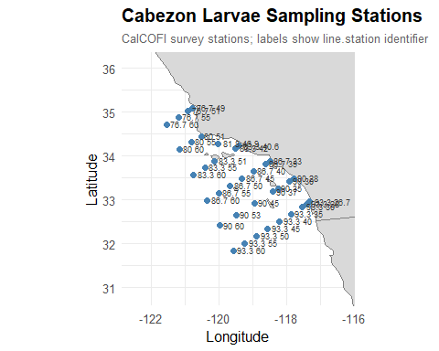
# ---- 4.b. Annual average larval abundance
ggplot(annual_cab_summary, aes(x = year, y = mean_larvae)) +
geom_ribbon(aes(ymin = mean_larvae - se, ymax = mean_larvae + se),
alpha = 0.5, fill = "skyblue") +
geom_line(color = "steelblue", linewidth = 1) +
geom_point(color = "steelblue") +
labs(
x = "Year",
y = expression("Mean larvae per 100 m"^3),
title = "Annual Mean Larval Abundance",
subtitle = expression("Ribbon shows " %+-% " 1 SE")
) +
theme_bw()

# ---- 4.c. Stacked bar chart: positive vs. total tows by year, month, season
# Shared elements
shared_fill <- scale_fill_manual(
values = c("negative_tows" = "grey80", "positive_tows" = "steelblue"),
labels = c("negative_tows" = "Larvae Absent", "positive_tows" = "Larvae Present")
)
shared_bar_theme <- theme_minimal(base_size = 12) +
theme(
strip.text = element_text(face = "bold", size = 13),
axis.text.x = element_text(angle = 45, hjust = 1),
legend.position = "bottom",
panel.grid.major.x = element_blank(),
plot.title = element_text(face = "bold", size = 15),
plot.subtitle = element_text(color = "grey40", size = 10)
)
# One plot for years; one plot for months + seasons
plot_data_year <- plot_data %>% filter(group_var == "Year")
plot_data_ms <- plot_data %>% filter(group_var %in% c("Month", "Season"))
# Years plot
ggplot(plot_data_year, aes(x = level, y = count, fill = tow_type)) +
geom_bar(stat = "identity", width = 0.7) +
shared_fill +
shared_bar_theme +
labs(
title = "Cabezon Larvae: Positive vs. Total Tows",
subtitle = "Stacked bars show larvae-present (blue) against total sampling effort (gray)",
x = NULL,
y = "Number of Tows",
fill = NULL
)
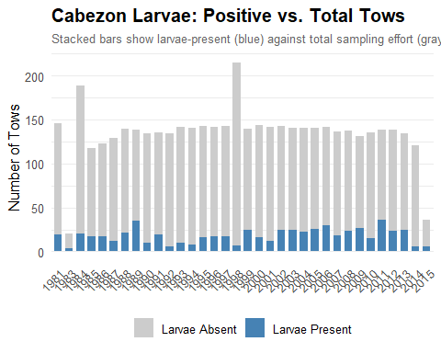
# Months + Seasons plot
ggplot(plot_data_ms, aes(x = level, y = count, fill = tow_type)) +
geom_bar(stat = "identity", width = 0.7) +
facet_wrap(~ group_var, scales = "free_x", nrow = 1) +
shared_fill + shared_bar_theme +
labs(
title = "Cabezon Larvae: Positive vs. Total Tows",
subtitle = "Stacked bar charts show larve-present (blue) against total sampling effort (gray)",
x = NULL,
y = "Number of Tows",
fill = NULL
)
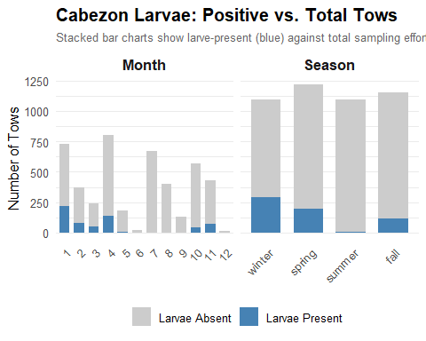
#---- 4.d. Boxplots: log-larvae by year, month, season (positive tows only)
# Data binning
box_data <- bind_rows(
cabezon %>% mutate(group_var = "Year", level = as.character(year)),
cabezon %>% mutate(group_var = "Month", level = as.character(month)),
cabezon %>% mutate(group_var = "Season", level = as.character(season))
) %>%
filter(larvae_100m3 > 0) %>%
mutate(
log_larvae = log(larvae_100m3),
group_var = factor(group_var, levels = c("Year", "Month", "Season")),
level = case_when(
group_var == "Month" ~ factor(level, levels = as.character(1:12)),
group_var == "Season" ~ factor(level, levels = c("winter", "spring", "summer", "fall")),
TRUE ~ factor(level)
)
)
# Shared elements
shared_box_theme <- theme_minimal(base_size = 12) +
theme(
strip.text = element_text(face = "bold", size = 13),
axis.text.x = element_text(angle = 45, hjust = 1),
legend.position = "none",
panel.grid.major.x = element_blank(),
plot.title = element_text(face = "bold", size = 15),
plot.subtitle = element_text(color = "grey40", size = 10)
)
# Years plot
ggplot(box_data %>% filter(group_var == "Year"),
aes(x = level, y = log_larvae)) +
geom_boxplot(fill = "steelblue", color = "grey30", alpha = 0.7, outlier.size = 1) +
shared_box_theme +
labs(
title = "Cabezon Larvae: Average Count by Year (Positive Tows Only)",
subtitle = "Log-transformed larvae per 100m³; zero-catch tows excluded",
x = NULL,
y = "log(Larvae per 100m³)"
)
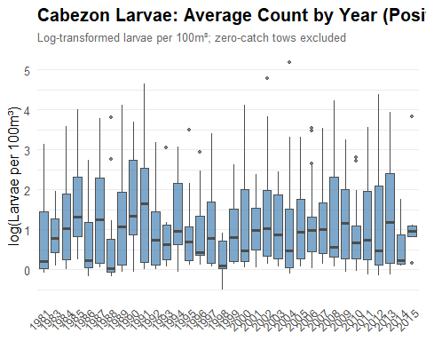
# Months + Seasons plot
ggplot(box_data %>% filter(group_var %in% c("Month", "Season")),
aes(x = level, y = log_larvae)) +
geom_boxplot(fill = "steelblue", color = "grey30", alpha = 0.7, outlier.size = 1) +
facet_wrap(~ group_var, scales = "free_x", nrow = 1) +
shared_box_theme +
labs(
title = "Cabezon Larvae: Average Count by Month and Season (Positive Tows Only)",
subtitle = "Log-transformed larvae per 100m³; zero-catch tows excluded",
x = NULL, y = "log(Larvae per 100m³)"
)
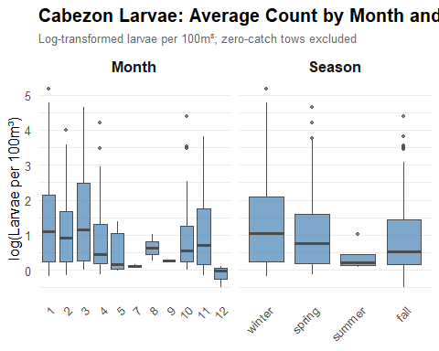
#---- 4.e. Heatmaps: mean log-larvae by station x year, month, season
heatmap_theme <- theme_minimal(base_size = 11) +
theme(
axis.text.y = element_text(size = 7),
plot.title = element_text(face = "bold", size = 15),
plot.subtitle = element_text(color = "grey40", size = 10)
)
heatmap_fill <- scale_fill_viridis_c(option = "mako", name = "log(Larvae\nper 100m³)", na.value = "white")
# Year plot
cabezon %>%
filter(larvae_100m3 > 0) %>%
group_by(line.station, year) %>%
summarise(mean_log_larvae = mean(log(larvae_100m3)), .groups = "drop") %>%
ggplot(aes(x = year, y = line.station, fill = mean_log_larvae)) +
geom_tile() + heatmap_fill + scale_y_discrete(limits = rev) + heatmap_theme +
labs(title = "Cabezon Larval Abundance by Station and Year",
subtitle = "Positive tows only; white = no positive tows recorded",
x = NULL, y = "South \u2190 Station \u2192 North")
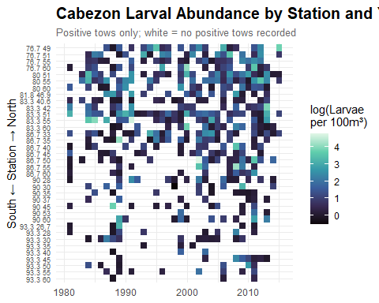
# Month plot
cabezon %>%
filter(larvae_100m3 > 0) %>%
group_by(line.station, month) %>%
summarise(mean_log_larvae = mean(log(larvae_100m3)), .groups = "drop") %>%
ggplot(aes(x = month, y = line.station, fill = mean_log_larvae)) +
geom_tile() + heatmap_fill +
scale_x_continuous(breaks = 1:12, labels = month.abb) +
scale_y_discrete(limits = rev) + heatmap_theme +
labs(title = "Cabezon Larval Abundance by Station and Month",
subtitle = "Positive tows only; white = no positive tows recorded",
x = NULL, y = "South \u2190 Station \u2192 North")
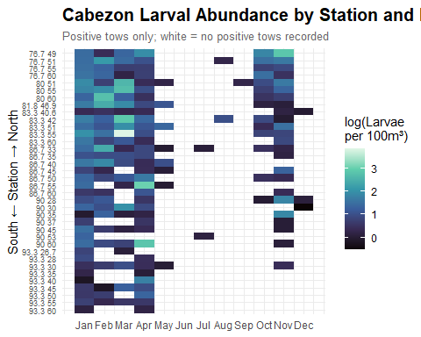
# Season plot
cabezon %>%
filter(larvae_100m3 > 0) %>%
group_by(line.station, season) %>%
summarise(mean_log_larvae = mean(log(larvae_100m3)), .groups = "drop") %>%
ggplot(aes(x = season, y = line.station, fill = mean_log_larvae)) +
geom_tile() + heatmap_fill + scale_y_discrete(limits = rev) + heatmap_theme +
labs(title = "Cabezon Larval Abundance by Station and Season",
subtitle = "Positive tows only; white = no positive tows recorded",
x = NULL, y = "South \u2190 Station \u2192 North")
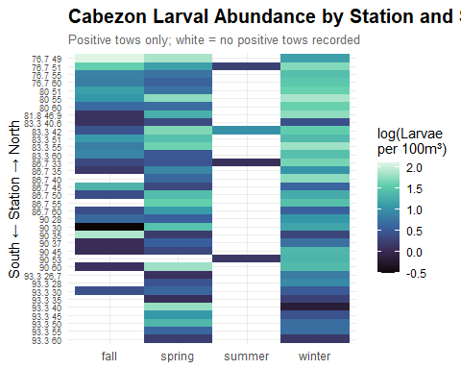

5. sdmTMB MODEL FITTING
#---- 5. sdmTMB MODEL FITTING
#---- 5.a. Build mesh
cab_mesh <- make_mesh(
cabezon,
xy_cols = c("longitude", "latitude"),
cutoff = 0.15
)
plot(cab_mesh); title("SPDE Mesh for Cabezon CalCOFI analysis")
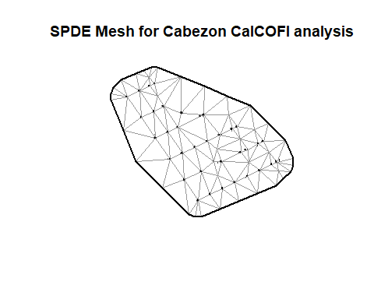
#---- 5.b. Fit candidate models
# Delta-Gamma: full AR1 spatial + spatiotemporal
cab_fit1 <- sdmTMB(
list(larvae_100m3 ~ 1, larvae_100m3 ~ 1),
data = cabezon,
mesh = cab_mesh,
time = "year",
family = delta_gamma(),
spatial = list("on", "on"),
spatiotemporal = list("ar1", "ar1"),
offset = NULL
)
## Detected irregular time spacing with an AR(1) or random walk process.
## Consider filling in the missing time slices with `extra_time`.
## `extra_time = c(1982)`
sanity(cab_fit1)
## ✔ Non-linear minimizer suggests successful convergence
## ✔ Hessian matrix is positive definite
## ✔ No extreme or very small eigenvalues detected
## ✔ No gradients with respect to fixed effects are >= 0.001
## ✔ No fixed-effect standard errors are NA
## ✔ No standard errors look unreasonably large
## ✔ No sigma parameters are < 0.01
## ✔ No sigma parameters are > 100
## ✔ Range parameters don't look unreasonably large
# Delta-Gamma: spatial only, spatiotemporal off
cab_fit1a <- sdmTMB(
list(larvae_100m3 ~ 1, larvae_100m3 ~ 1),
data = cabezon,
mesh = cab_mesh,
time = "year",
family = delta_gamma(),
spatial = list("on", "on"),
spatiotemporal = list("off", "off"),
offset = NULL
)
sanity(cab_fit1a)
## ✔ Non-linear minimizer suggests successful convergence
## ✔ Hessian matrix is positive definite
## ✔ No extreme or very small eigenvalues detected
## ✔ No gradients with respect to fixed effects are >= 0.001
## ✔ No fixed-effect standard errors are NA
## ✔ No standard errors look unreasonably large
## ✔ No sigma parameters are < 0.01
## ✔ No sigma parameters are > 100
## ✔ Range parameters don't look unreasonably large
# Delta-Gamma; Delta component AR1, Gamma spatiotemporal off
cab_fit1b <- sdmTMB(
list(larvae_100m3 ~ 1, larvae_100m3 ~ 1),
data = cabezon,
mesh = cab_mesh,
time = "year",
family = delta_gamma(),
spatial = list("on", "on"),
spatiotemporal = list("ar1", "off"),
offset = NULL
)
## Detected irregular time spacing with an AR(1) or random walk process.
## Consider filling in the missing time slices with `extra_time`.
## `extra_time = c(1982)`
sanity(cab_fit1b)
## ✔ Non-linear minimizer suggests successful convergence
## ✔ Hessian matrix is positive definite
## ✔ No extreme or very small eigenvalues detected
## ✔ No gradients with respect to fixed effects are >= 0.001
## ✔ No fixed-effect standard errors are NA
## ✔ No standard errors look unreasonably large
## ✔ No sigma parameters are < 0.01
## ✔ No sigma parameters are > 100
## ✔ Range parameters don't look unreasonably large
# Delta-Gamma: Gamma component AR1, Delta spatiotemporal off
cab_fit1c <- sdmTMB(
list(larvae_100m3 ~ 1, larvae_100m3 ~ 1),
data = cabezon,
mesh = cab_mesh,
time = "year",
family = delta_gamma(),
spatial = list("on", "on"),
spatiotemporal = list("off", "ar1"),
offset = NULL
)
## Detected irregular time spacing with an AR(1) or random walk process.
## Consider filling in the missing time slices with `extra_time`.
## `extra_time = c(1982)`
sanity(cab_fit1c)
## ✔ Non-linear minimizer suggests successful convergence
## ✔ Hessian matrix is positive definite
## ✔ No extreme or very small eigenvalues detected
## ✔ No gradients with respect to fixed effects are >= 0.001
## ✔ No fixed-effect standard errors are NA
## ✔ No standard errors look unreasonably large
## ✔ No sigma parameters are < 0.01
## ✔ No sigma parameters are > 100
## ✔ Range parameters don't look unreasonably large
# Tweedie: full AR1 spatial + spatiotemporal
cab_fit2 <- sdmTMB(
formula = larvae_100m3 ~ 1,
data = cabezon,
mesh = cab_mesh,
time = "year",
family = tweedie(),
spatial = "on",
spatiotemporal = "ar1",
offset = NULL
)
## Detected irregular time spacing with an AR(1) or random walk process.
## Consider filling in the missing time slices with `extra_time`.
## `extra_time = c(1982)`
sanity(cab_fit2)
## ✔ Non-linear minimizer suggests successful convergence
## ✔ Hessian matrix is positive definite
## ✔ No extreme or very small eigenvalues detected
## ✔ No gradients with respect to fixed effects are >= 0.001
## ✔ No fixed-effect standard errors are NA
## ✔ No standard errors look unreasonably large
## ✔ No sigma parameters are < 0.01
## ✔ No sigma parameters are > 100
## ✔ Range parameter doesn't look unreasonably large
# Tweedie: spatial only, spatiotemporal off
cab_fit2a <- sdmTMB(
formula = larvae_100m3 ~ 1,
data = cabezon,
mesh = cab_mesh,
time = "year",
family = tweedie(),
spatial = "on",
spatiotemporal = "off",
offset = NULL
)
sanity(cab_fit2a)
## ✔ Non-linear minimizer suggests successful convergence
## ✔ Hessian matrix is positive definite
## ✔ No extreme or very small eigenvalues detected
## ✔ No gradients with respect to fixed effects are >= 0.001
## ✔ No fixed-effect standard errors are NA
## ✔ No standard errors look unreasonably large
## ✔ No sigma parameters are < 0.01
## ✔ No sigma parameters are > 100
## ✔ Range parameter doesn't look unreasonably large
#---- 5.c. Cross validation
cv_m1 <- sdmTMB_cv(cab_fit1$call$formula, cabezon, cab_mesh, delta_gamma(),k_folds = 5)
## Running fits sequentially.
## Install the future and future.apply packages,
## set a parallel `future::plan()`, and set `parallel = TRUE` to use parallel processing.
cv_m1a <- sdmTMB_cv(cab_fit1a$call$formula, cabezon, cab_mesh, delta_gamma(), k_folds = 5)
## Running fits sequentially.
## Install the future and future.apply packages,
## set a parallel `future::plan()`, and set `parallel = TRUE` to use parallel processing.
cv_m1b <- sdmTMB_cv(cab_fit1b$call$formula, cabezon, cab_mesh, delta_gamma(), k_folds = 5)
## Running fits sequentially.
## Install the future and future.apply packages,
## set a parallel `future::plan()`, and set `parallel = TRUE` to use parallel processing.
cv_m1c <- sdmTMB_cv(cab_fit1c$call$formula, cabezon, cab_mesh, delta_gamma(), k_folds = 5)
## Running fits sequentially.
## Install the future and future.apply packages,
## set a parallel `future::plan()`, and set `parallel = TRUE` to use parallel processing.
cv_m2 <- sdmTMB_cv(cab_fit2a$call$formula, cabezon, cab_mesh, tweedie(), k_folds = 5)
## Running fits sequentially.
## Install the future and future.apply packages,
## set a parallel `future::plan()`, and set `parallel = TRUE` to use parallel processing.
cv_m2a <- sdmTMB_cv(cab_fit2a$call$formula, cabezon, cab_mesh, tweedie(), k_folds = 5)
## Running fits sequentially.
## Install the future and future.apply packages,
## set a parallel `future::plan()`, and set `parallel = TRUE` to use parallel processing.
#---- 5.d. Construct model comparison table
cv_table <- data.frame(
fit_name = c(
"cab_fit1",
"cab_fit1a",
"cab_fit1b",
"cab_fit1c",
"cab_fit2",
"cab_fit2a"
),
model = c(
"Delta-Gamma spatial + spatiotemporal AR1",
"Delta-Gamma spatial",
"Delta-Gamma spatiotemporal Delta AR1",
"Delta-Gamma spatiotemporal Gamma AR1",
"Tweedie spatial + spatiotemporal AR1",
"Tweedie spatial"
),
AIC = c(
AIC(cab_fit1),
AIC(cab_fit1a),
AIC(cab_fit1b),
AIC(cab_fit1c),
AIC(cab_fit2),
AIC(cab_fit2a)
),
delta_AIC = NA,
CV = c(
cv_m1$sum_loglik,
cv_m1a$sum_loglik,
cv_m1b$sum_loglik,
cv_m1c$sum_loglik,
cv_m2$sum_loglik,
cv_m2a$sum_loglik
),
delta_CV = NA
)
cv_table$delta_AIC <- cv_table$AIC - min(cv_table$AIC)
cv_table$delta_CV <- cv_table$CV - min(cv_table$CV)
cv_table <- cv_table[order(cv_table$CV, decreasing = T), ]
cv_table
## fit_name model AIC delta_AIC
## 5 cab_fit2 Tweedie spatial + spatiotemporal AR1 6737.554 66.99500
## 4 cab_fit1c Delta-Gamma spatiotemporal Gamma AR1 6723.836 53.27737
## 1 cab_fit1 Delta-Gamma spatial + spatiotemporal AR1 6670.559 0.00000
## 3 cab_fit1b Delta-Gamma spatiotemporal Delta AR1 6815.018 144.45983
## 2 cab_fit1a Delta-Gamma spatial 6868.296 197.73721
## 6 cab_fit2a Tweedie spatial 6897.969 227.41021
## CV delta_CV
## 5 -14147.15 278.40017
## 4 -14264.93 160.61647
## 1 -14289.64 135.91199
## 3 -14391.27 34.27524
## 2 -14396.90 28.65067
## 6 -14425.55 0.00000
#---- 5.e. Random effect parameter estimates for best models
tidy(cab_fit1, effects = "ran_pars")
## # A tibble: 4 × 6
## model term estimate std.error conf.low conf.high
## <dbl> <chr> <dbl> <dbl> <dbl> <dbl>
## 1 1 range 5.47 1.49 3.21 9.35
## 2 1 sigma_O 0.922 0.304 0.483 1.76
## 3 1 sigma_E 0.249 0.0649 0.150 0.416
## 4 1 rho 0.242 NA -0.190 0.595
tidy(cab_fit2, effects = "ran_pars")
## # A tibble: 6 × 5
## term estimate std.error conf.low conf.high
## <chr> <dbl> <dbl> <dbl> <dbl>
## 1 range 1.41 0.230 1.02 1.94
## 2 phi 8.42 0.393 7.69 9.23
## 3 sigma_O 0.831 0.150 0.584 1.18
## 4 sigma_E 1.08 0.0921 0.912 1.27
## 5 tweedie_p 1.45 0.0131 1.43 1.48
## 6 rho 0.206 NA -0.0247 0.415

6. cab_fit1 full D-G MODEL DIAGNOSTICS & ABUNDANCE INDEX
#---- 6. cab_fit1 full D-G MODEL DIAGNOSTICS & ABUNDANCE INDEX
#---- 6.a. Calibration summaries
pred_obs <- predict(cab_fit1, type = "response")
# Overall mean calibration
pred_obs %>%
summarise(
obs_mean = mean(larvae_100m3, na.rm = TRUE),
pred_mean = mean(est, na.rm = TRUE),
obs_occ = mean(larvae_100m3 > 0, na.rm = TRUE),
pred_occ = mean(est1, na.rm = TRUE),
obs_pos_mean = mean(larvae_100m3[larvae_100m3 > 0], na.rm = TRUE),
pred_pos_mean = mean(est2, na.rm = TRUE)
)
## obs_mean pred_mean obs_occ pred_occ obs_pos_mean pred_pos_mean
## 1 0.8761778 0.6218436 0.1343839 0.1343806 6.519961 3.982611
# Binomial calibration; i.e. predicted presence probability vs. observed presence rate
pred_obs$presence <- pred_obs$larvae_100m3 > 0
calibration_summary <- pred_obs %>%
mutate(prob_bin = cut(est1, breaks = seq(0, 1, by = 0.1))) %>%
group_by(prob_bin) %>%
summarise(
mean_pred = mean(est1),
observed = mean(presence),
n = n()
)
plot(calibration_summary$mean_pred, calibration_summary$observed,
xlab = "Predicted presence probability",
ylab = "Observed presence frequency")
abline(0,1,lty=2)
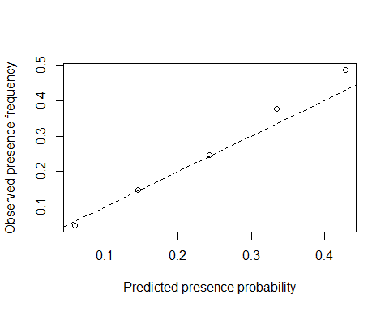
#---- 6.b. Predicted vs. observed plots
# Raw scale comparison
plot(
x = pred_obs$est,
y = cabezon$larvae_100m3,
xlab = "Predicted",
ylab = "Observed"
)
abline(0, 1, lty = 2)
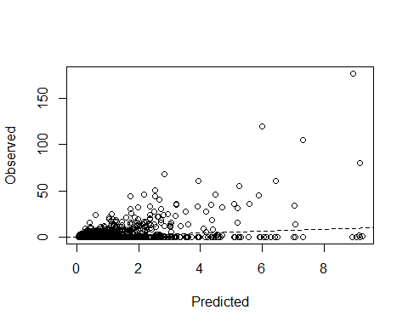
# Log scale comparison
plot(log1p(pred_obs$est), log1p(cabezon$larvae_100m3),
xlab = "log(Predicted + 1)", ylab = "log(Observed + 1)")
abline(0, 1, lty = 2)
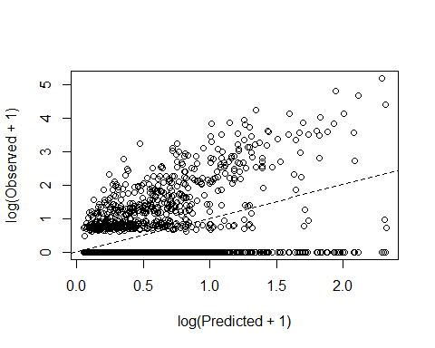
# Gamma (positive density) component only
pos_idx <- cabezon$larvae_100m3 > 0
plot(log(pred_obs$est2[pos_idx]), log(cabezon$larvae_100m3[pos_idx]),
xlab = "log(Predicted positive abundance)",
ylab = "log(Observed positive abundance)")
abline(0, 1, lty = 2)
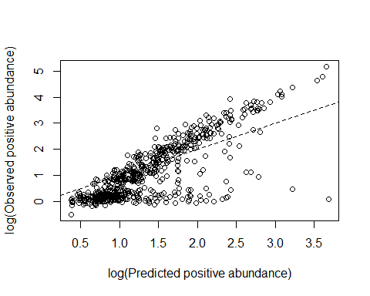
#---- 6.c. Randomized quantile residuals
rq_res <- residuals(cab_fit1, type = "mle-mvn")
## These are residuals for delta model component 1. Use the `model` argument to
## select the other component.
# QQ plot
qqnorm(rq_res)
qqline(rq_res)
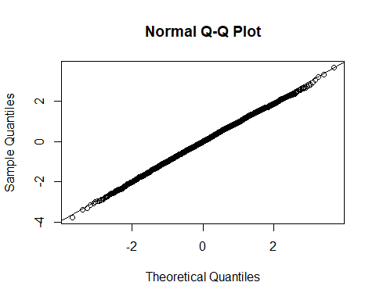
# Spatial residual map by year (kind of hard to see)
pred_obs$rq_resid <- rq_res
ggplot(pred_obs, aes(x = longitude, y = latitude, color = rq_resid)) +
geom_point() +
scale_color_gradient2() +
facet_wrap(~ year)
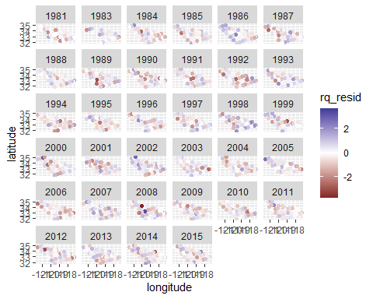
#---- 6.d. Temporal calibration
# Are predictions tracking temporal trends?
pred_obs %>%
group_by(year) %>%
summarize(
obs = mean(larvae_100m3),
pred = mean(est)
) %>%
ggplot(aes(x = year)) +
geom_line(aes(y = obs), color = "black") +
geom_line(aes(y = pred), color = "blue", linetype = "dashed")
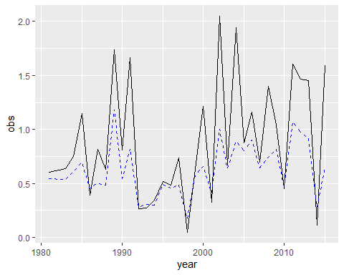
#---- 6.e. Abundance index construction
# Note! The index uncertainty here was far too wide using a regular spatial grid, probably because interpolation over years with no CalCOFI coverage was causing inflation. I kept that plot in for reference, but 4.f. (observed station grid) is probably preferred for diagnosis.
cab_mesh$mesh$loc[1:5, ]
## [,1] [,2] [,3]
## [1,] -119.5717 31.84667 0
## [2,] -119.2400 32.01333 0
## [3,] -118.8933 32.18000 0
## [4,] -118.5550 32.34666 0
## [5,] -118.2133 32.51333 0
x_limits <- c(-122, -117)
y_limits <- c(31, 36)
pred_grid <- expand.grid(
longitude = seq(x_limits[1], x_limits[2], by = 0.05),
latitude = seq(y_limits[1], y_limits[2], by = 0.05)
) %>%
tidyr::crossing(year = as.integer(sort(unique(cabezon$year))))
cab_map <- predict(cab_fit1, newdata = pred_grid, return_tmb_object = T)
cab_index <- get_index(cab_map, area = 0.05^2, bias_correct = T)
ggplot(cab_index, aes(x = year, y = est)) +
geom_line() +
geom_ribbon(aes(ymin = lwr, ymax = upr), alpha = 0.3) +
labs(y = "Estimated abundance index", x = "Year", title = "Abundance Index: Regular Grid (Inflated by Interpolation)")
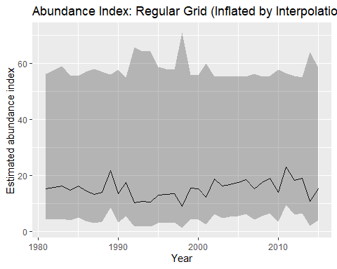
#---- 6.f. Abundance index: constrained to observed station grid (probably preferred)
pred_grid_obs <- cabezon %>%
dplyr::select(longitude, latitude, year) %>%
distinct()
cab_map_obs <- predict(cab_fit1,
newdata = pred_grid_obs,
return_tmb_object = T)
cab_index_obs <- get_index(cab_map_obs,
area = 1,
bias_correct = T)
ggplot(cab_index_obs, aes(x = year, y = est)) +
geom_line() +
geom_ribbon(aes(ymin = lwr, ymax = upr), alpha = 0.3) +
labs(y = "Estimated abundance index", x = "Year", title = "Abundance Index: Observed Station Grid")
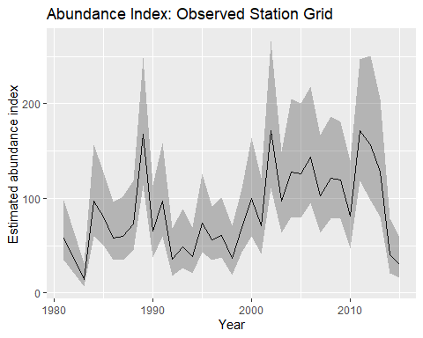

7. STAR COMPARISONS & CCFs TO cab_fit1 full D-G MODEL RUN
#---- 7. STAR COMPARISONS & CCFs TO cab_fit1 full D-G MODEL RUN
# Create one data frame to house all STAR + larval index data
# Note! For these comparisons, we move forward with the constrained 6.f. abundnance index, assuming it's more stable.
combined <- cab_index_obs %>%
dplyr::select(year, est) %>%
rename(larvae_index = est) %>%
left_join(STAR_SSB, by = "year") %>%
left_join(STAR_recdevs, by = "year") %>%
left_join(STAR_age0, by = "year")
# Filter to observed years
combined_obs <- combined %>%
filter(!is.na(larvae_index) | is.na(value))
# CCF: Restricted larval index vs. age-0 recruits
ccf(cab_index_obs$est, STAR_age0_calcofi$value,
lag.max = 10,
main = "CCF: Restricted Larval Index vs. Age-0 Recruits")
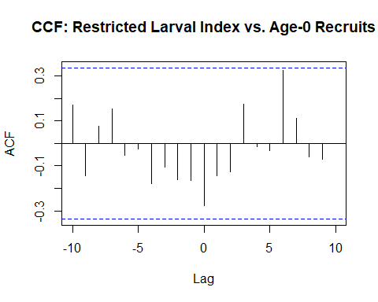
# CCF: Restricted larval index vs. recruitment deviations
ccf(cab_index_obs$est, STAR_recdevs_calcofi$value,
lag.max = 10,
main = "CCF: Restricted Larval Index vs. Recruitment Deviations")
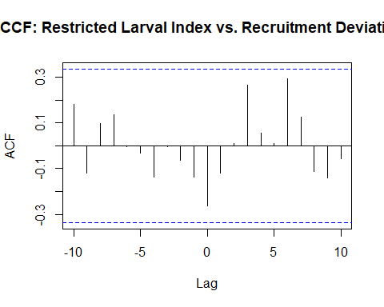
# Nothing really :( when we try against SSB, we get some strong signal, but this is probably due to a shared declining trend. We'll try to parse that.
# CCF: Restricted larval index vs. SSB
ccf(STAR_SSB$value, cab_index_obs$est,
lag.max = 10,
main = "CCF: Restricted Larval Index vs. Spawning Stock Biomass (raw)")
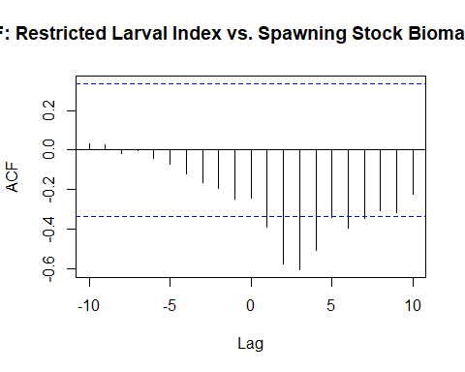
larvae_detrended <- residuals(lm(larvae_index ~ year, data = combined_obs))
ssb_detrended <- residuals(lm(value ~ year, data = combined_obs))
ccf(larvae_detrended, ssb_detrended,
lag.max = 10,
main = "CCF: Restricted Larval Index vs. SSB (detrended)")
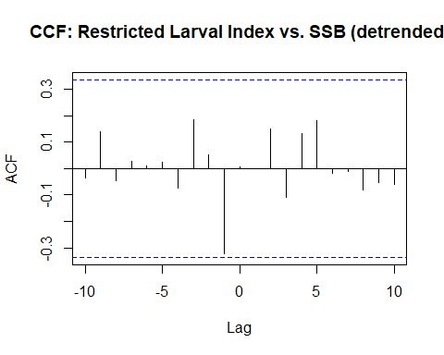

Extras
world <- ne_coastline(scale = "medium", returnclass = "sf")
# ── In-sample predictions ─────────────────────────────────────────────────────
# Delta-Gamma: est1 = occurrence prob, est2 = positive catch rate, combined = est1 * est2
pred_dg <- predict(cab_fit1, type = "response")
pred_dg$est_combined <- pred_dg$est1 * pred_dg$est2
# Tweedie: est is the combined expected value in response scale
pred_tw <- predict(cab_fit2, type = "response")
# Attach predicted values to observed data
obs_dg <- cabezon %>% mutate(predicted = pred_dg$est_combined, observed = larvae_100m3)
obs_tw <- cabezon %>% mutate(predicted = pred_tw$est, observed = larvae_100m3)
# ── Grid predictions for spatial maps ─────────────────────────────────────────
# Delta-Gamma (cab_map already exists; add combined column)
cab_map_df <- cab_map$data %>%
mutate(est_combined = est1 * est2)
plot_spatial_fit(cab_map_df, "est_combined", cabezon, "Delta-Gamma")
## Error in plot_spatial_fit(cab_map_df, "est_combined", cabezon, "Delta-Gamma"): could not find function "plot_spatial_fit"
# Tweedie grid predictions
cab_map_tw <- predict(cab_fit2, newdata = pred_grid, type = "response")
# ── 1. Predicted vs. Observed scatter plots ───────────────────────────────────
scatter_dg <- ggplot(obs_dg, aes(x = predicted, y = observed)) +
geom_point(alpha = 0.35, size = 1.2) +
geom_abline(slope = 1, intercept = 0, linetype = "dashed", color = "red", linewidth = 0.8) +
scale_x_continuous(trans = "log1p", labels = scales::comma) +
scale_y_continuous(trans = "log1p", labels = scales::comma) +
labs(
title = "Delta-Gamma: Predicted vs. Observed",
x = expression("Predicted larvae per 100 m"^3),
y = expression("Observed larvae per 100 m"^3)
) +
theme_bw()
scatter_tw <- ggplot(obs_tw, aes(x = predicted, y = observed)) +
geom_point(alpha = 0.35, size = 1.2) +
geom_abline(slope = 1, intercept = 0, linetype = "dashed", color = "red", linewidth = 0.8) +
scale_x_continuous(trans = "log1p", labels = scales::comma) +
scale_y_continuous(trans = "log1p", labels = scales::comma) +
labs(
title = "Tweedie: Predicted vs. Observed",
x = expression("Predicted larvae per 100 m"^3),
y = expression("Observed larvae per 100 m"^3)
) +
theme_bw()
scatter_dg
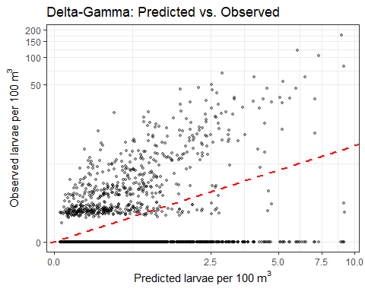
scatter_tw
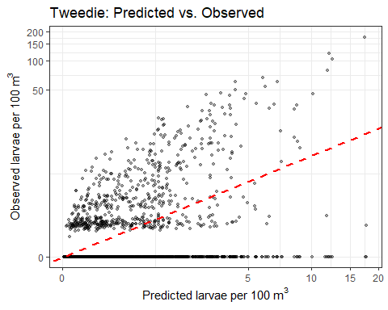
# ── 2. Faceted spatial maps: predicted surface + observed points ───────────────
plot_spatial_fit <- function(grid_preds, est_col, obs_data, model_name) {
ggplot() +
geom_raster(
data = grid_preds,
aes(x = longitude, y = latitude, fill = log1p(.data[[est_col]])),
interpolate = TRUE
) +
geom_sf(data = world, color = "gray30", fill = "gray85", linewidth = 0.3) +
geom_point(
data = obs_data,
aes(x = longitude, y = latitude, size = log1p(larvae_100m3)),
shape = 21, fill = "white", color = "black", stroke = 0.3, alpha = 0.75
) +
scale_fill_viridis_c(
name = expression(log(1 + hat(y))),
option = "plasma",
na.value = NA
) +
scale_size_continuous(
name = expression(log(1 + y)),
range = c(0.3, 3.5)
) +
coord_sf(xlim = x_limits, ylim = y_limits, expand = FALSE) +
facet_wrap(~ year) +
labs(title = paste(model_name, "— Predicted Surface & Observed Points")) +
theme_bw(base_size = 9) +
theme(
strip.text = element_text(size = 7),
axis.text = element_text(size = 6),
legend.title = element_text(size = 8),
legend.key.height = unit(0.6, "cm")
)
}
plot_spatial_fit(cab_map_df, "est_combined", cabezon, "Delta-Gamma")
## Warning in log1p(.data[["est_combined"]]): NaNs produced
## Warning: Removed 340938 rows containing missing values or values outside the scale range
## (`geom_raster()`).
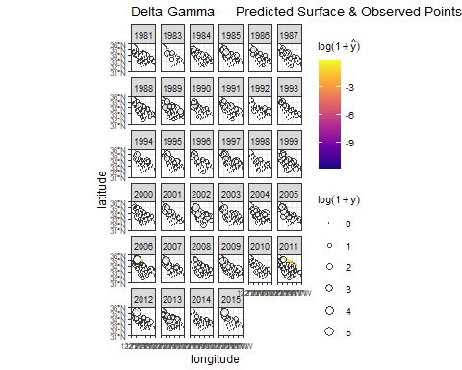
plot_spatial_fit(cab_map_tw, "est", cabezon, "Tweedie")
