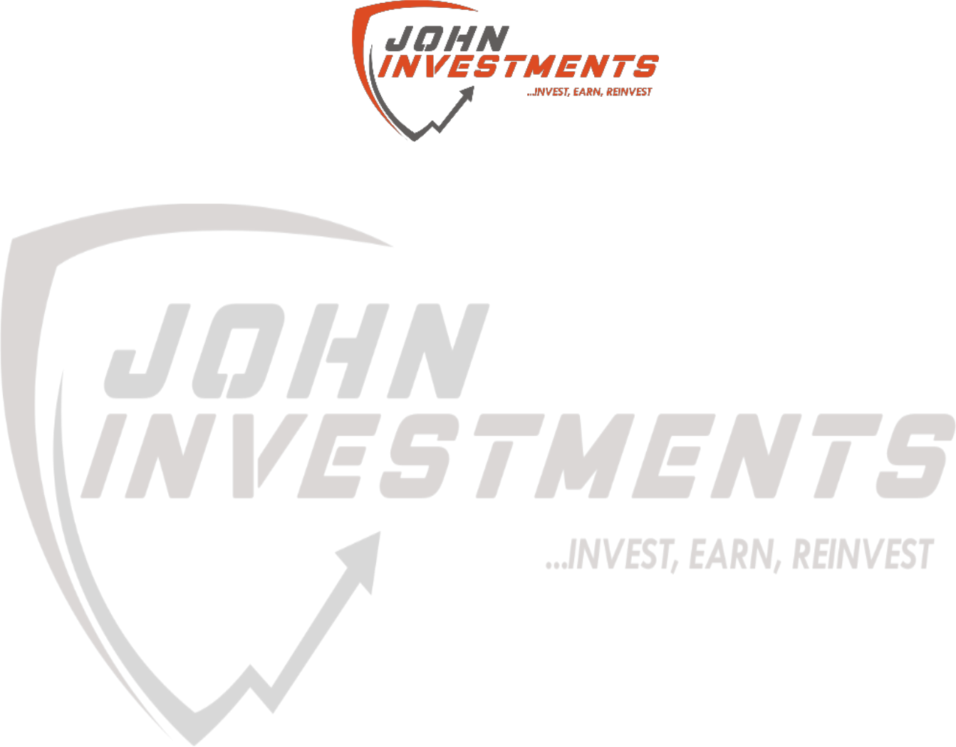

**MEMORANDUM OF UNDERSTANDING**

This is a document validating an agreement between **MR. OGABOR JOHN AND MR OLUREMI DANIEL YINKA** for the collaborative of 20% interest over a sum of **FIFTY THOUSAND NAIRA ONLY (N50,000) paid on the 12th of February, 2020.**

There is a binding agreement to pay the initial capital invested, alongside the interest, **SIXTY FIVE THOUSAND NAIRA ONLY (N65,000) on the 12th of March, 2020** by **MR. OGABOR JOHN TO MR OLUREMI DANIEL YINKA.**

Attached with this document is an evidence of payment by **MR OLUREMI DANIEL YINKA.**

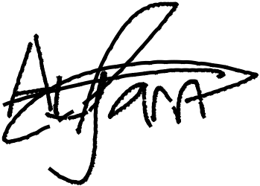

_________________________

_~~__~~_____~~___~~_~~_~~___________



**MR OLUREMI DANIEL YINKA**

**MR. OGABOR JOHN**

***(CEO, JOHN INVESTMENTS)***