Section: **HOW TO RUN THE PROGRAM**

1. Ensure RAqueries.txt, Play.txt, MOVIES.txt, ACTORS.txt, and KingCS4700P1.jar are in the same directory

2. Run KingCS4700P1.jar to produce RAoutput.csv.

Section: **IMPLEMENTED OPERATORS/QUERIES**

All operations required to execute the queries provided in RAqueries.txt have been implemented.

This includes PROJECT, SELECT, NATURAL JOIN (*), EXCEPT (-), UNION (U), and various compositions.

NOTE: All operations were assumed to be part of a relational model and therefore remove duplicate tuples from return values.

Section: **TWO SCREENSHOTS**

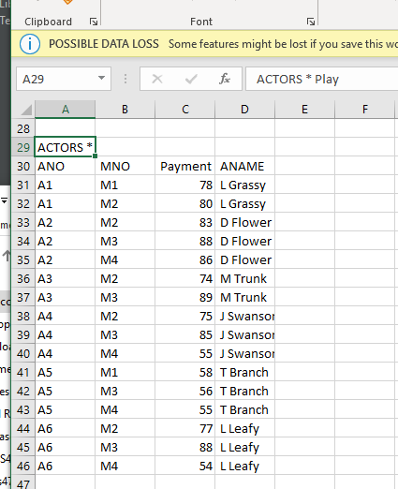

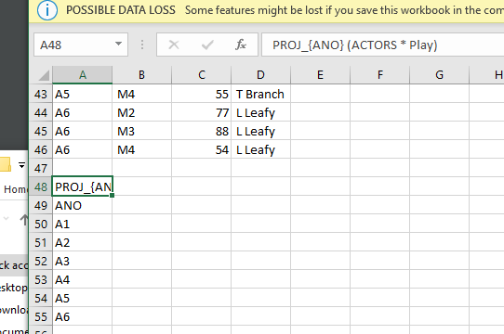

Section: **OUTPUT PRODUCED**

SELE_{Payment > 80} Play,

ANO, MNO, Payment,

A2, M2, 83,

A2, M3, 88,

A2, M4, 86,

A3, M3, 89,

A4, M3, 85,

A6, M3, 88,

PROJ_{ANO, MNO} Play,

ANO, MNO,

A1, M1,

A1, M2,

A2, M2,

A2, M3,

A2, M4,

A3, M2,

A3, M3,

A4, M2,

A4, M3,

A4, M4,

A5, M1,

A5, M3,

A5, M4,

A6, M2,

A6, M3,

A6, M4,

ACTORS * Play,

ANO, MNO, Payment, ANAME,

A1, M1, 78, L Grassy,

A1, M2, 80, L Grassy,

A2, M2, 83, D Flower,

A2, M3, 88, D Flower,

A2, M4, 86, D Flower,

A3, M2, 74, M Trunk,

A3, M3, 89, M Trunk,

A4, M2, 75, J Swanson,

A4, M3, 85, J Swanson,

A4, M4, 55, J Swanson,

A5, M1, 58, T Branch,

A5, M3, 56, T Branch,

A5, M4, 55, T Branch,

A6, M2, 77, L Leafy,

A6, M3, 88, L Leafy,

A6, M4, 54, L Leafy,

PROJ_{ANO} (ACTORS * Play),

ANO,

A1,

A2,

A3,

A4,

A5,

A6,

(PROJ_{ANO} (SELE_{Payment > 80} Play)) - (PROJ_{ANO} (SELE_{Payment < 70} Play)) ,

ANO,

A2,

A3,

(PROJ_{ANO} (SELE_{Payment > 80} Play)) U (PROJ_{ANO} (SELE_{Payment < 70} Play)),

ANO,

A2,

A3,

A4,

A5,

A6,