Daniel Ko

6782155

Math 104B Final Project

**Mathematically Modeling a Zombie Apocalypse**

For our final project, my group and I decided to employ Euler’s Method for approximations to simulate estimations for the SIR model. Primarily, the SIR model traces the spread of an infectious disease through a given population. The S, I, and R represent three subcategories within the population at a given time t, with S being the given amount of susceptible people, I being the number of infectious people, and R representing the number of recovered people. After introducing two more variables, an infectious rate alpha and a recovery rate beta, three ordinary differential equations model the flow of the population between the three subcategories. Furthermore, we made held some assumptions as true, though they would not necessarily be applicable in the real world. We assumed that the entire population was susceptible to the disease, that no one was born immune to it. Furthermore, we accepted that for the individuals that recovered after infection, there would be no possibility of remission. Lastly, we took out birth and death rates from affecting our initial population, as the a model including those transition rates would complicate it heavily. Taking this general setup, we fit the model to the case of a possible zombie apocalypse to see what exactly would happen in the case of a possible viral outbreak.

Aside from applying a fictional scenario to our model, our true motivation for using the SIR model was to gauge its usefulness in real world cases. Everyday, there are viral outbreaks and new diseases hailing from biological mutations, and fitting this model and also approximating it appeared to have real world applications. Furthermore, by understanding how infectious disease spread throughout a population, whether it be national or global,

We derived three ordinary differential equations to model the transition rates of the population flowing through the three subcategories. With each equation approximating the change in each subcategory with respect to a single increase in the unit of time, Euler’s Method appeared to be the best approach to construct the approximation from bottom up (initial time t_0 to t_b). The three equations tracking movement through the subcategories are:

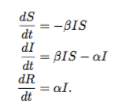

By employing Python, we constructed a function that would take in 6 arguments and created a plot tracking the changes in size amongst the three subcategories over a specified period of time. By plotting all three vectors of values against time together, we were able to visualize how the categories behaved with respect to each other.

The resulting plot appeared as:

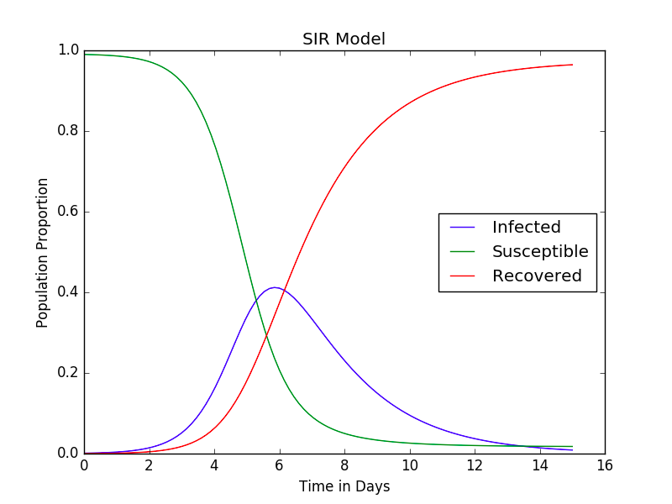

The first plot that begins at 1.0 (representing 100% of the population) tracks the Susceptible percentage of the population. The plot following the normal distribution follows the increase and decrease in the amount of people classified as infectious in the population. It behaves as a bell curve, displaying how the entire population, susceptible at first, become infected then recover. The plot appearing as the reverse of the Susceptible tracks the Recovered percentage of the population, and the final plot following a normal distribution tracks the Infected percentage of the population. For the Susceptible, it logically follows that at time 0, before the introduction of the disease into the model, the entire population remains healthy but vulnerable. In reverse of this behavior, the amount of individuals in the Recovered subcategory accounts for 0 percent of the total population.

Comparing our results with our initial hypotheses on the outcome of the problem, they followed what we assumed. As we had placed certain parameters on our model, the results behaved “normally” and followed logical expectations. The different subcategories interacted proportionally to one another as time progressed, and the system retained conservation of the total population throughout the scenario. However, although this model provides a straightforward representation of how a disease or viral outbreak would spread throughout a population over time once introduced, a real world model would have to account for multiple other factors. The most outstanding absence of a factor is death, as death could account for loss of members of the population regardless of the subcategory they are classified under. People may die from other natural causes not related to the disease, the disease itself could kill people off, and recovered individuals could face death from old age. Undoubtedly, even the loss of one person in the model would impact interactions between the subcategories. Furthermore, the possibility of death from members of all three will only further complicate the model.

Another possibility that would add another dimension to the model is the absence of a cure, or the pathogen causing the disease mutating to gain immunity to the initial vaccine/cure. There are countless different possibilities that hint at the population being non-conservative. However, for our model, the results logically followed our hypotheses.

From the results of our project, it is apparent that the SIR model has great potential for real world application. If the simulation takes into account various factors and the values inputted reflect accurately the real world situations (i.e. the infectious and recovery rates being very accurate), the model itself would present a clear estimate for how the disease would spread. This in turn could be applied to better prepare for possible epidemics, or even used to prevent them.