

UNIVERSITY OF TEHRAN

Report for Computer Assignment 4

Latches, flip-flops, and a little beyond

Instructor : Dr. Navabi

Danial Saeedi

Problem 1

Circuit Diagram

The worst-case delay of NAND according to its delays is 4 + 4 = 8ns.

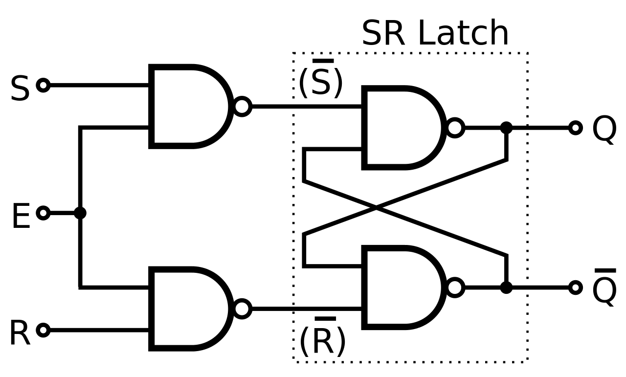

Verilog Code

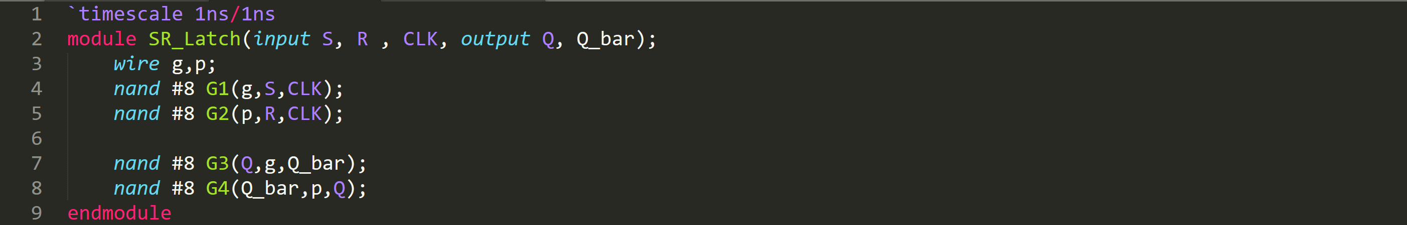

Problem 2

Testbench

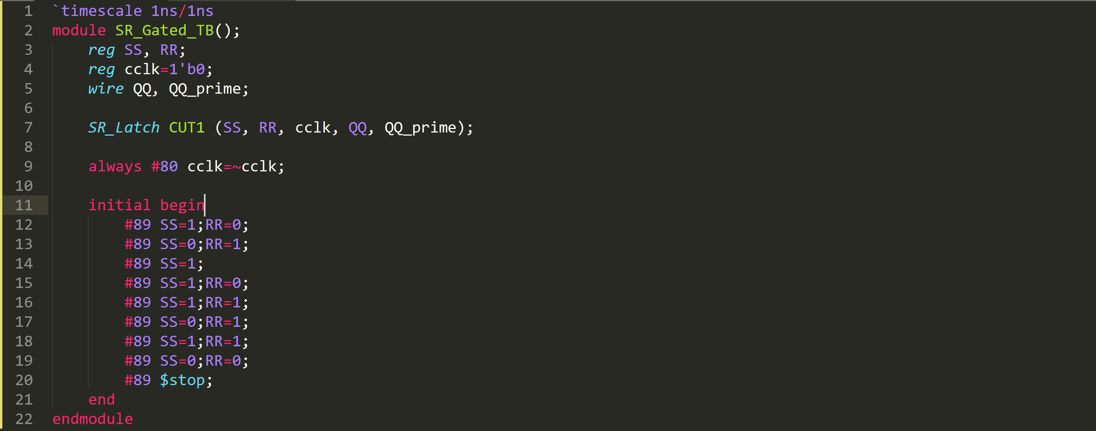

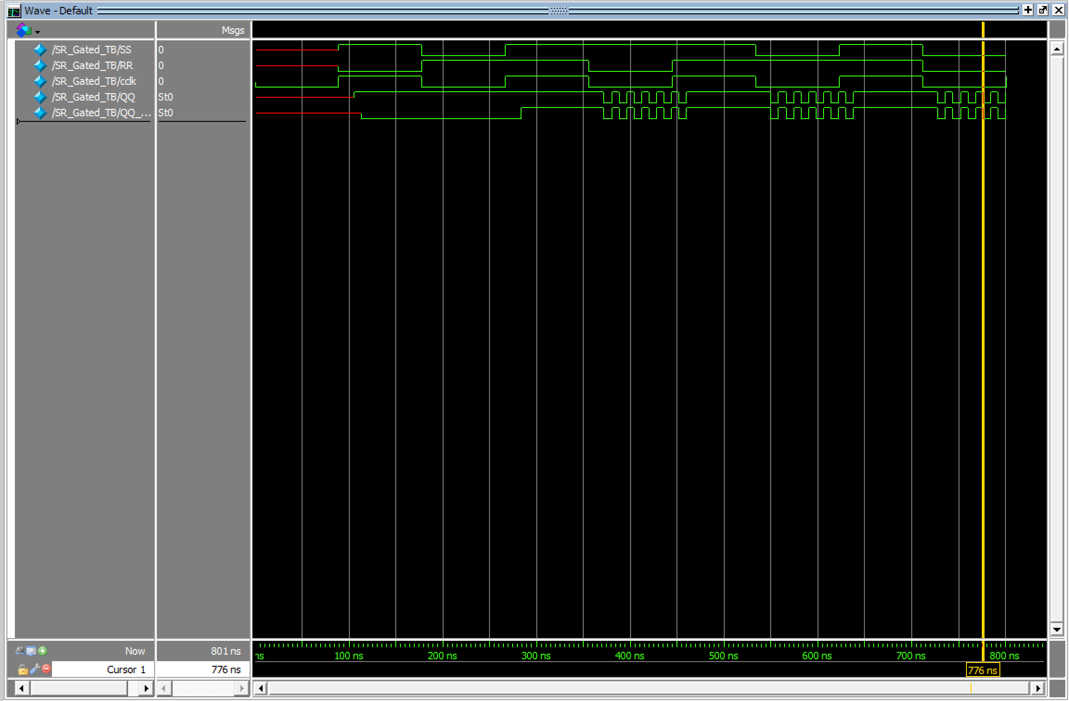

Problem 3

Circuit Diagram

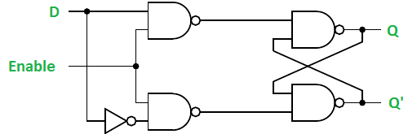

Verilog Code

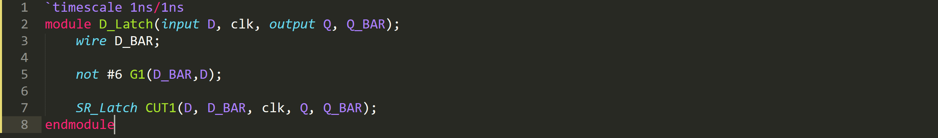

Testbench

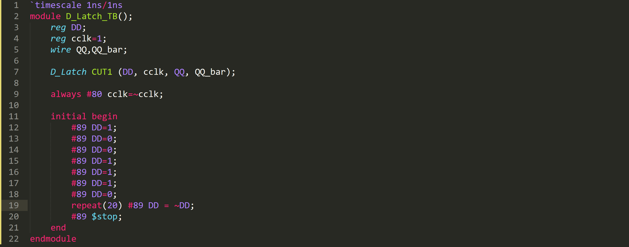

Simulation Result

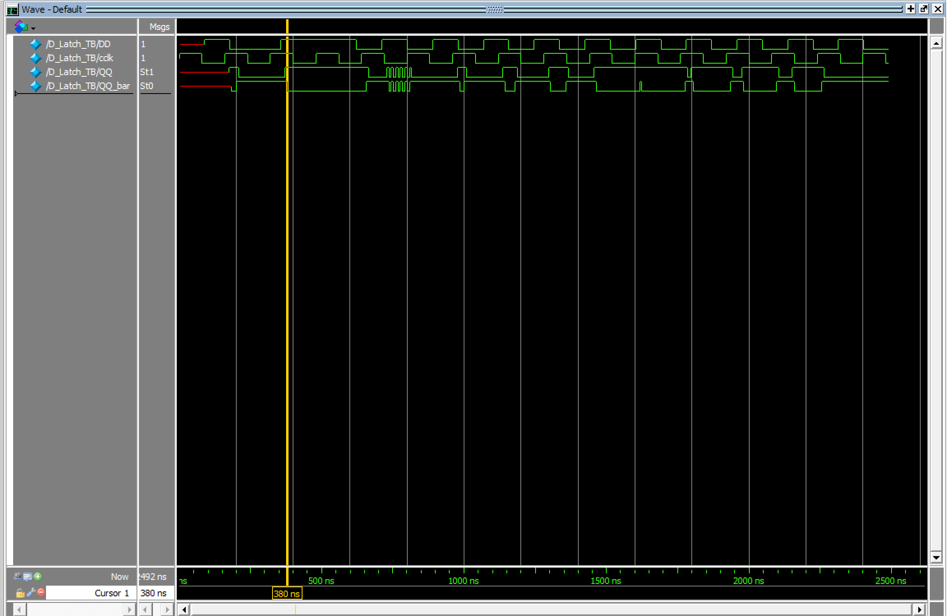

Problem 4

Circuit Diagram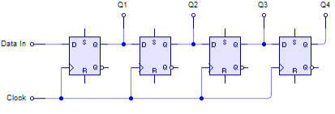

Verilog Code

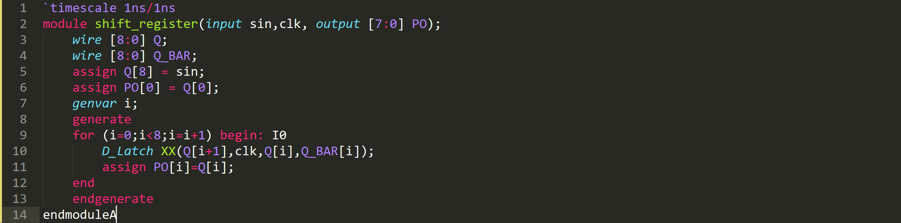

Problem 5

Testbench

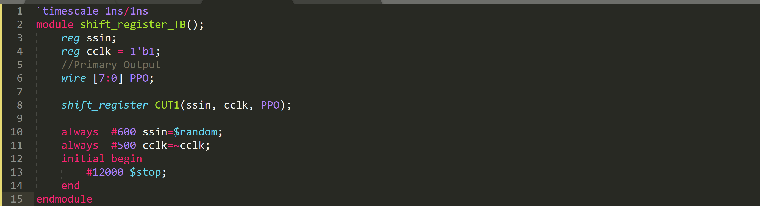

Simulation Result

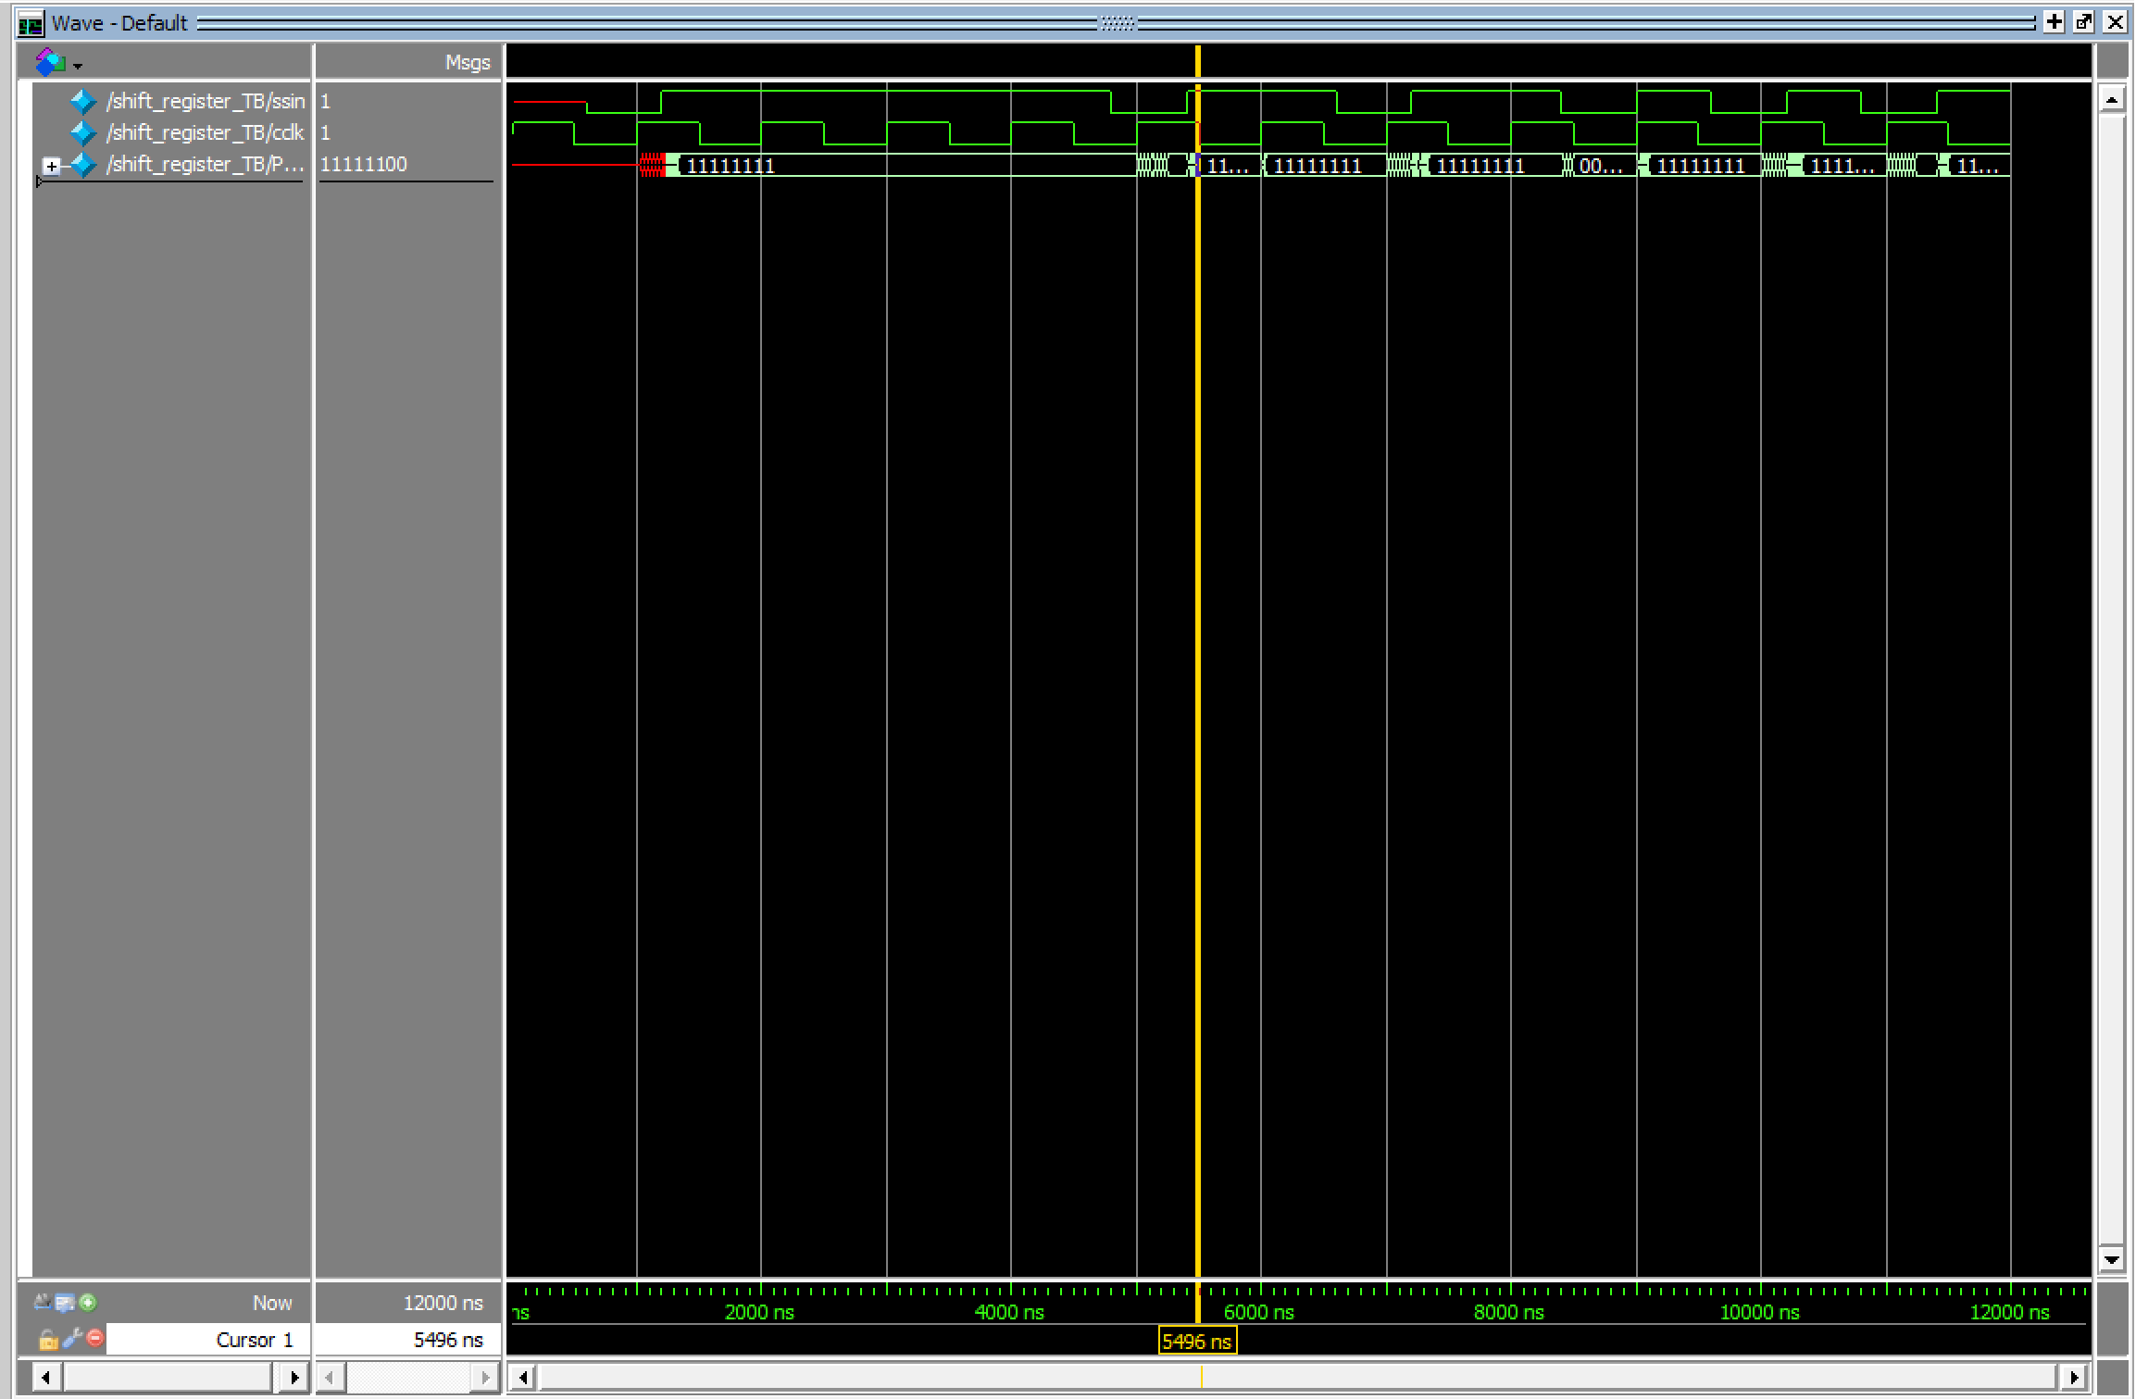

As you can see, this circuit **doesn’t** work because it has **transparency** issue.

Problem 6

Circuit Diagram

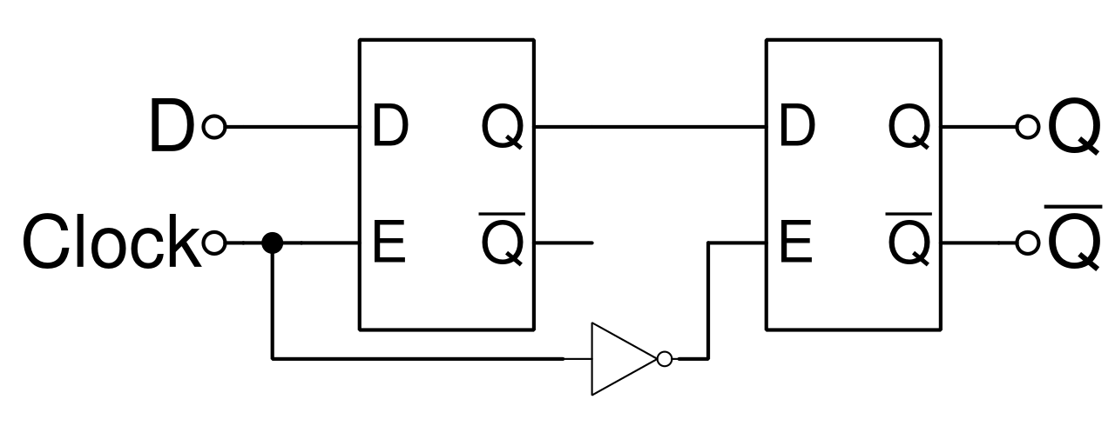

Verilog Code

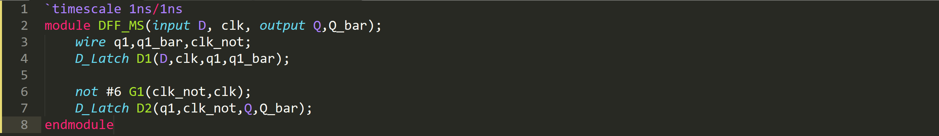

Testbench

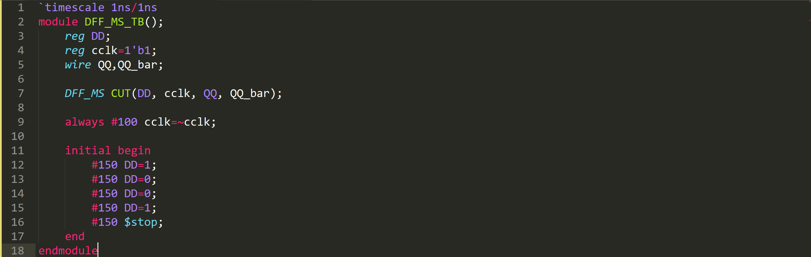

Simulation Result

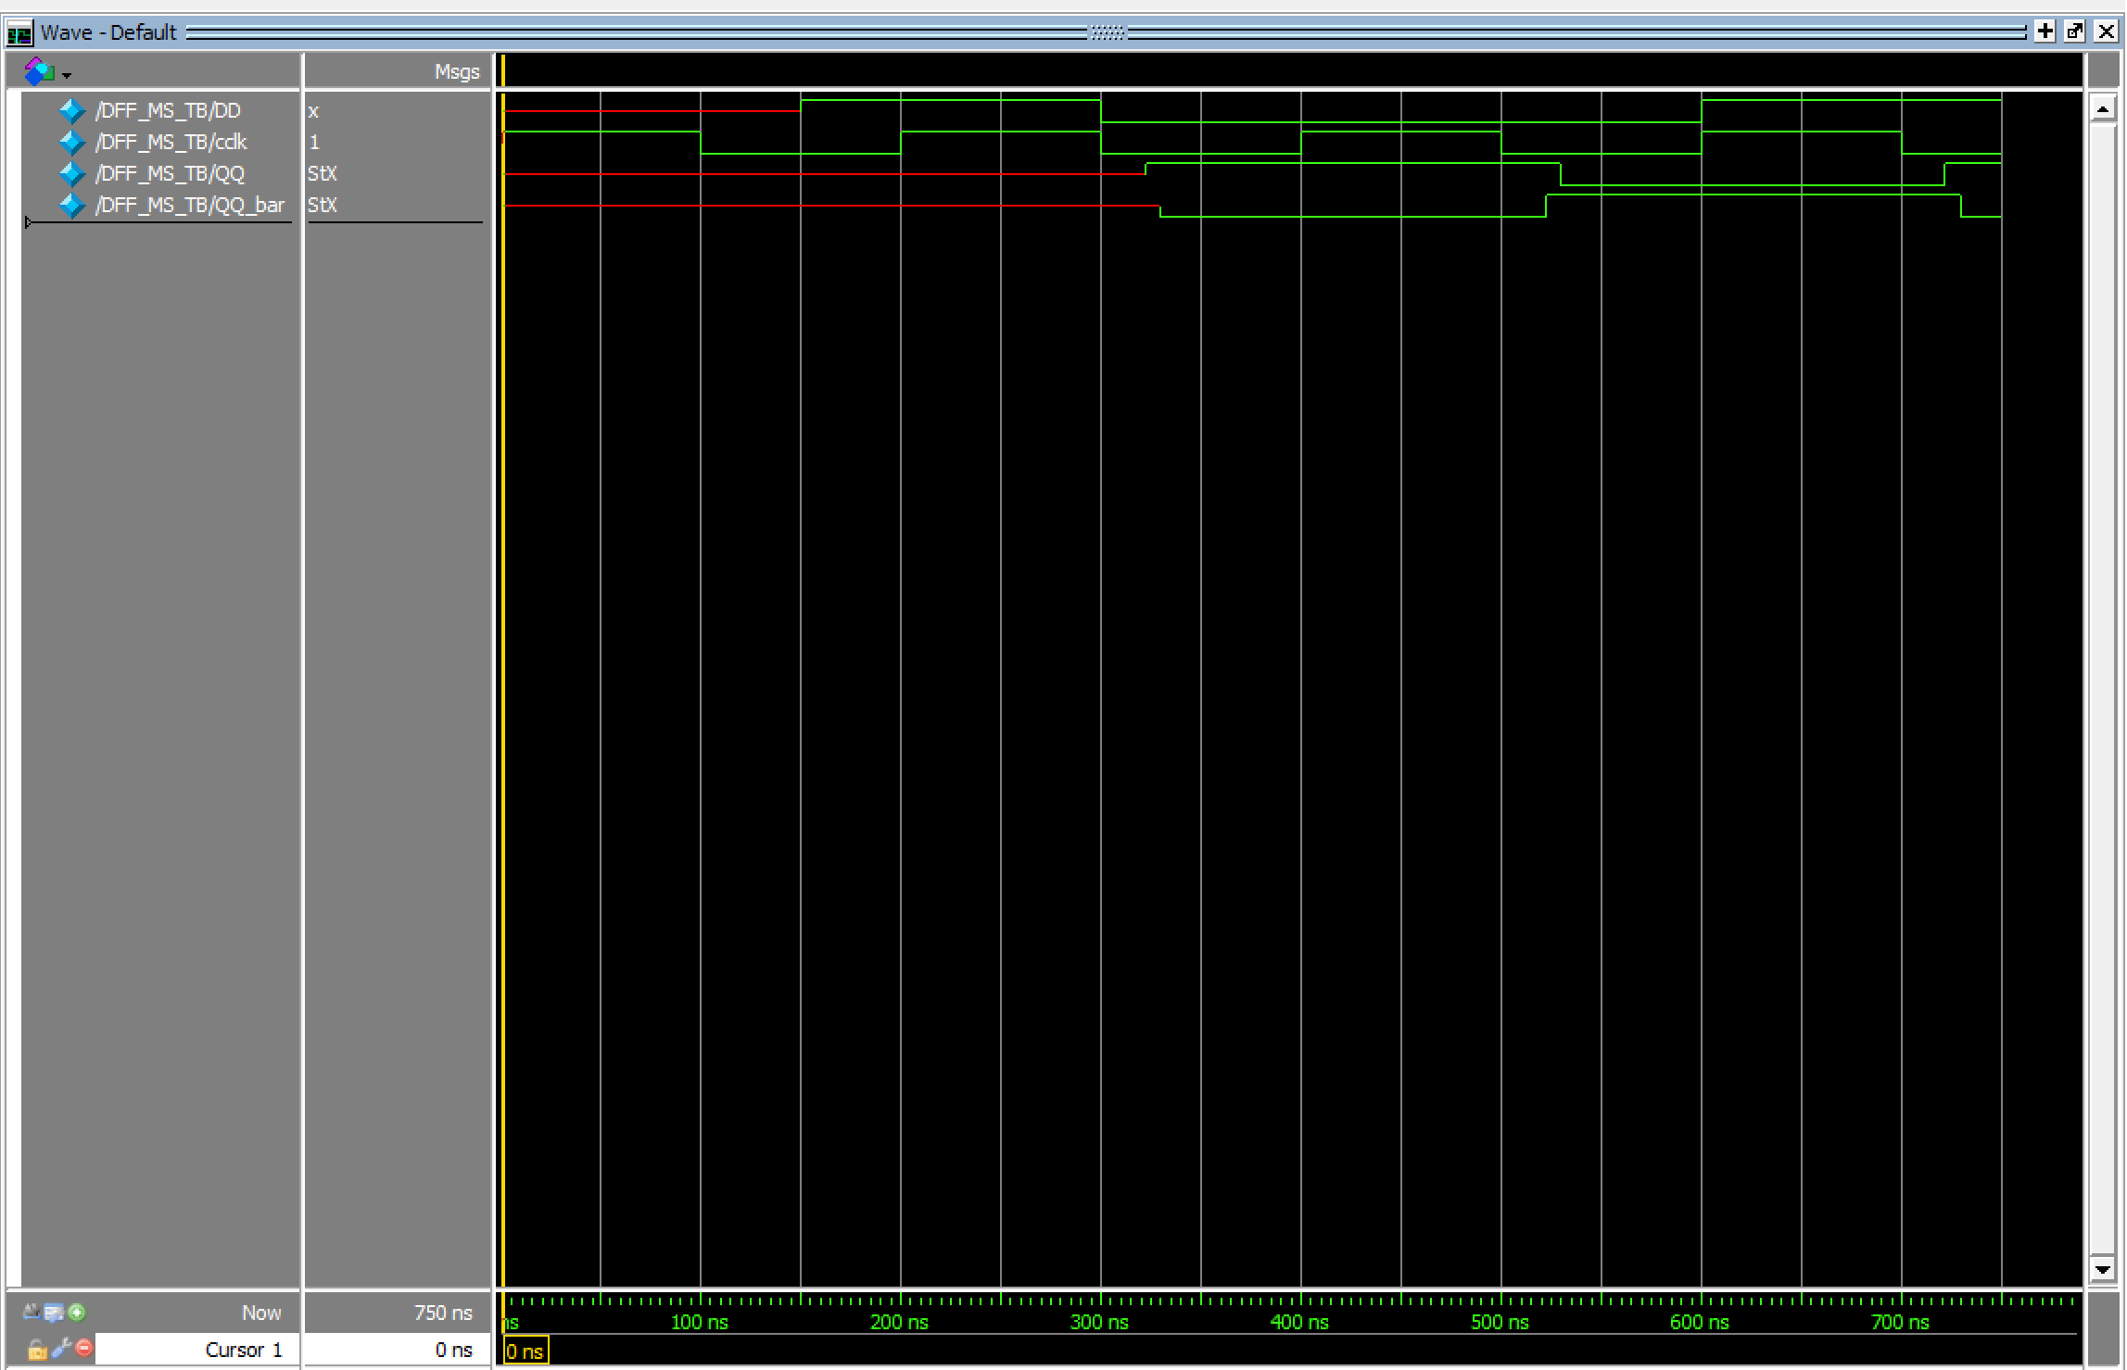

Problem 7

Verilog Code

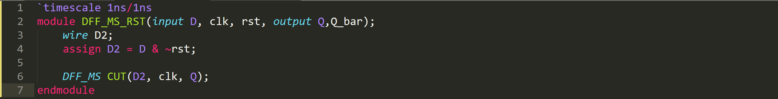

Testbench

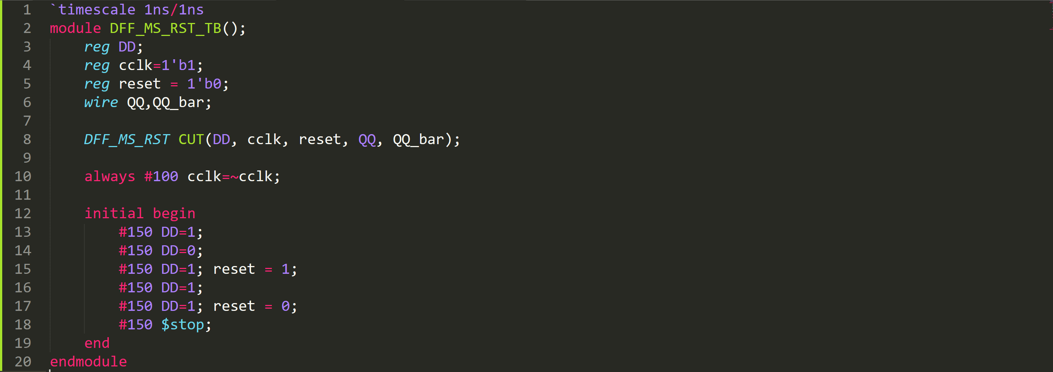

Simulation Result

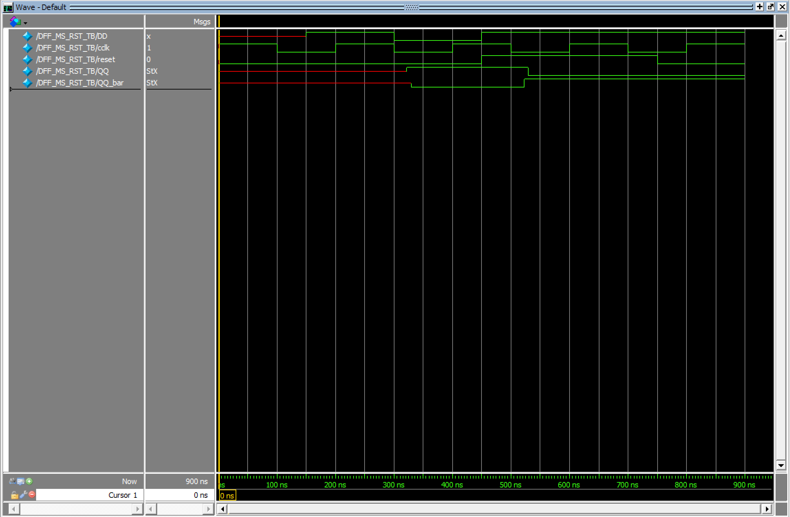

Problem 8

Circuit Diagram

Verilog Code

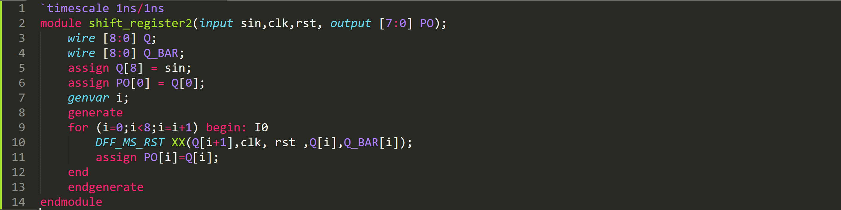

Testbench

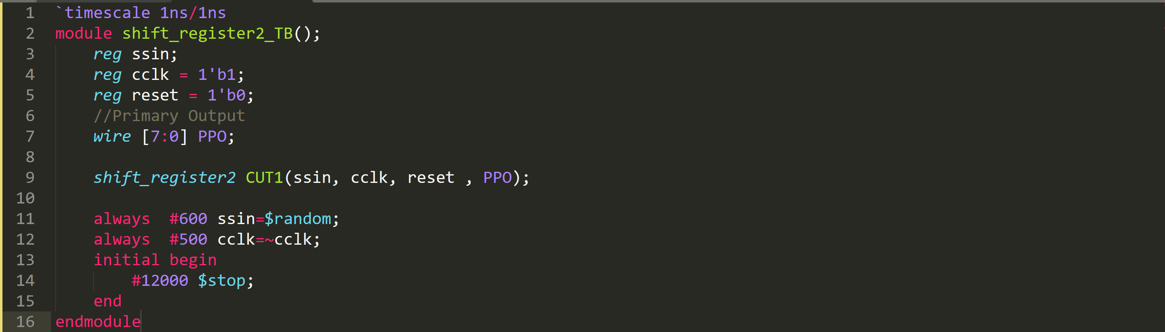

Simulation Result

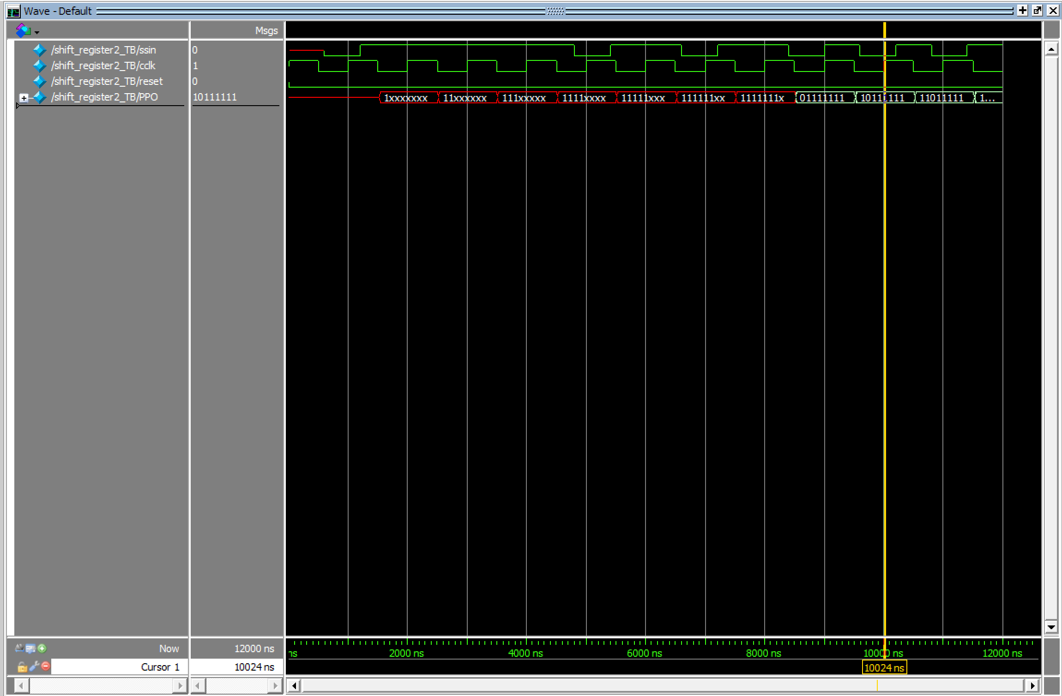

As you can see, this circuit works because it doesn’t has **transparency** issue unlike problem 4.

Problem 9

Verilog Code

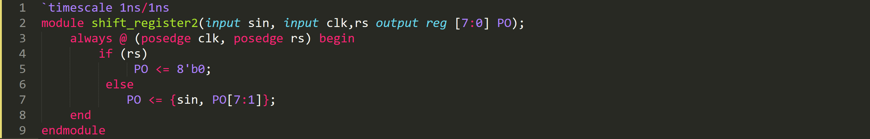

Testbench

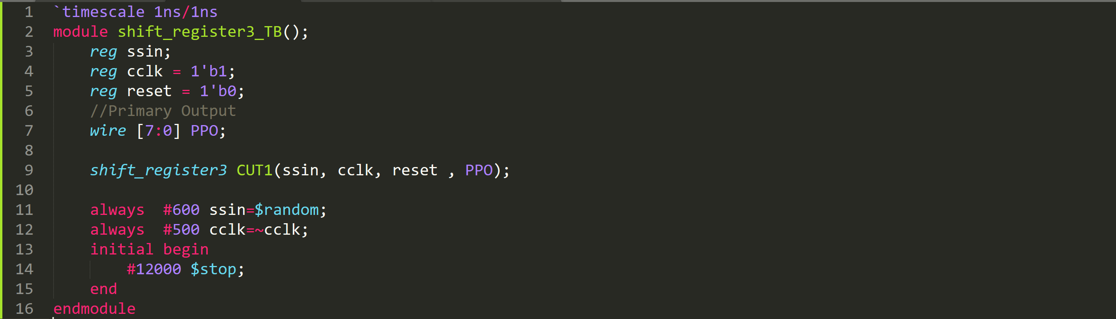

Simulation Result

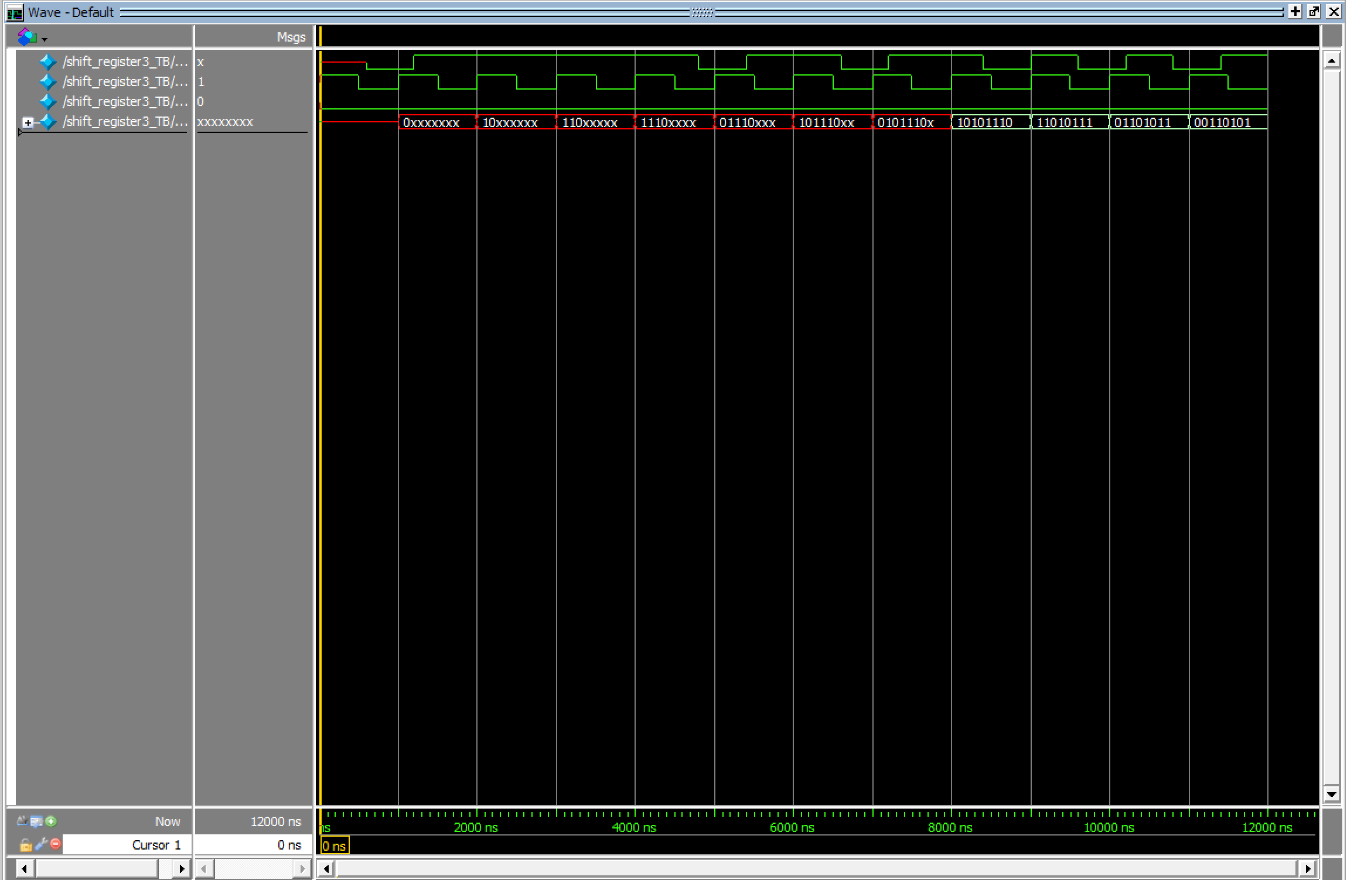

Problem 10

Circuit Diagram

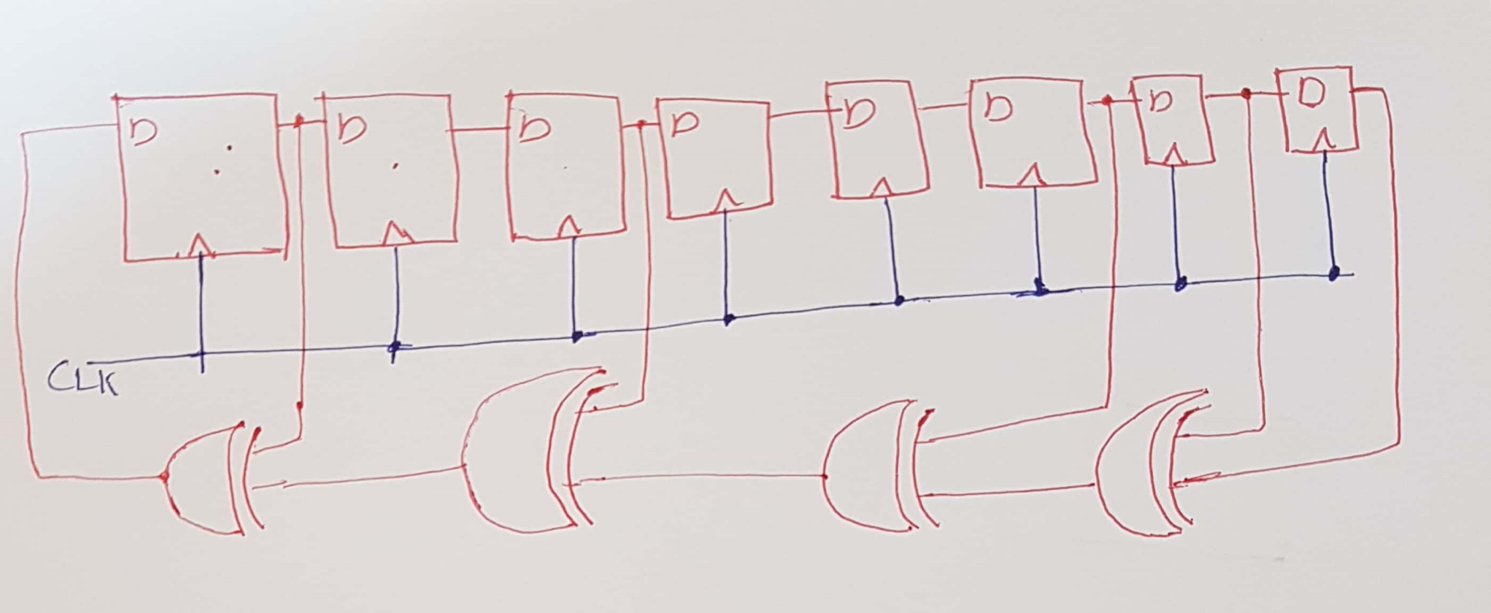

Verilog Code

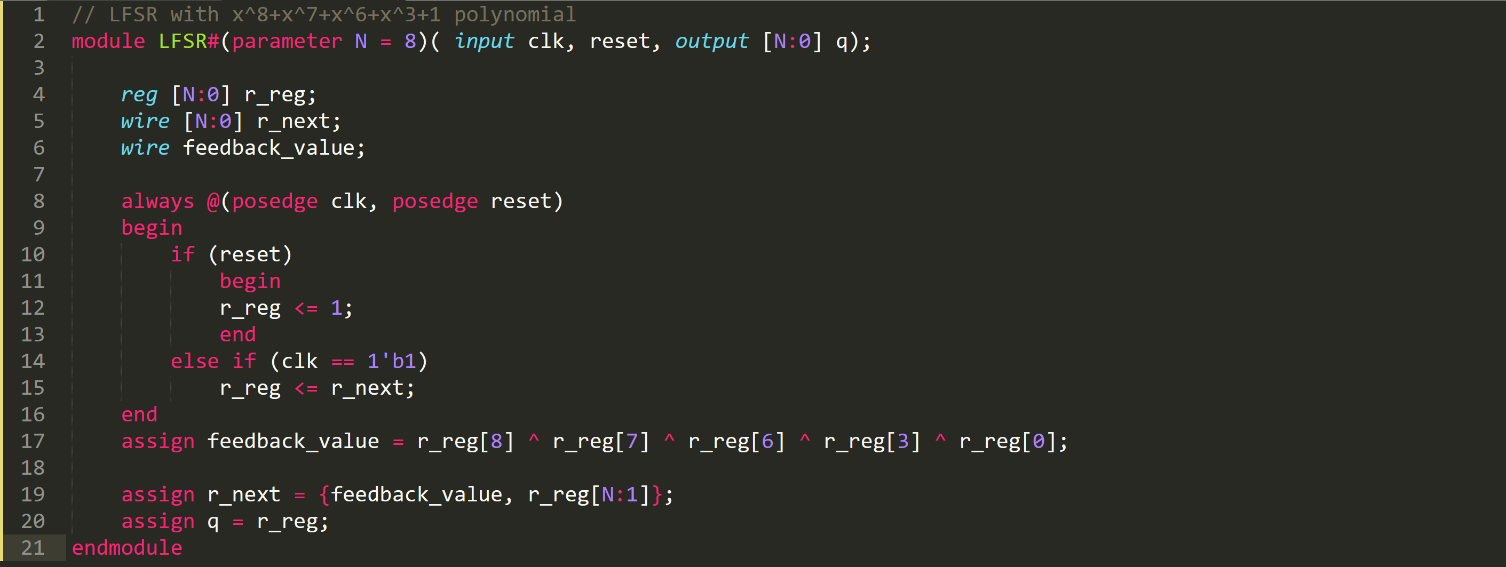

Testbench

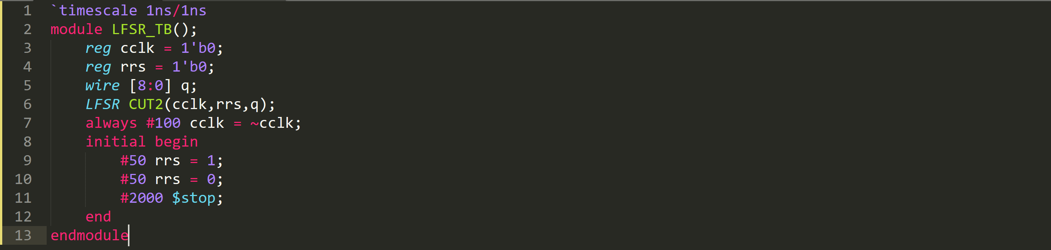

Simulation Result

