

UNIVERSITY OF TEHRAN

Report for Computer Assignment 5

**State Machine Coding, Pre- and Post-Synthesis**

Instructor : Dr. Navabi

Danial Saeedi

Problem a: 10010 detector

Moore State Diagram

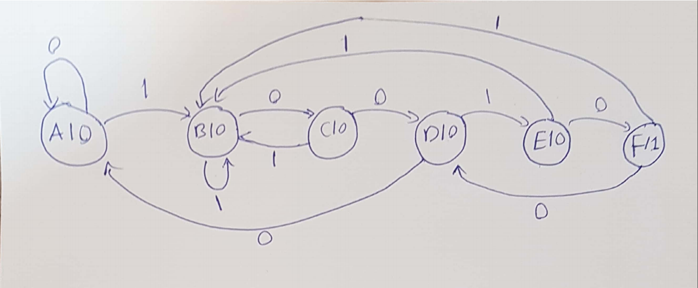

Verilog Code

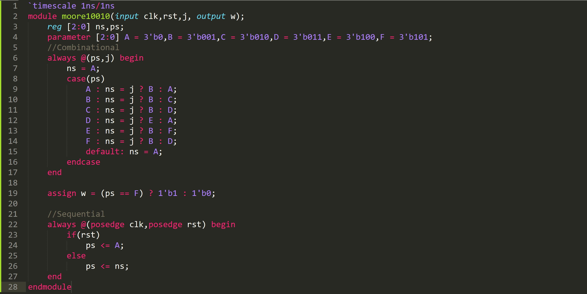

Part i.

Testbench

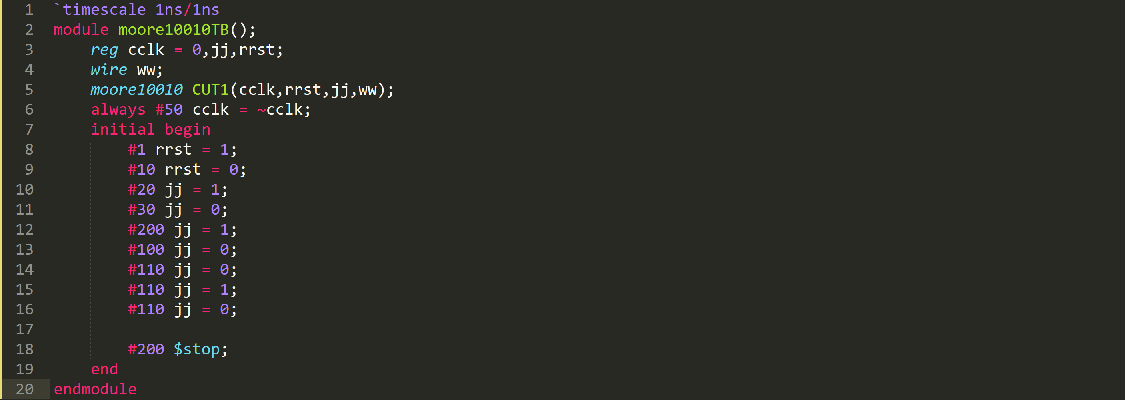

Simulation Result

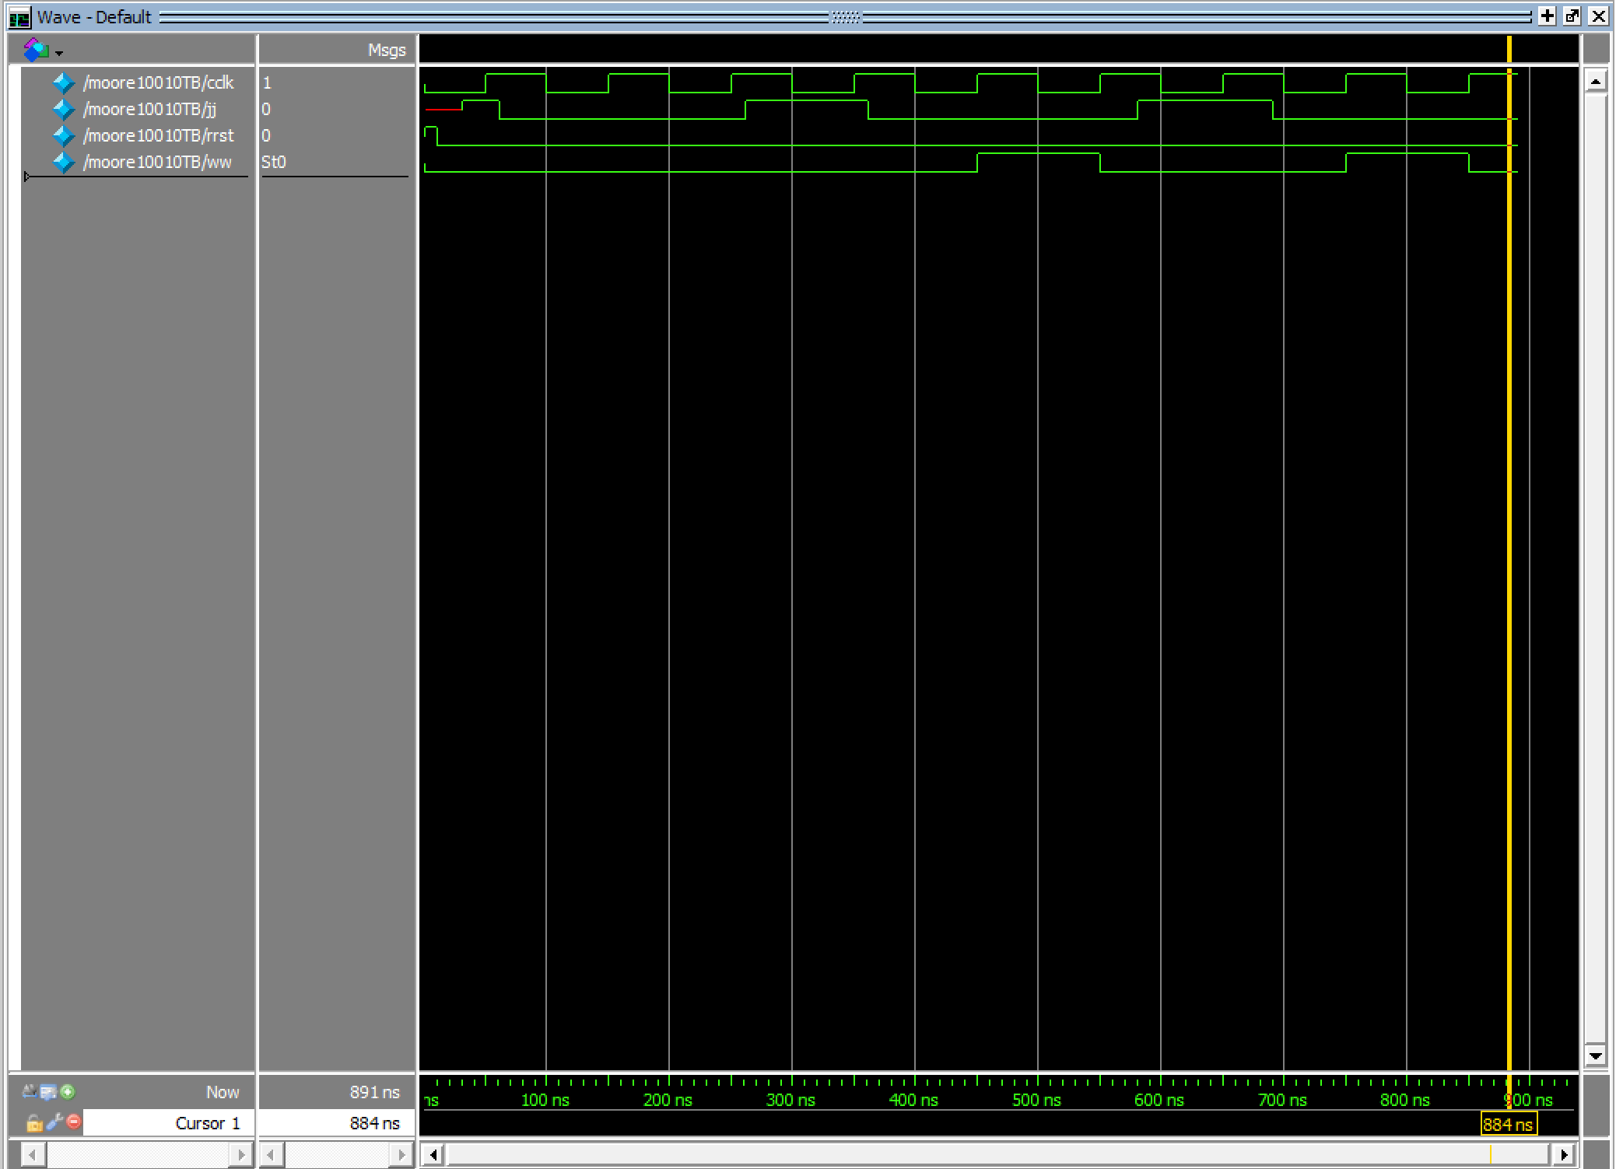

Part ii.

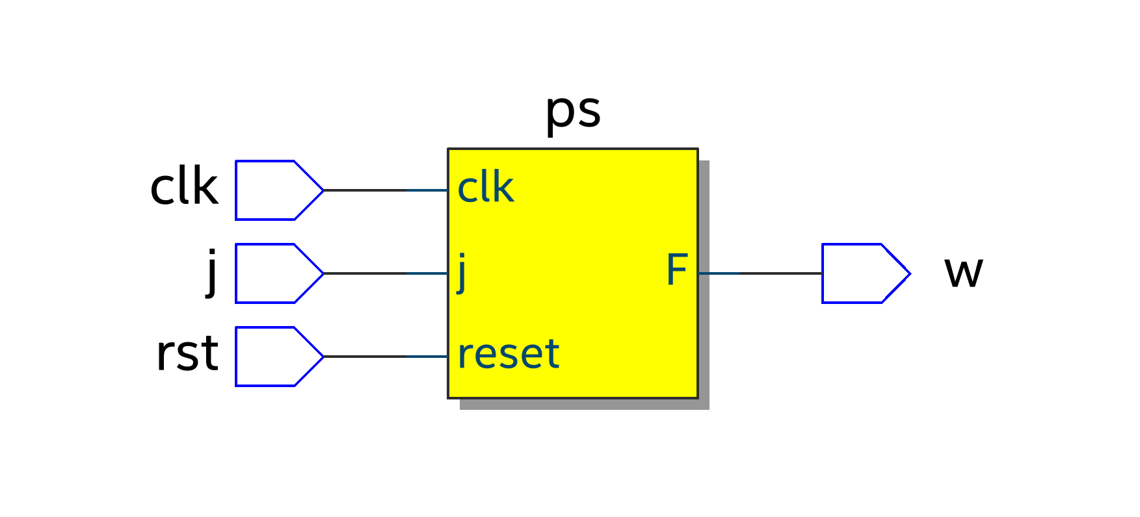

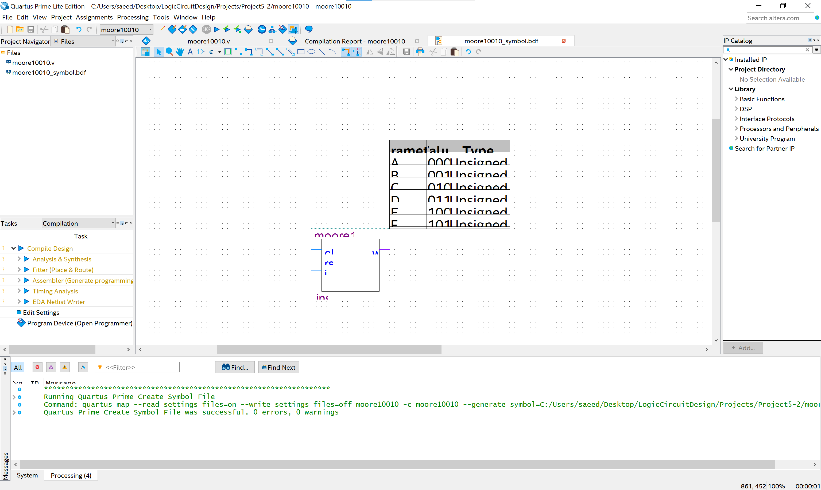

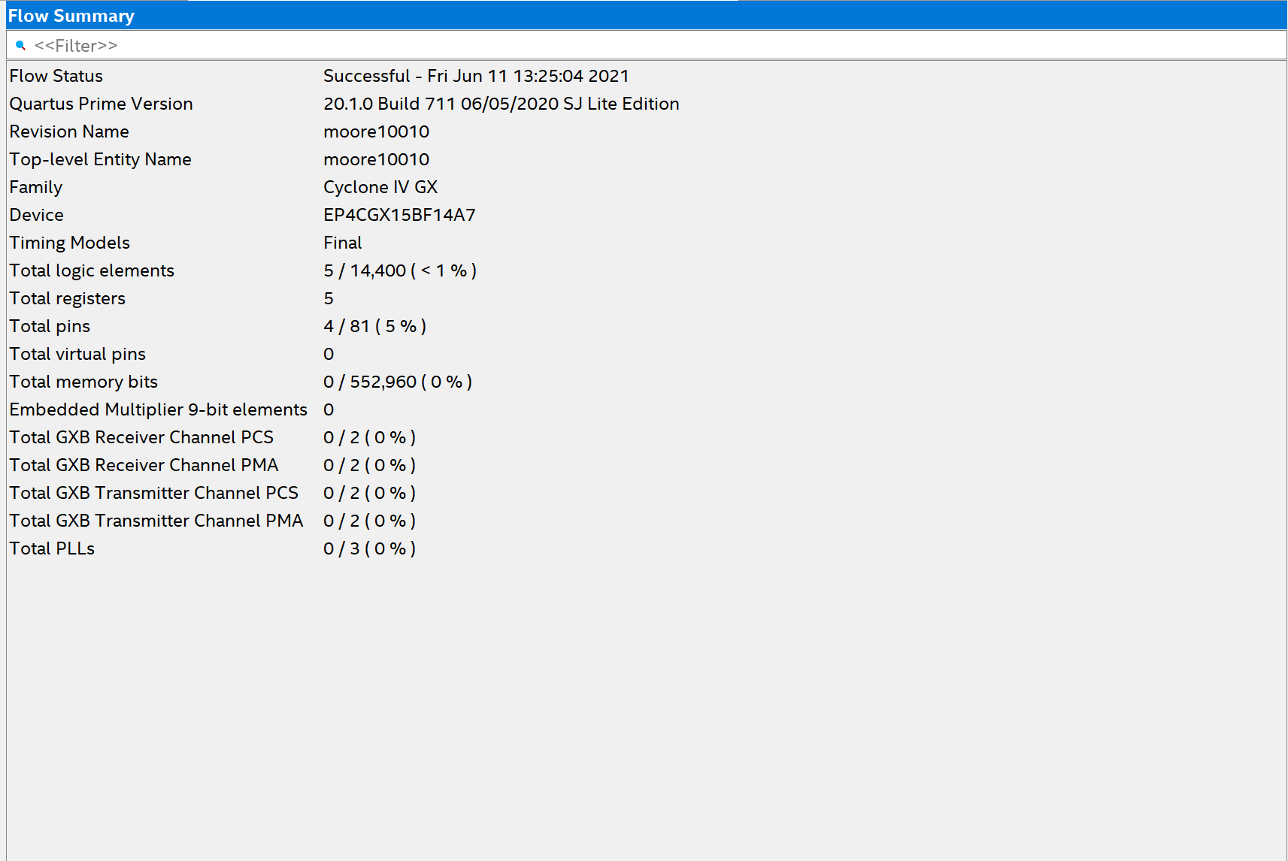

Part iii.

Testbench

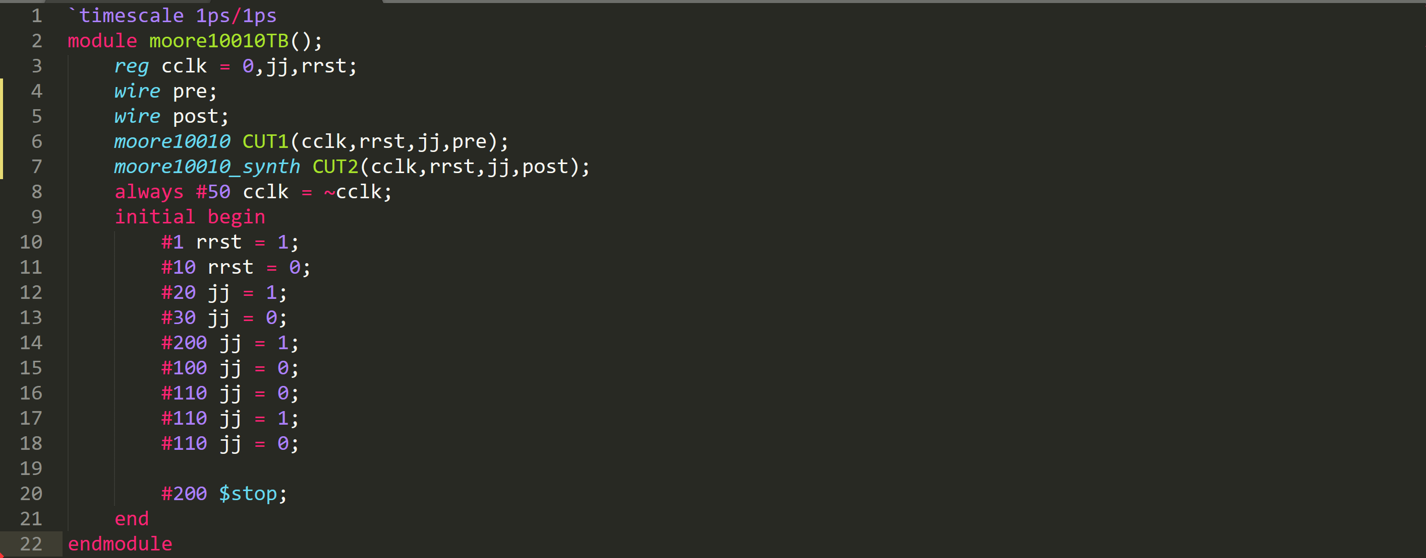

Simulation Result

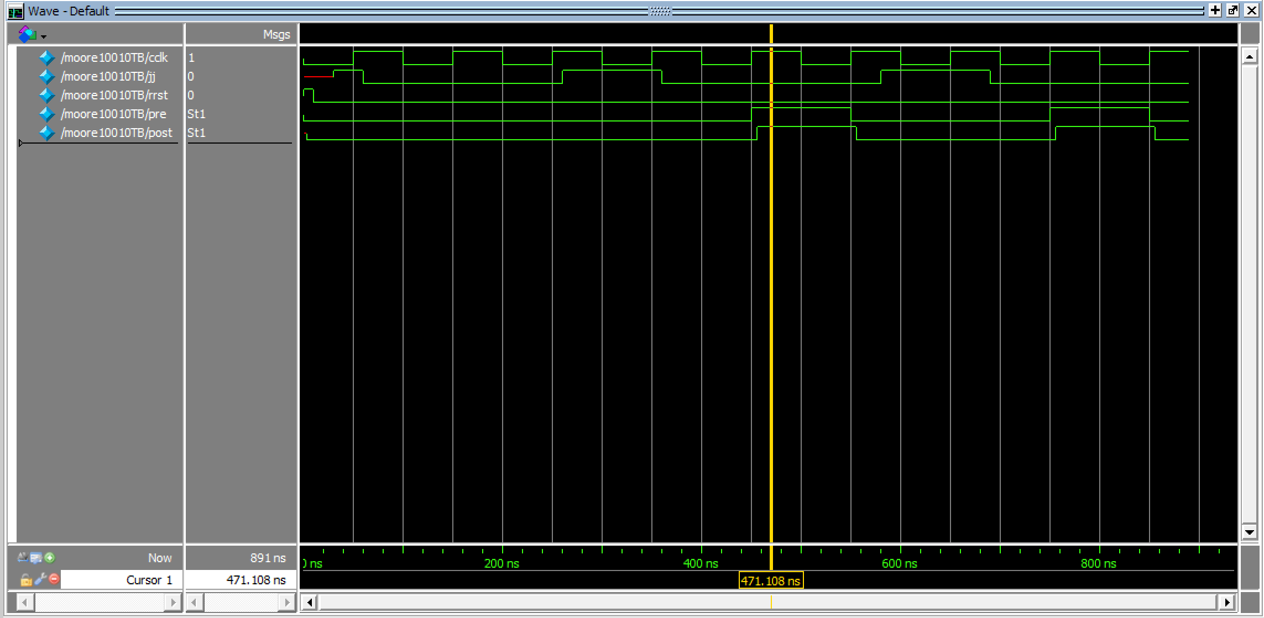

As you can see, the waveform of pre and post synthesis are the same.

Problem b: 10010 detector

Mealy State Diagram

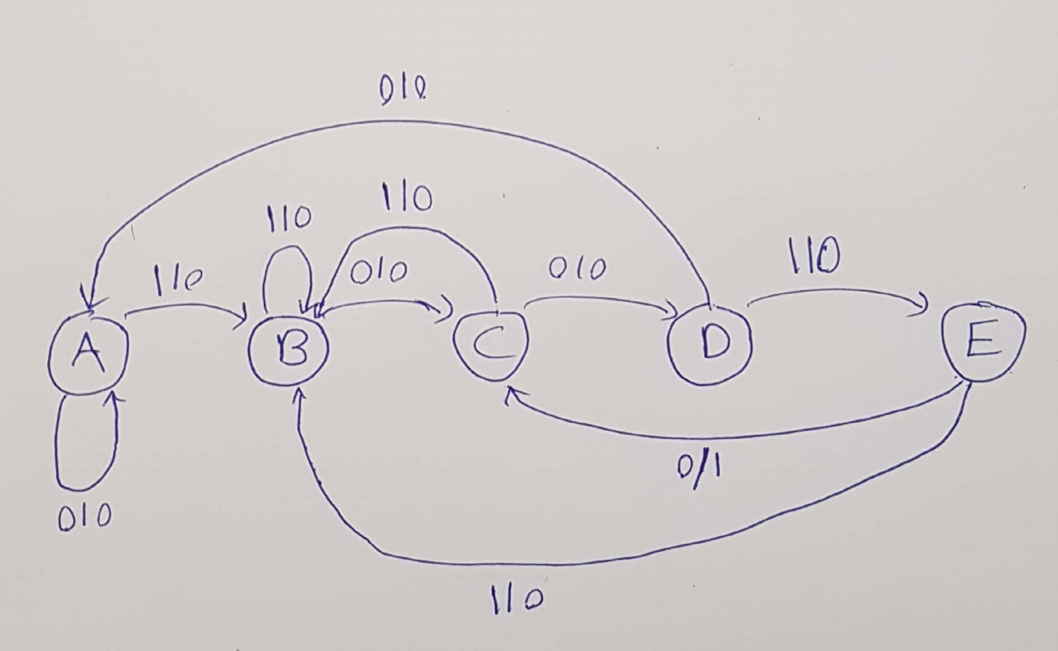

Verilog Code

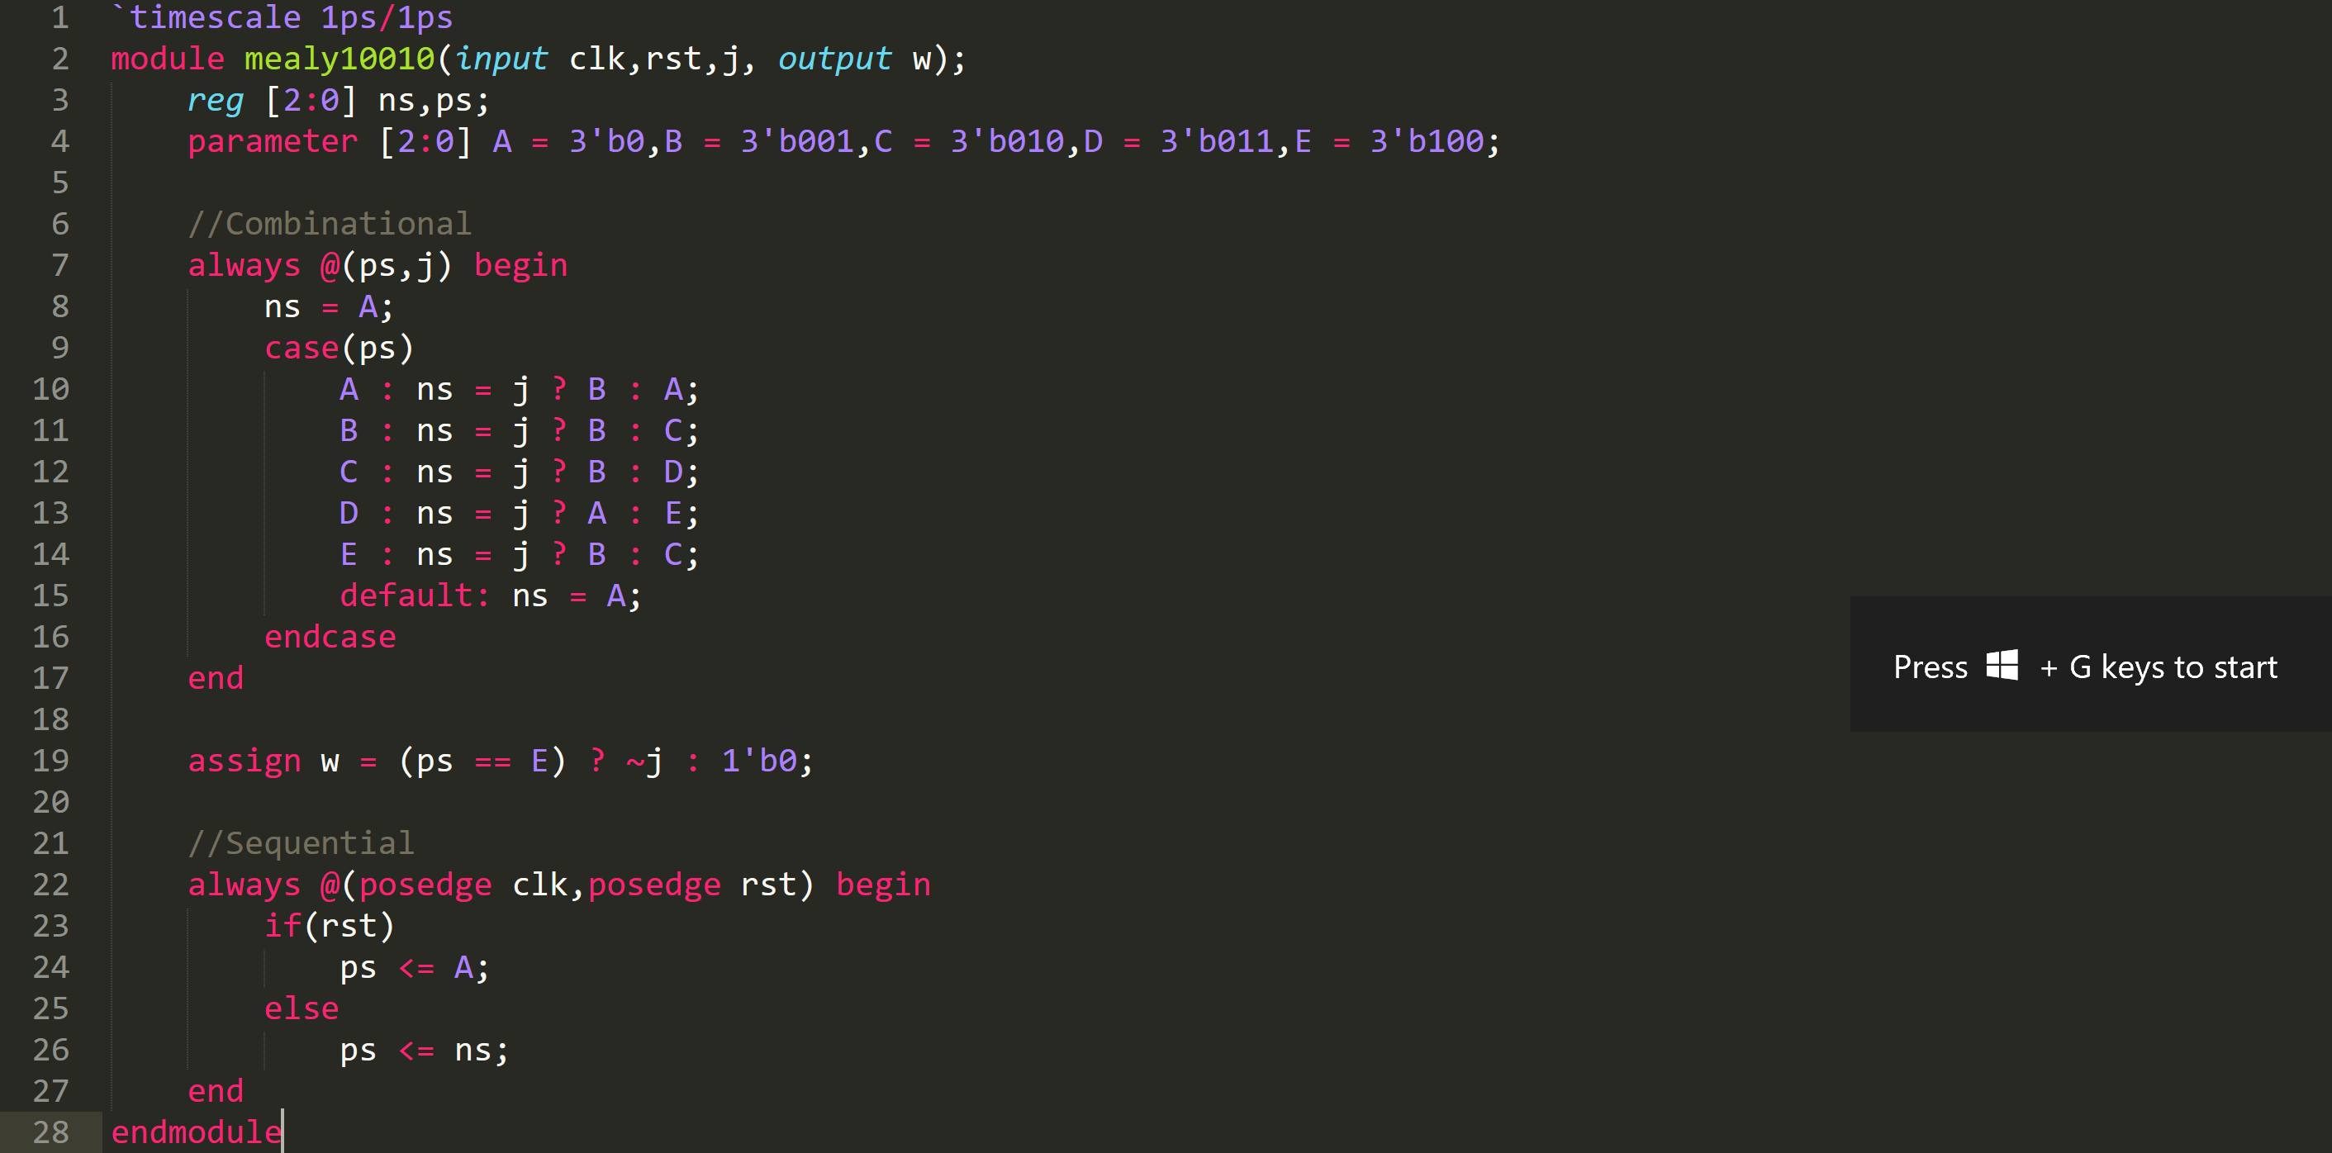

Part i.

Testbench

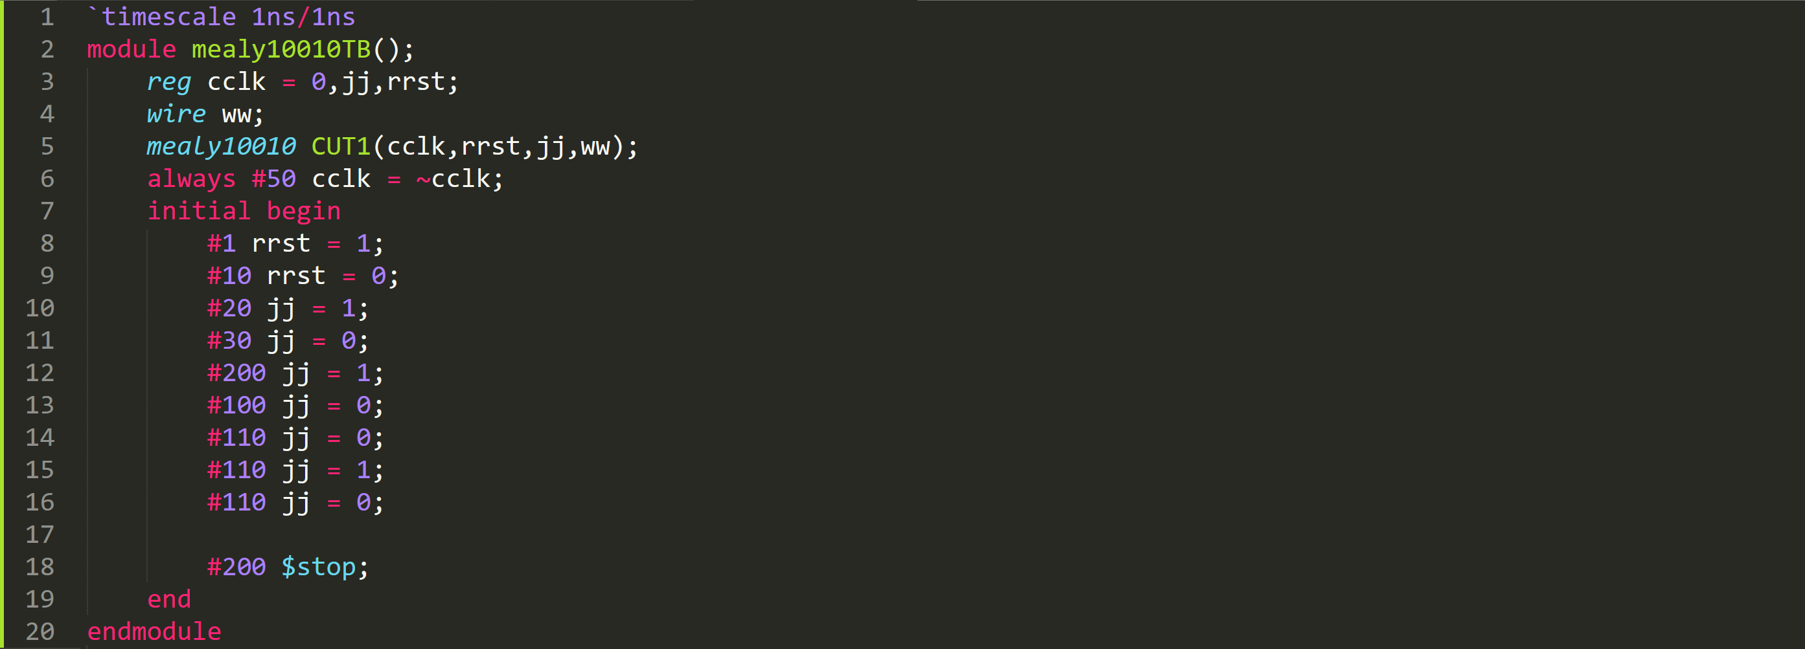

Simulation Result

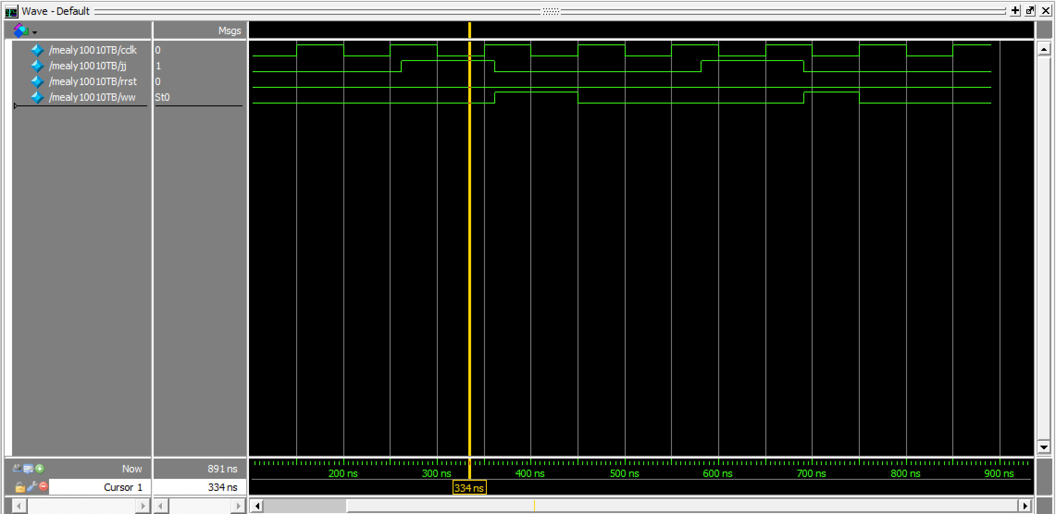

Part ii.

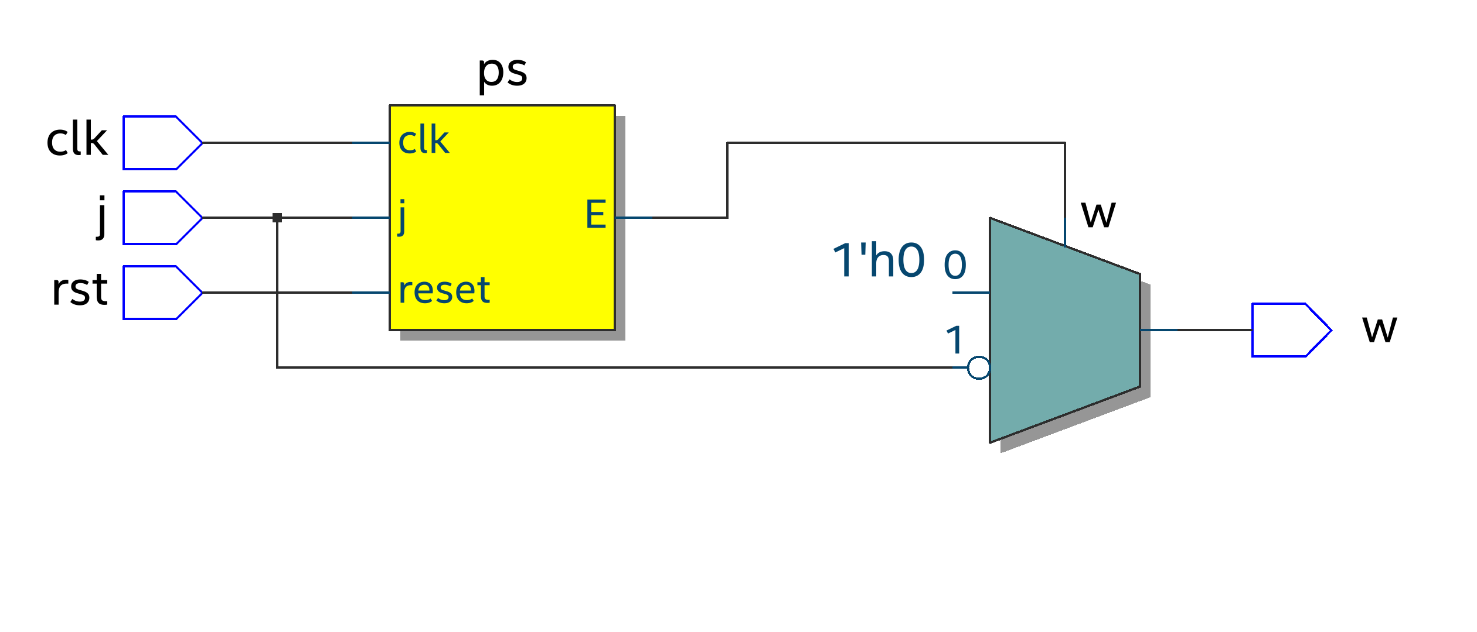

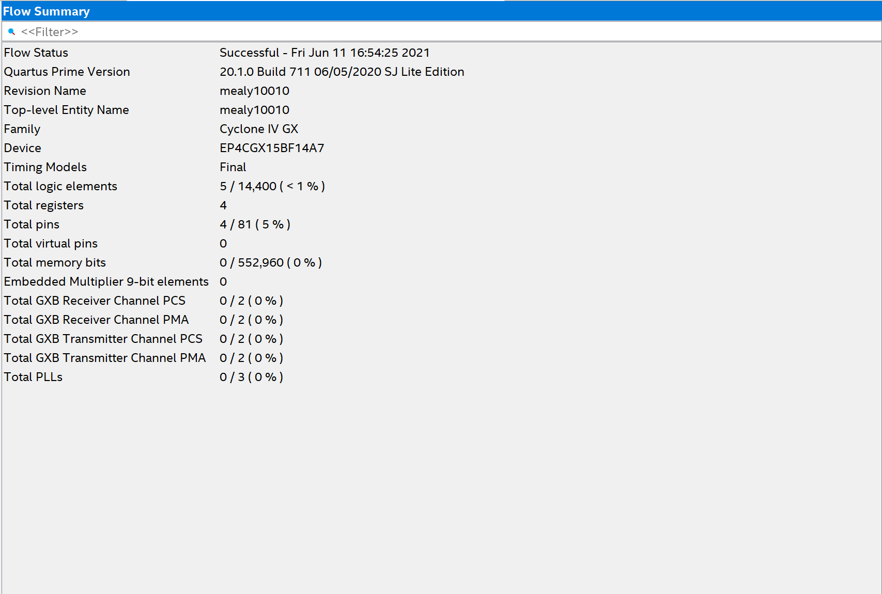

Part iii.

Testbench

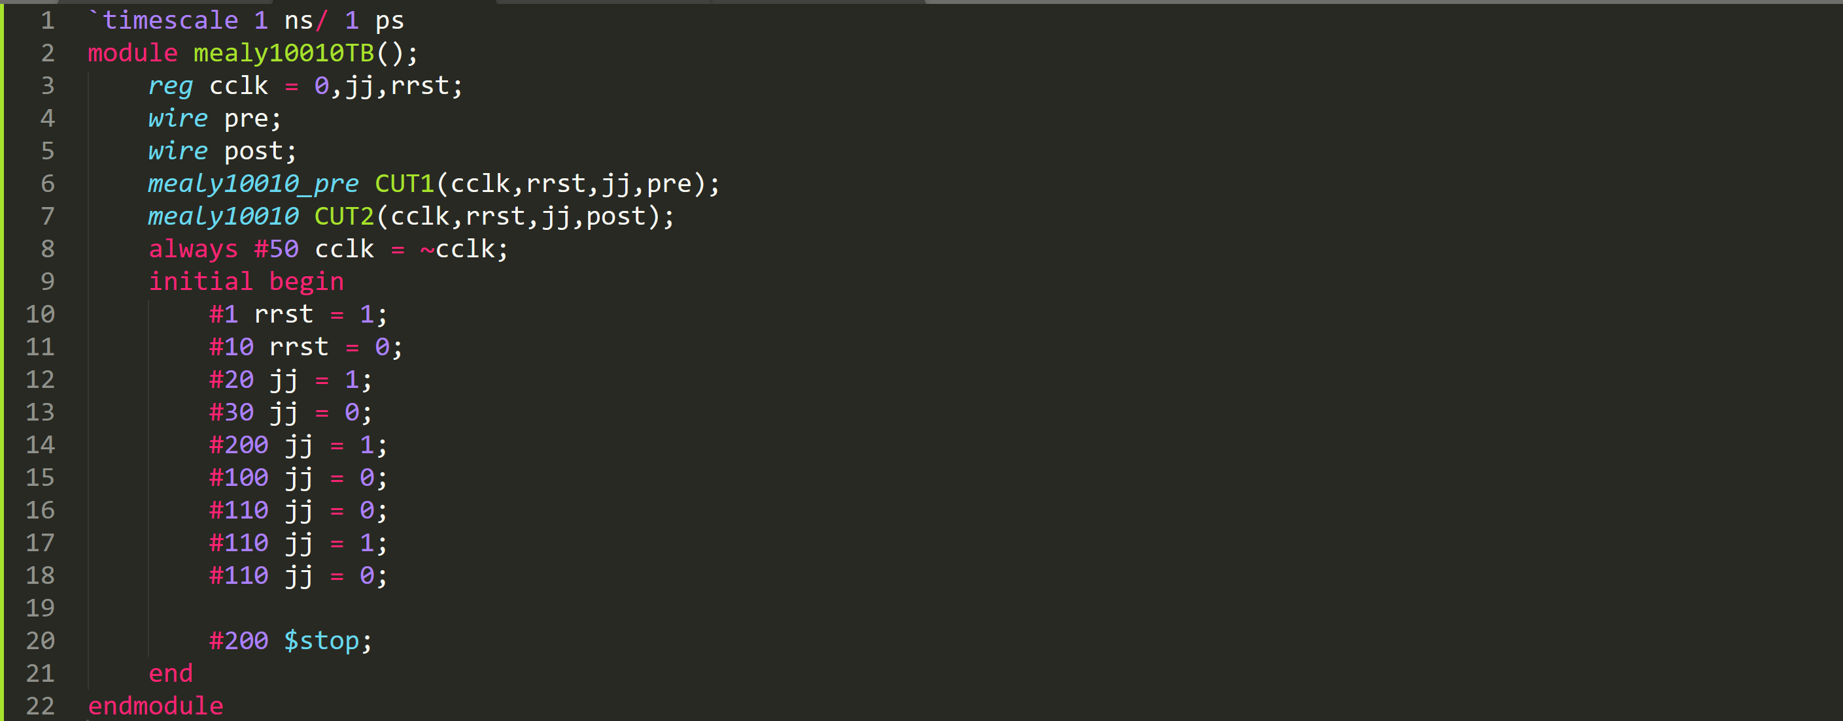

Simulation Result

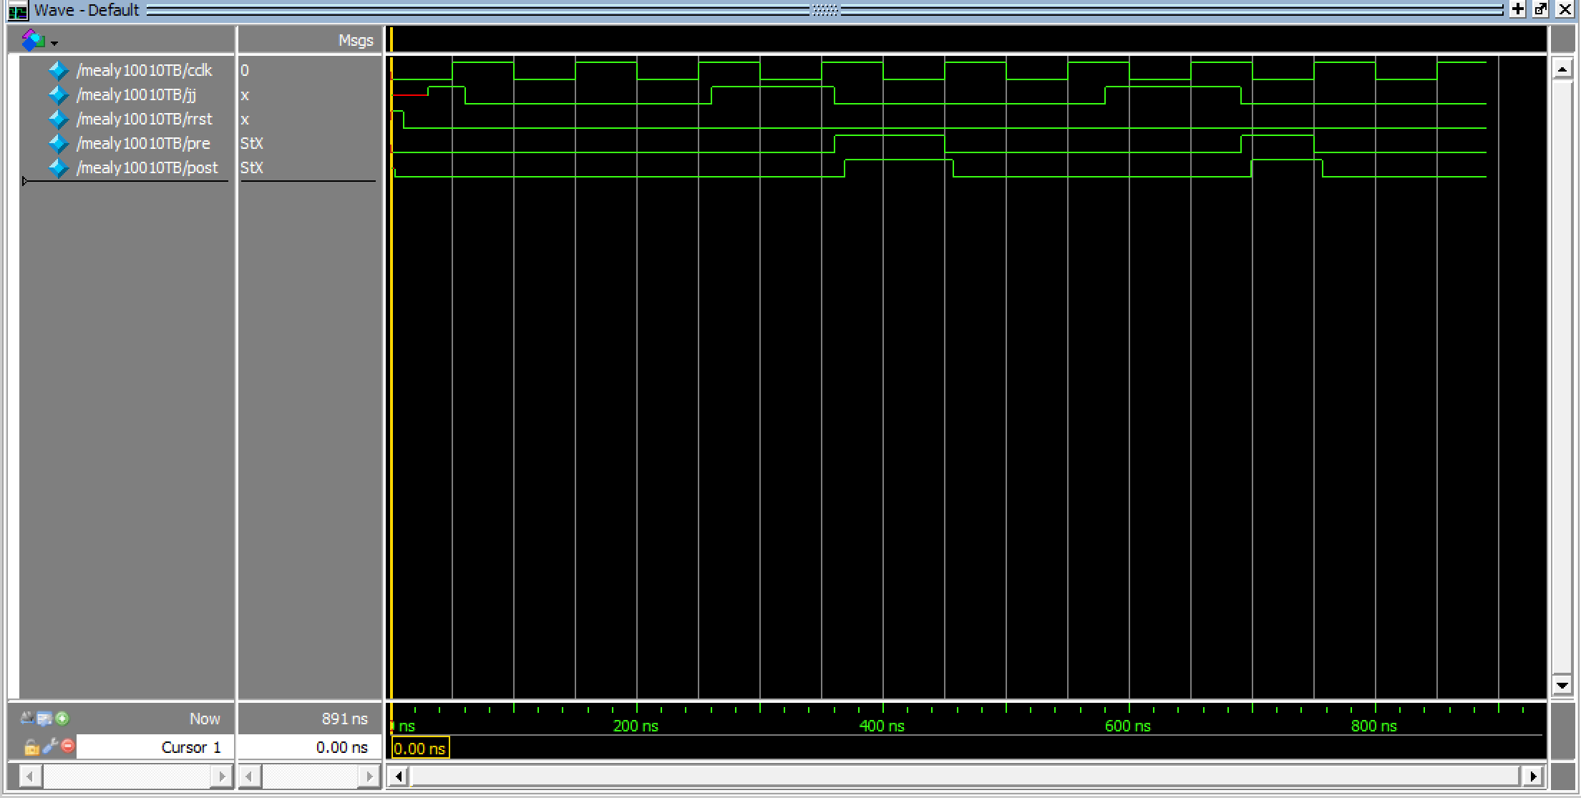

As you can see, the waveform of pre and post synthesis are the same.

Problem C: Compare Moore and Mealy Machine

Testbench

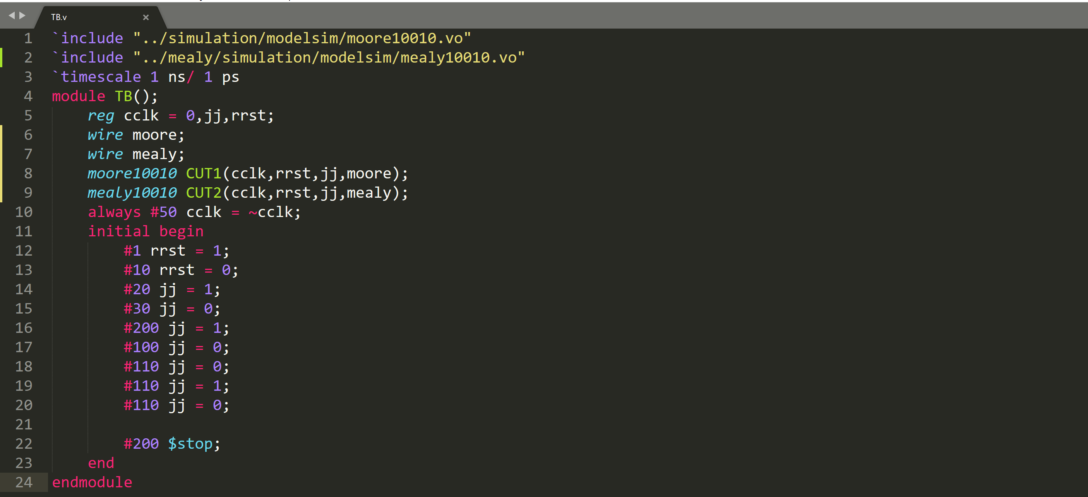

Simulation Result

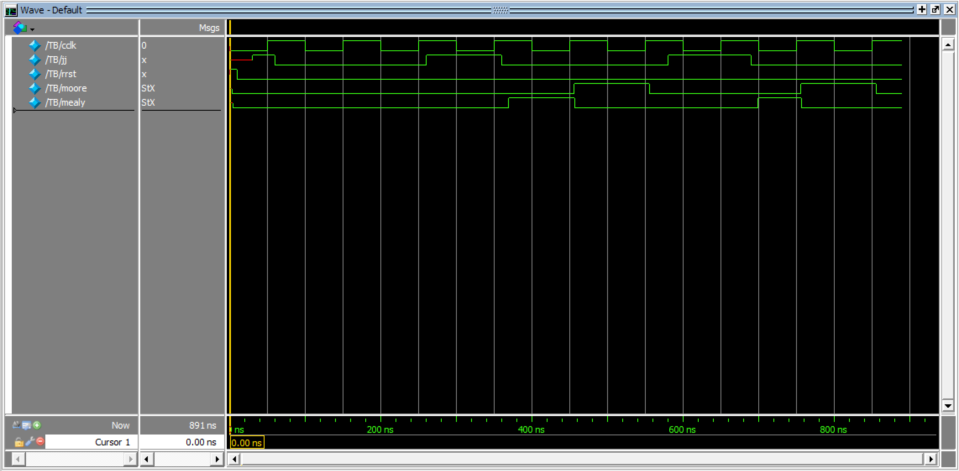

Part i.



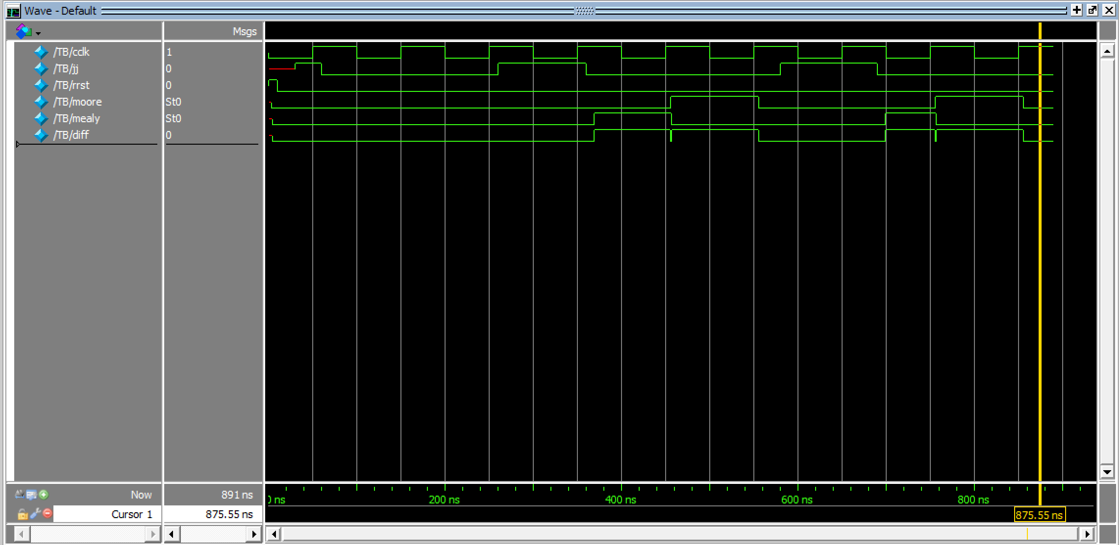

Part ii.

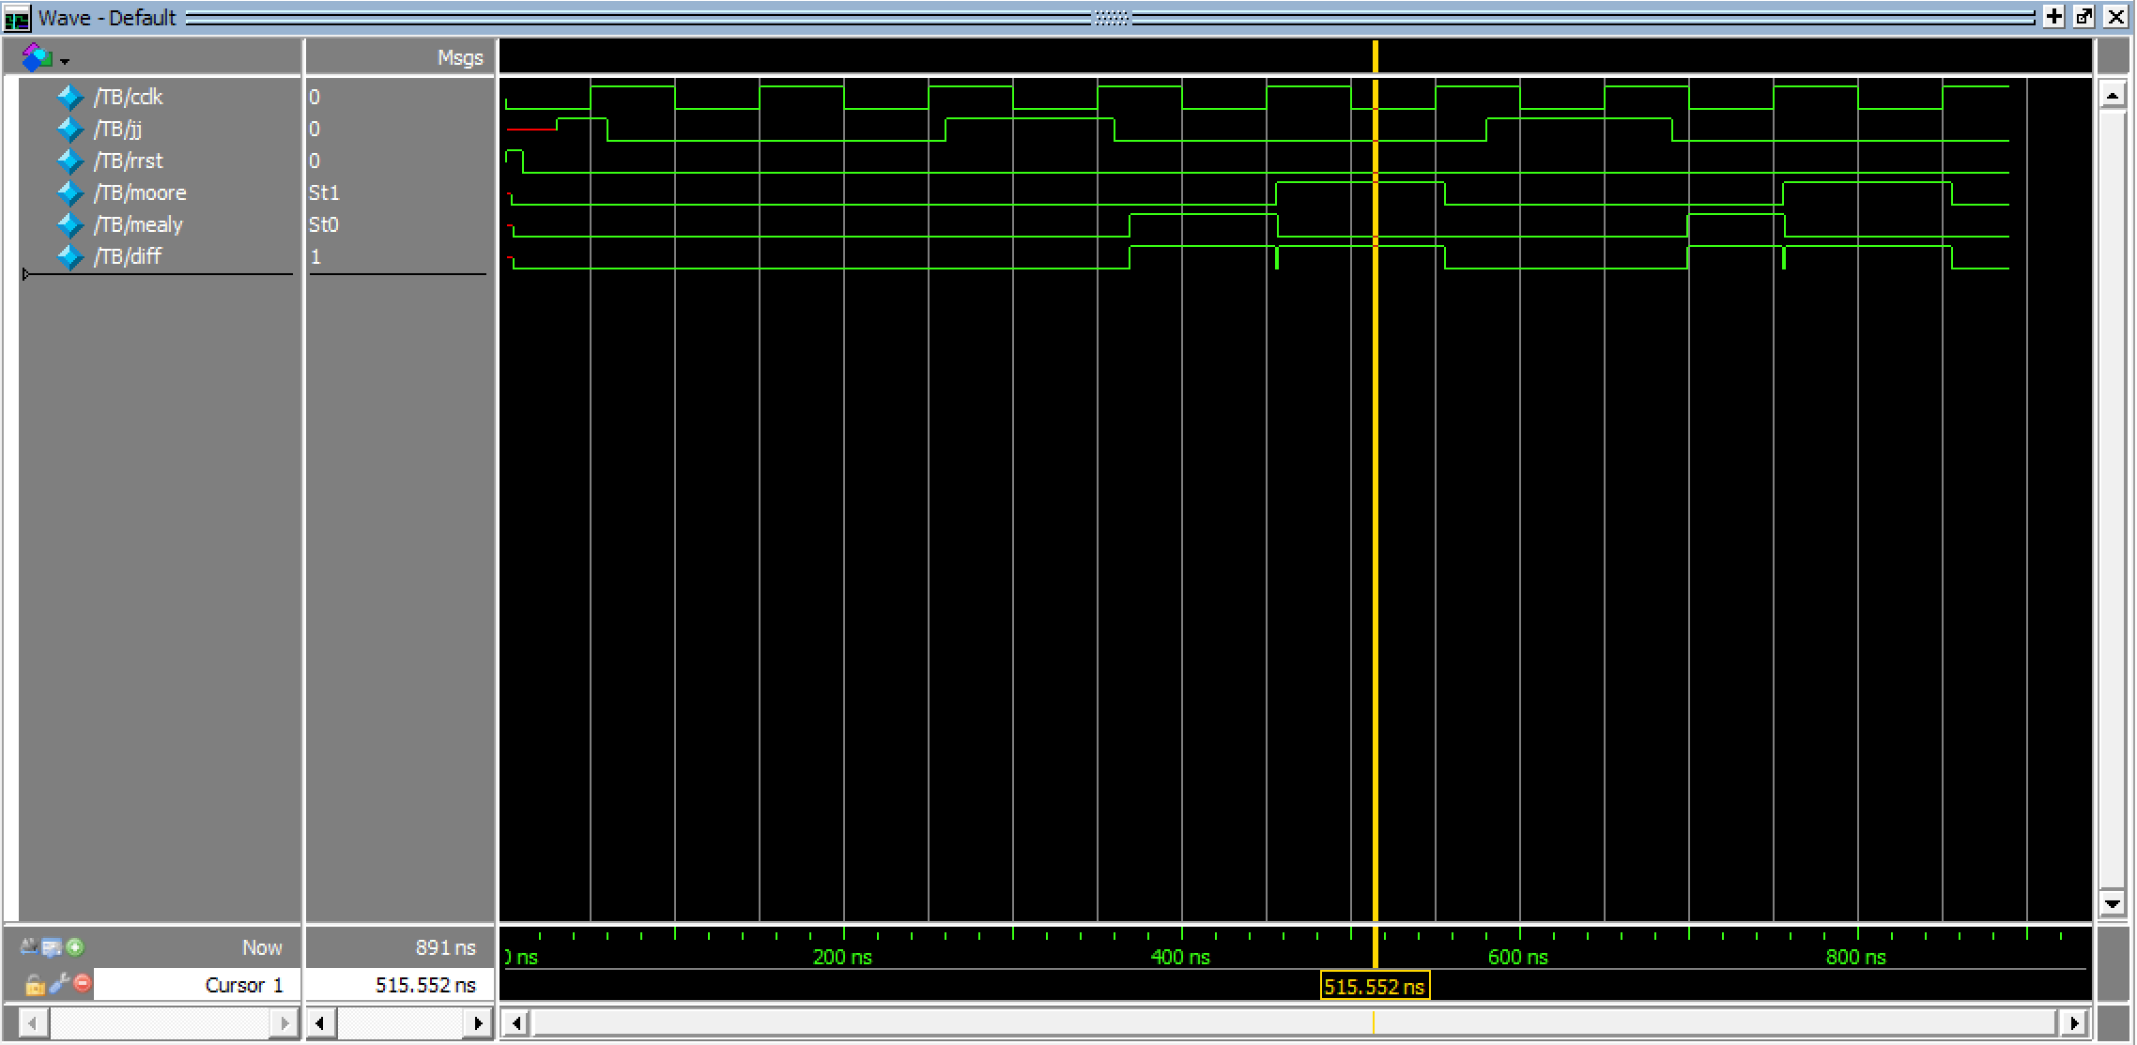

Part iii.

By adding delay to diff, the differences are due to changes on the inputs only:



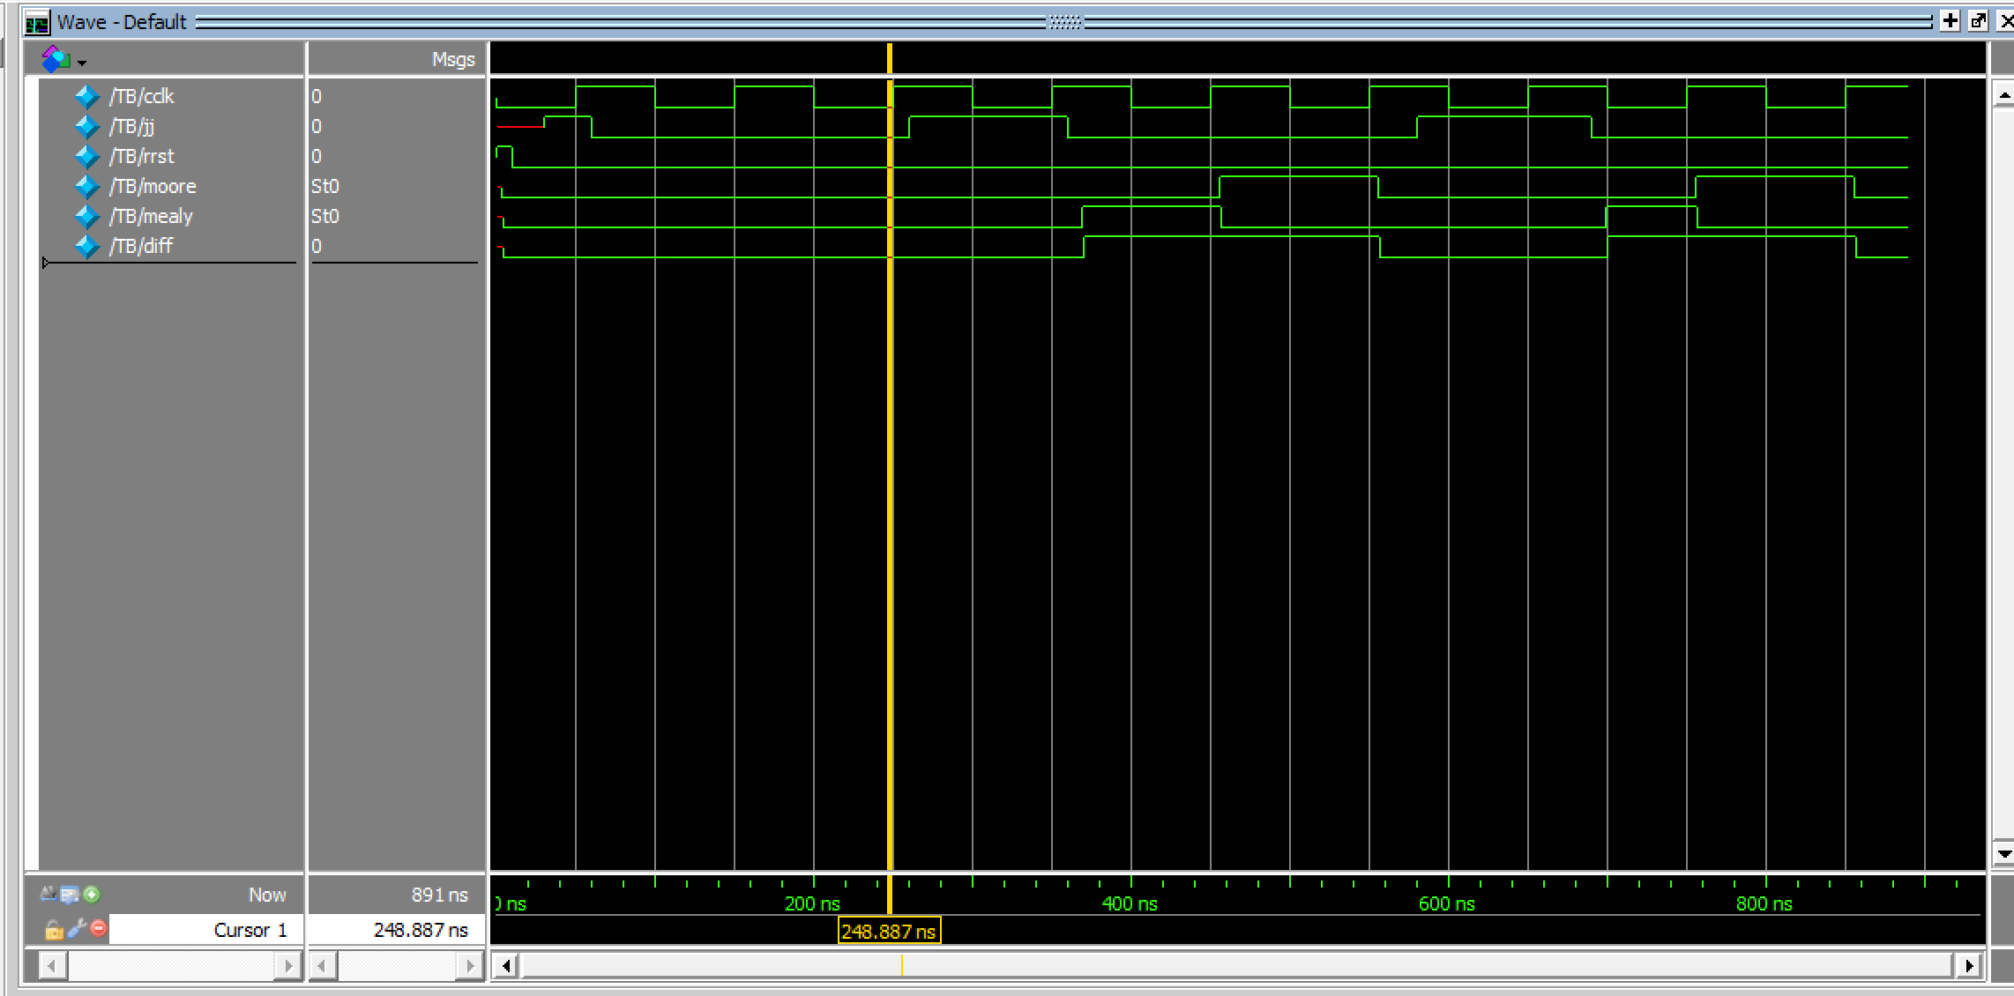

As you can see there is no glitch anymore.