THLOG

Wiring
Pro Micro | KY-015
A2 | Signal
VCC | Vcc | > Capacity
GND | Ground | > Capacity

Components

Overview

Side
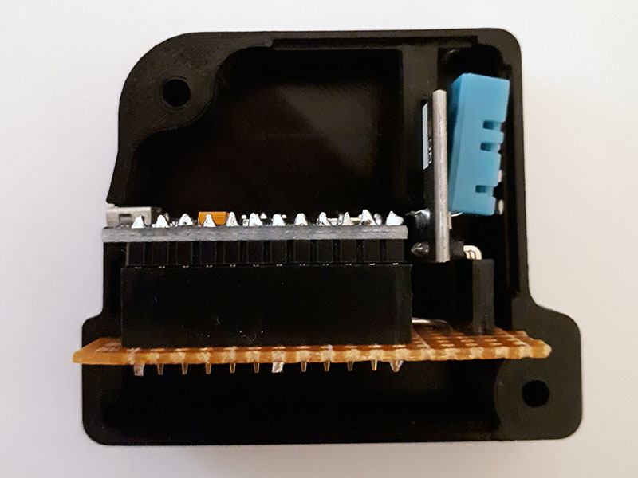

Front
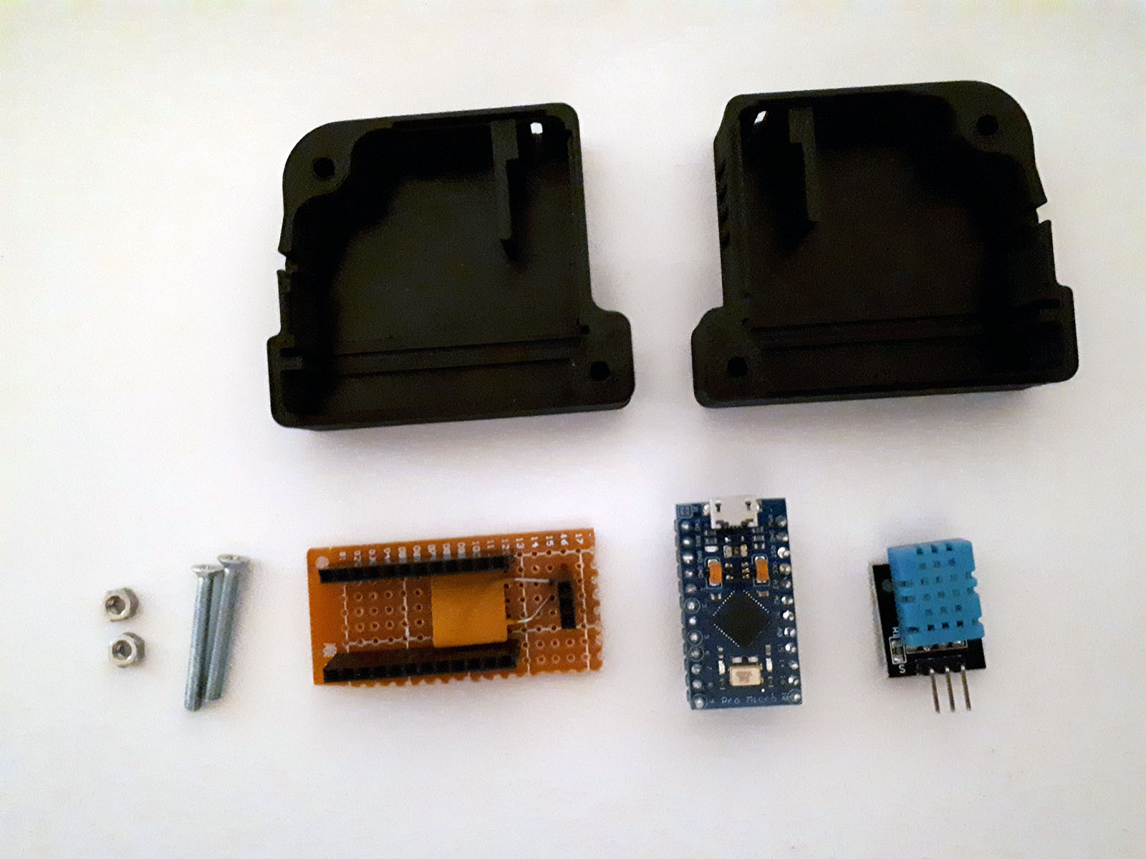

Back
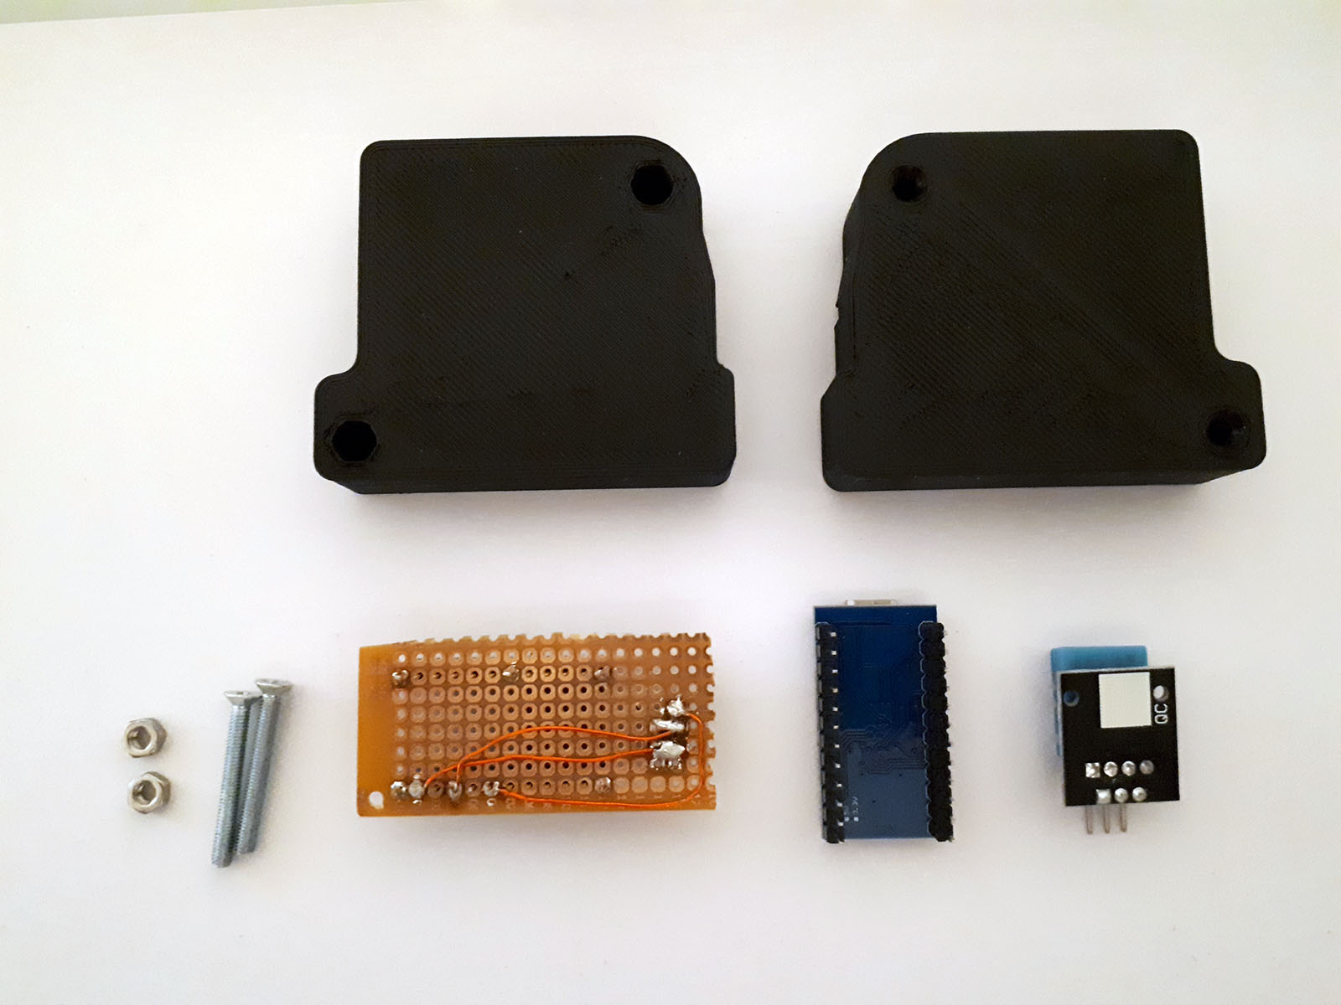

Details

Micro Controller
Name: Pro Micro
Voltage: 5V
MCU: ATmega32U4
Speed: 16MHz
USB: Micro USB
Bootloader: Arduino
Pinout:
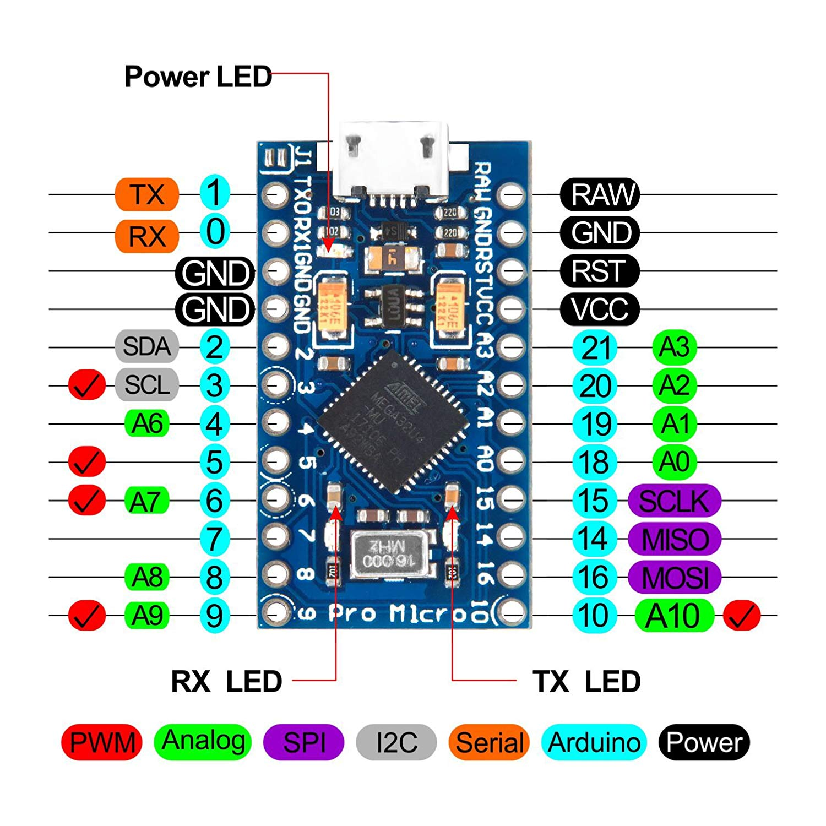Figure 1: 2019-06-24, https://images-na.ssl-images-amazon.com/images/I/81nOeGRzxPL._SL1500_.jpg

DHT11 Sensor
Name: KEYES KY-015
Voltage: 3.3V to 5.5V
Humidity:
Range: 20% to 90% RH
Accuracy: ±5% RH
Resolution 1% RH
Temperature:
Range: 0ºC to 50ºC
Accuracy: ±2ºC
Resolution: 1ºC
Pinout:
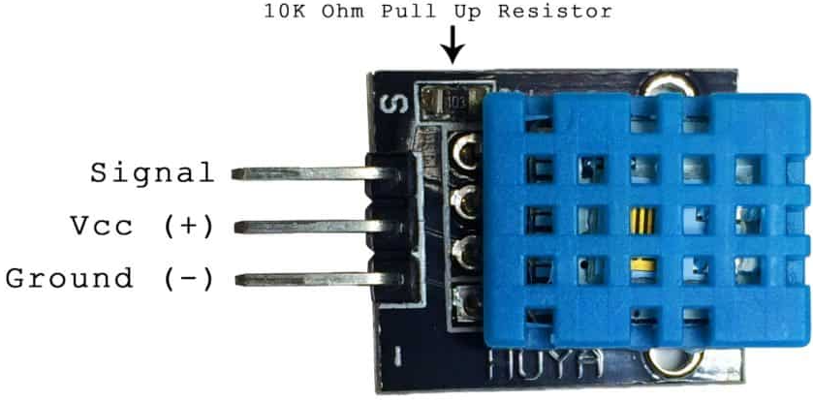Figure 2: 2019-06-24, http://www.circuitbasics.com/wp-content/uploads/2015/12/DHT11-Pinout-for-three-pin-and-four-pin-types-2.jpg

Screws
Name: M3x25 or M3x30
Head: Countersink
Nut: ISO 4032

Pin Header
Name: single row female pin header (3 pin and 12 pin)
Height: 8mm (without soldering pins)
Spacing: 2.54mm

Decoupling Capacity (optional)
Name: Capacitor
Value: 100nF

