USB Protocol

Packets
Each packet transmits an integral number of bytes at the current transmission rate. Packets start with a synchronization pattern, followed by the data bytes of the packet, and concluded with an End-of-Packet (EOP) signal. All USB packet patterns are transmitted least significant bit first. Before and after the packet, the bus is in idle state.
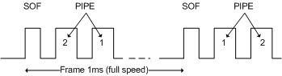
A special packet is the Start-of-Frame packet (SOF) that splits the USB bus into time segments. Each pipe is allocated a slot in each frame. The Start-of-Frame packet is sent every 1ms on full speed links. At high speed, the 1ms frame is divided into 8 microframes of 125μs each. A Start-of-Frame packet is sent at the beginning of each microframe using the same frame number. The frame number increments every 1ms.

- Token packets
  - Initiate transaction
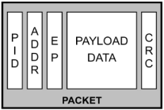
  - Identify device involved in transaction
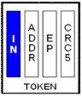
  - Always sourced by the host
- Data packets
  - Delivers payload data
  - Sourced by host or device
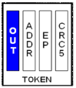
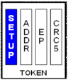
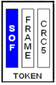
- Handshake packets
  - Acknowledge error-free data receipt
  - Sourced by receiver of data
- Special packets
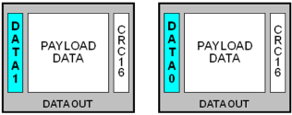
  - Facilitates speed differentials
  - Sourced by host-to-hub devices

Transaction
- The token packet is the header defining the transaction type and direction, the device address, and the endpoint.
- Data is transferred in a data packet.
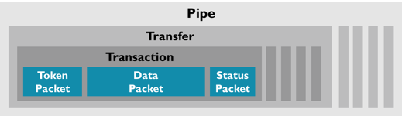
- The final status of the transaction is acknowledges in the handshake packet.
The transfer direction is specified in the token packet that is sent from the USB Host. Then, the source sends a data packet or indicates it has no data to transfer. In general, the destination responds with a handshake packet indicating whether the transfer was successful.
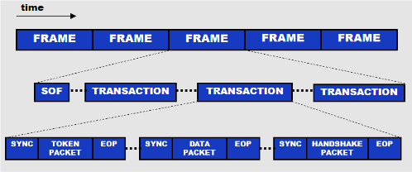

Transfers
Transfers (data flow types) can consist of one or more transactions. A pipe supports only one of the following transfer types:
- Control Transfers are typically used to setup an USB device. They always use IN/OUT Endpoint 0.
- Interrupt Transfers can be used where data is sent regularly, for example for status updates.
- Isochronous Transfers transmit real-time data such as audio and video. They have a guaranteed, fixed bandwidth, but no error detection.
- Bulk Transfers can be used to send data where timing is not important, for example to a printer.

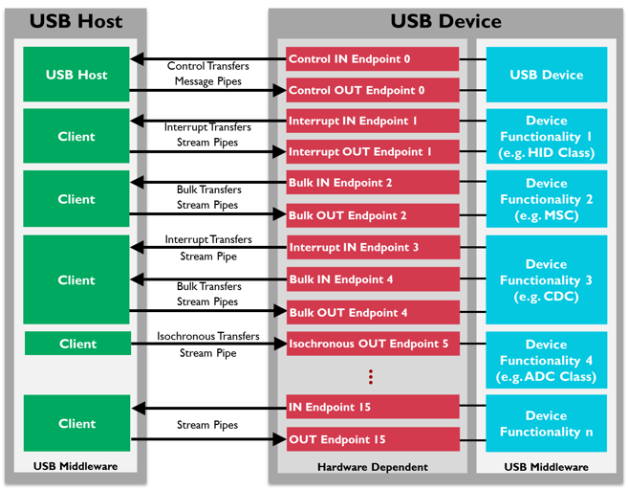
Pipes
- Message pipes have a defined USB format and are host controlled. Message pipes allow data to flow in both directions and support Control Transfers only.
- Stream pipes have no defined USB format and can either be controlled by the host or by the device. The data stream has a predefined direction, either IN or OUT. Stream pipes support Interrupt Transfers, Isochronous Transfers, and Bulk Transfers.
Most pipes come into existence when an USB Device has been connected to the USB Bus and configured by the USB Host. A pipe originates from a data buffer within the host client and terminates inside the USB Device at an Endpoint.

Endpoints
- A device can have up to 16 OUT and 16 IN endpoints.
- Each endpoint can have only one transfer direction.
- Endpoint 0 is used for control transfers only and can not be assigned to any other function.
- OUT always refers to the direction pointing from the host to the device.
- IN always refers to the direction pointing towards the host.
The total number of endpoints and the capability of each endpoint is defined by the underlying hardware.

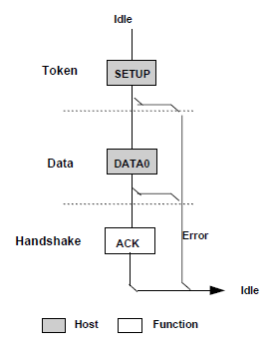
Control Transfers
Control Transfers are bi-directional transfers reserved for the host to send and request configuration information to and from the device using the IN and OUT Endpoint 0.
Control Transfers have three stages:
- The SETUP stage carries 8 bytes called the Setup packet, defining the request, and specifying how many data should be transferred in the DATA stage.
- The DATA stage is optional. If present, it always starts with a transaction containing a DATA1 packet. Then, the transaction type alternates between DATA0 and DATA1 until all required data have been transferred.
- The STATUS stage is a transaction containing a zero-length DATA1 packet. If the DATA stage was IN, then the STATUS stage is OUT, and vice-versa.
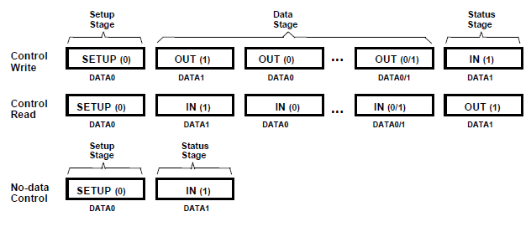

► https://www.beyondlogic.org/usbnutshell/usb4.shtml

References:
- https://www.cypress.com/file/134171/download
- https://www.beyondlogic.org/usbnutshell/usb3.shtml#USBProtocols
- https://www.keil.com/pack/doc/mw/USB/html/_u_s_b__endpoints.html
- http://www.usbmadesimple.co.uk/ums_4.htm

