Statistical Evaluation of Nuclear and Coal Power Generation

A hypothesis testing activity submitted by

Ada A. Lovelace
T09-A

Engr. Gyro A. Madrona
Instructor

Computer Engineering Technology
TECHNOLOGICAL UNIVERSITY OF THE PHILIPPINES VISAYAS
February 2026

1. About the Dataset
The dataset used in this analysis contains power generation values (measured in megawatts, MW) from two types of power plants: nuclear and coal. Each record represents the amount of electrical power produced at a given time .
source: https://www.kaggle.com/datasets/stefancomanita/hourly-electricity-consumption-and-production

2. Statistical Question
Is the power generation of nuclear power plants significantly higher than that of coal power plants?

3. Hypotheses
$$H_{o}: μ_{Nuc}=μ_{Coal}$$
$$H_{a}: μ_{Nuc}>μ_{Coal}$$

4. Test Statistic
4.1 Summary of statistics
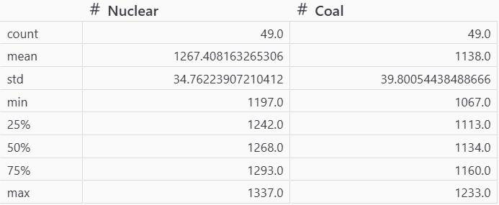
4.2 Boxplot
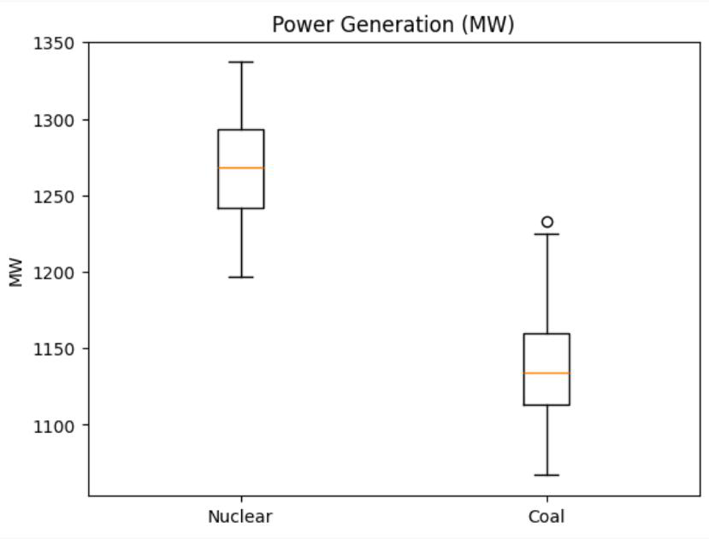

4.3 Normality Test
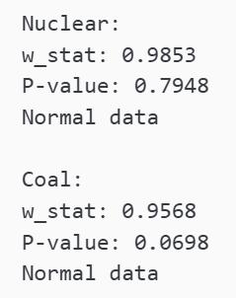
4.4 F-Test
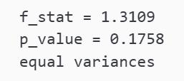
4.5 2-Sample t-Test
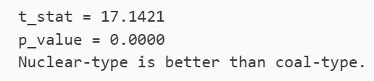
4.6 Power of the Test


5. Conclusion
Using a two-sample t-test to evaluate whether nuclear plants produce more power (in MW) than coal plants, the analysis yielded a t‑statistic of 17.1421 with a p‑value < 0.0000. At the 0.05 significance level, the null hypothesis is rejected. This result indicates that nuclear power plants produce significantly higher power output than coal power plants.

