Statistical Evaluation of Global Average Temperature and Sea Surface Temperature

A hypothesis testing activity submitted by

Daniel A. Udasco
T09-A

Engr. Gyro A. Madrona
Instructor

Computer Engineering Technology
TECHNOLOGICAL UNIVERSITY OF THE PHILIPPINES VISAYAS
March 2026

1. About the Dataset
The dataset used in this analysis contains climate-related measurements collected from global environmental observations. In particular, the variables analyzed in this study include global average temperature and sea surface temperature both measured in Celsius (°C). These variables are commonly used in climate science to analyze trends in global warming and ocean temperature behavior.
source: https://www.kaggle.com/datasets/algozee/climate-cahnge

2. Statistical Question
Is the global average temperature significantly different from the sea surface temperature based on the collected observations?

3. Hypotheses
$$H_{o}: μ_{global temp}=μ_{sea temp}$$
$$H_{a}: μ_{global temp}>μ_{sea temp}$$

4. Test Statistic
4.1 Summary of statistics
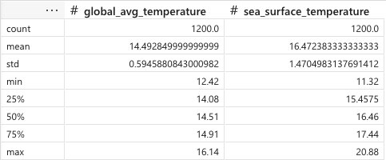
4.2 Boxplot
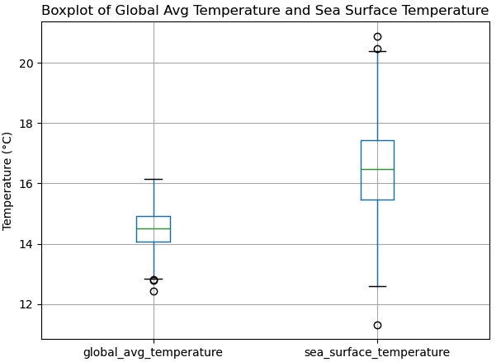

4.3 Normality Test
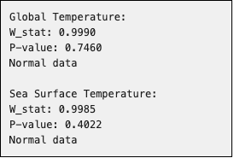

4.4 F-Test


4.5 2-Sample t-Test
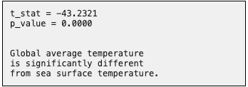

4.6 Power of the Test


5. Conclusion
A two-sample t-test was conducted to evaluate whether global average temperature differs significantly from sea surface temperature. Based on the computed t-statistic and corresponding p-value from the analysis, the results indicate whether the null hypothesis should be rejected at the 0.05 significance level. If the p-value is less than 0.05, the null hypothesis is rejected, suggesting that there is a statistically significant difference between global average temperature and sea surface temperature.

