# Effective communication between autistic and non-autistic people

[Research](https://dart.ed.ac.uk/double-empathy-problem-animated-podcasts/) tells us that both autistic people and neurotypical (non-autistic) people communicate effectively when interacting with others who share the same [neurotype](https://aucademy.co.uk/2021/05/11/glossary-of-autistic-terms/). This includes how language, emotional expression and social interactions are understood. Research also tells us that social interactions between people of differing neurotypes are frequently less successful. This is because of something called the [Double Empathy Problem](https://drive.google.com/file/d/14nxBDjBLWm8rEUTiGDg0v7vjtpePUh62/view) which identifies that mutual incomprehension is often due to differing perspectives and experiences impeding successful communication and understanding.

As social interaction is bidirectional, all those involved in interacting share responsibility for learning how others communicate and adapting and adjusting to ensure effective communication. Unfortunately, because of the Double Empathy Problem and lack of awareness about autism, it’s usually autistic people who have to do all the learning, adapting and adjusting. And it’s usually autistic people who are told they have poor communication skills even when it’s really neurotypical people causing communication breakdowns by failing to communicate effectively with autistic people. This can have a significant [detrimental impact](https://twitter.com/commaficionado/status/1276610730851262470) on autistic people.

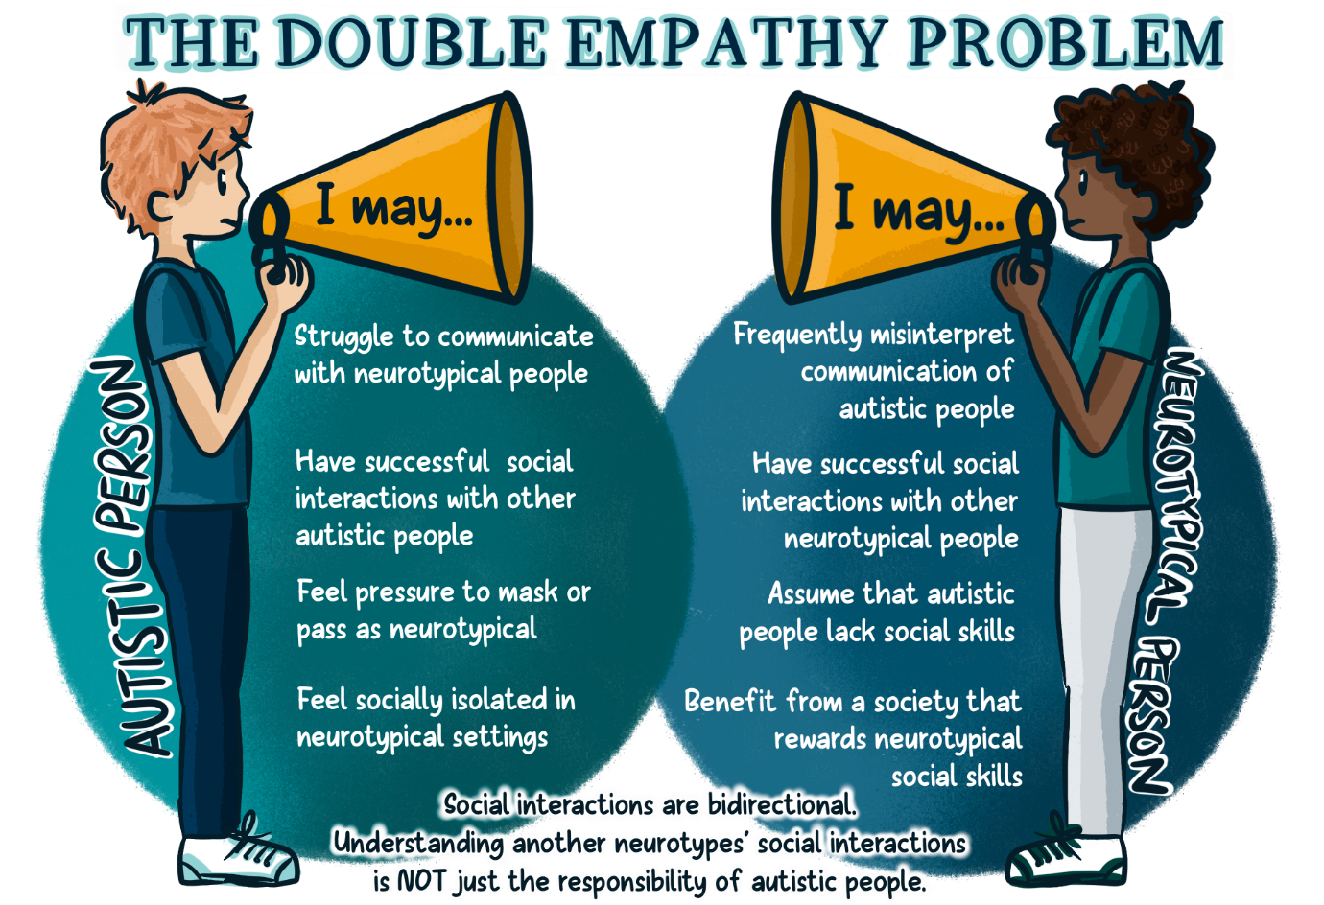

**Image credit:** [**Amanda Filbey**](https://www.theinformedslp.com/review/how-and-why-to-be-a-neurodiversity-friendly-slp)

**Tips for effective communication**

1. As a neurotypical person, recognise that you have a responsibility to **learn about autistic communication and adapt and adjust your communication** accordingly. Accept that your communication may not work for autistic people and commit to adjusting it.
2. Remember that the experience of autism is entirely individual and what works for one autistic person may not work for another. **Don’t make assumptions**.
3. Establish **preferred methods of contact** – this is very individual and may vary depending on the context, so it’s always a good idea to **ask**.
4. Always check the **sensory environment** when communicating. Autistic people frequently experience sensory distraction and overload which can make it more difficult to communicate effectively. [Consider all elements of the environment](https://aucademy.co.uk/wp-content/uploads/2021/03/common-environmental-challenges-potential-solutions-downloadable-table.pdf), whether physical or digital. Ask the person you are communicating with if they are comfortable with their environment. Agree to make adjustments.
5. **Be clear, concise, and unambiguous**. Say what you mean and mean what you say. This is especially important when you are giving instructions or setting expectations. Use plain English.
6. When communicating verbally **allow time for processing** without repeating or rephrasing the question.
7. **Summarise verbal information** in writing, but make sure you format it in a clear way (see below).
8. **Format written information clearly**, using bullet points, headings, and action lists.
9. When sending emails, **indicate in the subject line** whether the content is ‘For information only’ or whether ‘Action is required’.
10. Give **step by step instructions in writing**. Detail who, what, where, when and how, but format this appropriately.
11. Make sure you follow guidance for [**making meetings inclusive**](https://leeds365.sharepoint.com/sites/StudentEducationService/SitePages/Accessibility-guidance.aspx).
12. In one-to-one settings **try sitting side by side** rather than face to face as this will reduce the need for unnecessary eye contact, which can be difficult for some autistic people.
13. Give a clear **opportunity for questions** and give a clear point of contact for further information or guidance.
14. **Acknowledge any misunderstandings or miscommunication** and your part in these. Ask what alternative methods you can try.
15. **Remember that autistic people already adapt and adjust their communication constantly. The onus is on neurotypical people to start doing the same.**