2/20/26, 11:43 AM 19-01 Inspect Logs - ADMIN-230: Administrating Cloudera Data Platform
19-01 Inspect Logs
1. Introduction

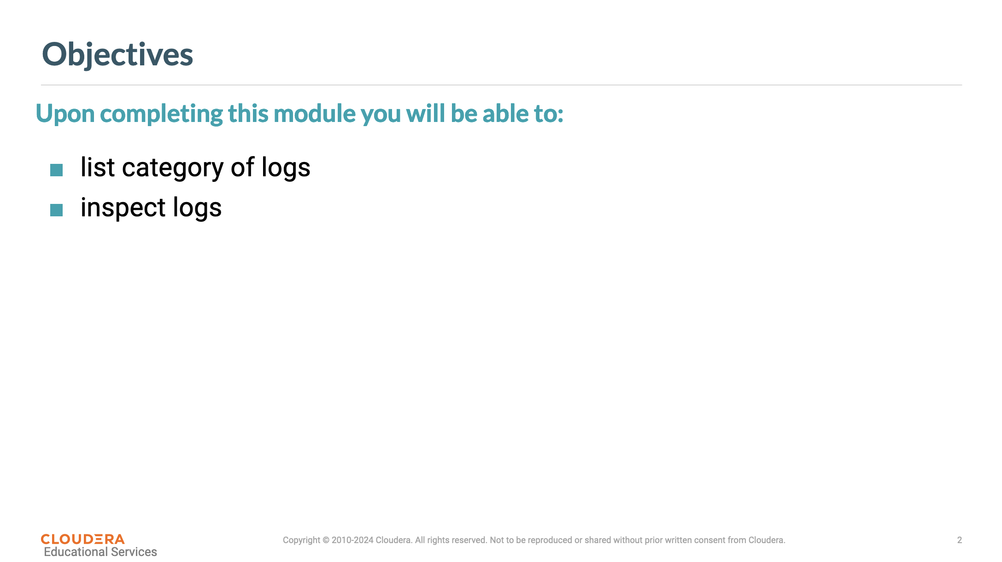
2. Category of Logs
file:///home/dzamo/01_Hot_Tier/curso-cloudera/external/_labs.puedata.com/_cmhost.example.com/home/training/software/exercises/gu… 1/6

2/20/26, 11:43 AM 19-01 Inspect Logs - ADMIN-230: Administrating Cloudera Data Platform
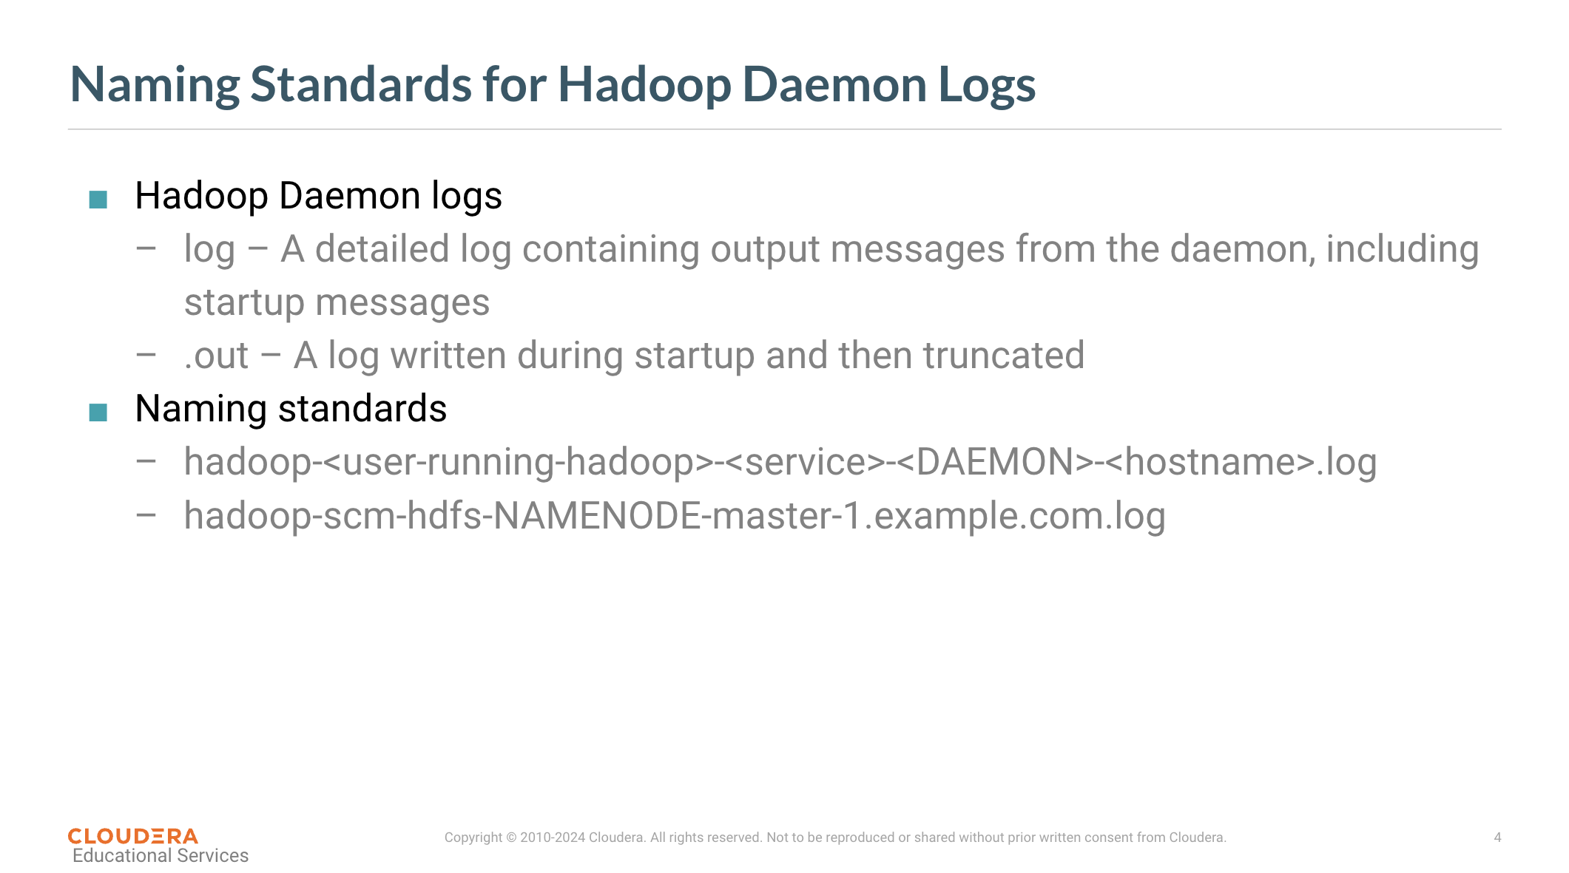
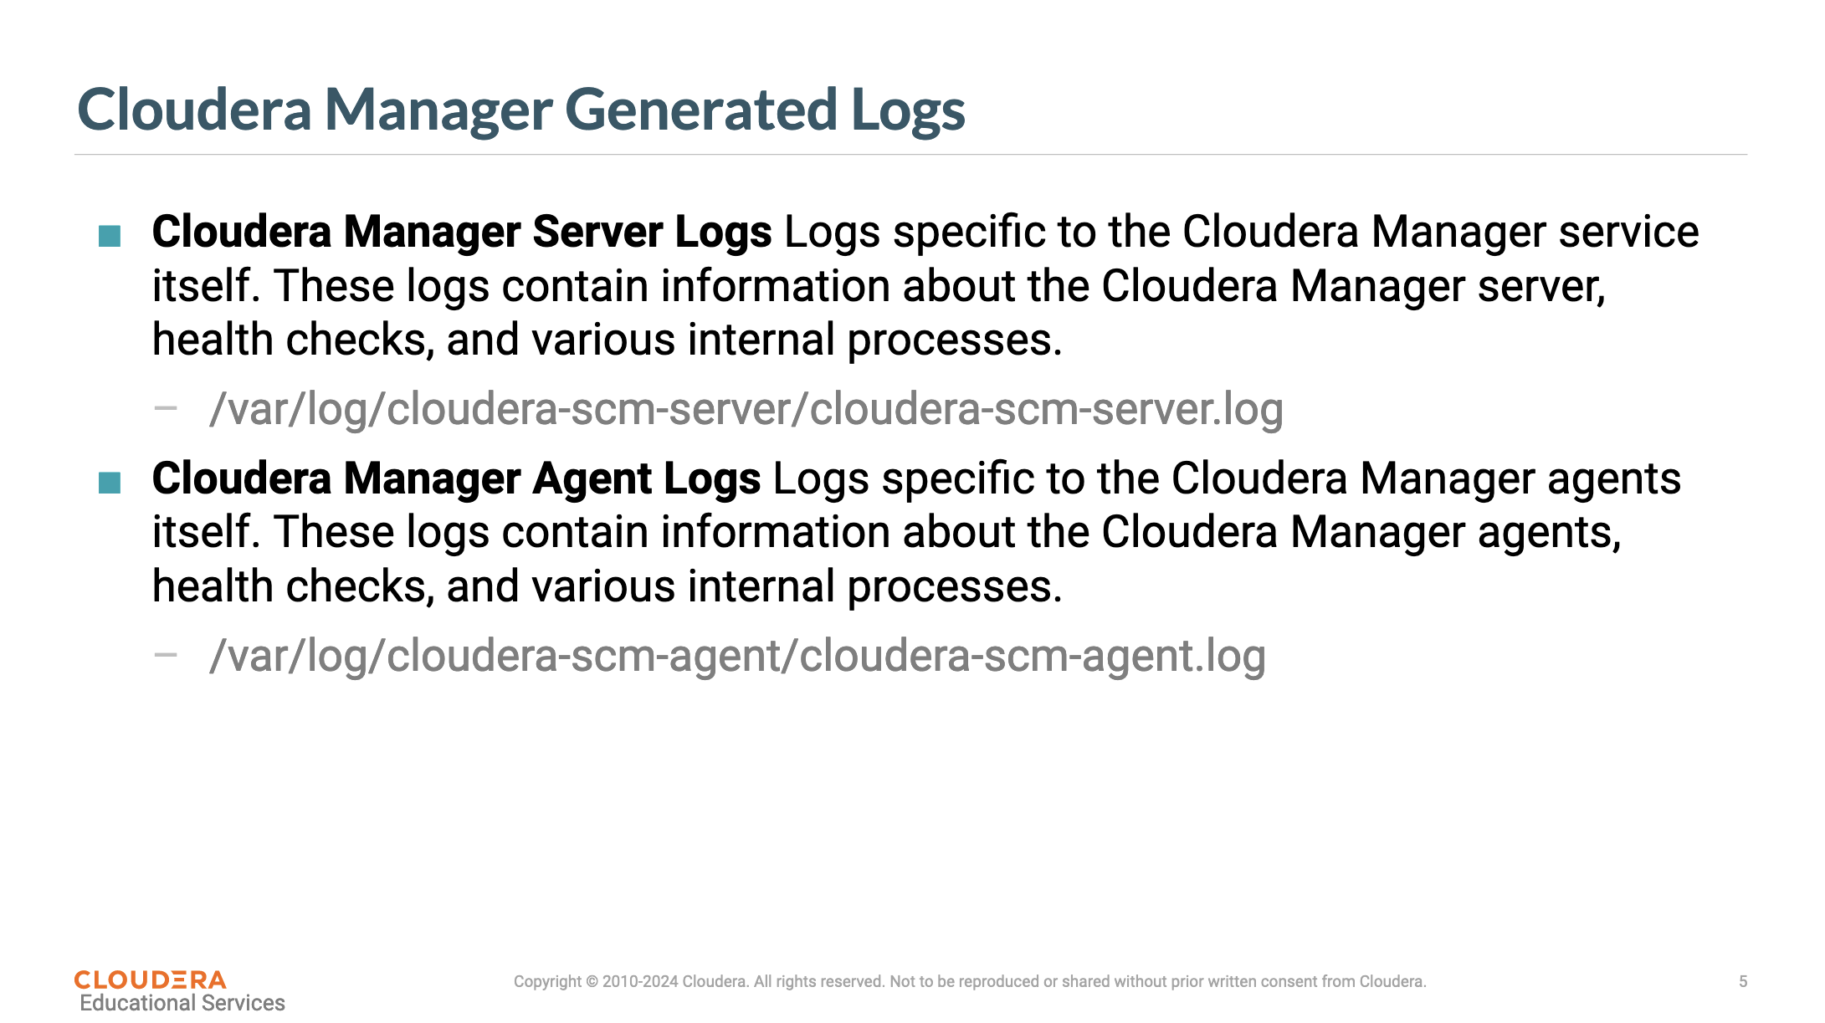
file:///home/dzamo/01_Hot_Tier/curso-cloudera/external/_labs.puedata.com/_cmhost.example.com/home/training/software/exercises/gu… 2/6

2/20/26, 11:43 AM 19-01 Inspect Logs - ADMIN-230: Administrating Cloudera Data Platform
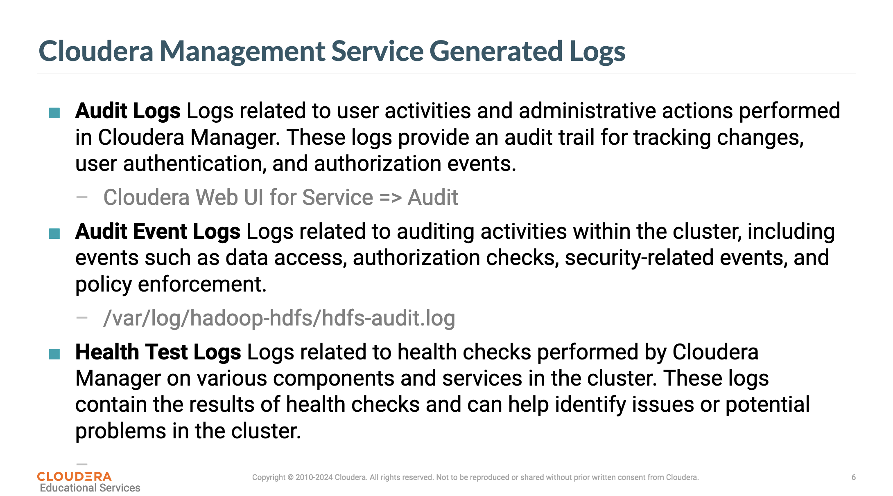
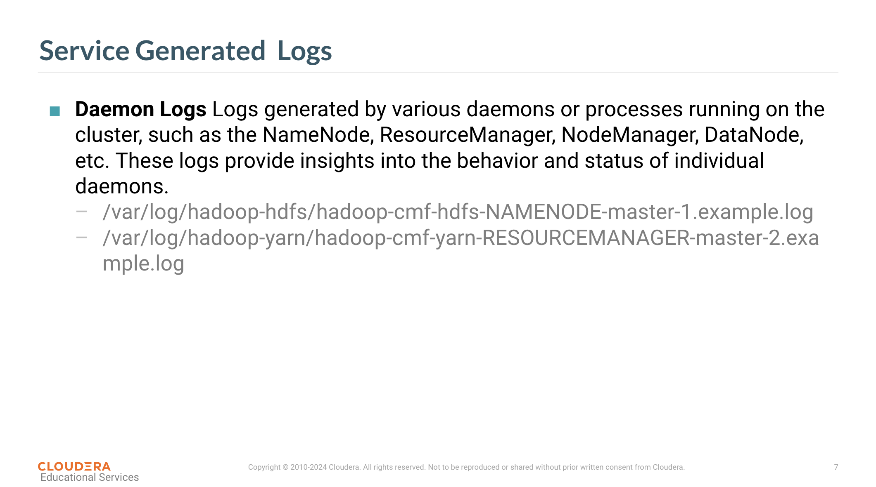
file:///home/dzamo/01_Hot_Tier/curso-cloudera/external/_labs.puedata.com/_cmhost.example.com/home/training/software/exercises/gu… 3/6

2/20/26, 11:43 AM 19-01 Inspect Logs - ADMIN-230: Administrating Cloudera Data Platform
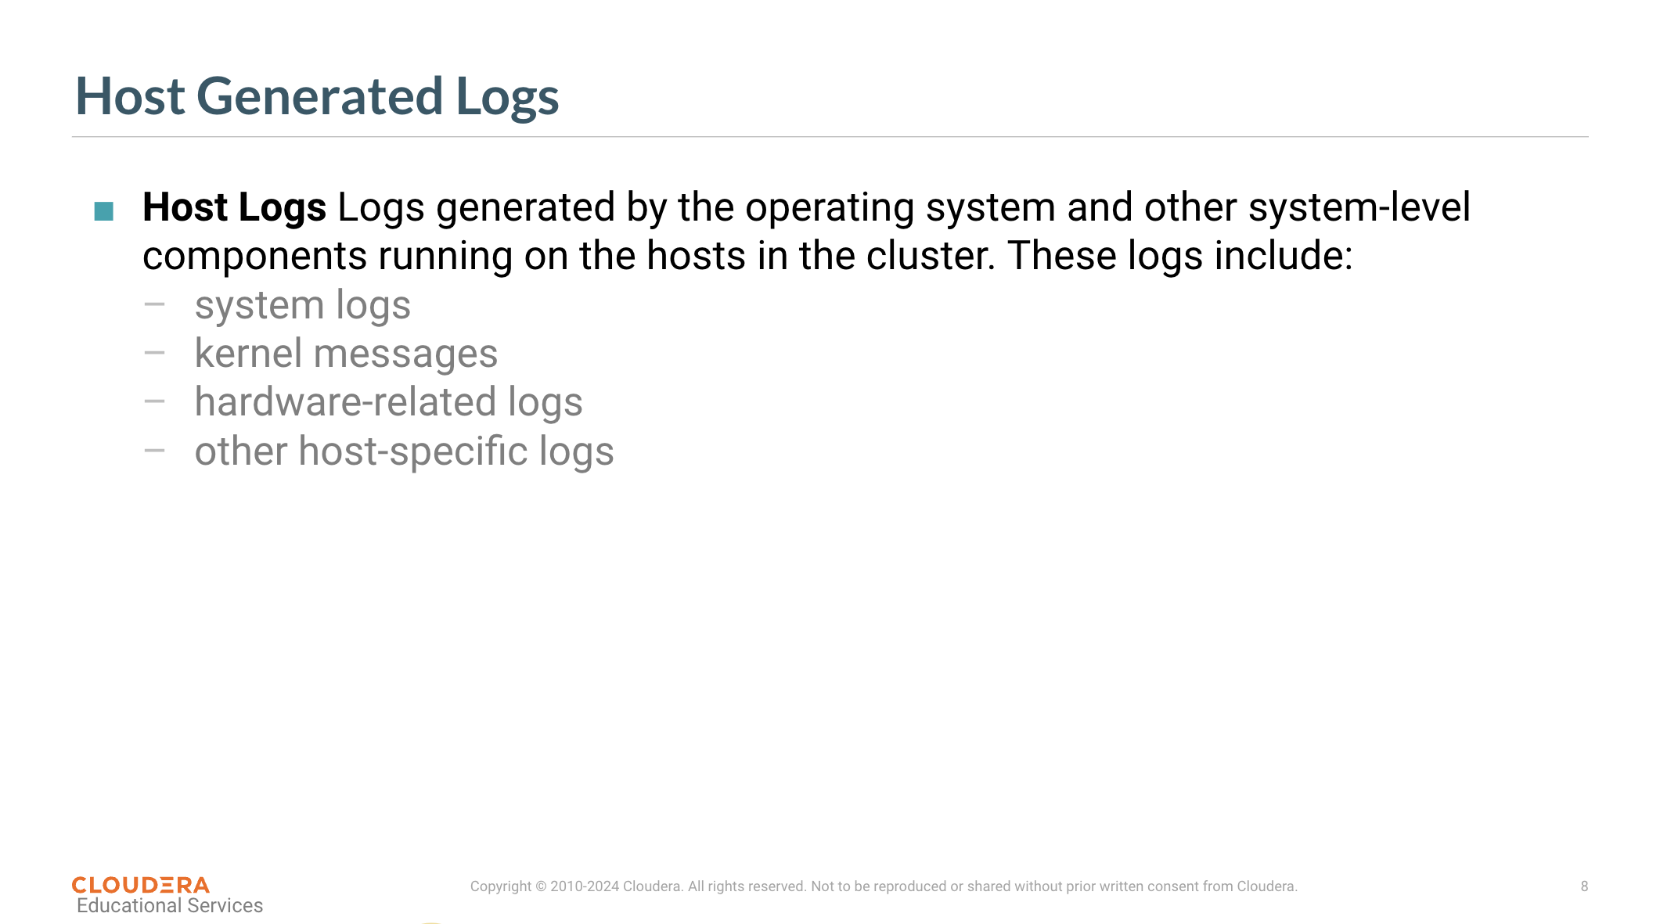
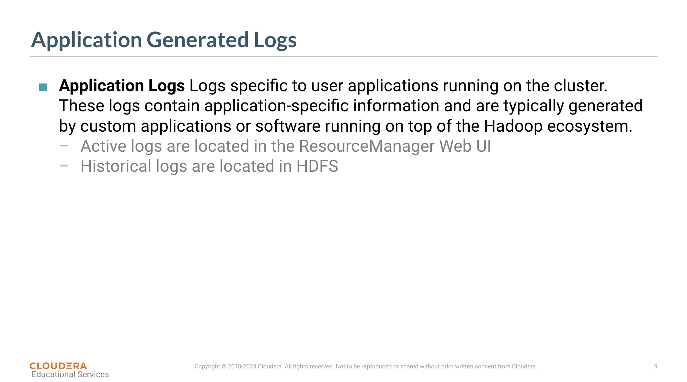
3. Inspect Logs
file:///home/dzamo/01_Hot_Tier/curso-cloudera/external/_labs.puedata.com/_cmhost.example.com/home/training/software/exercises/gu… 4/6

2/20/26, 11:43 AM 19-01 Inspect Logs - ADMIN-230: Administrating Cloudera Data Platform
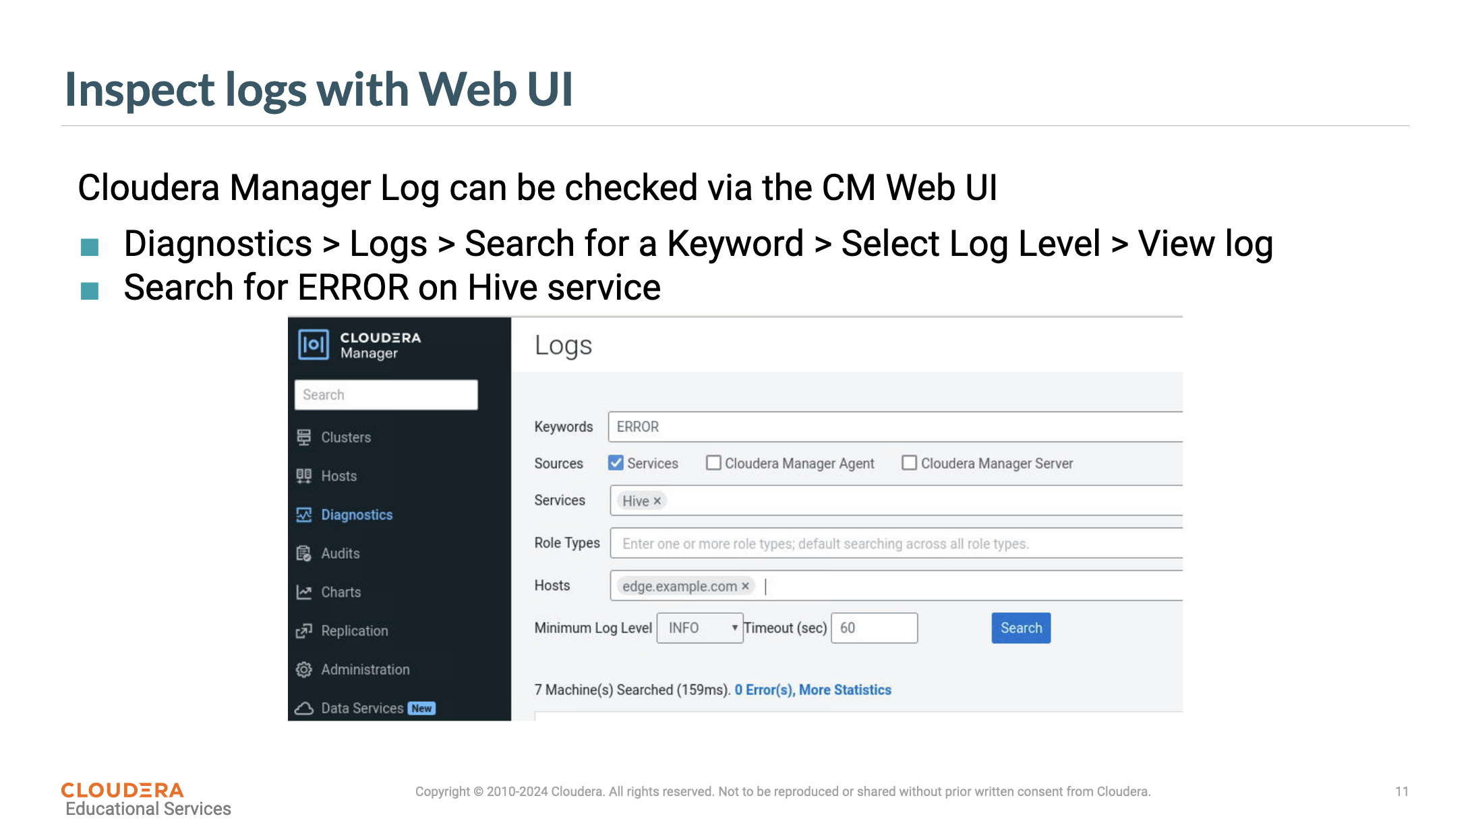
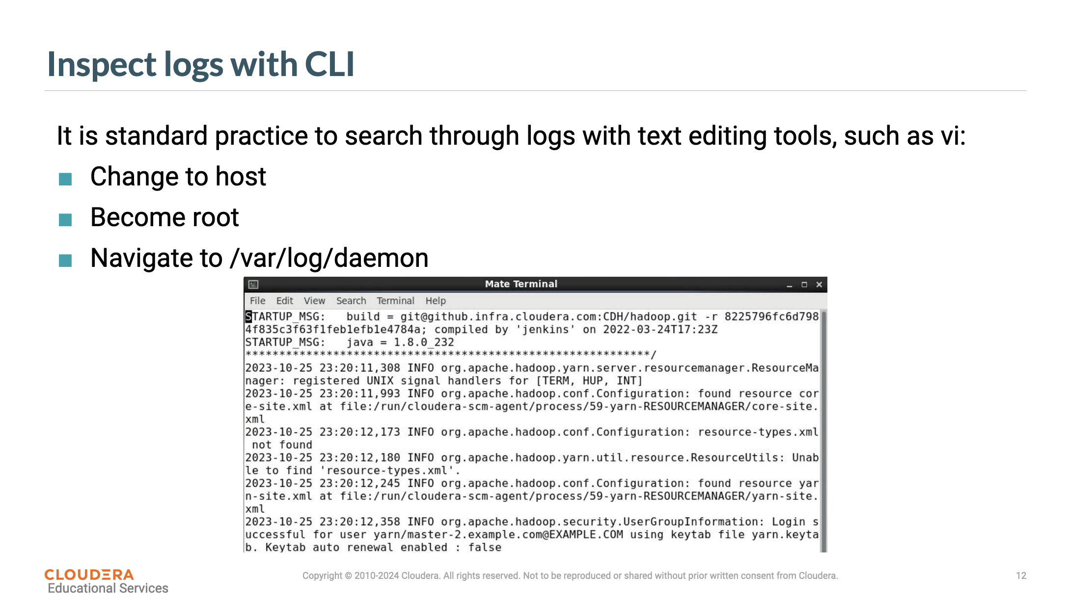
4. Exercise
file:///home/dzamo/01_Hot_Tier/curso-cloudera/external/_labs.puedata.com/_cmhost.example.com/home/training/software/exercises/gu… 5/6

2/20/26, 11:43 AM 19-01 Inspect Logs - ADMIN-230: Administrating Cloudera Data Platform
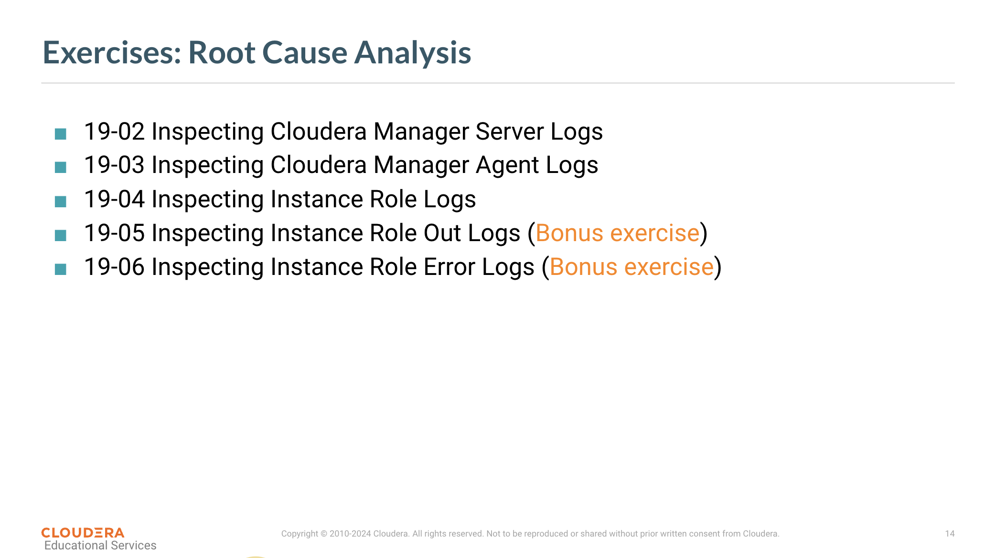
5. Summary
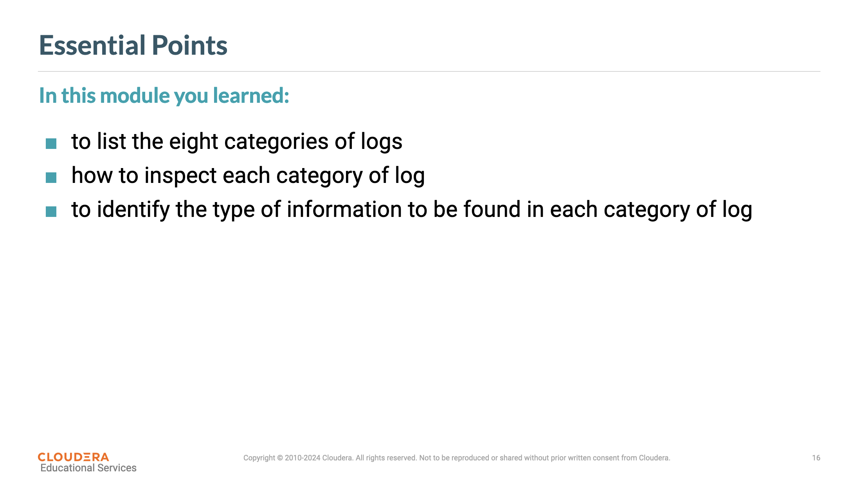
file:///home/dzamo/01_Hot_Tier/curso-cloudera/external/_labs.puedata.com/_cmhost.example.com/home/training/software/exercises/gu… 6/6

