Lab 6 – Assessment/Project practice

General Questions

Defining various terms:

a. Page Fault – A page fault is an alert such as an interrupt or exception that indicates a page of memory was accessed without being loaded into memory. It blocks the current process and another ready process may then end up getting the CPU. The page fault must be serviced. For example, a page fault can occur when operating with COW (Copy on write). This is a memory management technique that allows the OS to share physical memory between multiple processes. As soon as a process tries to modify the shared page, a copy of the page is created, so that only modifications affect the active process.

b. Reference Recency Summary or Principle of locality of refers to the phenomenon in which the same values or related storage locations are frequently accessed by a process. For example this is constantly used in virtual memory as it can help predict when pages are needed

c. The clock or second chance algorithm, maintains a circular list of page frames with a pointer to the next possible victim. Whereas first in first out maintains a simple list of page frame numbers.

d. Arrival Time – The time slot in which the process entered the queue
Eg.
Process 3 is running from 0 to 5 and Process 4’s arrival time is 3 meaning it arrived
before it can begin running

e. Reference Bit – A Referenced Bit: Referenced bit will say whether this page has been referred to in the last clock cycle or not. It is set to 1 by hardware when the page is accessed.

f. A dirty bit or modified bit is a bit that is associated with a block of computer memory and indicates whether the corresponding block of memory has been modified.

g. Reference counter - reference counters are programming techniques of storing the number of references, pointers, or handles to a resource, such as an object, a block of memory, disk space, and others.

h. Reference History - The term reference history in memory management refers to a record of the access patterns of memory locations over a specific period of time. This information is typically used to improve the efficiency of memory allocation and management algorithms.

Algorithm Specific Questions
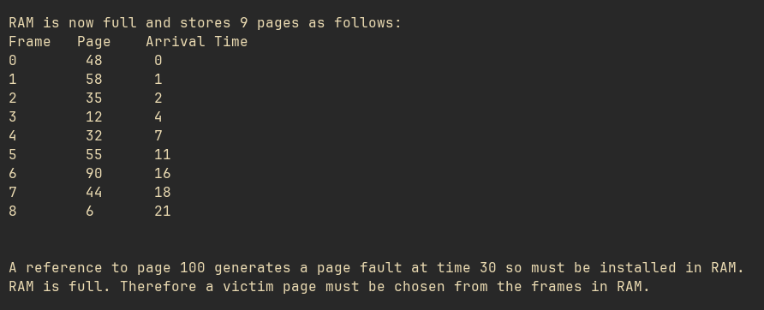
a.
Sample Data:

FIFO
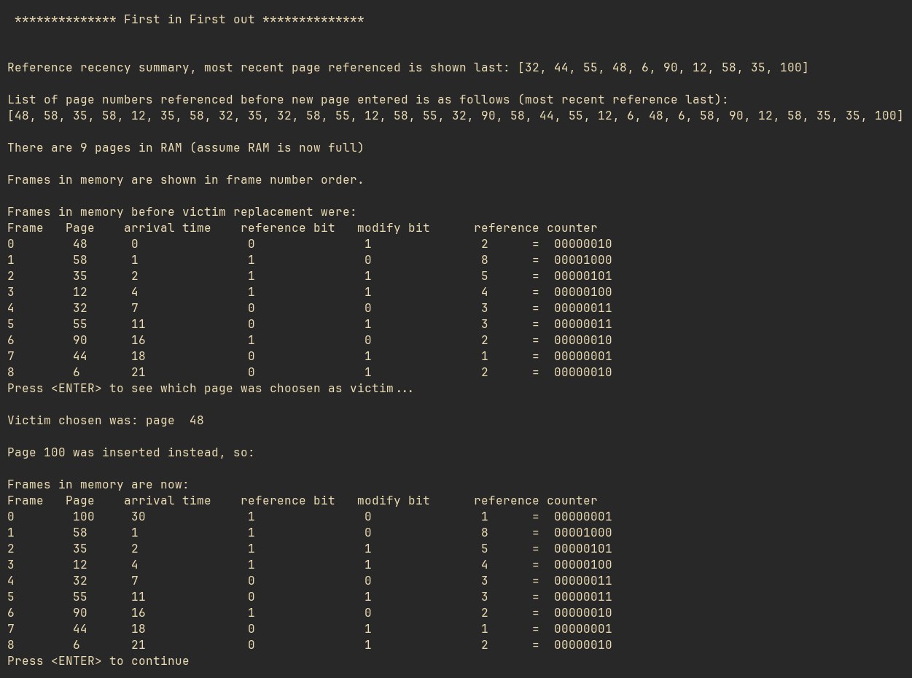
- The victim page 48 was chosen as it was the page that has been in memory the longest. It has an arrival time of 0. Throughout various other tests of FIFO it always seems to remove the page with an arrival time of 0 an replace it with page 100. This is because throughout its runtime it maintains a queue of pages ranked by how long the page has been in memory. Although theoretically getting rid of the longest lasting page sounds smart, it is naive as it doesn’t consider that this page may still be useful.
- Advantages:
Simple to Implement, simple list of page frame numbers.
- Disadvantages:
Naive as doesn’t consider if a page may still be useful
Takes no account of how recently a page has been referenced.

b.

- NRU (Not recently used)
- Not recently used focuses on the page that has not been recently referenced. To achieve this it uses the reference bit stored in the page table entry for each page. When a new process is started all of the references are cleared and once it is referenced again, its reference bit is set.
- From there reference bits are periodically cleared which allows one to distinguish between those that have been referenced recently from those who have not.
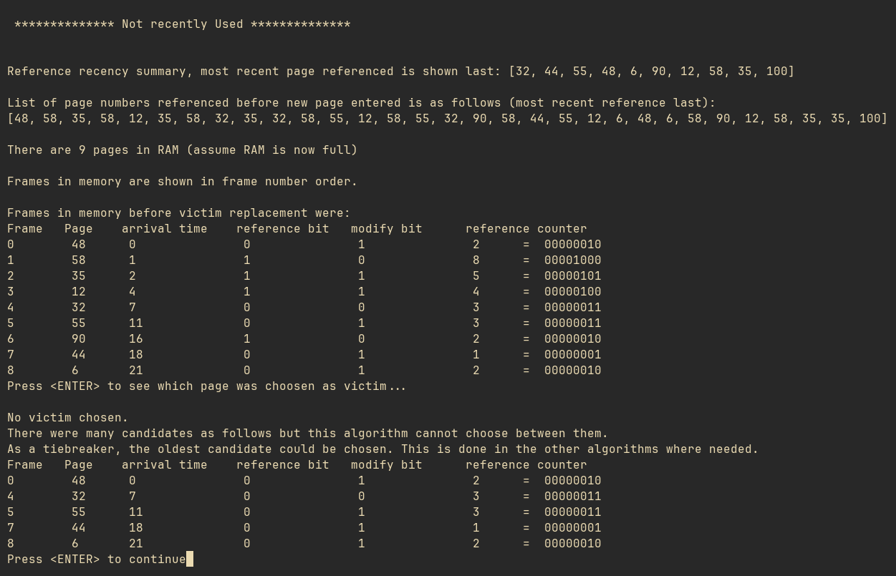
- As you can see below No victim was chosen because there were many candidates with a reference bit of 1, from here the program chose the oldest candidate as a tiebreaker.
- Advantage:
It is easy to implement,reference bit in page table periodically cleared.
- Disadvantages:
There may be many pages with a clear reference bit but there is no information available to choose between them so it defaults to the oldest candidate,making it at times similar to FIFO
It has no way of knowing which page has been referenced the least, ideally we would look to get rid of the page that has been least recently referenced

c. LRU (Least recently Used)

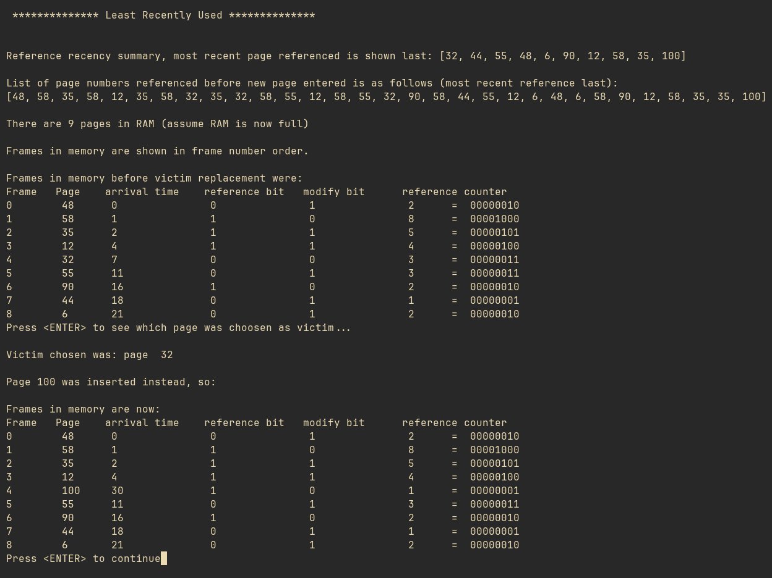
- As seen below, the page32, which has not been referenced or modified (ie 0 0) is the victim page. This is because it is picking the page that has been idle for the longest time
- The main advantage of this is that it uses the recent past as an approximation of the near future to guess which page will be needed least.
- However it is difficult to implement given that for for every memory referenced, the page referenced must be found in the linked list, deleted from there, and inserted at the end of the list which may take a significant amount of time and memory.

d. LFU (Least frequently used)

- Least frequently used keeps a binary counter of how often a page is referenced in memory.
- As seen below 44 was chosen as it only had a value of 1.
- The main advantage of this is that it is easy to implement and counter simply records the number of references.
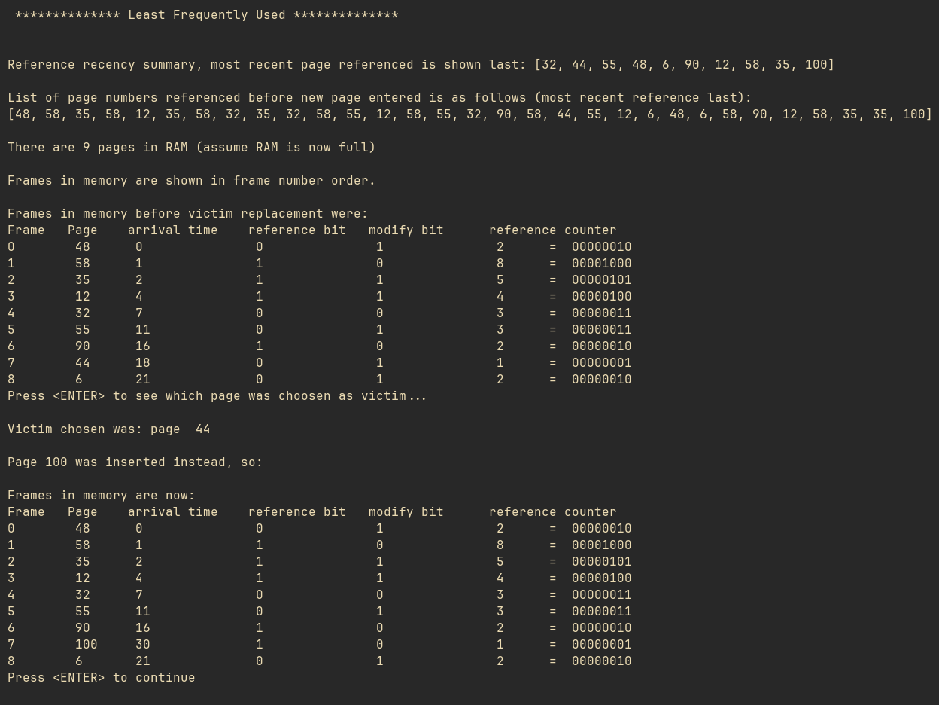
- However, it only takes frequency into account, ignores recency so a page that was used a whole load ages ago, will be kept whereas a new page that has just started may be the next victim.
e. LFUD (least frequently used with decay counter)

- This algorithm works very similarly to LFU however it divides the reference count periodically by two. For its victim it chooses the page with the lowest decayed reference counter
- Advantages:
- Again easy to implement
- Deals with glory pages
- Disadvantage:
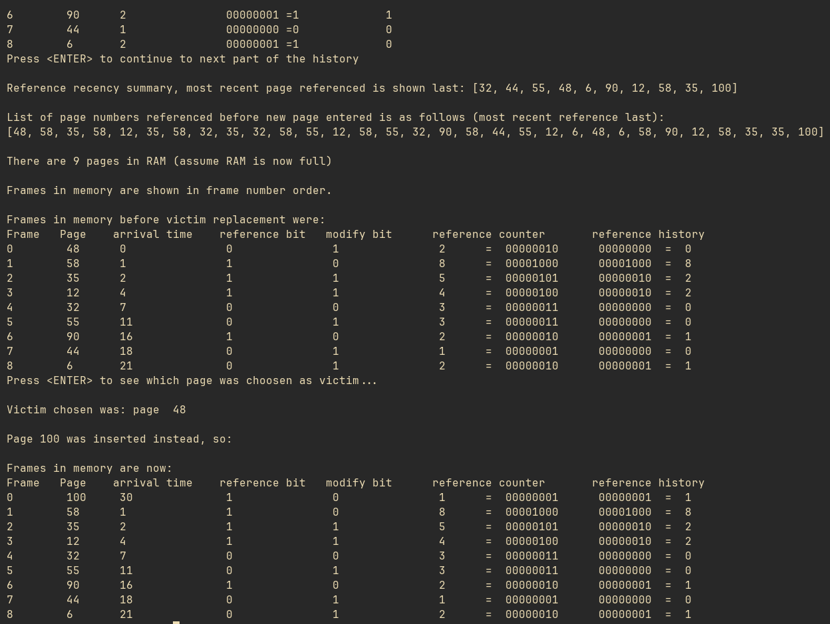
- Recent arrivals have again had little chance to rack up references and may be booted out.

f. LRUA (Least recently used aging)

