Lab Exam practice

1.

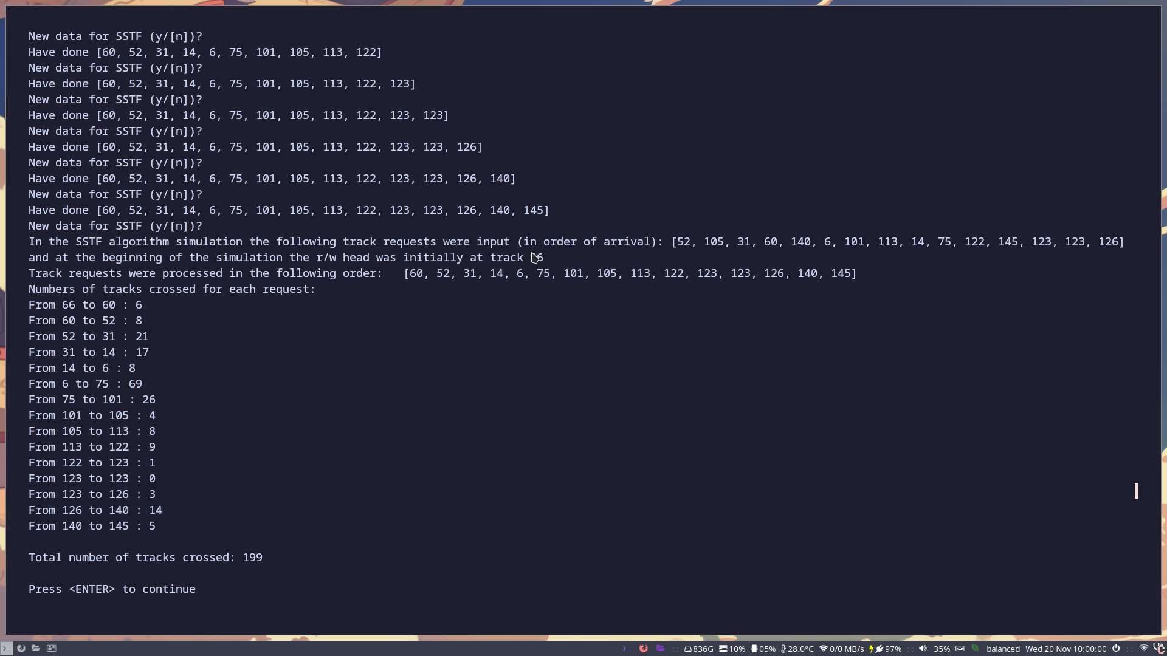
As we can see above after inserting various different data points, the disk scheduling algorithm starts at 66 as intended and moves from there to the closest point. It moves from 66 down to 60 and the next closest is 68 and so on. It did so as these were the closest tracks on the disk to where it was at the time. Although 6 to 75 took 69 track crossings, 75 was the closest track.

2.
C scan as a disk write scheduling algorithm scans our disk surface over and back continously until it has scanned everything. However it only services requests in one direction. Similarly to shortest seek time it always choosest the closest job at the nearest track however only in its current direction, for example if it was 199 to 0 and we started at 198 but the nearest job is 199 and the next nearest is 75, it will have to go down to 75.
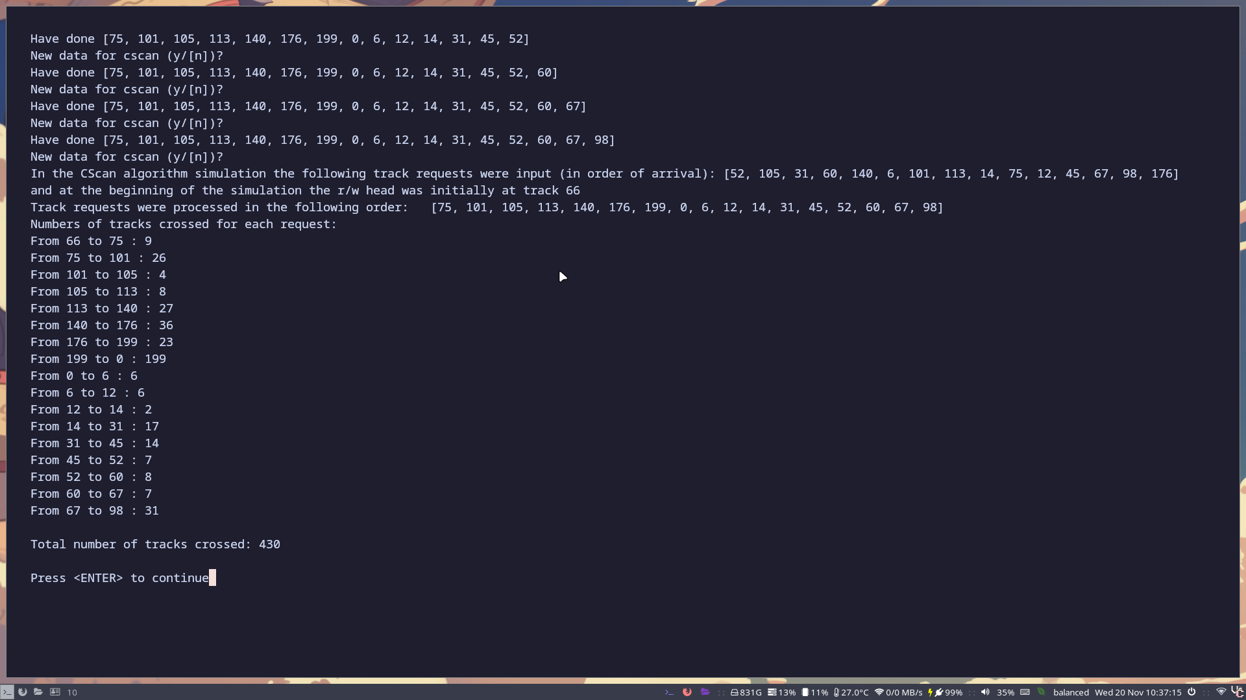
As we can see above after adding our data and selecting the direction of our scanning, the algorithm begins in the upper direction. We start at 66 and it would be much closer for us to go down to 60, since we are scanning from 0 to 199, we must go up to 75. After we hit 199, it brings us back down to 0 and then we begin scanning up again and it resembles shortest seek time first.

3. Flook

F Look is a disk scheduling algorithm which takes a spin on C scan/look,

