Re Assignment 4 Daniel Soden – Replication

Task
1.
I began using mkdir to create my Cork replica set and within that replica set I put my 5 nodes for the PSA architecture.
Then I ran the command below for node 0 to node 4 at each incremental port.
Here are one of the nodes running:
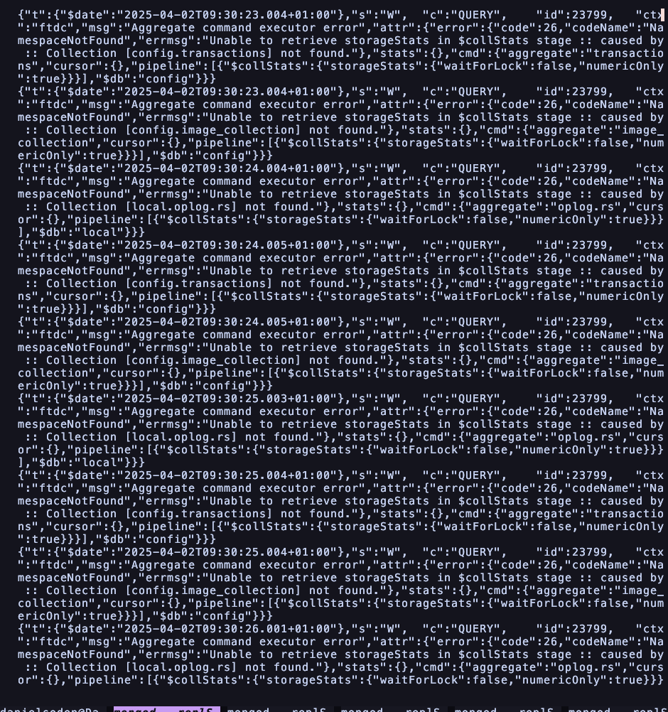
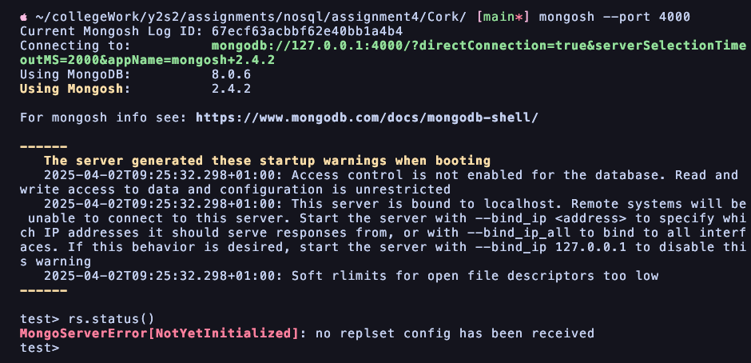
Then I entered the mongosh at the port of my designated primary node (node0)

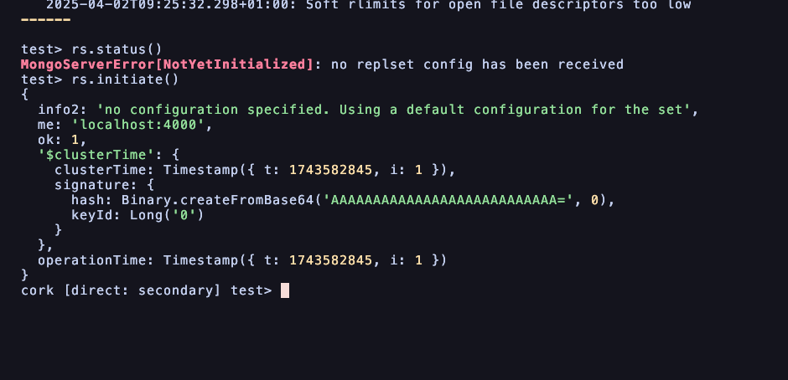
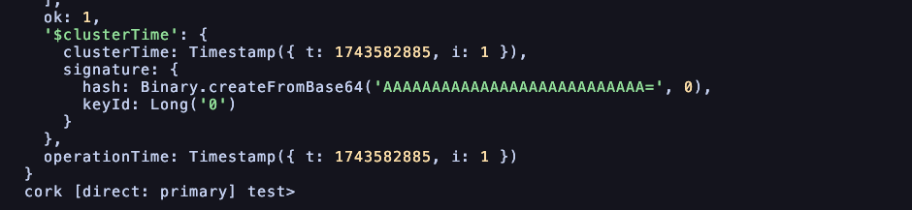
We have now designated it as the primary node after running the rs.status() command.
Then we added a slave of node1 node2 and node3 as then we can have node4 as the arbiter.

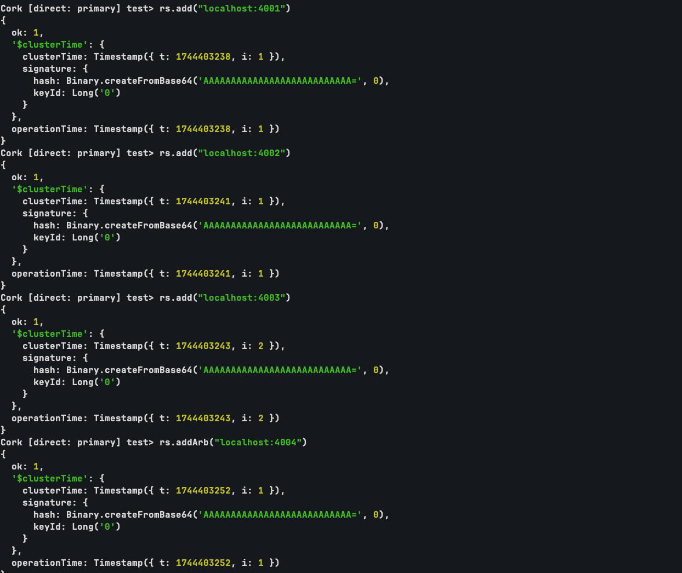

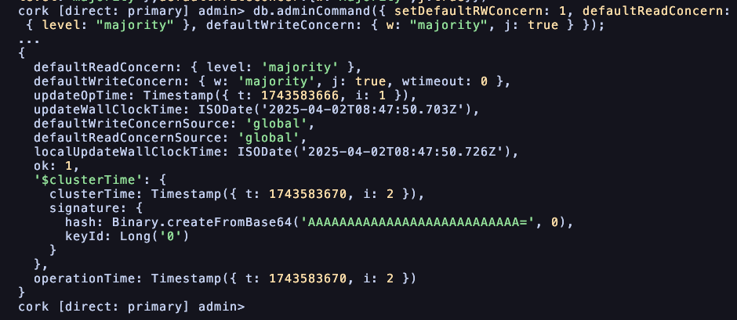
Setting up arbiter:
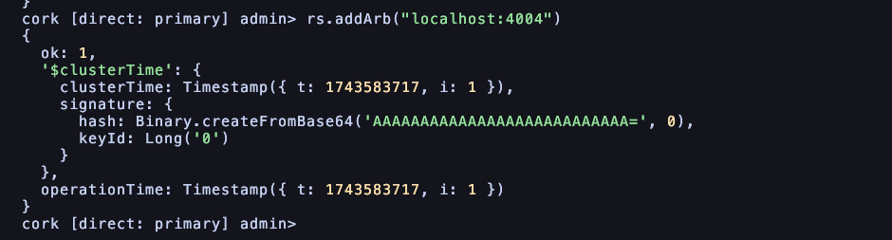
Status displaying all of the set up nodes:
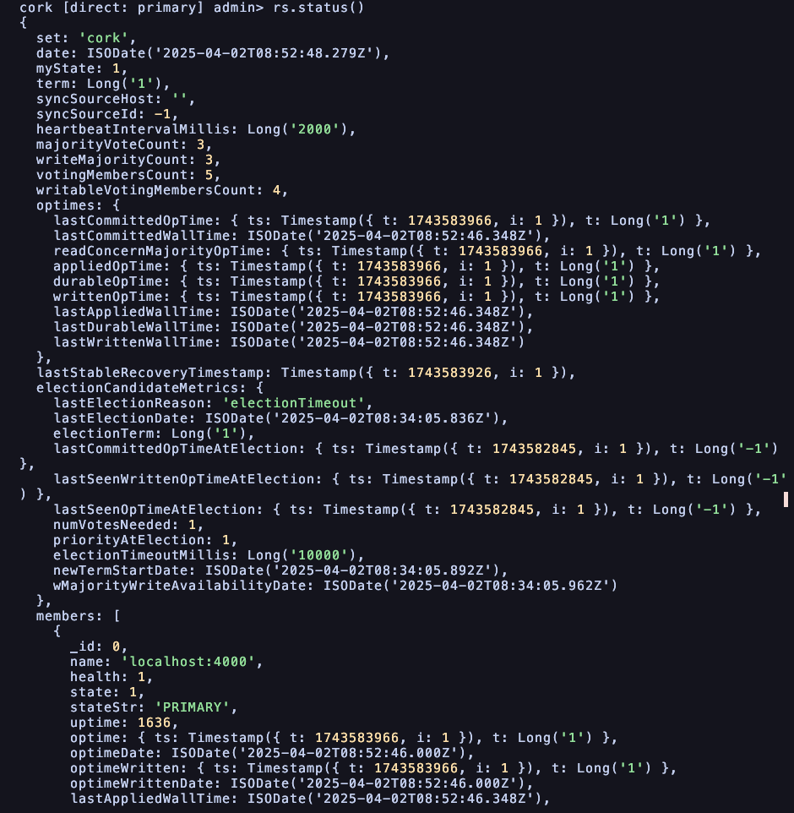
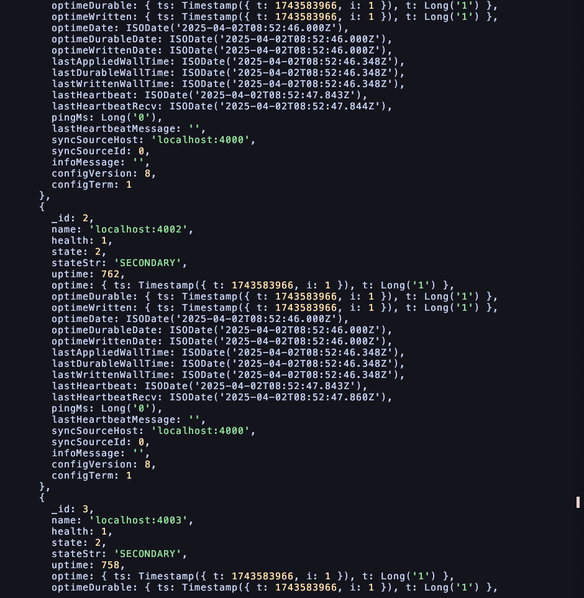
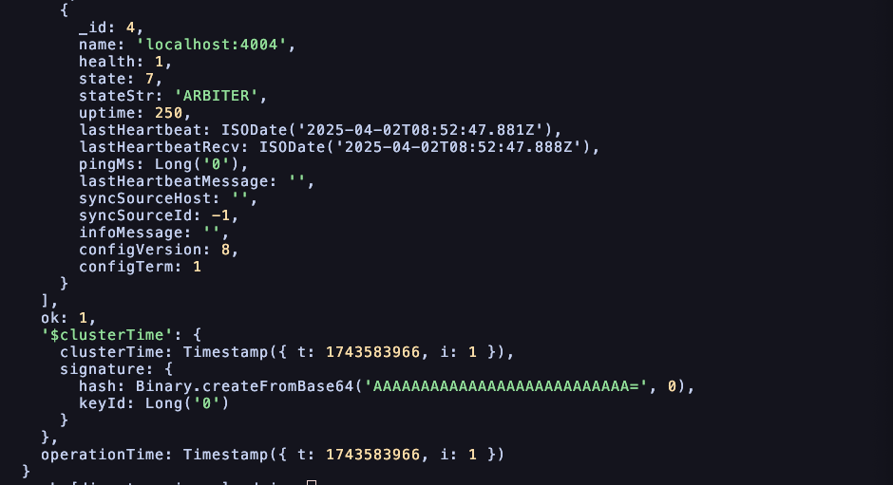
Importing data:
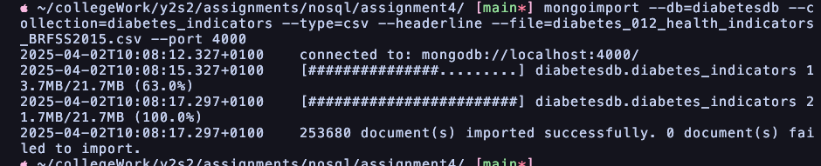

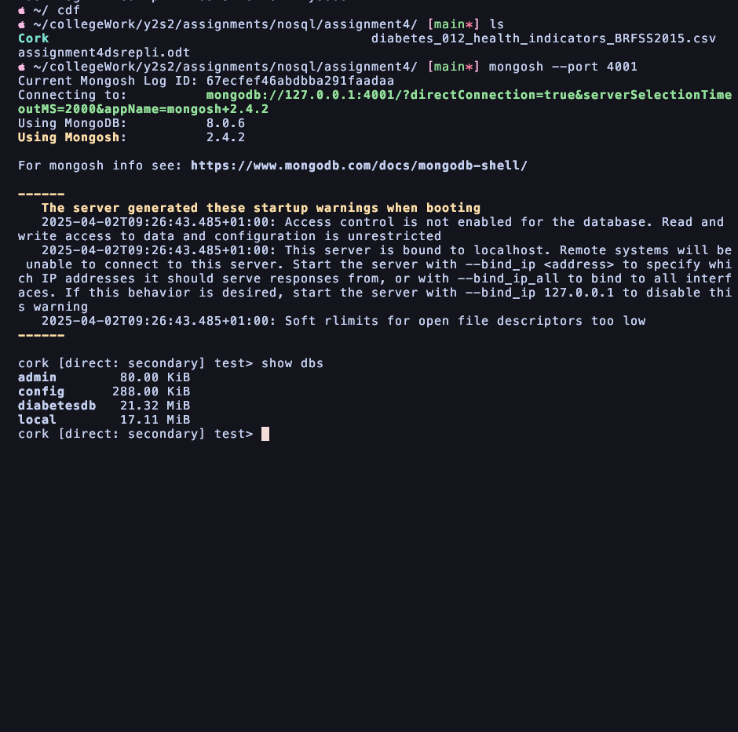
Displaying successfully imported database.
2.

To test our automatic failover what we’ll do is stop the process of one of the nodes
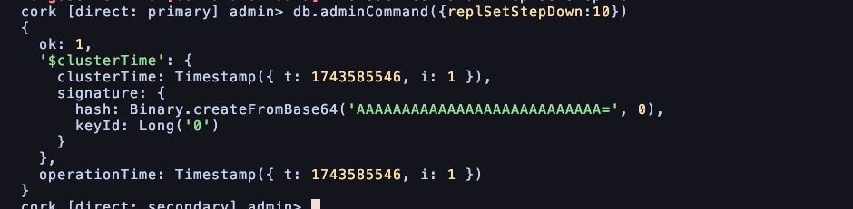
This takes down the master for ten seconds. Notice as well we are now in the secondary directory.

Now as you see below, the master is now localhost 4001 whereas original 4000 was the master
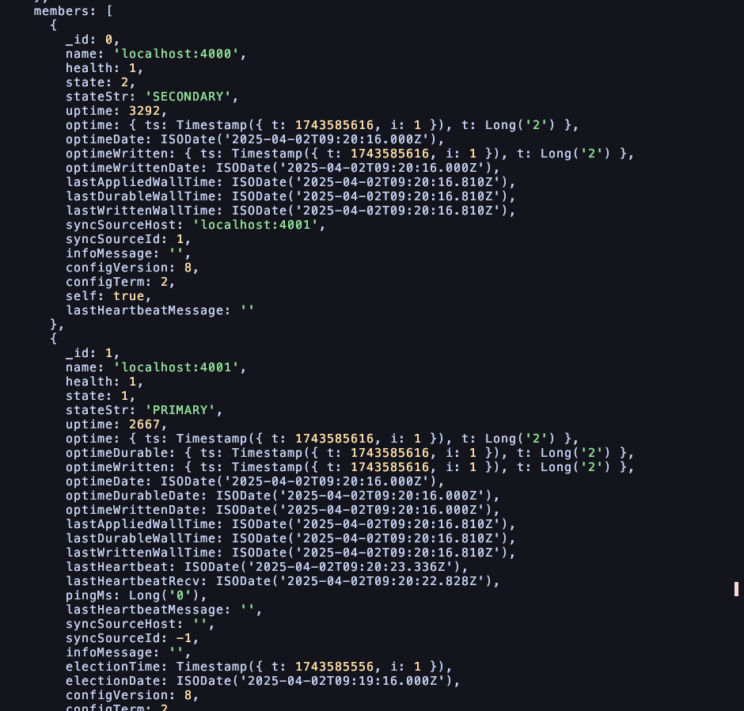
The master slave architecture acts in such a way that if a primary node fails, one of the slaves take over as the master to manage our read and write operations through the arbiters voting process. Now let’s test if we shutdown one of the slaves. Using the db.adminCommand({shutdown:1}) command

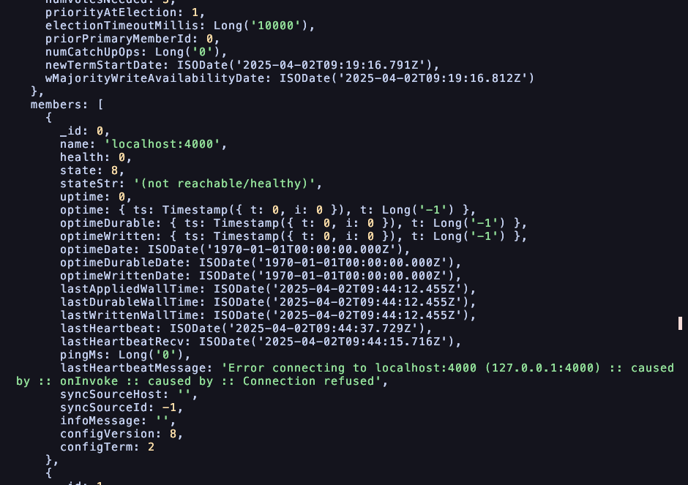
Notice the health of this node is now 0 and we see the last heartbeat message being an error connecting to the node.

Shutting down arbiter:
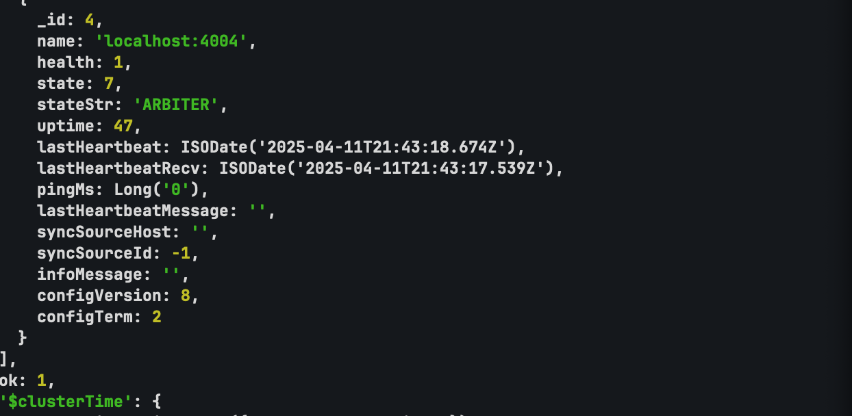
After shutting down, it stops the mongod process is halted and we need to manually start it again given its read only at this point.

Overall we can see that this mongodb replica set behaves where we see if a primary goes down, an election is held with the arbiter which determines the new arbiter. However if a secondary node goes down a certain amount of manual intervention is needed, the read and writes of the primary node are protected but the slaves may not be as protected.

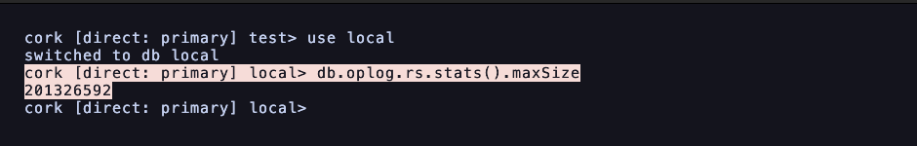
We are currently looking at a max oplog size of only 201.33mb or 0.2 gigabytes, a far cry from 25 gigs. To increase this command we need to run on each oplog:

cork [direct: primary] local> db.adminCommand({"replSetResizeOplog":1,size:Double(25000)})
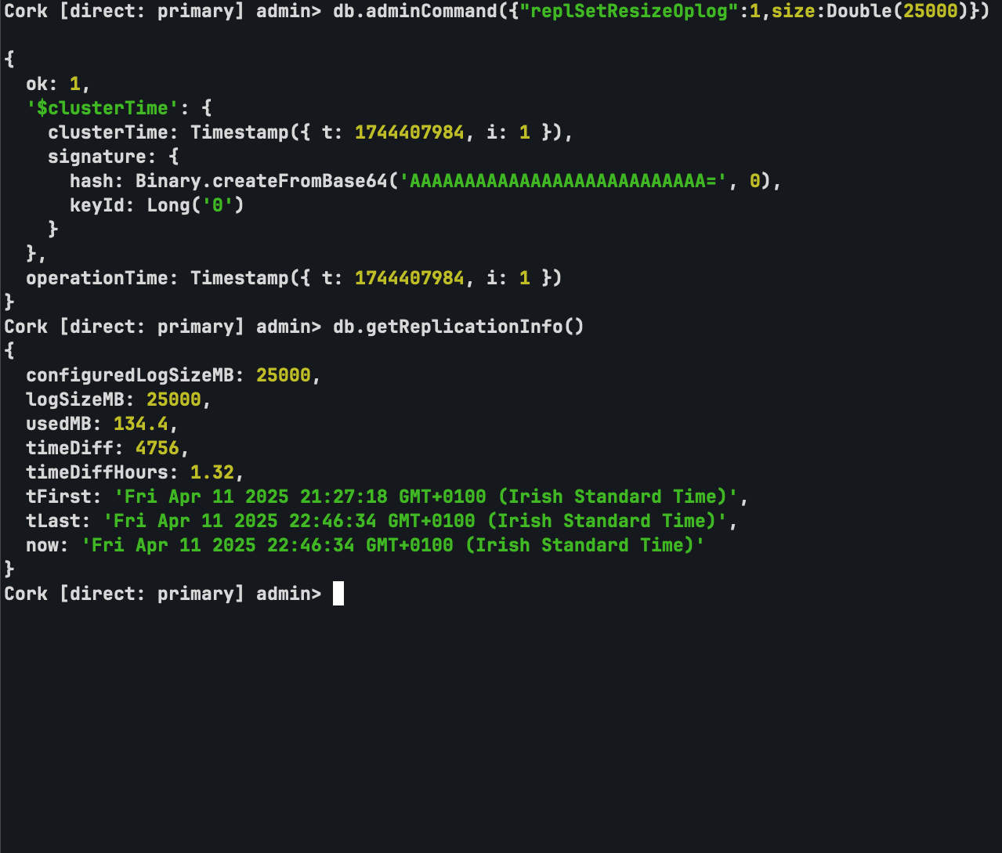

3.
How do you verify and globally reconfigure the write operation so that it is completed with two data-bearing members before returning?
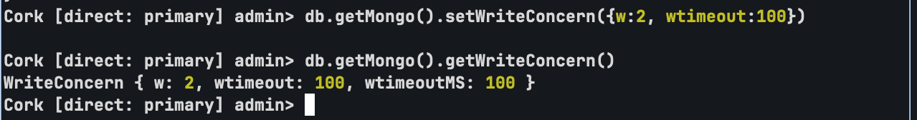

As seen above using the getMongo.writeConcern command, I have set it so that it is completed with two different data bearing members before returning.
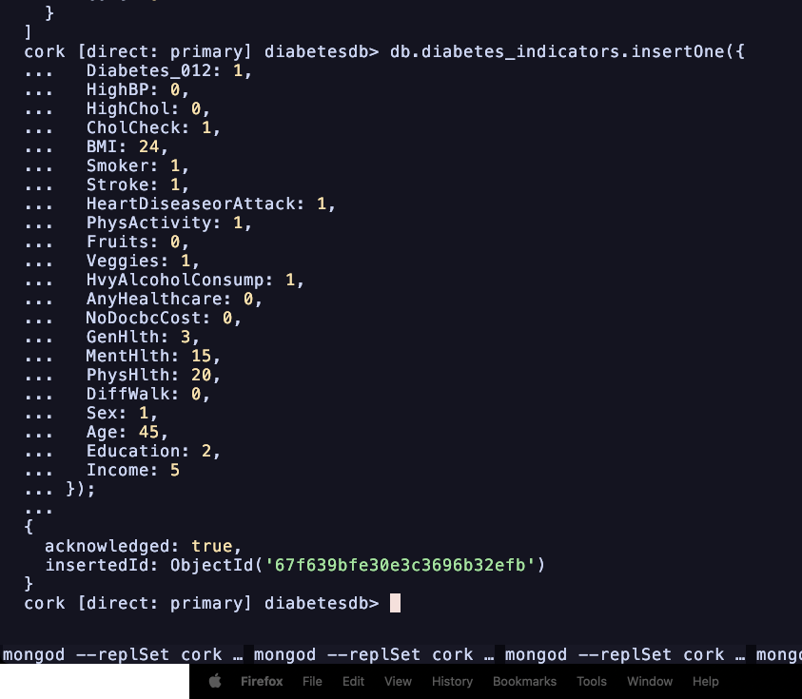
How do you reconfigure the read operation so that the replica set returning the most recent data when we perform a read operation?
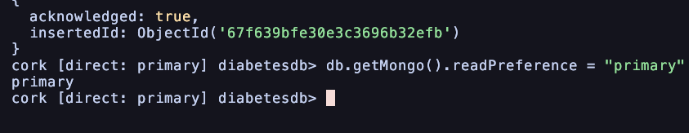

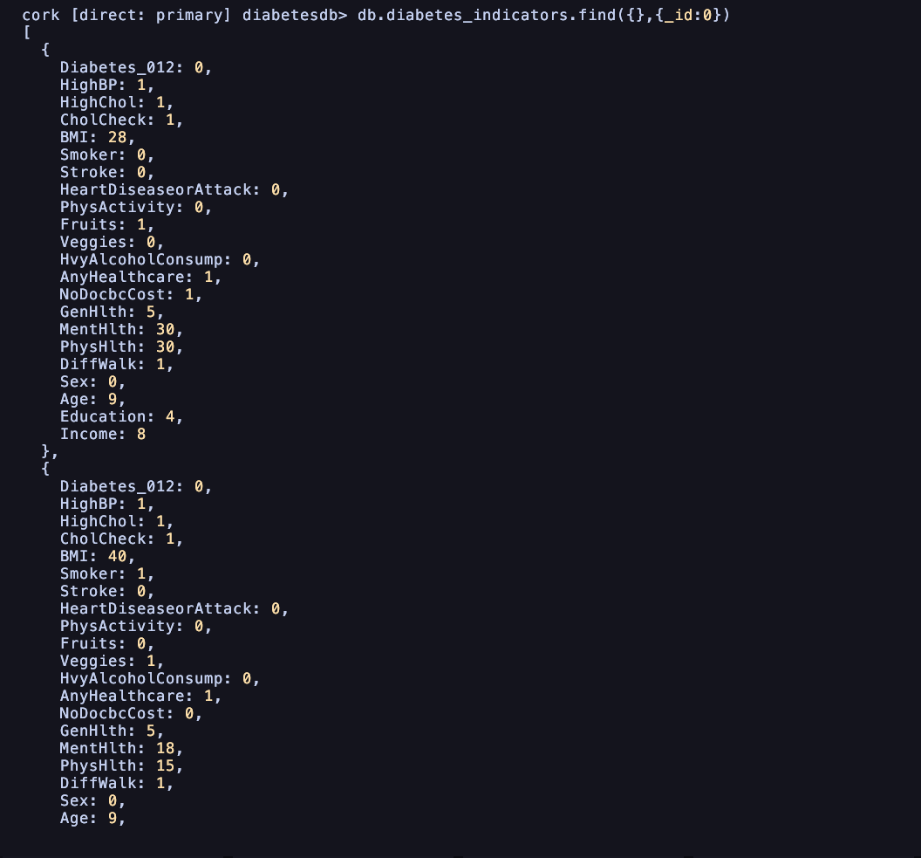
4. Supporting geographically local read operations in this replica set:
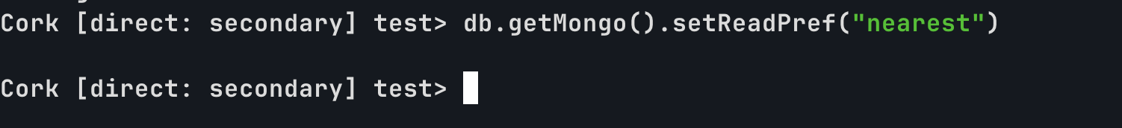
5.

To remove the replica set for this dataset i first need to remove the individual nodes. I will start with the arbiter node and then the secondary and finally the primary node.

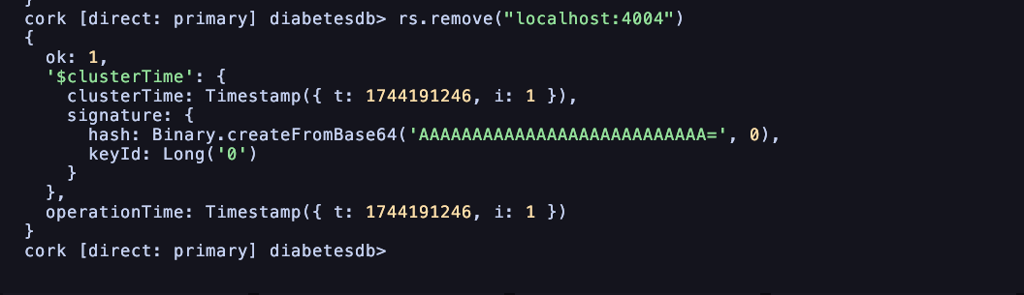
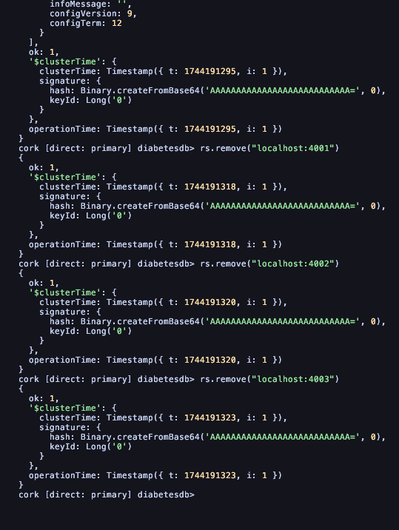
Finally I step down and shut down the server to the primary node:
