Daniel Soden Probability And Statistics 2025 R00247215 – Continuos Assessment 2

1 Hypothesis test based on the following data.

An introductory statements:
Variables:
μ: 3000g
σ:500g
Ho (Null hypothesis): μ <= 3000g
Ha (Alternative hypothesis): μ > 3000g

Exploratory analysis:
1. Given a claim, state the null hypothesis 𝐻0 and the alternative hypothesis 𝐻𝐴 (i.e., alternative to 𝐻0) and express them in symbolic form.

H0: μ <= 3000g – The null hypothesis is that the mean is still either 3000 or less than 3000.
HA: μ > 3000g – The alternative hypothesis is that the mean is greater than 3000.

However before proceeding we need to ensure we are performing the correct type of hypothesis test. There are two tailed and one tailed hypothesis tests and in this particular scenario we are looking at if it is greater than 3000 or if it is equal to or less than 3000. Therefore we would be working with a one tailed hypothesis test. In particular a right tailed test.

For visualisation purposes, I have used R to create a histogram representing its normalised curve:
As we can see below, although this isn’t enough to draw any concrete conclusion, we do see that the baby weights most fall within 3000-4000g, potentially supporting the null hypothesis.

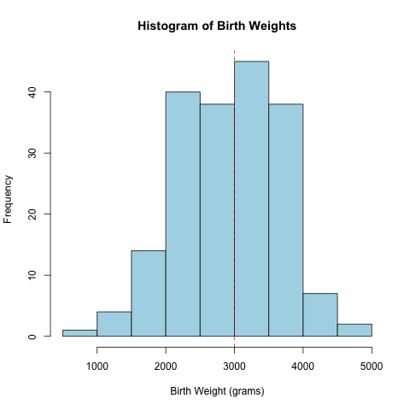

Figure 1.1 – Histogram of birthweights overall

2. Calculate the z-test statistic.

For our one-tailed hypothesis test examining if the mean birth weight in this study is greater than 3,000g, we will use the following formula to calculate the z-test statistic (also known as the z-score):
​​
Where:
- xˉ represents the sample mean birth weight calculated from the data in our study.
- μH0​ is the hypothesized population mean birth weight under the null hypothesis (3,000g).
- σ is the known population standard deviation of birth weights (500g).
- n is the number of babies in our sample.(189)

By plugging this formula into a calculator this is the result:

3. Given a significance level, identify the critical
value(s).

Given n >= 30, we will use the significance level of 0.05. Since this is also a one tailed test, we will be seeing if the calcualted p value is greater than 0.05. If that is the case then we can reject the null hypothesis.

Through a look up in the Z-table of this 1-0.05, we can see the answer of 1.645 as the critical value and from here we can look at the comparison between that and our z-test value.

4. Compare test statistic to critical values and state
conclusion of hypothesis test.

Given that -1.523... is less than 1.645, this means we fails to reject the null hypothesis

Conclusion:

Based on the sample data we do not have enough evidence at the 0.05 significance level to conclude the mean birth weight greater than 3000g.

2. Estimate of birth weight for the population with a 95% level of confidence

Given this sample is analysing the mean birth weight, we will use a 95% confidence interval test on the mean.
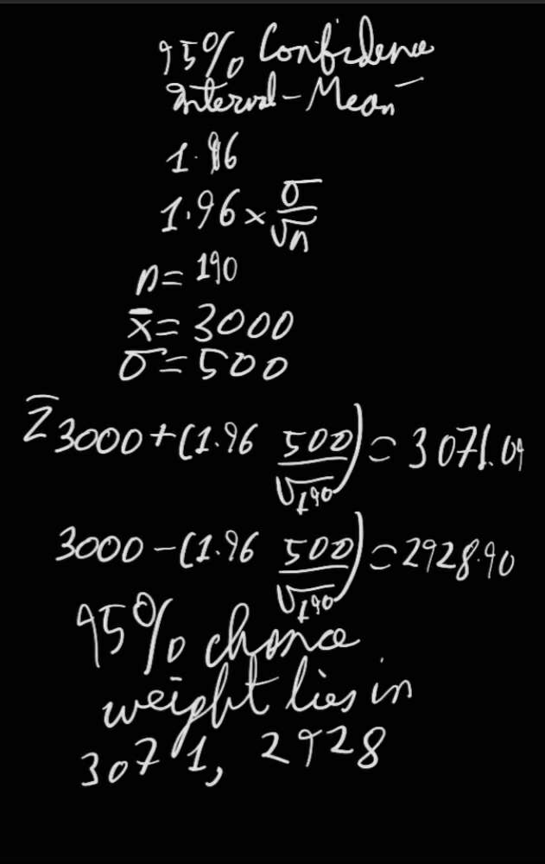
For calculating this I will use some R seen in my script as a means of verifying my calculations but most of it will be done by hand as seen above and to confirm these calculations.

This means there is a 95% chance that the mean is within the means of [2928,3071] roughly.

3. Perform a suitable test to determine if smoking is associated with lower birth weight.

Introduction:

A suitable test for determining if smoking is associated with lower birth weight is a two sample z test as the sample group of smoking mothers is greater than 30. Performing this test will allow us to see if the two populations are roughly equal ie in this situation, if the birth weight of children is affected by their mothers smoking.

Given this is another hypothesis test we need to clarify our null and alternative hypothesis.

H0 (Null hypothesis) = Motherly Smoking is not associated with lower birth weights
HA (Alternative hypothesis) = Motherly Smoking is associated with lower birth weights

X1 = Mean baby weight of Smoking mother
X2 = Mean baby weight of non-smoking mother

H0 = x1 >= x2
HA = x1 < x2

For collection of data we have all mothers who have the smoking variable set as 1 and those who don’t.

Exploratory Analysis:

Before we go into conducting this test, we need to clarify what variables we need. The formula for the two sample t test is as follows:

From here we know we need the means of both the samples, their standard deviation and n1 and n2 being the amount of elements in the samples.

N1 = 74 – Smoking mothers
N2 = 115 – Non-smoking mothers

Then we also need their respective means (calculated with R):
X1 = 3055.69
X2 = 2771.91

And finally the standard deviation of each sample group:

σ1 = 752.65

σ2 = 659.63

With these values we can finally calculated our z score which comes to (Done with R):

z = 2.729886...
z ~ 2.73

Some additional data includes (all calculated in report):

IQR Smokers babies: 875.25
Range Smokers babies: 3529
IQR Non-smokers: 1112.5
Range non smokers: 3969

Figure 3.1: Histogram showing the distribution of baby weight of non smoking mothers

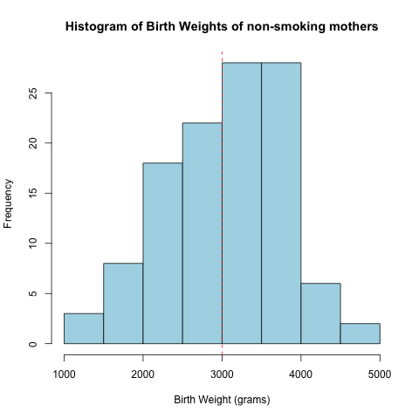

Figure 3.2 – Histogram for birth weights of babies with smoking mothers

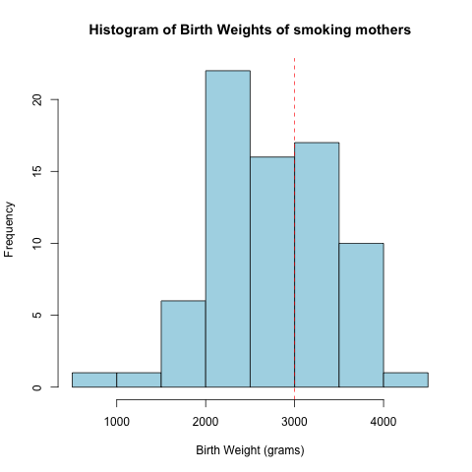

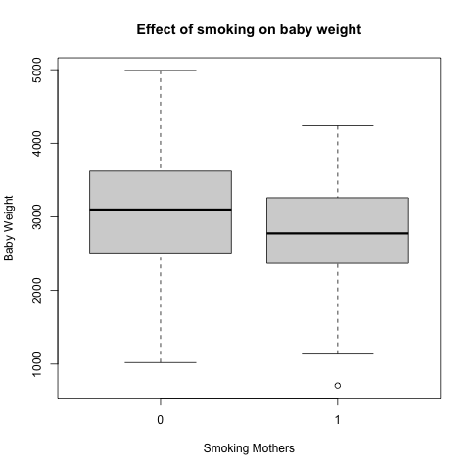
Figure 3.3 – Box plots demonstrating the effect of smoking on baby weights

Figure 3.4: QQ Graph of smoking mother baby weights

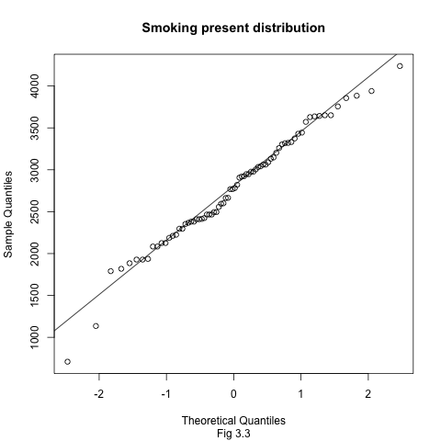

Figure 3.5: QQ graph of non-smoking mother baby weights:
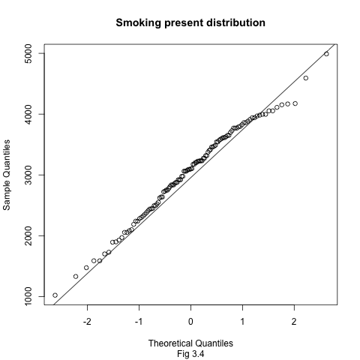

Critical value:
For our critical value in terms of a two sample Z test we need to get the p value from the Z table:

Through a two tailed z table lookup, we get the p-score of 0.0063 which is also supported in my R script.
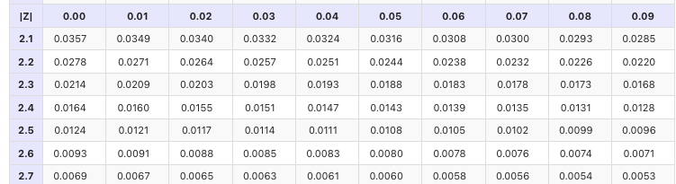
Conclusion:

Given it is true that 0.0063.. is less than 0.05, we now have enough evidence to reject the null hypothesis that a mother smoking does not effect the birth weight of the baby.
This can be supported in my box plot above where we have wider ranges between the baby’s min and max weight when the mother doesn’t smoke.

4. Perform a suitable test to determine if hypertension is associated with lower birth weight.

H0 (Null hypothesis) = Motherly hypertension is not associated with lower birth weights
H0 (Alternative hypothesis) = Motherly hypertension is associated with lower birth weights

Introduction:

A suitable test for determining if mothers having high blood pressure is associated with lower birth weight is a two sample t test as the sample group of hypertension stricken mothers is less than 30. Performing this test will allow us to see if the two populations are roughly equal ie in this situation, if the birth weight of children is affected by their mothers having high blood pressure.

H0 (Null hypothesis) = Motherly Hypertension is not associated with lower birth weights
HA (Alternative hypothesis) = Motherly hypertension is associated with lower birth weights

X1 = Mean baby weight of Hypertension mother
X2 = Mean baby weight of Hypertension mother

H0 = x1 >= x2
HA = x1 < x2

For collection of data we have all mothers who have the smoking variable set as 1 and those who don’t as 2.

Exploratory Analysis:

Before we go into conducting this test, we need to clarify what variables we need. The formula for the two sample z test is as follows:

From here we know we need the means of both the samples, their standard deviation and n1 and n2 being the amount of elements in the samples.

N1 = 12 – Hypertension mothers
N2 = 177 – Non-hypertension mothers

Then we also need their respective means (calculated with R):
X1 = 2536.83g
X2 = 2972.2316g

And finally the standard deviation of each sample group:

σ1 = 917.36g

σ2 = 709.4418g

Some additional data includes (all calculated in report):

IQR Hypertension babies: 1457.5g
Range Hypertension babies: 2655g – More narrow range for babies with mothers with high blood pressure
IQR Non-hypertension: 1063g
Range non-hypertension: 4281g – Wider range of weight for babies with mothers with non-high blood pressure

With these values we can finally calculated our z score which comes to (Done with R):

z = 2.0179...
z ~ 2.01

Finally to get our critical value, we needed to get the p value for this two tailed t test where t=2.017 and degrees of freedom are 187.

To get that we had to retrieve the degreees of freedemon being the two sizes – 2 and the following formula:

This gave us a p value of 0.04503196.

Conclusion:

Given it is true that 0.045.. is less than 0.05, we now have enough evidence to reject the null hypothesis that a mother having high blood pressure does not effect the birth weight of the baby.
This can be supported in my box plot below where we have much more drastic ranges between the baby’s min and max weight and in particular that the median baby weight is significantly lesser than meaning it is statistically significant.

Figure 4-1 – The effect of a mother with hypertension on the baby.
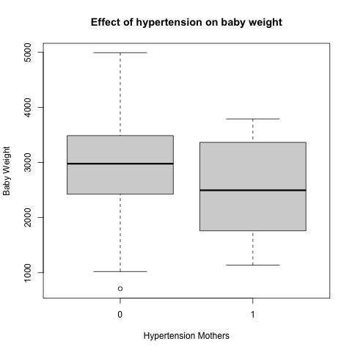

Figure 4-2 QQ graph for baby weight of mothers with high blood pressure

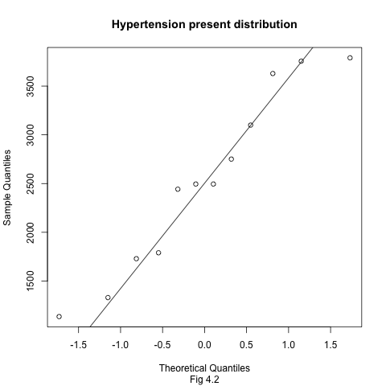

Figure 4-3 – QQ Graph for baby weight of mothers without high blood pressure

