Daniel Soden OOP Report – Computer Shop
Previous Project Reflection
In our last semester studying Object oriented principles for our final project I decided to create a computer shopping system. In this project using the concepts we had learned I implemented various fundamentals Object Oriented feature implementations such as abstraction, inheritances, interfaces,genericsd and much more.
Despite my shortcomings in terms of the deadline and my overall grade of 29/50 I was still quite satisfied with my work and was proud of myself for creating a full blown system in which users signed up , products were registered and a purchase was made. All this was entered into a normalised relational database using SQLite ad in this process I learned a lot about jar files, the jdbc and execute sql statements in java.
My main shortcomigs included but weren’t limted to the time it took for me to complete this project, my overuse of static methods and overall lack of understadning of how to effectively use objects from a database (serialization, getters,setters etc).

Project Stage 1
For the first stage of our Javafx project, the concept was simple being a continuation on the system we had developed previously therefore the majority of the code should be completely portable. However given my decision to try out sqlite, it would add quite a lot of complexity to the system given the database was already highly normalised and this stage only wanted the design and basic ability to access saved customers. Ultimately I decided to start the system from scratch and build upon what I learned previously.
UI/UX Design
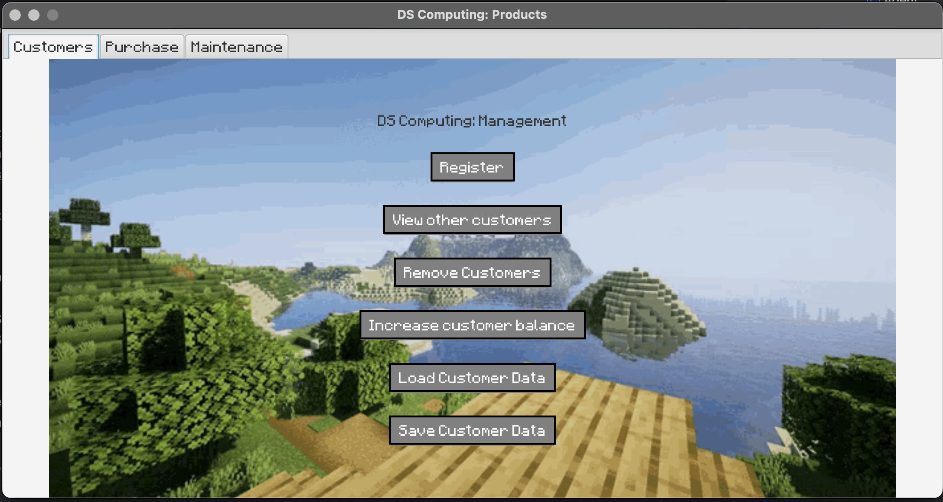

In retrospective, given this app is a desktop application I would have opted againist changing the content of the scenes for every opertation. This looked great in my first stage and had little to no issues apart from jsut ensuring I don’t reload my data upon switching Vbox, later along with the tabpanes I came across major issues.

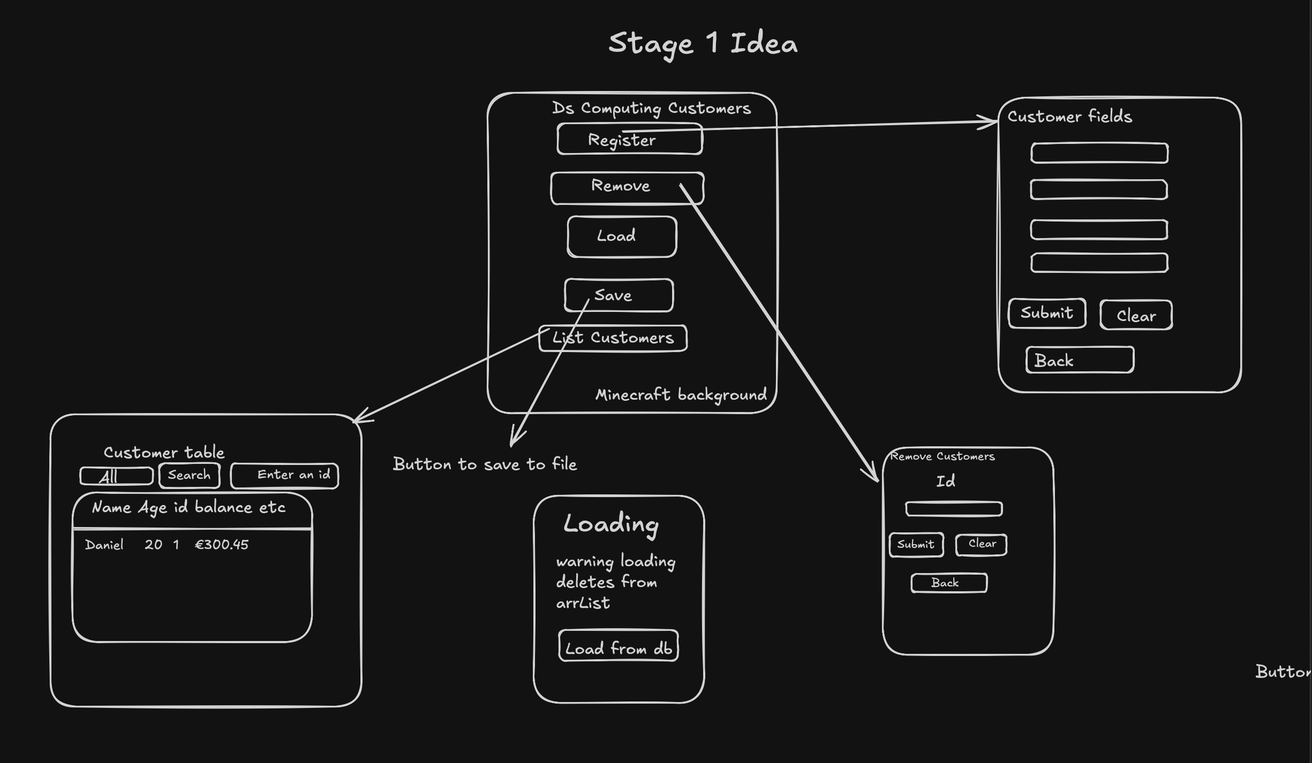
My main idea for the ui was simply the way that minecraft menus are structured given its another product programmed completely in Java, i thought it would be a nice nod to it. So for my background rather than worrying about css colours and layouts, I just had the background be the minecraft menu background.
Despite the simplicity I do think the way I structured it was really effective in that all elements were right where you expected them to be and useful UX features like clearing and savings as a button
UML Diagram
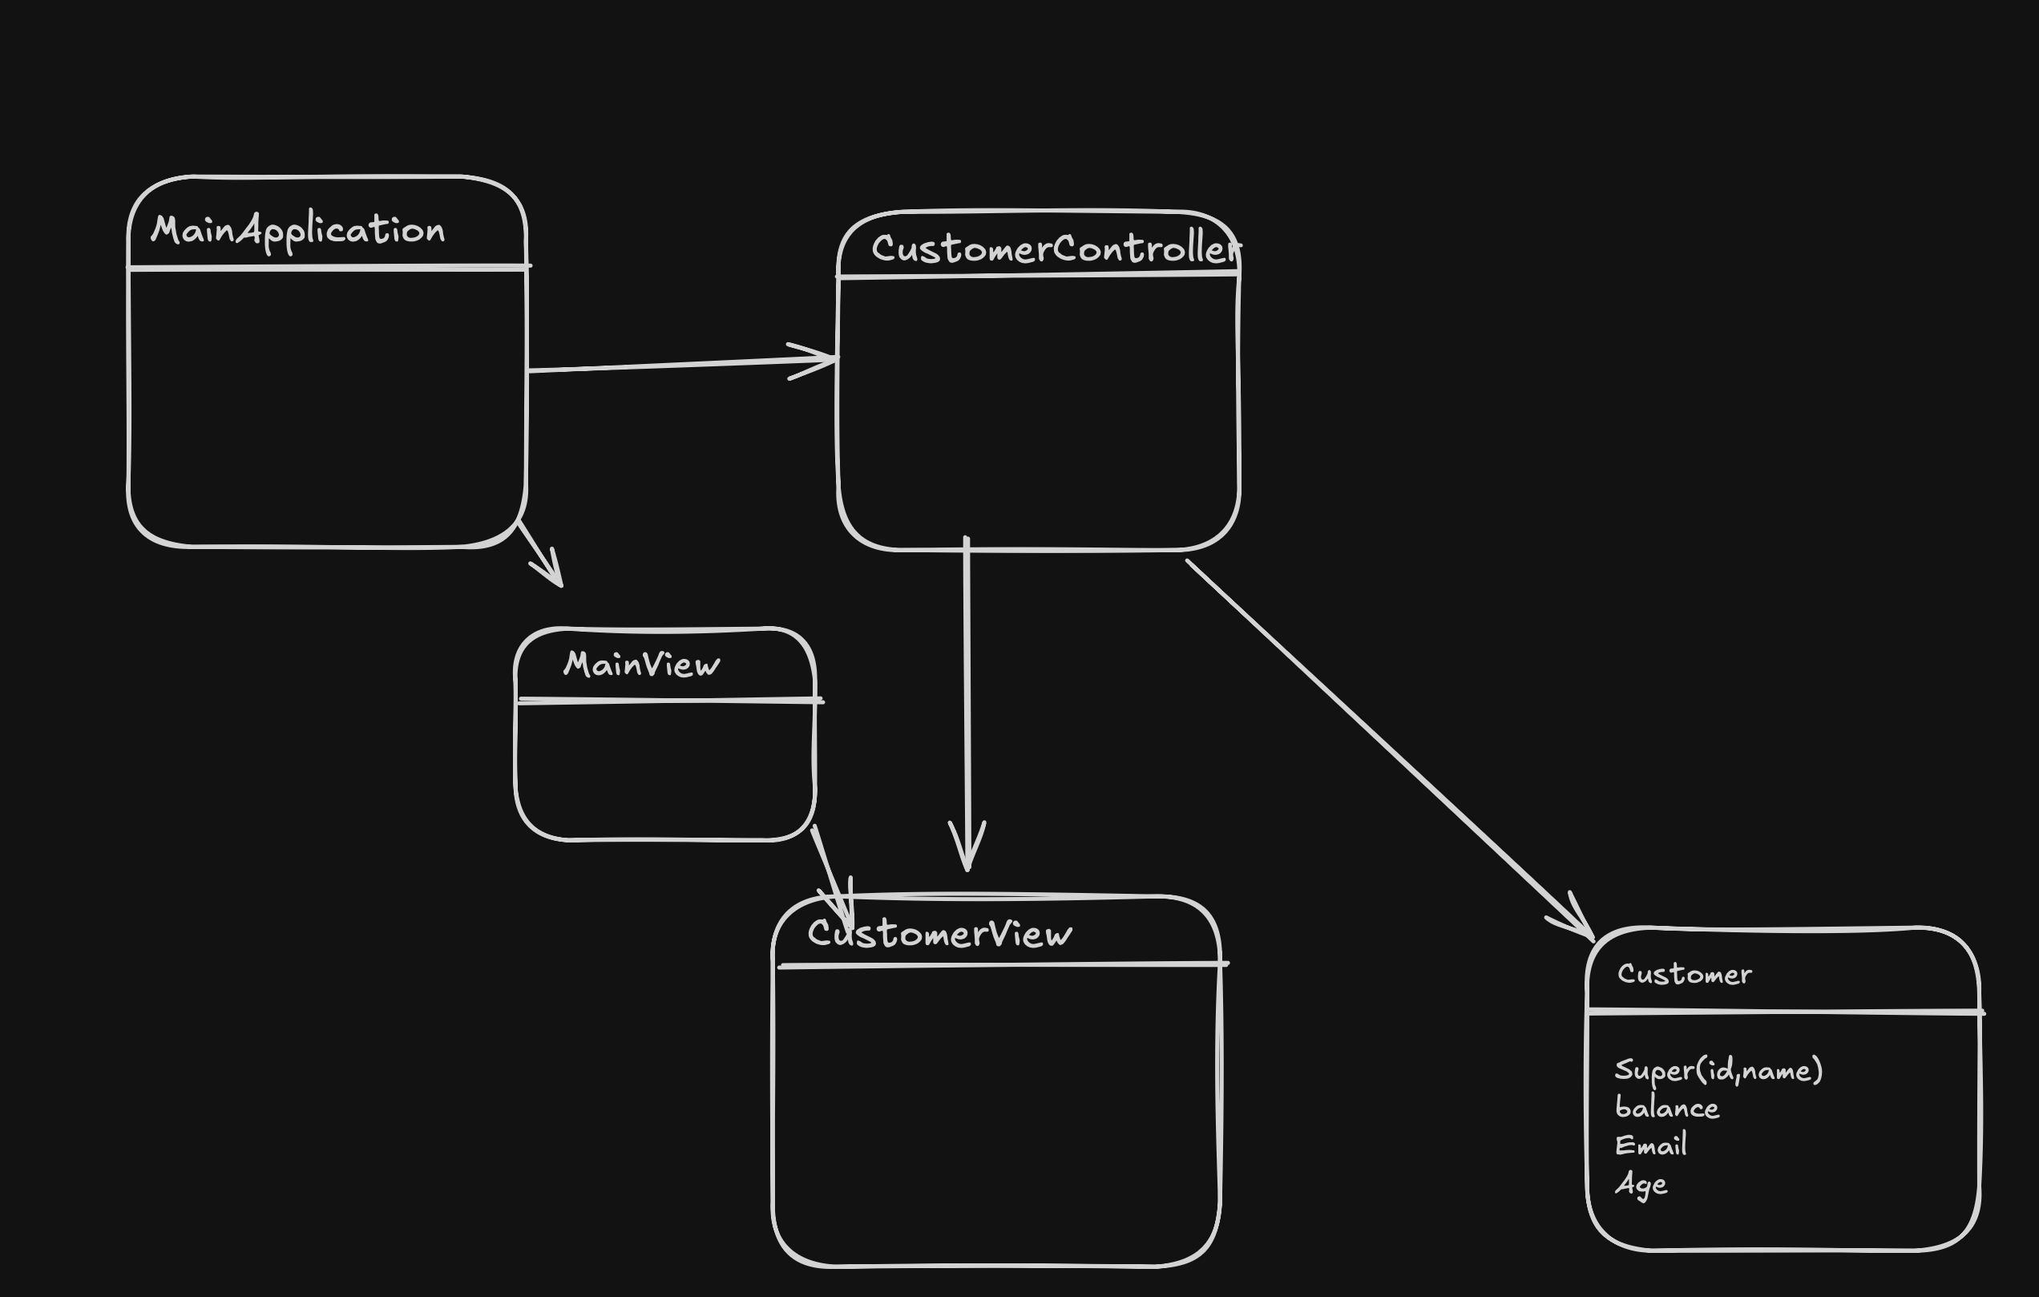
Core functionality
For this stage we were really just testing our CRUD implementation skills in which I found it quite easy to add customers, delete them by their given ID which they inherit from the agent class (Parent to both itself and product and only contains the field name and id), view customers in a table, load customers in from the original database and save these customers with a button.
Given I had used sql in the original project, it did take a bit of learning to adjust to reading from text files but it was actually quite easy in the end. I found using an ArrayList as recommended really handy as for deleting customers as each time I saved, all we had to do was iterate over the Arraylist and resave what was there now, including after deleting data
Although in the spec we were recommended to use a textarea to display the cutomser data, to me a table made a lot more sense as this system may have hundreds of customers and scrolling through a table is much more tailored than a text area with a simple side scroll bar
For deleting customers it is done purely by ID in this stage as we hadn’t been introduced to combo boxes yet. It just uses the method of removeif on our customer arraylist and once someone with that id is found, they are removed from the arraylist.
Customers are automatically loaded in upon startup however if you need to reload the customers once the application has started,say if you added some customers you don’t need, you can also do that in the load page, in hindsight like save this didn’t need it’s own page it could have simply just been a button .
The save button does exactly what’s said on the tin, call the save function from the controller and saves all customer data.
Project Stage 2
UI/UX Design
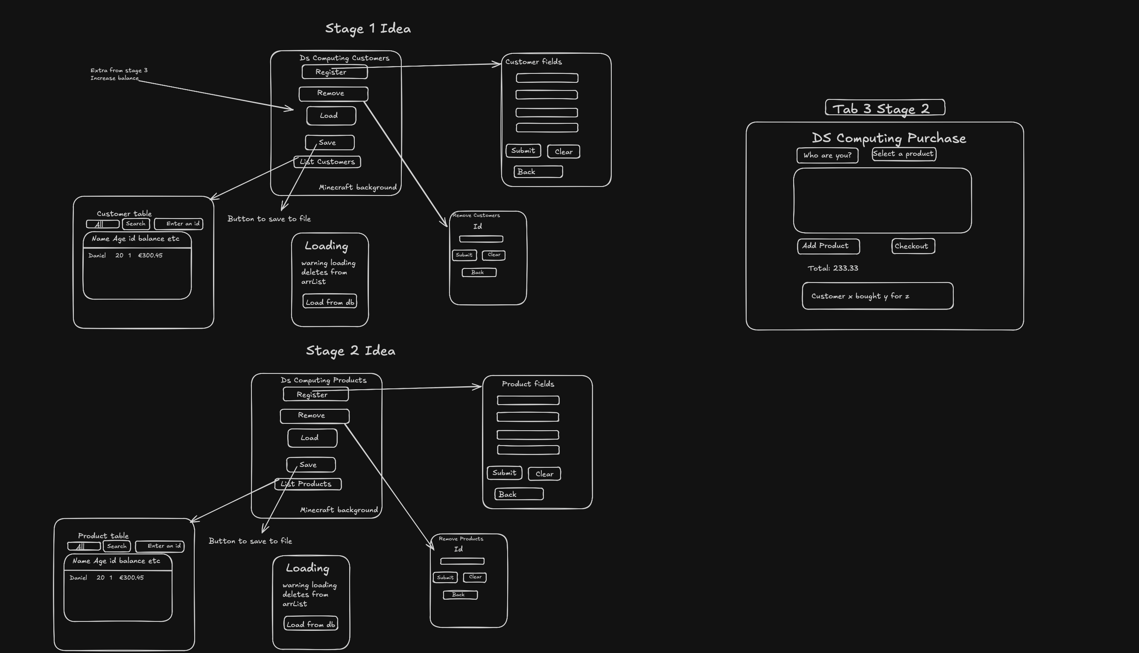
For the ui and ux of stage 2, we had to implement a tab structure in which the first tab would be our original content from stage 1. Surprisingly for this stage apart from adding an increasing balance option in the customer page, tab 1 remained entirely the same, I required this purely because to purchase an item after someones balance has been decremented significantly, a new customer would need to be created.
The third tab is near identical given all it is, is the same CRUD operations except with different fields for products. This tab is more so like the maintenance section for administrators where they add more products to the system, remove other products, view the current stock of products and search for specific stock.
For our third tab, a major revelation in this section was the usage of combo boxes as drop down menus, as it really improves the UX of not needing to know off the product ids, and make their pick of products and simply add it to the TextArea once they have identified themselves for the customer to make a purchase
Core (new) Functionality
As stated previously the third tabs functionality is identical to tab 1 apart from operating on different fields.
However the most important tab to this sytem is the customer facing purchase menu.
In this stage I simply implemented a system in which the customer’s balance and products stock respectively decremented as opposed to storing purchases as a record. I knew I had planned on storing these orders eventually but for what was required in thist stage it just made sense to stick with executing purchases.
Given I had previously used tables and wanted to try out another container for my object fields, I decided to use a text area to display the running cart as I believed it would be a more dynamic object for being able to add this much objections. This would pay dividends in the future as I will eventually need to sort this cart.
It was also in this stage that we were required to implement heavily the MVC design pattern in which we separate the functionality between our frontend, “backend” (less backend moreso just functions on the data) and objects interaction with the database.
I had already been somewhat implementing it since stage one so I didn’t have as much to work on, I had the models of customer,product agent and purchase,the abstract parent controller of base controller which defined the main functionality of each controller (However i did have to make an exception to this in the future for my purchase controller).
Finally for my views although not exactly like how was shown in the coffee example, I defined the Vboxes as return values within the
UML Diagram
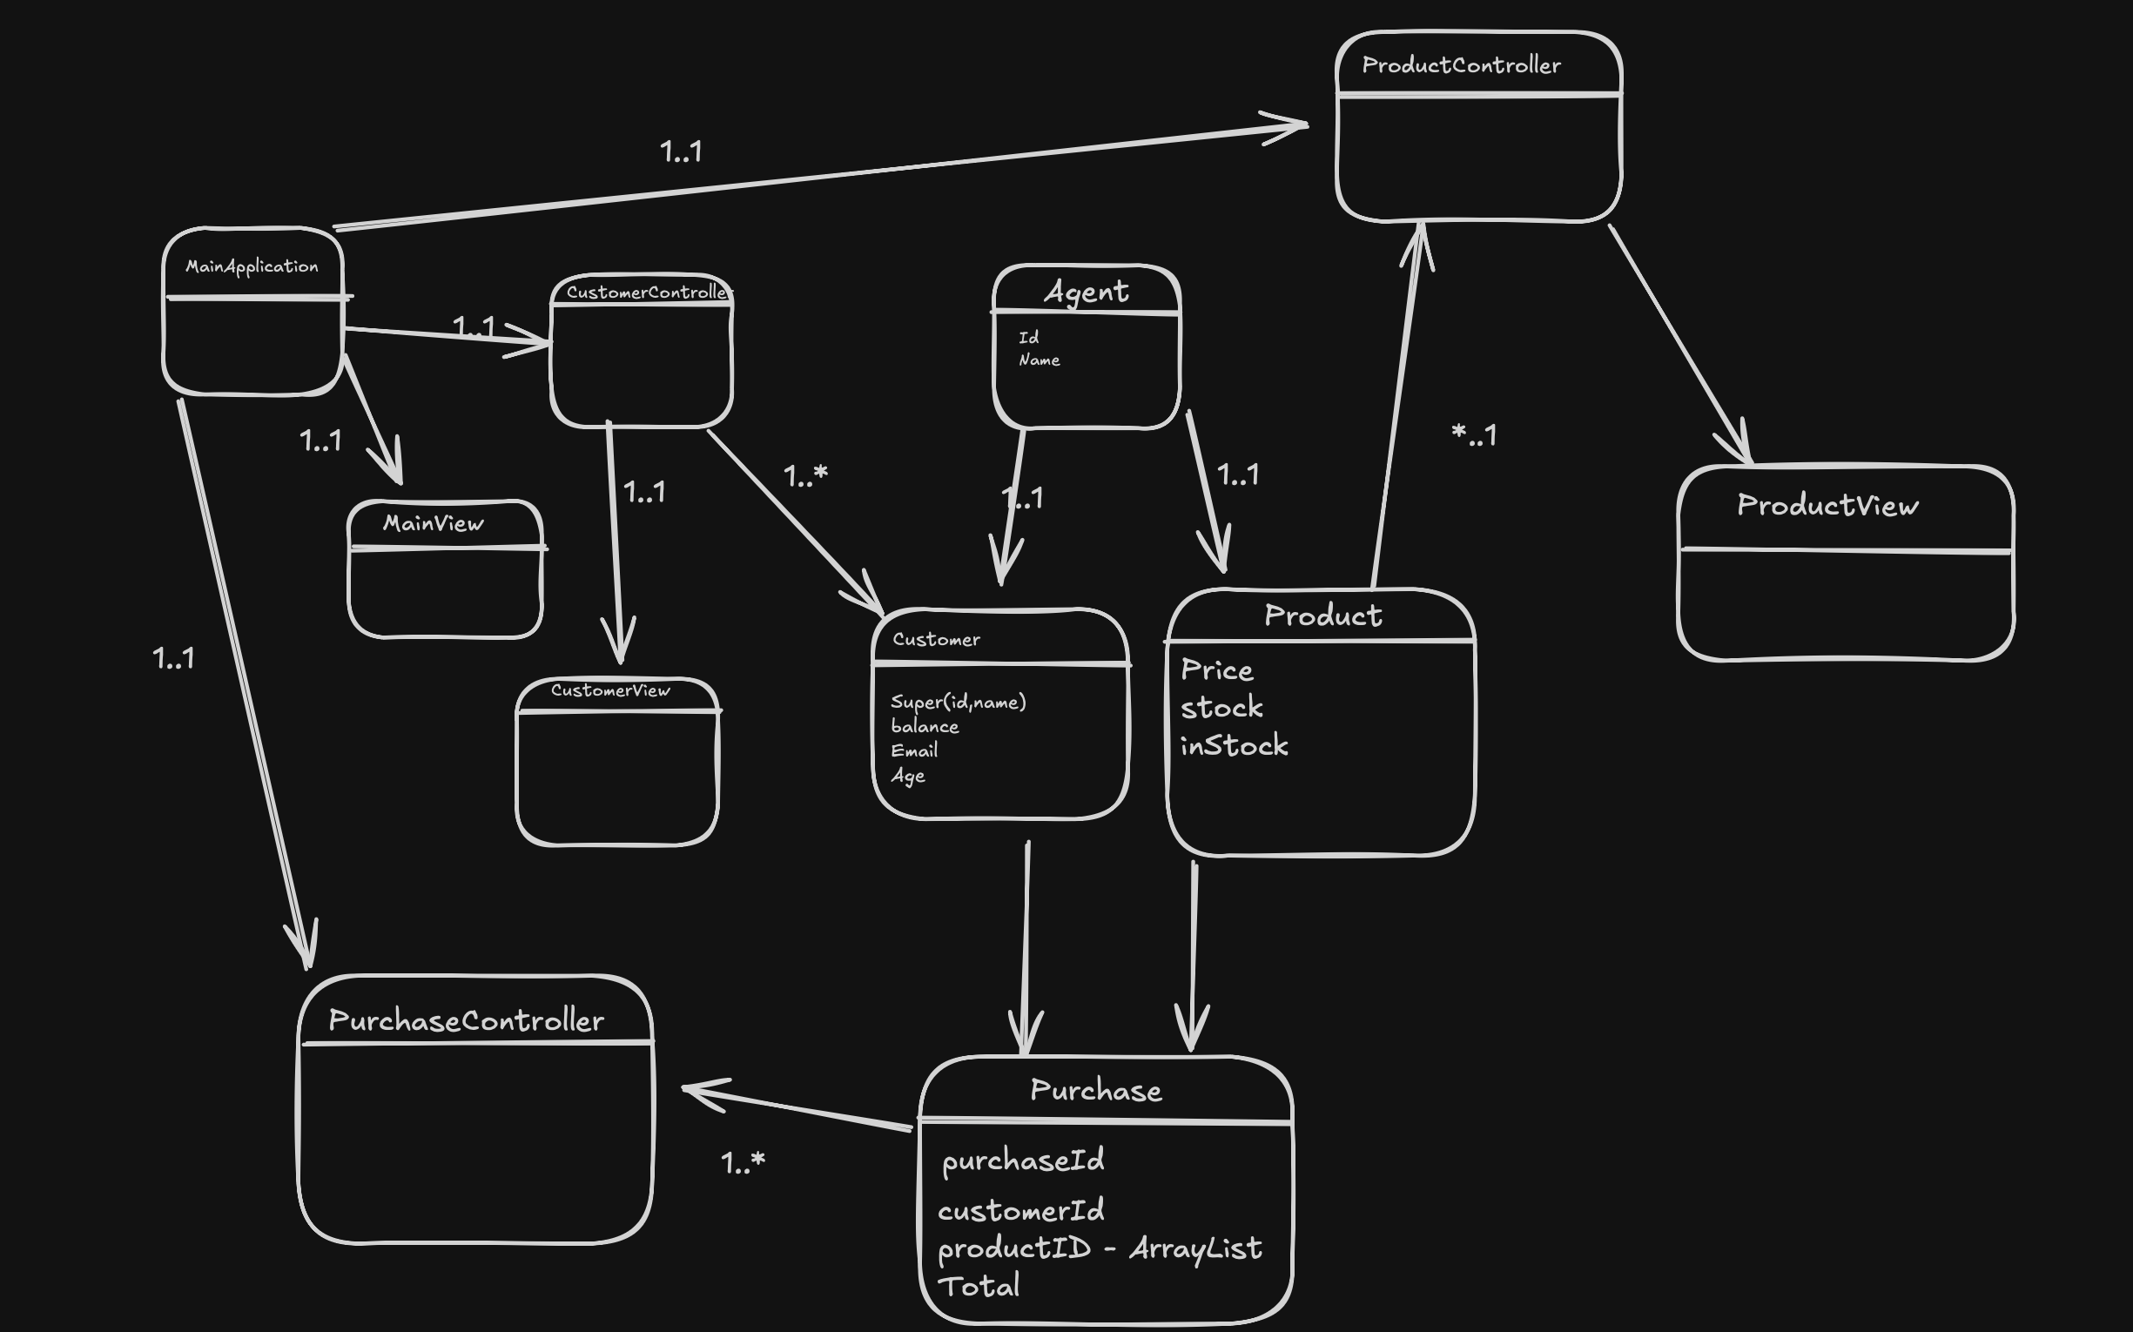
As seen in the above UML diagram, the project has undergone a significant amount of complexity in terms of introducing both products and purchases. Each Purchase contains a customer object/id (In my implementation I have it as a customer and product object but with a full blown relational database like SQLite I would purely use ids).
What could I have done better?
For this stage as stated previously and I explained in my video, the tab issue began wherein once I switched scenes the tabs above would dissapear. I know how to fix it but it would take a signfiicant amount of refactoring and it helped me learn that most desktop applications are really just single dynamic pages and don’t switch between scenes apart from generating new windows.
I also again had the opportunity of having customers register their account here but didn’t as I wanted to work moreso on the core functionality.
Project Stage 3
UI Diagram and Ideas and Overall UX
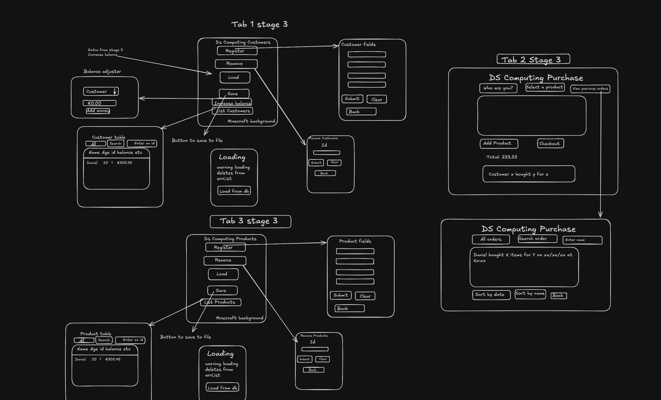
For the ui of my final stage, there really wasn’t much more added at all given most of the new additions in this stage were building upon pre-existing code.
However I did add a new vbox in which I added the ability to view,clear and sort previously made orders. I gave the options of sorting by date and personal name as I feel like those would be the most useful in a system of this sort.
Although there were a good few suggesitons like seeing last months purchase and sort by product name, with how my purchases are structured and adding purchases is based on the time/date now, checking last months purchases wouldn’t be very realistic for me.
UML Diagram
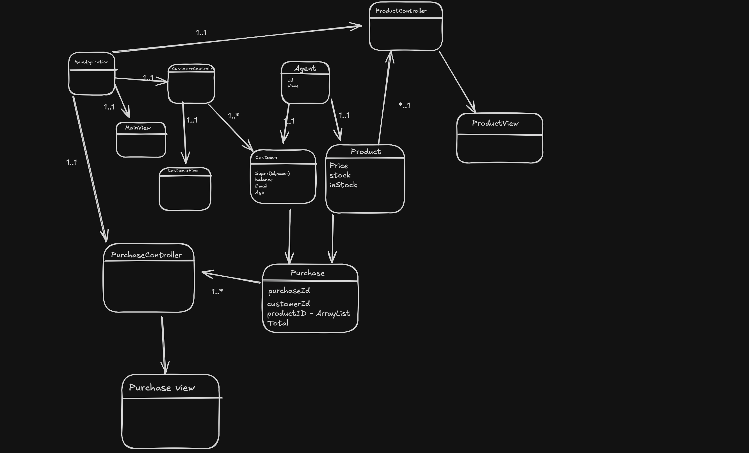
Core functionality
The main new functionality in this section was porting over from plain text files to still reading and writing to text files but in that process, undergoing serialisation and deserialisation. This method of storage was a lot easier than plain text files as we didn’t have to pick out the indexes for our object in a comma separated value system. I did encounter some difficulty with deserialisation which was easily fixed by creating empty constructors.
I also for the purposes of sorting by dates,names and cost had to implement comparators. These were special object specific methods that made it so I could sort ArrayLists of objects like purchases or products successfully. I had initially thought of implementing it directly in the text area but I’m much happier I took this approach.
Normalisation
Despite this not being a full blown relational database implementation, I still have it nromalised up to 2nd normal form but could easily be transformed to 3rd normal form if i were to utilise a relational database.
It adheres to 1st normal form as it has single atomic valued columns with no reptiton and all the columns apart from inherited ones like name and id from agent however again in my future JDBC implementation, I will name them accordingly in the schema. As well as this order of the data in all the tables doesn’t matter.
It adheres to 2nd normal form obviously as no attributes in our stored classes depend on non “key” attributes. Product is identified by its product id, so is customer and purchase has its own key after a customer has selected product(s). The final product really and truly sticks with second normal form as we will see in third normal form due to a concept we learned about in nosql data architecture (Impedance mismatch). This is due to the many to many relationship betwen Product and purchase as we can have many products being bought in many different purchases. Therefore we would need some kind of bridge table between purchase and product to really achieve third normal form as this addresses many to many relationships. We may see repititon of the column purchaseId in product_purchase however this still sticks with 3NF as all repeated columns are on unique rows.
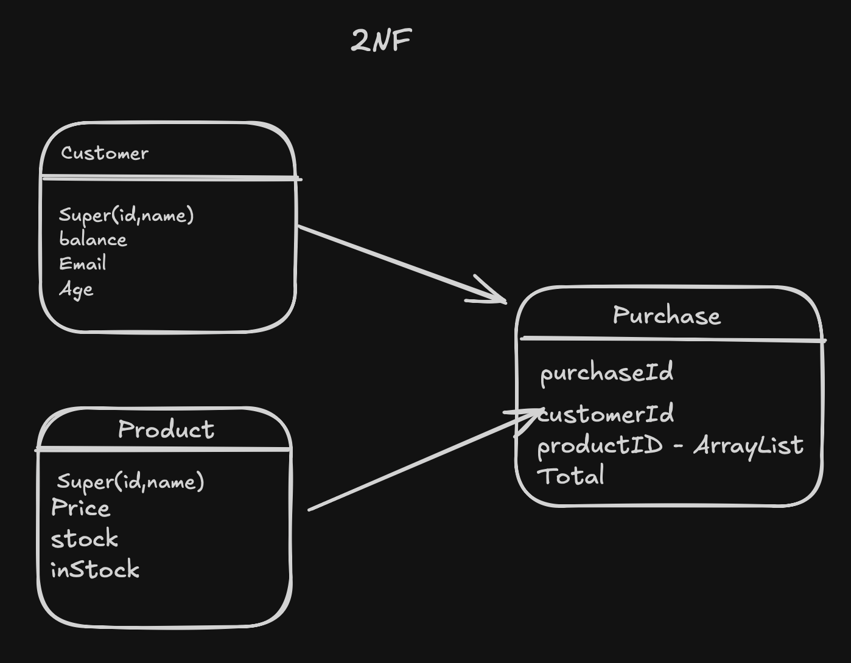
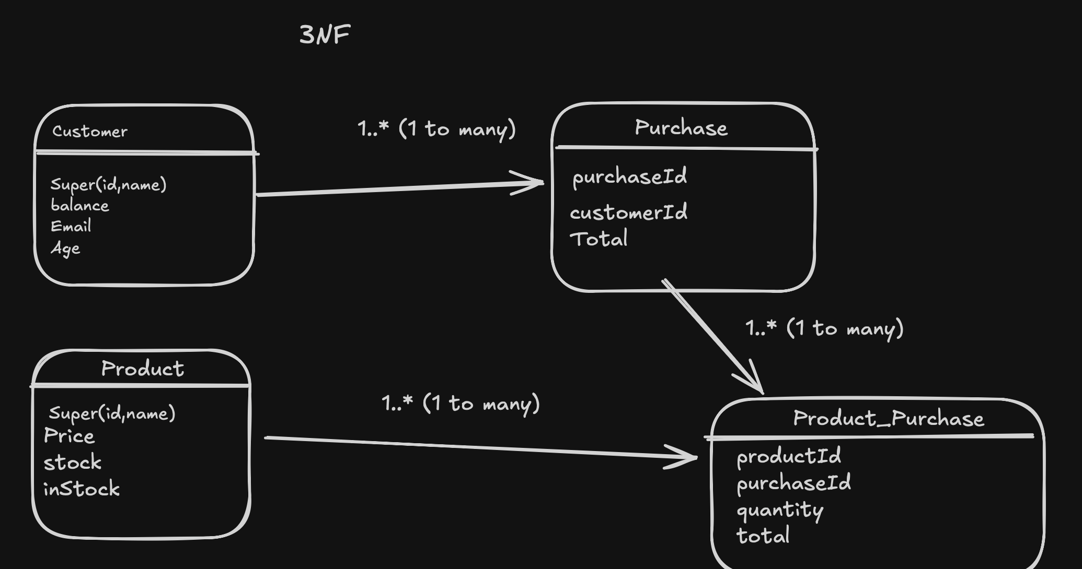
Conclusion
Overall this project was a great learning experience in terms of creating a full blown system from out previous code and adapting that code through our object oriented principles like polymorphism, abstraction etc. Javafx was a great UI library for this usecase as it effectively took our code and data and displated them really effectively.
If I could do this again I would definetly address my issue with tabpanes and try understnad the structure of desktop apps more. Not only that but I would also be really intrigued on how a relational fully normalised database would fit into this system.

Images:
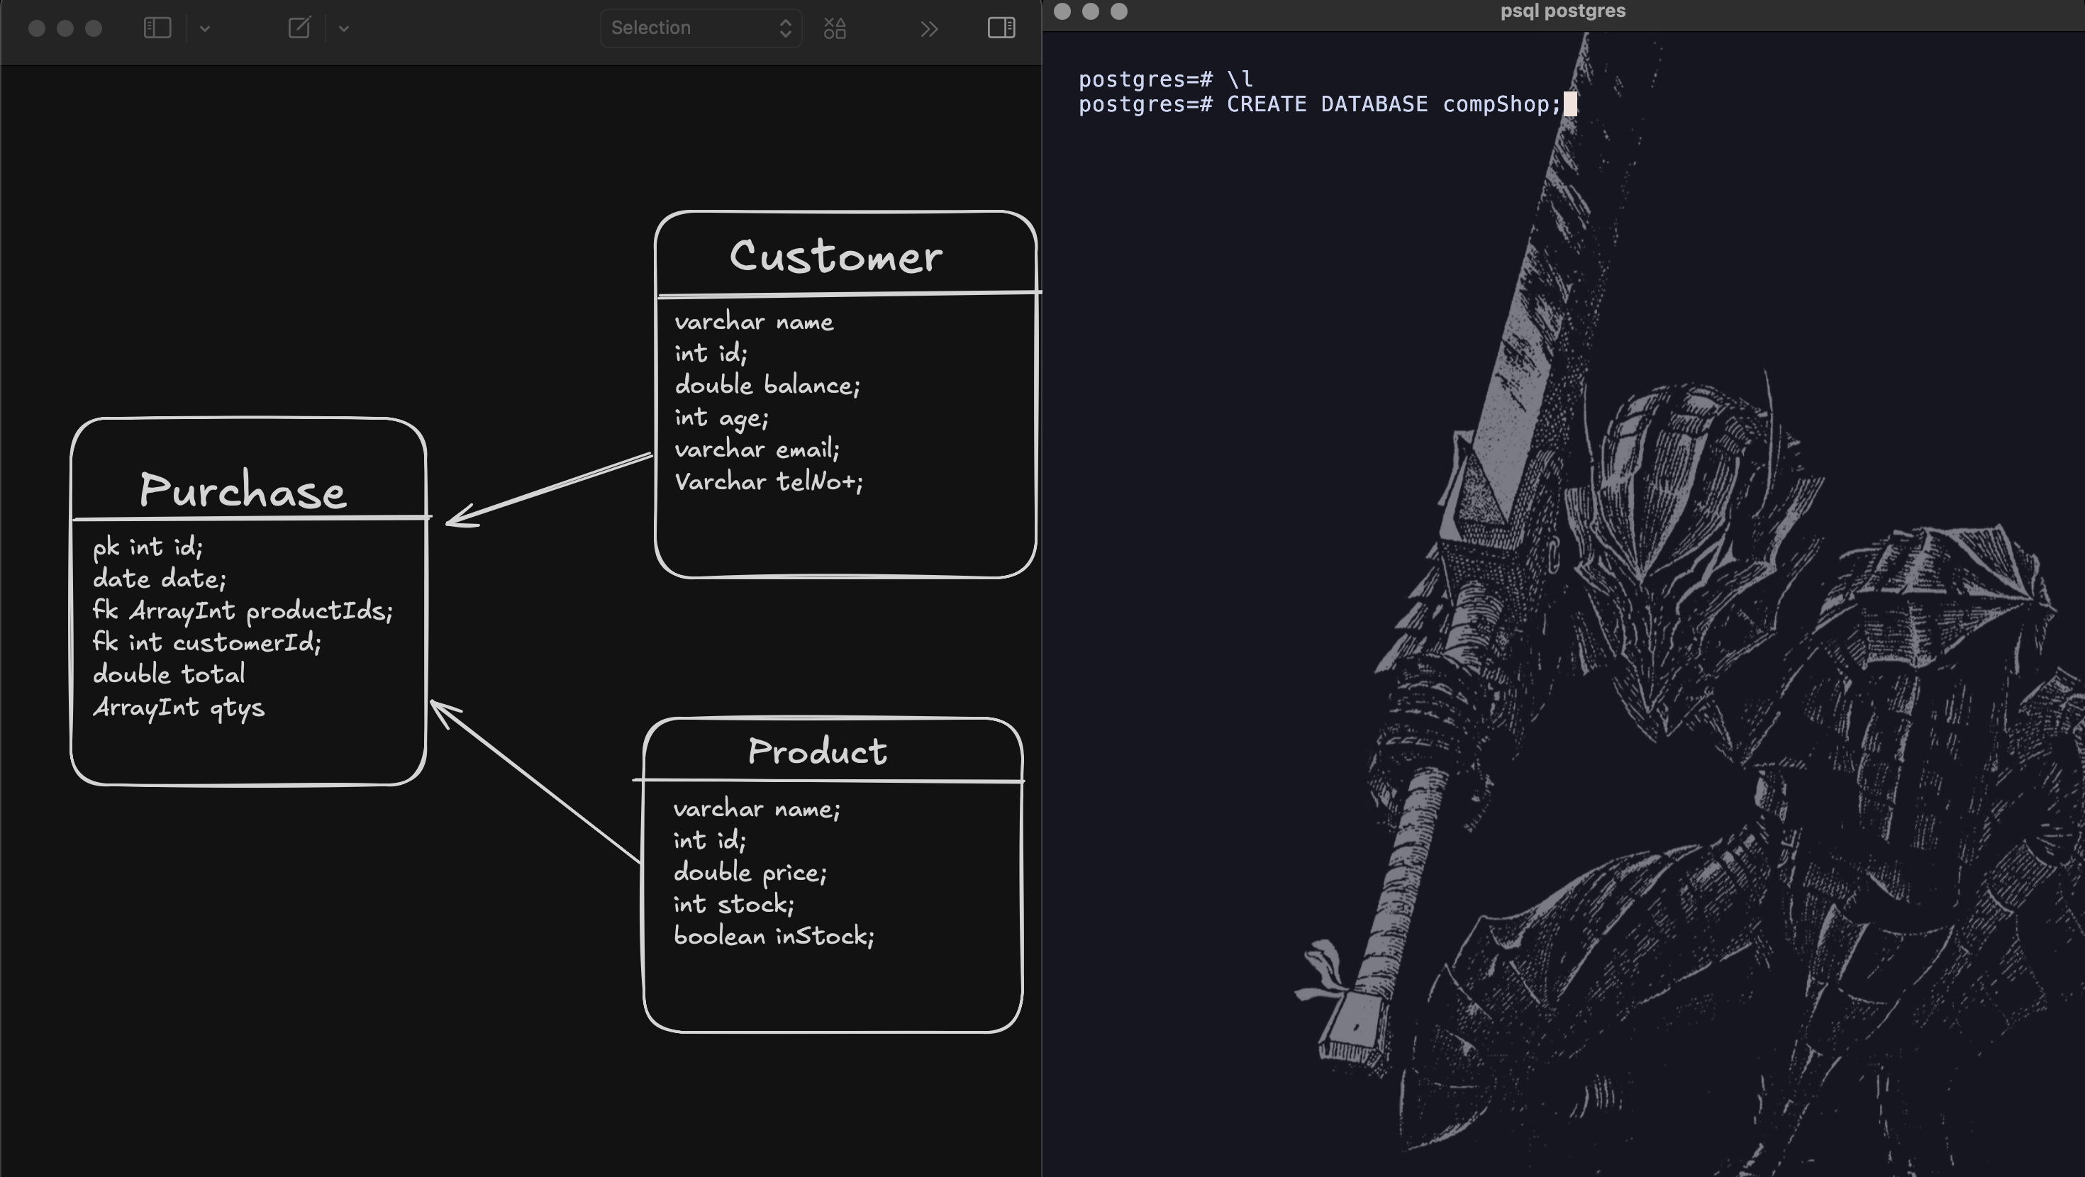
Working on creating postgres db

