Daniel Soden R0024715 – NoSQL Assignment 1
Question 1.

Conceptual Diagram:

- To draw up my conceptual diagram for the Flight delay system I had to majorly consider what an entity is versus what an entity type is. As seen below the primary entities for the conceptual diagram are Airlines,Airports,Flights, Cancellations, delays and diversions.
- The potential entity types could be a security delay or a carrier diversion.
- In the conceptual diagram we are only working with entities and we cannot include their attributes. On top of this many to many relationships as seen between airline airport and flights are permitted given it is only a conceptual diagram however this will be ironed out in the final entity relationship diagram.

Conceptual Diagram:

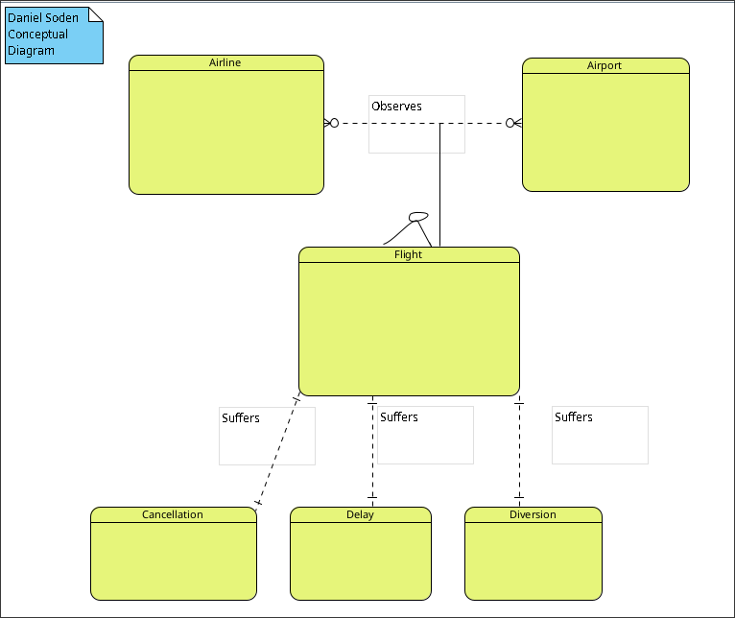
Entity Relationship Diagram:

In Contrast for the entity relationship diagram we ditch the flight entity as it would have a large quantity of many to many relationships which is not permitted in relational database management systems.
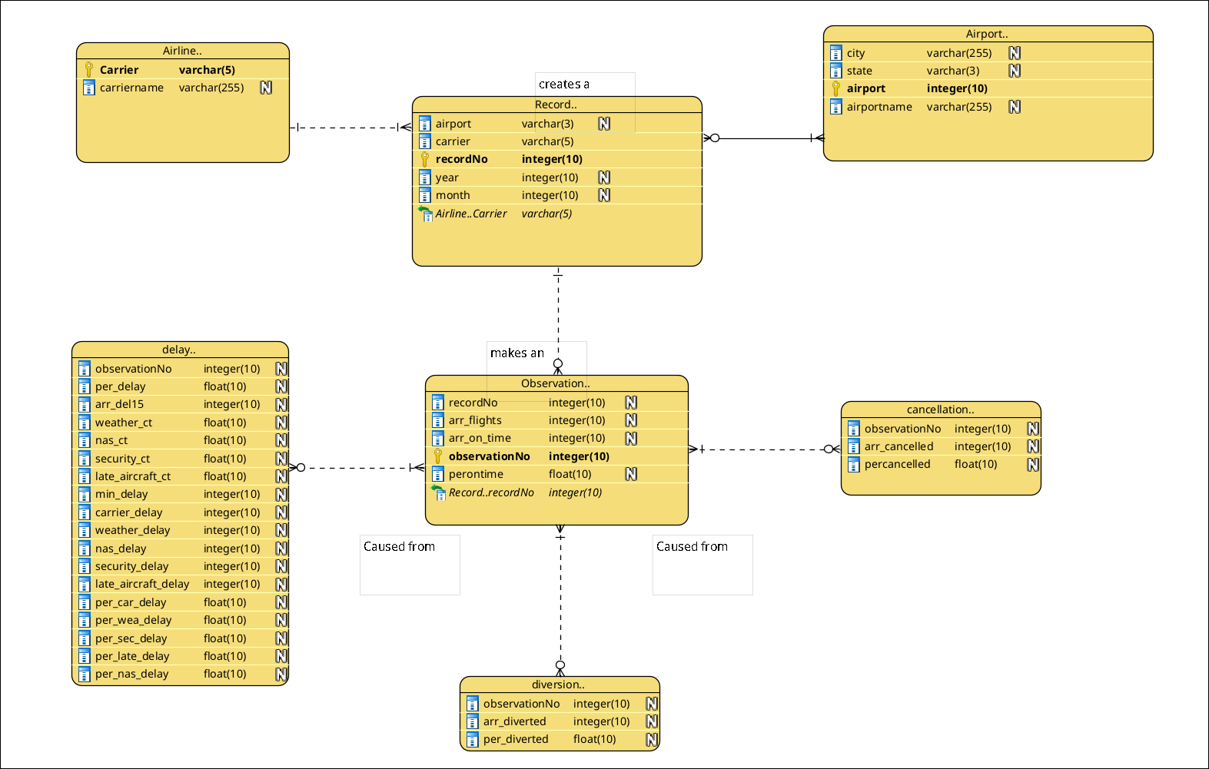
As we see above records are made from individual airlines and airports on a monthly basis and from these records, observations are made to analyse the previous entities of delays cancellations and diversions.

Question 2

Indexing justification
The main indexed attributes that are consistently being looked up should be employee id in the performance table and rank attribute in performance. In the sample selection statement which I adjusted to be a standard join, contains a multitude of attributes that are being selected however the computational logic is being performed on is the id in the performance table, performance rank and employee name. For my indexes I decided to use Btrees as they are extremely efficient at equality look ups which is especially relevant for both ids and ranks.

The main reason I didn’t have an index on the employee id for the employee table since its a primary key, it’s already indexed.

See my sql statements below
SQL Statements
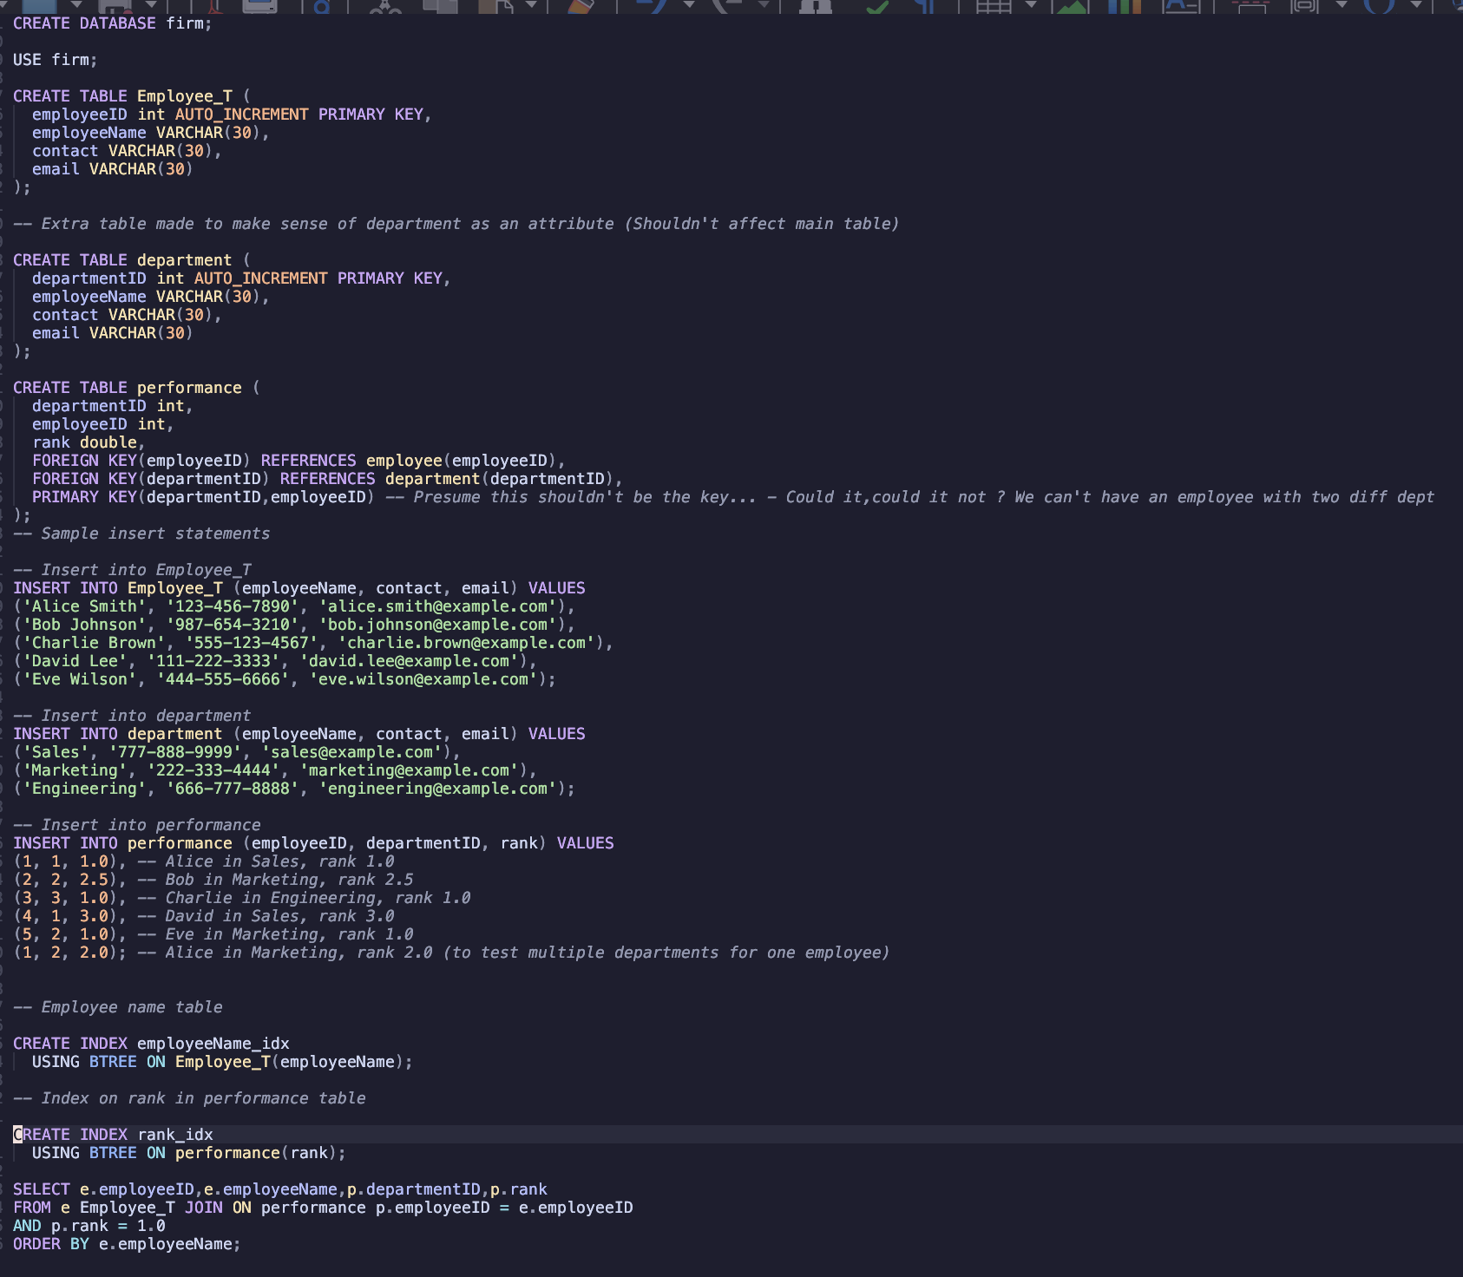

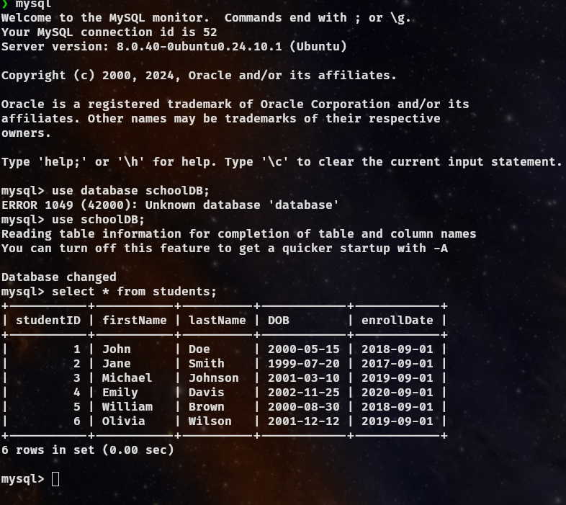
Question 3

As seen above I have created the provided students table. This table contains various different attributes of a student ranging from the day they enrolled to their first and last name. From here we will add a new email column and perform various updates on this data.

For all of my creation,updates, transactions, roll-backs and select statements, these will be contained within the provided q3.sql file, on top of this for any testing needed for ease of use I created a file that clears the database.

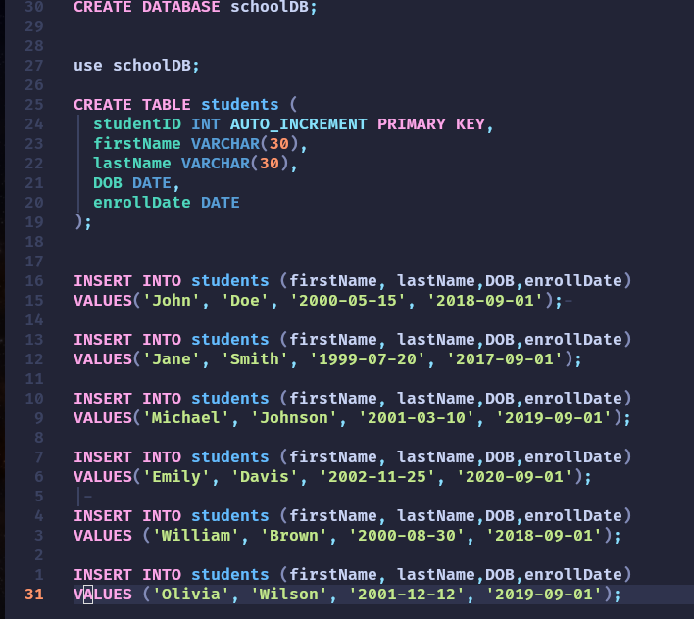
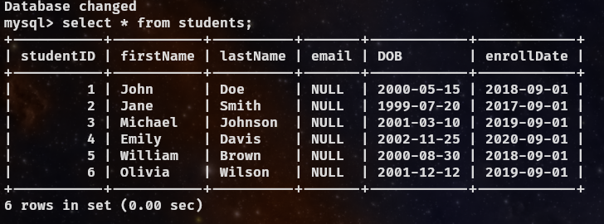
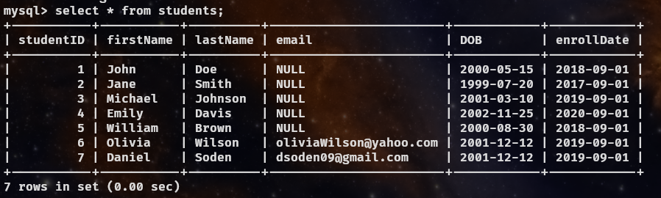
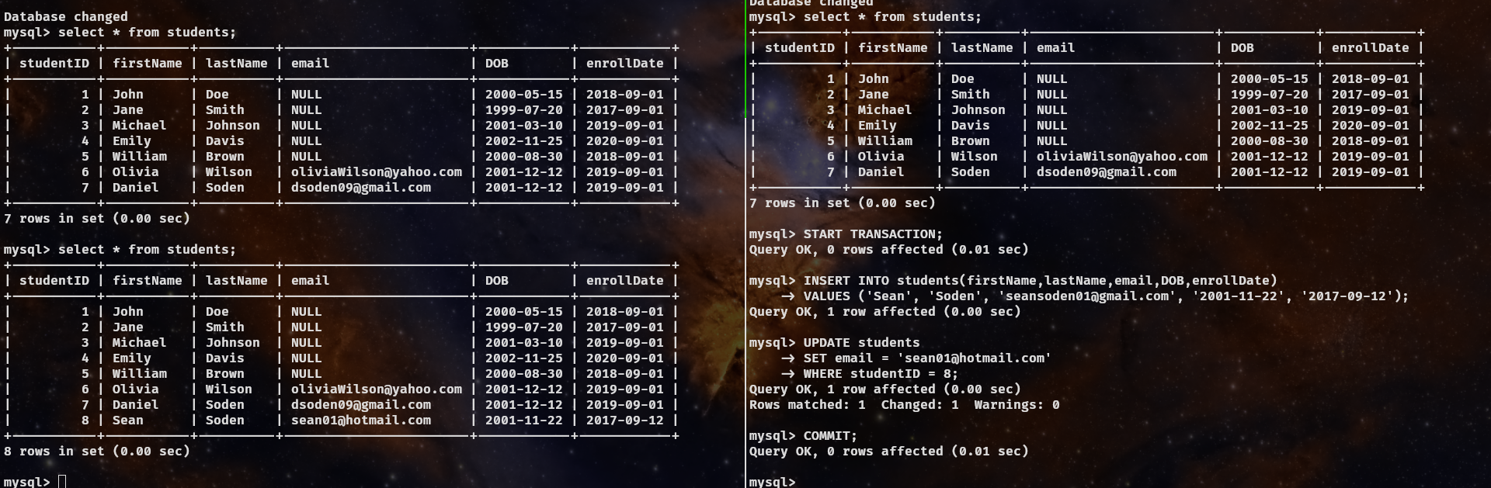

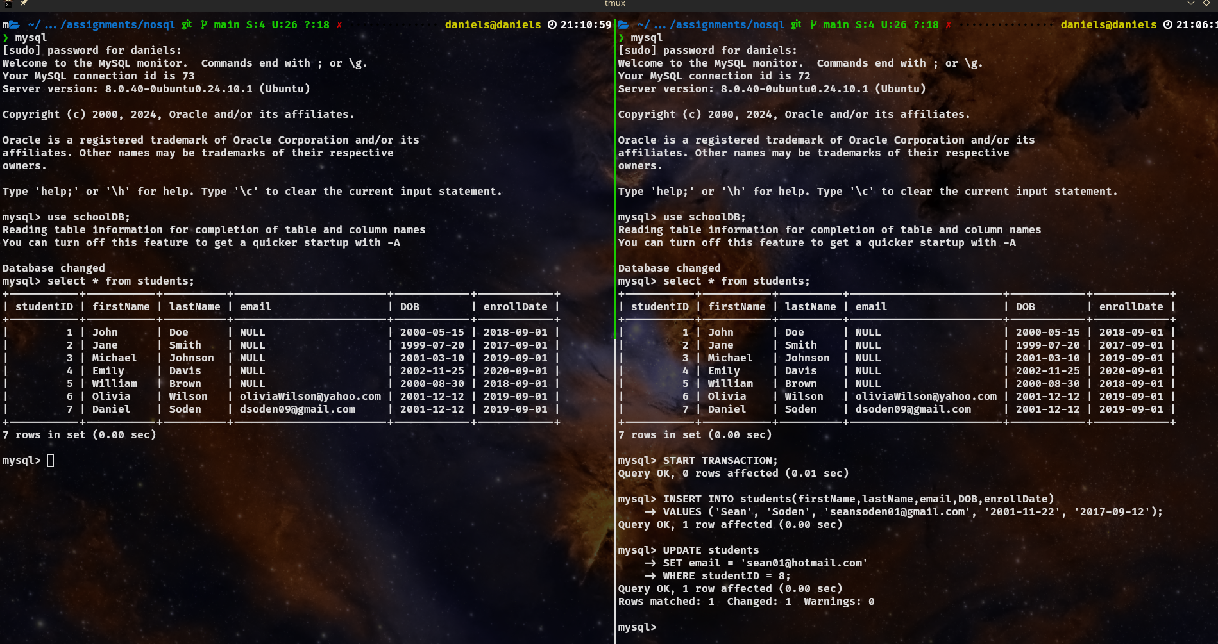
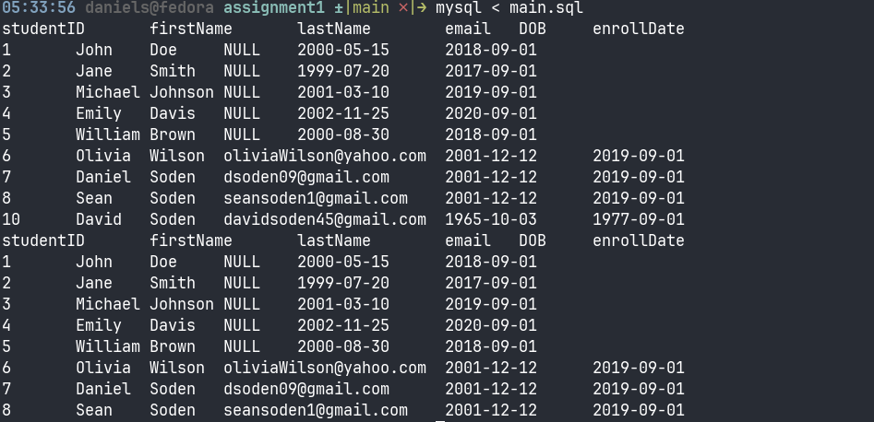
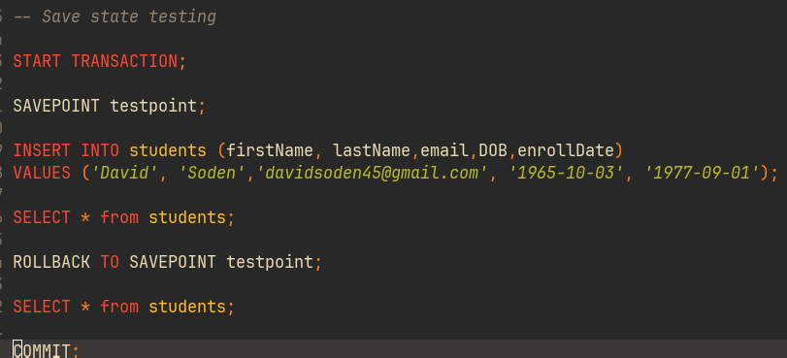
Above I have included all of the tasks in screen-shots, we can see how I have created a new line of data with the email row, created transactions, to committing the data, making save points and roll backing to those save points. On top of this I have opened second mysql (mariadb in some instances as I finished this assignment on various machines) instances and showed how before transactions have been committed, we cannot see the newly inserted data points.

