Daniel Soden Assignment 6 neo4j

1.

I started by execcuting play movie graph and then in the second page, I was prompted to execute this CREATE graph command:

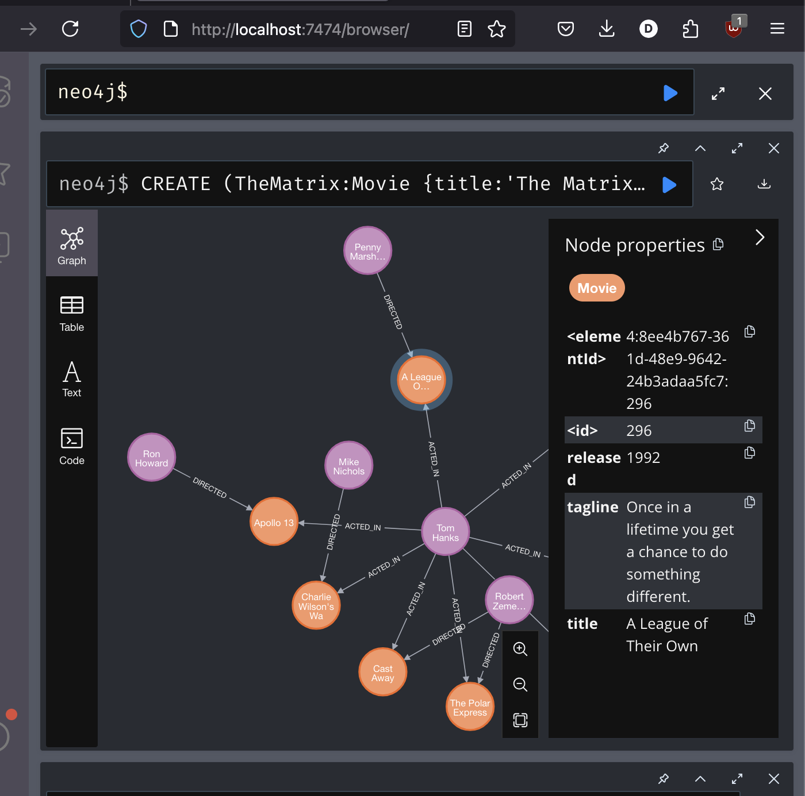
Then after running this command I was able to see the number of vertices, ie the nodes and the number of edges being the amount of relationships in the graph.

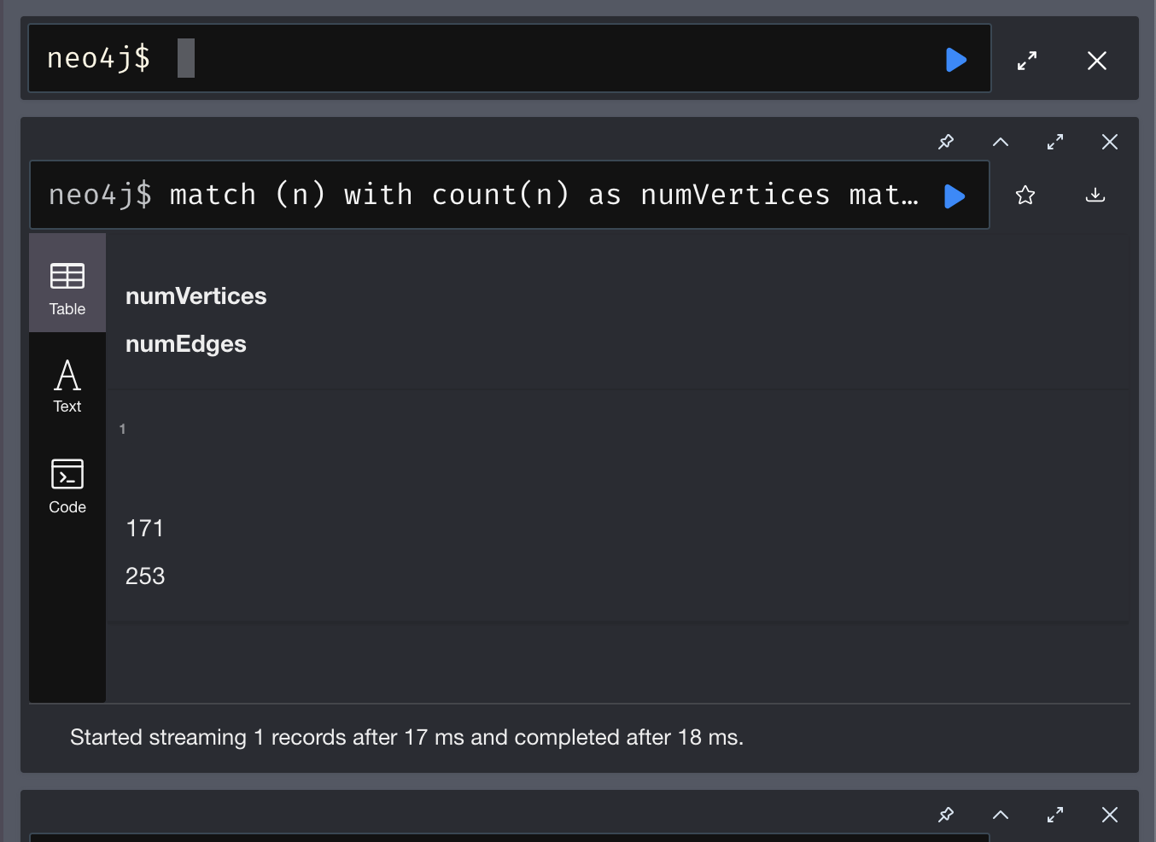
Then to view all the nodes and their relationships I ran this command:
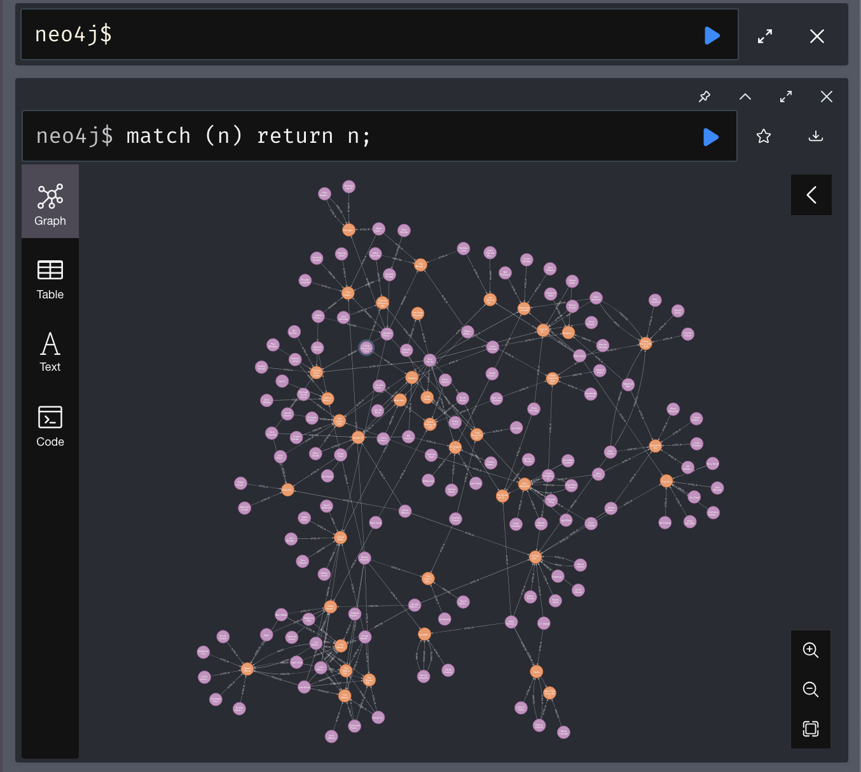
Now that our database is all setup and verified, we can start on the core db queries.

Before inserting the data relating to the movie Bridges of Mason County, I began checking if these nodes actually already existed for the director or actors. As seen above Clint Eastwood is already a person here so it stopped me from creating a dummy node.

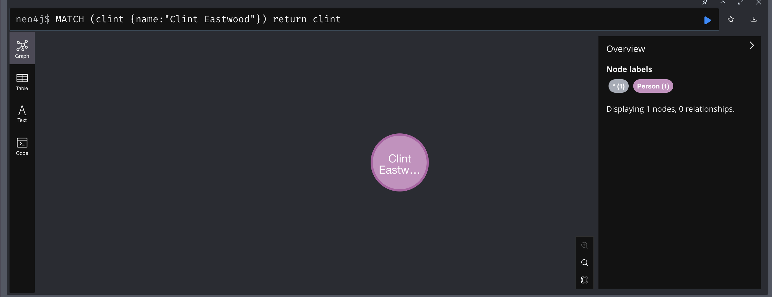
Then I checked what kind of connections Clint Eastwood already had in terms of acting and directing. Here we see he both acted and directed the movie Unforgiven
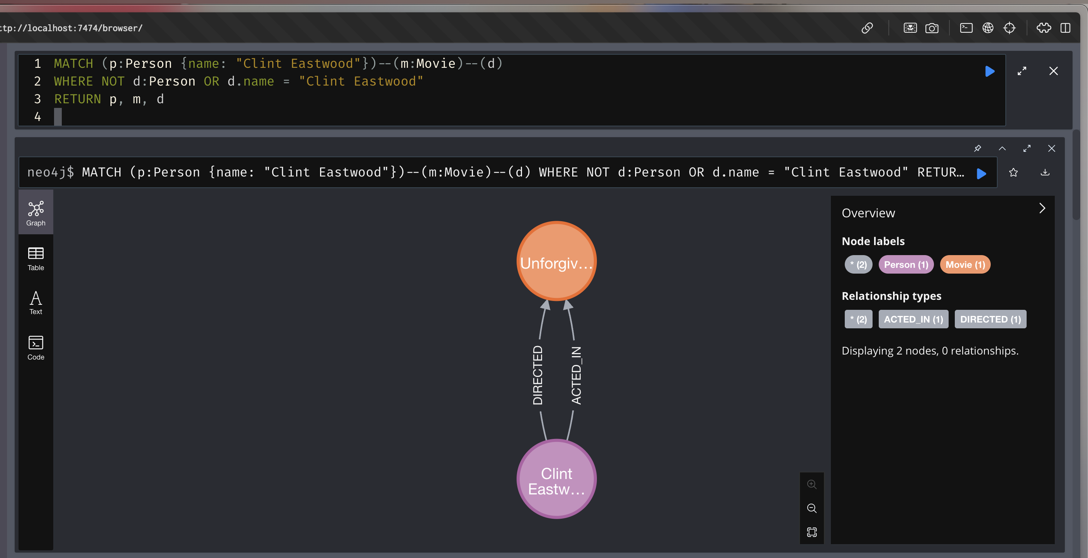

Then as seen below in the main tabs and sub tabs I picked the top three actors in this movie:

- Meryl Streep
- Victor Sizeak
- Annie Corley


Then I performed the same check as to make sure they wouldn’t become dummy nodes:
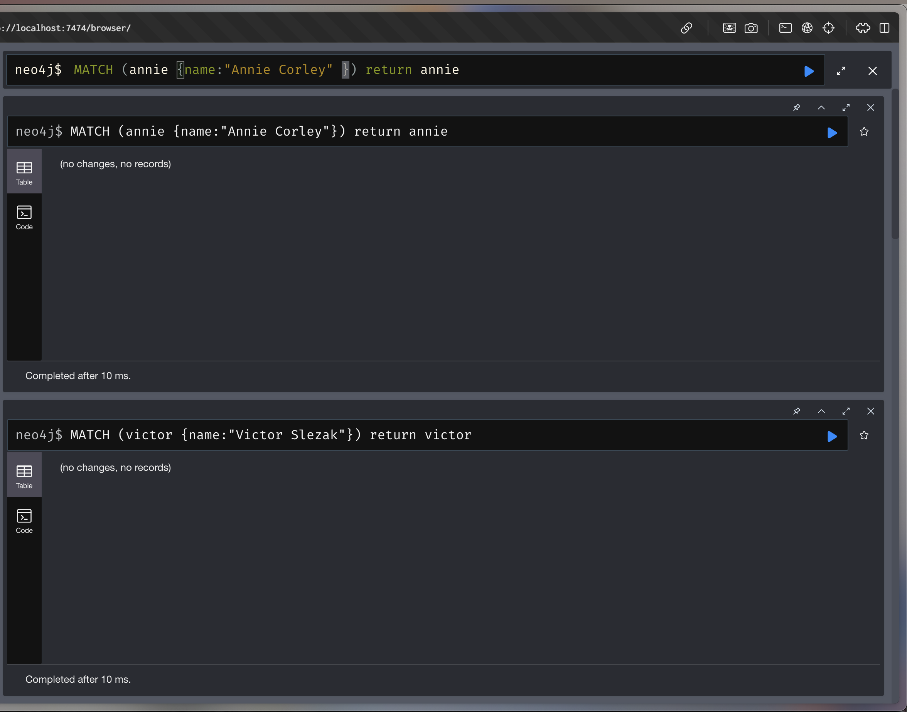
Each of them had no records so I created their vertices and connected them to the new Movie:

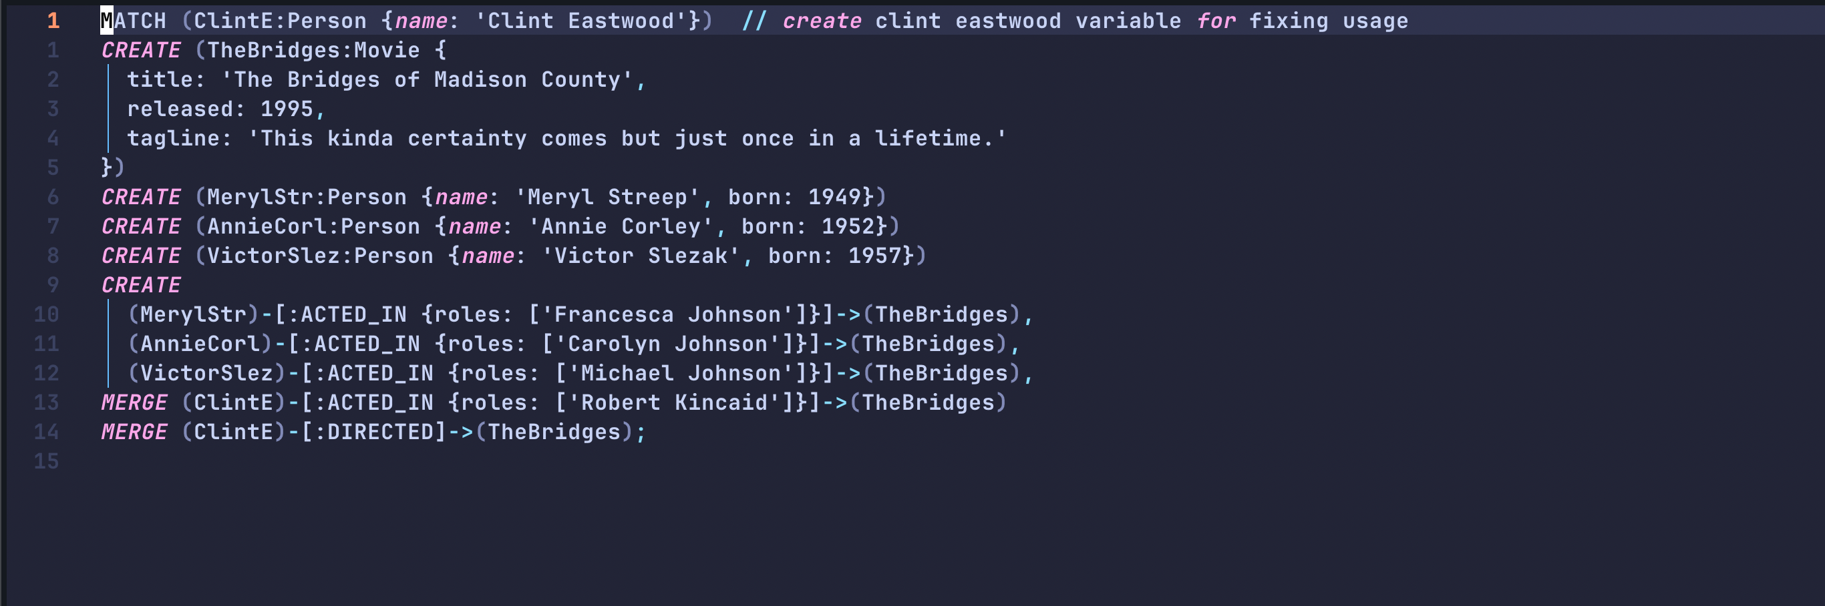
Rather than manually adding each entry, I decided in a separate .cypher file, to create the structure of the adding statement and then manually paste this in as to avoid dummy nodes.

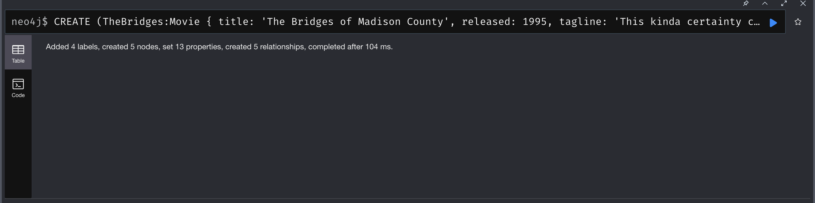
Successfully created person and movie relationships.

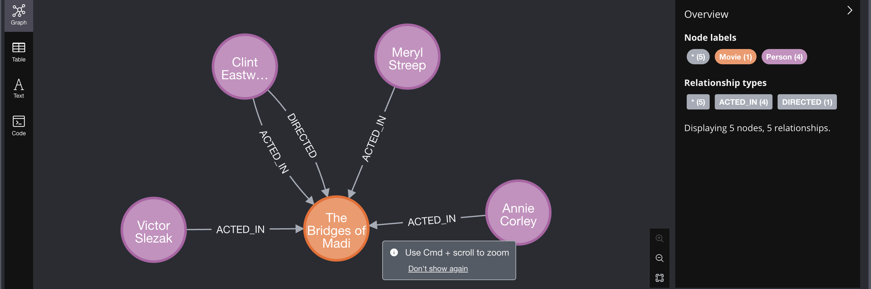
Now we have no dummy nodes through the use of merge and making Clint Eastwood a variable in this query through a match statement.

2.
To find this we need to use a match statement that outputs three elements: - the movie itself, the actors in this movie and a person acting and directing.

This is my query for that:

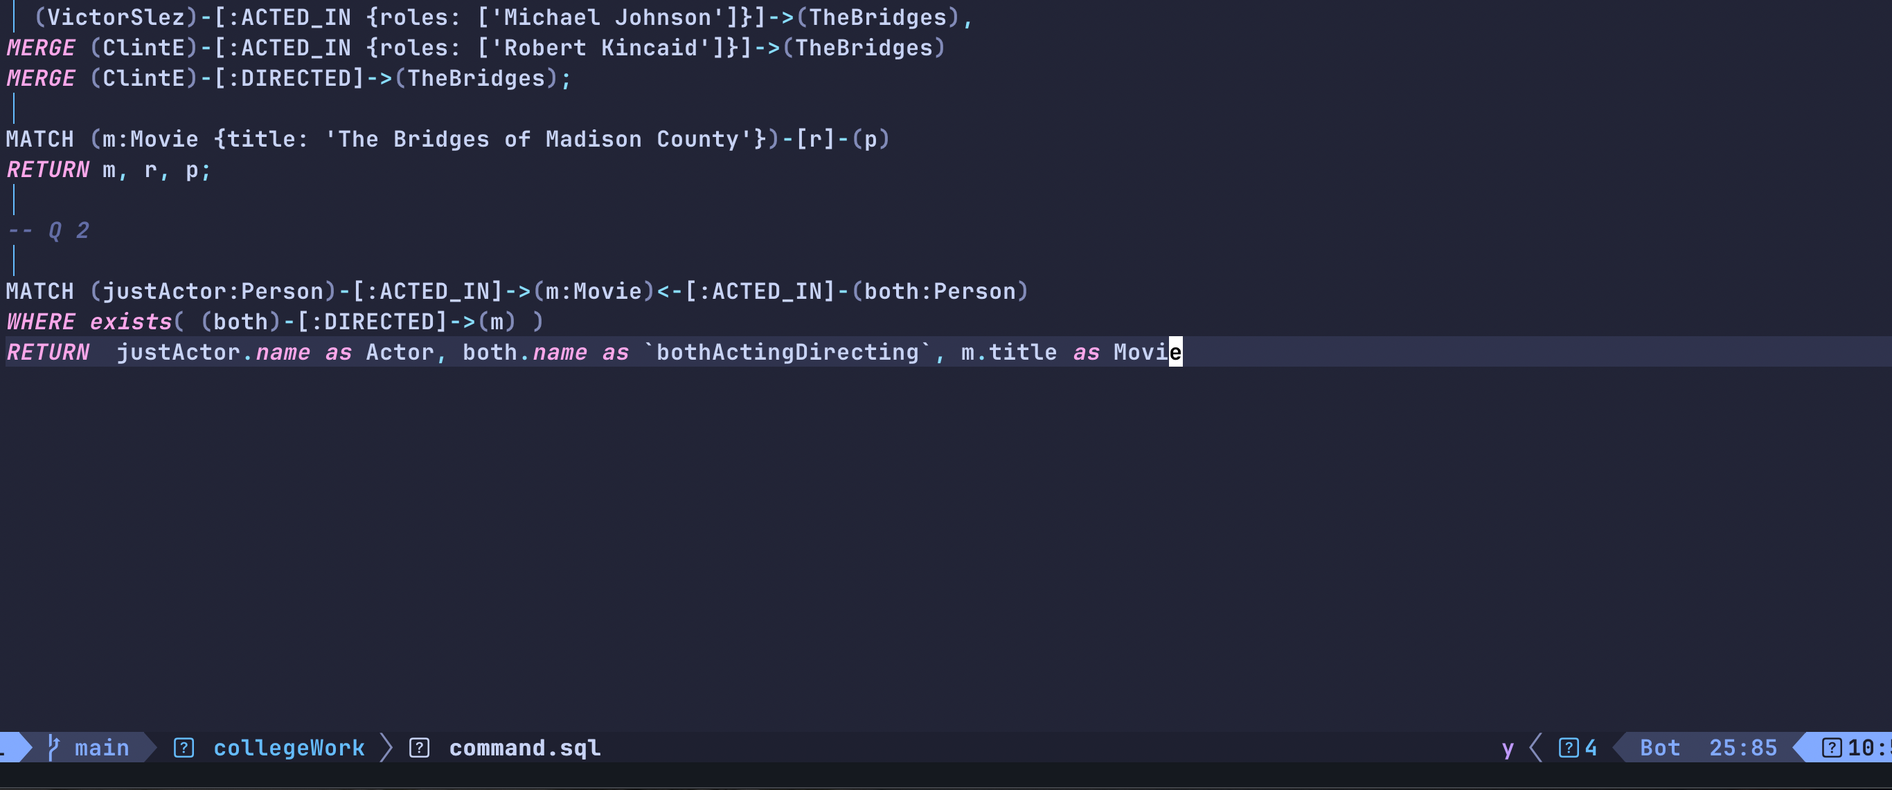
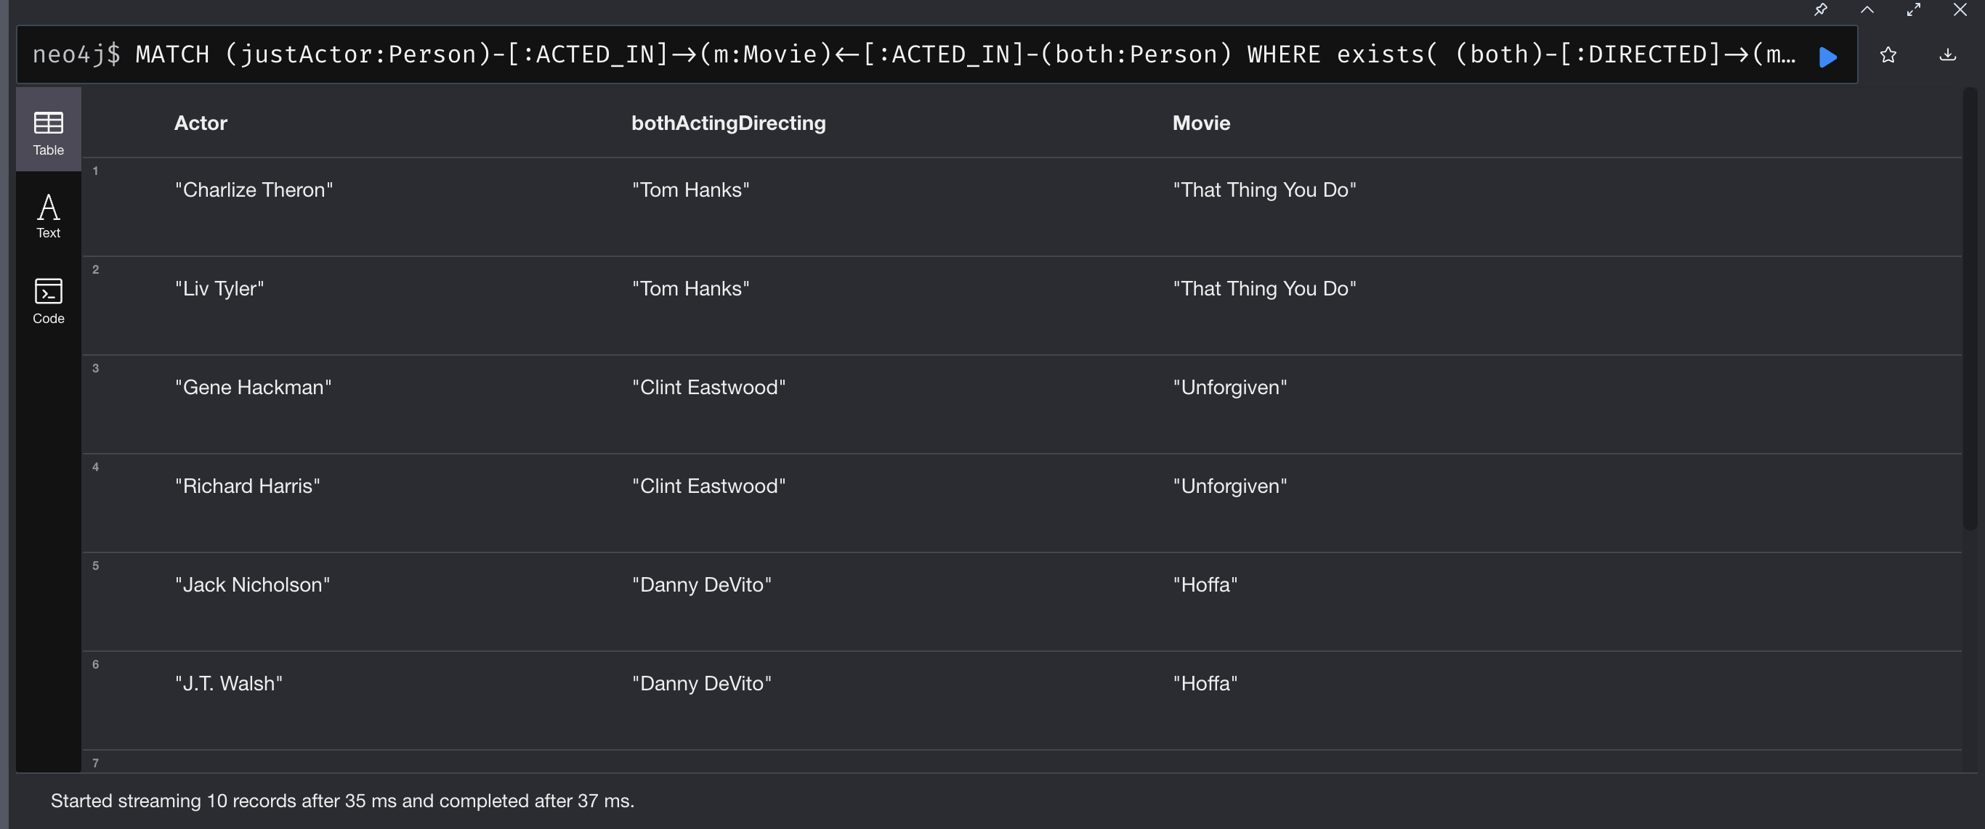
This output does provide duplicates and is only available in text/table format, but in a node format, it would be increasingly difficult to read.

3.

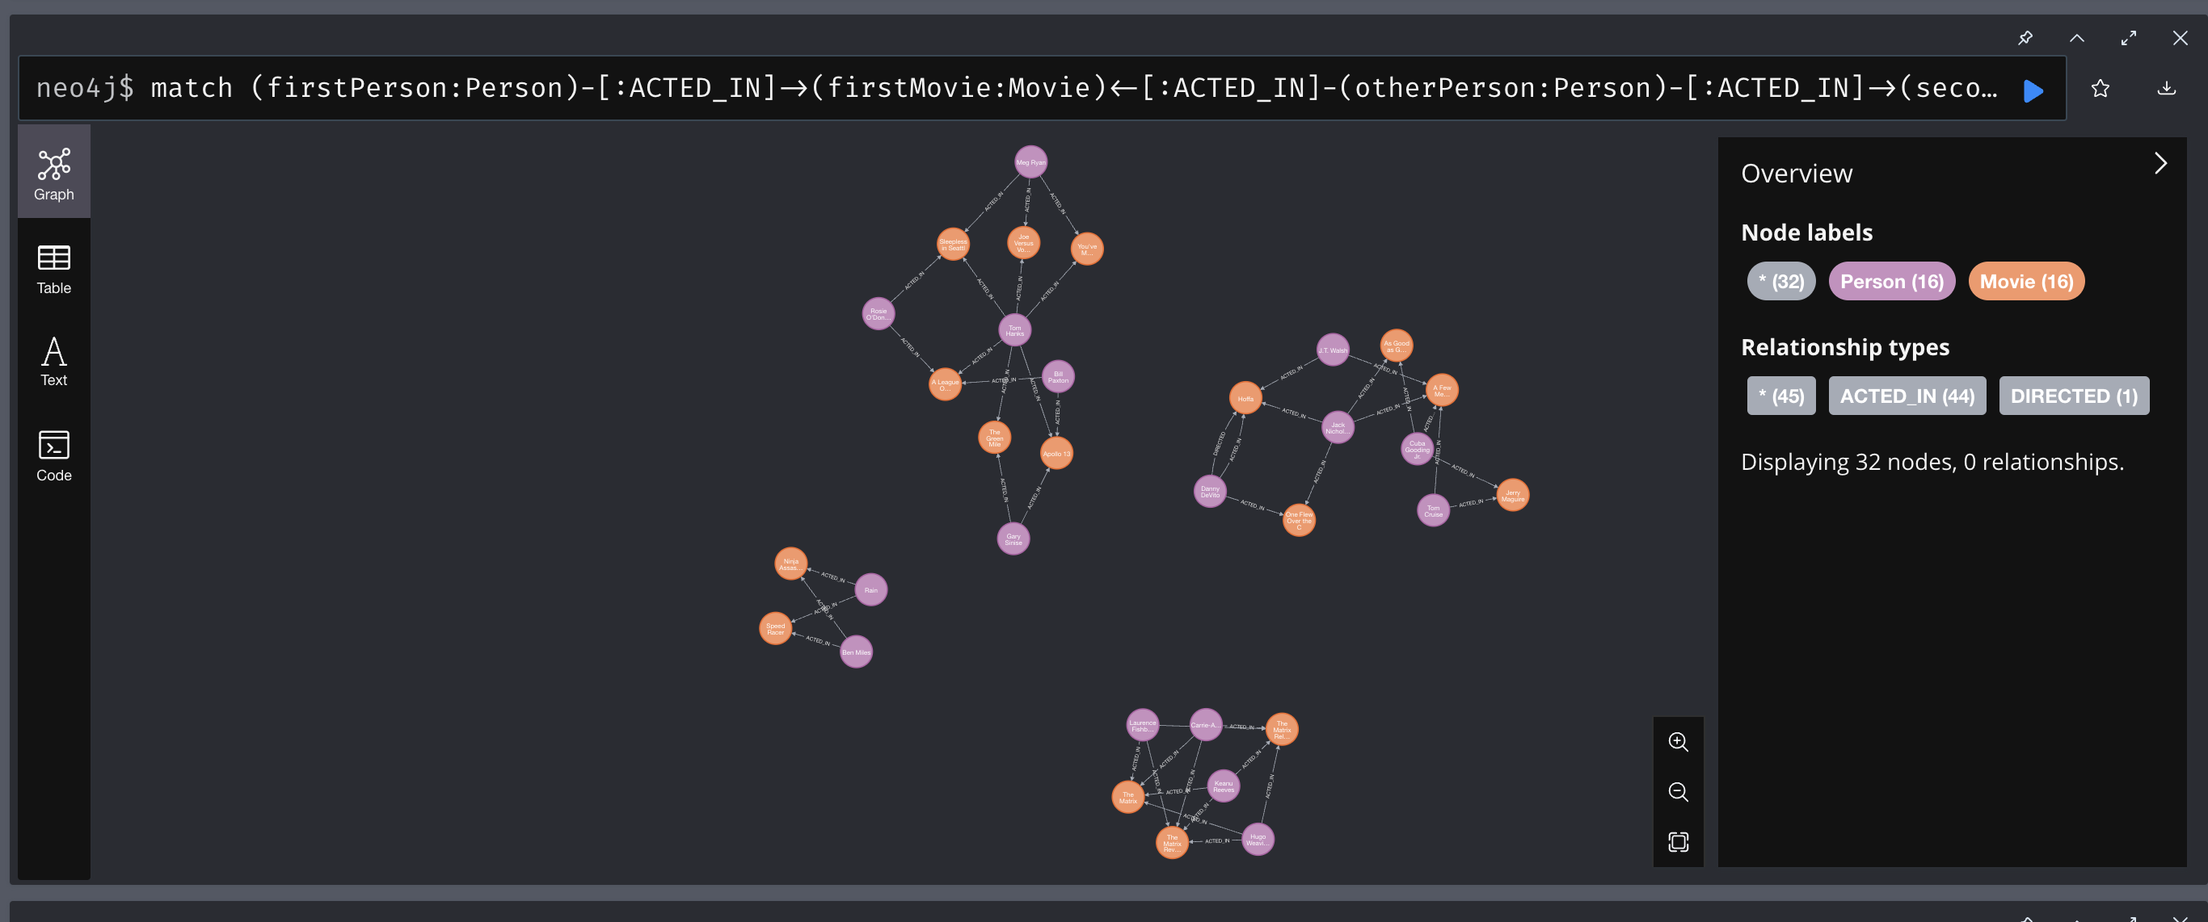
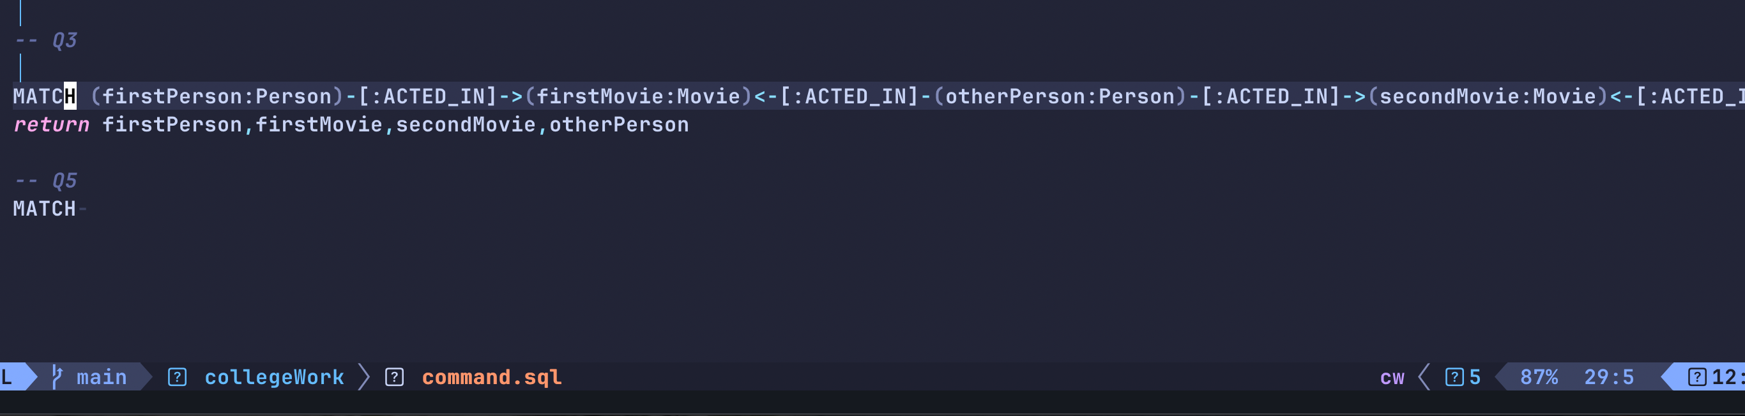
4.
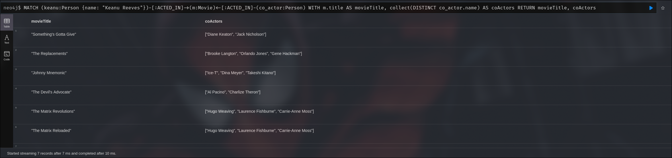
5.
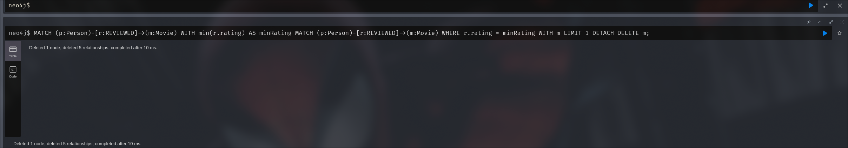
For deleting the movie with the lowest rating, we need to delete both the movie itself, and the leftover relationships:
I kept a limit of 1 just so it only deletes the movie with THE lowest rating.

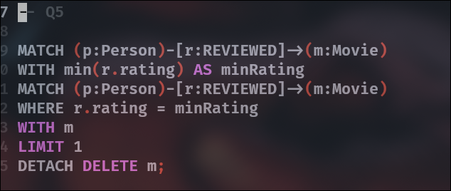

Part 2 (Personalized Learning Database)

- Before simply importing this dataset, we first need to decipher the csv data. From the pdf, we have two distint entities, students and courses. I initially assumed there may be occurrences of students being listed for multiple courses, but upon looking through the file, the ids for students only ever appear once. I was able to then use this command and import the csv:

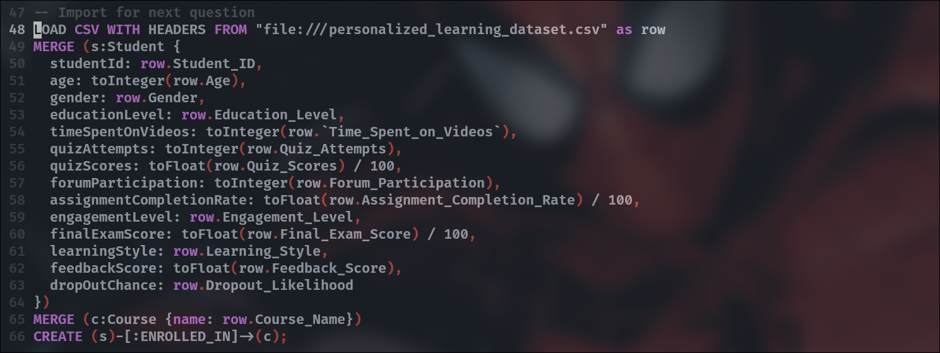

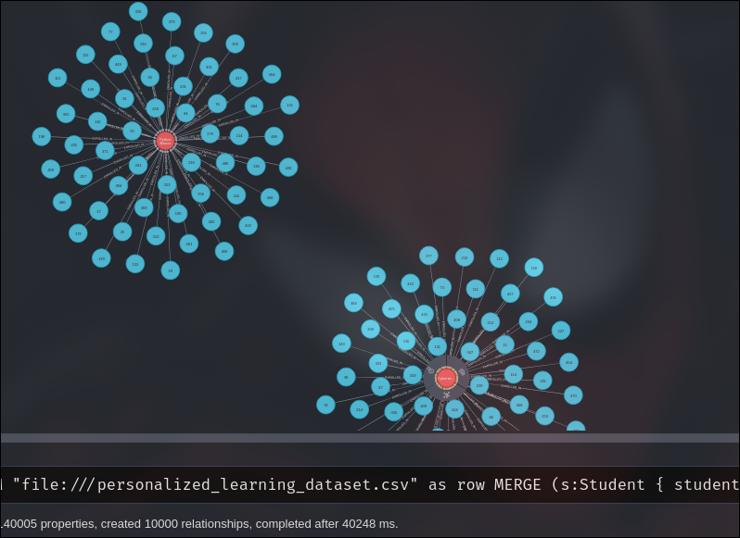
As seen below, we have hundreds of students each connected to python basics and cyber-security respectfully.

1.
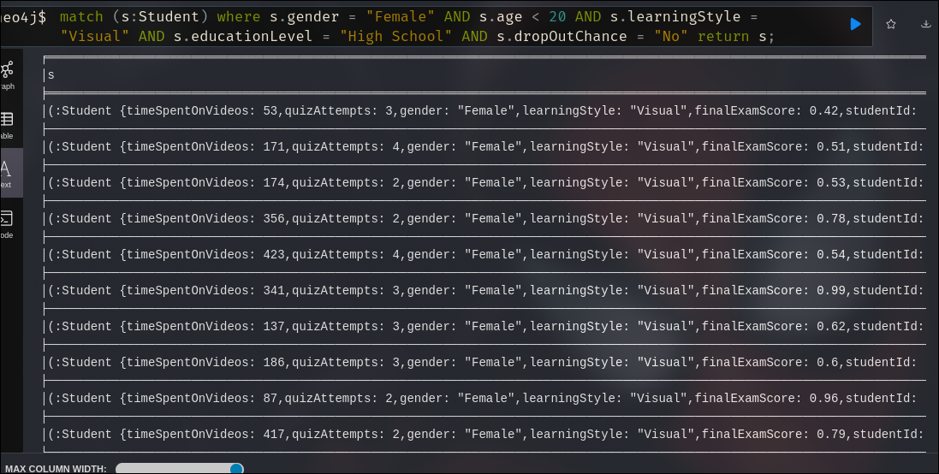

2.

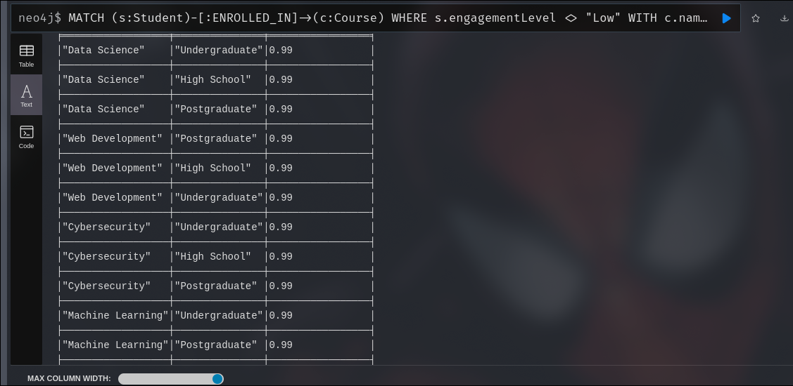
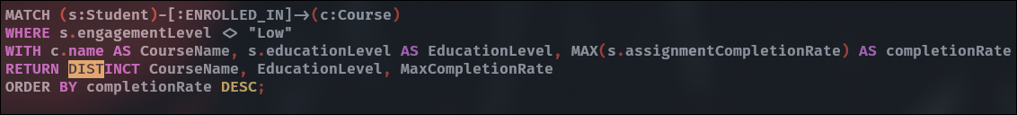

3.

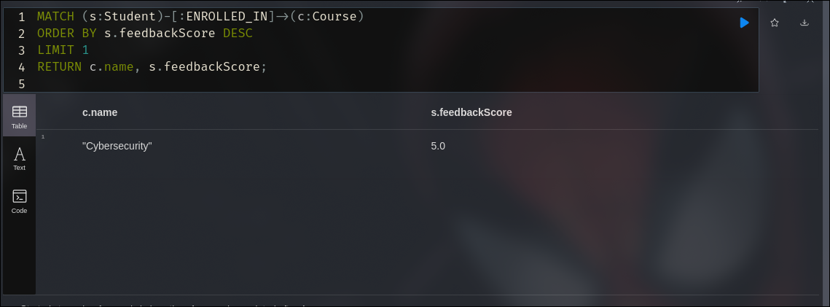
This simply gives the score any has achieved however a more accurate depiction would be an average:

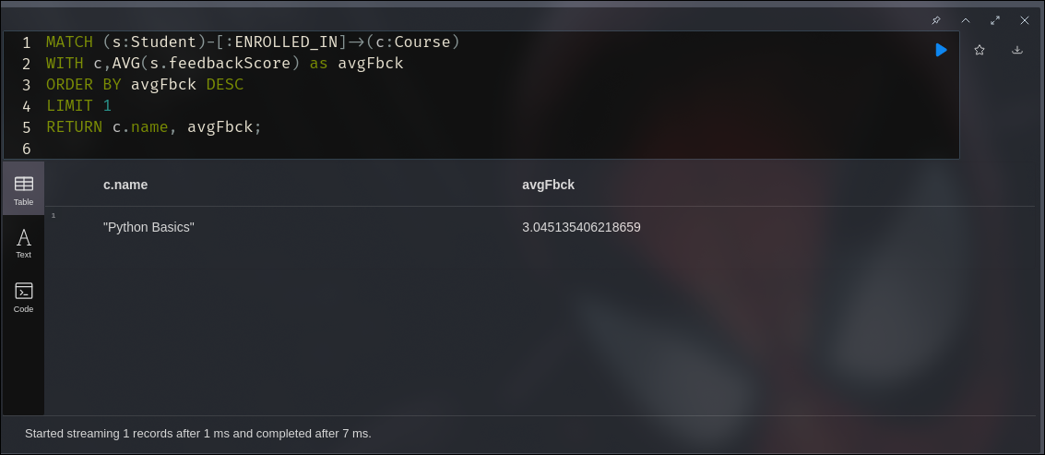

4.

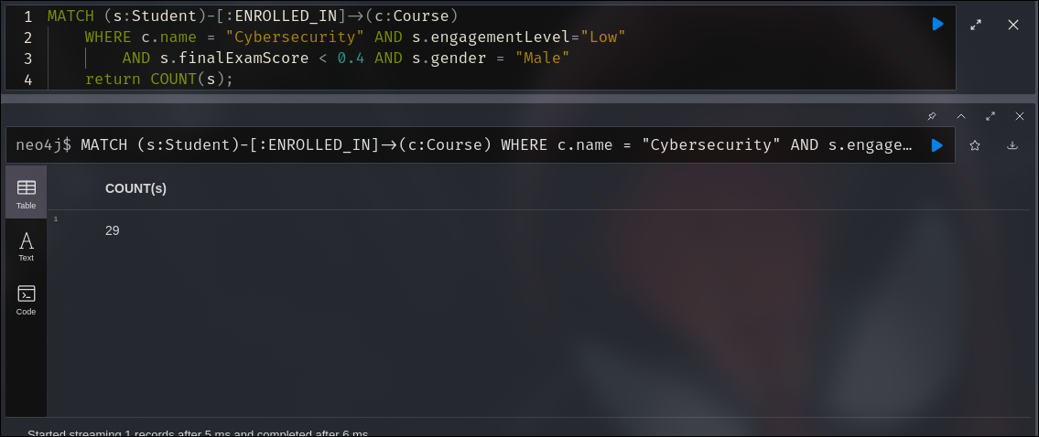

5.



