Daniel Soden Object Oriented Programming Report – Assignment 2

Stage 1 – Serialization & Singleton pattern.

The singleton pattern is a design pattern in which an object has only one instance of itself created and this instance is accessed via a getter. For this purpose, the Object I would need to apply this pattern to is the MainController as this is the object which manages all other controllers and the data they contain thus it fits perfect for saving the stores data & state.

Singleton Pattern Demonstration:

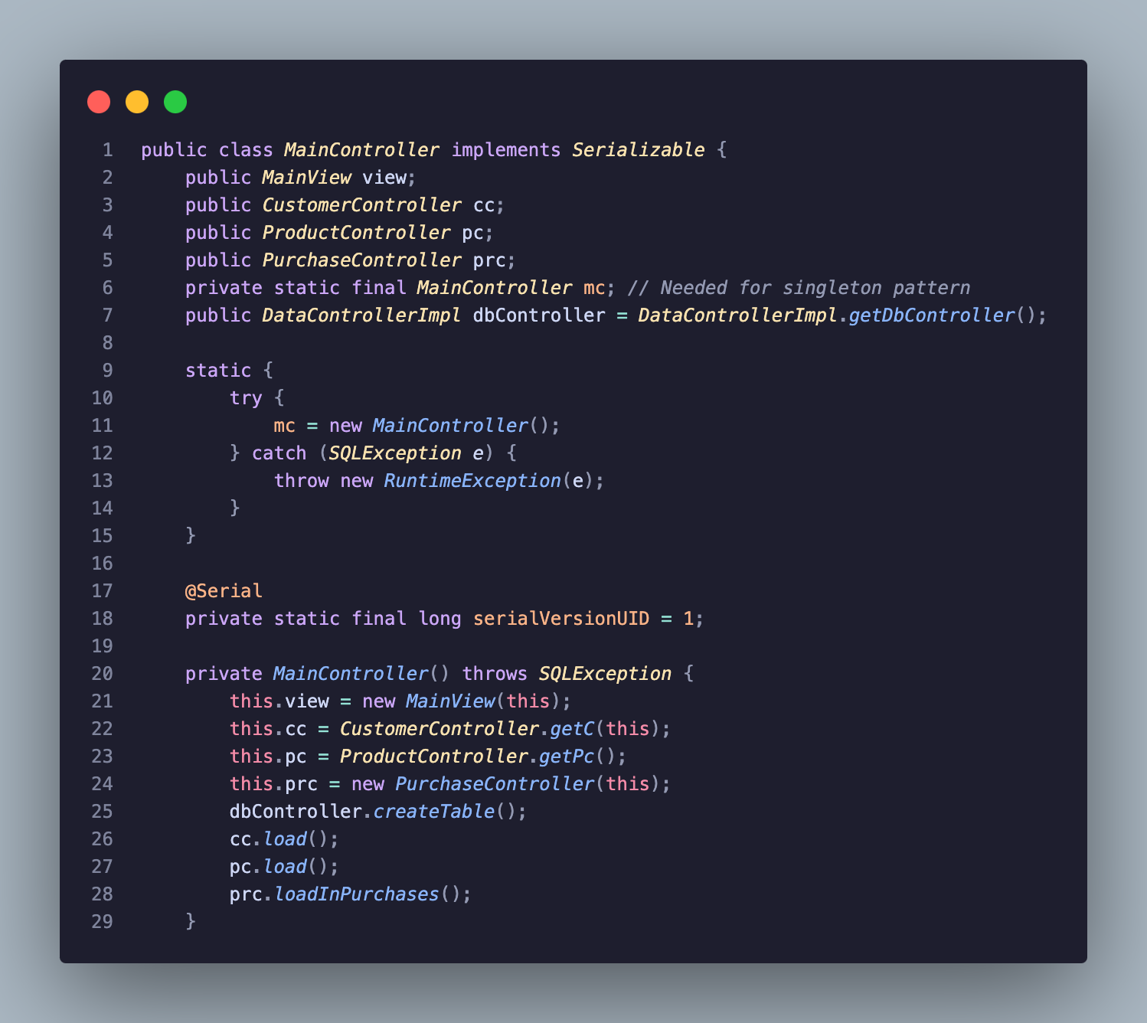
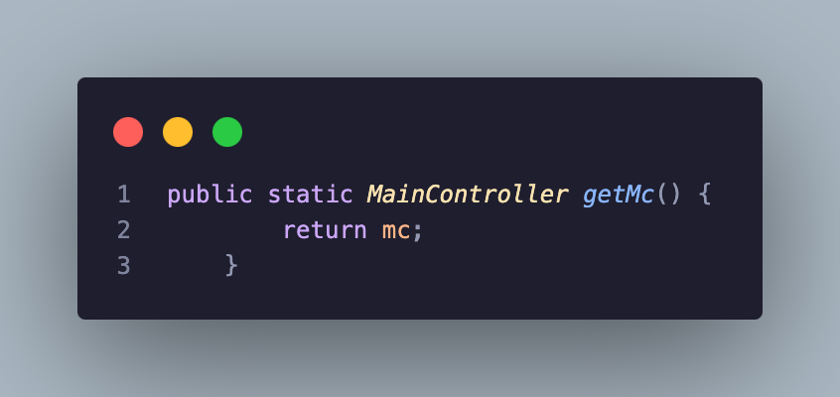

Although there is a lot of general other clutter needed for it’s functionality such as the SQL Exceptions and views, at the core of the singleton pattern we can see the static final MainController and in the singular creation of a MainController. As well as this we see the getter, which is used in other Controllers and views to utilise the MainContorller as a center connection to all other controllers and views.

From here you may also notice that it is implemented as serialisable so that we are able to save its state.

Next to create our serialisation, I created two other classes which are the saving and loading threads respectively.

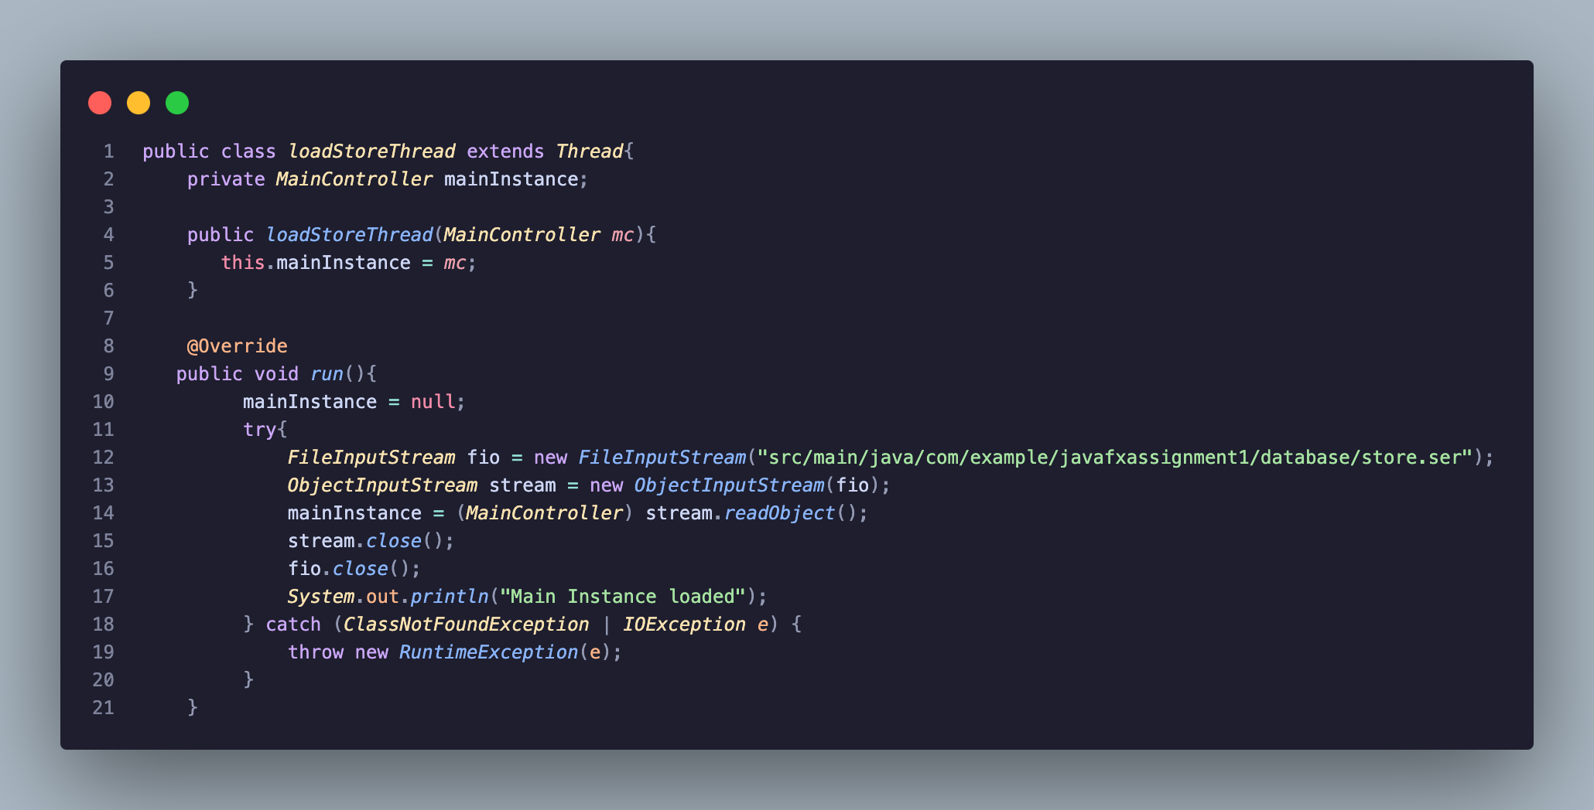
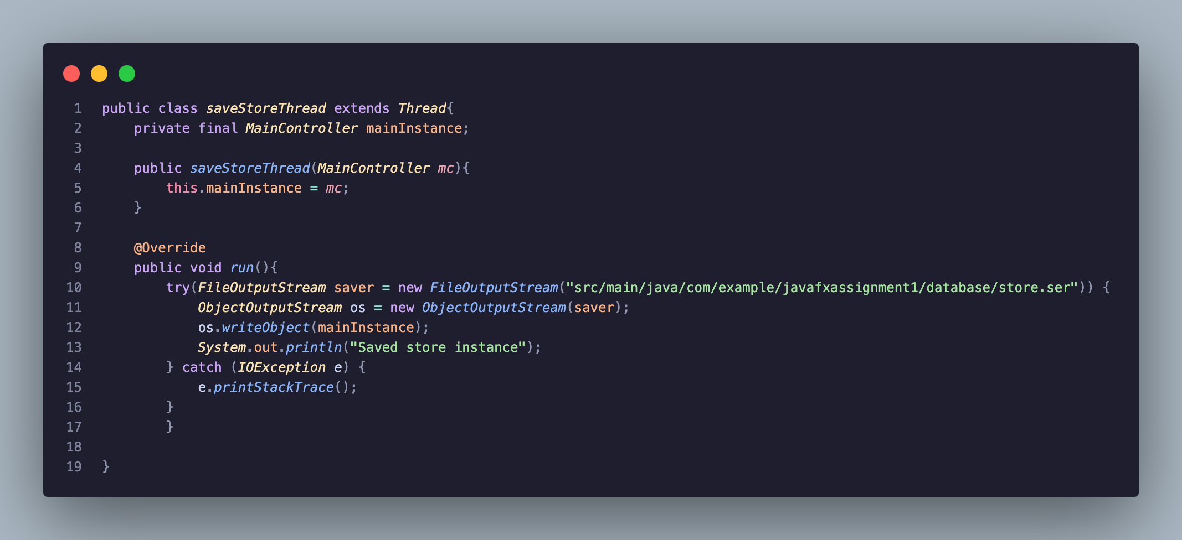
As seen above apart from saving to a .ser file and extending thread, this class contains near identical functionality to our previously demonstrated serialization. However on loading, the Main Controller instance is made null and reloaded with the saved instance. And saving is simply saving that Controller object as a blob of sorts in the serialised file. All of this functionality is overwritten within the special thread run method which allows it to be the .start() method for the newly created threads as demonstrated below:

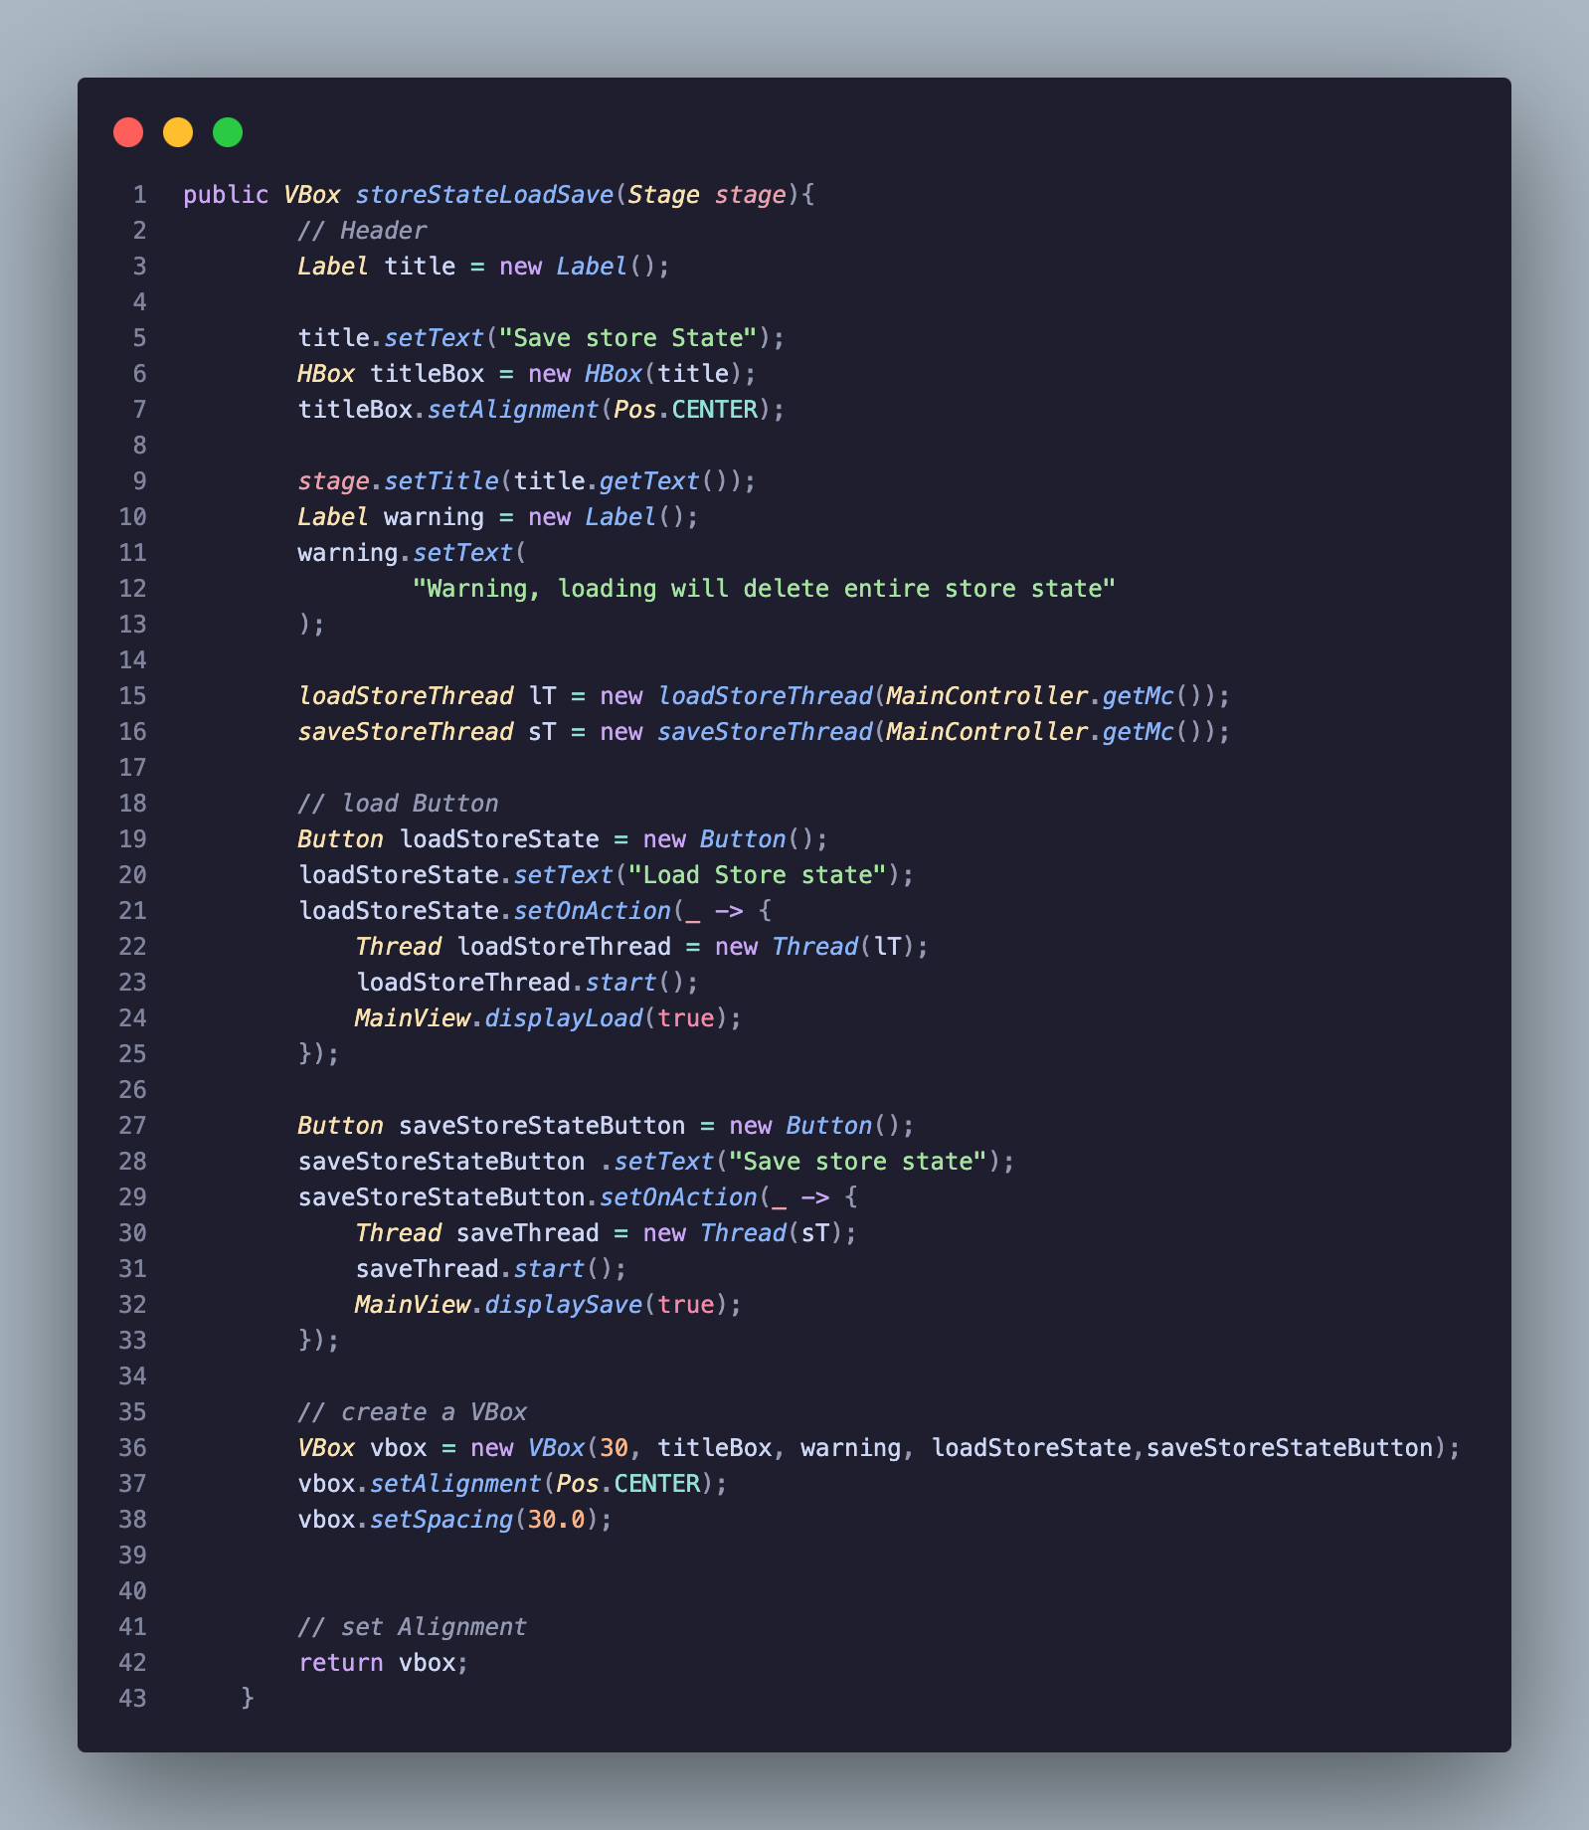
As demonstrated in my video, the saving and loading here runs on two different threads and displays a message upon each thread working.

Overall I do find the usage of threads quite compelling however in this scenario, I don’t believe it as necessary as here each button is being pressed at a different time and threads add no computational advantage.
The singleton pattern here is quite useful and I implemented it for other Controllers such as the DataController and CustomerController as it provides me with more freedom for usage of these controllers universally throughout the project due to the static nature of these objects while still keeping their storage objects persistent.

Stage 2 – Database connectivity and Builder pattern.

For the second stage of this Assignment, I had to install a relational database and create a normalised table and populate this table with data relating to my Computer shop.

SQLite: Why did I choose this database:

SQL is the most obvious and popular choice for a relational database and the database I have the most experience with. The main reason I chose sqlite is that it’s a simple SQL solution as the data is stored on a file in the project, opposed to other database solutions like MySQL or Postgresql which work upon linking to Localhost and creating a database from there. On top of this, upon submission, any interactions I myself have had with this database, will persist for correction such as tables created and inserted data. I did consider Postgresql given it’s interesting custom type feature however for our provided requirements and use case, I felt it would be better to keep it simple.

To connect to the database I first had to get the SQLite JDBC connection driver from https://github.com/xerial/sqlite-jdbc in the from of a maven dependency:
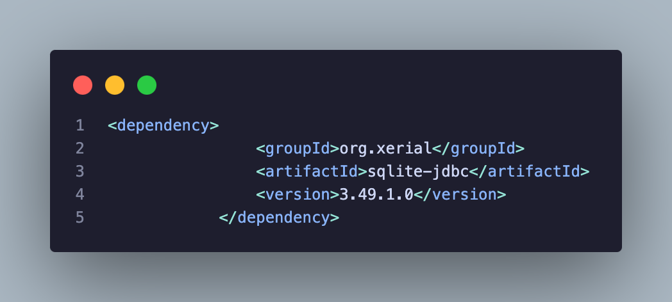
From here through my previous SQLite usage in last semesters project, I knew I had to create a .db file and this was in my database package in the src/main/java/com/example/javafxassignment1/database directory.

Before I could approach working with this relational data, I first needed to do three things:

a. Normalise the table I am storing
b. Apply the builder pattern to the object I am looking to store for rebuilding afterwards
c. Introduce the Data Access Object pattern

a:
As demonstrated in my last project and report, the customer table does hit 3NF however I will confirm this more here:

Table 1:
customerID (Primary key)
customerName
customerAge
customerBalance
customerEmail

Table 2:

productId (Primary key)
productName
productStock
productPrice

1NF:

1st normal form requires our table to have our fields to hold only value and as we can see that is the case here, there are no arrays being stored as values in the Product or Customer table. They also have primary keys of customerID/productId for identification. There are never any duplicated rows or columns due to this primary key and each column has only one value for each row in the table. Thus the objects already meets 1st normal form.

2NF:

For 2nd normal form the main idea is that there are no partial dependency ie the only dependence on attributes here are on the primary key. This holds completely true for Customer and Products however to illustrate my understandingm, for my previous submissions if for example we needed to normalise and store the Product table, inStock would be dependent on the product ID and the stock attribute. Thus Product does not pertain to 2nd normal form. To achieve 2nf in this, I decided to remove the instock variable given when a customer is purchasing, this check is implemented anyway.

3NF:

For 3rd normal form it focuses on removing transitive dependencies. This means no non-key attribute should depend on another non-key attribute. In our table each non-key attribute directly describes the customer/product identified by productID/customerID. For example, customerName/productName is a direct property of the customer, and so are stock/customerAge, price/customerBalance, and customerEmail . None of these non-key attributes depend on each other. Since there are no indirect dependencies via other non-key columns, the tables satisfies 3NF.

Although requested to do so, storing this data as seialised blobs woudl defeat the purpose of both normalisation and the DAO pattern.

B:

Upon investigating the builder pattern, I first tried implementing through the method demonstrated in the notes however upon reading further I realised this was the concrete builder system ie a pre-defined build system where you already know the fields being allocated to newly created objects.

From there I watched this video:
https://youtu.be/sZYfZrA-gA0

Which helped me understand creating a simpler more dynamic builder approach within the Customer class itself. I also applied this pattern to products and plan to in my own time eventually add it to purchases.

Here is my customer constructor after adding the Builder pattern:

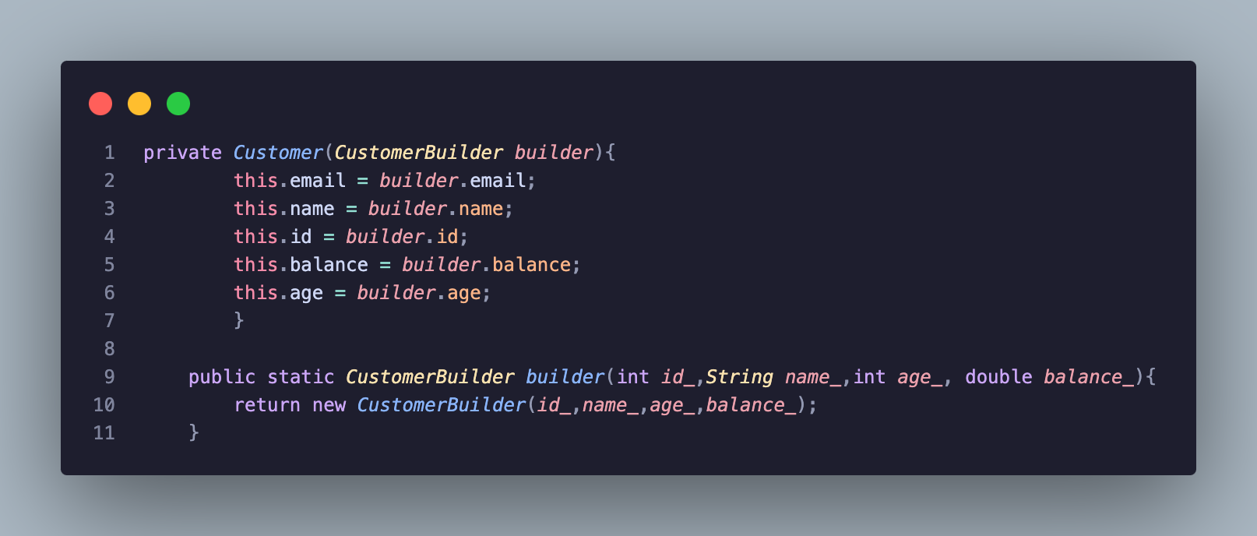
Then within this class I created a static subclass to build our customer:

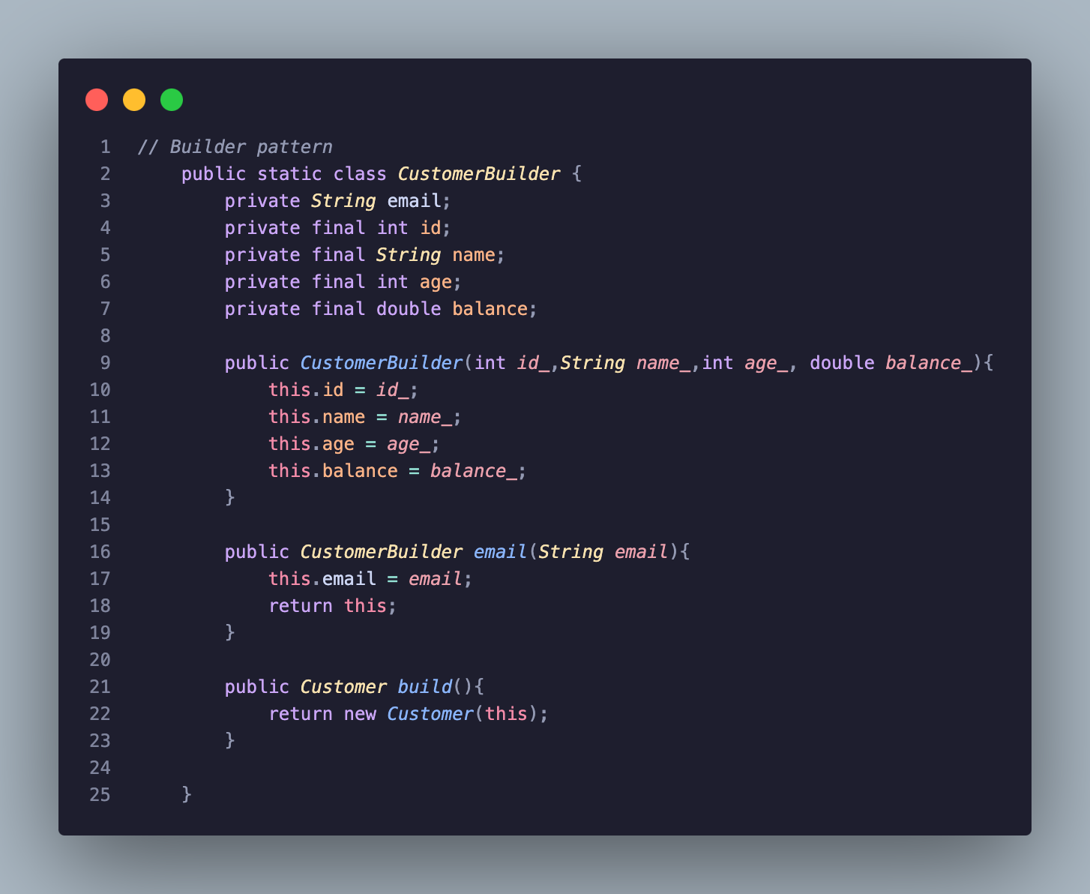
From here I figured out how to apply this builder system as opposed to standard constructors:

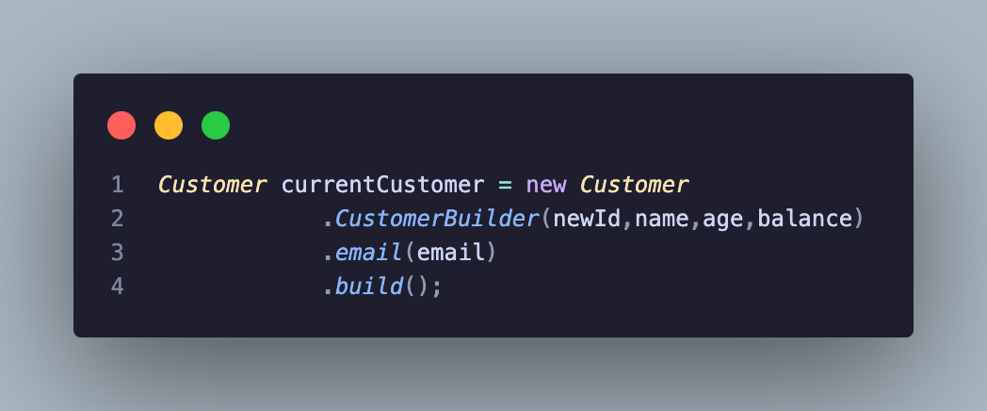
As seen above rather than making a standard constructor, we use the builder methods which returns a customer but not only this, as seen with the additonal email method, it allows for optional attributes to be built, although in my system there are not situations where a user is able to optionally not provide an attribute

C:

Finally adding the data access object pattern in which for implementing this database I created an interface that allows for easy access to interacting with the database, very similar to making an ORM.

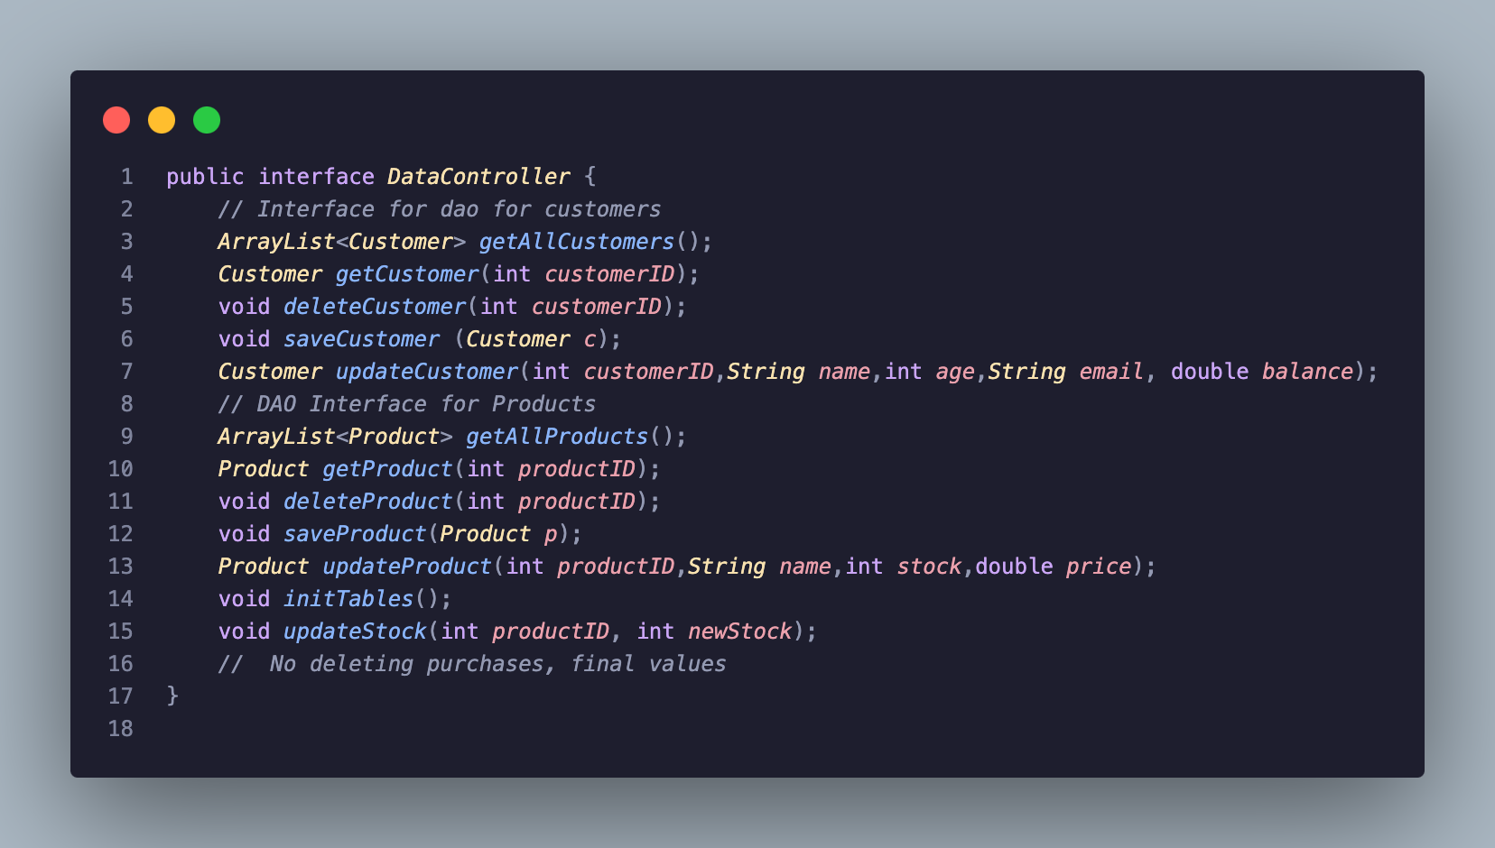
Here the methods I need to implement include, getting/loading in customers/products, deleting customers/products, saving/inserting customers/products and updating customer/products data. This allows us to interact with all the potential data related to objects.

Implementation:

Now that all of these features are implemented I was able to design and implement those methods above which will be demonstrated in my video first we needed to create the connection to this SQLite database:

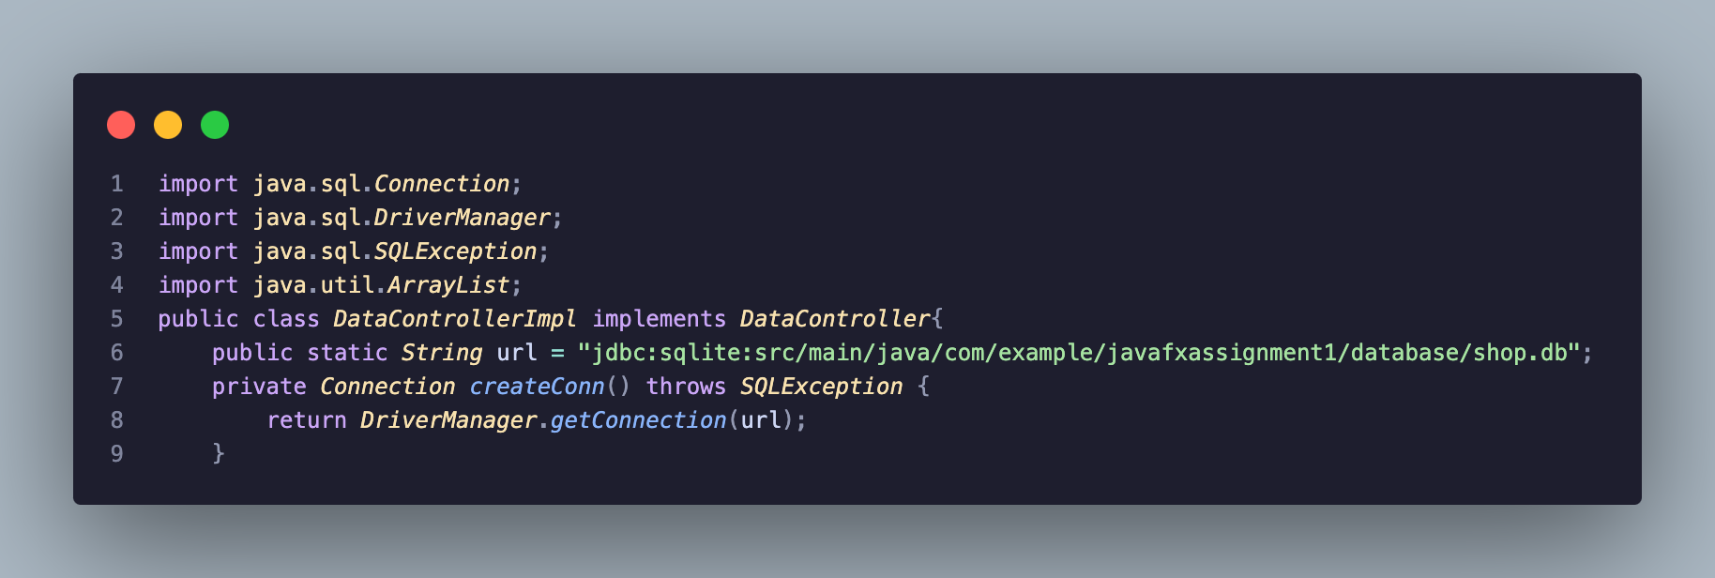
Now that a connection was created and declared as static, I was able to use this persistent connection to do all of my database operations throughout the project and here’s some of the sample data in some queries after registering some customers and making purchases:

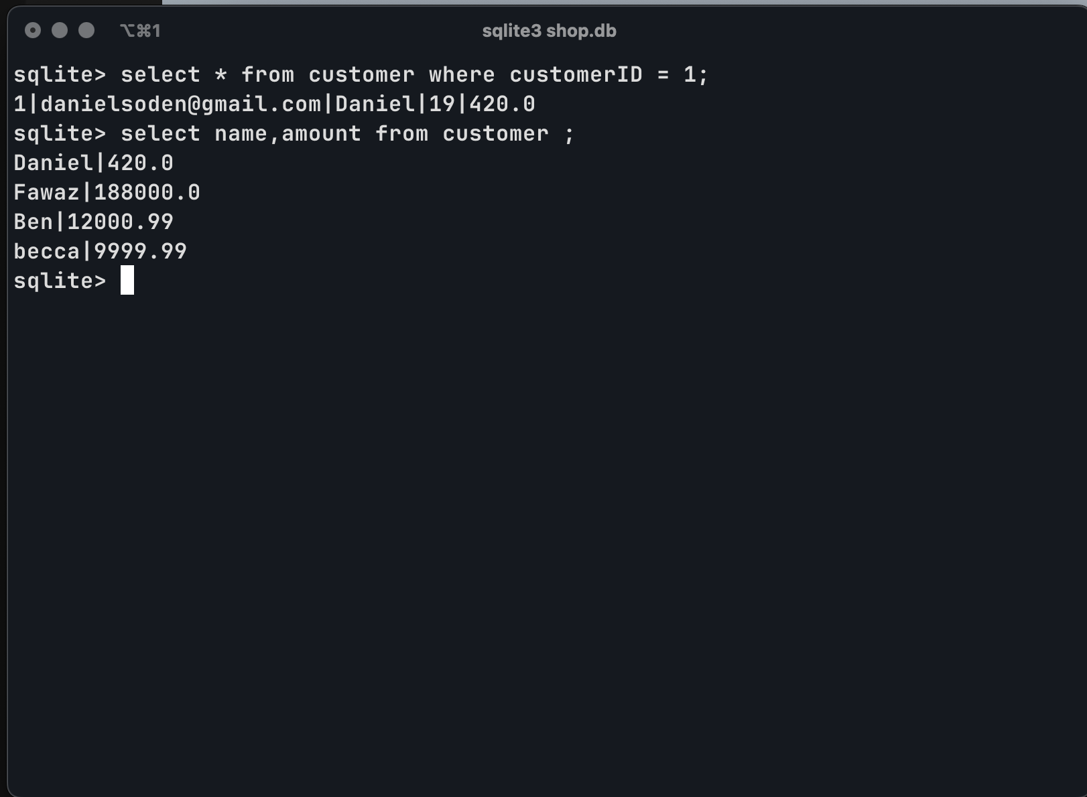
Here are some sample code for my implementations:

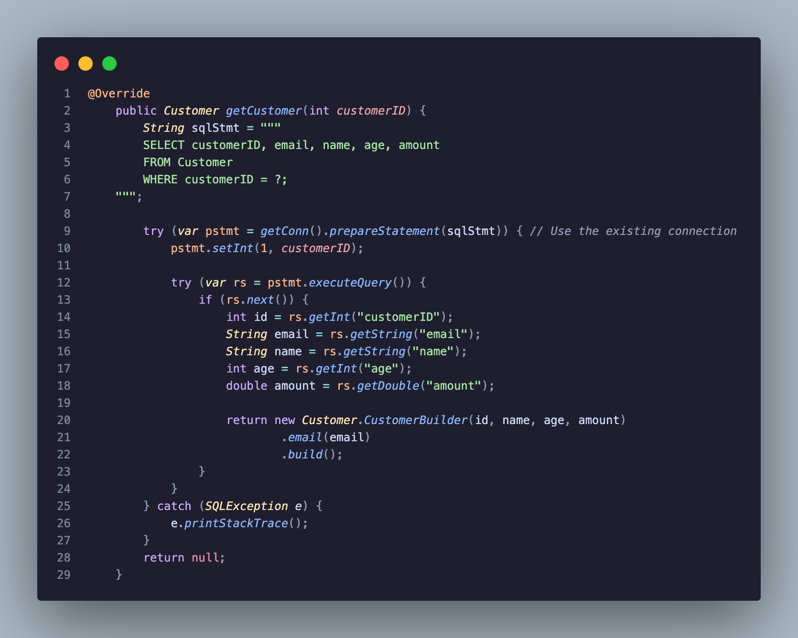
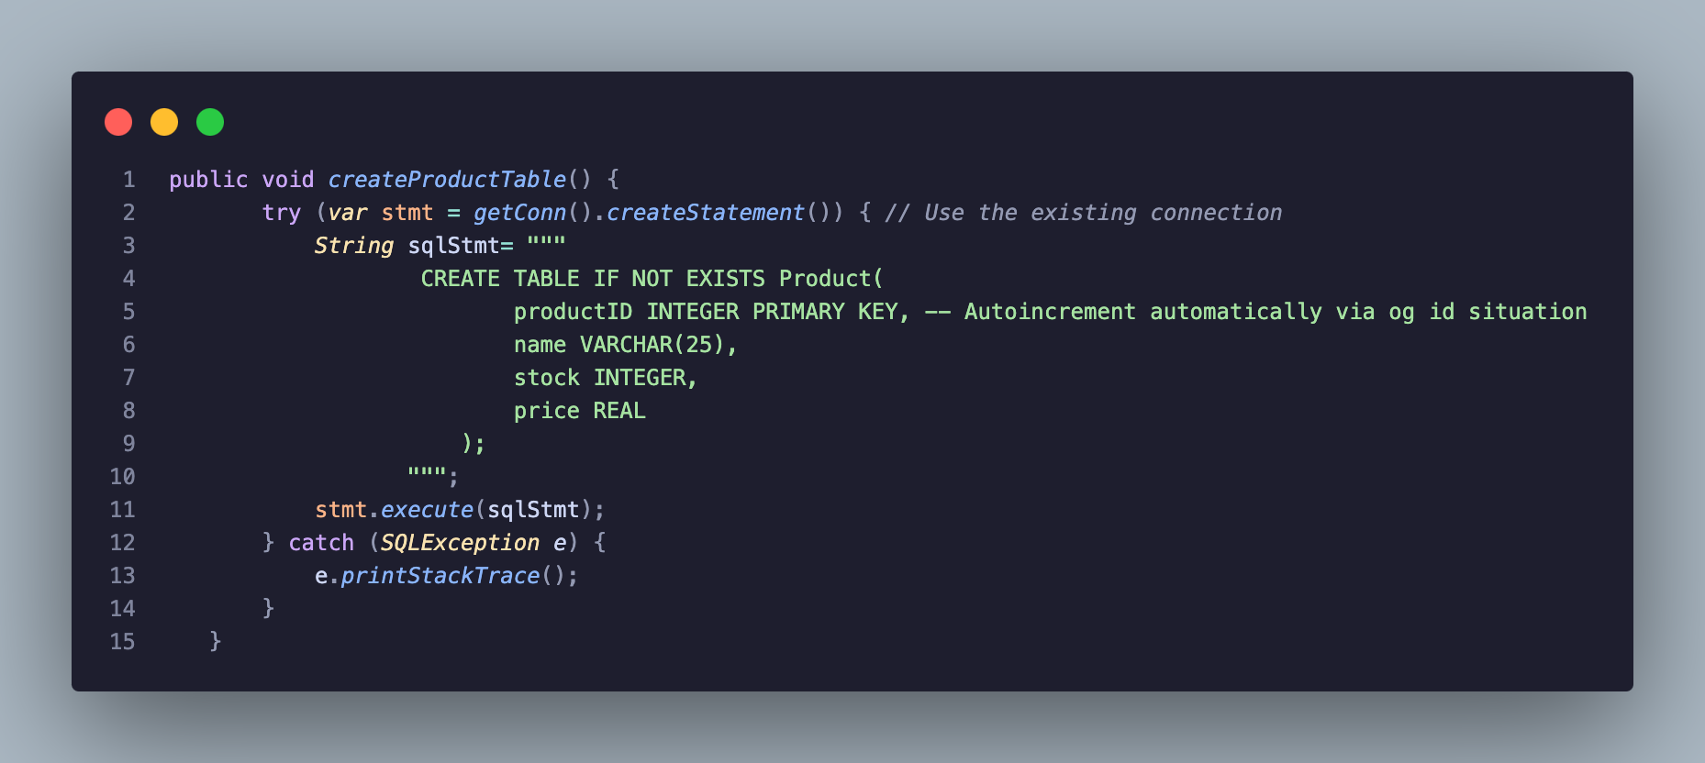
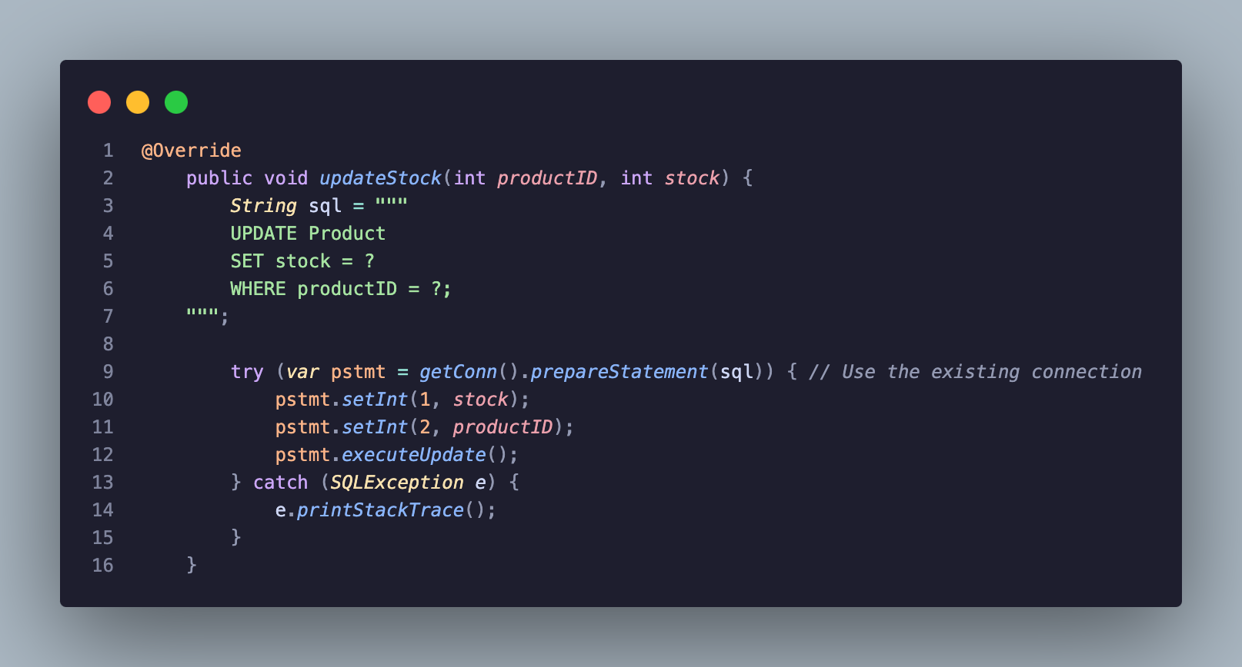
Stage 3 – Heap And Stack Experimentation.

For the final stage of this project, the requirements were fulfilled in a completely separate Java Project as it did not fit in in any way in the JavaFX computer shop.

For this experiment I designed two methods which simulate the creation of a large amount of large objects (longs) in which over time the allocated memory fills up and we need to measure three particular areas:

1. How many Longs I can create
2. How long it takes for Memory/Stack overflow exceptions>
3. When a slow down occurs (May casue issues given the good hardware I am using)

From here I will present these three experiments in the form of tables.

Given this is an experiment, I must make sure all variables apart from the amount of memory being allocated and the data structure being used, the experiment loop will be identical.

My experiments follow the same flow, I init an empty array list containing arrays of longs. Then I mark the start time, from there we have infinite loop through recursion or iterations where a long array of size 1000000 is added to that array and then the amount of objects made is tracked, we look at the amount of memory left, and see how long it takes to add that object

Experiment 1: Heap:

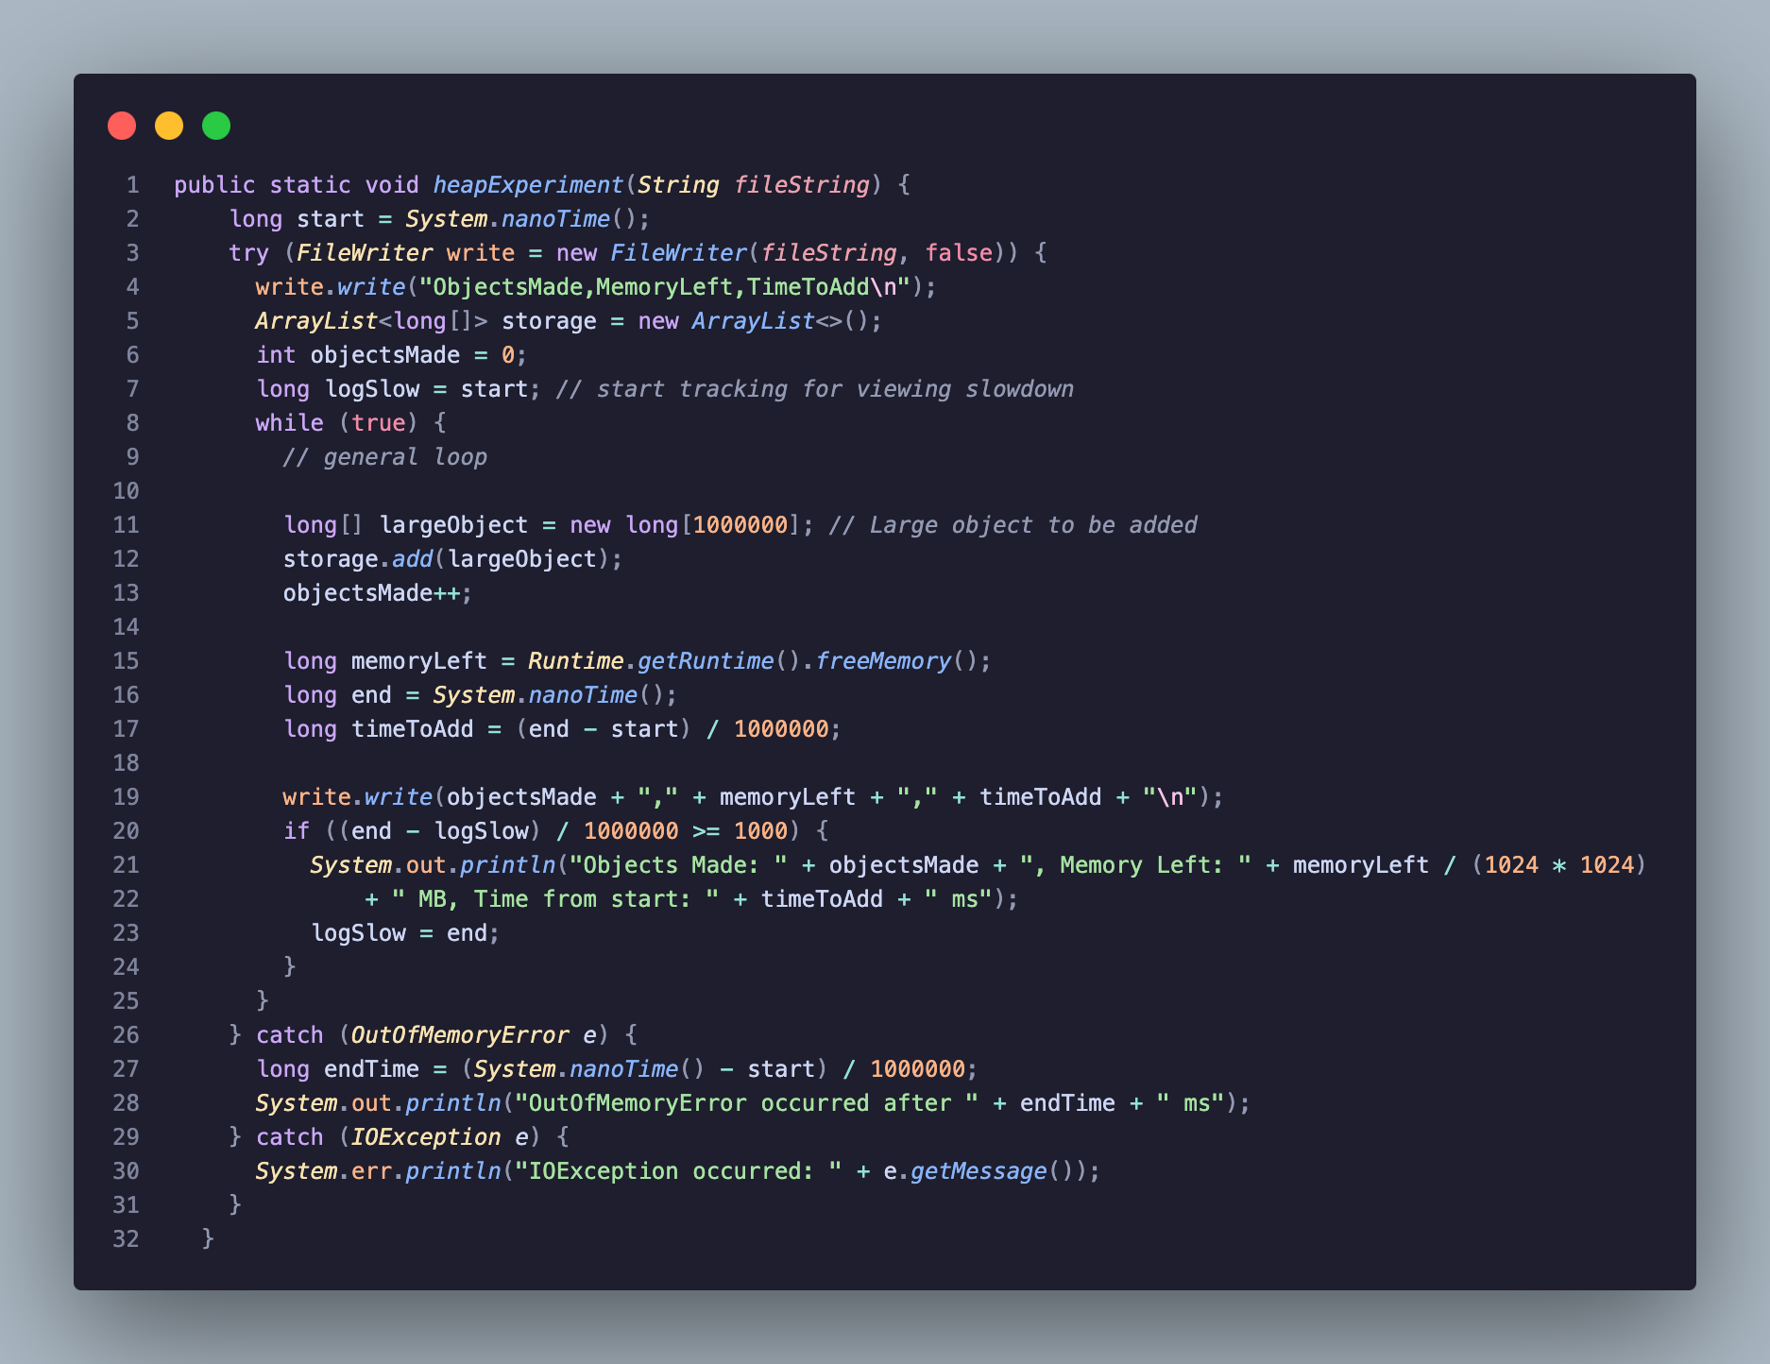

The code snippet above creates an infinite while where longs are added continuously until after using the two different experimental flags, it errors and as its looping it records the time it took to write so we can see when a slow down occurs, memory left and how many objects were made.

To test this code we need to use custom java runtime flags to allocate min and max memory to the heap here is a snippet of the bash script flags for the heap.

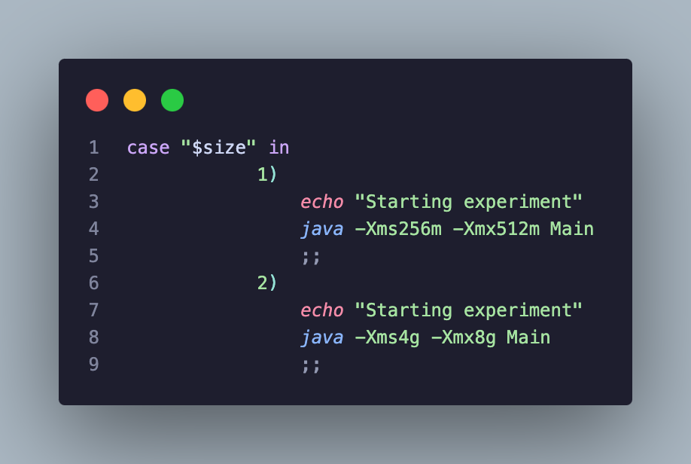
We either assign a min of 256 mb and max of 512mb or min of 4GB and max of 8GB.

After running each here is some sample data towards the end.

Smaller Allocation:
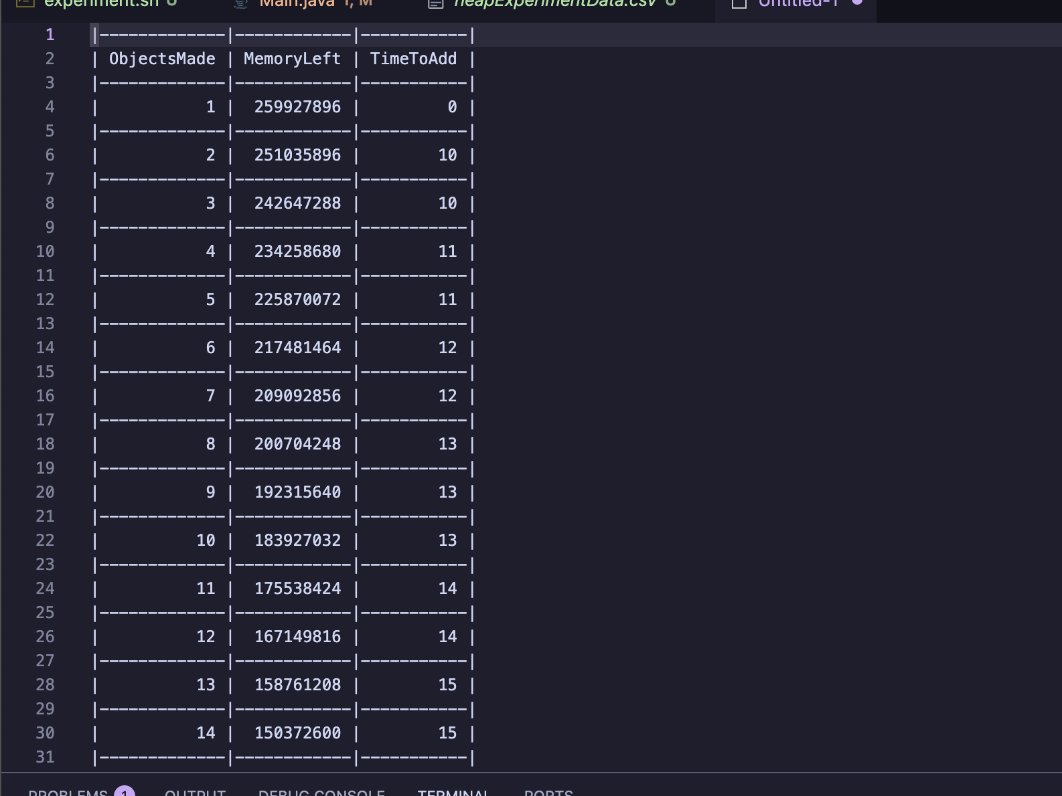
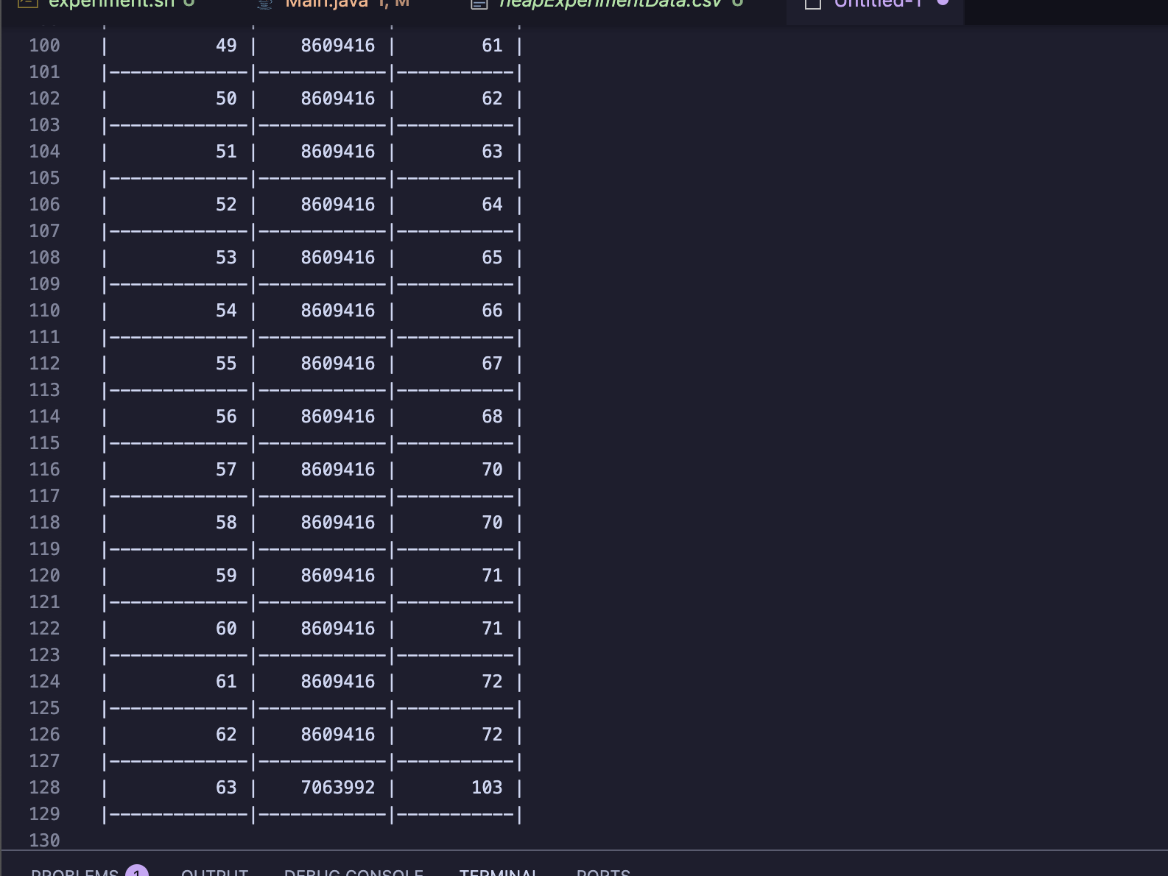
We see above that towards the end near our out memory exception, the time to add increases significantly from 72ms up to 103ms.

From the small allocation we made 63 long arrays.

Large allocation:

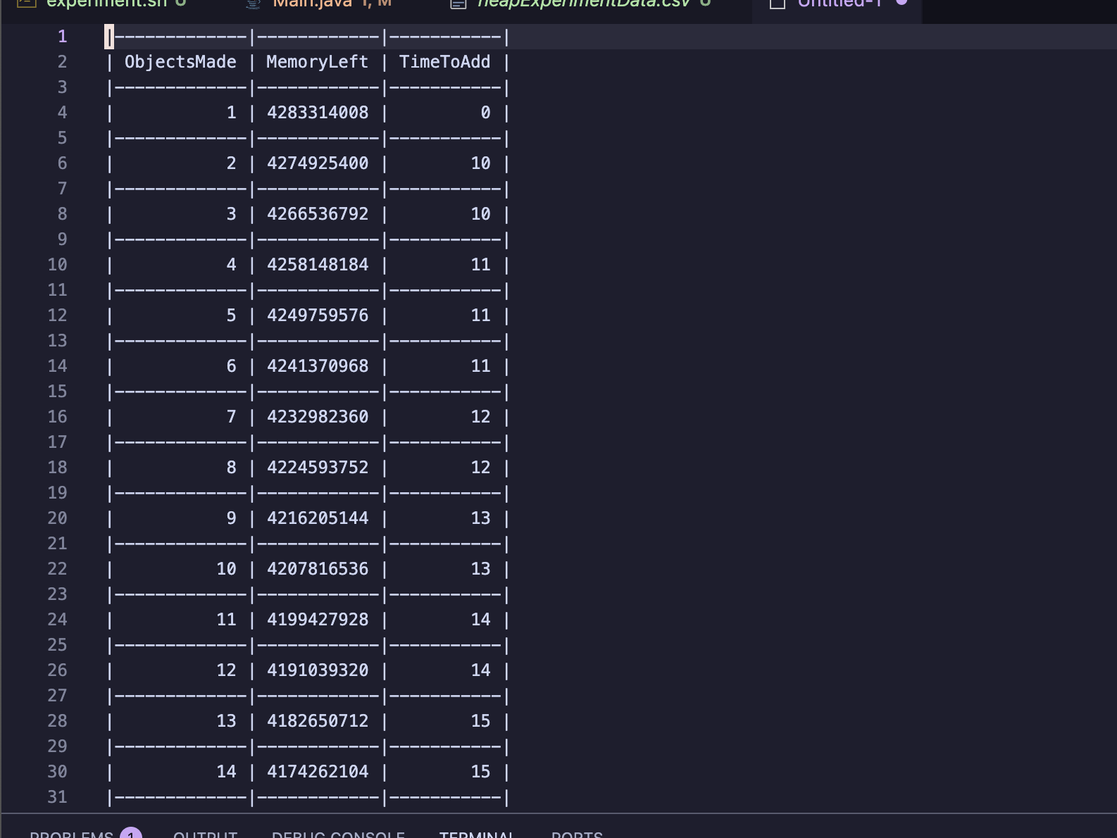
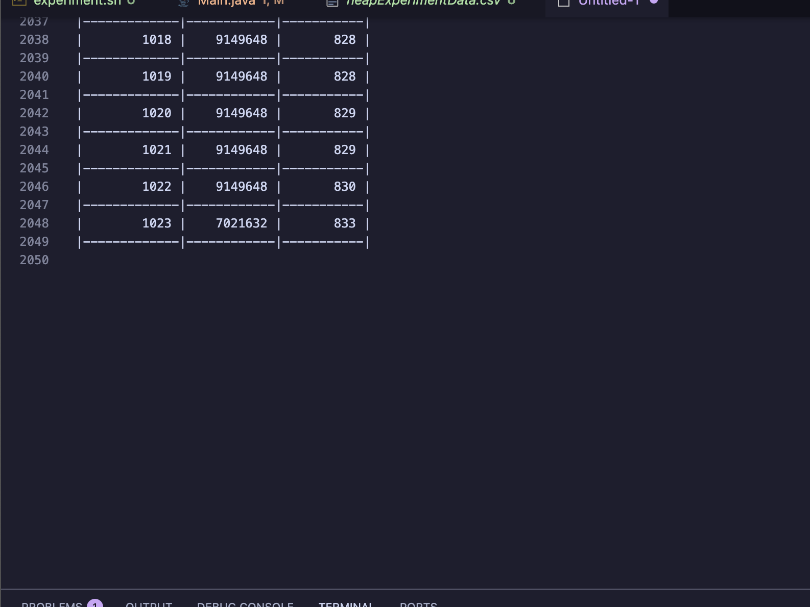
In the larger allocation we can see how the allocated memory progress where initially we have 4gb memory to play with and then near the end we have 8gb. Not only this but we are able to create objects much quicker before out outofmemory error seen by yhe only 3ms delay towards the end.
We in total were even able to create 1023 objects here.

Experiment 2 Stack:

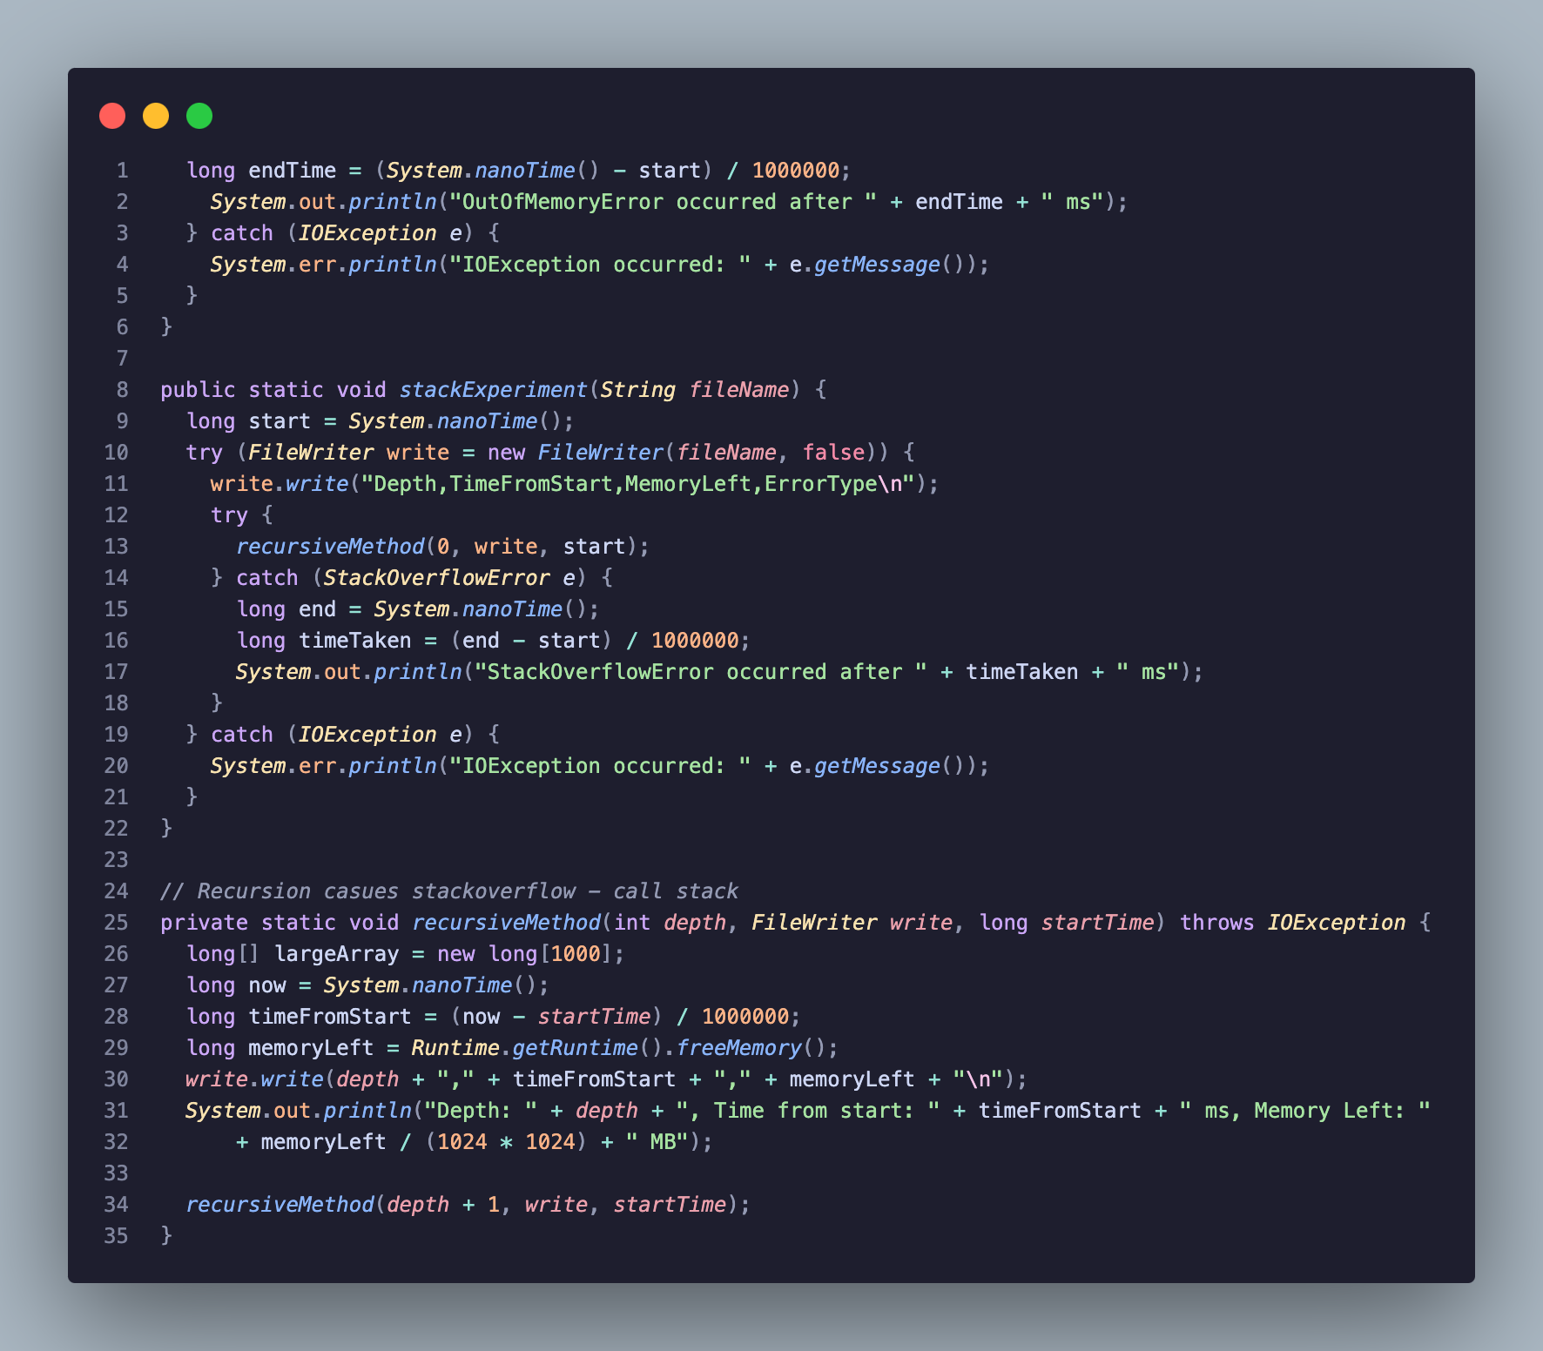

In the above code I utilise recursion in order to give the Arraylist in order to create this many long arrays and add them to our storage until the recursion hits a stack overflow exception. Here we track the depth in the call stack we get to , the time from start and the amount of memory left.

Ideally I would’ve liked to keep the allocations the same but wiht how they handle memory that just doesn’t work here.

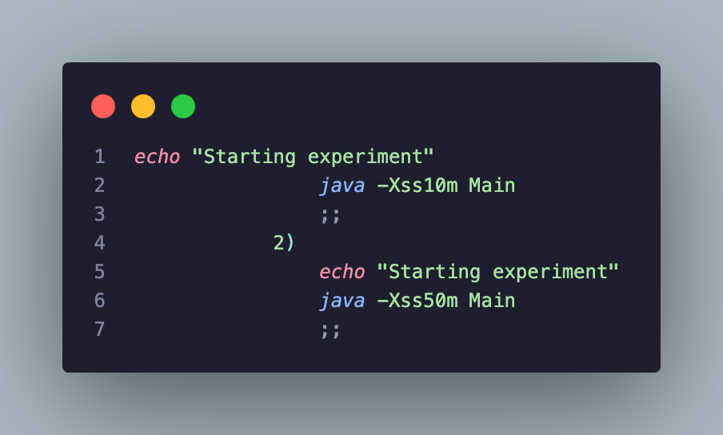
Here for the smaller size we allocate 10mb and for the alrger amount we allocate 50mb.

Small Allocation:

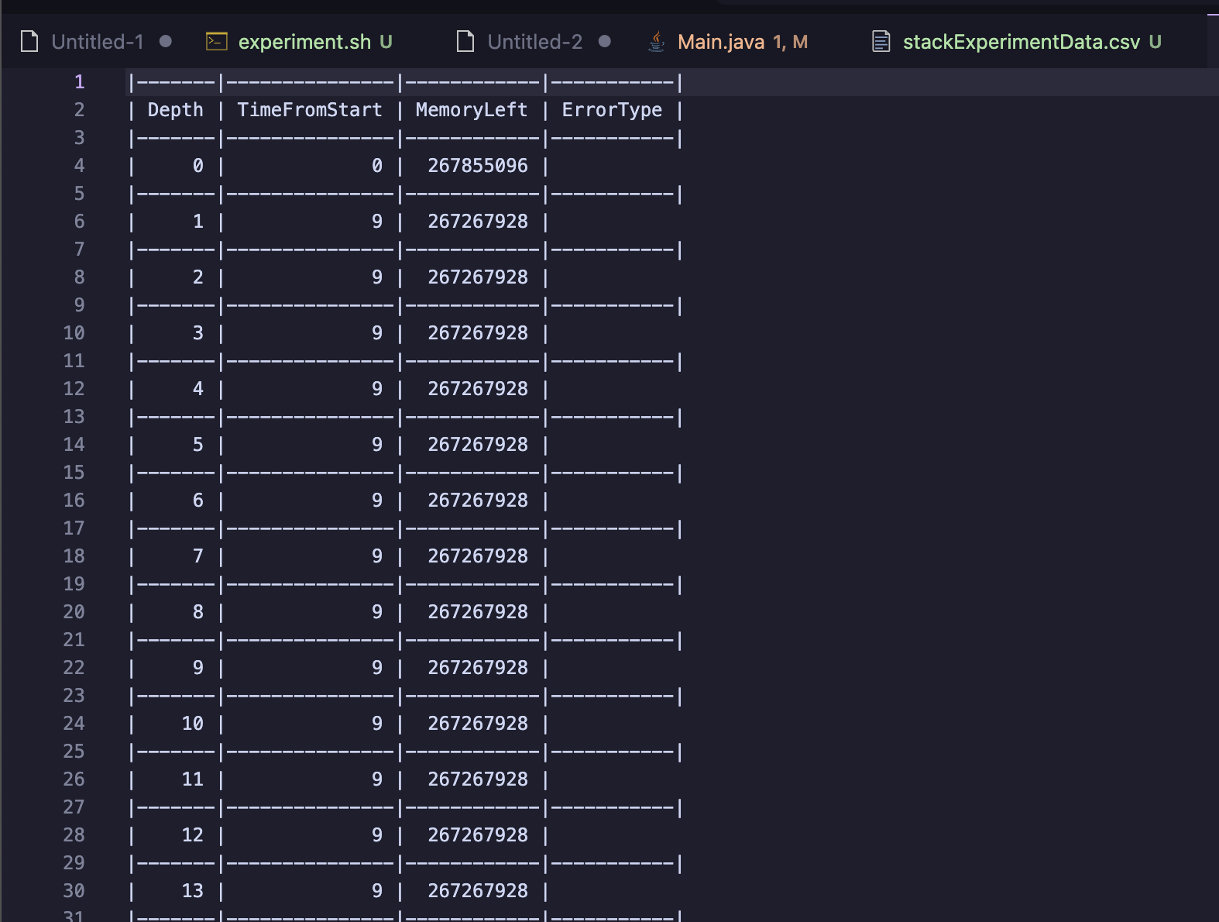
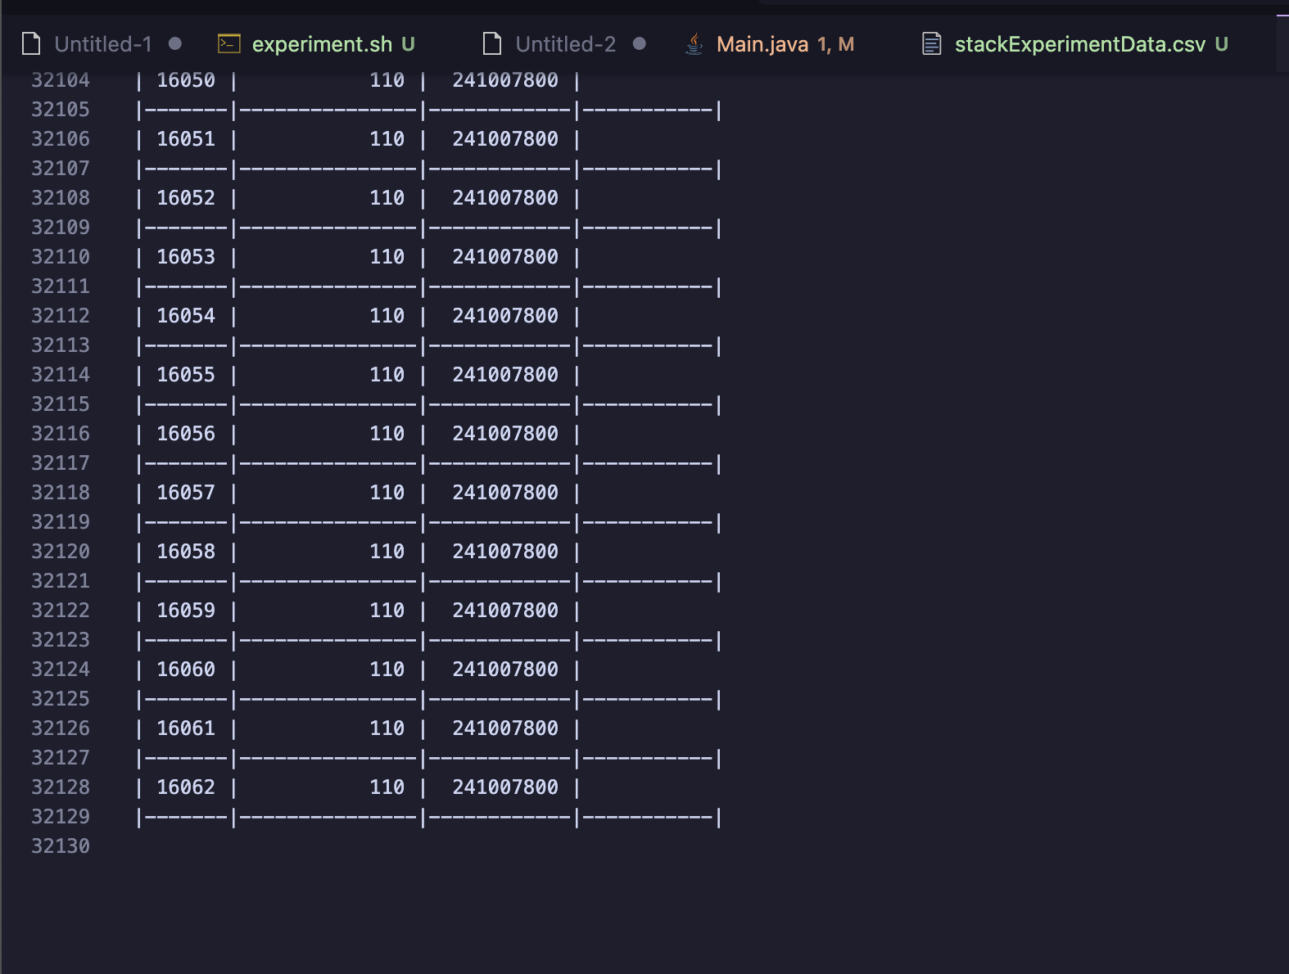

We can really see how efficient recursion is given how despite the small allocation we still were able to make that many objects and it is easy to tell the drawback here where the slowdown hit immediaetly around 9ms where by the end it took 110ms from the start to make final objects.

Large Allocation:

Strangely enough the results above with the larger allocation show little to no difference in both depth and time since start in terms of execution. It may be in an error in my testing but I am allocating much more in the larger run

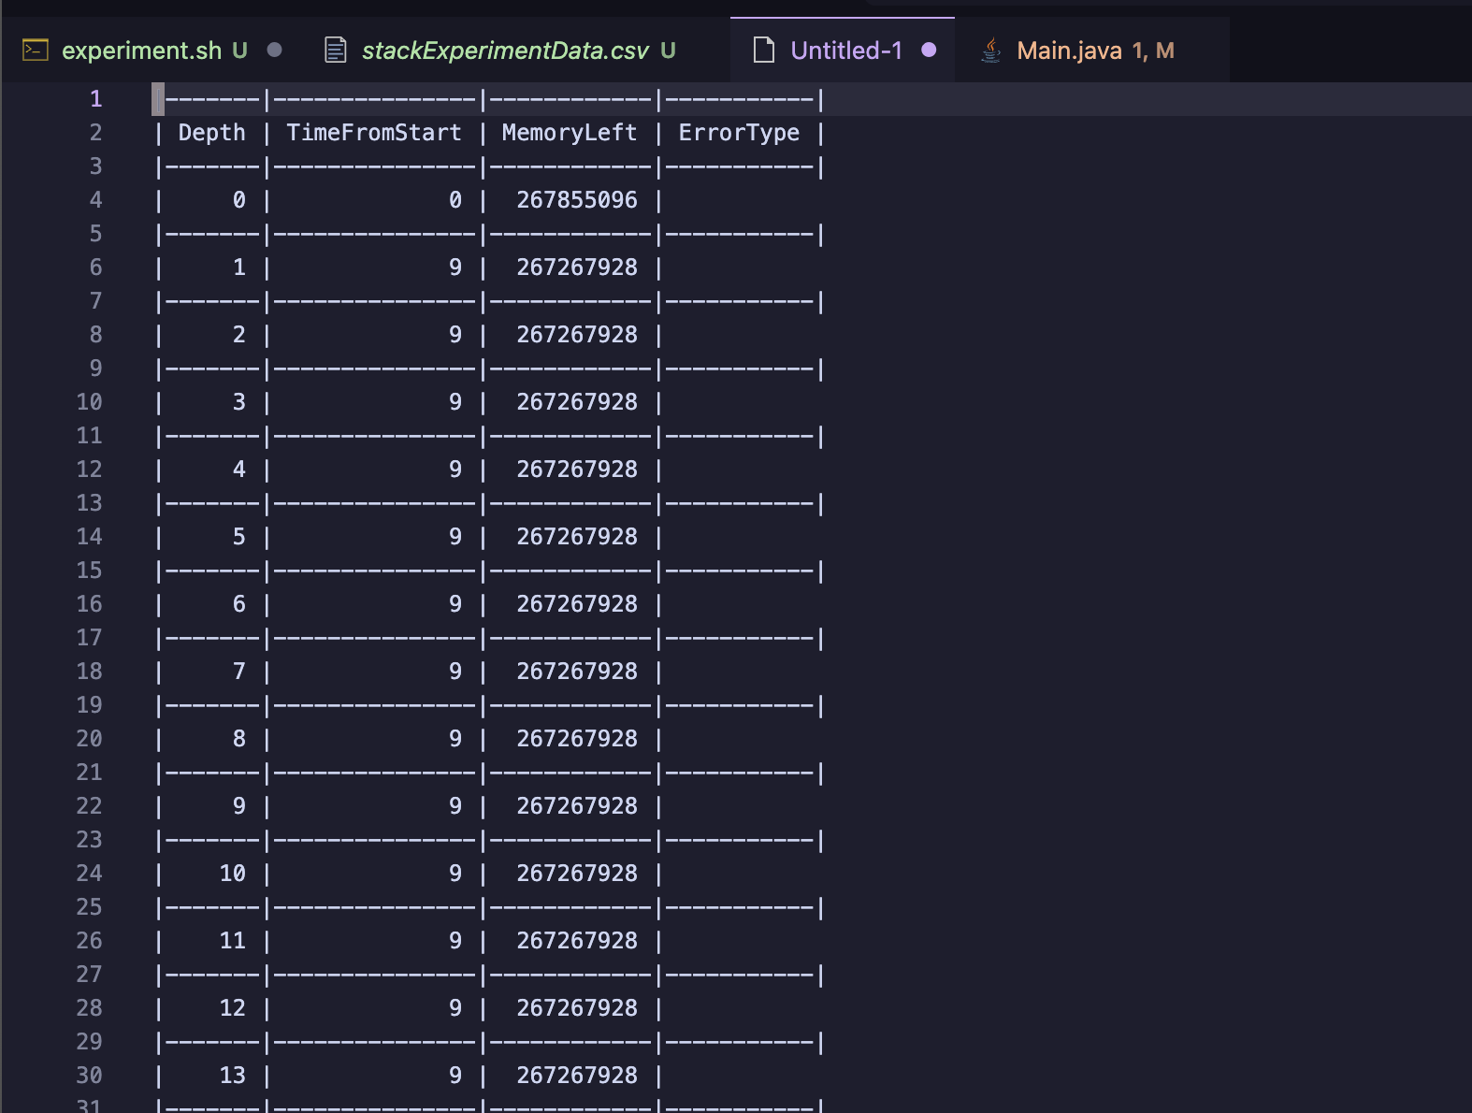
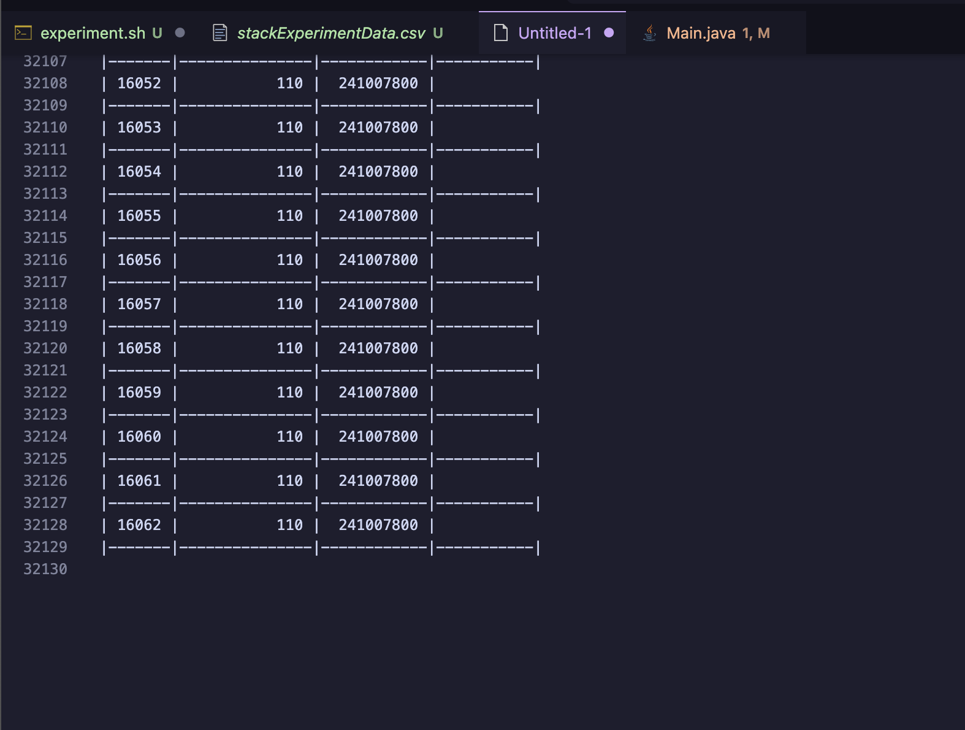

For this experimentation in conclusion we see that the stack is generally superior for creating objects as we are able to get much quicker times of creating objects from start and much more objects however the recursive calls take a signficantly larger amount of memory

