Daniel Soden Assignment 6 neo4j

1.

I started by execcuting play movie graph and then in the second page, I was prompted to execute this CREATE graph command:

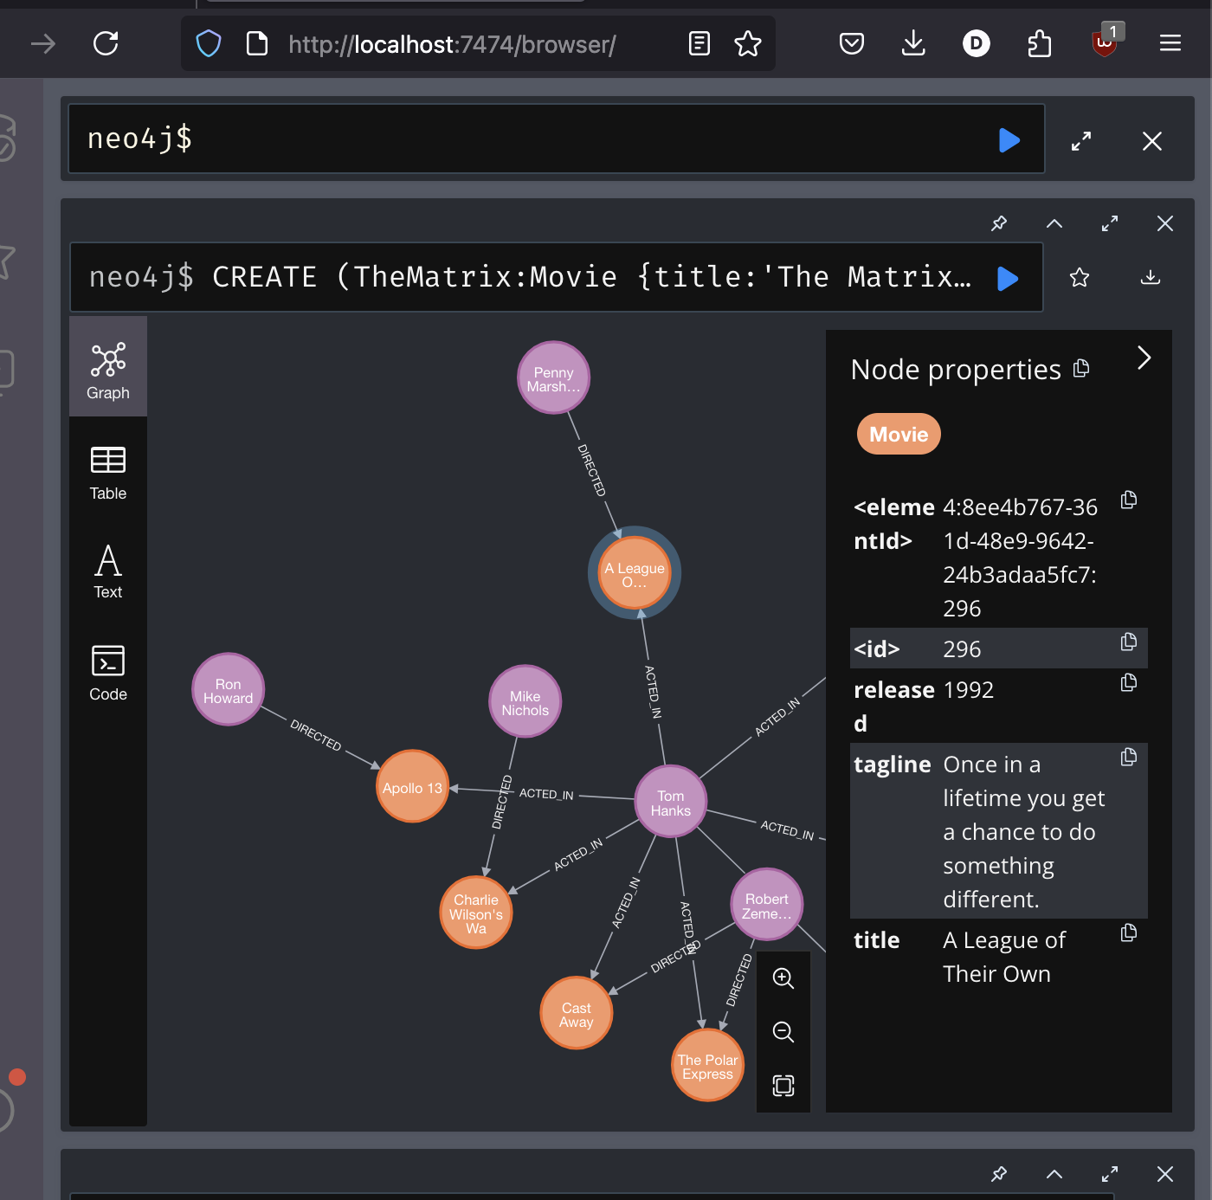
Then after running this command I was able to see the number of vertices, ie the nodes and the number of edges being the amount of relationships in the graph.

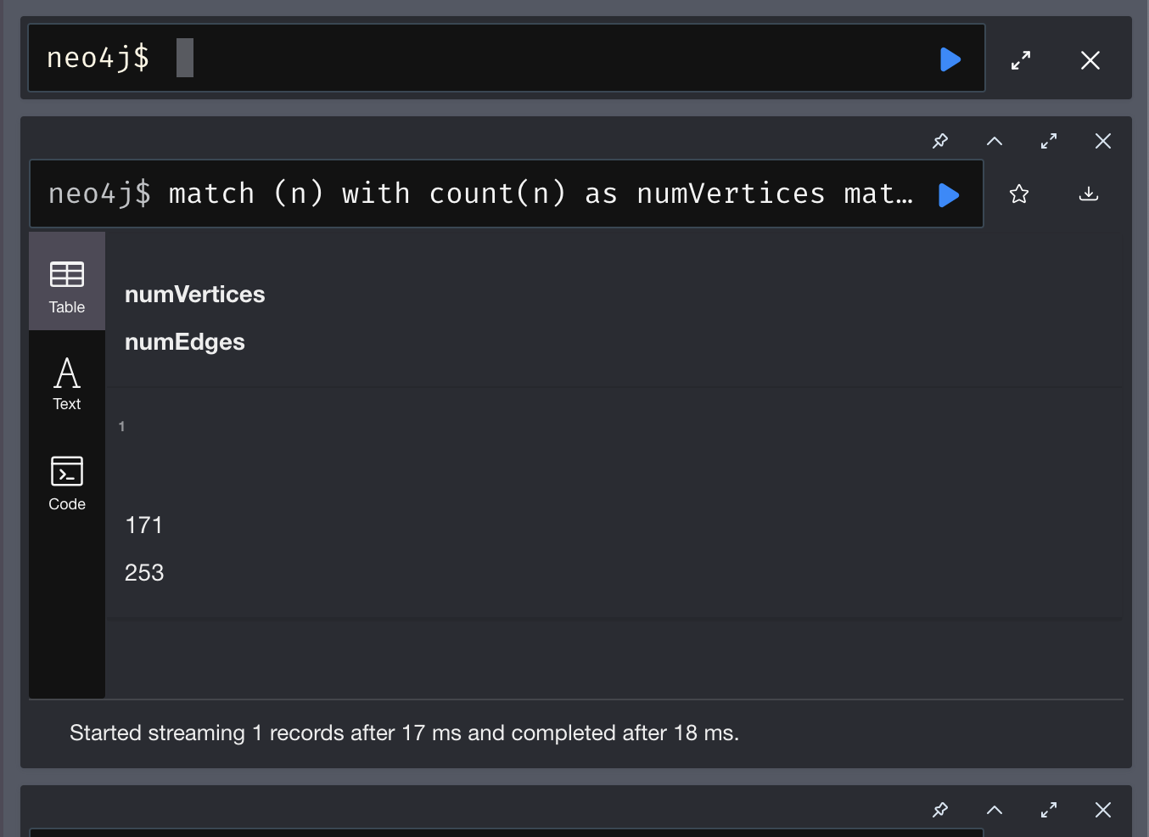
Then to view all the nodes and their relationships I ran this command:
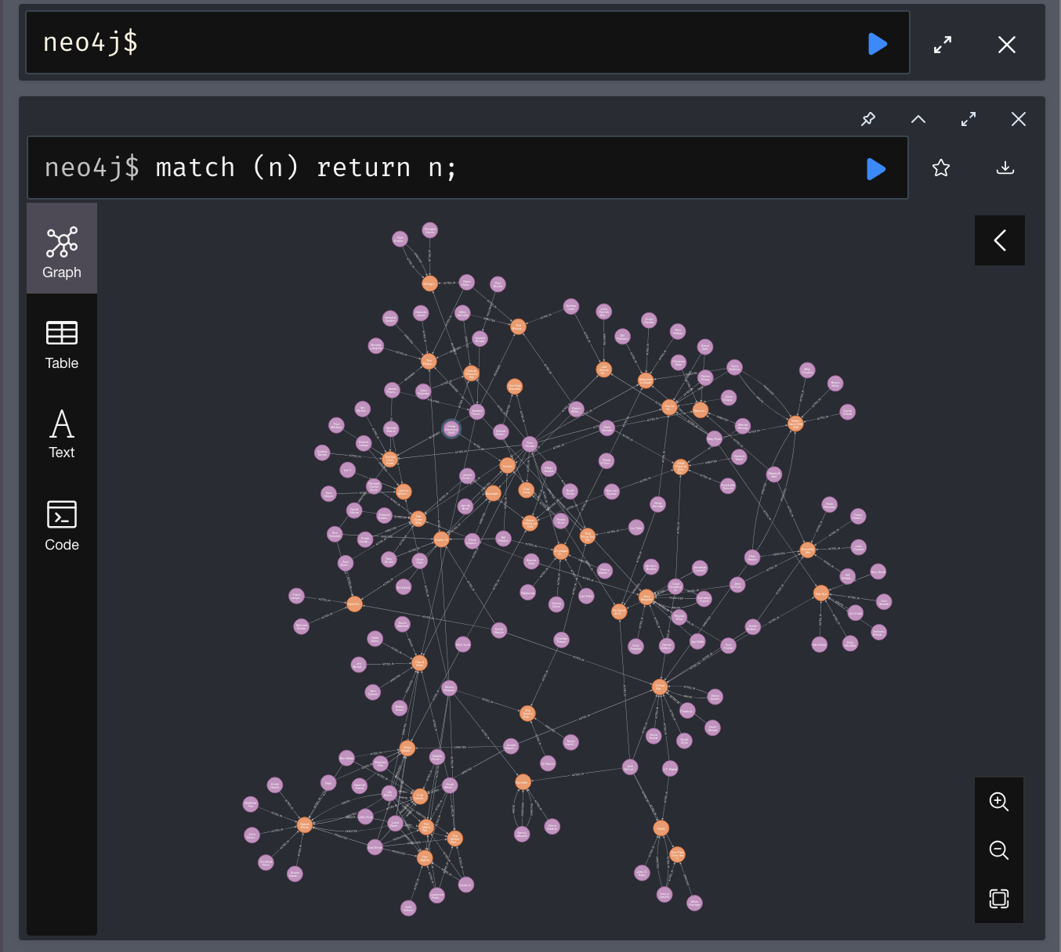
Now that our database is all setup and verified, we can start on the core db maintenance.

