Assignment 3 Daniel Soden

Task 1:

1. To start off this assingment I had to download the bank.json record, create the banks db and create the clients collection

Commands
1. use banksdb
2. db.createCollection(“clients”)
3.db.clients.insertMany([]) - Inside square brackets includes the banks.json pasted in

Output:

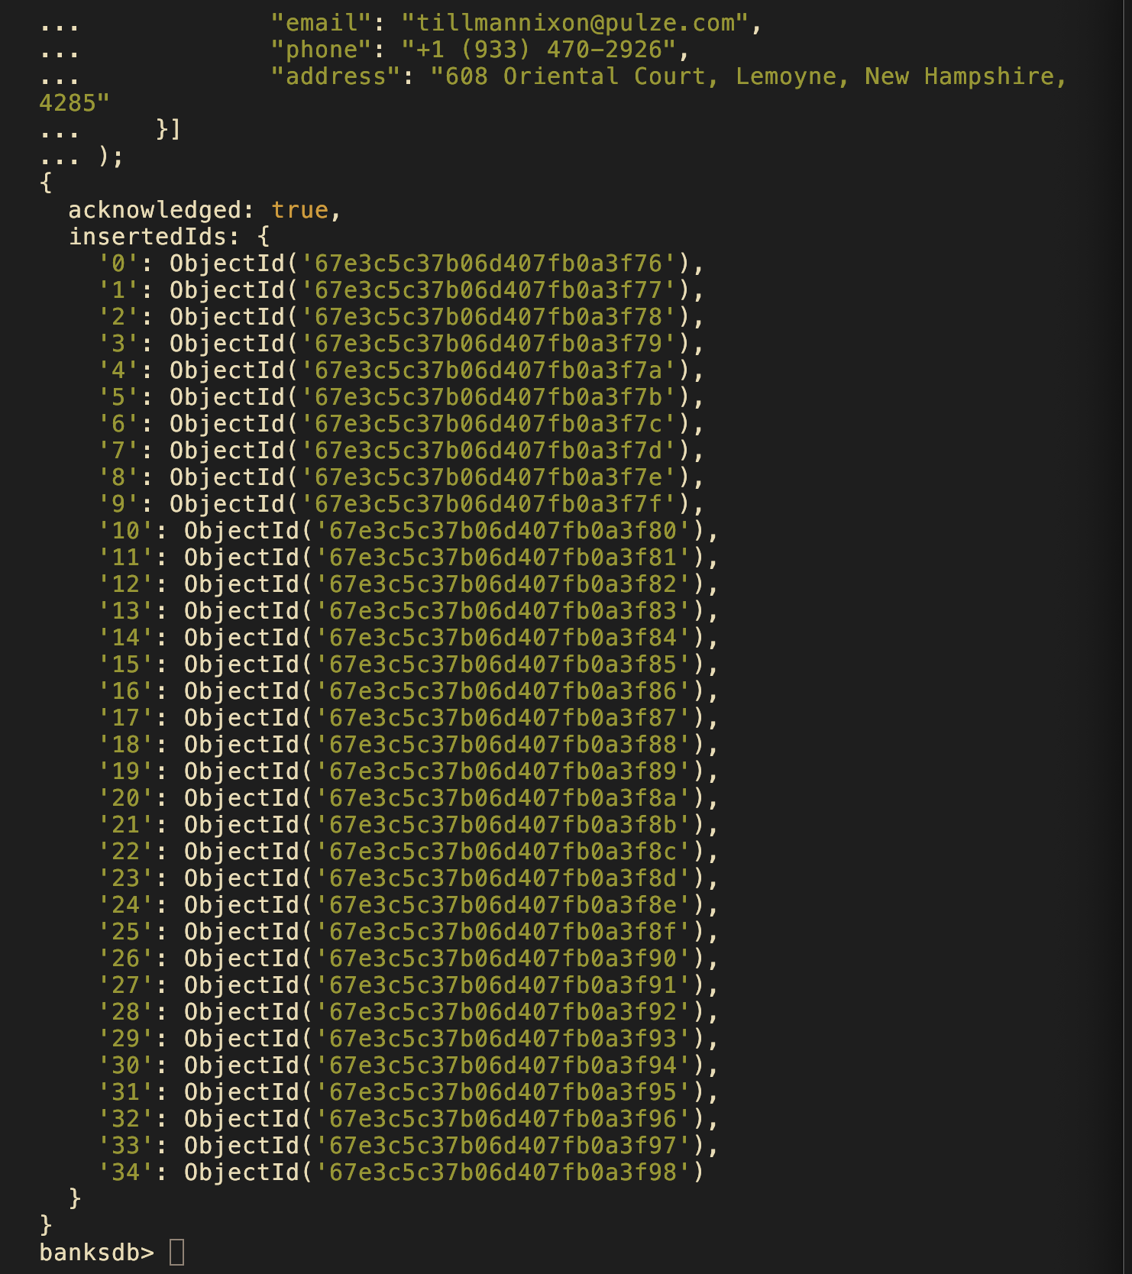
.

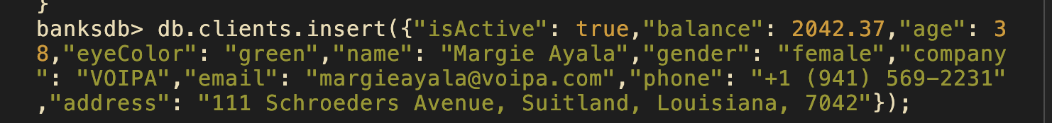

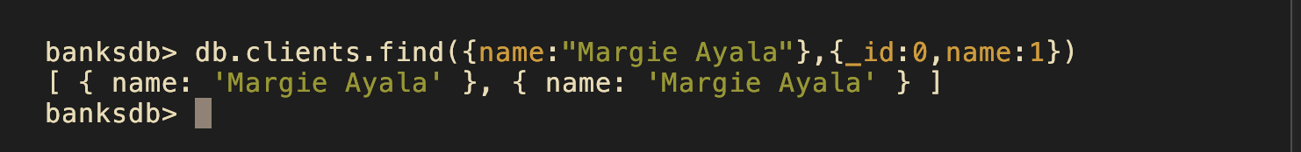
2.

To fix this duplication, I had to delete those two entries with this command:

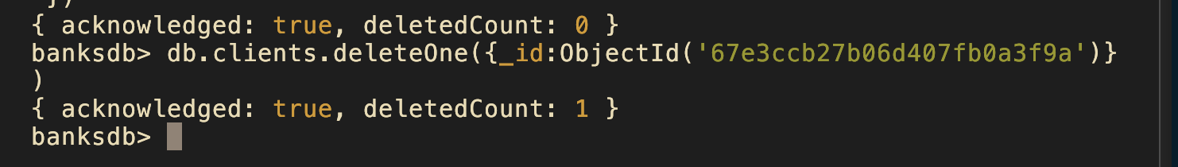
Then to fix the original mistake I added a unique index on email given the original Margie Ayala has a different email to who we are inserting

Directly counting the documents with that name would also be helpful in this scenario for verifying/debugging (Only says one just because I was in the middle of debugging, there’s two infact):
3.

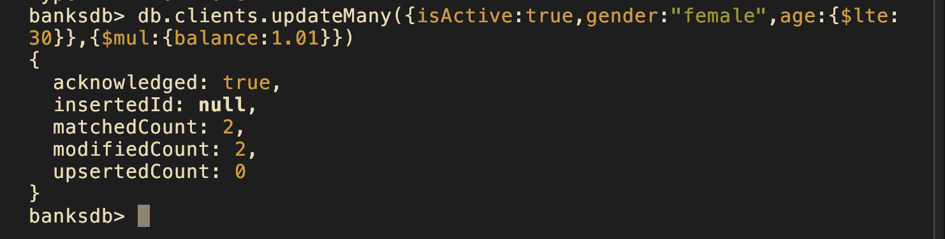
For this update I initially thought it would make sense to use the set operator, however since we are multiplying balance by itself, it makes more sense to use the mul operator to update this attribute.
Please see updated balance below.
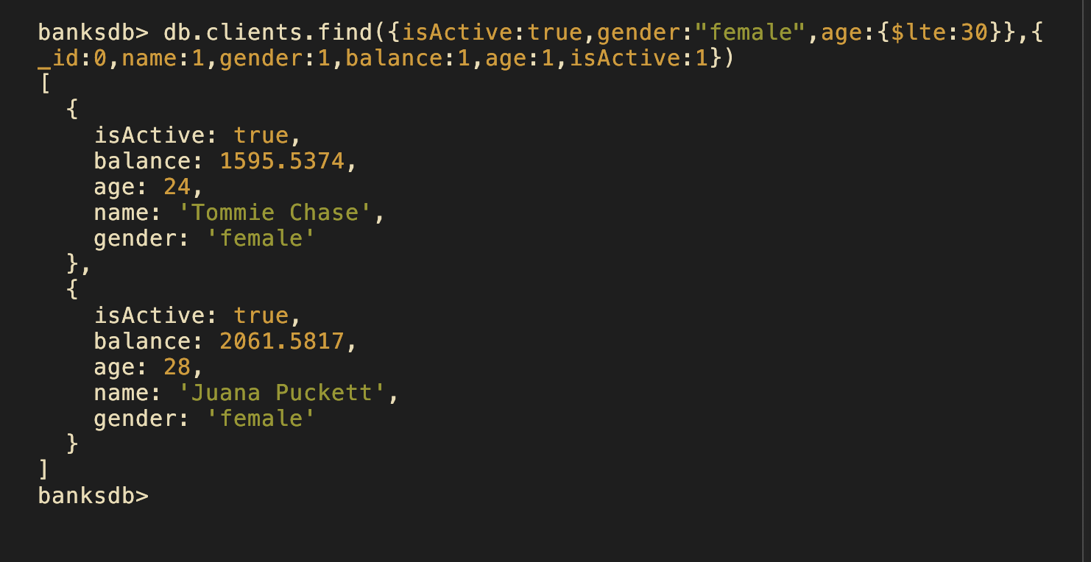
4.
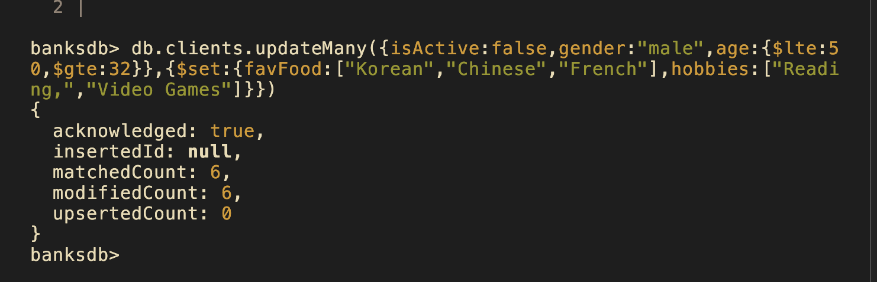
To add the new fields for favFood and hobbies, we simply do an update many on the inactive males between the ages of 50 and 32 (Middle aged). I do see now how great of a strength nosql is compared to relational databases in this scenario as we can add new attributes on the fly.
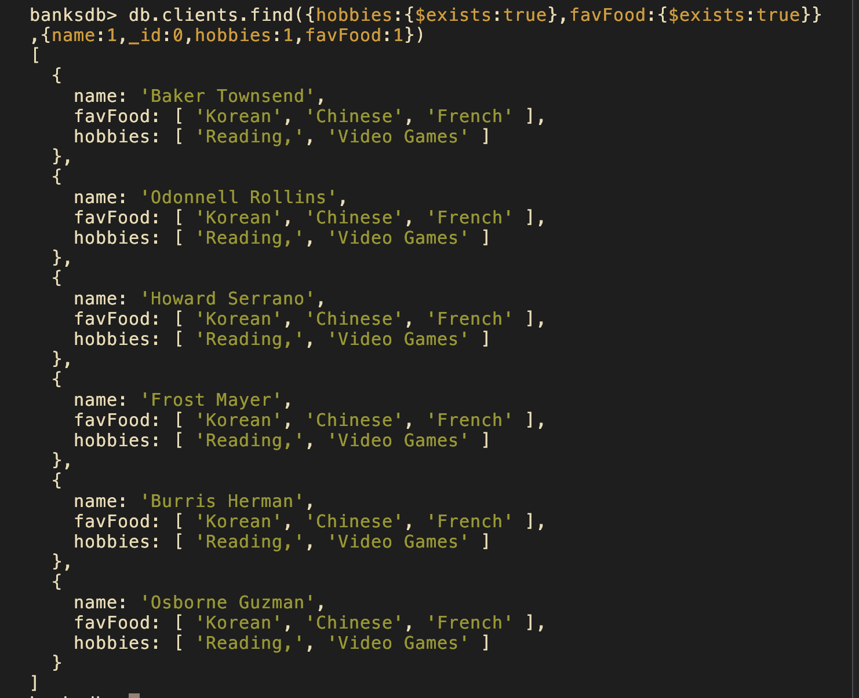
5.
Then to update the inactive males with green eyes, to reflect their disinterest in Korean food, we simply set the array the not include Korean food. There is definitely a more efficient way to simply extract Korean food out of this array however for now this solution for such a small dataset works okay.
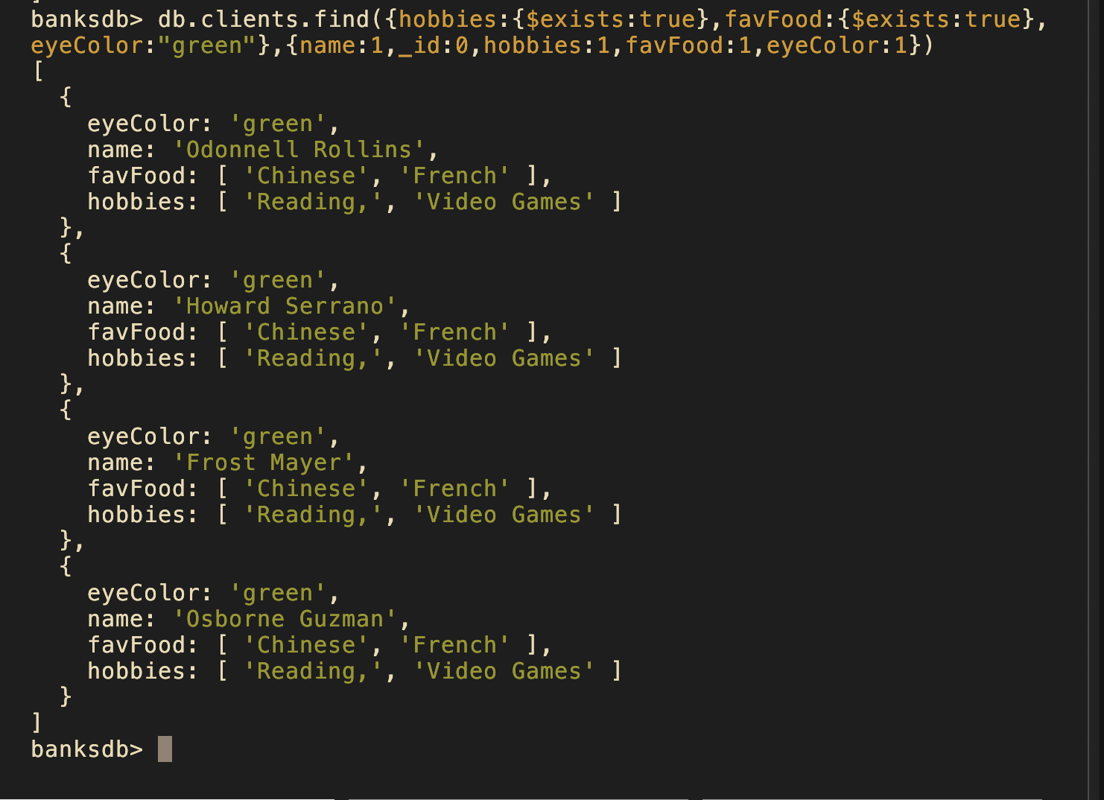
Task 2 Aggreg and queries JSON

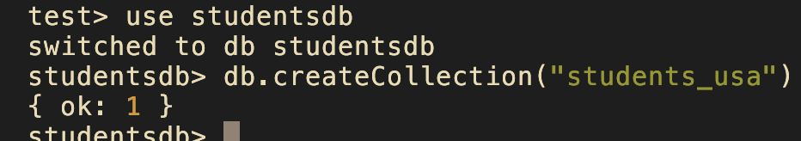
To start us off I created the studentsdb database and created the collection for this database. Then using the mongoimport command I filled that collection up with json documents

This particular task will take a lot of aggregate commands just from reading their descriptions, however for the first one a find will do just fine.
1.
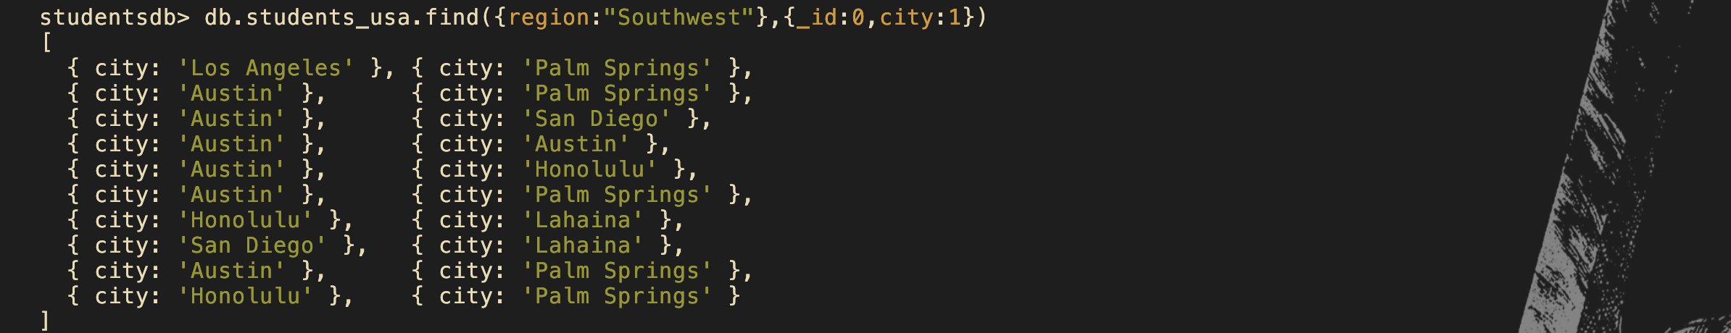
For simply listing the cities in the southwest this is somewhat sufficient however for the use of just seeing the unique cities in this region this command would do much better;
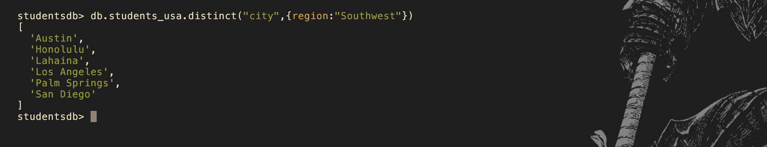
We can see there is no other different cities however there is now much less repition in the query output.

2.
Next we need to find all adolescents aged under 20, living in the Southern area of the United States, and have only one hobby.
This is when we find our query having that smidge more complexity that requires the use of an aggregation.
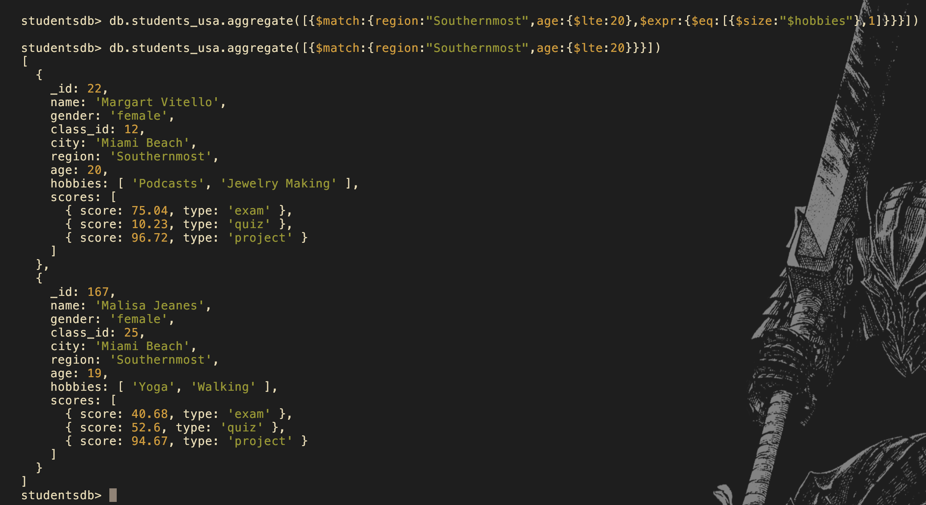
The first command executed above is correct for finding the adolescents under 20 with 1 hobby in the south however as we see, these students both have more than one hobby so no results are yielded upon execution.

Now we must add an index to improve the performance of this command. For this instance I will add an index on both age and region. On top of this I will create a new field hobby size so incase anyone else every happens to have only one hobby, it can be easily searched for.
