Assignment 2 NoSQL Daniel Soden

Student No: R0024715

Part 1:

- To improve the performance of queries to the following data set we should introduce the concept of redundancy into the database as a means to denormalize the database.
- This will reduce the number of joins required to retrieve particular datasets we require.

- Store (storeID, region, managerID, squareFeet)
- Employee (employeeID, whereWork, employeeName, employeeAddress)
- Department (departmentID, managerID, salesGoal)
- Schedule (departmentID, employeeID, date)

Short Circuiting

- Short circuiting is the concept of creating short-circuit keys that connect the lowest-level grandchild records to higher-level grandparent records. For this situation what we can do is include department ID in the employee table as to get to employee from the master table we, through the mangerID key, have to traverse from the master store, to department to then reach employee. This reduces queries relating to employees and what department they are a part of rather than having to do a multi table join to check this information.

Combining Department and Store tables:

- Although this may lead to some duplication of data in attributes like squareFeet and region, this will make sure there are no multi table joins throughout the rest of the database. We can remove storeID and put region and squarefeet in department so that we can easily join with employee and schedule as to relate the department to their employees and schedule. It means at the very most we will only ever need a two table join in order to access any combination of data from one table.

Final Table

Department:

Department(departmentID, mangerID, salesGoal,region, squareFeet)

Employee:

Employee(employeeID,whereID,whereWork,employeeName,employeeAddress)

Schedule:
Schedule (departmentID, employeeID, date)

Part 2: NoSQL Modelling

- An aggregate is the cluster of entities treated as a single unit for data changes. A boundary is the line that surrounds this aggregation and defines the scope of this aggregate in what entities and value objects are a part of it

- An aggregate boundary that could be made from the above ERD is mainly centred around the enrollee entity given as we see it already around the centre entity anyway. For my aggregation, I decided to keep enrollee with enrollee_id as the aggregate boundary identifier and including education and enrollee in the boundary. An enrollee’s education is tied to their identity ie a company wouldn’t manage education details without the context of the enrollee
- The next aggregate boundary is between the profile and experience with enrollee_id as our aggregate identifier. A user will likely explain their personal experience in a profile when registering with a particular company so having this data in an aggregate workouts better. A profile represents an enrollee’s career aspirations and is closely linked to their experience.
- The final aggregate boundary for this assignment would be company on its own as it is a stand alone representation of its own data.

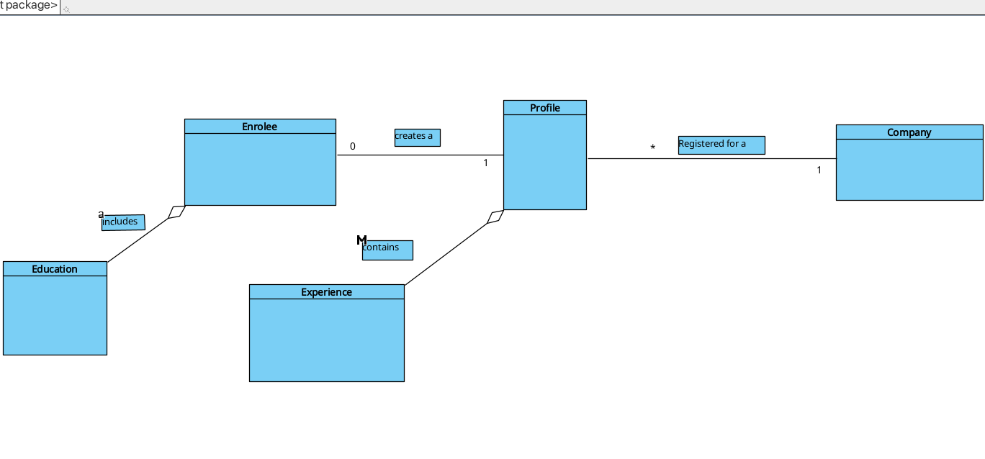

Json Files:

