Databases Project 2 Daniel Soden

(a)

Mock up textual analysis

Blue = Entities
Red = Attributes
Green = Relationships

MTU Thoroughbreds runs a number of horse clinics around Ireland. A particular clinic will
have many vets who is a member of staff. A member of staff manages at most one clinic (not
all staff manage clinics). Each clinic in the MTU Thoroughbreds clinics chain will have a
unique clinic number (clinicNo) along with address, phone number. Each member of staff will
have a unique staff number (staffNo). Further staff details such as first name, last name,
address, DOB, salary, position will also be stored. When a Horse owner contacts a clinic, the
owner’s Horse is registered with the clinic. An owner can own more than one Horse, but a
Horse can only register with one clinic. Each owner has a unique owner number (ownerNo),
name, address, phone number and each Horse has a unique Horse identifier (HorseID), DOB,
Horse Colour, Horse name. When the Horse comes to the MTU Thoroughbreds clinic, it
undergoes an examination by a member of the Veterinary staff. The examination may result in
the Horse being prescribed with one or more treatments. Each consultation has a unique
consultation number (consultNo) and each type of treatment has a unique treatment number
(treatNo).

Entities:
- Clinic
- Staff
- Owner
- Horses
- Consultations
- Treatments
Relationships:
- A clinic has many members of staff and a member of staff manages one clinic.
- A Horse is registered to only one clinic however one clinic can have many horses.
- An owner can own multiple horses and we assume a horse can only have one owner.
- A horse can go through multiple unique consultations but one consultation is only done on one horse .
- A consultation can lead to many treatments and treatments can come from many consultations so an extra entity of prescription (sample name) should be made to mitigate many to many.
Associations:
- Clinic to staff – One to many – One clinic has many staff members
- Staff to clinic – One to one (or zero) – A staff member can only manage one clinic (Assuming clinics do not have multiple managers.)
- Horse to clinic – one to one – One horse can only be registered with one clinic
- Clinic to horse – one to many – One clinic can contain many horses
- Owner to horse – one to Many – One owner can own many horses
- Horse to owner – One to one – One horse can only be owned by one owner
- Consutlation to horse – One to one – One consultation is assigned to one horse
- Horse to consulation – One to many – One horse can undergo many consultations
- Consultation to prescription – One to many – One consultation can potentially illicit multiple prescriptions.
- Prescription to consultation – One to one – One prescription only comes from one consultation.
- Treatment to prescription – One to one - One treatment comes from the one prescription not many different prescriptions.
- Prescription to treatment - One to many - One prescription can result in many treatments.

(b)

Clinic:
- clinicNo – Primary key
- Address
- Phone number

Staff:

staffNo – Primary Key
clinicNo – Foreign Key – Where the staff member is located
fName
lName
address
DOB
Salary
position – (Manager is a specifically important position to identify for the connection to clinic

Owner:
ownerNo – Primary key
fName
lName
telNo
address

Horses:
horseID – Primary key
ownerNo – Foreign key
clinicNo – Foreign key
color
horseName

Consultation:
consultNo – Primary key
horseID – foreign key

Prescription – Bridge Table (Reduce many to many)

consultNo – Foreign key – Composite key 1
treatmentNo – Foreign key Composite key 2

Treatments:
treatmentNo – Primary key
success – My own attribute added to determine the nature of the treatment

(c)

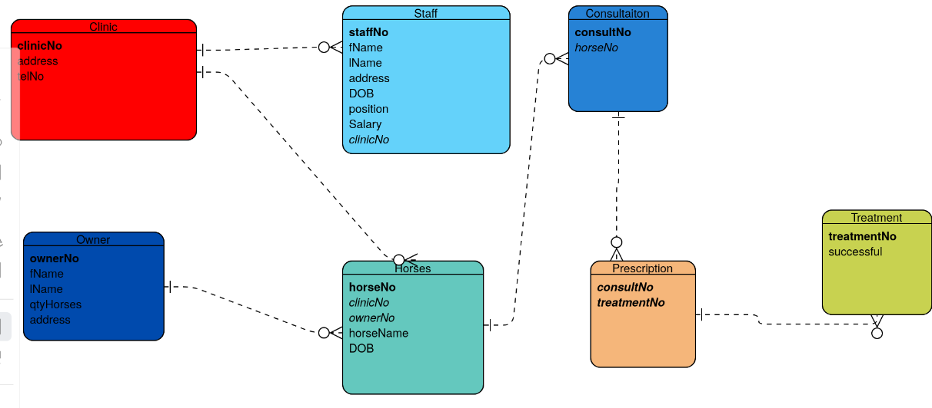

(d)

- From the given information seen above this page definitely isn’t UNF as before we ever split it into entities this table format couldn’t be a single flat table as we were given individual entities with particular attributes such as horseNo and the owner’s address.
- It also cannot be 1NF, we have no repeating data groups as they have been split into their respective tables with keys to uniquely identify specific instances of an entity.
- It is not 2NF as we have no partial or trivial dependencies due to entities like the prescription table as a bridge to eliminate a many to many association.
- The table is currently in 3rd Normal form and not boyecodd normal form as all determinants aren’t candidate keys yet. This can be done by taking a copy of determinant and removing the attributes it determines into a new table.
(e).

Create Code:

Creating the horseClinic Database

Creating the Tables and their data:

Insertion Code:

Selection Code:

