Lab 8 Operating Systems

General Questions

1.

a. What is a disk track request:
- The request the computer makes on a particular track before writing this data to disk
b. A disk scheduling algorithm:
- An algorithm which manages requests and decides the order of the disk access given to the requests

c. The value of the number of tracks crossed indicates efficiency as we can count the number of tracks that the read write head must cross over in processing jobs.

d. Scan direction is the way in which the disk arm begins at one end of the disk and moves to wards the other end. This is extremely prevalent in the scan algorithm where in which it servers requests generated by the memory management unit.

e. N is the size of the group in a queue. Ie N step scan chooses some N which will be the number of jobs that will be dealt with in one scan. For example if the scan works from 0 to 199 and if N=4 and the head starts at track 27 then requests will be dealt with in the following order:
Group 1:
37,98,122,183
Group 2:
124,67,65,14

f. A disk arm will stick around a particular track or tracks if there are a lot of requests for those tracks. However this sometimes leads to inefficient access for other requests ie starvation.

g. The starting track of a disk R/W head can vary depending on the particular disk drive and its current state however usually it s positioned at the outermost track when the drive is powered on and initialized. This thus allows for the fastest rotational speed and hence the highest data transfer rate.

Algorithms running questions

1.
a.

1.
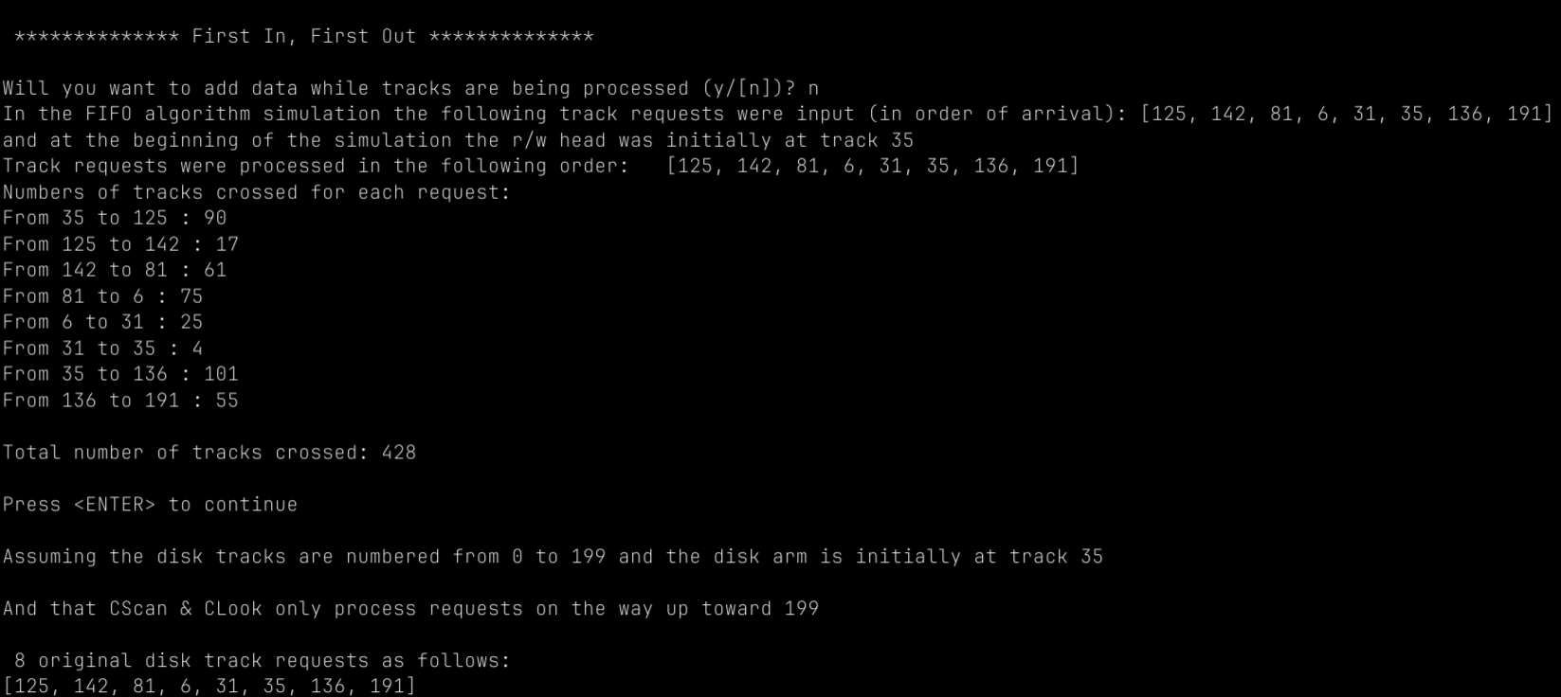
As we can see above FIFO takes the simple approach of servicing request in the order of their arrival meaning they are fair and simple. However this is extremely inefficient performance wise.
As seen above the read write head starts at track 30 zips over 125 then to 142 and so on. This is quite inefficient as it leads to much larger track crossing. For most algorithms I would go into more depth on each track change however this algorithm is the same each time.

2.

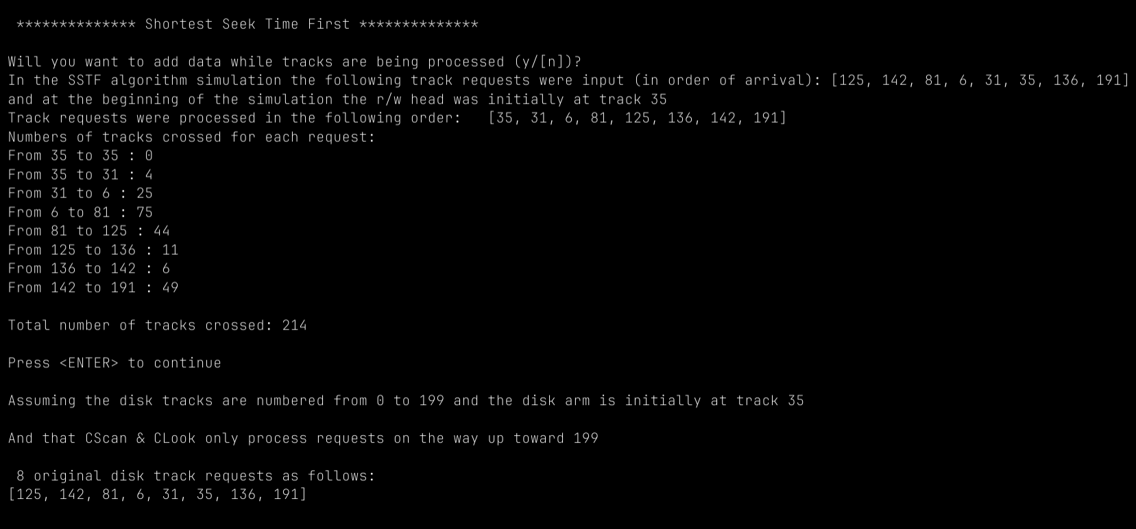
As seen above using the shortest seek time algorithm starting at 35, the shortest path next is 35 of course, from there the next shortest would be 31 then 6 then 81 to 125 etc.

3. Scan
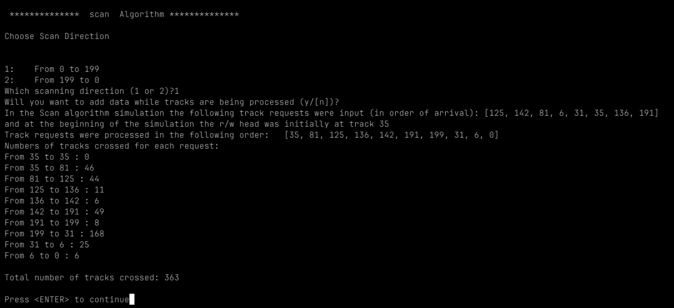
In scan it prompts the OS to pick a particular direction and from there it will only move towards that number ie 0 to 199 or 199 to. Above I picked 0 to 199 but I if I had picked 199 to 0 my first track movement would have been from 35 to 31 then to 6 and then 0. After it goes form 35 to 81, 81 to 125 and so on, it loops back and completes to 199 to 0 eventually and vice versa.

4. Look Algorithm

Look operates very similarly to scan in a sense except it also takes inspiration from SSTF by choosing the job at the next nearest job in its movement.

