Lab 1 Requirements Engineering

Name: Daniel Soden
Date: 16/09/2024
Class: SDH2-B

Task One

Part 1. User Roles:

- Fisherman
- Botanist

Part 2: Features for Roles

- Features for Fisherman:
1. Understand Marine weather advisory at specific coasts
2. Studying Buoy reports

- Features for a Botanist:
1. View detailed full forecast
2. Analayse 12-48 hour rainfall radars

Part 3. Requirement Scenarios:

Prompt 1:

“Penny is a tillage farmer living in west Cork. She is planning on sowing seeds and would
like to know if conditions are suitable for carrying out this activity”

Prompt 2:

“Billy is a surfer who is planning on going to Donegal next weekend but there is a red alert
for an incoming storm. He wants to know what the difference is between the different
alert categories.”

Penny

i. 1 minutes 27 seconds
ii. 3 clicks.
iii. No issues encountered
iv. As a tillage farmer living in west cork I want to find out if the weather is suitable, so that I can sow my seeds.

Billy

i. 2 mins 2 seconds
ii. 7 clicks
iii. Buried between various pages, had to search in the end
iv As a surfer in Donegal, I want to find out differences between weather warnings so that
I can ensure my safety.

Task Two

1. The student would need to find out the programme code or CRN. On this website they would
also need to find out their own timetable and whether or not this module fits into their timetable.

2. The name she would need is Server-Side Web development, SOFT7008, 27387

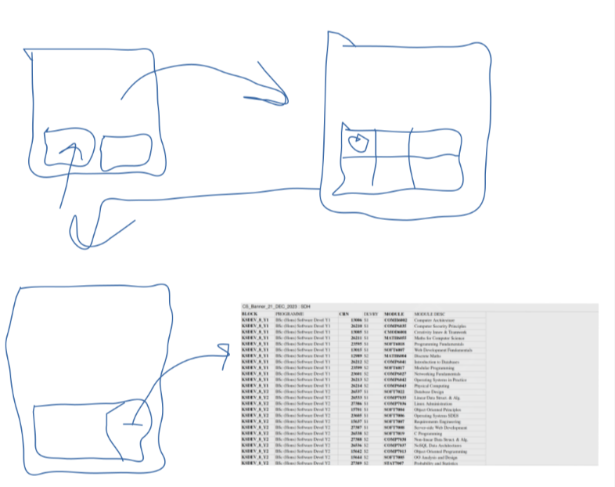
3.

