Daniel Soden OO Analysis Lab 1

Part A

1. How to draw an Object Diagram
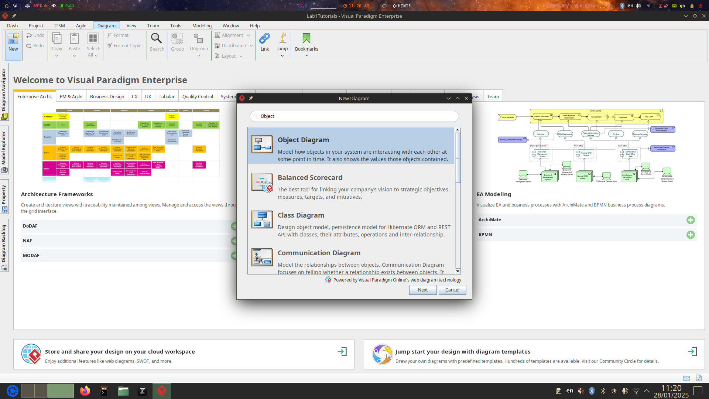
Here I am creating the object diagram as a start
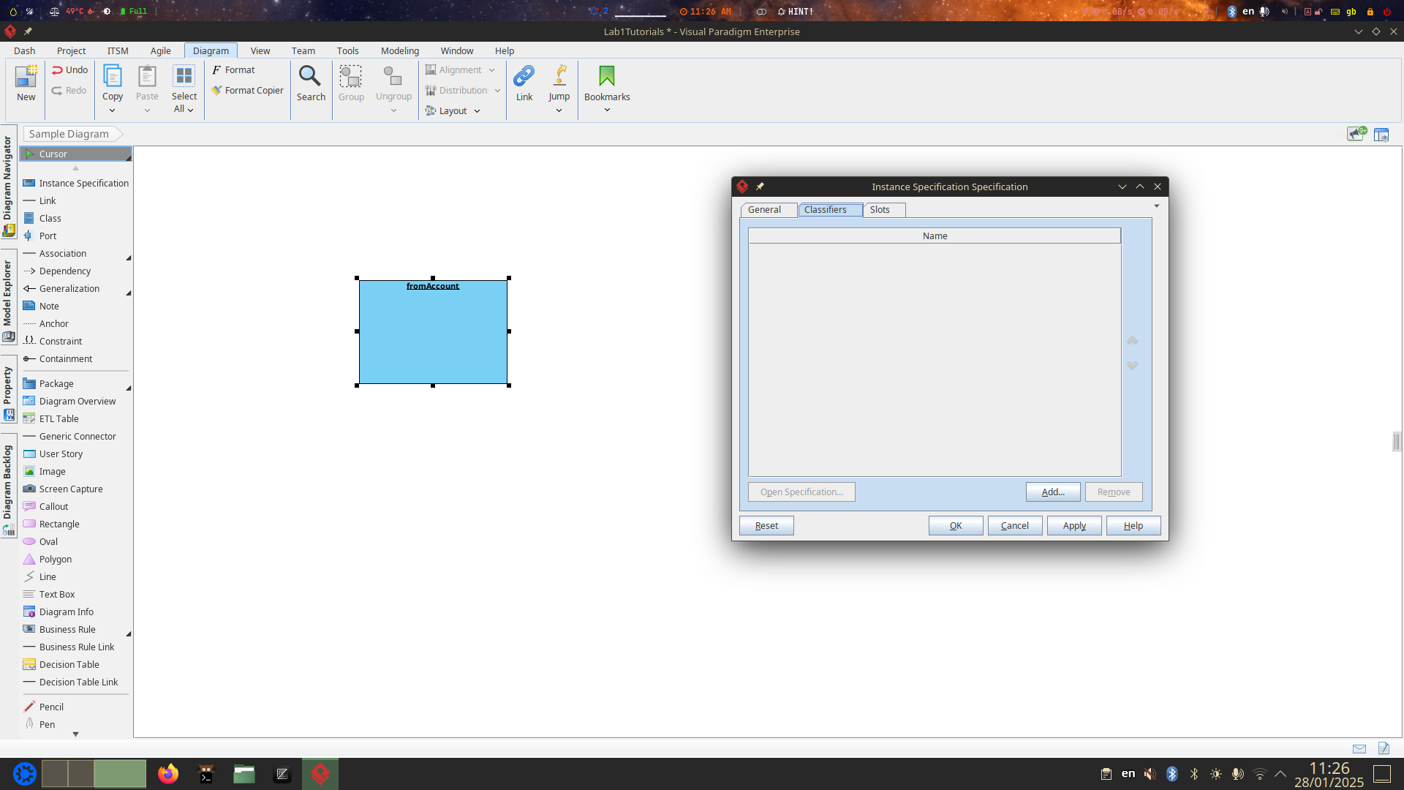
From here then we create an instance specification and attempt to create an instance specification shape and named it fromAccount as shown from the tutorial.
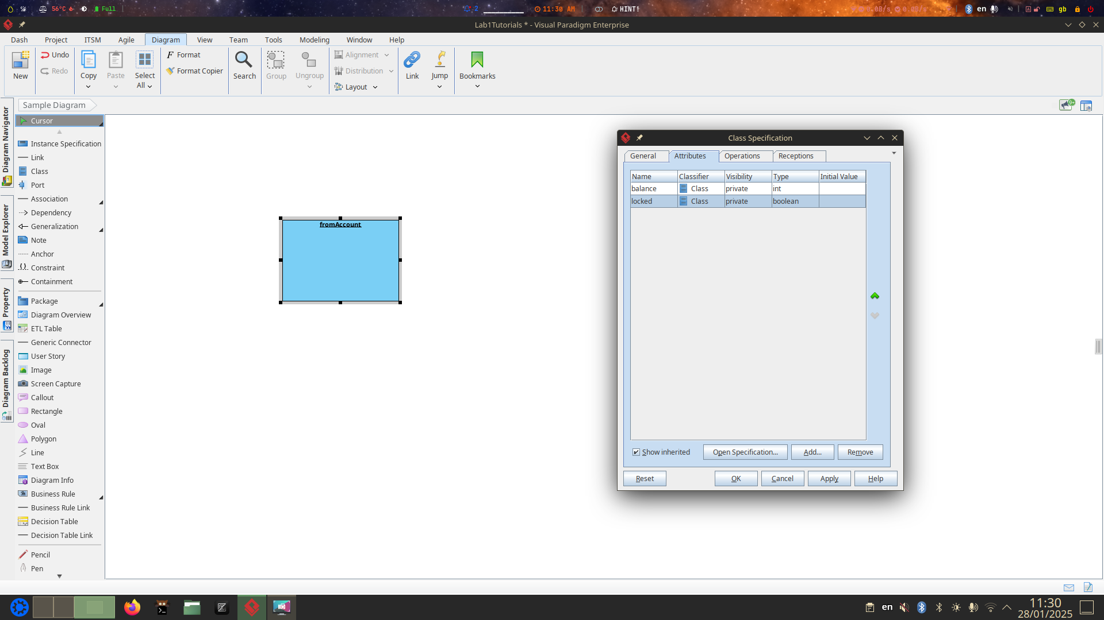
Then we create a class from this instance know as Account and give it the attributes of locked as a boolean and balance as int (Should be a double but sure).
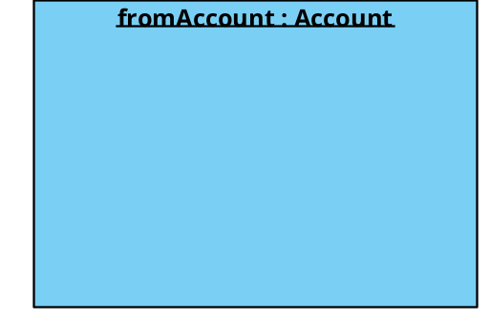
Selecting Classifiers
Despite creating the account perfectly in the last section, when I try to select the classifier and go into account it creates virtually nothing and is no help at all.
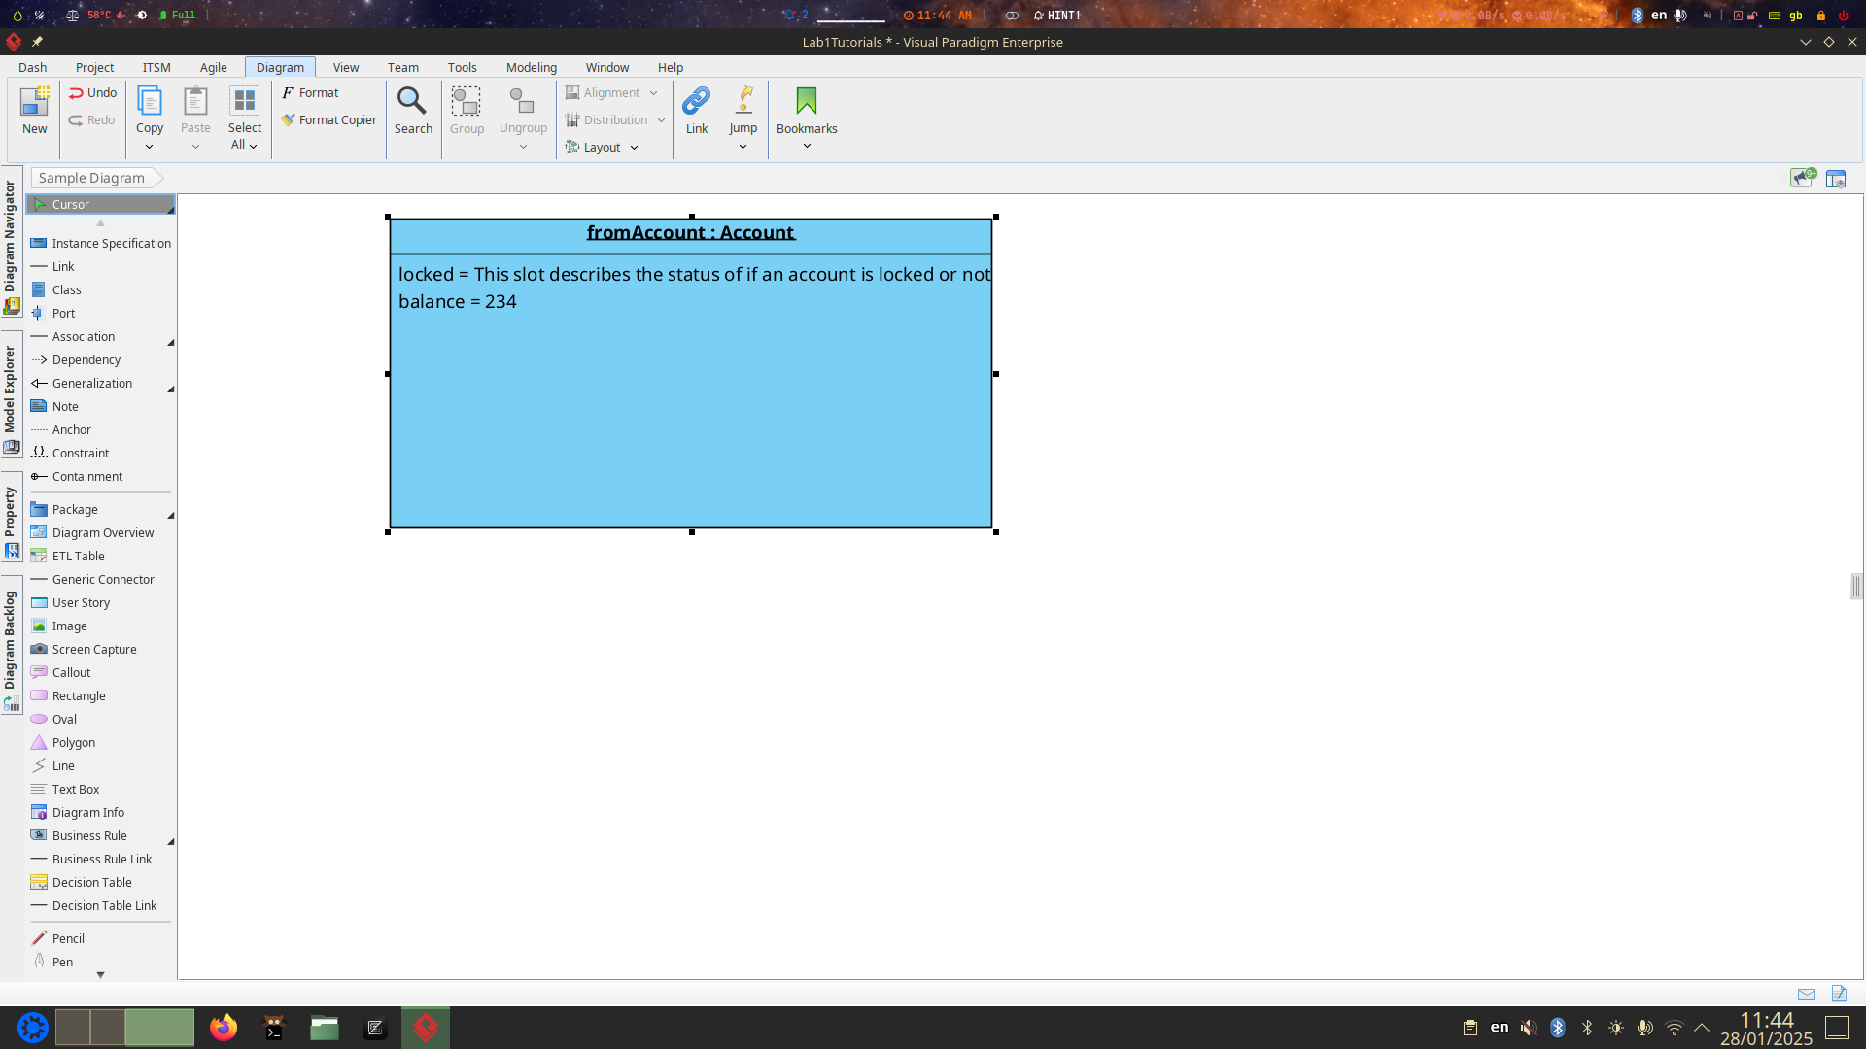
Creating Links

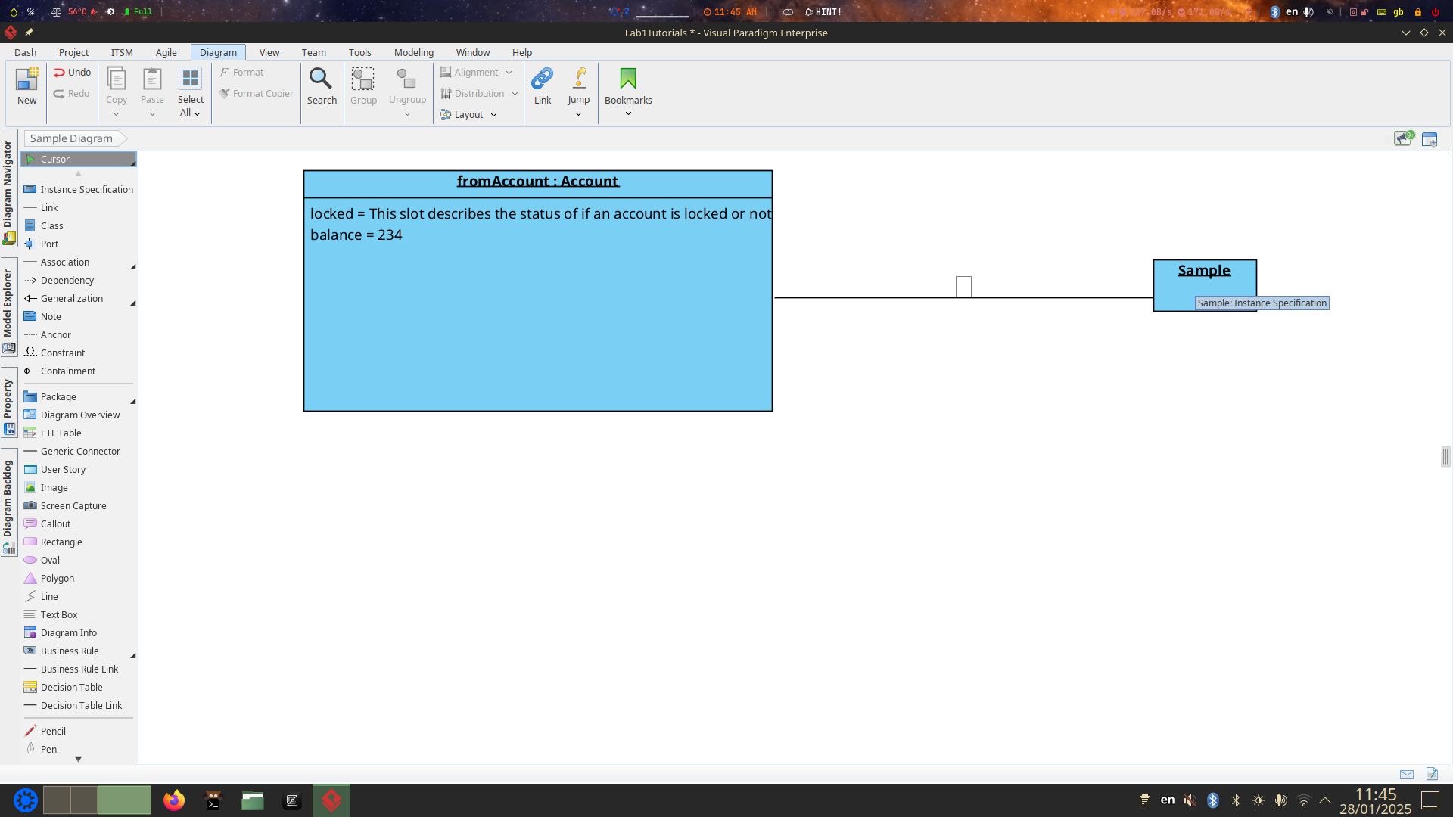
2. How to draw a class diagram
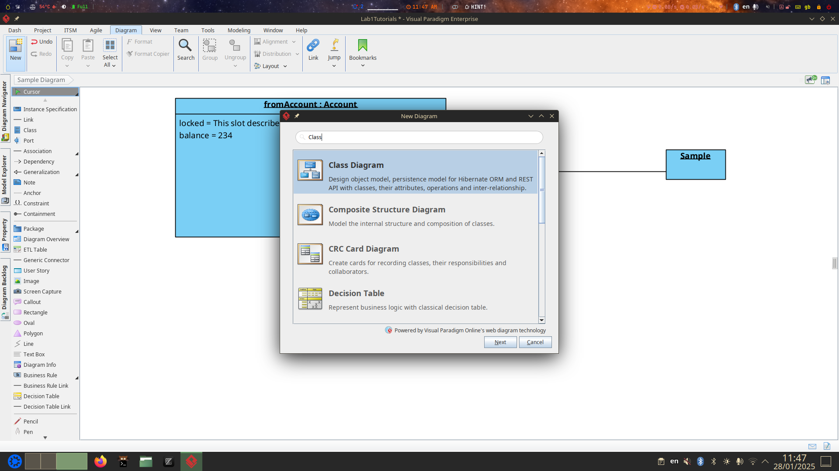
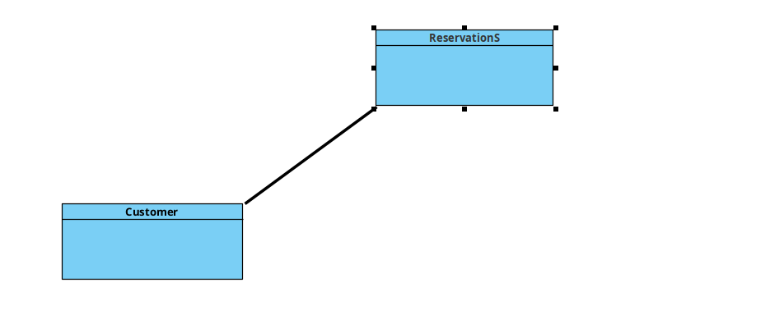
.
Here I have created an association between customers and reservations
And a multiplicity of * between the two.

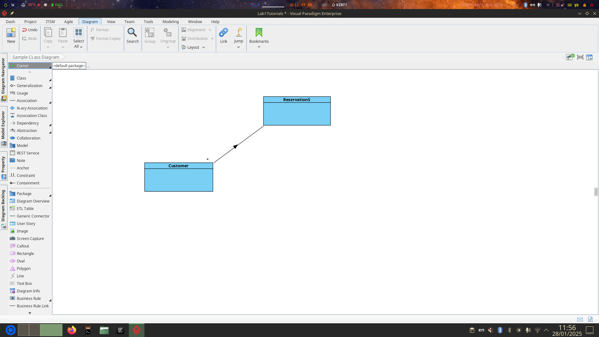
Creating attributes:

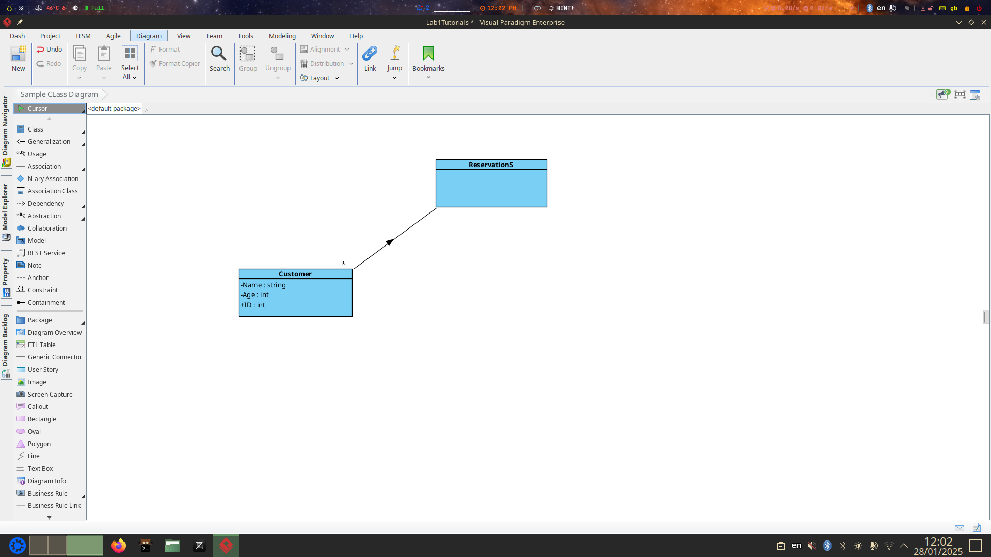
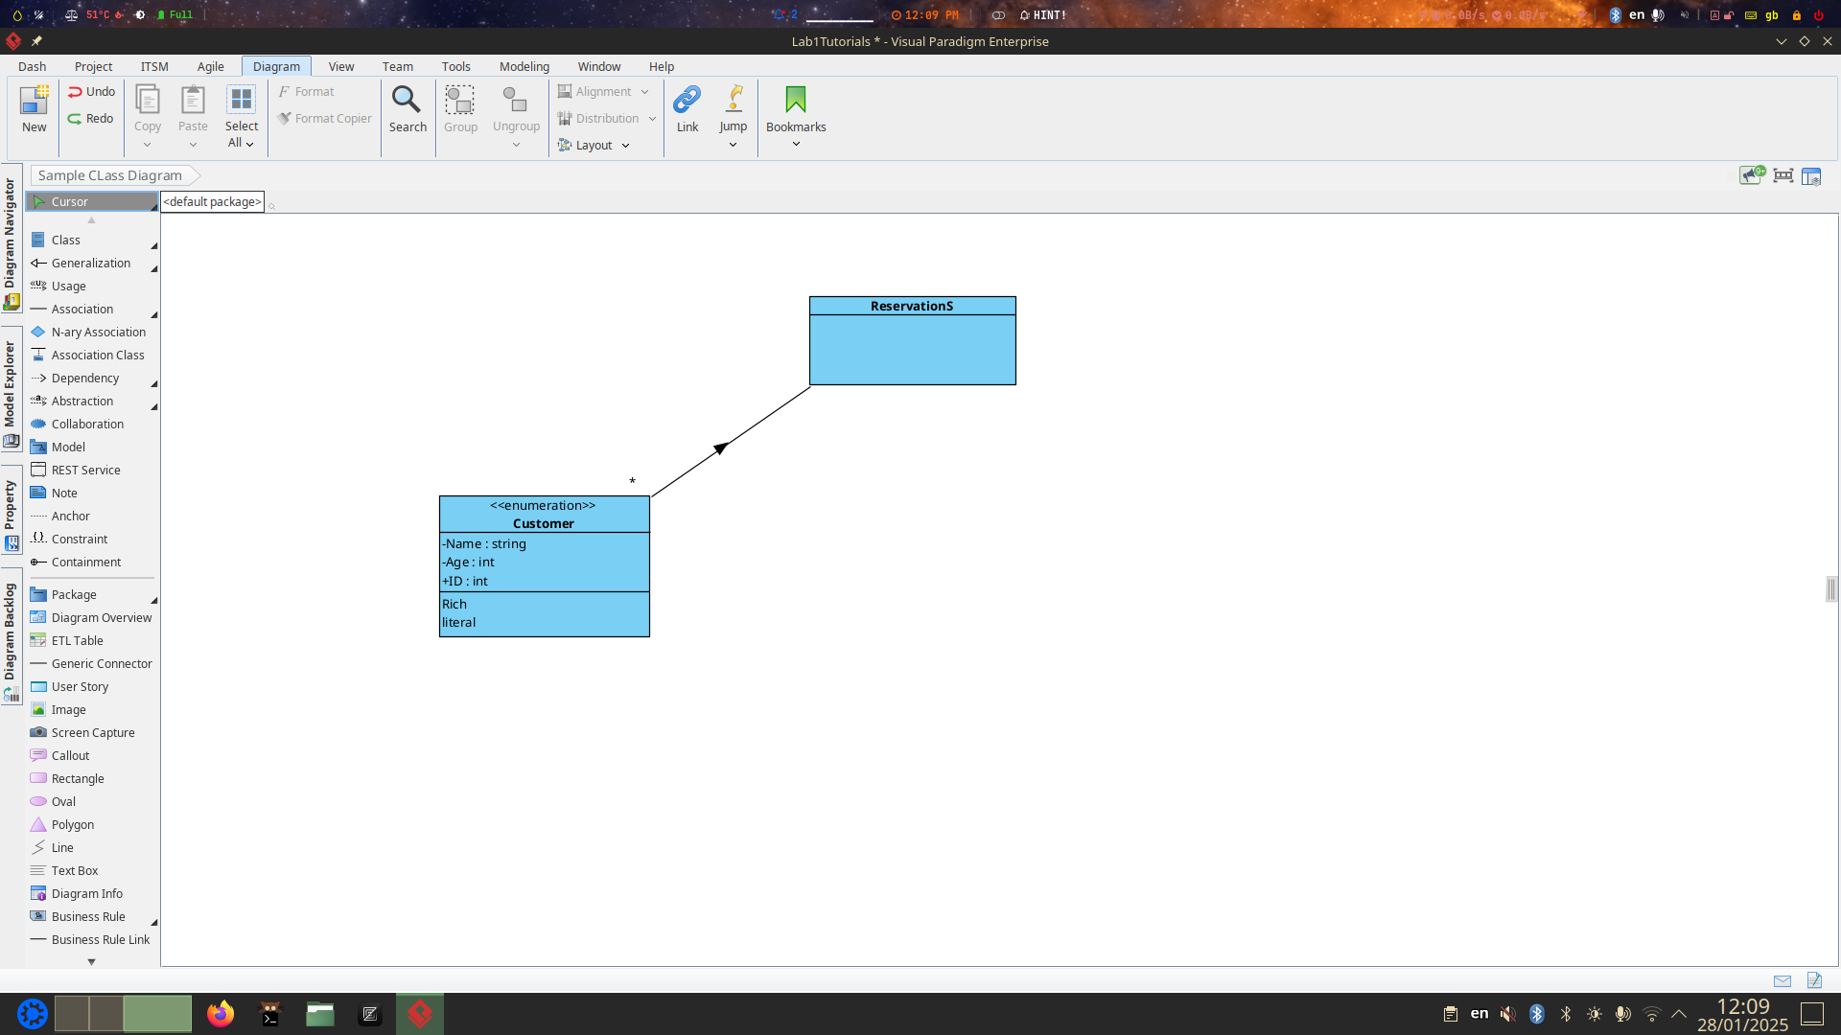
.

Part B
For each exercise do the following:

(a) Identify objects that are described in text.
- Registered Users
- Workstation
- Network
- Room
- Building
- University

(b) For each object, identify its classification.
- Registered Users – Classified under Users
- Workstations – Classified under computer
- Room – Classified under Building#
- Building
(c) For each classification, identify its attributes.
- User:
- Id
- Name
- Age

Computer:
- Ram
- ssd
- name
-cpu
-gpu
-id
et

Building;
- Id
- year built
- Purpose/Department

(d) For each identified object, Identify its attribute values.

- Registered User:
Registration Date
Id – Super
First name
Last name – Seperated from name of super
Age

- Workstation
- Ram
- ssd
- name
-cpu
-gpu
-id – All super
- Department/Purpose
- Price
- Roomid

- Room
- Id
- BuildingId
- Department

- Building
- Id
- year built
- Purpose/Department

(e) Identify which objects are connected to each other,
- Building – Room
- User – workstation…
- User – Department…?
- Room - workstation

(f) Identify relationships between different classifications that would allow for
objects to be connected as identified in
- Building to room – One to many
- Workstation to room – One to one
- User – Workstation – One to one

Exercise 1.
A computer network has five workstations attached to it numbered from 1 to 5. There
are three registered users of the network. Mary Davin , Joe Smith and Bill
O’Sullivan.
Mary is currently logged onto workstations 1 and 4. Bill is logged onto workstation
5. Joe is not logged on to any network.
Workstations 1 and 2 are in room C127.Workstations 3 and 4 are in IT2.3.
Workstation 5 is in B234. C127 and B234 are in the main building of MTU. IT2.3 is
in the IT building of the university.

a. Draw an object diagram representing the objects and relationships implied in this description.

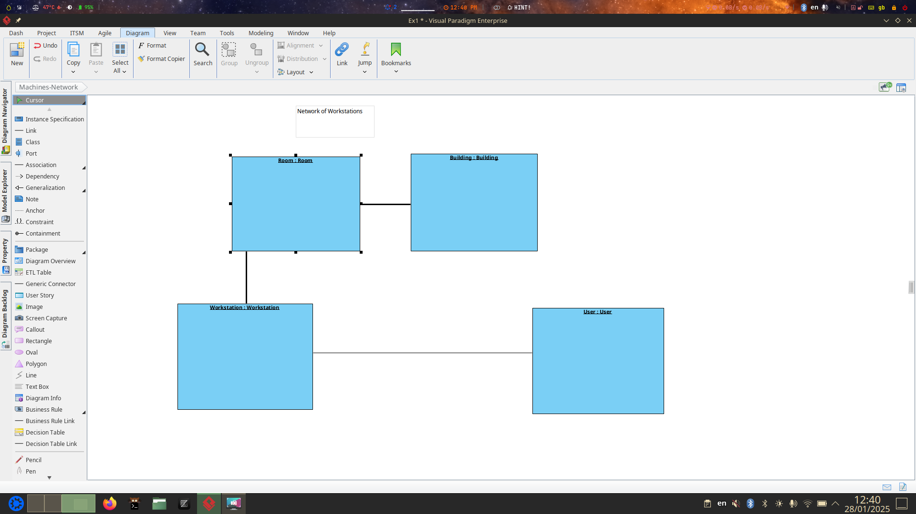

b. Draw a class diagram to support the above diagram

Exercise 2.

(a) Identify objects that are described in text.
(b) For each object, identify its classification.
(c) For each classification, identify its attributes.
(d) For each identified object, Identify its attribute values.
(e) Identify which objects are connected to each other,
(f) Identify relationships between different classifications that would allow for
objects to be connected as identified in

Jenny is the owner of a dog named Bradley. Bradley is a Labrador breed of dog. She
is microchipped. Her date of birth is the 12/4/2018. Jenny purchased a license for
snoopy on the 16/5/2018 from the local authority office in Cork. Jack is the owner of
a Rottweiler named Paddy . His date of birth is 11/11/2016 He is not microchipped
yet. He does not have a dog licence. This breed of dog is in the category of a “Ban
dog” and must be securely muzzled when out in public. Orla is the owner of a terrier
breed of dog named Sandy. She is microchipped. Her date of birth is the 8/2/2010.
Oral purchased a license for Sandy on the 5/5/2011 from Dublin county council after
receiving a fine for not having a license for her.

a. Draw an object diagram representing the objects and relationships implied in
this description.
b. Draw a class diagram to support the above diagram

