Lab 2 OO Analysis and Design – Daniel Soden

1.

Attributes for following classes

I.

Part A.

Series:
- seriesNo
- timeStart
- timeEnd
- noOfBreaks
- seriesTitle
- seriesSeason
Passenger:
- passengerNo
- flightNo
- firstName
- lastName
- ticketNo

Event:

eventNo
time
date
quantityPeople
departmentNo

Classroom:

roomNo
departmentNo
quantitySeats

Call:

callNo
callTime
callDate
duration

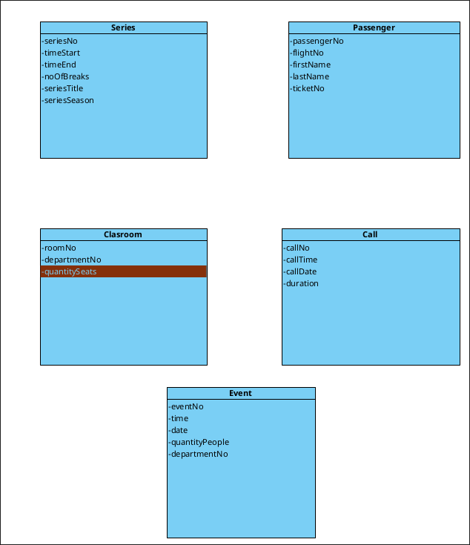
Part B
For each of the classes in Part A, identify a new class that it would be
related to for the given system. For each association, indicate the
following properties, name, and multiplicities.

Event – organiserNo

classroom – teacher

call – provider

series – Channel

passenger – Ticket

Refined some of the attributes:

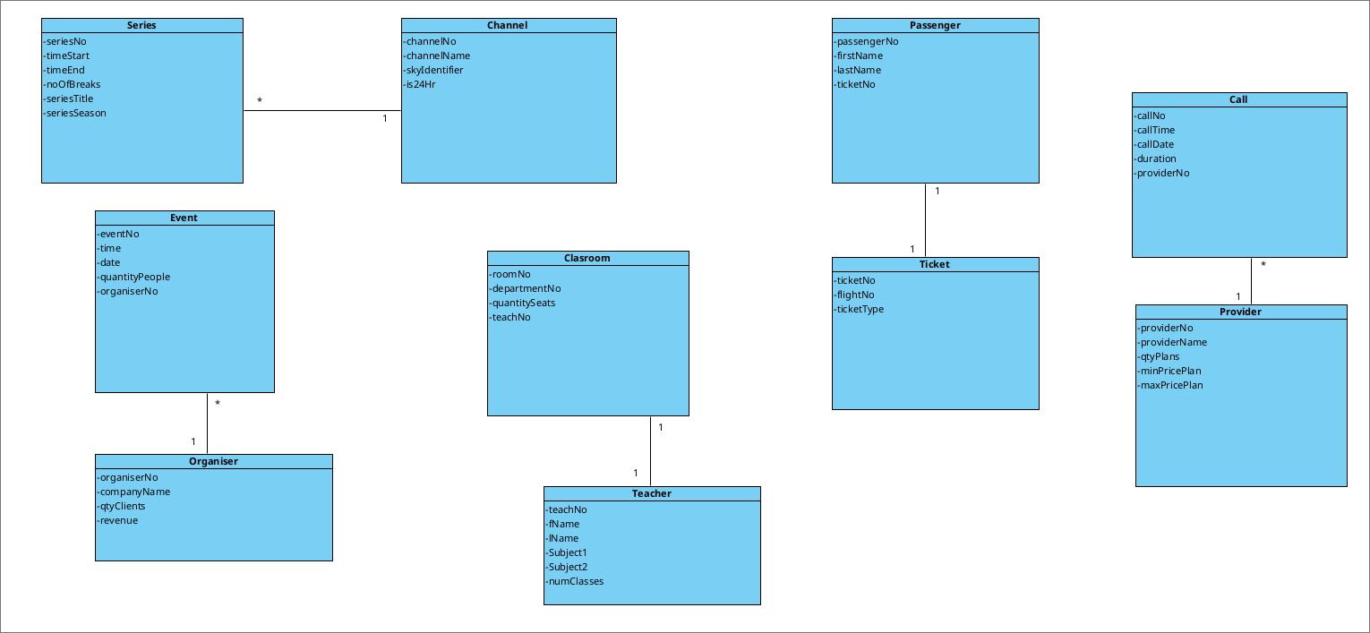
- Names and multiplicities shown in diagrams

