Daniel Soden Lab 4 OO Analysis

1.

Each university degree has several compulsory courses and several
elective courses. Each course is at a particular level and has a credit
point value. A course can be part of several degrees. Each degree
specifies a minimum total credit points value required for degree
completion. For example, BIT (Bachelor of information technology)
requires 68 credit points. Students may combine course offerings into
programs of study suited to their individual needs and leading to the
degree in which the student is enrolled.

Using what I have learned in previous modules like database design I have decided to split up Student course relationship and the degree to course relationship given above is stated that a student is enrolled in multiple courses and obviously courses foster multiple students. This works the same way for courses to degrees as it is stated that a course can be a part of multiple degrees and degrees have multiple courses. I have underlined above the various potential attributes and filled in some blanks like course names.
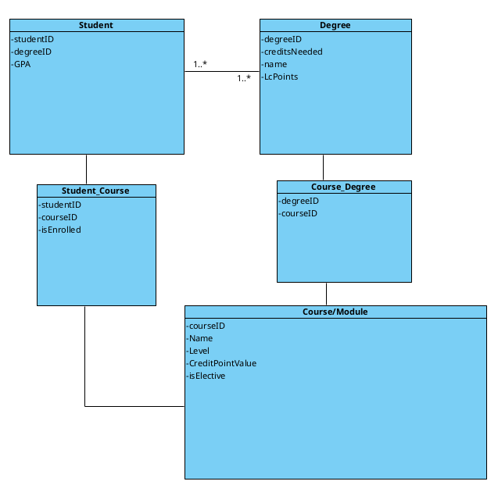

2.
A user can be assigned to a task as either a worker or a watcher but not
both. A worker needs to file the hours they work on a task. A worker
needs to track their progress on a task. A task is watched by any number
of watchers and may be assigned to one worker at a time. A watcher can
only be watching one task at a time. All previous workers of a task need
to be tracked.

