Daniel Soden Probability And Statistics 2025 R00247215 – Continuos Assessment 2

1 Hypothesis test based on the following data.

An introductory statements:

Variables:
μ: 3000g
σ:500g
Ho (Null hypothesis): μ > 3000g
Ha (Alternative hypothesis): μ = 3000g

Given the variables above I will perform a hypothesis test on the statement that the mean weight of babies is greater than 3,000g.

Exploratory analysis:

The main steps involved in hypothesis testing are as follows:
1. Given a claim, state the null hypothesis 𝐻0 and the alternative
hypothesis 𝐻𝐴 (i.e., alternative to 𝐻0) and express them in symbolic form.

H0: μ > 3000g – We are given this pre-defined statistic along with the standard deviation
HA: μ = 3000g – As apart of determining this, we will more accuretly calculate this mean and its standard deviation

For visualisation purposes, I have used R to create a histogram representing its normalised curve:
As we can see below, although this isn’t enough to draw any concrete conclusion, we do see that the baby weights most fall within 3000-4000g, potentially supporting the null hypothesis.

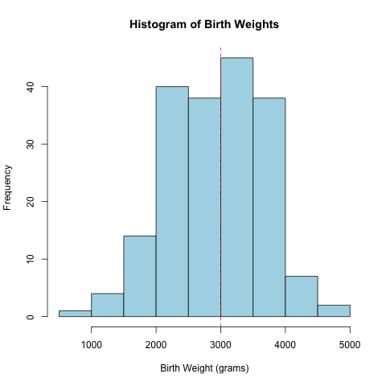

2. Calculate a test statistic.

For a claim about the mean we must use this formula to determine our test statistic aka the Z score.

By plugging this formula into a calculator this is the result:

3. Given a significance level, identify the critical
value(s).

4. Compare test statistic to critical values and state
conclusion of hypothesis test.

Results:

Based on this analysis, there is not enough statistical evidence to conclude that the mean birth weight of babies in this study is greater than 3000g. We can conclude this from our P value of 0.936195332170276 being greater than 0.05.

Conclusion:

2. Estimate of birth weight for the population with a 95% level of confidence

Given this sample is analysing the mean birth weight, we will use a 95% confidence interval test on the mean.

