Assignment 4 NoSQL: MongoDB ReplSet

1.
I started off by simply creating the three directories for the cork replicaset with mkdir

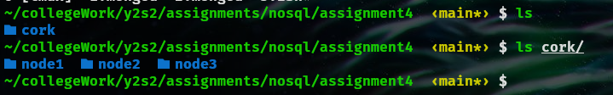
From here I created 3 different mongod instances in these individual nodes and assigned to localhost ports that I know would be free of 3000,8080 and 8000
Rather than opening 3 different terminal emulator apps, I used tmux to create different windows so I could run these instances.
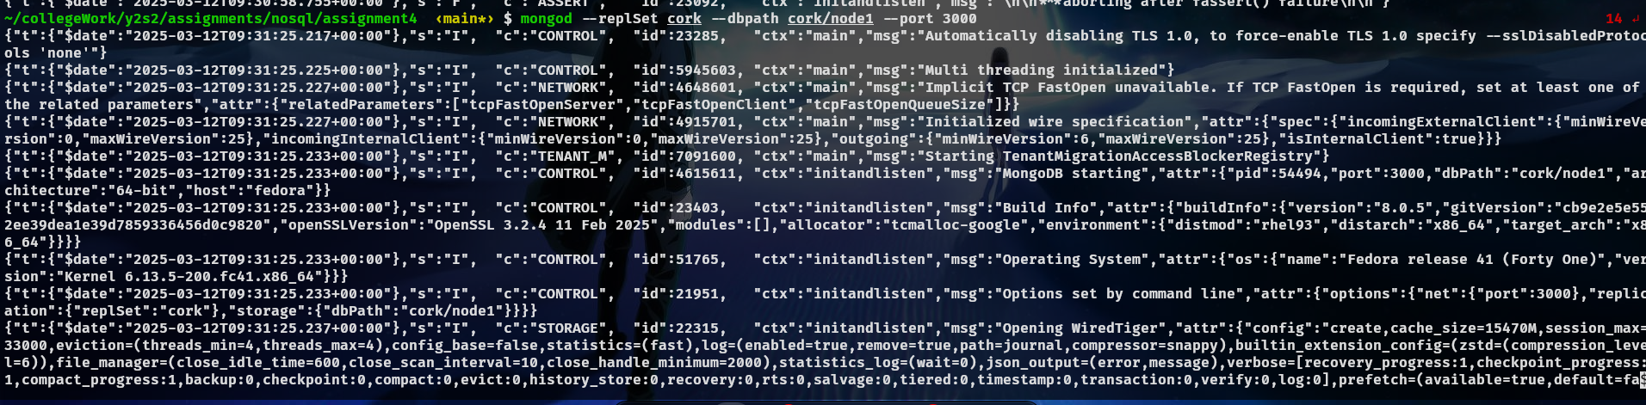
Command may be difficult to view but it was simply
mongod –replSet cork/ --dbpath cork/node1 –port 3000

And on my other windows I ran these commands to create these instances

mongod –replSet cork/ --dbpath cork/node2 –port 8080
mongod –replSet cork/ --dbpath cork/node2 –port 8000

From here I ran the mongosh command to connect to these nodes.

